**Exercise 1:**

In a file called ex1.html write the HTML needed for creating a web page with a for as close as possible as the following form:

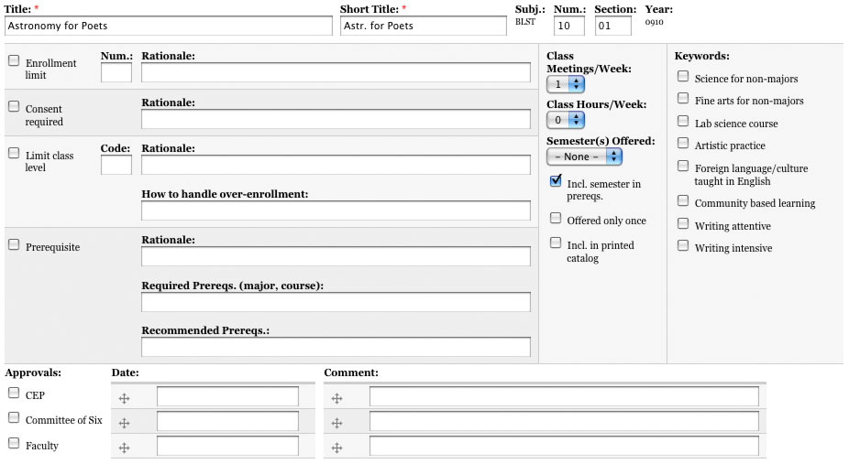

**Note: You must look for further info in order to get the the proper color and the proper borders.**

**Exercise 2:**

In a file called ex2.html write the HTML needed for creating a web page with a for as close as possible as the following form:

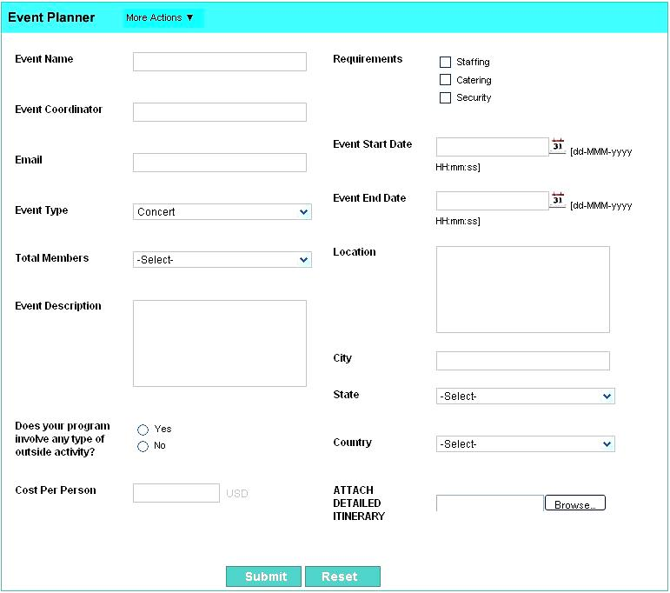

**Note: You must look for further info in order to get the the proper color and the proper borders. Look for images if you need someone**