Abstract Factory Design Pattern

Student: Hulea Andrei-Florin
Grupa : 30235

- Descriere
Sablonul de design Factory este ideal pentru situatiile in care avem nevoie de multiple instante ale unui obiect in run time. Asadar, in loc de a crea fiecare instanta, putem initializa mai multe instante, scopul fiind incapsularea codului pentru a fi refolosit de mai multe ori. Acest sablon rezolva problema crearii obiectelor fara a specifica clasa exacta a obiectului respectiv.
Crearea unui obiect adesea necesita procese complexe care nu sunt adecvate pentru a fi incluse in compozitia obiectului respectiv. Deci, crearea obiectului ar putea sa conduca la o duplicare semnificativa de cod, necesita informatie neaccesibila pentru obiectul in curs de creare sau nefurnizarea unui nivel suficient de abstractie. Sablonul factory creaza o metoda separata de a crea obiecte, metoda pe care subclasele o pot suprascrie pentru a specifica tipul de produs ce urmeaza a fi creat.
- Diagrama UML
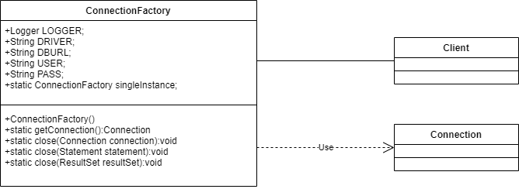
- Implementare
Implementarea acestui sablon a fost realizata folosind Java in cadrul unui proiect de management al unui aeroport.
Class.forName(DRIVER);-> Incarca driver-ul clasei si returneaza Class<Driver>.
connection = DriverManager.getConnection(DBURL, USER, PASS); -> permite driver-ului sa returneze o conexiune la url prin apelarea indirecta a functiei driver.connect, care va returna ConnectionImpl().
Metodele de close pentru ResultSet si Statement au rolul de a inchide conexiunile. La declararea unor obiecte de tip ResultSet si Statement se apeleaza automat connection.executeQuery(sql), respectiv connection.createStatement(), care returneaza la randul lor ResultSetImpl(), respectiv StatementImpl().x

package com.example.application.ConnectionFactory;
import java.sql.*;
import java.util.logging.Logger;
public class ConnectionFactory {
private static final Logger LOGGER = Logger.getLogger(ConnectionFactory.class.getName());
private static final String DRIVER = "com.mysql.cj.jdbc.Driver";
private static final String DBURL = "jdbc:mysql://localhost:3306/aeroport?useUnicode=true&useJDBCCompliantTimezoneShift=true&useLegacyDatetimeCode=false&serverTimezone=UTC";
private static final String USER = "root";
private static final String PASS = "1234";
private static ConnectionFactory singleInstance = new ConnectionFactory();
private ConnectionFactory(){
try {
Class.forName(DRIVER);
} catch (ClassNotFoundException e) {
e.printStackTrace();
}
}
/**
* Method used for enstablishing a new connection
* @return returns the connection status and enstablishes the connection
*/
public static Connection getConnection() {
Connection connection = null;
try {
connection = DriverManager.getConnection(DBURL, USER, PASS);
} catch (SQLException e) {
e.printStackTrace();
}
return connection;
}
/**
* Method used for closing a connection
* @param connection name of the connection
*/
public static void close(Connection connection) {
try {
connection.close();
} catch (SQLException e) {
e.printStackTrace();
}
}
/**
* Method used for closing a statement
* @param statement name of the statement we are closing
*/
public static void close (Statement statement) {
try {
statement.close();
} catch (SQLException e) {
e.printStackTrace();
}
}
/**
* Method used for closing a result set
* @param resultSet name of the result set we are closign
*/
public static void close(ResultSet resultSet){
try {
resultSet.close();
} catch (SQLException e) {
e.printStackTrace();
}
}
}

