RAPORT MIPS PIPELINE

Hulea Andrei-Florin
Grupa 30225

a)Modificari particulare pentru cele 4 instructiuni suplimentare
Instructiunile suplimentare au ramas la fel ca la MIPS ciclu unic

b)Tabelul cu descrierea registrilor de pipeline
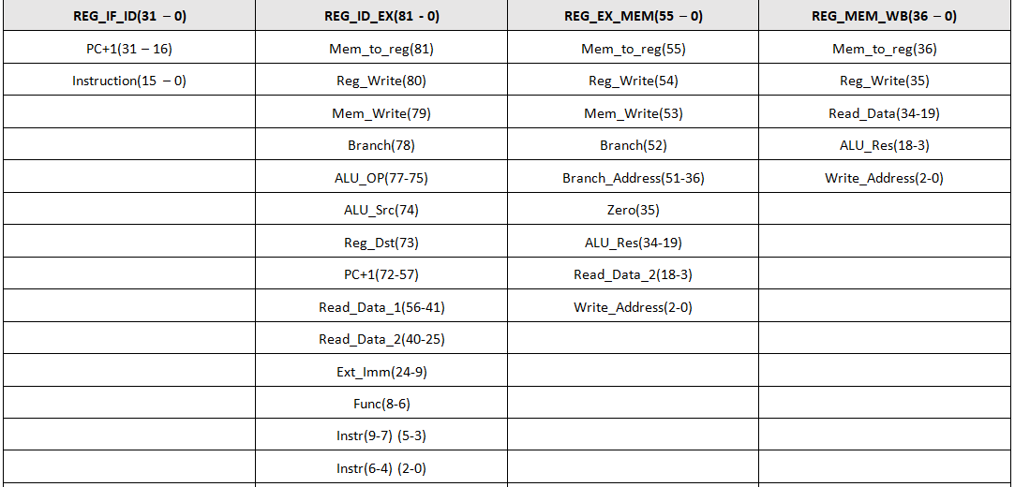
c)Schema procesor mips pipeline laborator 9
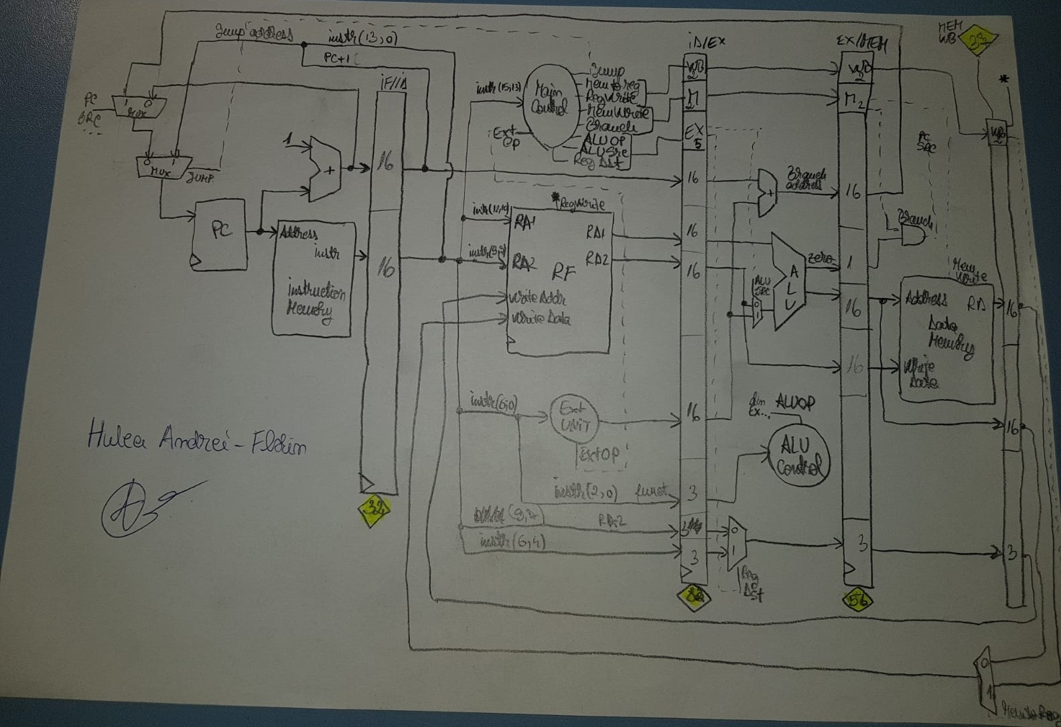
d)Analiza facuta in laboratorul 10
Cod original:
ADDI $s1, $s0, 1 #ultimul
ADDI $s2, $s0, 0 #penultimul
ADDI $s3, $s0, 10 #a
ADDI $s4, $s0, 15 #b
ADDI $s5, $s0, 0 #suma
ADDI $s7, $s0, 1 #pt verificare
loop: ADDI $s6, $s0, 0 #verificare interval
SLT $s6, $s4, $s1 # daca a iesit din interval
BEQ $s6, $s7, verif_prim # sare la verif_prim
ADDI $s6, $s0, 0 #verificare interval
SLT $s6, $s3, $s1 # daca a intrat in interval
BEQ $s6, $s7, add_to_sum
ADD $s1, $s1, $s2 #ultimu
SUB $s2, $s1, $s2 #penultimu
J loop
add_to_sum:
ADD $s1, $s1, $s2 #ultimu
SUB $s2, $s1, $s2 #penultimu
ADD $s5, $s5, $s2 #suma
J loop
verif_prim:ADDI $s1, $s0, 1 #counter
ADDI $s2, $s0, 0 #j
ADDI $s4, $s0, 0 #rez
ADDI $s7, $s0, 1 #verif
BEQ $s5, $s1, nu_e_prim
loop2:ADDI $s1, $s1, 1
BEQ $s1, $s5, end # for i,n
ADD $s2, $s0, $s1 # for j=i,n,j=j+i
loop3: BEQ $s2, $s5, nu_e_prim
ADD $s2, $s2, $s1 # j = j + i
ADDI $s6, $s0, 0 #verificare interval
SLT $s6, $s5, $s2
BEQ $s6, $s0, aici
J loop2
aici: J loop3
nu_e_prim:ADDI $s4, $s0, 0 # NOT_PRIME
J FINAL
end:ADDI $s4, $s0, 1 # IS_PRIME
FINAL: sw $s5,10($s0)
sw $s4,11($s0)

Cod dupa inserarea noop-urilor:
- Am folosit ADD $0,$0,$0 pe post de noop
0 ADDI $s1, $s0, 1
1 ADDI $s2, $s0, 0
2 ADDI $s3, $s0, 6
3 ADDI $s4, $s0, 30
4 ADDI $s5, $s0, 0
5 ADDI $s7, $s0, 1
6 loop: ADDI $s6, $s0, 0 #verificare interval
7 SLT $s6, $s4, $s1 # daca a iesit din interval
8 ADD $s0,$s0,$s0 ---
9 ADD $s0,$s0,$s0 ---
10 ADD $s0,$s0,$s0 ---
11 BEQ $s6, $s7, 42# sare la verif_prim
12 ADD $s0,$s0,$s0 ---
13 ADD $s0,$s0,$s0 ---
14 ADD $s0,$s0,$s0 ---
15 ADDI $s6, $s0, 0 #verificare interval
16 SLT $s6, $s3, $s1 # daca a intrat in interval
17 ADD $s0,$s0,$s0 ---
18 ADD $s0,$s0,$s0 ---
19 ADD $s0,$s0,$s0 ---
20 BEQ $s6, $s7, 34
21 ADD $s0,$s0,$s0 ---
22 ADD $s0,$s0,$s0 ---
23 ADD $s0,$s0,$s0 ---
24 ADD $s1, $s1, $s2 #ultimul
25 ADD $s0,$s0,$s0 ---
26 ADD $s0,$s0,$s0 ---
27 ADD $s0,$s0,$s0 ---
29 SUB $s2, $s1, $s2 #penultimul
30 ADD $s0,$s0,$s0 ---
31 ADD $s0,$s0,$s0 ---
32 J 6
33 ADD $s0,$s0,$s0
34 add_to_sum: ADD $s1, $s1, $s2 #ultimul
35 ADD $s0,$s0,$s0 ---
36 ADD $s0,$s0,$s0 ---
37 ADD $s0,$s0,$s0 ---
38 SUB $s2, $s1, $s2 #penultimul
39 ADD $s0,$s0,$s0 ---
40 ADD $s0,$s0,$s0 ---
41 ADD $s0,$s0,$s0 ---
42 ADD $s5, $s5, $s2 #suma
43 J 6
44 ADD $s0,$s0,$s0 ---
45 verif_prim: ADDI $s1, $s0, 1 #counter
46 ADDI $s2, $s0, 0 #j
47 ADDI $s4, $s0, 0 #rez
48 ADDI $s7, $s0, 1 #verif
49 BEQ $s5, $s1, 80
50 ADD $s0,$s0,$s0 ---
51 ADD $s0,$s0,$s0 ---
52 ADD $s0,$s0,$s0 ---
53 loop2 :ADDI $s1, $s1, 1
54 ADD $s0,$s0,$s0 ---
55 ADD $s0,$s0,$s0 ---
56 BEQ $s1, $s5, end # for i,n
57 ADD $s0,$s0,$s0 ---
58 ADD $s0,$s0,$s0 ---
59 ADD $s0,$s0,$s0 ---
60 ADD $s2, $s0, $s1 # for j=i,n,j=j+i
61 ADD $s0,$s0,$s0 ---
62 ADD $s0,$s0,$s0 ---
63 ADD $s0,$s0,$s0 ---
64 loop3: BEQ $s2, $s5, 80
65 ADD $s0,$s0,$s0 ---
66 ADD $s0,$s0,$s0 ---
67 ADD $s0,$s0,$s0 ---
68 ADD $s2, $s2, $s1 # j = j + i
69 ADD $s0,$s0,$s0 ---
70 ADD $s0,$s0,$s0 ---
71 ADDI $s6, $s0, 0 #verificare interval
72 ADD $s0,$s0,$s0 ---
73 ADD $s0,$s0,$s0 ---
74 SLT $s6, $s5, $s2
75 BEQ $s6, $s0, 78
76 ADD $s0,$s0,$s0 ---
77 ADD $s0,$s0,$s0 ---
78 ADD $s0,$s0,$s0 ---
79 J 50
80 ADD $s0,$s0,$s0 ---
81 aici: J 61
82 ADD $s0,$s0,$s0 ---
83 nu_e_prim: ADDI $s4, $s0, 0 # NOT_PRIME
84 J 86
85 ADD $s0,$s0,$s0 ---
86 end: ADDI $s4, $s0, 1 # IS_PRIME
87 ADD $s0,$s0,$s0 ---
88 ADD $s0,$s0,$s0 ---
89 FINAL: sw $s5,10($s0)
90 sw $s4,11($s0)

Diagrama pipeline:
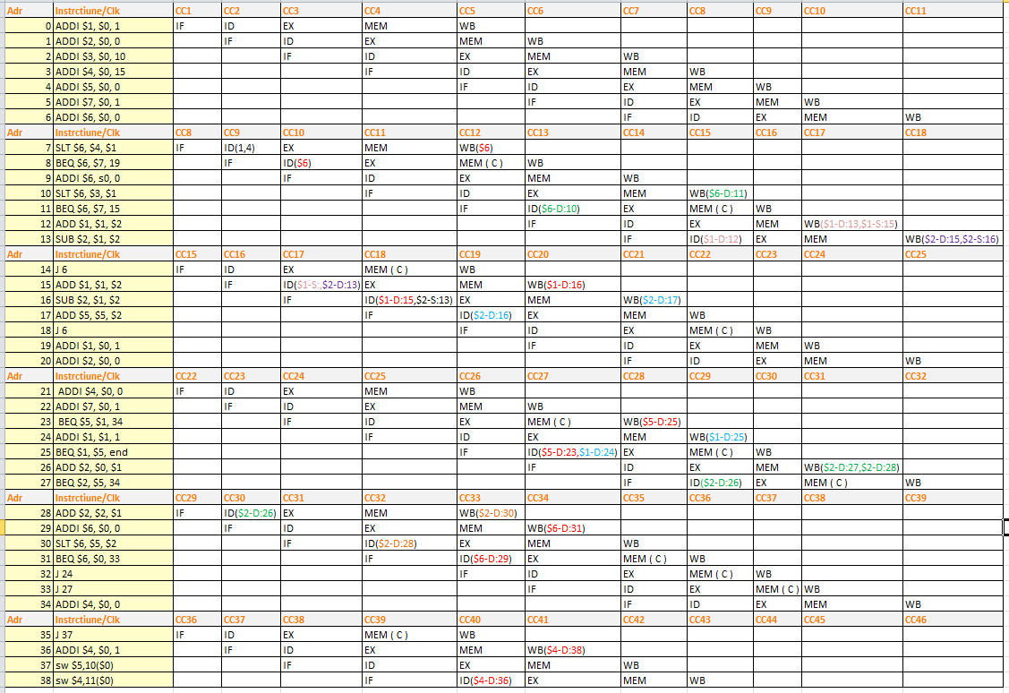
RTL Schematic:
