About this Document
This Low-Level Integration Document defines the technical design for the ABC Travel — Salesforce Customer Profile Update Email Notification Integration.

Executive Summary
The integration platform will follow API-Led connectivity approach to design the APIs that will deliver the outcome of orchestrating the events.
The Integration solution delivers business functionality through API-led connectivity, where functional services are realized by a coordinated set of Experience, Process, and System APIs rather than a single API artifact.
MuleSoft uses API‑led connectivity, so functionality is delivered through a logical service composed of APIs. To make this explicit, we have enhanced the LLDs with a Functional Service view, showing the business capability, owning Process API, supporting APIs, and end‑to‑end flow. Any API will generally fall into one of the following categories:
- System Level APIs: These are low-level APIs that are exposed directly for a target system.
- Process Level APIs: These are APIs that perform orchestration and mediation between different APIs
- Experience Level APIs: These are APIs intended to adopt integration between an organization and its external consumers.
This Low-Level Integration Design describes the design and implementation approach for a MuleSoft Experience API customer-profile-notification-api.

Objective
- Provide a production-ready implementation blueprint for development and deployment.
- Document runtime behaviour, sequencing, error handling, and observability.
- Define environment-specific configuration requirements for APIs, MQ, and downstream systems.
- Capture the technical decisions, assumptions, and non-functional design controls.

Design Principles
Design Principle | Description
Client | ABC Travel Company
Integration Platform | MuleSoft Mule 4
Source System | Salesforce
Target System | Email Notification API
Messaging Layer | Anypoint MQ / RabbitMQ
Deployment Target | CloudHub 2.0
Version | 1.0

Decisions
S.No | Outcome
D01 | EXP API returns 200 with message accepted status after successful publish to MQ.
D02 | API uses Anypoint MQ subscriber/listener with FIFO semantics and controlled concurrency
D03 | Retries are handled in layered fashion in process API. MQ redelivery for processing failures and HTTP/reconnect strategies for downstream transient failures
D04 | client id enforcement will be used to authorize Experience API to call Process API

Business Requirements
Requirement ID | Requirement Description
BR-001 | Customer profile information is stored in Salesforce.
BR-002 | Any addition or update to customer profile information should trigger an email notification.
BR-003 | The customer email address must be fetched from the Salesforce customer contact object.
BR-004 | Email notifications should be sent to the respective customer email address.
BR-005 | The notification process should run every 30 minutes.
BR-006 | The solution should support customer fields such as name, email, phone, mobile, address, birthdate, department, etc.

Functional Service Overview

Functional Service Name:
customer-profile-notification-api
Description:
ABC Travel stores customer profile information in Salesforce. Whenever a customer profile is created or updated, the customer must receive an email notification.
Examples of profile updates include:
- Name change
- Email update
- Phone or mobile number update
- Address update
- Department update
- Birthdate update
- Any other customer profile field update
The integration should run every 30 minutes, identify newly created or updated Salesforce customer records, validate required data, and send notification emails to the respective customers.
Functional Requirements Covered:
Requirement ID | Requirement Description
TR-001 | A scheduler should trigger the integration every 30 minutes.
TR-002 | MuleSoft should query Salesforce customer contact records based on date/time range.
TR-003 | The integration should support standard Salesforce Contact object or a custom customer contact object.
TR-004 | Required fields should be validated using JSON schema.
TR-005 | Required validation fields are AccountId, Birthdate, Department, Email, and Mobile.
TR-006 | Email API should not receive more than 10 requests per second.
TR-007 | Queue-based processing should be used to decouple Salesforce polling and email sending.
TR-008 | MuleSoft should publish valid customer update messages to Anypoint MQ or RabbitMQ.
TR-009 | MuleSoft should subscribe to the queue and send email notifications.
TR-010 | Common error handling should be implemented.

API-Led Mapping Responsibilities

Layer | API Name | Responsibility
Process | customer-profile-notification-api | Core orchestration
System | Email-api | Email Alert

Scope
• Salesforce is the system of record for customer profile data.
• The integration user has read access to the Salesforce Contact object or custom customer contact object.
• Email API is already available and accepts HTTP POST requests.
• Email API supports JSON request payload.
• Anypoint MQ is available in the Anypoint Platform.
• Salesforce records have a reliable LastModifiedDate or custom date/time field.
• MuleSoft Object Store is used to maintain the last successful polling timestamp.
• Email notification content can be simple and standardized.
• Failed queue messages can be retried or routed to a Dead Letter Queue.

Functional Integration Flow Design

Process
- Salesforce Polling and MQ Publishing
The producer flow is responsible for:
- Running every 30 minutes.
- Retrieving the last successful poll timestamp.
- Querying Salesforce for new or updated customer contact records.
- Validating required fields.
- Publishing valid records to Anypoint MQ.
- Updating the watermark after successful processing.

- MQ Subscription and Email Sending
The consumer flow is responsible for:
- Reading customer update messages from MQ.
- Processing messages at a controlled rate.
- Ensuring Email API is not called more than 10 times per second.
- Sending email notifications.
- Acknowledging successful messages.
- Requeueing or rejecting failed messages.

- Email API Throttling Design
To handle this limitation:
- MQ is used as a buffer.
- The consumer flow runs every 1 second.
- The consumer processes a maximum of 10 messages in each run.
- Flow concurrency is restricted using maxConcurrency="1".
- Manual ACK/NACK is used to prevent message loss.
This ensures the Email API is protected from high-volume Salesforce updates.

Sequence Diagram
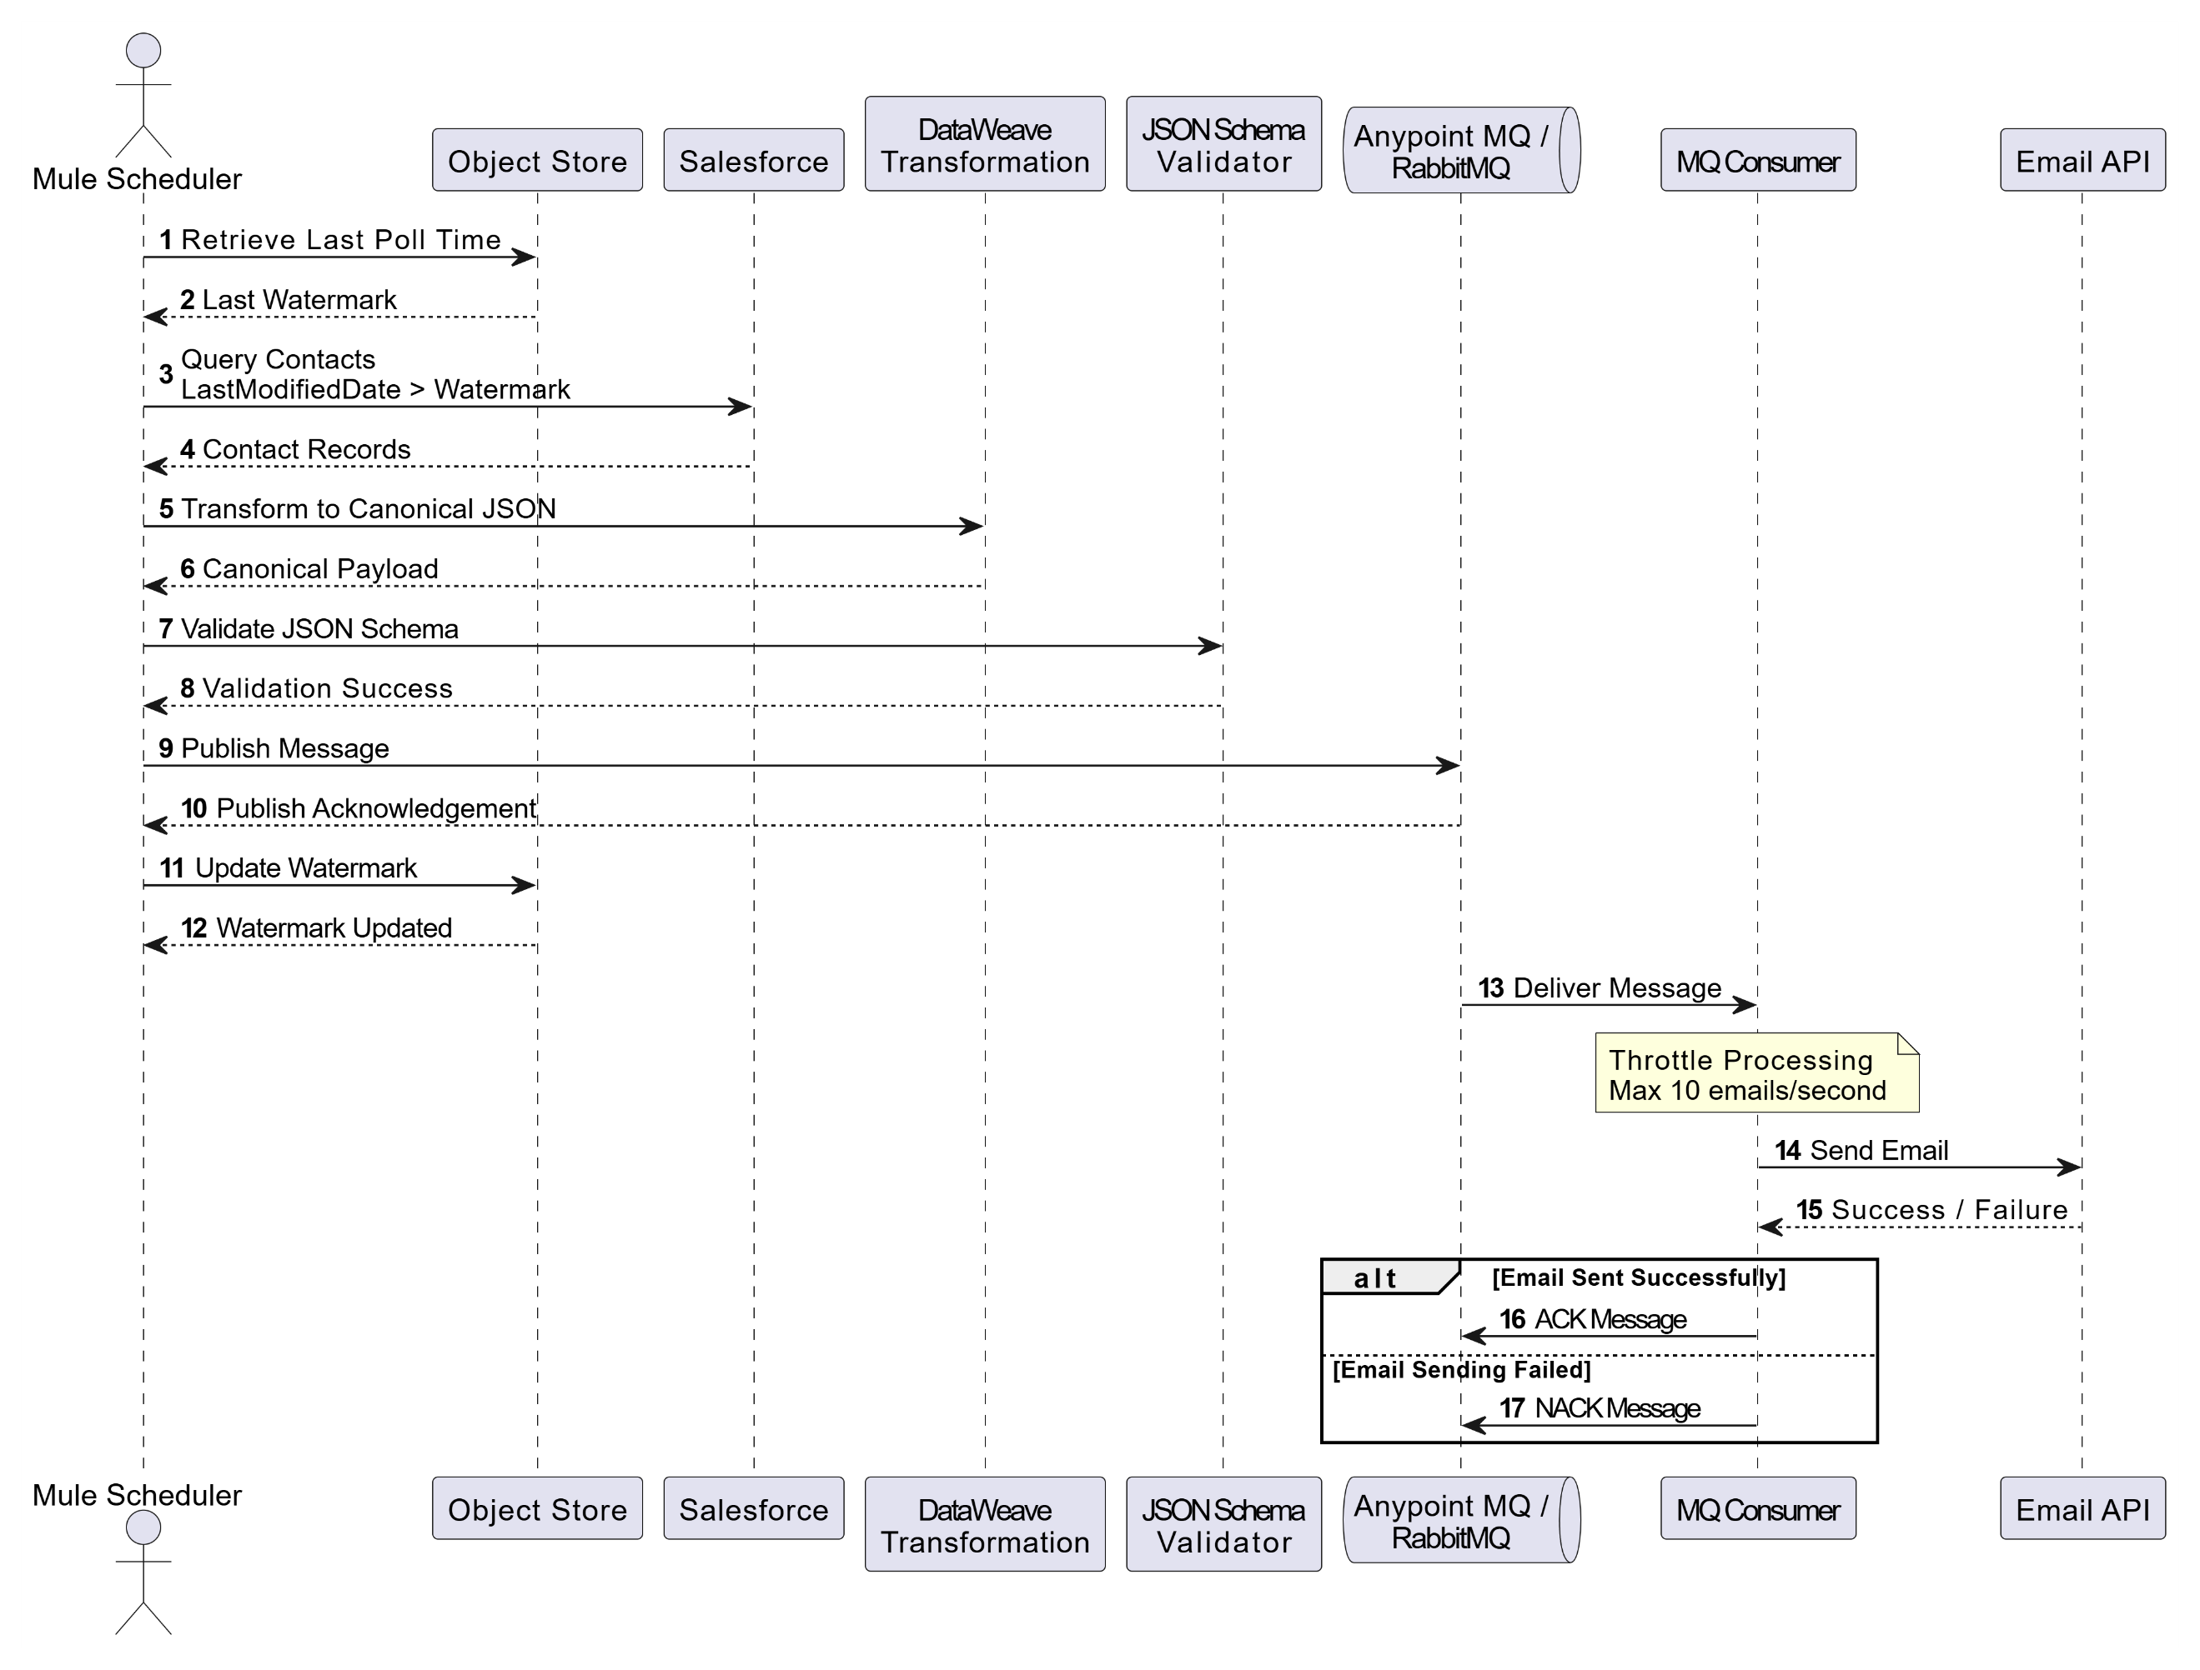

Interface Details

Failure Stage | Purpose
Name | customer-profile-notification-api
API Type | Process API
Protocol | HTTPS
Primary Endpoint | Scheduler
Authentication | Client-ID enforcement
Trigger | HTTP, MQ
Response Pattern | Synchronous acknowledgement only; business processing is asynchronous
Success Response | 200 Success
Failure Response | 4xx for validation/auth failures, 5xx for publish/platform failures

Flow Process

The ABC Travel Processing Flow
- Scheduler starts every 30 minutes.
- Mule retrieves last successful poll time from Object Store.
- Mule sets current runtime.
- Mule queries Salesforce records modified between last runtime and current runtime.
- Mule transforms Salesforce records into canonical JSON.
- Mule validates mandatory fields using JSON schema.
- Valid records are published to Anypoint MQ.
- Invalid records are logged and skipped.
- Watermark is updated after successful producer processing.
- Consumer flow runs every second.
- Consumer reads maximum 10 messages from MQ.
- Mule builds Email API request.
- Mule sends notification email.
- On success, Mule ACKs the message.
- On failure, Mule NACKs the message.
- All milestones and errors are logged in JSON format.

Salesforce Custom Object ContactTravelDetail__c

Custom Field | Description
Name | Record Name
Name__c | Customer Name
Email__c | Customer Email
Phone__c | Customer Phone
Mobile__c | Customer Mobile
AccountId__c | Account Reference
Birthdate__c | Birthdate
Department__c | Department
Address__c | Address
LastModifiedDate__c | Custom Last Modified Date

JSON SCHEMA VALIDATION
Custom Field | Required
AccountId | Yes
Birthdate | Yes
Department | Yes
Email | Yes
Mobile | Yes

FLOW CANVAS
This MuleSoft scheduler flow runs every 30 minutes, retrieves the last processed watermark from Object Store, queries Salesforce for updated contacts, transforms the records into MQ messages, and prepares them for downstream asynchronous processing with centralized error handling.
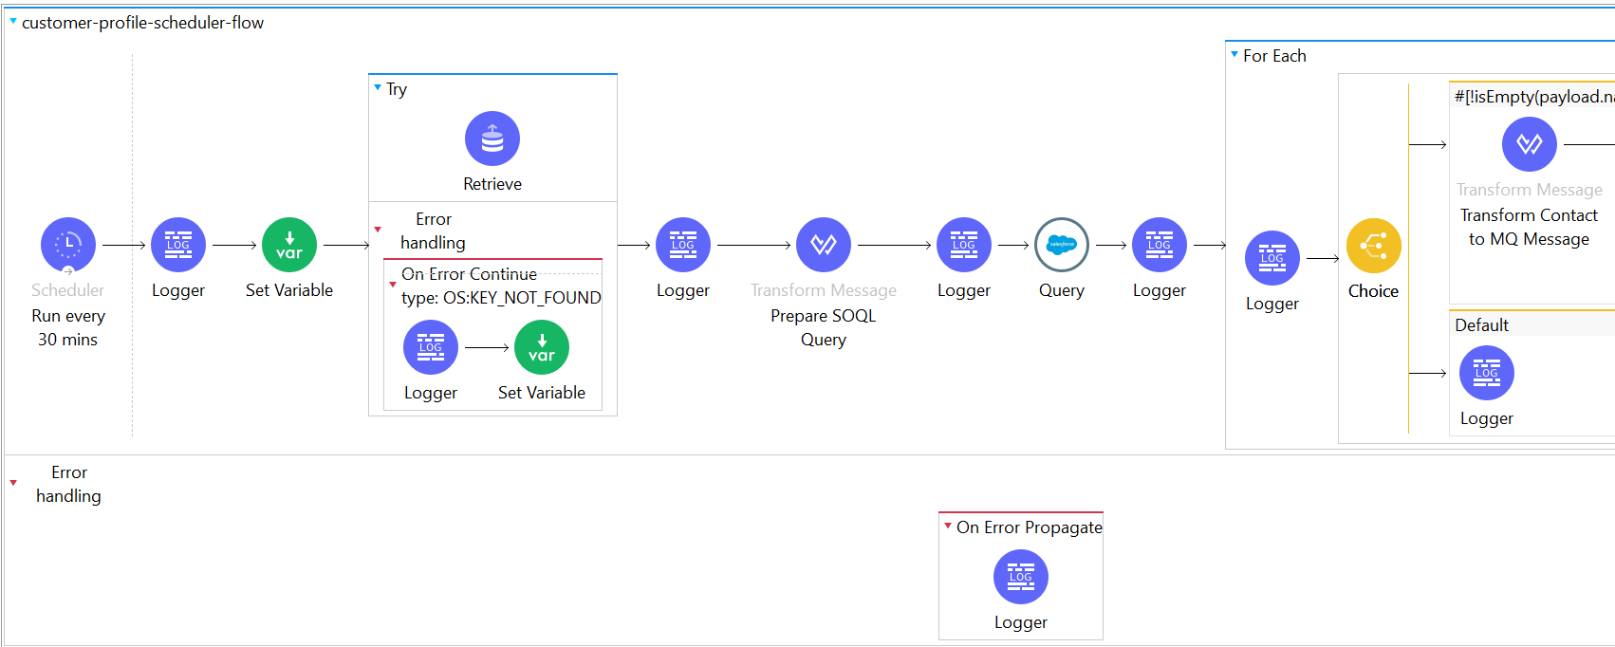

The emailAlertFlow receives a message, transforms the payload into an email format, sends the notification through the configured email service, and logs the processing status for monitoring and troubleshooting purposes.

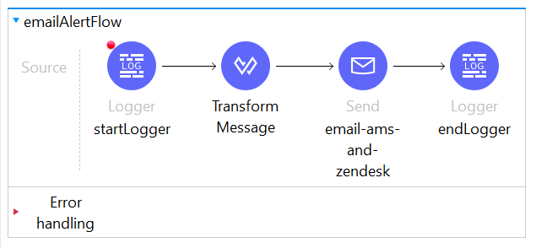
Response Codes

Status Code | Description
200 | Event acknowledged
404 | Not Found
405 | Method Not allowed
500 | Internal Server Error

Environment configuration

Mule API Environment Details
Environment | Runtime | Workers | URL
PRIME | 4.11 | 1x0.1

Unit Testing & Acceptance Criteria

Scenario | Description | http status
VALIDATION | JSON schema validation failure | VALIDATION
SALESFORCE | Salesforce query or connection failure | SALESFORCE
ANYPOINT_MQ | MQ publish, consume, ACK, or NACK failure | ANYPOINT_MQ
EMAIL_API | Email API request failure | EMAIL_API
SYSTEM | Unexpected application error | SYSTEM

Glossary

Term | Definition
Credentials | Store credentials using Mule Secure Configuration Properties
Salesforce | Use least-privilege integration user
Email API | Use API key or OAuth token
Secrets | Do not hardcode passwords, tokens, or API keys
Transport | Use HTTPS for all external communication
Logging | Avoid logging sensitive data such as full tokens or passwords
MQ | Restrict queue access using client ID and client secret
Deployment | Use secure CloudHub 2.0 properties
Monitoring | Enable alerts for failures and high error rate
Data | Mask PII in logs where required

