**DJI Agra Drone**

***“Better Growth, Better Life”***

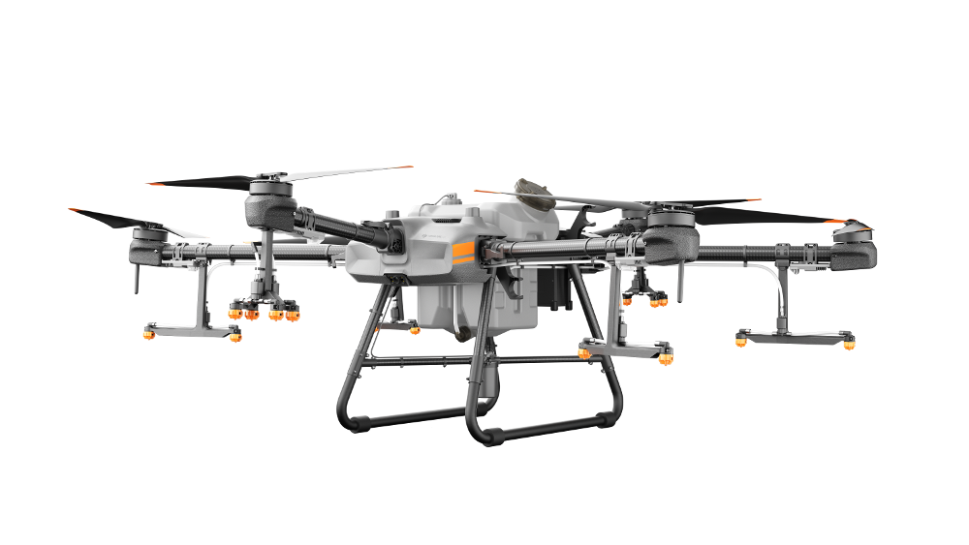

**Object Description**

The T100 Agricultural Drone, a groundbreaking creation twelve years in the making, boasts a maximum payload of 100 kg[1]. Its operational efficiency is doubled, supporting multiple application scenarios, including spraying, spreading, and lifting tasks. Featuring industry-leading safety systems[2] and advanced algorithms, it delivers unparalleled safety performance and an intelligent operational experience. Source: DJI.com

**From Farmland to Frontline**

In an incident documented by displaced civilians, footage shared on July 17, 2024, shows a DJI Agras drone dropping a bomb onto the IHH Turkish charity’s building in Jabalia, northern Gaza, less than 100 metres (330ft) from a school serving as a shelter and aid distribution centre. Source: [Al Jazeera](https://www.aljazeera.com/news/2025/5/8/israel-retrofitting-dji-commercial-drones-to-bomb-and-surveil-gaza#:~:text=Residents%20and%20humanitarian%20organisations%20reported,civilian%20drones%20armed%20with%20explosives), [youtube](https://youtu.be/rpUbsgTr-FI?si=GDPObp7kXfqQ7hug)

In November in Beit Lahia, northern Gaza, a DJI Agras drone dropped a bomb in a residential neighbourhood where civilians had fled after Israeli shelling of a UN-operated school-turned-shelter. Source [Al Jazeera](https://www.aljazeera.com/news/2025/5/8/israel-retrofitting-dji-commercial-drones-to-bomb-and-surveil-gaza#:~:text=Residents%20and%20humanitarian%20organisations%20reported,civilian%20drones%20armed%20with%20explosives)

**Object Profile**

DJI is a Chinese tech giant known globally for consumer and agricultural drones. The Agras model, designed for crop dusting, can carry heavy loads with precision [aljazeera.com](https://www.aljazeera.com/news/2025/5/8/israel-retrofitting-dji-commercial-drones-to-bomb-and-surveil-gaza#:~:text=Sanad%20has%20documented%20several%20DJI,been%20adapted%20for%20military%20use). Until recently, it was an unlikely weapon. We note that **DJI had suspended sales to Russia and Ukraine in 2022** amid misuse in warfare [aljazeera.com](https://www.aljazeera.com/news/2025/5/8/israel-retrofitting-dji-commercial-drones-to-bomb-and-surveil-gaza#:~:text=This%20is%20not%20the%20first,Ukraine%20war%20in%202022), but pointedly **“has not stopped selling drones to Israel.”**[aljazeera.com](https://www.aljazeera.com/news/2025/5/8/israel-retrofitting-dji-commercial-drones-to-bomb-and-surveil-gaza#:~:text=At%20the%20time%2C%20DJI%20suspended,how%20high%20they%20could%20fly) This Chinese-made gadget has been repurposed into a tool of war over Gaza. Since DJI did not ban sales to Israel, units were acquired and then **retrofitted by the Israeli military**. Investigative reports reveal the Israeli army was extensively using DJI drones by 2018, even training operators on models like the Matrice 600[aljazeera.com](https://www.aljazeera.com/news/2025/5/8/israel-retrofitting-dji-commercial-drones-to-bomb-and-surveil-gaza#:~:text=The%20Israeli%20army%E2%80%99s%20use%20of,DJI%20drones%20is%20not%20new). By late 2023, engineers in the IDF were customizing Agras drones to carry improvised explosives and grenades [aljazeera.](https://www.aljazeera.com/news/2025/5/8/israel-retrofitting-dji-commercial-drones-to-bomb-and-surveil-gaza#:~:text=Sanad%20has%20documented%20several%20DJI,been%20adapted%20for%20military%20use)

**Who makes money**

Accel - Institutional Investor

Sequioa Capital China