Aldosterone

Plasma aldosterone concentration increases during exercise in response to adrenal zona glomerulosa stimulation by angiotensin II (see Renin & Angiotensin) and increased plasma K⁺ (see Potassium).

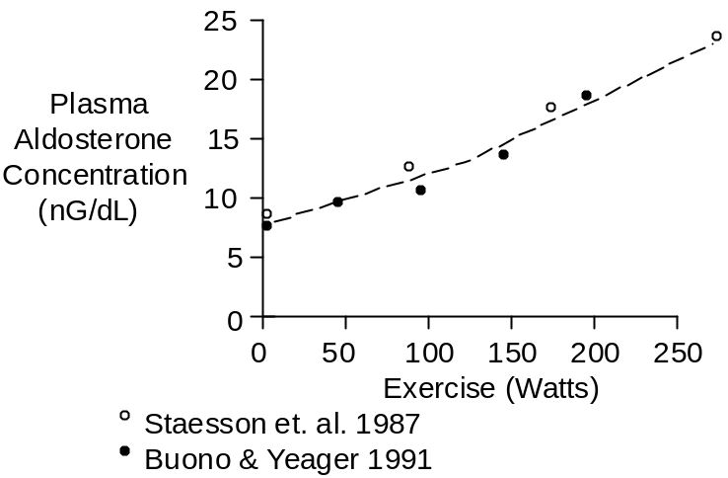

Concentration increases slowly for two reasons. First the angiotensin II stimulus increases slowly (see Renin & Angiotensin). Secondly, the aldosterone response involves increased aldosterone synthesis and this takes some time.

Aldosterone measurements made during short-term exercise (e.g., shown above) will probably not represent steady-state values.

Compare the magnitude of the response shown above with the magnitude shown below.

The data shown below were collected during upright cycling at 67% of maximum O₂ uptake.

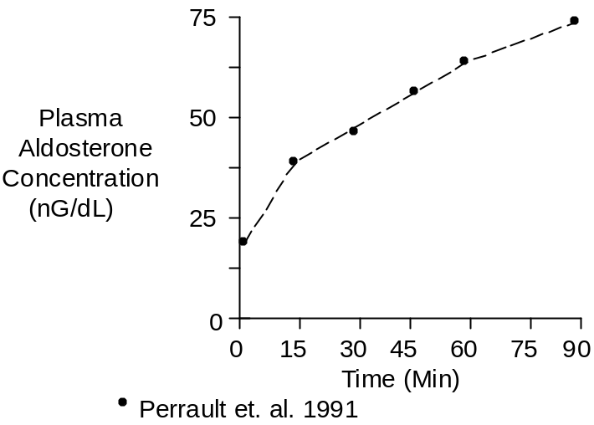

Chemistry

Aldosterone has a molecular weight of 360.45. Composition is C₂₁H₂₈O₅.

Aldosterone concentration in plasma is typically 12 nG/dL or 330 pMol/L.

Units

Popular units are nG/dL and pMol/L.

To convert nG/dL to pMol/L, multiply by 27.7.

References

Buono, M.J. and J.E. Yeager. Increases in aldosterone precede those of cortisol during graded exercise. J. Sports Med. Phys. Fitness 31:48-51, 1991.

Perrault, H., M. Cantin, G. Thibault, G.R. Brisson, G. Brisson and M. Beland. Plasma atriopeptin response to prolonged cycling in humans. J. Appl. Physiol. 70:979-987, 1991.

Staessen, J., R. Fagard, P. Hespel, R.Lijnen, L. Vanhees and A. Amery. Plasma renin system during exercise in normal men. J. Appl. Physiol. 63:188-194, 1987.

