Anaerobic Metabolism

The main steps in the metabolism of glycogen are illustrated below. With an adequate O₂ supply, glycogen is metabolized all the way to CO₂ and H₂O. When the oxygen supply is fully utilized, additional energy is released by metabolizing glycogen to pyruvate and lactate.

Note that anaerobic glycogen metabolism is only 8% as effective as aerobic glycogen metabolism.

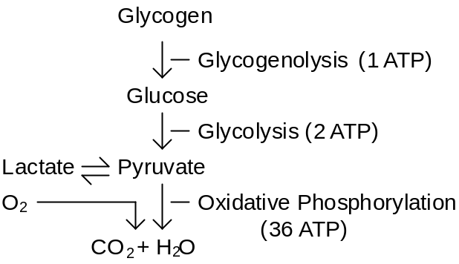

An the intensity of exercise increases, ventilation and cardiac output increase to deliver enough oxygen to support aerobic metabolism. But at some point, cardiac output hits its maximum value. Any increase in exercise intensity beyond this point is supported by anaerobic metabolism.

Anaerobic metabolism consumes lots of glycogen and produces lots of lactate. Thus, two of the main features of anaerobic metabolism are glycogen depletion and lactic acidosis. See Glycogen and Lactic Acid.

Anaerobic metabolism can be maintained only for short periods as shown below.

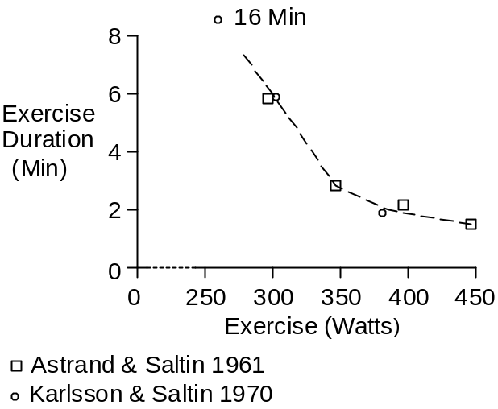

References

Åstrand, P.-O. and B. Saltin. Oxygen uptake during the first minutes of heavy muscular exercise. J. Appl. Physiol. 16:971-976, 1961.

Karlsson, J. and B. Saltin. Lactate, ATP, and CP in working muscles during exhaustive exercise in man. J. Appl. Physiol. 29:598-602, 1970.

