Antidiuretic Hormone

Antidiuretic hormone is also known as vasopressin and arginine vasopressin in humans.

Plasma antidiuretic hormone concentration increases in severe exercise and in moderate exercise of long duration. Changes in mild exercise are small.

The data shown below were collected during recumbent cycling.

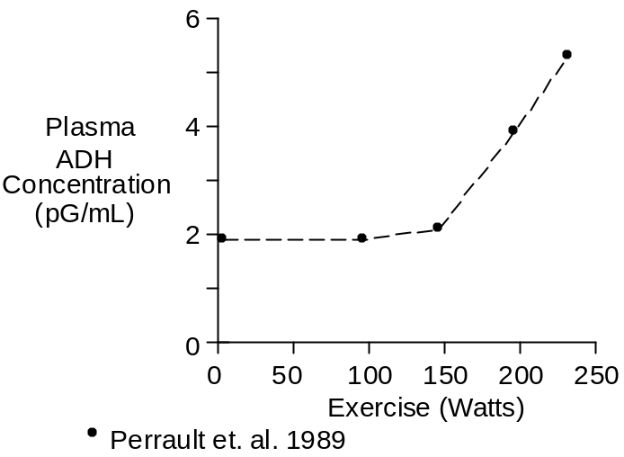

The data shown below were collected during upright cycling at 67% of maximum O₂ uptake.

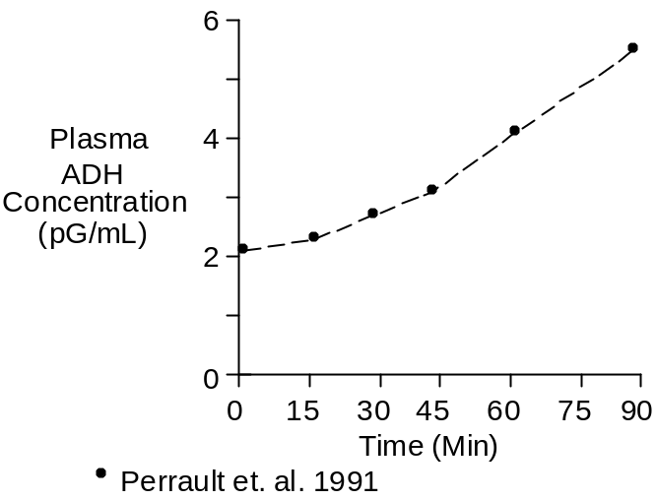

Chemistry

The structure of antidiuretic hormone is

Cys-Tyr-Phe-Gln-Asn-Cys-Pro-Arg-Gly NH₂

This structure is conserved across many species, with proline being substituted for arginine at position eight – hence the naming convention.

Molecular weight is 1084. Composition is C₄₆H₆₅N₁₅O₁₂S₂.

Vasopressin concentration in plasma is typically 2.0 pG/mL.

Units

The prefix femto is sometimes used to describe vasopressin mass and concentration. Femto is 10⁻¹⁵. while pico is 10⁻¹².

The following three amounts of vasopressin are equal

- 1 fMol
- 1.084 pG
- 0.434 μU.

References

Perrault, H., M. Cantin, G. Thibault, G.R. Brisson, G. Brisson and M. Beland. Plasma atrial natriuretic peptide during brief upright and supine exercise in humans. J. Appl. Physiol. 66:2159-2167, 1989.

Perrault, H., M. Cantin, G. Thibault, G.R. Brisson, G. Brisson and M. Beland. Plasma atriopeptin response to prolonged cycling in humans. J. Appl. Physiol. 70:979-987, 1991.

