Hemodynamics

Cardiac output increases with the intensity of aerobic exercise. Oxygen delivery is a function of this increased flow and increased oxygen extraction.

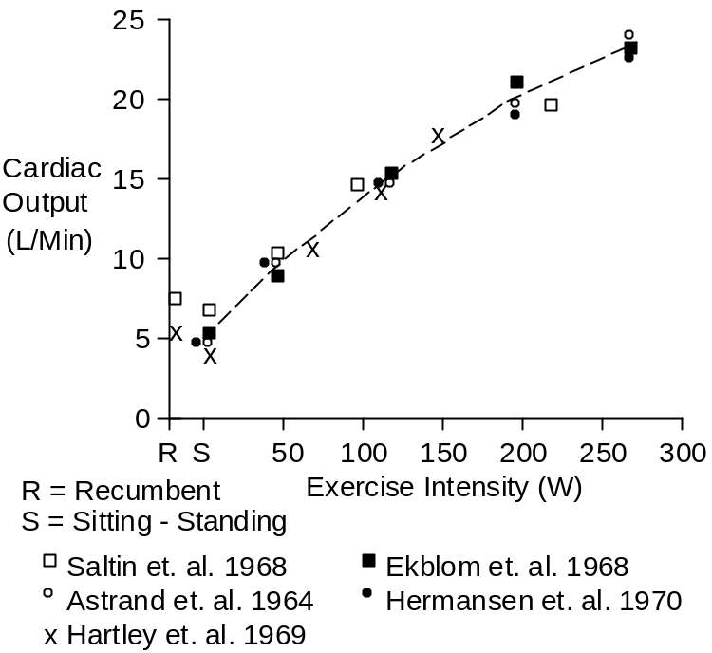

Heart rate also increases with increasing intensity of exercise, until of maximum of about 190 beats per minute is reached.

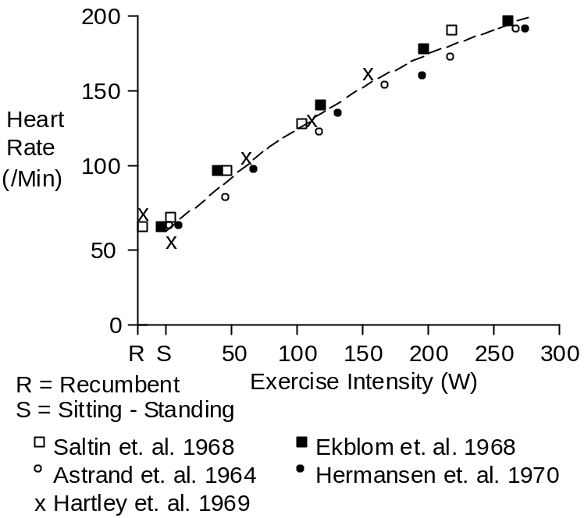

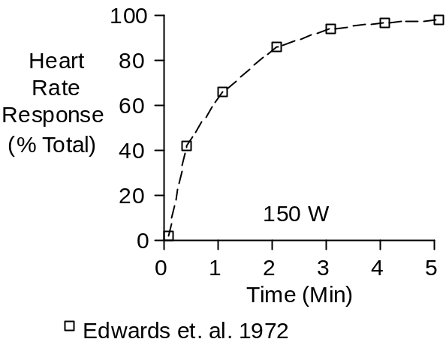

Heart rate does not increase instantaneously, but instead increases quickly and smoothly, with a time constant of about 45 seconds (Edwards et. al. 1972), as shown above.

Cardiac output is equal to heart rate multiplied by stroke volume. Most of the increase in cardiac output in exercise is associated with an increase in heart rate, as the figure above shows.

Stroke volume jumps up with light exercise and then increases slowly as exercise intensity increases.

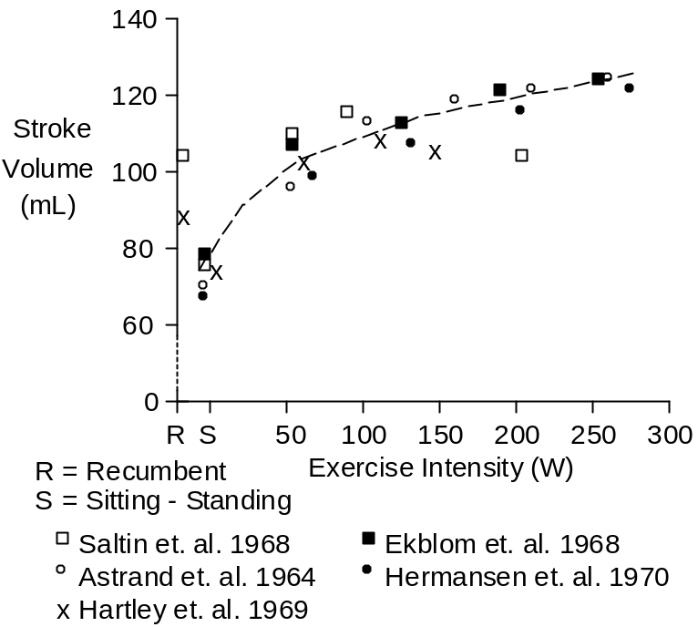

Total peripheral resistance falls dramatically as the intensity of exercise increases.

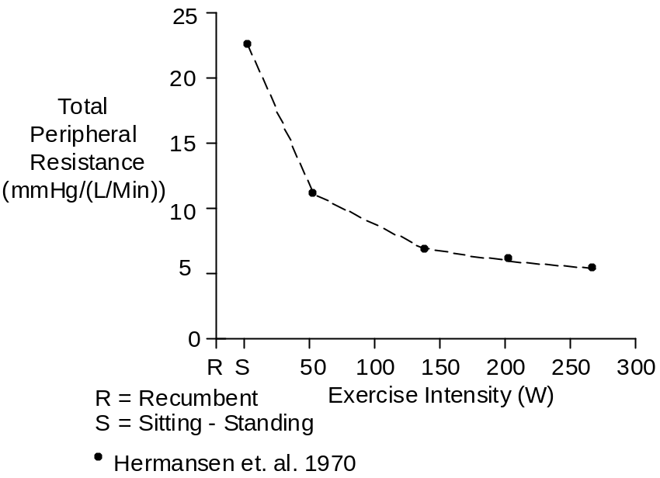

Systolic, mean and diastolic blood pressures all increase as the intensity of exercise increases.

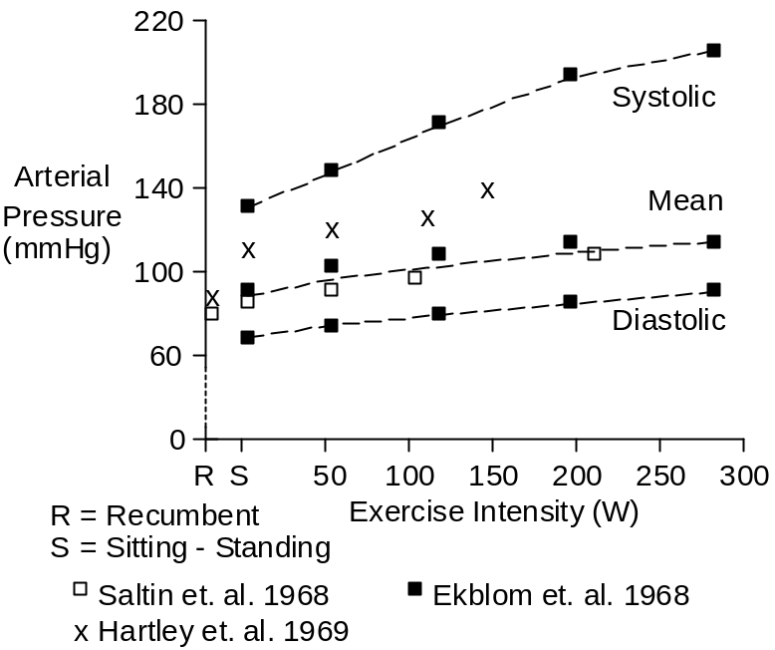

Note the increase in pulse pressure.

References

Åstrand, I., P.-O., T.E. Cuddy, B. Saltin and J. Stenberg. Cardiac output during submaximal and maximal work. J. Appl. Physiol. 19:268-274, 1964.

Edwards, R.H.T., D.M. Denison, G. Jones, C.T.M. Davies and E.J.M. Campbell. Changes in mixed venous gas tensions at start of exercise in man. J. Appl. Physiol. 32:165-169, 1972.

Ekblom, B. P.-O. Åstrand, B. Saltin, J. Stenberg and B. Wallström. Effect of training on circulatory response to exercise. J. Appl. Physiol. 24:518-528, 1968.

Hartley, L.H., G. Grimby, Å. Kilbom, N.J. Nilsson, I Åstrand, J. Bjure, E. Ekblom and B. Saltin. Physical training in sedentary middle-aged and older men. III. Cardiac output and gas exchange at submaximal and maximal exercise. Scand. J. Clin. Lab. Invest. 24:335-344, 1969.

Hermansen, L., B. Ekblom and B. Saltin. Cardiac output during submaximal and maximal treadmill and bicycle exercise. J. Appl. Physiol. 29:82-86, 1970.

Saltin, B., G. Blomqvist, J.H. Mitchell, R.L. Johnson, Jr., K. Wildenthal and C.B. Chapman. Response to exercise after bed rest and after training. Circulation 38(Suppl. 7):1-78, 1968.

