Baroreceptor Reflex

The baroreceptor reflex stabilizes arterial pressure. Stability helps to provide uninterrupted flow to vital organs.

The strength of the reflex can be studied by altering baroreceptor perfusion pressure and then noting the subsequent effect on arterial pressure (show below, data from Angel-James & Daly). A decrease in carotid perfusion pressure causes an increase in systemic arterial pressure, a relationship that helps to stabilize arterial pressure.

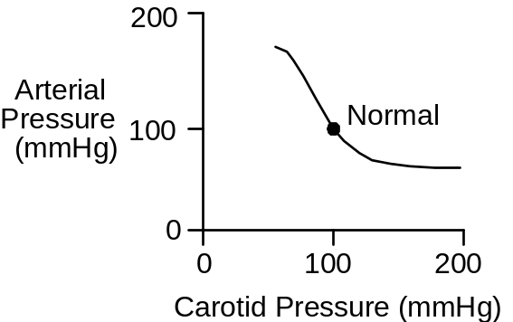

Pressure in the carotid arteries stimulates the baroreceptors. This stimulation, via the central nervous system, changes autonomic outflow. The efferent pathways of the baroreceptor reflex innervate the heart, systemic arteries and systemic veins. Changes in heart rate, cardiac contractility, arterial conductance and venous unstressed volume all help to determine arterial pressure. But carotid artery pressure is equal to systemic artery pressure, closing the baroreceptor reflex loop.

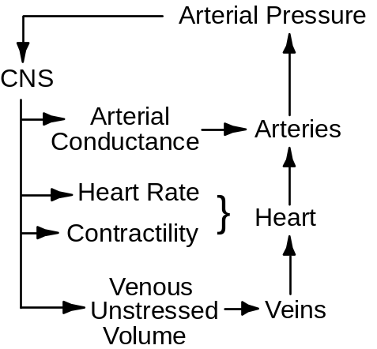

In this exercise, we’ll replicate the classical protocol while also following the details of the response to carotid pressure changes.

The Baroreceptor Reflex Protocol

Click Restart to reestablish initial conditions.

Go to Autonomic Afferents. Slide carotid perfusion pressure up to 60 mmHg and click the carotid perfusion pump switch to on. Advance the solution for 1 minute and record the appropriate neural and hemodynamic data in the table below.

Repeat for carotid perfusion pressures of 80, 100, 120 and 140 mmHg.

Carotid Pressure (mmHg)
Autonomic Firing
Vagal Firing
Heart Rate (/Min)
Stroke Volume (mL)
Cardiac Output (mL/Min)
Total Peripheral Resistance (mmHg/(mL/Min))
Arterial Pressure (mmHg)

Carotid Pressure | 60 | 80 | 100 | 120 | 140
Autonomic Firing(Hz) | 2.3 | 1.9 | 1.5 | 1.0 | .8
Vagal Firing(Hz) | 0.8 | 1.3 | 2.1 | 4.3 | 5.4
Heart Rate(bpm) | 90 | 82 | 71 | 56 | 52
Stroke Volume(mL) | 70 | 72 | 75 | 80 | 82
Cardiac Output(mL/min) | 6277 | 5853 | 5290 | 4509 | 4229
TPR(mmHg*min/mL) | .019 | .019 | .018 | .017 | .017
Arterial Pressure(mmHg) | 121 | 109 | 95 | 77 | 71

Using the data collected above, plot arterial pressure as a function of carotid artery pressure.

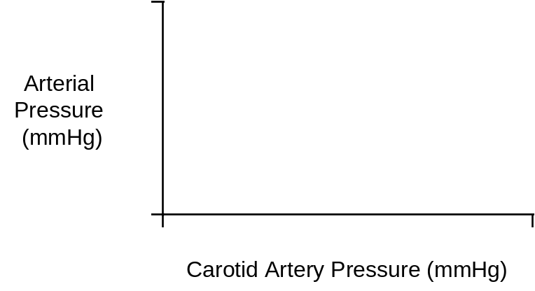

Note that this protocol measures the acute responses to carotid pressure change. Over the longer term, what factors might modify the response? You can study this by restarting the solution, setting and turning on the carotid perfusion pump, and then advancing the solution for 30 minutes, 1 hour and longer.

References

Angel-James, J. & M. de B. Daly. Comparison of reflex vasomotor responses to separate and combined stimulation of carotid sinus and aortic arch baroreceptors by pulsatile and non-pulsatile pressures in the dog. J. Physiol. 209:257-293, 1970.

