Changes In Salt Intake

We now normally consume a sodium-rich diet, but historically sodium has not always been abundant in the diet.

When dietary sodium intake is decreased, excretion initially exceeds intake; extracellular sodium and plasma volume decrease. Then, plasma angiotensin II concentration increases and sodium excretion falls to a level that matches intake. Sodium balance is reestablished. The timecourse of this transition is shown below (data from Epstein).

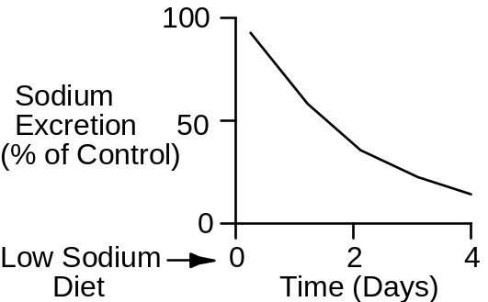

The Changes In Salt Intake Protocol
We will give QCP normal, low and high-salt diets in this exercise and follow the mechanisms involved in adjusting renal sodium excretion.

Begin by clicking Restart to reset the model’s variables to their initial values. The normal sodium intake is 180 mEq/Day. Advance the solution for 1 week and record normal values in the table below.

Next we will study a low-salt diet. Click Restart again. Click Diet. Slide Na+ intake down to 20 mEq/Day and Cl- intake down to 40 Eq/Day. Advance the solution for 1 week and record values below.

The final diet is high salt. Click Restart. Click Diet. Slide Na+ and Cl- intake up to 500 Eq/Day. Advance the solution for 1 week and record values below.

Arterial Pressure (mmHg)
Right Atrial Pressure (mmHg)
Left Atrial Pressure (mmHg)
Plasma [AII] (pG/mL)
Plasma [Aldosterone] (pMol/L)
Plasma [ANP] (pMol/L)
Na+ Excretion (mEq/Min)

Sodium Intake | 20 | 180 | 500
Arterial Pressure(mmHg) | 95 | 97 | 100
Right Atrial Pressure(mmHg) | -.0 | .5 | .7
Left Atrial Pressure(mmHg) | 3.5 | 4.3 | 4.7
Plasma [AngII](pg/mL) | 29 | 17 | 12
Plasma [Aldosterone](pmol/L) | 549 | 296 | 203
Plasma [ANP](pmol/L) | 18 | 21 | 23
Urine Na+ Excretion(mEq/min) | .03 | .14 | .36

Compare the changes in plasma [AII], [Aldosterone] and [Atrial Natriuretic Peptide]. Why are changes in [ANP] relatively small during changes in salt intake?

Importance Of Angiotensin In Sodium Balance

The increase in plasma angiotensin concentration during sodium deprivation has two positive effects:

It helps the kidney to reabsorb sodium.

It supports arterial pressure in the face of decreased blood volume.

The blood pressure response to blocking AII formation while on a low-salt diet is shown below (data from Hall).

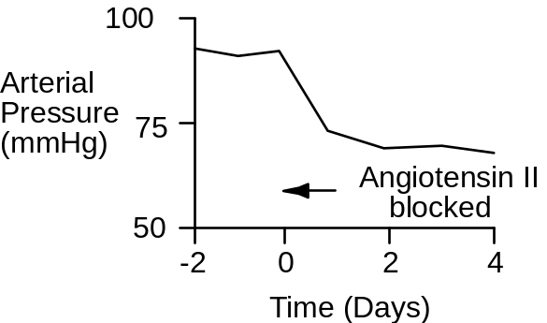

We will now explore the importance of the renin-angiotensin-aldosterone system in the regulation of arterial pressure and body fluid volumes. We will repeat the 3 simulations described above, but in each case formation of angiotensin will be blocked. In each case, Click Restart. Click Blocker. Slide angiotensin converting enzyme inhibition to 100%. Click Diet. Set the Na+ and Cl- intake as described above. Advance the solution for 1 week and record the data in the table below.

Arterial Pressure (mmHg)
Right Atrial Pressure (mmHg)
Left Atrial Pressure (mmHg)
Plasma [AII] (pG/mL)
Plasma [Aldosterone] (pMol/L)
Plasma [ANP] (pMol/L)
Na+ Excretion (mEq/Min)

Sodium Intake | 20 | 180 | 500
Arterial Pressure(mmHg) | 84 | 90 | 92
Right Atrial Pressure(mmHg) | -.5 | .1 | .4
Left Atrial Pressure(mmHg) | 2.5 | 3.6 | 4.1
Plasma [AngII](pg/mL) | 0 | 0 | 0
Plasma [Aldosterone](pmol/L) | 287 | 185 | 148
Plasma [ANP](pmol/L) | 14 | 18 | 20
Urine Na+ Excretion(mEq/min) | .02 | .14 | .37

Long-Term Pressure Natriuresis Curve

Plot sodium excretion as a function of arterial pressure on the coordinates below for (a) the normal case, and (b) with AII formation blocked.

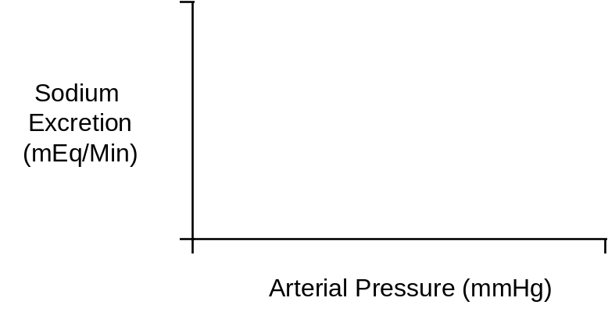

Under normal conditions, is arterial pressure salt sensitive? Why?

References

Epstein, M. & N. K. Hollenberg. Age as a determinant of renal sodium conservation in normal man. J. Lab. Clin. Med. 87:411-417, 1976.Hall, J. E., A. C. Guyton, M. J. Smith, Jr., & T. G. Coleman. Chronic blockade of angiotensin II formation during sodium deprivation. Amer. J. Physiol. 237:F424-F432, 1979.

