Heart Failure

Left-heart failure typically begins with a myocardial infarction. The infarction decreases both myocardial contractility and blood flow to the heart. Stroke volume is diminished and this causes decreases in cardiac output and arterial pressure.

The immediate response to a left-side myocardial infarction is a shift in blood volume from the peripheral circulation to the pulmonary circulation. This shift increases left heart end-diastolic volume. Increased cardiac filling helps to offset impaired emptying. In addition to the volume shift, increased sympathetic outflow increases left-heart contractility (shown below, data from Griffiths, Cody).

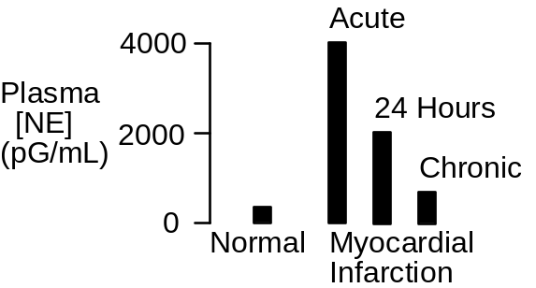

The Heart Failure Protocol

Click Restart to reestablish initial conditions and then record the control data. Go to Left Heart. Scroll down to the myocardial infarction box. Slide the slidebar over to serious. Advance the solution 10 minutes.

We are interested in the acute effect of the infarction on hemodynamics and the subsequent compensations that help to maintain oxygen delivery.

Arterial Pressure (mmHg)
Cardiac Output (mL/Min)
Heart Rate (/Min)
Stroke Volume (mL)
Left Ventricle EDV (mL)
Left Ventricle EDP (mmHg)
Ejection Fraction
Sympathetic Nerve Activity
Plasma Renin Activity
Na+ Excretion (mEq/Min)

Erythropoietin
Blood Volume (mL)
Red Cell Volume (mL)
Plasma Volume (mL)
Hematocrit (%)

Time | 0  Min | 10  Min | 1  Day | 1  Week
Arterial Pressure(mmHg) | 96 | 86 | 84 | 86
Cardiac Output(mL/min) | 5361 | 4757 | 4649 | 4907
Heart Rate(bpm) | 72 | 75 | 71 | 70
Stroke Volume(mL) | 74 | 64 | 66 | 70
LV EDV(mL) | 124 | 155 | 155 | 150
LV EDP(mmHg) | 3.6 | 8.4 | 8.6 | 7.8
Ejection Fraction | .60 | .41 | .43 | .47
Symp Nerves(Hz) | 1.5 | 1.6 | 1.4 | 1.4
Plasma Renin(ngAI/mL/hr) | 2.0 | 2.0 | 2.2 | 1.8
Na+ Excretion(mEq/min) | .12 | .08 | .07 | .13
Erythropoietin(mU/mL) | 19 | 18 | 8 | 12
Blood Volume(mL) | 5400 | 5399 | 5450 | 5491
Red Cell Volume(mL) | 2400 | 2400 | 2399 | 2367
Plasma Volume(mL) | 3000 | 2999 | 3052 | 3124
Hematocrit(%) | 44 | 44 | 44 | 43

Ejection Fraction

The heart’s ejection fraction is the ratio of stroke volume to end-diastolic volume. The normal ejection fraction is 0.60.

Ejection fraction is a useful clinical finding, since it decreases in proportion to the severity of heart failure. Decreases are typically due to both decreasing stroke volume and increasing end-diastolic volume.

Exercise Tolerance

Tolerance to exercise is decreased in heart failure (shown below, data from Wilson).

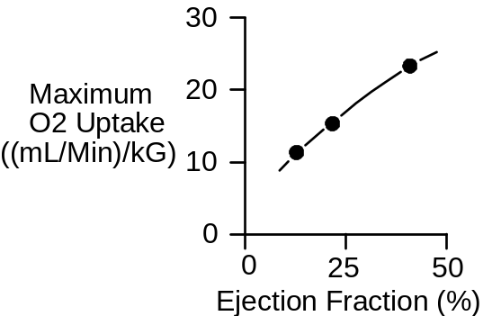

Use an exercise stress test to characterize QCP’s cardiac function at 7 days.

Treadmill Speed (MPH)
Treadmill Grade (%)
Heart Rate (/Min)

Time | 0’ | 1’ | 2’ | 3’ | 4’ | 5’
Speed | 0 | 6 | 6 | 6 | 6 | 6
Grade | 0% | 0% | 2% | 4% | 6% | 8%
Heart Rate | 86 | 126 | 137 | 149 | 176 | X

Record the elapsed time and distance when this subject finally gives up.

Elapsed Time (Min) | 4:42
Distance Traveled (Ft) | 1953

References

Cody, R. J., K. W. Franklin, J. Kluger, & J. H. Laragh. Sympathetic responsiveness and plasma norepinephrine during therapy of chronic congestive heart failure with captopril. Amer. J. Med. 72:791-797, 1982.

Griffiths, J. & F. Leung. The sequential estimation of plasma catecholamines and whole blood histamine in myocardial infarction. Amer. Heart J. 82:171-179, 1971.

Wilson, J. R., J. L. Martin, D. Schwartz, & N. Ferraro. Exercise intolerance in patients with chronic heart failure. Role of impaired nutritive flow to skeletal muscle. Circulation 69:1079-1087, 1984.

