Carbon Monoxide Inhalation

Carbon monoxide binds to hemoglobin in competition with oxygen.

Hemoglobin's affinity for carbon monoxide is 230 times its affinity for oxygen (Allen & Root). Thus, low concentrations of carbon monoxide will displace normal concentrations of oxygen on the hemoglobin molecule. The normal delivery of oxygen to the tissues is disrupted and tissue hypoxia ensues.

Hemoglobin (Hgb) bound with carbon monoxide (CO) is carboxyhemoglobin (CO Hgb). The percentage of total Hgb that is CO Hgb is denoted as %CO Hgb.

John Haldane administered carbon monoxide to himself and then reported the consequences. His report gives an early but accurate account of CO poisoning (Haldane). Carboxyhemoglobin formation as a function of time is shown below for Haldane’s experiment VII, inhalation of 0.21% CO.

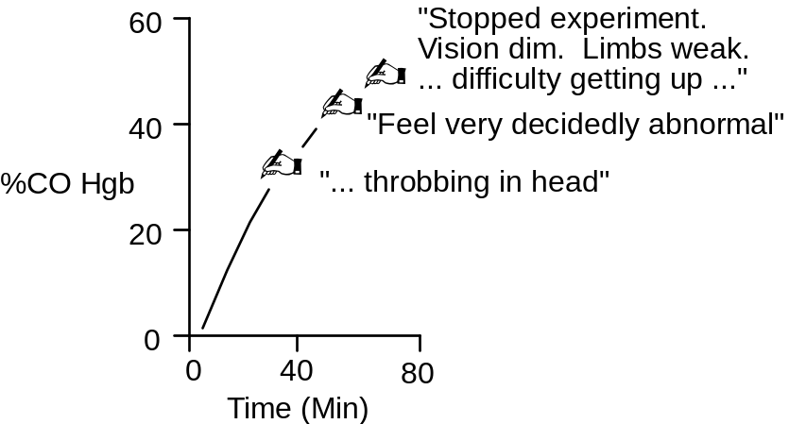
Inhaled carbon dioxide accumulates in the blood as a function of inhaled concentration and time of exposure (shown below, data from Petersen).

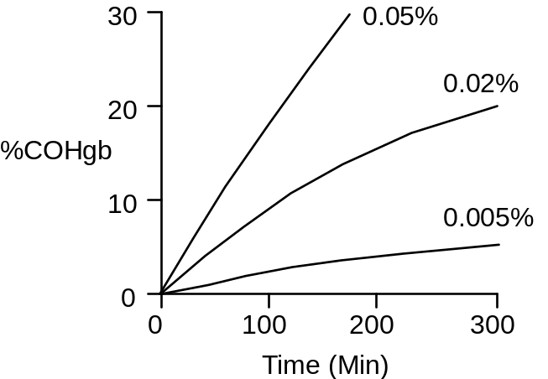

Early accumulation of inhaled CO in the blood can be described by the formula (Forbes)

%CO Hgb = 3 * Inhaled CO (%) * Time (Min)

Late accumulation is slower than early accumulation, as steady-state is approached. Signs of poisoning appear.

Optional The rate of carboxyhemoglobin formation during CO inhalation is highly dependent on the rate of alveolar ventilation. Design a protocol that quantitates CO uptake as a function of alveolar ventilation at one concentration of inhaled CO.

The Carbon Monoxide Inhalation Protocol

We will repeat Haldane’s experiment (described above) in this exercise.

Click Restart to reestablish initial conditions. Go to Carbon Monoxide. In the Gas Tanks box slide the CO PPM slidebar up to 2000. To convert parts per million to % concentration, multiply by 10⁻⁴. Click the gas tanks switch to on. Advance time and record data.

Pay particular attention to the effect of CO on O2 transport by the blood. Blood Volume has a bar graph that shows the status of QCP’s hemoglobin.

Carboxyhemoglobin (%)
Arterial pO2 (mmHg)
Arterial [O2] (mL/mL)
Venous pO2 (mmHg)
Venous [O2] (mL/mL)
Cardiac Output (mL/Min)

Time | 0  Min | 30  Min | 1  Hr | 2  Hr
%CO Hgb | .4 | 12.4 | 23.7 | 43.0
Arterial pO2(mmHg) | 91 | 84 | 78 | 77
Arterial [O2](mL/mL) | .20 | .17 | .15 | .11
Venous pO2(mmHg) | 42 | 33 | 28 | 20
Venous [O2](mL/mL) | .15 | .13 | .11 | .08
Cardiac Output(mL/min) | 5361 | 5436 | 5733 | 6523

Wrapup
Advance time an additional 1 or 2 hours to show that this CO concentration is fatal with continuing inhalation.

Elimination Of Inhaled CO
Once inhalation of CO is stopped, the gas is expired as slowly as it was previously inspired. Since, oxygen and CO are competitive at the hemoglobin molecule, inhaling oxygen at high concentration will displace the CO, thereby accelerating CO blow off (shown below, data from Pace, Petersen). This is a standard treatment for CO poisoning.

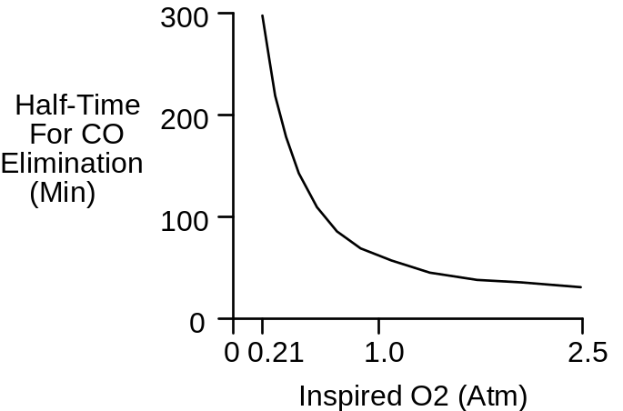

Design a protocol that first creates CO poisoning and then compares normal CO elimination after CO inhalation to the accelerating effect of oxygen administration.

References

Allen, T. A. and W. S. Root. Partition of carbon monoxide and oxygen between air and whole blood of rats, dogs and men as affected by plasma pH. J. Appl Physiol. 10:186-190, 1957.

Forbes, W. H., F. Sargent and F. J. W. Roughton. The rate of carbon monoxide uptake by normal men. Amer. J. Physiol. 143:594-608, 1945.

Haldane, J. S. The action of carbonic oxide in man. J. Physiol. 18:430-462, 1895.

Pace, N., E. Strajman and E. L. Walker. Acceleration of carbon monoxide elimination in man by high pressure oxygen. Science 111:652-654, 1950.

Petersen, J. E. and R. D. Steward. Absorption and elimination of carbon monoxide by inactive young men. Arch. Environ. Health 21:165-171, 1970.

