Quantitative
Circulatory
Physiology



Laboratory
Manual

Contents

Before Starting
Normal Values
Exercise Tolerance
Laboratory Exercises
- Hemorrhage
- A-V Fistula
- Fick’s Principle
- Pulmonary Shunt
- Respiratory Acidosis
- Water Load
- Starvation
- Baroreceptor Reflex
- Insulin Overdose
- Renal Artery Stenosis
- Heart Failure
- High Altitude
- Changes In Salt Intake
- Aldosterone And Sodium Escape
- A Normal Meal
- Diabetes Mellitus
- Pericardial Hemorrhage
- Carbon Monoxide Inhalation
- Anemia
- Diabetes Insipidus
- Pneumothorax
- Cardiac Arrest
- Asphyxia
24. Cardiopulmonary Resuscitation
25. Introduction to Acid / Base
26. Sodium Bicarbonate
27. Ketoacidosis
28. Mitral Stenosis
29. Aortic Regurgitation
30. Osmolarity
31. Nephrotic Syndrome

Clinical Exercises
32. Mr. Johnson
Mr. Johnson – Notes

33. Ms. Lake
Ms. Lake – Notes

34. Ms. Nance
Ms. Nance – Notes

35. Mr. Parks
Mr. Parks – Notes

36. Mr. Stone
Mr. Stone – Notes

37. Ms. Thomas
Ms. Thomas – Notes

38. Mr. White
Mr. White – Notes

39. Mr. Wilson
Mr. Wilson – Notes

Before Starting

If QCP is not installed on your computer, read Installation in the User’s Guide.

If QCP is installed on your computer but you have never used the program, read Basic Stuff and A Complete Simulation in the User’s Guide.

If you are interested in seeing some simulated patients, read Patients in the User’s Guide.

If you have used QCP, you might find some useful, more advanced information in Patients, Emergencies and Special Features in the User’s Guide.

Otherwise, you’re ready to go …

Installation

Before Installing

Make sure that the destination drive 2 megabytes of free space.

Software Download
The computer software that can be downloaded from this Web site
http://physiology.umc.edu/themodelingworkshop/index.html
specifically does not do the following:
- Write anything unusual to your computer's hard drive or other storage devices.
- Connect to the Internet.
- Alter your computer's registry.
- Require the installation of any additional dynamic link libraries (DLL's).
There is no installation software. The QCP download package is an exploding (self-extracting) program.
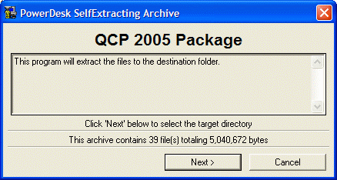
Download QCP 2005 Package.EXE and run it once to obtain the necessary executable and data files. The lead files are QCP 2005.EXE, QCP 2005.DAT, QCP 2005.HLP and lots of initial condition files with the filename extension ICS.
Put the EXE, DAT and HLP files in the same folder to allow the components to find one another.

Operating Systems
This software is designed to run on the following operating systems: Windows 95 / 98 / Me / xp / NT / 2000.

Uninstall

To uninstall just delete all of the files from the folder which contain the QCP files.

