A-V Fistula

Trauma may create a direct vascular connection between peripheral artery and vein. This is an arteriovenous or a-v fistula.

An a-v fistula shunts oxygenated arterial blood directly to the venous circulation. Fistula flow produces no metabolic benefit. In fact, the flow supporting metabolism may fall (shown below, data from Frank, Murphy).

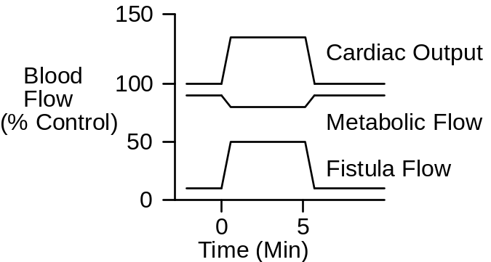

The immediate effect of opening an a-v fistula is that arterial conductance increases and, consequently, cardiac output increases. Arterial pressure falls. A reflex increase in sympathetic outflow gives cardiac output and arterial pressure a boost (shown below, data from Dobbs).

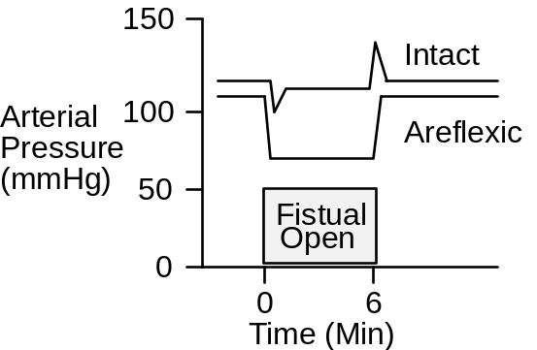

The A-V Fistula Protocol

Click Restart to reestablish initial conditions and then collect control data. Go to Conductance. Scroll down to the a-v fistula box. Slide the size slidebar over to moderate. Advance the solution 10 minutes

Arterial Pressure (mmHg)
Cardiac Output (mL/Min)
Heart Rate (/Min)
Stroke Volume (mL)
Fistula Flow (mL/Min)
Brain Blood Flow (mL/Min)
G.I. Tract Blood Flow (mL/Min)
Kidney Blood Flow (mL/Min)
Skeletal Muscle Blood Flow (mL/Min)
Sympathetic Nerve Activity
Plasma Renin Activity
Na+ Excretion (mEq/Min)

Erythropoietin
Blood Volume (mL)
Red Cell Volume (mL)
Plasma Volume (mL)
Hematocrit (%)

For the venous O2 tests, since the lab didn’t specify, the benchmarks I used were: Restart > Apply Fistula > Immediately Record Data.(acute effects)

Sympathetic Nerve Activity Recorded from CNS Autonomics > Integration > General Nerve Activity > Firing Rate
Time | 0  Min | 10  Min | 1  Day | 1  Week | 1  Month
Arterial Pressure(mmHg) | 96 | 74 | 75 | 73 | 84
Cardiac Output(mL/min) | 5361 | 7050 | 6802 | 7442 | 9019
Heart Rate(bpm) | 72 | 85 | 78 | 71 | 70
Stroke Volume(mL) | 74 | 83 | 87 | 104 | 129
Fistula Flow(mL/min) | 0 | 3090 | 3143 | 3293 | 3791
Brain Blood Flow(mL/min) | 845 | 664 | 659 | 634 | 842
G.I. Blood Flow(mL/min) | 975 | 688 | 649 | 803 | 970
Kidney Blood Flow(mL/min) | 1185 | 887 | 703 | 777 | 940
Muscle Blood Flow(mL/min) | 631 | 442 | 415 | 472 | 554
Symp. Nerves(Hz) | 1.5 | 2.0 | 1.7 | 1.5 | 1.4
Plasma Renin(ng AI/mL)/hr | 2.0 | 2.7 | 8.5 | 2.4 | 1.6
Na+ Excretion(mEg/min) | .12 | .01 | .00 | .08 | .14
Erythropoietin(mU/mL) | 19 | 18 | 18 | 19 | 62
Blood Volume(mL) | 5400 | 5402 | 5415 | 5956 | 6168
Red Cell Volume(mL) | 2400 | 2400 | 2400 | 2390 | 2533
Plasma Volume(mL) | 3000 | 3002 | 3016 | 3566 | 3636
Hematocrit(%) | 44 | 44 | 44 | 40 | 41

Use an exercise stress test to characterize cardiac function at 1 week.

Treadmill Speed (MPH)
Treadmill Grade (%)
Heart Rate (/Min)

Time | 0’ | 1’ | 2’ | 3’ | 4’ | 5’
Speed | 0 | 6 | 6 | 6 | 6 | 6
Grade | 0% | 0% | 2% | 4% | 6% | 8%
Heart Rate | 79 | X | X | X | X | X

Record the elapsed time and distance when this subject finally gives up.

Elapsed Time (Min) | :40
Distance Traveled (Ft) | 0

The patient nears unconsciousness while moving at 0 mph during the first minute of using the treadmill.

A-V Fistula And Venous O2 Content

In suspected A-V fistula, a useful clinical finding is mixed venous O2 saturation. Saturation is elevated in proportion to the severity of the fistula, due to shunting of oxygen-rich arterial blood.

Fistula Size | Venous O2  Sat (%) | Venous  [O2](mL/mL)
None | 74 | .15
Small | 78 | .16
Moderate | 80 | .16
Large | 82 | .17
Extreme | 84 | .17

Optional Use arterial and venous O2 content and an assumption about metabolic flow to calculate A-V fistula flow. Compare the result to actual fistula flow.

References

Dobbs, W. A., Jr., J. W. Prather, & A. C. Guyton. Relative importance of nervous control of cardiac output and arterial pressure. Amer. J. Card. 27:507-512, 1971.

Frank, C. W., H.-H. Wang, J. Lammerant, R. Miller, & R. Wégria. An experimental study of the immediate hemodynamic adjustments to acute arteriovenous fistulae of various sizes. J. Clin. Invest. 34:722-731, 1955.

Murphy, Q. R., Jr., K. S. Gullixson, C. H. Kratochvil, & J. Simoes e Silva, Jr. Circulatory and renal adjustments to acute femoral arteriovenous fistulas. Circ. Res. 6:710-714, 1958.

