Exercise Tolerance

The Energy Cost Of Running

The energy required for walking and running is proportional to speed and body weight. O2 use as a function of velocity is shown below (data from Menier).

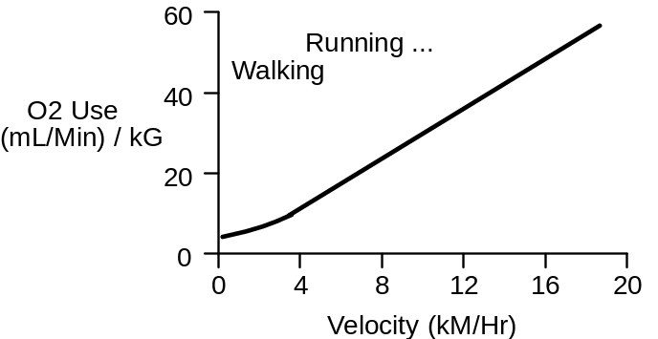

Since both energy required and distance covered are proportional to walking and running speed, it takes a fixed amount of energy to travel a fixed distance: 0.2 ml O2 per meter traveled per kg body weight (Margaria, 1975).

The energy required to run up a grade is proportional to the steepness of the grade (shown below, data from Margaria, 1963). The premium is 0.20 x level-ground needs per % grade.

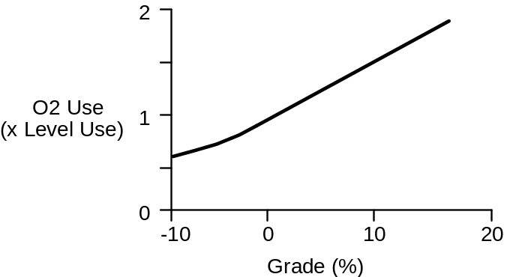

Use Exercise Tolerance To Evaluate Respiratory-Circulatory Function

Inadequate function in either the respiratory system or circulatory system will decrease a subject’s tolerance to physical exercise. At some point, oxygen delivery to the working skeletal muscle will become inadequate, metabolism will switch from aerobic to anaerobic, and the subject will be unable to continue. Thus, the subject’s tolerance to exercise can be used as a measure of respiratory-circulatory function.

An Exercise Tolerance Test

We’ll use the treadmill in this section to measure a normal subject’s tolerance to exercise. The general idea is to observe the subject’s response to exercise, as the exercise becomes more and more strenuous.

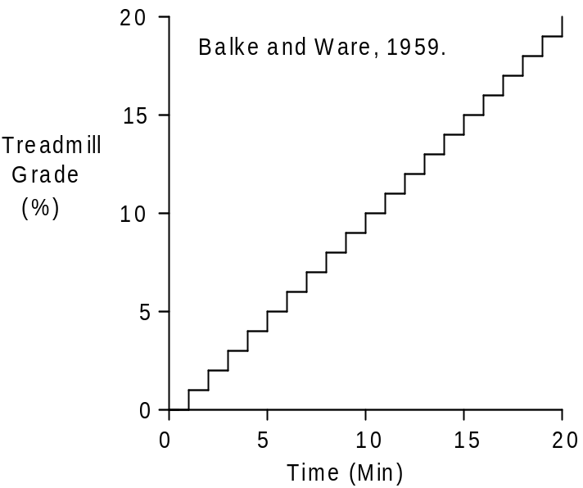

This will be a slightly modified Balke and Ware (1959) protocol.

Click Restart to reestablish initial conditions.

Note that the patient has to be standing when using the treadmill. Click and suggest standing.

Record the initial or control values in the table below (at 0’). Then click to start the treadmill. Set exercise type to treadmill. Select run. Set treadmill speed to 3.5 MPH. Initially set treadmill grade to 0%.

The protocol (shown above) is to advance the solution for 1 minute at each treadmill grade. Then increase the treadmill grade 1% and repeat until either the protocol is complete or the subject stops exercising. Record data at the intervals shown below.

Treadmill Speed (MPH)
Treadmill Grade (%)
Heart Rate (/Min)

Time | 0’ | 5’ | 10’ | 15’ | 20’
Speed | 0 | 3.5 | 3.5 | 3.5 | 3.5
Grade | 0% | 5% | 10% | 15% | 20%
Heart Rate | 114 | 141 | 158 | 188 | X

Record the elapsed time and distance when this normal subject finally gives up.

Elapsed Time (Min) | 19:46
Distance Traveled (Ft) | 6088

Record additional values in the table below.

Arterial Pressure (mmHg)
Cardiac Output (mL/Min)
Heart Rate (/Min)
Stroke Volume (mL)
Respiration Rate (/ Min)
Total Ventilation (L/Min)
Arterial [O2] (mL/mL)
Venous [O2] (mL/mL)
Muscle Blood Flow (mL/Min)

Temperature (deg. F)

Time | 0’ | 5’ | 10’ | 15’ | 20’
Speed MPH | 0 | 3.5 | 3.5 | 3.5 | 3.5
Grade | 0% | 5% | 10% | 15% | 20%
Blood Pressure(mmHg) | 154/95 | 145/78 | 145/77 | 153/86 | X
Cardiac Output(mL/min) | 11192 | 15887 | 18058 | 21041 | X
Heart Rate(bpm) | 114 | 141 | 158 | 188 | X
Stroke Volume(mL) | 98 | 113 | 114 | 112 | X
Respiration Rate(breaths/min) | 24 | 30 | 33 | 39 | X
Total Ventilation(L/min) | 35.1 | 59.6 | 80.6 | 118.4 | X
Arterial [O2](mL/mL) | .20 | .20 | .20 | .20 | X
Venous [O2](mL/mL) | .09 | .07 | .06 | .05 | X
Muscle Flow(mL/min) | 6046 | 10641 | 12191 | 13754 | X
Temperature(C˚) | 98.6 | 99.1 | 99.8 | 100.6 | X

You may want to give this test to other subjects. You can then compare their response to the normal response documented here.

Questions For Discussion

Why did this subject stop exercising?
What interventions might improve exercise tolerance?

References

Balke, B. and R.W. Ware. An experimental study of “physical fitness” of Air Force personnel. U.S. Armed Forces Med. J. 10:675-688, 1959.

Margaria, R., P. Aghemo, & F. Piñera Limas. A simple relation between performance in running and maximal aerobic power. J. Appl. Physiol. 38:351-352, 1975.

Margaria, R., P. Cerretelli, P. Aghemo, & G. Sassi. Energy cost of running. J. Appl. Physiol. 18:367-370, 1963.

Menier, D. R. & L. G. C. E. Pugh. The relation of oxygen intake and velocity of walking and running, in competition walkers. J. Physiol. 197:717-721, 1968.

Exercise Tolerance - Notes

Instructor’s notes for exercise tolerance go here.

