Clinical Exercises

A patient initially presents as a data set frozen in time -- a quantitative snapshot. There are two lines of inquiry that are often informative:

- What physiological and pathophysiological events helped to define the patient's current status? How much time did it take?

- How should we proceed from here?

Seeing A Patient

Patients are simulations that begin with a set of unusual initial conditions. To see a patient, click on the File main menu selection and then click on Load Initial Conditions. A dialog box will list available patients as file names with an ICS extension, such as MR_SMITH.ICS. Select a patient, the patient’s data will be loaded, and the simulation can be undertaken.
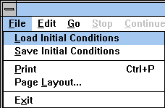

Initially, the toolbar may only show buttons that are relevant to clinical medicine. You may be able to add additional buttons to the toolbar using the View main menu selection. If the View main menu selection is grayed out, you’re stuck with the initial lineup of toolbar buttons.
A brief patient history is presented in the upper left-hand corner of the Charts panel.

Returning To Normal

Mr. Norm Subject represents a normal subject. When a patient is loaded, the patient’s initial conditions replace Norm’s initial conditions and the patient history section of the Charts panel is updated.

After a patient is loaded, the Restart main menu selection starts the solution again using the patient’s initial conditions.

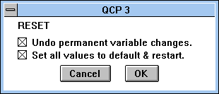

To re-establish Norm Subject’s initial conditions, click Options / Reset... The default checks are correct. Click OK. If successful, Norm’s thumbnail sketch will reappear on the Charts panel.

Norm Subject is your source for normal numerical values.

