Quantitative
Circulatory
Physiology



Laboratory
Manual

Contents

Before Starting
Normal Values
Exercise Tolerance
Laboratory Exercises
Hemorrhage
A-V Fistula
Fick’s Principle
Pulmonary Shunt
Respiratory Acidosis
Water Load
Starvation
Baroreceptor Reflex
Insulin Overdose
Renal Artery Stenosis
Heart Failure
High Altitude
Changes In Salt Intake
Aldosterone And Sodium Escape
A Normal Meal
Diabetes Mellitus
Pericardial Hemorrhage
Carbon Monoxide Inhalation
Anemia
Diabetes Insipidus
Pneumothorax
Cardiac Arrest
Asphyxia
Cardiopulmonary Resuscitation
Introduction to Acid / Base
Sodium Bicarbonate
Ketoacidosis
Mitral Stenosis
Aortic Regurgitation
Osmolarity
Nephrotic Syndrome

Clinical Exercises
Mr. Johnson
Mr. Johnson – Notes

Ms. Lake
Ms. Lake – Notes

Ms. Nance
Ms. Nance – Notes

Mr. Parks
Mr. Parks – Notes

Mr. Stone
Mr. Stone – Notes

Ms. Thomas
Ms. Thomas – Notes

Mr. White
Mr. White – Notes

Mr. Wilson
Mr. Wilson – Notes

Before Starting

If QCP is not installed on your computer, read Installation in the User’s Guide.

If QCP is installed on your computer but you have never used the program, read Basic Stuff and A Complete Simulation in the User’s Guide.

If you are interested in seeing some simulated patients, read Patients in the User’s Guide.

If you have used QCP, you might find some useful, more advanced information in Patients, Emergencies and Special Features in the User’s Guide.

Otherwise, you’re ready to go …

Installation

Before Installing

Make sure that the destination drive 2 megabytes of free space.

Software Download
The computer software that can be downloaded from this Web site
http://physiology.umc.edu/themodelingworkshop/index.html
specifically does not do the following:
- Write anything unusual to your computer's hard drive or other storage devices.
- Connect to the Internet.
- Alter your computer's registry.
- Require the installation of any additional dynamic link libraries (DLL's).
There is no installation software. The QCP download package is an exploding (self-extracting) program.
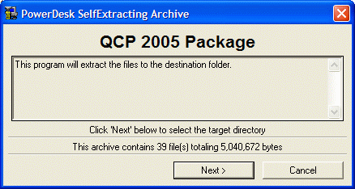
Download QCP 2005 Package.EXE and run it once to obtain the necessary executable and data files. The lead files are QCP 2005.EXE, QCP 2005.DAT, QCP 2005.HLP and lots of initial condition files with the filename extension ICS.
Put the EXE, DAT and HLP files in the same folder to allow the components to find one another.

Operating Systems
This software is designed to run on the following operating systems: Windows 95 / 98 / Me / xp / NT / 2000.

Uninstall

To uninstall just delete all of the files from the folder which contain the QCP files.

Normal Values

Use Normal Values To Identify Abnormal Ones

Develop a knowledge of QCP’s normal numerical values and use this knowledge to identify abnormal values as they occur.

Record Important Normal Values Here

Click Restart to reestablish initial conditions. Then click the toolbar buttons to display the initial (presumably normal) values of QCP’s variables.

The View main menu selection can be used to adjust the toolbar button lineup.

Charts

Blood Pressure (mmHg)
Heart Rate (/Min)
Respiratory Rate (/Min)
Body Temperature (deg. F)

ECG

Blood Chemistry

Blood [Na+] (mEq/L)
Venous [HCO3-] (mEq/L)
Blood [Glucose] (mG/dL)
Venous pH
Venous [H+] (nEq/L)
Blood [Protein] (G/dL)
Colloid Pressure (mmHg)
Osmolarity (mOsm/L)
Hematocrit (%)
Arterial pO2 (mmHg)
Arterial O2 Content (mL/mL)
Venous pO2 (mmHg)
Venous O2 Content (mL/mL)
Arterial pCO2 (mmHg)
Venous pCO2 (mmHg)
Plasma [AII] (pG/mL)
Venous [ADH] (pG/mL)
Plasma [Aldosterone] (pMol/L)

Flow

Cardiac Output (mL/Min)
Stroke Volume (mL)

Pressure

Right Atrial Pressure (mmHg)
Left Atrial Pressure (mmHg)
Pulm. Art. Pressure (mmHg)

Conductance

TPR (mmHg / (mL / Min))

Blood Volume

Blood Volume (mL)

Left Heart

End-Diastolic Volume (mL)
End-Diastolic Pressure (mmHg)
End-Systolic Volume (mL)
End-Systolic Pressure (mmHg)

H2O

Total Body H2O (L)
Extracellular Volume (L)
Plasma Volume (mL)

Lungs

Total Ventilation (L/Min)
Alveolar Ventilation (L/Min)
Tidal Volume (mL)

Metabolism

Metabolic Rate (kCal/Min)

Autonomic Efferents

Sympathetic Ganglia Firing (Hz)

Circulating Catecholamines

[Norepinephrine] (pG/mL)
[Epinephrine] (pG/mL)

Erythropoietin

Plasma [Erythropoietin] (mU/mL)

Insulin

Plasma [Insulin] (uU/mL)

Glucagon

Plasma [Glucagon] (pG/mL)

Glomerulus

Filtration Rate (mL/Min)

Urine

Water Excretion (mL/Min)
Sodium Excretion (mEq/Min)

Exercise Tolerance

The Energy Cost Of Running

The energy required for walking and running is proportional to speed and body weight. O2 use as a function of velocity is shown below (data from Menier).

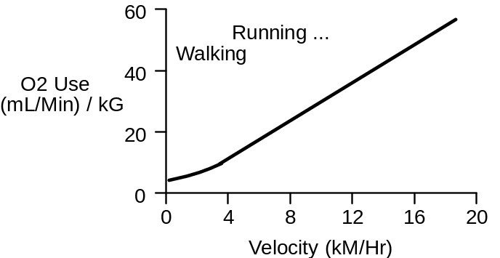

Since both energy required and distance covered are proportional to walking and running speed, it takes a fixed amount of energy to travel a fixed distance: 0.2 ml O2 per meter traveled per kg body weight (Margaria, 1975).

The energy required to run up a grade is proportional to the steepness of the grade (shown below, data from Margaria, 1963). The premium is 0.20 x level-ground needs per % grade.

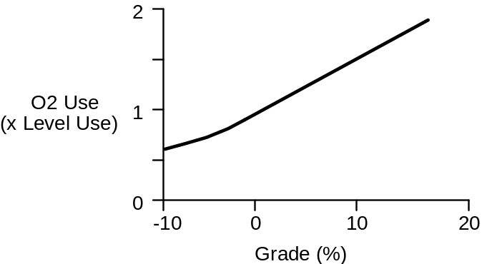

Use Exercise Tolerance To Evaluate Respiratory-Circulatory Function

Inadequate function in either the respiratory system or circulatory system will decrease a subject’s tolerance to physical exercise. At some point, oxygen delivery to the working skeletal muscle will become inadequate, metabolism will switch from aerobic to anaerobic, and the subject will be unable to continue. Thus, the subject’s tolerance to exercise can be used as a measure of respiratory-circulatory function.

An Exercise Tolerance Test

We’ll use the treadmill in this section to measure a normal subject’s tolerance to exercise. The general idea is to observe the subject’s response to exercise, as the exercise becomes more and more strenuous.

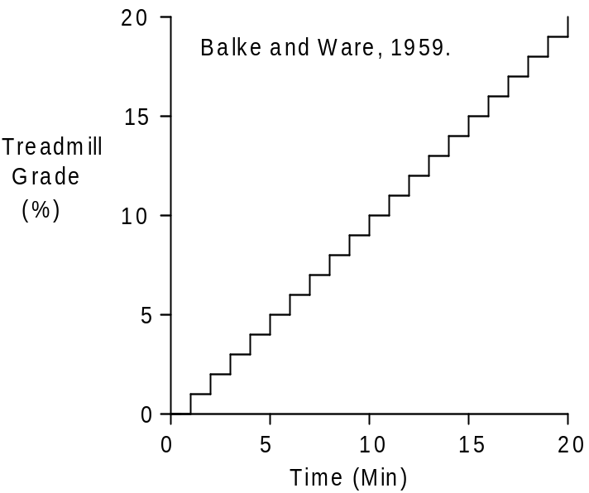

This will be a slightly modified Balke and Ware (1959) protocol.

Click Restart to reestablish initial conditions.

Note that the patient has to be standing when using the treadmill. Click and suggest standing.

Record the initial or control values in the table below (at 0’). Then click to start the treadmill. Set exercise type to treadmill. Select run. Set treadmill speed to 3.5 MPH. Initially set treadmill grade to 0%.

The protocol (shown above) is to advance the solution for 1 minute at each treadmill grade. Then increase the treadmill grade 1% and repeat until either the protocol is complete or the subject stops exercising. Record data at the intervals shown below.

Treadmill Speed (MPH)
Treadmill Grade (%)
Heart Rate (/Min)

Time | 0’ | 5’ | 10’ | 15’ | 20’
Speed | 0 | 3.5 | 3.5 | 3.5 | 3.5
Grade | 0% | 5% | 10% | 15% | 20%
Heart Rate

Record the elapsed time and distance when this normal subject finally gives up.

Elapsed Time (Min)
Distance Traveled (Ft)

Record additional values in the table below.

Arterial Pressure (mmHg)
Cardiac Output (mL/Min)
Heart Rate (/Min)
Stroke Volume (mL)
Respiration Rate (/ Min)
Total Ventilation (L/Min)
Arterial [O2] (mL/mL)
Venous [O2] (mL/mL)
Muscle Blood Flow (mL/Min)

Temperature (deg. F)

Time | 0’ | 5’ | 10’ | 15’ | 20’
Speed MPH | 0 | 3.5 | 3.5 | 3.5 | 3.5
Grade | 0% | 5% | 10% | 15% | 20%
Blood Pressure
Cardiac Output
Heart Rate
Stroke Volume
Respiration Rate
Total Ventilation
Arterial [O2]
Venous [O2]
Muscle Flow
Temperature

You may want to give this test to other subjects. You can then compare their response to the normal response documented here.

Questions For Discussion

Why did this subject stop exercising?
What interventions might improve exercise tolerance?

References

Balke, B. and R.W. Ware. An experimental study of “physical fitness” of Air Force personnel. U.S. Armed Forces Med. J. 10:675-688, 1959.

Margaria, R., P. Aghemo, & F. Piñera Limas. A simple relation between performance in running and maximal aerobic power. J. Appl. Physiol. 38:351-352, 1975.

Margaria, R., P. Cerretelli, P. Aghemo, & G. Sassi. Energy cost of running. J. Appl. Physiol. 18:367-370, 1963.

Menier, D. R. & L. G. C. E. Pugh. The relation of oxygen intake and velocity of walking and running, in competition walkers. J. Physiol. 197:717-721, 1968.

Exercise Tolerance - Notes

Instructor’s notes for exercise tolerance go here.

Laboratory Exercises

Reviewing Homeostasis

The body preserves life by maintaining a relatively constant internal environment in the face of threatening changes in the external environment. This is homeostasis.

All of the body’s organs make important contributions to homeostasis. These contributions must be controlled and coordinated.

A Typical Laboratory Exercise

Our goal here is to explore those parts of human physiology that contribute to homeostasis. Exploring in this case focuses on the interactions of the body’s major organ systems.

A typical laboratory exercise or simulation begins with quiet (steady-state) conditions. A disturbance is then created and the body’s response to this disturbance is observed as time advances.

In one exercise that follows, the disturbance is hemorrhage. The response over time is a combination of neural and humoral compensations, salt and water retention and increased erythropoiesis. We can observe the magnitude and time course of these different components of the response and in some cases we can study the quantitative importance of the components.

Note that this is an interactive environment. You can create multiple disturbances, for instance, or create a disturbance and follow it up with some potentially beneficial (therapeutic) interventions.

Hemorrhage

An adequate cardiac output depends on an adequate blood volume. This is evident in hemorrhage when bloods loss decreases cardiac output and imperils oxygen delivery.

The physiological response to hemorrhage is a three-part process. The principal features are:

• Rapidly responding neural and humoral mechanisms direct available blood flow toward vital organs.

• More slowly evolving salt and water retention by the kidneys replaces the lost plasma.

• Erythropoiesis gradually replaces the lost red blood cells.

Acute Response To Hemorrhage

The acute response includes a primary decrease in cardiac output, a secondary decrease in arterial pressure and compensatory increases in heart rate and vascular resistance (shown below, data from Barcroft).

Autonomic Involvement

Increased heart rate and peripheral vasoconstriction signal the autonomic nervous system's participation in the acute response to hemorrhage. Autonomic dysfunction decreases the body's tolerance to blood loss (shown below, data from DuCharme).

Selective Vasoconstriction

Sympathetic vasoconstriction during hemorrhage is selective. Many organs show intense vasoconstriction, while the cerebral and coronary circulations show little response to increased sympathetic outflow (shown below, data from Kaihara).

The benefit of selectivity is that available blood flow, as meager as it may be, is preferentially directed to the brain and heart -- the vital organs.
Support From Renin-Angiotensin System

The renin-angiotensin system supports arterial pressure in hemorrhage by constricting non-vital organs. This response is slower than the response of the sympathetic nervous system, but it is still an important part of the acute circulatory response to hemorrhage (shown below, data from Brough).

Salt And Water Retention

After hemorrhage, with no intervention, salt and water retention over several days will increase blood volume to normal or above. Erythrocytes are replaced much more slowly, so a fairly severe anemia can result (shown below, data from Ebert, Adamson).

The Hemorrhage Protocol

Click Restart to reestablish initial conditions and then record the control data. Go to Blood Volume. In the arterial hemorrhage box, set volume to 1000 and timespan to 10. Turn the hemorrhage switch on and advance the solution 10 minutes.

We are interested in the immediate impact of the hemorrhage and the subsequent compensations.

Fast compensations are activation of the sympathetic nervous system and increased secretion of renin. When does each have its maximum effect? Use Autonomic Efferents / Sympathetic Ganglia / Firing Rate as an indicator of sympathetic nerve activity Does this fast response help to maintain blood flow to the brain?

The medium-term compensation is renal salt and water retention. When does this have its maximum effect? Note that while blood volume is quickly restored, red cell volume is not. Keep an eye on hematocrit.

The long-term compensation is replacement of the lost erythrocytes. Track erythropoietin as a stimulus and red cell volume as the response.

Blood Volume (mL)
Red Cell Volume (mL)
Plasma Volume (mL)
Hematocrit (%)
Arterial Pressure (mmHg)
Cardiac Output (mL/Min)
Heart Rate (/Min)
Stroke Volume (mL)
Sympathetic Nerve Activity

Plasma Renin Activity
Na+ Excretion (mEq/Min)

Erythropoietin
Brain Blood Flow (mL/Min)

Time | 0  Min | 10  Min | 1  Hour | 1  Day | 1  Month
Blood
Volume
Red Cell
Volume
Plasma
Volume
Hematocrit

Arterial
Pressure
Cardiac
Output
Heart
Rate
Stroke
Volume
Sympathetic Nerve Act.
Plasma
Renin Act.
Na+
Excretion
Erythropoietin

Brain Blood
Flow

References

Adamson, J. and R. S. Hillman. Blood volume and plasma protein replacement following acute blood loss in normal man. J. Amer. Med. Assn. 205:609-612, 1968.

Barcroft, H., O. G. Edholm, J. McMichael and E. P. Sharpy-Schafer. Posthaemorrhagic fainting. Study by cardiac output and forearm flow. Lancet 1:489-491, 1944.

Brough, R. B., Jr., A. W. Cowley, Jr. and A. C. Guyton. Quantitative analysis of the acute response to haemorrhage of the renin-angiotensin-vasoconstrictor feedback loop in areflexic dogs. Cardiovas. Res. 9:722-733, 1975.

DuCharme, D. W. and L. Beck. The relative effect of the renal pressor and sympathetic nervous systems on vascular capacity during hypotension. J. Pharmacol. Exp. Ther. 177:56-68, 1971.

Ebert, R. V., E. A. Stead, Jr. and J. G. Gibson, II. Response of normal subjects to acute blood loss. Arch. Int. Med. 68:578-590, 1941.

Kaihara, S., R. B. Rutherford, E. P. Schwentker and H. N. Wagner, Jr. Distribution of cardiac output in experimental hemorrhage in dogs. J. Appl. Physiol. 27:218-222, 1969.

A-V Fistula

Trauma may create a direct vascular connection between peripheral artery and vein. This is an arteriovenous or a-v fistula.

An a-v fistula shunts oxygenated arterial blood directly to the venous circulation. Fistula flow produces no metabolic benefit. In fact, the flow supporting metabolism may fall (shown below, data from Frank, Murphy).

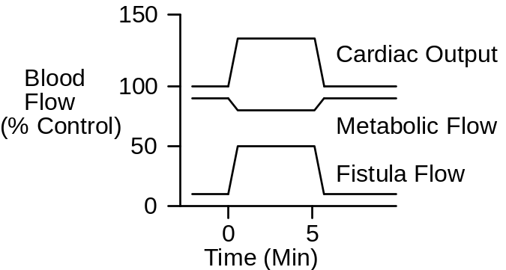

The immediate effect of opening an a-v fistula is that arterial conductance increases and, consequently, cardiac output increases. Arterial pressure falls. A reflex increase in sympathetic outflow gives cardiac output and arterial pressure a boost (shown below, data from Dobbs).

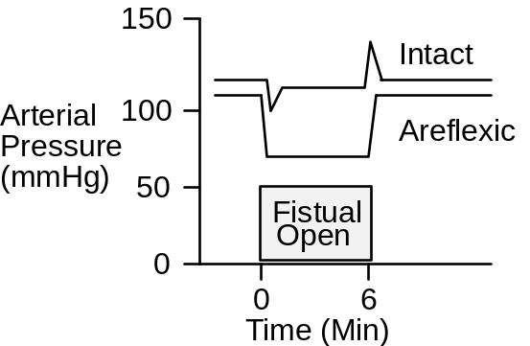

The A-V Fistula Protocol

Click Restart to reestablish initial conditions and then collect control data. Go to Conductance. Scroll down to the a-v fistula box. Slide the size slidebar over to moderate. Advance the solution 10 minutes

Arterial Pressure (mmHg)
Cardiac Output (mL/Min)
Heart Rate (/Min)
Stroke Volume (mL)
Fistula Flow (mL/Min)
Brain Blood Flow (mL/Min)
G.I. Tract Blood Flow (mL/Min)
Kidney Blood Flow (mL/Min)
Skeletal Muscle Blood Flow (mL/Min)
Sympathetic Nerve Activity
Plasma Renin Activity
Na+ Excretion (mEq/Min)

Erythropoietin
Blood Volume (mL)
Red Cell Volume (mL)
Plasma Volume (mL)
Hematocrit (%)

Time | 0  Min | 10  Min | 1  Day | 1  Week | 1  Month
Arterial Pressure
Cardiac Output
Heart Rate
Stroke Volume
Fistula Flow
Brain Blood Flow
G.I. Blood Flow
Kidney Blood Flow
Muscle Blood Flow
Symp. Nerves
Plasma Renin
Na+ Excretion
Erythropoietin
Blood Volume
Red Cell Volume
Plasma Volume
Hematocrit

Use an exercise stress test to characterize cardiac function at 1 week.

Treadmill Speed (MPH)
Treadmill Grade (%)
Heart Rate (/Min)

Time | 0’ | 1’ | 2’ | 3’ | 4’ | 5’
Speed | 0 | 6 | 6 | 6 | 6 | 6
Grade | 0% | 0% | 2% | 4% | 6% | 8%
Heart Rate

Record the elapsed time and distance when this subject finally gives up.

Elapsed Time (Min)
Distance Traveled (Ft)

A-V Fistula And Venous O2 Content

In suspected A-V fistula, a useful clinical finding is mixed venous O2 saturation. Saturation is elevated in proportion to the severity of the fistula, due to shunting of oxygen-rich arterial blood.

Fistula Size | Venous O2  Sat (%) | Venous  [O2]

None
Small
Moderate
Large
Extreme

Optional Use arterial and venous O2 content and an assumption about metabolic flow to calculate A-V fistula flow. Compare the result to actual fistula flow.

References

Dobbs, W. A., Jr., J. W. Prather, & A. C. Guyton. Relative importance of nervous control of cardiac output and arterial pressure. Amer. J. Card. 27:507-512, 1971.

Frank, C. W., H.-H. Wang, J. Lammerant, R. Miller, & R. Wégria. An experimental study of the immediate hemodynamic adjustments to acute arteriovenous fistulae of various sizes. J. Clin. Invest. 34:722-731, 1955.

Murphy, Q. R., Jr., K. S. Gullixson, C. H. Kratochvil, & J. Simoes e Silva, Jr. Circulatory and renal adjustments to acute femoral arteriovenous fistulas. Circ. Res. 6:710-714, 1958.

Cardiac Output via Fick’s Principle

Fick’s principle has been stated in various ways. The paraphrase used here is: At steady-state, the rate of flow of a material into a compartment is equal to the rate of flow out of the compartment.

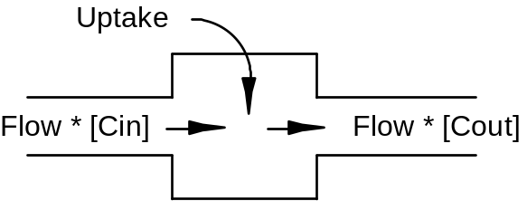

In this exercise, we’ll calculate cardiac output using the rate of flow of oxygen into and out of the lungs. Oxygen inflow (O2 Inflow) into the lungs is equal to the cardiac output (Flow) multiplied by the oxygen concentration in the pulmonary artery ([Cin]) plus the rate of oxygen uptake from the environment (Uptake).

O2 Inflow = Flow * [Cin] + Uptake (1)

Oxygen outflow from the lungs (O2 Outflow) is equal to the cardiac output (Flow) multiplied by the oxygen concentration in the pulmonary veins ([Cout]).

O2 Outflow = Flow * [Cout] (2)

We now assume oxygen outflow is equal to oxygen inflow. From equations (1) and (2) above, we get

Flow * [Cout] = Flow * [Cin] + Uptake (3)
We now rearrange equation (3) to solve for cardiac output (Flow).

Flow = Uptake / ([Cin] - [Cout]) (4)

Click Restart to reestablish initial conditions. Record oxygen concentration (content) in the pulmonary artery and veins and the oxygen uptake. Calculate cardiac output and compare to the actual cardiac output.

Pulmonary Artery [O2] (mL/mL)
Pulmonary Vein [O2] (mL/mL)
O2 Uptake (mL/Min)
Cardiac Output (mL/Min))

Pulmonary Artery [O2]
Pulmonary Vein [O2]
O2 Uptake
Calculated Cardiac Output
Actual Cardiac Output

What is the error in calculated cardiac output when either of the 2 oxygen concentrations has a 10% error? What is the error in calculated cardiac output when oxygen uptake has a 10% error?

Questions For Discussion

Can Fick’s principle be used to accurately calculate cardiac output during exercise?

Where else in the body can Fick’s principle be put to good use?

Pulmonary Shunt

Proper oxygenation of blood in the lungs depends on having almost all of the pulmonary blood flow come in contact with well-ventilated alveoli. If blood shunts from pulmonary artery to pulmonary vein without contacting working alveoli, the blood in the peripheral circulation will subsequently not be fully oxygenated.

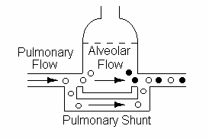

Pulmonary shunting, also called venous admixture, can be significant in some cardiovascular and respiratory diseases.

The Pulmonary Shunt Protocol

Click Restart to reestablish initial conditions and then record control data. Go to . Scroll down to the hemodynamics box and slide the basic shunt flow up to 2000. Advance the solution 10 minutes

Acutely, focus on the ability of shunt to alter arterial pO2 and oxygen content.

Arterial pO2 (mmHg)
Arterial [O2] (mL/mL)
Venous pO2 (mmHg)
Venous [O2] (mL/mL)
Arterial Pressure (mmHg)
Cardiac Output (mL/Min)
Heart Rate (/Min)
Stroke Volume (mL)
Fistula Flow (mL/Min)
Sympathetic Nerve Activity
Plasma Renin Activity
Na+ Excretion (mEq/Min)

Erythropoietin
Blood Volume (mL)
Red Cell Volume (mL)
Plasma Volume (mL)
Hematocrit (%)

Time | 0  Min | 10  Min | 1  Day | 1  Month
Arterial pO2
Arterial [O2]
Venous pO2
Venous [O2]
Blood Pressure
Cardiac Output
Heart Rate
Stroke Volume
Symp. Nerves
Plasma Renin
Na+ Excretion
Erythropoietin
Blood Volume
Red Cell Volume
Plasma Volume
Hematocrit

Use an exercise stress test to characterize cardiac function.

Treadmill Speed (MPH)
Treadmill Grade (%)
Heart Rate (/Min)

Time | 0’ | 1’ | 2’ | 3’ | 4’ | 5’
Speed | 0 | 6 | 6 | 6 | 6 | 6
Grade | 0% | 0% | 2% | 4% | 6% | 8%
Heart Rate

Record the elapsed time and distance when this subject finally gives up.

Elapsed Time (Min)
Distance Traveled (Ft)

Pulmonary Shunt And Arterial pO2

In this exercise, we’ll observe the effect of pulmonary shunt on arterial pO2 and [O2].

Pulmonary Shunt (mL/Min)
Arterial pO2 (mmHg)
Arterial [O2] (mL/mL)

Shunt (mL/Min) | 500 | 1000 | 1500 | 2000 | 2500 | 3000
Shunt (%CO)
Arterial [O2]
Arterial pO2
Art. pO2 (% Norm)

Plot arterial pO2 as a function of pulmonary shunt. Use percent of normal as units for pO2. Use percent of cardiac output as units for shunt.

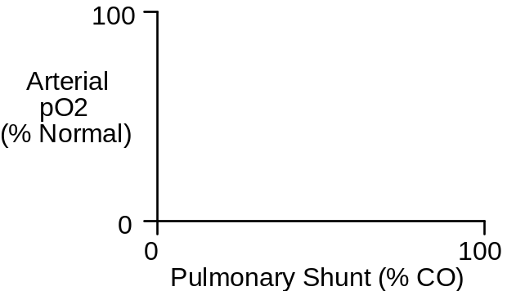

Can arterial pO2 be used to predict the magnitude of pulmonary shunt?

Question For Discussion

To distinguish between pulmonary shunting and diffusion block, a patient is given pure (100%) O2. What is the rationale for this test? Try it.

Water Load

Water intake in excess of the body’s needs is readily excreted in the urine. Diuresis following a water load is caused by

- Absorption of water into the blood from the gut. Added water decreases plasma osmolarity.

- Decreased osmolarity inhibits antidiuretic hormone (ADH) release and lower ADH concentration causes the kidney to increase water excretion.

Water Absorption Is Quite Rapid

Water absorption from the gut is quite rapid following a 1L oral water load.
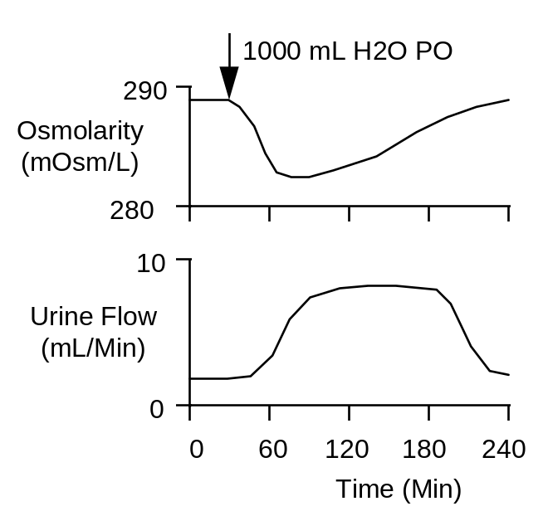

Absorption is nearly complete at about 60 minutes (data above from Baldes & Smirk, 1934; Findley & White,1937).

A 1L oral water load will decrease plasma osmolarity about 10 mOsm/L with the nadir occurring at about 60 minutes.

Hypoosmolarity Inhibits ADH Secretion

A decrease in plasma osmolarity of 20 mOsm/L will completely inhibit ADH secretion (data at right from Robertson et.al., 1973).
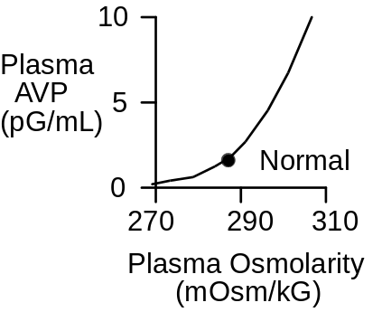

Water excretion increases about 8-fold with a 1L water load. Excretion remains elevated until the entire load is excreted (shown above).

A water load does not increase excretion in patients with diabetes insipidus (Findley & White).

The Water Load Protocol

In this exercise, we will administer a large, oral water load and then observe its distribution and disposition over the following 24 hours.

Begin by clicking Restart to reset the model’s variables to their initial values. Record control (0 Min) data in the table below. Then click Misc. Treatments. In the oral water / glucose load box set the quantity to 1000 ml, the duration to 10 Min, and the glucose (%) to 0. Click the oral water / glucose load switch to on. Advance the solution and record data.

G.I. Lumen H2O Volume (mL)
Plasma Volume (mL)
Plasma Osmolarity (mOsm/L)
Interstitial Fluid Volume (L)
Plasma [ADH] (pG/mL)
Urine Flow (mL/Min)
Urine Osmolarity (mOsm/L)

Time | 0  Min | 1  Hr | 2  Hrs | 3  Hrs | 6  Hrs | 1  Day
GI H2O Volume
Plasma Volume
Plasma Osm
IFV
Plasma [ADH]
Urine Flow
Urine Osm

Where does the water go as a function of time? Monitor water in the gut, plasma volume and urine formation.

What factors control the synthesis and release of antidiuretic hormone?

Role Of Antidiuretic Hormone In Water Balance

In the exercise above changes in antidiuretic hormone concentration [ADH] appeared to be an important part of the response. We will investigate the importance of ADH more completely in this exercise by giving a water load with [ADH] clamped at its normal value.

Begin again by clicking Restart to reset the model’s variables to their initial values. Record control (0 Min) data in the table below. Click Antidiuretic Hormone. Turn the ADH secretion clamp on to clamp plasma [ADH] at its normal value.

Next click Misc. Treatments. In the oral water / glucose load box set the quantity to 1000 ml, the duration to 10 Min, and the glucose (%) to 0. Click the oral water / glucose load switch to on. Advance the solution and record data.

G.I. Lumen H2O Volume (mL)
Plasma Volume (mL)
Plasma Osmolarity (mOsm/L)
Interstitial Fluid Volume (L)
Plasma [ADH] (pG/mL)
Urine Flow (mL/Min)
Urine Osmolarity (mOsm/L)

Time | 0  Min | 1  Hr | 2  Hrs | 3  Hrs | 6  Hrs | 1  Day
GI H2O Volume
Plasma Volume
Plasma Osm
IFV
Plasma [ADH]
Urine Flow
Urine Osm

References

Baldes, E.J. and F.H. Smirk. The effect of water drinking, mineral starvation and salt administration on the total osmotic pressure of the blood in man, chiefly in relation to the problems of water absorption and water diuresis. J.Physiol. 82:62-74, 1934.

Findley, T., Jr. and H.L. White. The response of normal individuals and patients with diabetes insipidus to the ingestion of water. J.Clin.Invest. 16:197-202, 1937.

Robertson, G. L., E. H. Mahr, S. Athar and T. Sinha. Development and clinical application of a new method of radioimmunoassay of arginine vasopressin in human plasma. J. Clin. Invest. 52:2340-2352, 1973.

Starvation

This exercise investigates the metabolic response to complete cessation of caloric intake. If the metabolic substrate is not coming from food intake, where is it coming from? We need to keep an eye on these sources of fuel:

Metabolism / Liver Glycogen
Body Composition / Adipose Tissue Lipids
Cell Composition / Cell Protein

We can arbitrarily divide the body’s response into acute (a few hours), intermediate (a few days), and long-term (a few weeks) responses.

The Starvation Protocol

Begin by clicking Restart to reset the model’s variables to their initial values. Record control values. Click and set carbos, fat and protein intake to 0. Advance the solution and record the data.

Liver Glycogen Mass (G)
Adipose Lipid Mass (G)
Cell Protein Mass (G)
Plasma [Ketoacids] (mG/dL)
Plasma [Glucose] (mG/dL)
Brain Ketoacid Use (mG/Min)
Brain Glucose Use (mG/Min)
Skeletal Muscle Glucose Use (mG/Min)
Skeletal Muscle FFA Use (mG/Min)
Plasma [Insulin] (uU/mL)
Plasma [Glucagon] (pG/mL)

Time | 0 | 6  Hrs | 1  Day | 2  Days | 1  Wk | 2  Wks | 3  Wks
Liver Glycogen
Adipose Lipid
Cell Protein
Plasma [KA]
Plasma [Glu]
Brain KA Use
Brain Glu Use
Musc. Glu Use
Musc. FFA Use
[Insulin]
[Glucagon]

Baroreceptor Reflex

The baroreceptor reflex stabilizes arterial pressure. Stability helps to provide uninterrupted flow to vital organs.

The strength of the reflex can be studied by altering baroreceptor perfusion pressure and then noting the subsequent effect on arterial pressure (show below, data from Angel-James & Daly). A decrease in carotid perfusion pressure causes an increase in systemic arterial pressure, a relationship that helps to stabilize arterial pressure.

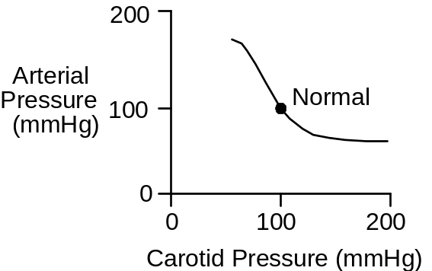

Pressure in the carotid arteries stimulates the baroreceptors. This stimulation, via the central nervous system, changes autonomic outflow. The efferent pathways of the baroreceptor reflex innervate the heart, systemic arteries and systemic veins. Changes in heart rate, cardiac contractility, arterial conductance and venous unstressed volume all help to determine arterial pressure. But carotid artery pressure is equal to systemic artery pressure, closing the baroreceptor reflex loop.

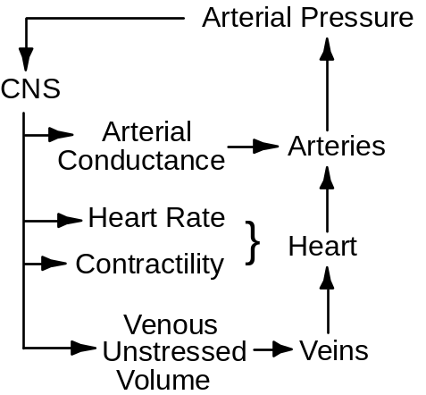

In this exercise, we’ll replicate the classical protocol while also following the details of the response to carotid pressure changes.

The Baroreceptor Reflex Protocol

Click Restart to reestablish initial conditions.

Go to Autonomic Afferents. Slide carotid perfusion pressure up to 60 mmHg and click the carotid perfusion pump switch to on. Advance the solution for 1 minute and record the appropriate neural and hemodynamic data in the table below.

Repeat for carotid perfusion pressures of 80, 100, 120 and 140 mmHg.

Carotid Pressure (mmHg)
Autonomic Firing
Vagal Firing
Heart Rate (/Min)
Stroke Volume (mL)
Cardiac Output (mL/Min)
Total Peripheral Resistance (mmHg/(mL/Min))
Arterial Pressure (mmHg)

Carotid Pressure | 60 | 80 | 100 | 120 | 140
Autonomic Firing
Vagal Firing
Heart Rate
Stroke Volume
Cardiac Output
TPR
Arterial Pressure

Using the data collected above, plot arterial pressure as a function of carotid artery pressure.

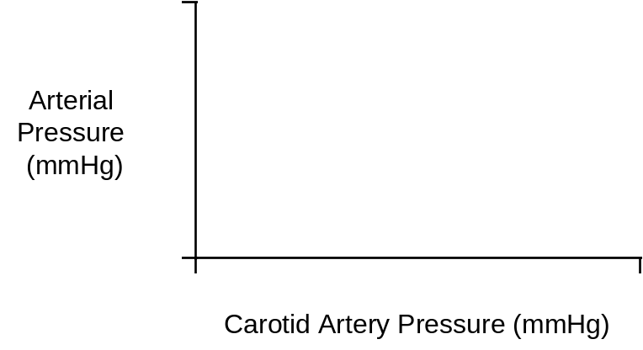

Note that this protocol measures the acute responses to carotid pressure change. Over the longer term, what factors might modify the response? You can study this by restarting the solution, setting and turning on the carotid perfusion pump, and then advancing the solution for 30 minutes, 1 hour and longer.

References

Angel-James, J. & M. de B. Daly. Comparison of reflex vasomotor responses to separate and combined stimulation of carotid sinus and aortic arch baroreceptors by pulsatile and non-pulsatile pressures in the dog. J. Physiol. 209:257-293, 1970.

Insulin Overdose

Elevated blood levels of insulin are appropriate when glucose is being absorbed from the gut. But when glucose is not being absorbed from the gut, elevated blood levels of insulin can, in fact, be fatal. We pay particular attention here to the brain’s fuel supply.

The Insulin Overdose Protocol

Begin by clicking Restart to reset the model’s variables to their initial values. Advance the solution 1 hour and record control data. Go to Diet. Create a fasting state in the dietary goals box by sliding carbos, fat and protein goals down to 0.

Advance the solution for 6 hours and record data for the fasting state. Now it is time for an insulin injection. Go to Misc. Treatments. In the insulin injection box, set the dose (U) at 40 U and the duration of action at normal (4 Hrs). To inject the insulin, click the Inject Insulin Now button. The total injections count should now be 1.

Advance the solution 10 minutes at a time, recording data at the end of each time period.

Plasma Insulin] (uU/mL)
Plasma Glucagon (pG/mL)
Plasma Glucose (mG/dL)
Brain Glucose Use (mG/Min)
Brain Ketoacids Use (mG/Min)
Blood Pressure (mmHg)
Heart Rate (/ Min)
Neurological Signs
Sympathetic Nerve Activity

Time | 12:00 | 6:00 | 6:10 | 6:20 | 6:30 | 6:40 | 6:50
Plasma [Insulin]
Plasma [Glucagon]
Plasma [Glucose]
Brain Glucose Use
Brain KA Use
Blood Pressure
Heart Rate
Neurological Signs
Sympathetic Firing

Where is the glucose coming from and where is it going? Why is the brain not making better use of ketoacids?

Demonstrate the proper clinical intervention in this case -- before it’s too late.

Renal Artery Stenosis

Partial obstruction of a renal artery -- renal artery stenosis -- produces hypertension. Clinically, the cause is often atherosclerosis or comparable forms of vascular damage. Experimentally, renal artery stenosis is produced by a clamp.

Before the work of Harry Goldblatt, there was no reliable way to produce hypertension in experimental animals. Then Dr. Goldblatt demonstrated that partial constriction of the renal arteries produces a sustained blood pressure increase (shown below, data from Goldblatt) that is proportional to the severity of the constriction. This technique was then simplified to partial constriction of one renal artery with surgical removal of the other kidney.

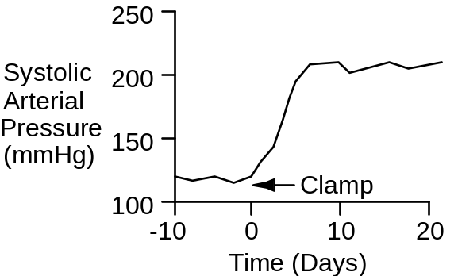

Clinically, hypertension due to renal artery stenosis is relatively rare and potentially very serious. It is often surgically correctable.

Renal artery stenosis decreases pressure in the renal vasculature beyond the obstruction. Decreased pressure immediately decreases salt and water excretion. Renin secretion is stimulated. First angiotensin II and then retained sodium work to elevate systemic arterial pressure. An increase in arterial pressure elevates renal artery pressure beyond the stenosis and sodium balance is reestablished. The price paid for reestablishing sodium balance is chronic arterial hypertension (shown below, data from Murphy).

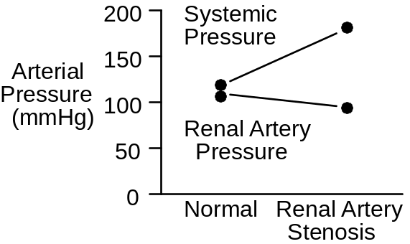

The Renal Artery Stenosis Protocol
Begin by clicking Restart to reset the model’s variables to their initial values. Record control data in the table below. Then go to Circulation. Slide the renal artery stenosis slidebar over to severe and record data for the immediate response (0+). Advance time and record data as hypertension develops.

Arterial Pressure (mmHg)
Arcuate Artery Pressure (mmHg)
Plasma Renin Activity
Sympathetic Nerve Activity
Plasma Volume (mL)
Extracellular Fluid Volume (L)
Na+ Excretion (mEq/Min)

Time | 0  Min | 0+  Min | 1  Hr | 1  Day | 1  Week
Arterial Pressure
Arcuate Pressure
PRA
Sympathetics
Plasma Volume
ECFV
Na+ Excretion

References

Goldblatt, H., J. Lynch, R. F. Hanzal, & W. W. Summerville. Studies on experimental hypertension. I. The production of persistent elevation of systolic blood pressure by means of renal ischemia. J. Exp. Med. 59:347-379, 1934.

Murphy, W. R., T. G. Coleman, T. L. Smith, & K. A. Stanek. Effects of graded renal artery constriction on blood pressure, renal artery pressure, and plasma renin activity in Goldblatt hypertension. Hypertension 6:68-74, 1984.

Heart Failure

Left-heart failure typically begins with a myocardial infarction. The infarction decreases both myocardial contractility and blood flow to the heart. Stroke volume is diminished and this causes decreases in cardiac output and arterial pressure.

The immediate response to a left-side myocardial infarction is a shift in blood volume from the peripheral circulation to the pulmonary circulation. This shift increases left heart end-diastolic volume. Increased cardiac filling helps to offset impaired emptying. In addition to the volume shift, increased sympathetic outflow increases left-heart contractility (shown below, data from Griffiths, Cody).

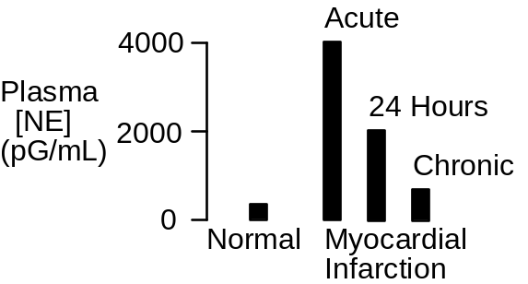

The Heart Failure Protocol

Click Restart to reestablish initial conditions and then record the control data. Go to Left Heart. Scroll down to the myocardial infarction box. Slide the slidebar over to serious. Advance the solution 10 minutes.

We are interested in the acute effect of the infarction on hemodynamics and the subsequent compensations that help to maintain oxygen delivery.

Arterial Pressure (mmHg)
Cardiac Output (mL/Min)
Heart Rate (/Min)
Stroke Volume (mL)
Left Ventricle EDV (mL)
Left Ventricle EDP (mmHg)
Ejection Fraction
Sympathetic Nerve Activity
Plasma Renin Activity
Na+ Excretion (mEq/Min)

Erythropoietin
Blood Volume (mL)
Red Cell Volume (mL)
Plasma Volume (mL)
Hematocrit (%)

Time | 0  Min | 10  Min | 1  Day | 1  Week
Arterial Pressure
Cardiac Output
Heart Rate
Stroke Volume
LV EDV
LV EDP
Ejection Fraction
Symp Nerves
Plasma Renin
Na+ Excretion
Erythropoietin
Blood Volume
Red Cell Volume
Plasma Volume
Hematocrit

Ejection Fraction

The heart’s ejection fraction is the ratio of stroke volume to end-diastolic volume. The normal ejection fraction is 0.60.

Ejection fraction is a useful clinical finding, since it decreases in proportion to the severity of heart failure. Decreases are typically due to both decreasing stroke volume and increasing end-diastolic volume.

Exercise Tolerance

Tolerance to exercise is decreased in heart failure (shown below, data from Wilson).

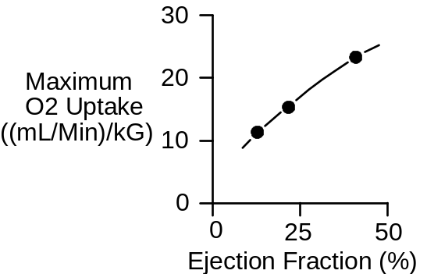

Use an exercise stress test to characterize QCP’s cardiac function at 7 days.

Treadmill Speed (MPH)
Treadmill Grade (%)
Heart Rate (/Min)

Time | 0’ | 1’ | 2’ | 3’ | 4’ | 5’
Speed | 0 | 6 | 6 | 6 | 6 | 6
Grade | 0% | 0% | 2% | 4% | 6% | 8%
Heart Rate

Record the elapsed time and distance when this subject finally gives up.

Elapsed Time (Min)
Distance Traveled (Ft)

References

Cody, R. J., K. W. Franklin, J. Kluger, & J. H. Laragh. Sympathetic responsiveness and plasma norepinephrine during therapy of chronic congestive heart failure with captopril. Amer. J. Med. 72:791-797, 1982.

Griffiths, J. & F. Leung. The sequential estimation of plasma catecholamines and whole blood histamine in myocardial infarction. Amer. Heart J. 82:171-179, 1971.

Wilson, J. R., J. L. Martin, D. Schwartz, & N. Ferraro. Exercise intolerance in patients with chronic heart failure. Role of impaired nutritive flow to skeletal muscle. Circulation 69:1079-1087, 1984.

High Altitude

The partial pressure of inspired oxygen decreases with increasing altitude. This causes a decrease in oxygen saturation in the arterial blood and impairs oxygen delivery to the tissues.
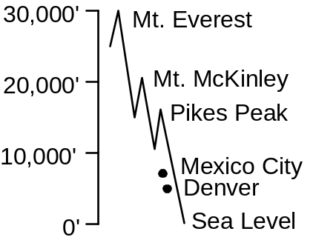

Record barometric pressure and inspired pO2 as altitude is increased from sea level to 25,000 feet in 5000 foot increments.

Altitude (Feet)
Barometric Pressure (mmHg)
Inspired pO2 (mmHg)

Altitude | 0 | 5000 | 10000 | 15000 | 20000 | 25000
Baro. Pressure
Inspired pO2

Ventilation At High Altitude

An important part of the acute response to high altitude is increased ventilation (shown below, data from Huston, Pugh).

Other important parts of the acute response to high altitude are vasodilation of hypoxic tissues and increased cardiac output supported in part by increased sympathetic outflow.

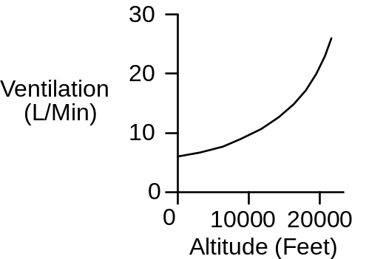

Blood Volume At High Altitude

An important part of the chronic response to high altitude is increased erythropoiesis, leading to increased red cell volume and hematocrit (shown below, data from Rotta). The positive part of this response is that the blood's oxygen carrying capacity is increased. The negative part is that blood viscosity is increased.

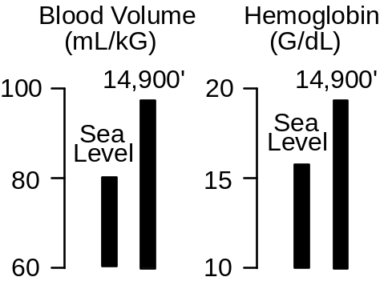

The High Altitude Protocol

Click Restart to reestablish initial conditions. Go to . In the Altitude box slide the Feet slidebar up to 10,000. Advance the solution 10 minutes.

Acutely, focus on effect of altitude on oxygen’s partial pressure and the ability of the body to load arterial hemoglobin. Chronically, focus on compensations that alter the body’s ability to deliver oxygen to the tissues.

Arterial pO2 (mmHg)
Arterial [O2] (mL/mL)
Venous pO2 (mmHg)
Venous [O2] (mL/mL)
Arterial pCO2 (mmHg)
Venous pH
Cardiac Output (mL/Min)
Heart Rate (/Min)
Stroke Volume (mL)
Sympathetic Nerve Activity
Plasma Renin Activity
Na+ Excretion (mEq/Min)

Erythropoietin
Blood Volume (mL)
Red Cell Volume (mL)
Plasma Volume (mL)
Hematocrit (%)
Oxygen Uptake (mL/Min)

Time | 0  Min | 10  Min | 1  Day | 1  Month
Arterial pO2
Arterial [O2]
Venous pO2
Venous [O2]
Arterial pCO2
Venous pH
Cardiac Output
Heart Rate
Stroke Volume
Symp Nerves
Plasma Renin
Na+ Excretion
Erythropoietin
Blood Volume
Red Cell Volume
Plasma Volume
Hematocrit
Oxygen Uptake

Use an exercise stress test to characterize cardiac function.

Treadmill Speed (MPH)
Treadmill Grade (%)
Heart Rate (/Min)

Time | 0’ | 1’ | 2’ | 3’ | 4’ | 5’
Speed | 0 | 6 | 6 | 6 | 6 | 6
Grade | 0% | 0% | 2% | 4% | 6% | 8%
Heart Rate

Record the elapsed time and distance when this subject finally gives up.

Elapsed Time (Min)
Distance Traveled (Ft)

Discussion Question

What is the cardiovascular and respiratory response to loss of cabin pressure in an aircraft flying at 30,000 feet?

References

Houston, C. S. & R. L. Riley. Respiratory and circulatory changes during acclimatization to high altitude. Amer. J. Physiol. 149:565-588, 1947.

Pugh, L. G. C. E. Resting ventilation and alveolar air on Mount Everest: With remarks on the relation of barometric pressure to altitude in mountains. J. Physiol. 135:590-610, 1957.

Rotta, A., A. Cánepa, A. Hurtado, T. Velásquez, & R. Chávez. Pulmonary circulation at sea level and at high altitude. J. Appl. Physiol. 9:328-336, 1956.

Changes In Salt Intake

We now normally consume a sodium-rich diet, but historically sodium has not always been abundant in the diet.

When dietary sodium intake is decreased, excretion initially exceeds intake; extracellular sodium and plasma volume decrease. Then, plasma angiotensin II concentration increases and sodium excretion falls to a level that matches intake. Sodium balance is reestablished. The timecourse of this transition is shown below (data from Epstein).

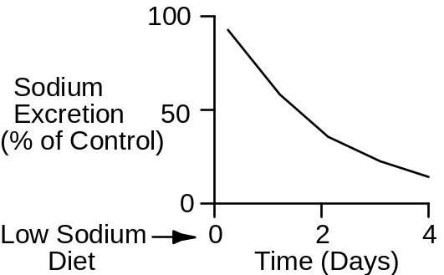

The Changes In Salt Intake Protocol
We will give QCP normal, low and high-salt diets in this exercise and follow the mechanisms involved in adjusting renal sodium excretion.

Begin by clicking Restart to reset the model’s variables to their initial values. The normal sodium intake is 180 mEq/Day. Advance the solution for 1 week and record normal values in the table below.

Next we will study a low-salt diet. Click Restart again. Click Diet. Slide Na+ intake down to 20 mEq/Day and Cl- intake down to 40 Eq/Day. Advance the solution for 1 week and record values below.

The final diet is high salt. Click Restart. Click Diet. Slide Na+ and Cl- intake up to 500 Eq/Day. Advance the solution for 1 week and record values below.

Arterial Pressure (mmHg)
Right Atrial Pressure (mmHg)
Left Atrial Pressure (mmHg)
Plasma [AII] (pG/mL)
Plasma [Aldosterone] (pMol/L)
Plasma [ANP] (pMol/L)
Na+ Excretion (mEq/Min)

Sodium Intake | 20 | 180 | 500
Arterial Pressure
Right Atrial Pressure
Left Atrial Pressure
Plasma [AII]
Plasma [Aldosterone]
Plasma [ANP]
Urine Na+ Excretion

Compare the changes in plasma [AII], [Aldosterone] and [Atrial Natriuretic Peptide]. Why are changes in [ANP] relatively small during changes in salt intake?

Importance Of Angiotensin In Sodium Balance

The increase in plasma angiotensin concentration during sodium deprivation has two positive effects:

It helps the kidney to reabsorb sodium.

It supports arterial pressure in the face of decreased blood volume.

The blood pressure response to blocking AII formation while on a low-salt diet is shown below (data from Hall).

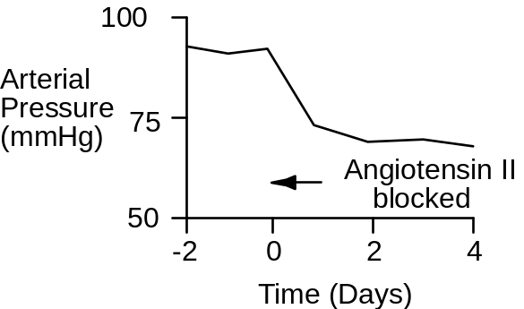

We will now explore the importance of the renin-angiotensin-aldosterone system in the regulation of arterial pressure and body fluid volumes. We will repeat the 3 simulations described above, but in each case formation of angiotensin will be blocked. In each case, Click Restart. Click Blocker. Slide angiotensin converting enzyme inhibition to 100%. Click Diet. Set the Na+ and Cl- intake as described above. Advance the solution for 1 week and record the data in the table below.

Arterial Pressure (mmHg)
Right Atrial Pressure (mmHg)
Left Atrial Pressure (mmHg)
Plasma [AII] (pG/mL)
Plasma [Aldosterone] (pMol/L)
Plasma [ANP] (pMol/L)
Na+ Excretion (mEq/Min)

Sodium Intake | 20 | 180 | 500
Arterial Pressure
Right Atrial Pressure
Left Atrial Pressure
Plasma [AII]
Plasma [Aldosterone]
Plasma [ANP]
Urine Na+ Excretion

Long-Term Pressure Natriuresis Curve

Plot sodium excretion as a function of arterial pressure on the coordinates below for (a) the normal case, and (b) with AII formation blocked.

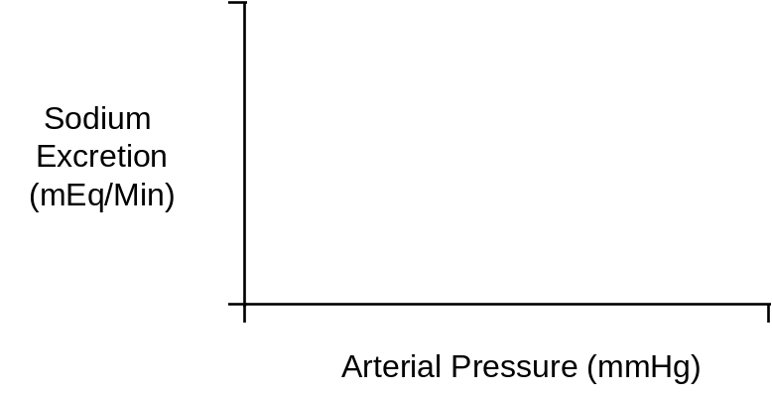

Under normal conditions, is arterial pressure salt sensitive? Why?

References

Epstein, M. & N. K. Hollenberg. Age as a determinant of renal sodium conservation in normal man. J. Lab. Clin. Med. 87:411-417, 1976.Hall, J. E., A. C. Guyton, M. J. Smith, Jr., & T. G. Coleman. Chronic blockade of angiotensin II formation during sodium deprivation. Amer. J. Physiol. 237:F424-F432, 1979.

Aldosterone And Sodium Escape

Aldosterone increases sodium reabsorption and potassium secretion. However, during chronic aldosterone excess, such as in primary aldosteronism, sodium balance is achieved. Achieving this balance is known as sodium escape. There has been considerable interest in the mechanisms which account for sodium escape.

In this exercise, we will simulate primary aldosteronism and then observe the factors which control sodium excretion.

The Aldosterone And Sodium Escape Protocol

Begin by clicking Restart to reset the model’s variables to their initial values. Record the control (Day 0) data in the table below. Click Aldosterone. Slide the basic aldosterone formation rate down to 0. Slide the aldosterone pump rate up to 2000 and click the aldosterone pump switch to on. Advance the solution and record data in table below.

On Day 10, increase the Na+ and Cl- intake (at ) from normal to 500 mEq/Day. Advance the solution for 1 more week and record the Day 17 data.

Arterial Pressure (mmHg)
Right Atrial Pressure (mmHg)
Left Atrial Pressure (mmHg)
Plasma [AII] (pG/mL)
Plasma [Aldosterone] (pMol/L)
Plasma [ANP] (pMol/L)
Plasma [Na+] (mEq/L)
Plasma [K+] (mEq/L)
Glomerular Filtration Rate (mL/Min)
Proximal Na+ Inflow (mEq/Min)
Proximal Na+ Reabsorption (mEq/Min)
Distal Na+ Inflow (mEq/Min)
Distal Na+ Reabsorption (mEq/Min)
Collecting Duct Na+ Inflow (mEq/Min)
Collecting Duct Na+ Reabsorption (mEq/Min)
Na+ Excretion (mEq/Min)

Plasma Volume (mL)

ECFV (L)

Ascites (mL)

Time (Days) | 0 | 1 | 3 | 10 | 17
Arterial Pressure
Right Atrial Pressure
Left Atrial Pressure
Plasma [AII]
Plasma [Aldosterone]
Plasma [ANP]
Plasma [Na+]
Plasma [K+]
GFR
Proximal Na+ Inflow
Proximal Na+ Reab.
Distal Na+ Inflow
Distal Na+ Reab.
CD Na+ Inflow
CD Na+ Reabsorption
Urine Na+ Excretion
Plasma Volume
ECFV
Ascites

Describe the time-dependent effects of aldosterone on urinary sodium and potassium excretion. Are sodium and potassium balance achieved during aldosterone excess? Does aldosterone have a sustained effect on sodium reabsorption and potassium secretion in the distal nephron? Does edema occur during primary aldosteronism? Is aldosterone hypertension salt-sensitive? How does increased salt intake affect plasma potassium concentration in primary aldosteronism?

When Sodium Escape Does Not Occur

In states of secondary aldosteronism, such as congestive heart failure, sodium escape may not occur. In this exercise, we will investigate the role of renal perfusion pressure in sodium escape. We will repeat the protocol given above with renal perfusion pressure clamped at a normal value.

Begin again by clicking Restart to reset the model’s variables to their initial values. Record the control (Day 0) data in the table below. Click Circulation. At the perfusion pump, slide perfusion pressure up to 96 and click the perfusion pump switch to on. Click Aldosterone. Slide the basic aldosterone formation rate down to 0. Slide the aldosterone pump rate up to 2000 and click the aldosterone pump switch to on. Advance the solution and record data in table below. Stop at Day 10 (see below).

Arterial Pressure (mmHg)
Right Atrial Pressure (mmHg)
Left Atrial Pressure (mmHg)
Plasma [AII] (pG/mL)
Plasma [Aldosterone] (pMol/L)
Plasma [ANP] (pMol/L)
Plasma [Na+] (mEq/L)
Plasma [K+] (mEq/L)
Glomerular Filtration Rate (mL/Min)
Proximal Na+ Inflow (mEq/Min)
Proximal Na+ Reabsorption (mEq/Min)
Distal Na+ Inflow (mEq/Min)
Distal Na+ Reabsorption (mEq/Min)
Collecting Duct Na+ Inflow (mEq/Min)
Collecting Duct Na+ Reabsorption (mEq/Min)
Na+ Excretion (mEq/Min)

Plasma Volume (mL)

ECFV (L)

Ascites (mL)

Time (Days) | 0 | 1 | 3 | 10 | 17
Arterial Pressure
Right Atrial Pressure
Left Atrial Pressure
Plasma [AII]
Plasma [Aldosterone]
Plasma [ANP]
Plasma [Na+]
Plasma [K+]
GFR
Proximal Na+ Inflow
Proximal Na+ Reab.
Distal Na+ Inflow
Distal Na+ Reab.
CD Na+ Inflow
CD Na+ Reabsorption
Urine Na+ Excretion
Plasma Volume
ECFV
Ascites

Does sodium escape occur? Why? Is edema present?

As before, on Day 10 increase the Na+ and Cl- intake (at ) from normal to 500 mEq/Day. Advance the solution 1 more week and record the Day 17 data.

A Normal Meal

A normal meal consists of carbohydrate, fat and protein. In this exercise, we want to see where these fuels go after ingestion. We want to identify the hormonal controls that are involved.

Keep an eye on the contents of the gut, plasma insulin and glucagon concentrations, liver metabolic activity and fuel use by the brain and skeletal muscle.

The Normal Meal Protocol

Begin by clicking Restart to reset the model’s variables to their initial values. Record control values. Then go to Diet and change the food and water schedule from continuous to at mealtime.

Go to GI Tract - Lumen to monitor changes in the contents of the gut. The first meal is breakfast, scheduled for 7:00 AM. Advance the solution for 7 (6 + 1) hours. The guy’s been sleeping. The clock should display 7:00 AM. Record fasting data. It’s time for breakfast. Advance the solution to the times shown in the table below and record data.

G.I. Tract Glucose Mass (G)
G.I. Tract Fat Mass (G)
G.I. Tract Protein Mass (G)
Plasma [Glucose] (mG/dL)
Tissue Glucose Use (mG/Min)
Brain Glucose Use (mG/Min)
Fat Glucose Use (mG/Min)
Skeletal Muscle Glucose Use (mG/Min)
Plasma Free Fatty Acid (mG/dL)
Tissue FFA Use (mG/Min)
Skeletal Muscle FFA Use (mG/Min)
Plasma [Triglycerides] (mG/dL)
Fat Triglyceride Uptake (mG/Min)
Liver Glycogen Mass (G)
Plasma [Insulin] (uU/mL)
Plasma [Glucagon] (pG/mL)

Time | 12:00 | 7:00 | 7:10 | 7:20 | 7:30 | 8:00 | 9:00
Glucose Mass
Fat Mass
Protein Mass
Plasma [Glu]
Tissue Glu Use
Brain Glu Use
Fat Glu Use
Muscle Glu Use
Plasma [FFA}
Tissue FFA Use
Muscle FFA Use
Plasma [Trigly.]
Fat Trigly. Uptake
Liver Glycogen
Plasma [Insulin]
Plasma [Glucagon]

Diabetes Mellitus

When glucose is being absorbed, increased blood levels of insulin are beneficial. This insulin facilitates glucose uptake by the tissues and helps to replenish the glycogen stores of liver and skeletal muscle.

In diabetes mellitus, the beta cells of the pancreas do not secrete adequate amounts of insulin when it is needed. Need is most evident following a carbohydrate-rich meal.

In this exercise, we’ll first stop insulin production and then view the consequences of eating a meal in a repeat of the eating exercise presented in another lab.

The Diabetes Mellitus Protocol

Begin by clicking Restart to reset the model’s variables to their initial values. Record control data. Go to Pancreas - Beta Cells. Set insulin synthesis basic rate and insulin secretion basic fraction to 0.

Go to Diet and change the food and water schedule from continuous to at mealtime.

Keep an eye on the contents of the gut, plasma glucagon concentration, liver metabolic activity and fuel use by the brain and skeletal muscle. Plasma insulin should be 0 throughout.

Go to GI Tract - Lumen to monitor changes in the contents of the gut. The first meal is breakfast, scheduled for 7:00 AM. Advance the solution for 7 (6 + 1) hours. The guy’s been sleeping. The clock should display 7:00 AM. Record fasting data. It’s time for breakfast. Advance the solution to the times shown below and record data.

G.I. Tract Glucose Mass (G)
G.I. Tract Fat Mass (G)
G.I. Tract Protein Mass (G)
Plasma [Glucose] (mG/dL)
Brain Glucose Use (mG/Min)
Fat Glucose Use (mG/Min)
Muscle Glucose Use (mG/Min)
Plasma [FFA] (mG/dL)
Tissue FFA Use (mG/Min)
Muscle FFA Use (mG/Min)
Plasma [Triglycerides] (mG/dL)
Fat Triglyceride Uptake (mG/Min
Liver Glycogen Mass (G)
Plasma [Insulin] (uU/mL)
Plasma [Glucagon] (pG/mL)

Time | 12:00 | 7:00 | 7:10 | 7:20 | 7:30 | 8:00 | 9:00

Glucose Mass

Fat Mass

Protein Mass

Plasma [Glu]

Tissue Glu Use

Brain Glu Use

Fat Glucose Use

Muscle Glu Use

Plasma [FFA}

Tissue FFA Use

Muscle FFA Use
Plasma [Trig.]
Fat Trig. Uptake

Liver Glycogen

Plasma [Insulin]
Plasma [Gluca’n]

Pericardial Hemorrhage

An unspecified amount of bleeding and severe hypotension usually suggests hypovolemic shock, but that is not always the case.

This exercise is taken from a case developed by R. Summers (1996). Quoting Dr. Summers

A 23 year old man arrived by ambulance after gunshot wounds to the neck and chest. The patient presented awake, confused and combative, with a heart rate of 120 beats/min, a respiratory rate of 20 breaths/min, and no audible blood pressure.

This patient was severely hypotensive but did not respond to aggressive fluid therapy. Finally, cardiac ultrasound revealed pericardial hemorrhage, presumably caused by a bullet or fragment. A pericardial drain was inserted and the man made a satisfactory recovery.

The Pericardial Hemorrhage Protocol

We’ll now recreate the clinical setting. Click Restart to reestablish initial conditions and then record the control data. Go to Pericardium. Slide the pericardial hemorrhage slidebar over to extreme. Click the pericardial hemorrhage switch to on. Advance the solution 10 minutes at a time to 30 minutes, collecting data every 10 minutes.

We are interested in the acute effect of the hemorrhage on hemodynamics and the subsequent compensations that help to maintain oxygen delivery.

Pericardial Volume (mL)
Arterial Pressure (mmHg)
Cardiac Output (mL/Min)
Heart Rate (/Min)
Stroke Volume (mL)
Left Ventricle EDV (mL)
Left Ventricle EDP (mmHg)
Sympathetic Nerve Activity
Plasma Renin Activity

Time | 0  Min | 10  Min | 20  Min | 30  Min | 1  Hour
Pericard. Volume
Arterial Pressure
Cardiac Output
Heart Rate
Stroke Volume
LV EDV
LV EDP
Symp Nerves
Plasma Renin

Wrapup

You can advance time to 1 hour to gauge the severity of the situation. Then go to Misc. Treatments or Pericardium and install a pericardial drain.

Supporting Evidence

Several experimental studies provide data that is consistent with this simulation. These data are typically collected from canine protocols. Pericardial hemorrhage is simulated using saline or air injection into the pericardial space. Severity is reported as pressure increase.

Cardiac output and stroke volume decrease with increased pericardial fluid (Isaacs et.al., 1954; Metcalfe et.al., 1952). Decreased flow does not initially lead to decreased arterial pressure (Metcalfe et.al., 1952) presumabnly due to reflex support.

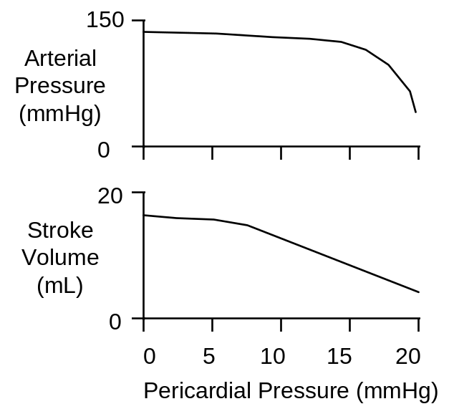

While transfusion will increase cardiac output in a normal subject, it has almost no effect on cardiac output when there has been a pericardial hemorrhage (Isaacs etal, 1954).

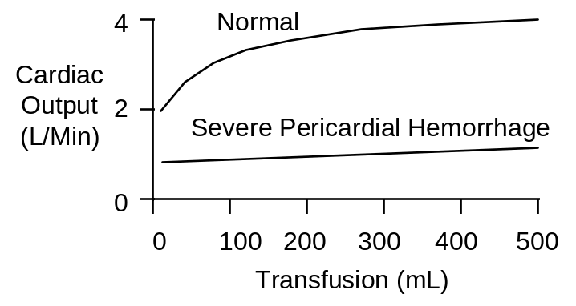

This would explain the patient’s lack of response to administered fluids.

References

Isaacs, J.P., E. Berglund and S.J. Sarnoff. Ventricular function. III. The pathologic physiology of acute cardiac tamponade studied by means of ventricular function curves. Amer. Heart J. 48:66-76, 1954.

Metcalfe, J., J.W. Woodbury, V. Richards and C.S. Burwell. Studies in experimental pericardial tamponade. Effects on intravascular pressures and cardiac output. Circulation 5:518-523, 1952.

Summers, R.L. Evidence-based medicine vs. scientific reasoning. Acad. Emer. Med. 3:183-184, 1996.

Carbon Monoxide Inhalation

Carbon monoxide binds to hemoglobin in competition with oxygen.

Hemoglobin's affinity for carbon monoxide is 230 times its affinity for oxygen (Allen & Root). Thus, low concentrations of carbon monoxide will displace normal concentrations of oxygen on the hemoglobin molecule. The normal delivery of oxygen to the tissues is disrupted and tissue hypoxia ensues.

Hemoglobin (Hgb) bound with carbon monoxide (CO) is carboxyhemoglobin (CO Hgb). The percentage of total Hgb that is CO Hgb is denoted as %CO Hgb.

John Haldane administered carbon monoxide to himself and then reported the consequences. His report gives an early but accurate account of CO poisoning (Haldane). Carboxyhemoglobin formation as a function of time is shown below for Haldane’s experiment VII, inhalation of 0.21% CO.

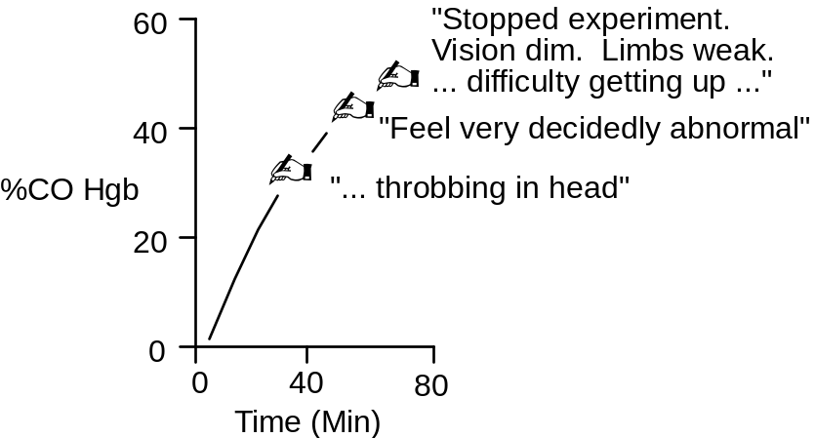
Inhaled carbon dioxide accumulates in the blood as a function of inhaled concentration and time of exposure (shown below, data from Petersen).

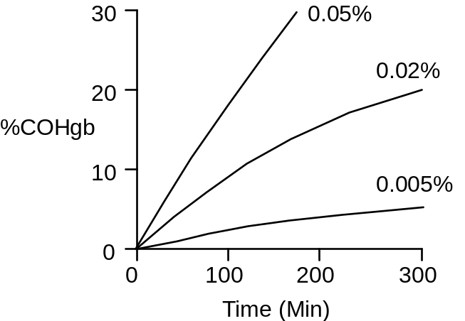

Early accumulation of inhaled CO in the blood can be described by the formula (Forbes)

%CO Hgb = 3 * Inhaled CO (%) * Time (Min)

Late accumulation is slower than early accumulation, as steady-state is approached. Signs of poisoning appear.

Optional The rate of carboxyhemoglobin formation during CO inhalation is highly dependent on the rate of alveolar ventilation. Design a protocol that quantitates CO uptake as a function of alveolar ventilation at one concentration of inhaled CO.

The Carbon Monoxide Inhalation Protocol

We will repeat Haldane’s experiment (described above) in this exercise.

Click Restart to reestablish initial conditions. Go to Carbon Monoxide. In the Gas Tanks box slide the CO PPM slidebar up to 2000. To convert parts per million to % concentration, multiply by 10⁻⁴. Click the gas tanks switch to on. Advance time and record data.

Pay particular attention to the effect of CO on O2 transport by the blood. Blood Volume has a bar graph that shows the status of QCP’s hemoglobin.

Carboxyhemoglobin (%)
Arterial pO2 (mmHg)
Arterial [O2] (mL/mL)
Venous pO2 (mmHg)
Venous [O2] (mL/mL)
Cardiac Output (mL/Min)

Time | 0  Min | 30  Min | 1  Hr | 2  Hr
%CO Hgb
Arterial pO2
Arterial [O2]
Venous pO2
Venous [O2]
Cardiac Output

Wrapup
Advance time an additional 1 or 2 hours to show that this CO concentration is fatal with continuing inhalation.

Elimination Of Inhaled CO
Once inhalation of CO is stopped, the gas is expired as slowly as it was previously inspired. Since, oxygen and CO are competitive at the hemoglobin molecule, inhaling oxygen at high concentration will displace the CO, thereby accelerating CO blow off (shown below, data from Pace, Petersen). This is a standard treatment for CO poisoning.

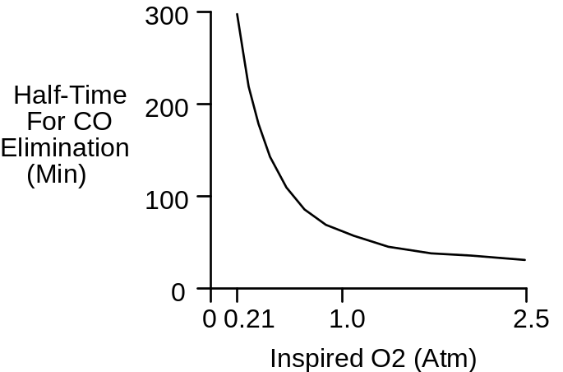

Design a protocol that first creates CO poisoning and then compares normal CO elimination after CO inhalation to the accelerating effect of oxygen administration.

References

Allen, T. A. and W. S. Root. Partition of carbon monoxide and oxygen between air and whole blood of rats, dogs and men as affected by plasma pH. J. Appl Physiol. 10:186-190, 1957.

Forbes, W. H., F. Sargent and F. J. W. Roughton. The rate of carbon monoxide uptake by normal men. Amer. J. Physiol. 143:594-608, 1945.

Haldane, J. S. The action of carbonic oxide in man. J. Physiol. 18:430-462, 1895.

Pace, N., E. Strajman and E. L. Walker. Acceleration of carbon monoxide elimination in man by high pressure oxygen. Science 111:652-654, 1950.

Petersen, J. E. and R. D. Steward. Absorption and elimination of carbon monoxide by inactive young men. Arch. Environ. Health 21:165-171, 1970.

Anemia

Red cell volume is below normal in anemia, as signaled by a decreased hematocrit.Anemia impairs oxygen delivery to the tissues due to the decreased oxygen carrying capacity of the blood. A main part of the homeostatic response is tissue vasodilation, which improves tissue oxygen delivery via increased cardiac output (shown below, data from Brannon).

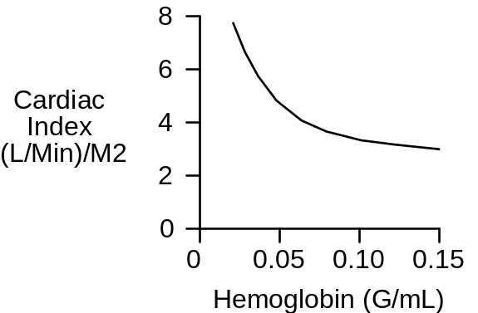
Blood viscosity is decreased in anemia, and this may be beneficial.

Erythropoietin production is stimulated in anemia that is caused by a non-erythropoietic defect in red cell production (shown below, data from Garcia).

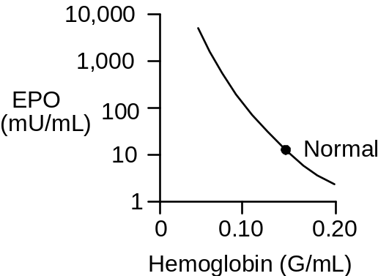

The Anemia Protocol

Click Restart to reestablish initial conditions and then record the control data. Go to Blood Volume. In the red cell production box, set the basic production rate to 0. Advance time and record data. Note the slow decline in red cell volume over time due to the long life span of redcells.

Red Cell Volume (mL)
Plasma Volume (mL)
Hematocrit (%)
Arterial [O2] (mL/mL)
Arterial pO2 (mmHg)
Venous [O2] (mL/mL)
Venous pO2 (mmHg)
Cardiac Output (mL/Min)

Time | 0  Min | 1  Month | 2  Months
Red Cell Volume
Plasma Volume
Hematocrit
Arterial [O2]
Arterial pO2
Venous [O2]
Venous pO2
Cardiac Output

Exercise Tolerance

Tolerance to exercise is decreased in acute and chronic anemia (shown below, data from Davies).

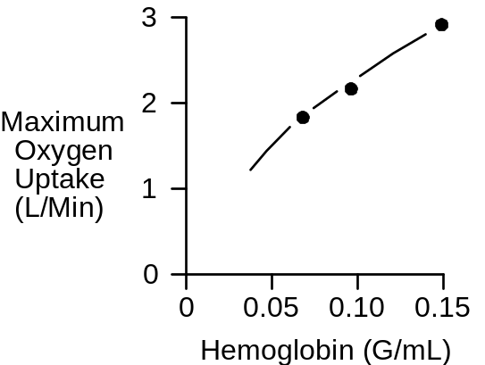

Use an exercise stress test to characterize QCP’s exercise tolerance in anemia.

Treadmill Speed (MPH)
Treadmill Grade (%)
Heart Rate (/Min)

Time | 0’ | 1’ | 2’ | 3’ | 4’ | 5’
Speed | 0 | 6 | 6 | 6 | 6 | 6
Grade | 0% | 0% | 2% | 4% | 6% | 8%
Heart Rate

Record the elapsed time and distance when this subject finally gives up.

Elapsed Time (Min)
Distance Traveled (Ft)

Wrapup

Return basic red cell production to its normal value of 0.014 mL/Min and follow the recovery of red cell volume. Note the role of EPO.

Blood Viscosity And Anemia

Blood viscosity is a function of hematocrit (shown below, data from Whittaker, Stone).

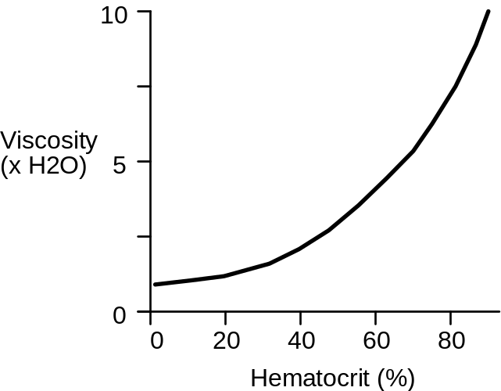

Follow changes in blood viscosity during the development of anemia at Conductance.

Click Restart to reestablish initial conditions and then record the control data. Again, go to Blood Volume and decrease basic red cell production rate to 0. Advance time and record data.

Hematocrit (%)
Blood Viscosity (x Normal)
Cardiac Output (mL/Min)

Time | 0  Min | 1  Month | 2  Months
Blood Viscosity
Hematocrit
Cardiac Output

Decreased blood viscosity in anemia has a beneficial effect on cardiac output. Return viscosity to normal using the fixed viscosity switch at Conductance and note the fall in cardiac output.

References

Brannon, E. S., A. J. Merrill, J. V. Warren and E. A. Stead, Jr. The cardiac output in patients with chronic anemia as measured by the technique of right atrial catheterization. J. Clin. Invest. 24:332-336, 1945.

Davies, C. T. M., A. C. Chukweumeka and J. P. M. vanHaaren. Iron-deficiency anaemia: Its effect on maximum aerobic power and responses to exercise in African males aged 17-40 years. Clin. Sci. 44:555-562, 1973.

Garcia, J. F., S. N. Ebbe, L. Hollander, H. O. Cutting, M. E. Miller and E. P. Cronkite. Radioimmunoassay of erythropoietin: Circulating levels in normal and polycythemic human beings. J. Lab. Clin. Med. 99:624-635, 1982.

Stone, H. O., H. K. Thompson, Jr. and K. Schmidt-Nielsen. Influence of erythrocytes on blood viscosity. Amer. J. Physiol. 214:913-918, 1968.

Whittaker, S. R. F. and F. R. Winton. The apparent viscosity of blood flowing in the isolated hindlimb of the dog, and its variation with corpuscular concentration. J. Physiol. 78:339-369, 1933.

Diabetes Insipidus

Antidiuretic hormone (ADH) normally conserves the body's water by concentrating the urine.

Inadequate ADH secretion, known as diabetes insipidus, may occur when the brain is traumatized.Diabetes insipidus is characterized by excretion of large amounts of dilute urine (shown below, data from Valtin).

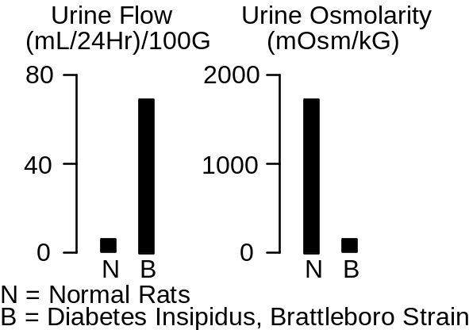
Plasma osmolarity and thirst are both increased in diabetes insipidus (shown below, data from Valtin).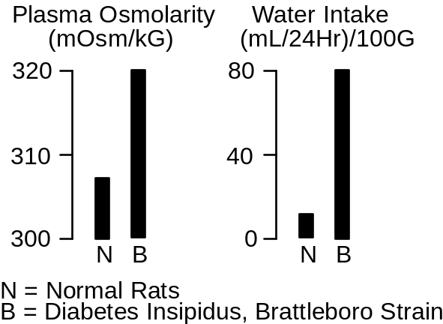

A popular experimental model of diabetes insipidus is a strain of rats, called the Brattleboro strain, which was created upon the chance discovery of a litter of rats with inherited or familial diabetes insipidus (Valtin & Schroeder).

The Diabetes Insipidus Protocol

Click Restart to reestablish initial conditions and then record the control data. Go to Antidiuretic Hormone. Set the secretion basic fraction to 0. Advance the solution and record data. Note the rapid decrease in plasma [ADH].

Plasma [ADH] (pG/mL)
Plasma [Osmolarity] (mOsm/L)
Water Intake (mL/Min)
Extracellular Fluid Volume (L)
Urine Flow (mL/Min)
Urine [Osmolarity] (mOsm/L)

Time | 0  Min | 10  Min | 1  Day | 1  Week
Plasma [ADH]
Plasma [Osm]
H2O Intake
ECFV
Urine Flow
Urine [Osm]

What are the initial and final water intakes in L/Day?

References

Valtin, H. and H. A. Schroeder. Familial hypothalamic diabetes insipidus in rats (Brattleboro strain). Amer. J. Physiol. 206:425-430, 1964.

Pneumothorax

Inspiration moves the ribcage out and the diaphragm down, creating a negative pressure in the pleural space. This negative pressure pulls at and inflates the lungs.

If air is allowed to enter the pleural space from the lung or through the ribcage during inspiration, the lung does not inflate. This is pneumothorax.

Bilateral pneumothorax is quickly fatal if not attended to immediately. Unilateral pneumothorax is more interesting physiologically and is the topic of this exercise.

Unilateral pneumothorax has three main components.

The negative pleural pressure is lost on the ipsilateral side. This pressure tends to hold open the pulmonary blood vessels and when it is lost the pulmonary vascular resistance increases and cardiac output decreases (Ann. Thoracic Surg., 1993).

The loss of negative pleural pressure and increased pulmonary vascular resistance on the ipsilateral side reroutes some pulmonary blood flow the contralateral side where relatively normal lung inflation continues (Carvalho, et.al., 1996). This is beneficial.

Thirdly, pulmonary blood flowing though the ipsilateral side is not oxygenated due to the absence of lung inflation. This constitutes a massive right-to-left pulmonary shunt (Rutherford, 1968). Severe arterial hypoxia is the immediate result.

You can view these consequences of pneumothorax in the exercise that follows.

Before undertaking the exercise, recall that arterial hypoxia stimulates ventilation. Will this be beneficial? Would administering 100% O2 help? What will be the body’s long-term response to this condition?

The Pneumothorax Protocol

Click Restart to reestablish initial conditions and then record control values.

Go to Thorax and click open the right hemithorax. Record the acute hemodynamic effects of this stenosis. Advance time and record data. Look for evidence of compensation.

Cardiac Output (mL/Min)
Stroke Volume (mL)
Heart Rate (Beats/Min
Arterial pO2 (mmHg)
Blood Volume (mL)
Total Ventilation (L/Min)
Ventilation Rate (/Min)
Tidal Volume (mL)
Right Lung Inflation (x Normal)
Left Lung Inflation (x Normal)
Respiratory Drive (x Normal)

Time | Control | Acute | 1 Week
Cardiac Output
Heart Rate
Stroke Volume
Arterial pO2
Blood Volume
Total Ventilation
Ventilation Rate
Tidal Volume
Right Inflation
Left Inflation
Respiratory Drive

References

Carvalho, P., J. Hilderbrandt and N.B. Charan. Changes in bronchial and pulmonary artery blood flow with progressive tension pneumothorax. J. Appl. Physiol. 81:1664, 1996.

Ann. Thoracic Surg. 55:1379, 1993.

Rutherford. J. Trauma 8:212, 1968.

Cardiac Arrest

Cardiac arrest stops oxygen delivery to the tissues. Any remaining metabolism in anaerobic. Organ failure is rapid.

Ventilation and sympathetic nerve activity are temporarily stimulated, but this is of little value.

In this exercise, we’ll use ventricular fibrillation to create cardiac arrest.

The Cardiac Arrest Protocol

Click Restart to reestablish initial conditions and then record control values.

Go to Ventricles and click the fibrillate now button. Record the acute hemodynamic effects of loss of ventilation. Advance time and record data.

Blood Pressure (mmHg)
Cardiac Output (mL/Min)
Total Ventilation (L/Min)
Sympathetic Ganglia Firing (Hz)

Time | Control | 30 Sec | 1 Min
Blood Pressure
Cardiac Output
Ventilation
Symp Activity

You can go to Structure / Function to monitor changes in organ function with time. Charts shows neurological signs.

Go to Misc. Treatments to attempt defibrillation. See the exercise Cardiopulmonary Resuscitation for more on this.

References

None at this time.

Asphyxia

Asphyxia occurs when ventilation stops. Oxygen delivery to the tissues subsequently stops and the remaining metabolism in anaerobic. Organ failure is rapid.

Asphyxia can be caused by loss of respiratory drive, airway obstruction, or inhalation of inadequately oxygenated air.

You can trace the timecourse of organ failure in asphyxia in this exercise.

The Asphyxia Protocol

Click Restart to reestablish initial conditions and then record control values.

Go to Ventilation and reduce central and peripheral respiratory drive to 0. Record the acute hemodynamic effects of loss of ventilation. Advance time and record data.

Blood Pressure (mmHg)
Cardiac Output (mL/Min)
Heart Rate (Beats/Min)
Stroke Volume (mL)
Arterial pO2 (mmHg)
Blood pH

Time | Control | 30 Sec | 1 Min | 5 Min
Blood Pressure
Cardiac Output
Heart Rate
Stroke Volume
Arterial pO2
Blood pH

You can go to Structure / Function to monitor changes in organ function with time. Charts shows neurological signs.

Note that the early problem is re-establishing adequate oxygen delivery, while a later problem is re-establishing a heartbeat. See the exercise Cardiopulmonary Resuscitation for more on this.

References

None at this time.

Cardiopulmonary Resuscitation

Cardiopulmonary resuscitation creates ventilation and cardiac output in an attempt to maintain the myocardium until defibrillation can be attempted.

External cardiac compression is often the only means available for producing cardiac output, but it is not particularly effective.

Chances of re-establishing a normal heartbeat depend on the coronary blood flow created during CPR (Ann. Emer. Med., 1984).

Coronary Blood Flow (mL/Min/G) | Outcome
0.1 | Can’t Revive
0.3 | Hard To Revive
0.5 | Easy To Revive

Repeated injection of large doses of epinephrine may raise arterial pressure, thus improving coronary blood flow (Crit. Care Med., 1993).

Protocol | Coronary Perfusion Pressure (mmHg)
No Epinephrine | 15
Epi (0.02 mG/kG) | 20
Epi (0.2 mG/kG) | 35

In this exercise, we’ll produce cardiac arrest by fibrillating the heart. CPR will then be started and the hemodynamic details can be observed. Defibrillation will be attempted at 10 minutes.

The Cardiopulmonary Resuscitation Protocol

Click Restart to reestablish initial conditions and then record control values.

Go to Ventricles and click the fibrillate now button. Note that the heart is no longer pumping blood. Then go to Misc. Treatments and set the CPR switch to on. Record the acute hemodynamic effects of cardiac arrest plus CPR. Advance time and record data.

Blood Pressure (mmHg)
Cardiac Output (mL/Min)
Heart Rate (Beats/Min)
Stroke Volume (mL)
Left Heart (Coronary) Blood Flow (mL/Min)
Arterial pO2 (mmHg)
Blood pH
Blood [Lactate-] (mEq/L)
Total Ventilation (L/Min)
Sympathetic Ganglia Firing (Hz)

Time | Control | 30 Sec | 1 Min | 10 Min
Blood Pressure
Cardiac Output
Heart Rate
Stroke Volume
Coronary Flow
Arterial pO2
Blood pH
Blood [Lac-]
Ventilation
Symp Activity

You can go to Structure / Function to monitor changes in organ function with time. Charts shows neurological signs.

After 10 minutes, go to Misc. Treatments to attempt defibrillation.

The probability of successful defibrillation decreases 5% with each passing minute of CPR.

Design a strategy for re-establishing a normal heartbeat after 20 minutes of CPR.

Design a strategy for re-establishing a normal heartbeat after 10 minutes of cardiac arrest with no life support followed by a period of 10 minutes of CPR.

References

Ann. Emer. Med. 13:79, 1984.

Crit. Care Med. 21:413, 1993.

Introduction To Acid / Base

Pure derangements in acid / base balance can be produced in the laboratory by directly altering the blood’s ionic and carbon dioxide content.

Clinically, derangements in acid / base balance are usually complications resulting from one or more underlying disease processes. A primary treatment goal is to diagnose and treat the underlying disease.

But in addition, acid / base disturbances can proceed to a severe acidosis or alkalosis that is damaging in its own right and potentially fatal. Thus, accurate evaluation of acid / base status is an important clinical objective.

This exercise tests your diagnostic skills by presenting 5 patients who may or may not have derangements in acid / base balance.

In each case, load the patient, go to , take the necessary blood samples, and answer the questions regarding the patent’s acid / base status based on the blood chemistry.

If you are not familiar with the process of loading patients, refer to the chapter Patients in QCP’s User’s Guide.

Evaluating Acid / Base Status

This is a brief review of what to look for in evaluating acid / base balance. Refer to your textbook for additional information.

Blood pH Examine the pH to see if it is greater than or less than normal. Remember that in certain circumstances, serious derangements in acid / base balances are accompanied by rather small changes in blood pH.

Blood H+ concentration, in nMol/L, is an alternative to pH. [H+] and pH supply exactly the same information.

pH = -log ([H+]) with H+ in Mol/L

Blood pCO2. Examine blood pCO2 to see if it is greater than or less than normal. The partial pressure of CO2 in the blood has a significant affect on blood pH and also respiration rate. Changes may be either primary (and causal) or secondary (and compensatory).

Anion Gap. Look for an abnormal blood anion gap. The anion gap is defined as the blood’s sodium concentration minus the chloride concentration minus the bicarbonate concentration.

Anion Gap = [Na+] – [Cl-] – [HCO3-]

With sodium being the blood’s chief cation and chloride and bicarbonate being the blood’s chief anions, the anion gap represents additional unmeasured anions in the blood. If the gap increases, it signals the presence in the blood of additional, unseen anions. Lactate and ketoacids are prime suspects.

Normal Values

Before loading and analyzing the patients, go to , take the necessary blood samples, and record normal values for venous blood.

pH
[H+] (nMol/L)
pCO2 (mmHg)
[HCO3-] (mEq/L)
Anion Gap (mEq/L)

Patient Acid_1

pH
[H+] (nMol/L)
pCO2 (mmHg)
[HCO3-] (mEq/L)
Anion Gap (mEq/L)

Primary Disturbance | Compensation
Normal | None
Respiratory Acidosis | Respiratory
Respiratory Alkalosis | Metabolic
Metabolic Acidosis
Metabolic Alkalosis

The most likely explanation is

Patient Acid_2

pH
[H+] (nMol/L)
pCO2 (mmHg)
[HCO3-] (mEq/L)
Anion Gap (mEq/L)

Primary Disturbance | Compensation
Normal | None
Respiratory Acidosis | Respiratory
Respiratory Alkalosis | Metabolic
Metabolic Acidosis
Metabolic Alkalosis

The most likely explanation is

Patient Acid_3

pH
[H+] (nMol/L)
pCO2 (mmHg)
[HCO3-] (mEq/L)
Anion Gap (mEq/L)

Primary Disturbance | Compensation
Normal | None
Respiratory Acidosis | Respiratory
Respiratory Alkalosis | Metabolic
Metabolic Acidosis
Metabolic Alkalosis

The most likely explanation is

Patient Acid_4

pH
[H+] (nMol/L)
pCO2 (mmHg)
[HCO3-] (mEq/L)
Anion Gap (mEq/L)

Primary Disturbance | Compensation
Normal | None
Respiratory Acidosis | Respiratory
Respiratory Alkalosis | Metabolic
Metabolic Acidosis
Metabolic Alkalosis

The most likely explanation is

Patient Acid_5

pH
[H+] (nMol/L)
pCO2 (mmHg)
[HCO3-] (mEq/L)
Anion Gap (mEq/L)

Primary Disturbance | Compensation
Normal | None
Respiratory Acidosis | Respiratory
Respiratory Alkalosis | Metabolic
Metabolic Acidosis
Metabolic Alkalosis

The most likely explanation is

Sodium Bicarbonate

Intuitively, sodium bicarbonate would seem to be an ideal agent for treating acidosis. But there are some surprises.

The Na+ in NaHCO3 is beneficial since it increases the plasma Na+ concentration which increases the strong ion difference, increasing pH.

The HCO3- in NaHCO3 is potentially a big problem since it can be the source of large amounts of CO2 according to

[H+] + [HCO3-] ←→ CO2 + H2O

If NaHCO3 is added to a closed system, the beneficial effects of Na+ are offset by the CO2 generated and the pH doesn’t change much (2).

While a closed system may seem far removed from the clinical management of acid / base disorders, I cite 2 examples to the contrary. Both involve impaired respiratory elimination of CO2, making the body a good approximation to a closed system.

Any disorder that impedes the respiratory elimination of CO2 will probably cause respiratory acidosis and blunt the therapeutic effect of sodium bicarbonate by impeding the elimination of the newly generated CO2. Respiratory distress syndrome in newborn infants is an example.

In another example, a patient in cardiac arrest was intubated for ventilation, given cardiac massage, and given an IV injection of NaHCO3 (3). Unfortunately, the endotracheal tube was placed in the esophagus, effectively making the patient a closed system. Arterial pCO2 was 194 mmHg before the NaHCO3 injection and rose to 280 mmHg after it.

The effectiveness of NaHCO3 injection depends on a venous injection site and adequate ventilation to quickly eliminate some of the newly generated CO2. Still, some of this CO2 passes through the pulmonary circuit into the systemic arteries (1,3). This CO2 will decrease the pH in brain (4) which is not the desired outcome when acidosis is being treated.

On the positive side, lower cerebral pH stimulates respiration and this helps to blow off the extra CO2. The overall respiratory response, then, is an early increase in ventilation caused by CO2 followed by a later depression of respiration caused by the alkalosis (1).

The Sodium Bicarbonate Protocol

We can see the effects described above by giving a rapid IV NaHCO3 infusion to a normal subject.

Click Restart to reestablish initial conditions. Record control values. Go to IV Drip. Create an IV drip that delivers 500 mMol of NaHCO3 over 10 minutes. Advance time 5, 10, 15 and 20 minutes and observe the effect of the infusion on acid / base balance, respiration and brain pH.

Venous pH
Venous pCO2 (mmHg)
Arterial pH
Arterial pCO2 (mmHg)
Brain pH
Total Ventilation (L/Min)

Time (Min) | 0 | 5 | 10 | 15 | 20

Venous pH
Venous pCO2
Arterial pH
Arterial pCO2
Brain pH
Ventilation

References

- J. Clin. Invest. 35:245, 1956.
- J. Pediatric. 80:671, 1972.
- J.A.M.A. 235:506, 1976.
- Am. J. Physiol. 25:H1316, 1989.

Ketoacidosis

The brain generally uses glucose as its exclusive fuel. Fatty acids are not an option since they don’t cross the blood-brain barrier.

When dietary glucose is not available, glucose stored in the liver as glycogen is released and used by the brain. Hepatic glycogen storage is limited, however, so this is not a long-term option. See the laboratory exercise titled Starvation.

There is a long-term option available for brain fuel in ketoacids. The liver normally synthesizes small amounts of ketoacids from fatty acid, but synthesis is increased markedly when glucose is scarce and fatty acid is abundant.

The kidney filters ketoacids and then avidly reabsorbs them, treating them like the precious fuel that they are.

Untreated diabetics (Type I) typically have low insulin levels and high glucagon levels. Ketoacid synthesis is stimulated by glucagon, so these untreated diabetics may be synthesizing large amounts of ketoacids.

Ketoacids are a very useful part of metabolism when hepatic production is balanced by peripheral consumption. Problems develop when production exceeds consumption.

In this exercise, we’ll follow the onset of ketoacidosis caused by deficient insulin.

The Ketoacidosis Protocol

Click Restart to reestablish initial conditions and then record control values.

Go to Beta Cells and decrease fractional insulin secretion to 0. Advance time and note the changes in ketoacid balance and acid / base balance. Identify respiratory compensations.

pH
Strong Ion Difference (mEq/L)
Anion Gap (mEq/L)
[Ketoacids] (mG/dL)
pCO2 (mmHg)
Hepatic KA Synthesis (mG/Min)
Brain KA Use (mG/Min)
Renal KA Excretion (mG/Min)
Respiratory Drive (x Normal)
Total Ventilation (L/Min)

To convert ketoacids in mG/dL to mEq/L, multiply by 0.1.

Time | Control | 1 Day | 1 Week
pH
SID
Anion Gap
[KA]
PCO2
KA Made
KA Brain Use
KA Excretion
Resp. Drive
Ventilation

Severe Ketoacidosis

Ketoacid synthesis is not well controlled in the normal physiological sense. Any increase in synthesis and / or decrease in disposal beyond that seen above at 1 week can cause a potentially fatal acidosis.

Increased synthesis might be caused by additional glucagon secretion. Decreased disposal might be caused by coma decreasing brain ketoacid metabolism or renal dysfunction causing decreased renal ketoacid secretion.

Design a protocol that leads to fatal ketoacidosis.

Mitral Stenosis

The 4 valves of the heart are normally very efficient, providing almost no resistance to forward flow when open and nearly infinite resistance to backflow when closed.

Valves that fail to open properly can create a significant impediment to forward flow. This is called stenosis.

Valves that fail to close properly provide less than infinite resistance to backflow. This backflow is called regurgitation.

In this exercise, we’ll investigate the hemodynamic consequences of stenosis of the mitral valve.

The Mitral Stenosis Protocol

Click Restart to reestablish initial conditions and then record control values.

Go to Valves and reduce the open area of the mitral valve to 0.8 mM^2. Record the acute hemodynamic effects of this stenosis. Advance time and record data. Look for evidence of compensation.

Cardiac Output (mL/Min)
Pulm. Artery Pressure (mmHg)
Pulm. Capillary Pressure (mmHg)
Pulm. Vein Pressure (mmHg)
Left Atrial Pressure (mmHg)
Plasma Colloid Pressure (mmHg)
Arterial pO2 (mmHg)
Blood Volume (mL)
Excess Lung H2O (mL)

Time | Control | Acute | 1 Week
Cardiac Output
Pulm. Artery Pressure
Pulm. Caps Pressure
Pulm. Vein Pressure
Left Atrial Pressure
Plasma COP
Arterial pO2
Blood Volume
Excess Lung H2O

Pulmonary Edema

Normally, the plasma colloid pressure is considerably greater than the pulmonary capillary pressure. Note the control data above. This creates a negative filtration pressure in the pulmonary capillaries and keeps the lungs dry.

Mitral stenosis increases the pulmonary capillary pressure and erodes the pressure gradient. In severe mitral stenosis, the pressure gradient can swing to a positive value (Finlayson, et.al., 1961). A life threatening pulmonary edema will result.
Click Restart to reestablish initial conditions and then record control values.

Go to Valves and reduce the open area of the mitral valve to 0.6 mM^2. Record the acute hemodynamic effects of this stenosis. Attempt to advance time for a week, but stop and record data if QCP’s condition deteriorates.

Time | Control | Acute | 1 Week
Cardiac Output
Pulm. Artery Pressure
Pulm. Caps Pressure
Pulm. Vein Pressure
Left Atrial Pressure
Plasma COP
Arterial pO2
Blood Volume
Excess Lung H2O

Physical exertion increases the likelihood that a patient with mitral stenosis will develop pulmonary edema. Why?

References

Finlayson, J. K., M. N. Luria, C. A. Stanfield, & P. N. Yu. Hemodynamic studies in acute pulmonary edema. Ann Int Med. 54:244-253, 1961.
Aortic Regurgitation

The 4 valves of the heart are normally very efficient, providing almost no resistance to forward flow when open and nearly infinite resistance to backflow when closed.

Valves that fail to open properly can create a significant impediment to forward flow. This is called stenosis.

Valves that fail to close properly provide less than infinite resistance to backflow. This backflow is called regurgitation.

In this exercise, we’ll investigate the hemodynamic consequences of aortic valve regurgitation.

The Aortic Regurgitation Protocol

Click Restart to reestablish initial conditions and then record control values.

Go to Left Heart Valves and increase the closed area of the aortic valve to 0.12 mM^2. Record the acute hemodynamic effects of this stenosis. Advance time and record data. Look for evidence of compensation.

Cardiac Output (mL/Min)
Pulm. Artery Pressure (mmHg)
Pulm. Capillary Pressure (mmHg)
Pulm. Vein Pressure (mmHg)
Left Atrial Pressure (mmHg)
Plasma Colloid Pressure (mmHg)
Arterial pO2 (mmHg)
Blood Volume (mL)
Excess Lung H2O (mL)

Time | Control | Acute | 1 Week
Cardiac Output
Pulm. Artery Pressure
Pulm. Caps Pressure
Pulm. Vein Pressure
Left Atrial Pressure
Plasma COP
Arterial pO2
Blood Volume
Excess Lung H2O

Pulmonary Edema

Normally, the plasma colloid pressure is considerably greater than the pulmonary capillary pressure. Note the control data above. This creates a negative filtration pressure in the pulmonary capillaries and keeps the lungs dry.

Aortic regurgitation can interfere with left heart diastolic filling, increasing pressures in the pulmonary circulation. Pulmonary edema can develop.

Click Restart to reestablish initial conditions and then record control values.

Go to Left Heart Valves and increase the closed area of the aortic valve to 0.14 mM^2. Attempt to advance time for a week, but stop and record data if QCP’s condition deteriorates.

Time | Control | Acute | 1 Week
Cardiac Output
Pulm. Artery Pressure
Pulm. Caps Pressure
Pulm. Vein Pressure
Left Atrial Pressure
Plasma COP
Arterial pO2
Blood Volume
Excess Lung H2O

What effect does aortic regurgitation have on tolerance to exercise?

Osmolarity

References below to Guyton and Hall, Textbook of Medical Physiology, 9th Edition, 1996 are denoted as G&H.

The osmolarity of body fluids is an important part of many physiological responses.

Water can move freely between the intracellular and extracellular spaces and between the plasma and interstitium. Thus, the osmolarities of plasma, interstitial fluid, and intracellular fluid are nearly identical. See G & H, chapter25. In this exercise this osmolarity will be called the osmolarity of body fluids.

The scenario is that Billy Bob is going hiking. It is a very hot day and Billy Bob forgot his water bottle. But he’s going ahead anyway.

We created Billy Bob by changing several relevant parameters – see Appendix. These conditions were then saved in an initial conditions file named BILLYBOB.ICS using the main menu File / Save Initial Conditions menu selection.

You can reload Billy Bob now using the main menu File / Load Initial Conditions menu selection, specifying the file named BILLYBOB.ICS.

There are three main objectives in this exercise.

Observe water loss from the body’s various compartments during exertion in heat. Look for changes in water distribution.

Observe sodium loss from the body during exertion in heat. Devise a strategy for replacing the lost sodium.

Observe osmolarity changes during exertion in heat. Calculate the resultant volume changes in a red blood cell in plasma. Calculate volume changes in a red blood cell as it travels into the renal medulla, where osmolarity is quite high.

A  in a table row below indicates that calculation is required.

Water Loss During Exertion In Heat

Exertion in heat raises the body temperature. This triggers sweating and the sweating moves water from the body to the environment. Sweating triggers thirst and we drink water to replace the lost amount. In this case, however, water intake has been restricted so we can specifically track water loss.

Click Restart to establish Billy Bob’s initial conditions. Use the Go main menu selection to advance time. Record volumes at control (0 hours) and at 1, 2 and 3 hours of hiking.

- Panel shows volumes.
Sweat – Panel shows sweating, FYI.

Note: Billy Bob will probably get worn out before 3 hours. He will stop exercising and the following page will be displayed.

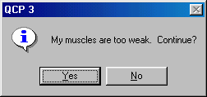

What a wimp. Click Yes to continue on to 3 hours.

 | Control | 1 Hr | 2 Hrs | 3 Hrs
Total Body Water (L)
 Cumulative Water Loss In Sweat (L) | 0
Plasma Volume (L)
Interstitial Volume (L)
Cell Water (L)

The compartment of body water that is the major source of the water for sweat is

The compartment of body water that is least changed by sweat is

Why?

Sodium Loss During Exertion In Heat

Sweating not only moves water from the body to the environment, but sodium, potassium and chloride as well. Track sodium loss in this exercise.

Click Restart to again establish Billy Bob’s initial conditions. Use the Go main menu selection to advance time. Record data at control (0 hours) and at 1, 2 and 3 hours of hiking.

Na+ - Panel shows extracellular Na+.

 | Control | 1 Hr | 2 Hrs | 3 Hrs
Extracellular Na+ Conc (mEq/L)
Extracellular Na+ Mass (mEq)
 Cumulative Na+ Loss (mEq) | 0
 Cumulative NaCl Loss (G)
 Volume (mL) Of Normal Saline Needed To Replace NaCl Loss

In Row 4 above, convert the Na+ loss in mEq to NaCl loss in G. The molecular weight of NaCl is 58.5 or 58.5 G/Mol.

In Row 5 above, calculate the volume of normal saline that must be given to replace the lost NaCl. Normal saline is 0.9% or 0.9 G/100 mL.

Is the volume of normal saline calculated above also sufficient to replace the water lost?

Why?

Osmolarity And Cell Volume

Loss of both water and sodium can change the osmolarity of body fluids.

In this part, we’ll track changes in plasma osmolarity during exertion in the heat.

We will also look at osmolarity in the renal medulla. This osmolarity is normally high (see G&H, chapter 28) and it goes even higher when the kidney is creating concentrated urine.

Click Restart to establish Billy Bob’s initial conditions. Use the Go main menu selection to advance time. Record volumes at control (0 hours) and at 1, 2 and 3 hours of hiking.

In this part, we’ll be looking at some additional panels. Use the View main menu selection to put buttons on the toolbar for Organ Details and Nephron Details. Visible groups of toolbar buttons are checked on the View menu.

… - Organ Details buttons.
– Nephron Details button.

Osmolarity - Panel shows whole-body (plasma) osmolarity.
Circulation – Panel shows renal blood flow.
Medulla / Vasa Recta – Panel shows vasa recta blood flow and renal medullary osmolarity.

 | Control | 1 Hr | 2 Hrs | 3 Hrs
Osmolarity, Plasma (mOsm/L)
Osmolarity, Renal Medulla (mOsm/L)
 Red Cell Volume,  Plasma (femtoL) | 90
 Red Cell Volume,
Medulla (femtoL)
Renal Blood Flow (mL/Min)
Vasa Recta Blood Outflow (mL/Min)

In Row 3 above, calculate the volume of a red cell in the plasma as osmolarity changes. Assume a red cell’s volume at normal plasma osmolarity is 90 femtoL. One femto liter is 10⁻¹⁵ L. In these calculations, assume the osmoles in the red cell remain constant.

In Row 4 above, calculate the volume of a red cell in the renal vasa recta as medullary osmolarity changes.

Identify the factors in this situation that will promote red cell sickling, particularly in the renal medulla.

Appendix – Creating Billy Bob

Billy Bob was created as follows:

A hot day was created by increasing ambient temperature to 100 deg. F.

Physical exertion was created by setting the treadmill speed to 2 MPH. Treadmill exercise type was selected. Wind was set at 2 MPH.
Water restriction was created by setting water intake to fixed amount. Intake was then decreased to zero.

These setting were then save in the initial conditions file named BILLYBOB.ICS.

Nephrotic Syndrome

Nephrotic syndrome is characterized by

Loss of protein in the urine.

Depletion of vascular and extravascular protein.

Loss of water across capillary walls to form interstitial edema.

Renal retention of large amounts of salt and water used in creating the edema.

A primary cause of nephrotic syndrome is increased permeability to plasma protein, namely albumin, at the glomerular membrane.

Protein loss leads to decreased protein concentration in the plasma and, consequently, decreased plasma colloid osmotic pressure. This alters the Starling forces at the systemic and pulmonary capillaries to increase ultrafiltration. We would also expect decreased colloid pressure to increase glomerular filtration, enhancing sodium excretion. This last response is not observed, leading to the notion that nephrotic syndrome has at least two importance causal components, both involving the glomerular membrane.

Increased protein permeability at the glomerular membrane.

Decreased filtration coefficient at the glomerular membrane.

We'll investigate both of these defects in this laboratory exercise, first separately and then combined.

Note that increased sodium reabsorption in the distal tubule and/or collecting has also been implicated in nephrotic syndrome; this possibility will not be explored in this exercise.

Use the View main menu selection to place the Nephron Details button on the toolbar.

Protein Loss

Click Restart to establish initial conditions.

Go to the Glomerular Filtrate box in the Glomerulus panel and slide protein permeability up from none to severe. Go to Urine to observe urinary protein loss. Advance the solution 1 week.

Physical units for urinary protein loss are G/Min. Calculate daily loss.

______ G/Min x 1440 = _______ G/Day

Go to Circulating Protein and note the changes in vascular and interstitial protein.

Plasma Protein | Normal | Now
Mass (G) | 208
Concentration (G/dL) | 6.9
Colloid Pressure (mmHg) | 28

Interstitial Protein | Normal | Now
Mass (G) | 235
Concentration (G/dL) | 2.0
Colloid Pressure (mmHg) | 7

Go to Interstitium and note the distribution and movement of extravascular water.

 | Normal | Now
Plasma Volume (L) | 3.0
Interstitial Volume (L) | 12.0
Capillary Filtrate (mL/Min) | 1.4
Lymph Flow (mL/Min) | 1.0

Go to Glomerulus and note the change in glomerular filtration rate that helped to prevent edema formation.

In summary, protein loss has caused some important changes in the body fluids, but it didn't cause significant edema. Keep in mind that rapid edema formation requires a lot of salt and water retention.

Note that extreme protein loss is fatal. What do think will be the cause of death?

Sodium Retention

Click Restart again to establish initial conditions.

Go to the GFR Determinants box in the Glomerulus panel and slide permeability down from 20 to 4. Notice the immediate effect on glomerular filtration rate. Go to Urine to observe urinary sodium excretion. Advance the solution 1 week.

Go to Interstitium and note the distribution and movement of extravascular water.

 | Normal | Now
Plasma Volume (L) | 3.0
Interstitial Volume (L) | 12.0
Capillary Filtrate (mL/Min) | 1.4
Lymph Flow (mL/Min) | 1.0

Go to Na+ and note the change in extracellular sodium mass. Sodium balance has been reestablished after a modest increase in extracellular sodium.

Extracellular Sodium | Normal | Now
Mass (G) | 2170

Over this week, several mechanisms were quietly working to offset the decrease in glomerular membrane permeability. Check on

Arterial pressure at Pressure
Glomerular pressure at Glomerulus
Plasma renin activity at Angiotensin
Atrial natriuretic peptide at Atrial Natriuretic Peptide
Aldosterone at Aldosterone
Renal nerve activity at Autonomic Efferents

 | Normal | Now
Arterial Pressure (mmHg) | 97
Glomerular Pressure (mmHg) | 60
Plasma Renin Activity | 2.0
Atrial Natriuretic Peptide (Art) | 26
Aldosterone | 300
Renal Nerve Activity | 1.5

Nephrotic Syndrome

We will now combine protein loss with sodium retention to create a model of nephrotic syndrome.

Click Restart again to establish initial conditions.

Go to the Glomerular Filtrate box in the Glomerulus panel and slide protein permeability up from none to severe. Then slide glomerular membrane permeability down from 20 to 4 in the GFR Determinants box. Go to Urine to observe urinary sodium excretion and protein loss. Advance the solution 1 month to capture the full effect.

Go to Circulating Protein and note the changes in vascular and interstitial protein.

Plasma Protein | Normal | Now
Mass (G) | 208
Concentration (G/dL) | 6.9
Colloid Pressure (mmHg) | 28

Interstitial Protein | Normal | Now
Mass (G) | 235
Concentration (G/dL) | 2.0
Colloid Pressure (mmHg) | 7

Go to Interstitium and note the distribution and movement of extravascular water.

 | Normal | Now
Plasma Volume (L) | 3.0
Interstitial Volume (L) | 12.0
Capillary Filtrate (mL/Min) | 1.4
Lymph Flow (mL/Min) | 1.0

Go to Na+ and note the change in extracellular sodium mass. Again, sodium balance has been reestablished

Extracellular Sodium | Normal | Now
Mass (G) | 2170

Wrap up by revisiting the determinants of sodium excretion explored in the previous section.

 | Normal | Now
Arterial Pressure (mmHg) | 97
Glomerular Pressure (mmHg) | 60
Plasma Renin Activity | 2.0
Atrial Natriuretic Peptide (Art) | 26
Aldosterone | 300
Renal Nerve Activity | 1.5

In summary, the nephrotic syndrome can show a variety of clinical faces, but the most typical elements are

Protein loss by the kidney that lowers plasma colloid osmotic pressure and allows loss of salt and water into the interstitium.

Renal salt and water retention to furnish the interstitial edema fluid.

References

Palmer, B.F. and R.J. Alpern. Pathogenesis of edema formation in the nephrotic syndrome. Kidney Int. Suppl. 59:S21-S27, 1997.
Clinical Exercises

A patient initially presents as a data set frozen in time -- a quantitative snapshot. There are two lines of inquiry that are often informative:

- What physiological and pathophysiological events helped to define the patient's current status? How much time did it take?

- How should we proceed from here?

Seeing A Patient

Patients are simulations that begin with a set of unusual initial conditions. To see a patient, click on the File main menu selection and then click on Load Initial Conditions. A dialog box will list available patients as file names with an ICS extension, such as MR_SMITH.ICS. Select a patient, the patient’s data will be loaded, and the simulation can be undertaken.
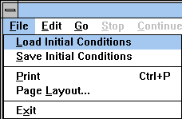

Initially, the toolbar may only show buttons that are relevant to clinical medicine. You may be able to add additional buttons to the toolbar using the View main menu selection. If the View main menu selection is grayed out, you’re stuck with the initial lineup of toolbar buttons.
A brief patient history is presented in the upper left-hand corner of the Charts panel.

Returning To Normal

Mr. Norm Subject represents a normal subject. When a patient is loaded, the patient’s initial conditions replace Norm’s initial conditions and the patient history section of the Charts panel is updated.

After a patient is loaded, the Restart main menu selection starts the solution again using the patient’s initial conditions.

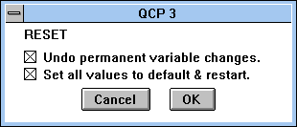

To re-establish Norm Subject’s initial conditions, click Options / Reset... The default checks are correct. Click OK. If successful, Norm’s thumbnail sketch will reappear on the Charts panel.

Norm Subject is your source for normal numerical values.

Mr. Johnson

Load Mr. Johnson (Mr Johnson.ICS) using the File | Load Initial Conditions main menu selection.

Is Mr. Johnson OK? Actually, the thumbnail sketch on the Charts panel suggests that he is not OK. He has a lot to complain about including lower body swelling and dyspnea.

To get a rough idea of Mr. Johnson’s condition, advance the solution 1 day at a time for a couple of days. Check Mr. Johnson’s blood pressure, heart rate, temperature and respiration using the Monitor panel.

Variable | Day 1 | Day 2 | Day 3
Systolic Blood Pressure (mmHg)
Diastolic Blood Pressure (mmHg)
Heart Rate (/Min)
Temperature
(deg F)
Respiration Rate
(/Min)

Click main menu selection Restart to restart the solution.

Attend to Mr. Johnson. Be prepared to discuss the following points.

What is the matter with Mr. Johnson?

What interventions are possible? Which do you recommend? Can you describe a beneficial course of action?

What physiological and pathophysiological mechanisms are causing Mr. Johnson’s condition?

What physiological mechanisms are actually beneficial to Mr. Johnson’s condition?

What is Starling’s law of the capillary and how might this apply to Mr. Johnson?

What are the determinants of lymph flow and how might this apply to Mr. Johnson?

What are some causes of abnormal amounts and distributions of body fluids and how might this apply to Mr. Johnson?

Mr. Johnson – Notes

Mr. Johnson has nephrotic syndrome.

It’s severe. If you advance the solution for a couple of days with no intervention, Mr. Johnson develops a fatal case of pulmonary edema.

Creating Mr. Johnson

Mr. Johnson was created simply by increasing glomerular membrane protein permeability and letting a suitable amount of time go by.

The variable “Glomerulus, Protein Permeability” was increased from 0 (Normal) to 0.5 (Severe) and the solution was advanced 2 weeks. Then permeability was increased to 1.0 (Very Severe) and the solution was advanced 2 more weeks. Finally, permeability was set to 2.0 (Extreme) with 2 more weeks. At this point, Mr. Johnson is starting to develop pulmonary edema.

I could have added some impaired sodium excretion (see discussion below) but, as you can see, it really isn’t necessary.

Useful Displays

The clinical buttons toolbar group has several useful interventions.

- Dietary salt.
- Diuretics
- IV drip including protein

Note that steroids are not available.

Select View | Basic Physiology to put the basic physiology group of panels on the toolbar.

- Pressures and flows.
- Volumes.
- Pulmonary edema.

Select View | Orthostasis to put the orthostasis group of panels on the toolbar. These panels show regional interstitial fluid volume, protein concentration and lymph flow.

Select View | Nephron Details to put the nephron group of panels on the toolbar. The click on Glomerulus to view the cause to the nephrotic syndrome. Click Urine to see what is being excreted.

Edema Formation

Edema can be severe in nephrotic syndrome, with extracellular fluid volume increasing to two or more times normal (Koomans et.al. 1986). Check Mr. Johnson’s body weight at the Charts panel.

It takes a lot of renal salt and water retention to generate the large amounts of edema fluid filling the interstitium.

Sodium Retention In Nephrotic Syndrome

Here is the classic picture of nephrotic syndrome. Albumin is lost into the urine. Plasma colloid pressure falls and water shifts from the plasma to the interstitium. Sodium retaining mechanisms are activated by the decreased plasma volume and sodium is retained. The retained sodium leaks into the interstitium and edema forms.

But Dorhout Mees noted in 1979 that the typical nephrotic syndrome patient does not show signs of plasma volume contraction and activation of sodium retaining mechanisms. In fact, the opposite is seen.

The best evidence comes from serial studies in patients that have episodes of nephrotic syndrome followed by spontaneous remission or favorable response to steroids.

In the new picture of nephrotic syndrome, plasma volume and blood volume are expanded, plasma renin activity and aldosterone concentration are normal or decreased (Dorhout Mees et.al., Shapiro et.al.). Glomerular filtration is decreased. Dorhout Mees reported one patient that had a creatinine clearance of 34 mL/Min during nephrotic syndrome and 127 mL/Min during recovery. A water load is excreted slowly during nephrotic syndrome (Shapiro et.al.). Arterial pressure tends to be elevated.

The glomerular membrane is a complex tissue, but it appears that protein permeability is increased in nephrotic syndrome while sodium permeability is decreased. Note that albumin is an anion while sodium is a cation and the glomerular membrane is normally loaded with negative charges.

Experimental Nephrotic Syndrome.

In rats. Puromycin aminonucleoside (PAN) will produce a very good model of nephrotic syndrome in rats following close or systemic infusion.

These rats dump albumin and other small proteins as expected.

These animals also retain sodium. The whole kidney and single nephron glomerular filtration rates are decreased (Ichikawa et.al.). Sodium excretion as a function of renal perfusion pressure is greatly reduced (Firth et.al.). Firth has a great graph.

There is also some evidence for increased distal sodium reabsorption, although the reason is not clear. I need to look into this a bit more.

COP And Na+ Excretion In Normal Kidneys

Christine Bayliss, Thomas Maack and other have investigated the effect of colloid osmotic pressure on sodium excretion in normal kidneys. Usually using rats.

Decreased colloid osmotic pressure increases glomerular filtration and decreases tubular reabsorption. This two factors combine to net a big increase in sodium excretion, which is basically the opposite of what is seen in nephrotic syndrome.

Bayliss Amer. J. Physiol. 232:F58-F64, 1977 has some nice data.

Some other potentially useful references are:

AJP 226:426-430, 1974.
AJP 226:512-517, 1974.
Pflugers 301:7-15, 1968.
Circ. Res. 61:531-538, 1987.
Pfluger 306:92-102, 1969.
JCI 82:1757-1768, 1988.
Kid. Int. 34:220-223, 1988.

Physiological Compensations

There are many important physiological compensations that help to keep the nephrotic syndrome patient alive.

Blood volume tends to be elevated slightly and in proportion to the extracellular fluid volume expansion.

Decreased plasma colloid pressure leads to increased capillary ultrafiltration. But falling plasma protein concentration slows the flux of protein from plasma to interstitium and this helps to keep available protein in the plasma.

Falling plasma protein concentration increases the Starling pressure gradient across the capillary wall. This increases the flux of water from plasma to interstitium. Interstitial fluid pressure increases (Noddeland et.al. 1982). Lymph flow increases and washes interstitial protein back into the plasma. Interstitial protein concentration can fall to a very low level (Noddeland et.al. 1982, Koomans et.al. 1985) Koomans has a very nice graph..

Protein washout moves the available protein to the plasma where it is needed. But also, protein washout and the resultant decrease in interstitial colloid pressure (Koomans et.al. 1985) modifies the capillary Starling forces, opposing the increased capillary ultrafiltration.

These responses in total keep as much of the available protein as possible in the plasma and not in the interstitium, but the price, of course, is that severe edema develops.

References

Dorhout Mees, E.J., J.C. Roos, R. Boer, O.H. Yoe and T.A. Simatupang. Observations on edema formation in the nephrotic syndrome in adults with minimal lesions. Amer. J. Med. 67:378-384, 1979,

Firth, J.D., A.E.G. Raine and J.G.G. Leddingham. Abnormal sodium handling occurs in the isolated perfused kidney of the nephrotic rat. Clin. Sci. 76:387-395, 1989.

Ichikawa, I., H.G. Renke, J.R. Hoyer, K.F. Badr, N. Schor, J.L. Troy, C.P. Lechene and B.M Brenner. Role for intrarenal mechanisms in the impaired salt excretion of experimental nephrotic syndrome. J. Clin. Invest. 71:91-103, 1983.

Koomans, H.A., B. Braam, A.B. Geers, J.C. Roos, and E.J. Dorhout Mees. The importance of plasma protein for blood volume and blood pressure homeostasis. Kid. Int. 30:730-735, 1986.

Koomans, H.A., W. Kortlandt, A.B. Geers and E.J. Dorhout Mees. Lowered protein content of tissue fluid in patients with nephrotic syndrome: observations during disease and recovery. Nephron 40:391-395, 1985.

Joles, J.A., T.J. Rabelink, B. Braam and H.A. Koomans. Plasma volume regulation: Defenses against edema formation (with special emphasis on hypoproteinemia). Am. J. Nephrol. 13:399-412, 1993.

Noddeland, H., S.M. Riisnes and H.O. Fadnes. Interstitial fluid colloid osmotic and hydrostatic pressures in subcutaneous tissue of patents with nephrotic syndrome. Scand. J. Clin. Lab. Invest. 42:139-146, 1982.

Shapiro, M.D., K.M. Nicholls, B.M. Groves and R.W. Schrier. Role of glomerular filtration rate in the impaired sodium and water excretion of patients with the nephrotic syndrome. Amer. J. Kid. Dis. 8:81-87, 1986.

Mr. Johnson – Instructors Notes

Mr. Johnson has nephrotic syndrome.

It’s severe. If you advance the solution for 1 week without intervention, Mr. Johnson develops a fatal case of pulmonary edema.

The clinical buttons toolbar group has several useful interventions.

- Dietary salt.
- Diuretics
- IV drip including protein

Note that steroids are not available.

Select View | Basic Physiology to put the basic physiology group of panels on the toolbar.

- Pressures and flows.
- Volumes.
- Pulmonary edema.

Select View | Orthostasis to put the orthostasis group of panels on the toolbar. These panels show regional interstitial fluid volume, protein concentration and lymph flow.

Select View | Nephron Details to put the nephron group of panels on the toolbar. The click on Glomerulus to view the cause to the nephrotic syndrome. Click Urine to see what is being excreted.

Sodium Retention In Nephrotic Syndrome

Here is the classic picture of nephrotic syndrome. Albumin is lost into the urine. Plasma colloid pressure falls and water shifts from the plasma to the interstitium. Sodium retaining mechanisms are activated by the decreased plasma volume and sodium is retained. The retained sodium leaks into the interstitium and edema forms.

But Dorhout Mees noted in 1979 that the typical nephrotic syndrome patient does not show signs of plasma volume contraction and activation of sodium retaining mechanisms. In fact, the opposite is seen.

The best evidence comes from serial studies in patients that have episodes of nephrotic syndrome followed by spontaneous remission or favorable response to steroids.

In the new picture of nephrotic syndrome, plasma volume and blood volume are expanded, plasma renin activity and aldosterone concentration are normal or decreased (Dorhout Mees et.al., Shapiro et.al.). Glomerular filtration is decreased. Dorhout Mees reported one patient that had a creatinine clearance of 34 mL/Min during nephrotic syndrome and 127 mL/Min during recovery. A water load is excreted slowly during nephrotic syndrome (Shapiro et.al.). Arterial pressure tends to be elevated.

The glomerular membrane is a complex tissue, but it appears that protein permeability is increased in nephrotic syndrome while sodium permeability is decreased. Note that albumin is an anion while sodium is a cation and the glomerular membrane is normally loaded with negative charges.

Experimental Nephrotic Syndrome.

In rats. Puromycin aminonucleoside (PAN) will produce a very good model of nephrotic syndrome in rats following close or systemic infusion.

These rats dump albumin and other small proteins as expected.

These animals also retain sodium. The whole kidney and single nephron glomerular filtration rates are decreased (Ichikawa et.al.). Sodium excretion as a function of renal perfusion pressure is greatly reduced (Firth et.al.). Firth has a great graph.

There is also some evidence for increased distal sodium reabsorption, although the reason is not clear. I need to look into this a bit more.

COP And Na+ Excretion In Normal Kidneys

Christine Bayliss, Thomas Maack and other have investigated the effect of colloid osmotic pressure on sodium excretion in normal kidneys. Usually using rats.

Decreased colloid osmotic pressure increases glomerular filtration and decreases tubular reabsorption. This two factors combine to net a big increase in sodium excretion, which is basically the opposite of what is seen in nephrotic syndrome.

Bayliss Amer. J. Physiol. 232:F58-F64, 1977 has some nice data.

Some other potentially useful references are:

AJP 226:426-430, 1974.
AJP 226:512-517, 1974.
Pflugers 301:7-15, 1968.
Circ. Res. 61:531-538, 1987.
Pfluger 306:92-102, 1969.
JCI 82:1757-1768, 1988.
Kid. Int. 34:220-223, 1988.

Physiological Compensations

There may be many important physiological compensations that help to keep the nephrotic syndrome patient alive. I don’t have a big list at this time.

Falling plasma protein concentration slows the flux of protein from plasma to interstitium and this helps to keep available protein in the plasma.

Falling plasma protein concentration increases the Starling pressure gradient across the capillary wall. This increases the flux of water from plasma to interstitium. Interstitial pressure increases (Noddeland et.al.). Lymph flow increases and washes interstitial protein back into the plasma. Interstitial protein concentration can fall to a very low level (Noddeland et.al., Koomans et.al.) Koomans has a very nice graph..

These responses in total keep as much of the available protein as possible in the plasma (where it is needed) and not in the interstitium.

References

Dorhout Mees, E.J., J.C. Roos, R. Boer, O.H. Yoe and T.A. Simatupang. Observations on edema formation in the nephrotic syndrome in adults with minimal lesions. Amer. J. Med. 67:378-384, 1979,

Firth, J.D., A.E.G. Raine and J.G.G. Leddingham. Abnormal sodium handling occurs in the isolated perfused kidney of the nephrotic rat. Clin. Sci. 76:387-395, 1989.

Ichikawa, I., H.G. Renke, J.R. Hoyer, K.F. Badr, N. Schor, J.L. Troy, C.P. Lechene and B.M Brenner. Role for intrarenal mechanisms in the impaired salt excretion of experimental nephrotic syndrome. J. Clin. Invest. 71:91-103, 1983.

Koomans, H.A., W. Kortlandt, A.B. Geers and E.J. Dorhout Mees. Lowered protein content of tissue fluid in patients with nephrotic syndrome: observations during disease and recovery. Nephron 40:391-395, 1985.

Joles, J.A., T.J. Rabelink, B. Braam and H.A. Koomans. Plasma volume regulation: Defences against edema formation (with special emphasis on hypoproteinemia). Am. J. Nephrol. 13:399-412, 1993.

Noddeland, H., S.M. Riisnes and H.O. Fadnes. Interstitial fluid colloid osmotic and hydrostatic pressures in subcutaneous tissue of patents with nephrotic syndrome. Scand. J. Clin. Lab. Invest. 42:139-146, 1982.

Shapiro, M.D., K.M. Nicholls, B.M. Groves and R.W. Schrier. Role of glomerular filtration rate in the impaired sodium and water excretion of patients with the nephrotic syndrome. Amer. J. Kid. Dis. 8:81-87, 1986.

Ms. Lake

Load Ms. Lake (MS_LAKE.ICS) using the File / Load Initial Conditions main menu selection.

Is Ms. Lake OK? In her thumbnail sketch on the Charts panel, she complains of headaches, but that is not very informative.

Check Ms. Lake’s blood pressure, heart rate, temperature and respiration using the Monitor panel.

Normal values were taken from Norm Subject.

Variable | Ms. Lake | N. Subject | Units
Blood Pressure |  | 120 / 81 | mmHg
Heart Rate |  | 73 | Beats / Min
Temperature |  | 98.8 | degree F
Respiration Rate |  | 12 | Breaths / Min

Ms. Lake is presenting with a fairly high blood pressure.

Blood Chemistry

Its time for some blood chemistry. Go to the Blood And Urine Samples panel. Get venous blood gases. Click Take Sample Now in the Venous Blood Gases box. Is there evidence of an acid/base disturbance?

Variable | Ms. Lake | N. Subject | Units
pCO2 |  | 42 | mmHg
pH |  | 7.40 | pH Units
[H+] |  | 40 | pMol/L
[HCO3-] |  | 28 | mEq/L

Check blood electrolytes. Click Take Sample Now in the Venous Blood Sample box. Are the blood electrolytes normal?

Variable | Ms. Lake | N. Subject | Units
[Na+] |  | 145 | mEq/L
[K+] |  | 4.4 | mEq/L
[Cl-] |  | 108 | mEq/L
[BUN] |  | 13 | mG/dL
[Protein] |  | 6.9 | G/dL
Osmolarity |  | 292 | mOsm/L
Hematocrit |  | 44 | %

The plasma [K+] value is a bit worrisome. We may return to this matter later.

Invasive Studies

Use the View / Basic Physiology and Nephron Details main menu selections to install the basic physiology and nephron toolbar buttons.

Several clinical studies indicate that most patients with hypertension present with elevated arterial pressure and elevated vascular resistance but normal cardiac output.

Go to Pressure and record mean arterial pressure. Then go to Flow and record cardiac output. Finally, go to Conductance and record total peripheral resistance.

Variable | Ms. Lake | N. Subject | Units
Mean Arterial Pressure |  | 97 | mmHg
Cardiac Output |  | 5360 | mL/Min
Peripheral Resistance |  | 0.018 | mmHg/  (mL/Min)

What are the percent changes in pressure, flow and resistance?

Pressure change is ______ %.
Cardiac output change is ______ %.
Peripheral resistance change is ______ %.

Ms. Lake seems pretty typical.

Sodium Balance

We may learn something from Ms. Lake's sodium balance. Go to the Diet panel and note Ms. Lake's daily sodium intake. Then go to the Urine panel and note Ms. Lake's rate of Na+ excretion.

Na+ ______ mEq/Min x 1440 = ______ mEq/Day

Variable | Ms. Lake | N. Subject | Units
Na+ Intake |  | 180 | mEq/Day
Na+ Output |  | 180 | mEq/Day

Two questions must be answered.

Is Ms. Lake in sodium balance?
Is Ms. Lake on a high, normal or low sodium diet?

Increased extracellular Na+ mass may be contributing to Ms. Lake's hypertension. Go to Na+ and note the Na+ mass.

Variable | Ms. Lake | N. Subject | Units
ECFV Na+ Mass |  | 2150 | mEq

What is a reasonable diagnosis at this point?

Hormones In The Blood

An examination of some blood hormones may be beneficial. Go to Blood Chemistry and examine the relevant concentrations.

Variable | Ms. Lake | N. Subject | Units
[AII] |  | 20 | mEq/Day
Renin |  | 2.0 | GU
[Aldo] |  | 330 | pMol/L
[ADH] |  | 2.0 | pG/mL
[ANP] |  | 20 | pMol/L

Considering that Ms. Lake is taking a fairly salt rich diet, her concentrations for renin and angiotensin are very, very high.

What is a reasonable diagnosis now?

Renin vs. Salt

A decreased salt intake stimulates renal renin secretion. This increases plasma renin and angiotensin levels. Increased angiotensin decreases renal blood flow and increases sodium reabsorption, helping to conserve sodium and maintain sodium balance. Increased angiotensin also produces peripheral vasoconstriction which helps to maintain arterial pressure.

An increased sodium intake inhibits renin secretion which promotes renal sodium excretion and peripheral vasodilation.

This reciprocal relationship between sodium intake and renin is plotted below for Norm Subject. It is roughly a hyperbola.

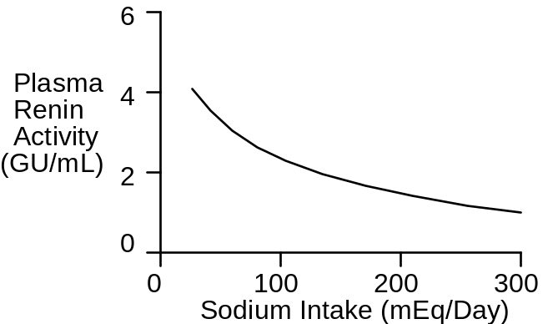

Plot Ms. Lake's data on this graph.

Thus, Ms. Lake's plasma renin activity is inappropriately high for the amount of sodium in her diet.

Therapy

To lower Ms. Lake's blood pressure, we might consider decreased sodium intake, blocking the formation of angiotensin or both.

First, lowered sodium intake. Go to Diet and slide table salt down to 40 mMol/Day. Go to Monitor to monitor blood pressure changes. Advance the solution 1 week.

Variable | Day 1 | Day 8 | Units
Blood Pressure |  |  | mmHg

In addition to blood pressure, check on changes in plasma renin activity, plasma angiotensin concentration and extracellular sodium mass.

It appears that decreased sodium intake decreased extracellular sodium mass while also stimulating more renin secretion. The net result was little change in blood pressure. Note the narrowing of pulse pressure. What caused that?

Next we'll block angiotensin formation. Click Restart to reestablish Ms. Lake's initial conditions. Then go to Blockers and slide AII converting enzyme inhibition up to 70%. Again, go to Monitor to monitor blood pressure changes. Advance the solution 1 week.

Variable | Day 1 | Day 8 | Units
Blood Pressure |  |  | mmHg

In addition to blood pressure, check on changes in plasma renin activity, plasma angiotensin concentration and extracellular sodium mass. Note that we've now uncoupled plasma renin activity and angiotensin concentration.

Finally, we'll lower sodium intake and block angiotensin formation. Click Restart to reestablish Ms. Lake's initial conditions. Go to Diet and slide table salt down to 40 mMol/Day. Then go to Blockers and slide AII converting enzyme inhibition up to 70%. Again, go to Monitor to monitor blood pressure changes. Advance the solution 1 week.

Variable | Day 1 | Day 8 | Units
Blood Pressure |  |  | mmHg

This is more like it. Ms. Lake's hypertension is under pretty good (but not perfect) control. Isn't it? Check out the relevant variables and make a final assessment.

References

Might put a Laragh reference to renin vs. salt here.

Ms. Lake - Notes

Ms. Lake’s thumbnail sketch notes that she claims to be in good health but gets too many headaches.

In fact, Ms. Lake has severe hypertension caused by a renin secreting tumor and elevated table salt intake.

Creating Ms. Lake

The renin secreting tumor is turned on and intake of table salt is increased. The new parameter values are:

“Renin Secretion, Tumor Secretion” = 1000.0
“Diet Goal, Table Salt (mMol/Day)” = 260.0

The units for tumor renin secretion are GU (Goldblatt Units)/Min. Tumor secretion is displayed at the bottom of the Angiotensin panel.

Then the solution was advanced for 1 month (43200 minutes).

Ms. Lake is ready.

Recap

This is a case of high blood pressure with elevated total peripheral resistance.

The subject was in sodium balance on a moderately high sodium diet with extracellular sodium mass normal to slightly expanded. In such a setting, we would expect plasma renin and angiotensin concentrations to be significantly lower than normal.

But renin and angiotensin were markedly above normal.

Blocking angiotensin formation in combination with decreased sodium intake created a natriuresis and brought blood pressure down to close to normal.

Postscript

What was really wrong with Ms. Lake? Go to Angiotensin and scroll to the bottom of the panel.

Ms. Lake Wrap-up

Summary

This is a case of high blood pressure with elevated total peripheral resistance.

The subject was in sodium balance on a moderately high sodium diet with extracellular sodium mass normal to slightly expanded. In such a setting, we would expect plasma renin and angiotensin concentrations to be significantly lower than normal.

But renin and angiotensin were markedly above normal.

Blocking angiotensin formation in combination with decreased sodium intake created a natriuresis and brought blood pressure down to close to normal.

Postscript

What was really wrong with Ms. Lake? Go to Angiotensin and scroll to the bottom of the panel.

Ms. Nance

Load Ms. Nance (MS_NANCE.ICS) using the File / Load Initial Conditions main menu selection.

Is Ms. Nance OK? Actually, the thumbnail sketch on the Charts panel suggests there may be problems. Ms. Nance complains that she tires easily and sometimes can't get enough air.

Check Ms. Nance’s blood pressure, heart rate, temperature and respiration using the Monitor panel.

Normal values were taken from Norm Subject.

Variable | Ms. Nance | N. Subject | Units
Blood Pressure |  | 120 / 81 | mmHg
Heart Rate |  | 73 | Beats / Min
Temperature |  | 98.8 | degree F
Respiration Rate |  | 12 | Breaths / Min

What values are abnormal and what does this tell you?

Wait And See

First, we will observe Ms. Nance for a day to see if this is a stable condition. Use the Go main menu selection to advance the solution for 1 day.

Note that if Ms. Nance should expire, you can request an autopsy report. Use the View / Autopsy Report main menu selection to install the autopsy report toolbar button. Then click Autopsy Report.

Blood Chemistry

It appears the Ms. Nance has a serious problem. We'll start over. Click the Restart main menu selection to restart Ms. Nance.

Blood chemistry may be helpful. Go to the Blood And Urine Samples panel.

Check blood electrolytes. Click Take Sample Now in the Venous Blood Sample box. Are the blood electrolytes normal?

Variable | Ms. Nance | N. Subject | Units
[Na+] |  | 145 | mEq/L
[K+] |  | 4.4 | mEq/L
[Cl-] |  | 108 | mEq/L
[BUN] |  | 13 | mG/dL
[Protein] |  | 6.9 | G/dL
Osmolarity |  | 292 | mOsm/L
Hematocrit |  | 44 | %

Get arterial blood gases. Click Take Sample Now in the Arterial Blood Gases box. Are there abnormal values here?

Variable | Ms. Nance | N. Subject | Units
pO2 |  | 94 | mmHg
[O2] |  | 0.20 | mL/mL
Saturation |  | 98 | %
pCO2 |  | 38 | mmHg
pH |  | 7.44 | pH Units
[H+] |  | 36 | pMol/L
[HCO3-] |  | 26 | mEq/L

What is a possible connection between the arterial blood values observed above and our initial observation of respiratory rate?

Get venous blood gases. Click Take Sample Now in the Venous Blood Gases box. Are there abnormal values here?

Variable | Ms. Nance | N. Subject | Units
pO2 |  | 39 | mmHg
[O2] |  | 0.15 | mL/mL
Saturation |  | 73 | %
pCO2 |  | 43 | mmHg
pH |  | 7.39 | pH Units
[H+] |  | 41 | pMol/L
[HCO3-] |  | 27 | mEq/L

Exercise Tolerance

Next we will evaluate Ms. Nance's tolerance to exercise. We'll use the treadmill and gradually increase the slope or grade of the belt.

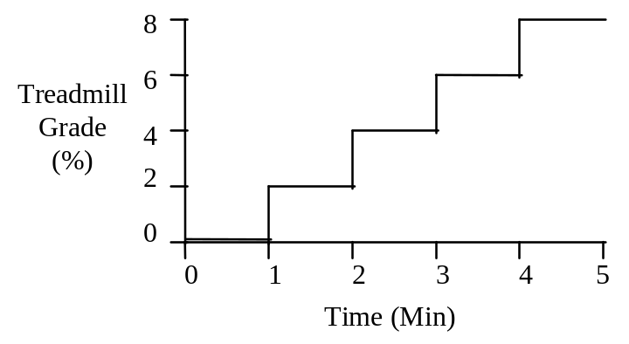
The protocol (shown above) is to advance the solution for 1 minute at each treadmill grade and to record heart rate at the end of the minute. Then increase the treadmill grade and repeat until either the protocol is complete or Ms. Nance stops exercising.

Record Ms. Nance's initial, or resting, heart rate in the table below (at 0’). Then go to Exercise.

Set exercise type to treadmill. Set treadmill speed to 6 MPH. Initially set treadmill grade to 0%. Advance the solution for 1 minute. Record heart rate. Increase the treadmill grade and repeat.

Norm S. = Heart rate data for Norm Subject.
X = Could not complete the protocol.

Time | 0’ | 1’ | 2’ | 3’ | 4’ | 5’
Speed | 0 | 6 | 6 | 6 | 6 | 6
Grade | 0% | 0% | 2% | 4% | 6% | 8%
Norm S. | 73 | 124 | 137 | 142 | X | X
Heart Rate

Invasive Studies

Use the View / Basic Physiology and Nephron Details main menu selections to install the basic physiology and nephron toolbar buttons.

Click the Restart main menu selection to restart Ms. Nance.

Go to Flow and record cardiac output, stroke volume and heart rate. This is clearly a low flow condition caused by a diminished stroke volume.

Variable | Ms. Nance | N. Subject | Units
Cardiac Output |  | 5360 | mL/Min
Stroke Volume |  | 73 | mL
Heart Rate |  | 73 | /Min

Various Blood Pressures

Go to Pressure and record the blood pressures at various locations in the circulation.

Variable | Ms. Nance | N. Subject | Units
Syst. Arteries. |  | 97 | mmHg
Perph. Veins |  | 7.3 | mmHg
Portal Vein |  | 8 | mmHg
Right Atrium |  | 0.3 | mmHg
Pulm. Artery |  | 13 | mmHg
Pulm. Caps |  | 9 | mmHg
Pulm. Vein. |  | 5.7 | mmHg
Left Atrium |  | 3.7 | mmHg

Pressures in the systemic circulation and right atrium are not entirely normal, but seem to be OK. In contrast, pressures in the pulmonary circulation and left atrium are markedly elevated.

There are 2 stories developing here:

- There is something seriously wrong with Ms. Nance's left heart.

- There is a threat that pulmonary edema might develop.

Pressure And Volume In The Left Heart

Go to Pumping and note the end-diastolic (ED) and end-systolic (ES) pressures and volumes. Calculate or observe Ms. Nance's ejection fraction.

Variable | Ms. Nance | N. Subject | Units
EDP |  | 3.2 | mmHg
EDV |  | 121 | mL
ESP |  | 123 | mmHg
ESV |  | 48 | mL
Stroke Volume |  | 73 | mL
Ejection Fraction |  | 61 | %

What is your diagnosis at this point? Have you considered stenosis of the aortic valve? Why.

Left Heart Contractility And Coronary Flow

Go to Muscle and note myocardial contractility and the effect of pH on contractility.

Variable | Ms. Nance | N. Subject | Units
Contractility |  | 0.018 | mmHg/mL
pH Effect |  | 1.0 | x Normal

We're getting close to an explanation.

Use the View / Organ Details main menu selection to install the organ details toolbar buttons.

Go to (yellow heart) Circulation and note the blood flow to the left heart. Go to Metabolism and note the metabolic rate, tissue pH and tissue lactate concentration.

Variable | Ms. Nance | N. Subject | Units
Blood Flow |  | 180 | mL/Min
Metabolic Rate |  | 129 | Cal/Min
pH |  | 6.98 | mmHg
[Lac-] |  | 2.0 | mEq/L

We are looking at a failing, acidotic, somewhat anaerobic left heart.

Salt And Water Balance

Salt and water retention is often an integral part of heart failure. We'll check on Ms. Nance.

Go to Diet and note daily sodium intake. Then go to Urine and note sodium excretion rate.

Na+ Output ____ mEq/Min x 1440 = ____ mEq/Day

Variable | Ms. Nance | N. Subject | Units
Na+ Intake |  | 180 | mEq/Day
Na+ Output |  | 180 | mEq/Day

There is a major sodium imbalance here. Where is that sodium going?

Body Fluids

The sodium picture above suggests that one or more volumes in the body are abnormal.

Go to Blood Volume and note the volume and composition of the blood.

Variable | Ms. Nance | N. Subject | Units
Blood Volume |  | 5400 | mL
Red Cells |  | 2400 | mL
Plasma Volume |  | 3000 | mL

Go to Water and record the volumes of important body fluid compartments.

Variable | Ms. Nance | N. Subject | Units
Total Body H2O |  | 43.2 | L
ECFV |  | 15.0 | L
Plasma |  | 3.0 | L
Interstitium |  | 12.0 | L
Excess Lung |  | 0.0 | L
Ascites |  | 0.0 | L
Cell H2O |  | 28.2 | L

The picture is now getting clearer. It appears that Ms. Nance's kidney is avidly retaining salt and water and much of this salt and water, in turn, is spilling into the lungs. Our last stop will be the pulmonary capillaries.

Pulmonary Capillaries

Go to Lung Fluids and note the hydrostatic pressure in the capillaries and the colloid osmotic pressure.

Variable | Ms. Nance | N. Subject | Units
Hydrostatic Pressure |  | 9 | mmHg
Plasma COP |  | 28 | mmHg
Filtration |  | 0 | mL/Min

The long-term problem then is heart failure, while the acute problem is the formation of pulmonary edema.

Treatment

Create a treatment strategy that stabilizes (or possibly improves) Ms. Nance's condition over 1 month. Diuretics, digitalis and other treatments are available at and . Gas can be administered at Air Supply. Changes in environment and diet might also be considered.

Ms. Nance - Notes

Ms. Nance’s thumbnail sketch notes that she’s tired and can’t get enough air.

In fact, Ms. Nance is in heart failure.

Creating Ms. Nance

This is a new look Ms. Nance who shows weight gain, peripheral edema, and the start of pulmonary edema. She has bilateral dysfunction that has both systolic and diastolic components.

The new parameter values are:

“Right Heart Contractility, Basic (%)” = 50.0
“Right Heart Pumping, Stiffness” = 0.0132
“Left Heart Contractility, Basic (%)” = 50.0
“Left Heart Pumping, Stiffness” = 0.0227

Advance the solution 2 weeks (20160 minutes).

Ms. Nance is ready.

Recap

Chronic bilateral heart failure impaired diastolic filling and impaired systolic ejection. This lowers stroke volume, cardiac output and arterial pressure. The kidneys retain salt and water, expanding blood and interstitial volume.

Expanded blood volume and redistribution of blood volume enhance left ventricular filling. This, in turn, increases stroke volume, which is small but otherwise would be even smaller.

The left and right ventricles operate at increased end-diastolic and end-systolic volumes and a reduced ejection fraction.

Increased left and right heart filling pressure is possible only when blood pressure is increased in all of the pulmonary circulation and in the peripheral veins.

When blood pressure in the pulmonary capillaries exceeds colloid osmotic pressure in the blood, fluid rapidly ultrafilters into the lungs. This pulmonary edema impairs the diffusion of O2 and CO2 in the lungs and also decreases tidal volume. Blood pO2 falls and deterioration is rapid.

Increased pressure in the peripheral veins leads to the formation of ascites.

Ms. Nance Wrap-up

Summary

Chronic (left side) heart failure lowers stroke volume, cardiac output and arterial pressure. The kidneys retain salt and water, expanding blood volume.

Expanded blood volume and redistribution of blood volume enhance left ventricular filling. This, in turn, increases stroke volume, which is small but otherwise would be even smaller.

The left ventricle operates at increased end-diastolic and end-systolic volumes and a reduced ejection fraction.

Increased left heart filling pressure is possible only when blood pressure is increased in all of the pulmonary circulation.

When blood pressure in the pulmonary capillaries exceeds colloid osmotic pressure in the blood, fluid rapidly ultrafilters into the lungs. This pulmonary edema impairs the diffusion of O2 and CO2 in the lungs and also decreases tidal volume. Blood pO2 falls and deterioration is rapid.

Postscript

Ms. Nance's condition was caused by atherosclerosis in the coronary vessels feeding her left heart. Go to (yellow heart) Circulation and note the value of large vessel conductance. A normal value is 20.

Mr. Parks

Load Mr. Parks (MR_PARKS.ICS) using the File / Load Initial Conditions main menu selection.

Is Mr. Parks OK? Actually, the thumbnail sketch on the Charts panel suggests that he is not OK.

Check Mr. Parks’ blood pressure, heart rate, temperature and respiration using the Monitor panel.

Normal values were taken from Norm Subject.

Variable | Mr. Parks | N. Subject | Units
Blood Pressure |  | 120 / 81 | mmHg
Heart Rate |  | 73 | Beats / Min
Temperature |  | 98.8 | degree F
Respiration Rate |  | 12 | Breaths / Min

Estimating Cardiac Output

We'll use some basic hemodynamic concepts in this section to make an estimate of Mr. Park's cardiac output (See G&H, pp. 152 - 156).

Variable | Symbol | Units
Cardiac Output | CO | mL/Min
Heart Rate | HR | /Min
Stroke Volume | SV | mL
Pulse Pressure | PP | mmHg
Proportionality | K | mL/mmHg

Cardiac output is equal to heart rate multiplied by stroke volume.

CO = HR * SV (1)

We can observe heart rate at this point but not stroke volume. But, pulse pressure is proportional to stroke volume for each cardiac ejection -- and we can observe pulse pressure. Equation (1) is modified to get

CO = HR * K * PP (2)

The proportionality constant K is currently unknown. We will take data from Norm Subject to apply to Mr. Parks, hoping that these two have roughly the same arterial compliance.

Symbol | Value | Units
CO | 5368 | mL/Min
HR | 73 | /Min
PP | 39 | mmHg
K | 1.9 | mL/mmHg

Solving Equation (2) for K using Norm Subject's data yields a value for K of 1.9.

Use this value of K and Mr. Parks hemodynamic data to estimate his cardiac output.

Variable | Value | Units
Pulse Pressure |  | mmHg
Proportionality | 1.9 | mL/mmHg
Heart Rate |  | /Min
Cardiac Output |  | mL/Min

At this point, what is your preliminary diagnosis? Why?

Invasive Hemodynamics

Use the View / Basic Physiology main menu selection to install the basic physiology toolbar buttons.

Select the Blood Flow panel and read Mr. Parks' true stroke volume and cardiac output.

Variable | Value | N. Subject | Units
Stroke Volume |  | 73 | mL
Cardiac Output |  | 5368 | mL/Min

Select the Blood Volume panel and read Mr. Parks' blood volume.

Variable | Mr. Parks | N. Subject | Units
Blood Volume |  | 5400 | mL
Red Cell Volume |  | 2400 | mL
Plasma Volume |  | 3000 | mL
Hematocrit |  | 44 | %

Acute Compensations

Hemorrhage elicits a variety of compensations that help to maintain blood flow to vital organs by supporting blood pressure and redistributing flow toward vital organs (See G&H, Chapter 24). We'll consider two here: increased autonomic nerve activity and increased plasma angiotensin concentration.

Select the Autonomic Efferents panel and read general and kidney autonomic firing rates.

Select the Angiotensin panel and read the plasma angiotensin concentration.

Variable | Mr. Parks | N. Subject | Units
General Autonomic Firing Rate |  | 1.5 | Hz
Renal Autonomic Firing Rate |  | 1.5 | Hz
Plasma [AII] |  | 20 | pG/mL

Time permitting, you might try blocking the increase in autonomic activity and increase in plasma angiotensin to obtain an indication of their effect on arterial pressure.

To block (alpha) autonomic activity, go to Blockers and set alpha receptors % block to 100%. Then go to Monitor to observe the effects of this blockade.

To block the formation of plasma angiotensin conversion, go to Blockers and set AII converting enzyme inhibition to 100%. Again, go to Monitor to observe the effects of this inhibition.

The vasoconstrictor effect of the sympathetic nervous system and angiotensin during hemorrhage is beneficial only if the vasoconstriction is selective. Namely, we hope that brain and heart blood flow (vital organs) is maintained at the expense of flow in other organs, as show below (data from Kaihara).

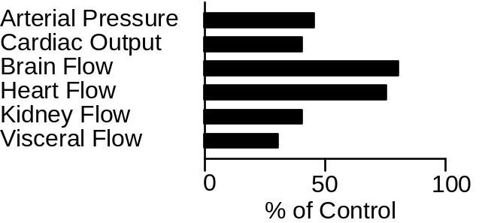

Select the Blood Flow panel and estimate Mr. Parks' brain and hepatic vein blood flow from the graph. Or, select View / Organ Details to make the organ details toolbar buttons visible. Then select the Brain Circulation and Gut panels to get numerical values for blood flow.

Variable | Mr. Parks | N. Subject | Units
Brain Blood Flow |  | 706 | mL/Min
Hepatic Vein Blood Flow |  | 1217 | mL/Min

Severity Of Hemorrhage

Compensation can almost completely hide the hemodynamic consequences of a mild hemorrhage, such as giving a unit of blood at a blood bank. More severe hemorrhage produces obvious signs even with the strong support of the compensations. With very severe hemorrhage, the compensations are maximum and cannot contribute further; cardiovascular collapse is a real possibility.

It would be instructive to know the severity of Mr. Parks' hemorrhage. Observe Mr. Parks for 10 minutes. Use the main menu Go command to advance the solution by 10 minutes.

Interventions

Intervention is advised.

Lost blood volume is usually replaced by one of three types of solutions.

- Saline. It is readily available and safe, but it tends to leak out of the circulation where it is of no or negative value. Saline dilutes the available hemoglobin.

- Saline With Colloid Pressure. Colloid pressure keeps the replacement fluid in the circulation where it boosts cardiac output, but it also dilutes available hemoglobin.

- Whole Or Artificial Blood. Blood is often not readily available (see G&H, Chapter 24). When it is available, it offers colloid pressure to keep the replacement fluid in the circulation and hemoglobin or a functional equivalent to carry oxygen.

We'll try each of these interventions. Note that the fundamental goal of intervention is to maintain or improve oxygen delivery to the tissues. We'll keep an eye on O2 movement in the simulations that follow.

In each case, begin by clicking Restart to take Mr. Parks back to his initial condition. Use the arrow buttons on the toolbar to move among the needed panels.

Saline. Select the IV Drip panel. Set the volume to 1000 mL, the timespan to 10 Min, [NaCl] to 140 mMol and click switch to on. Go back to Monitor, advance the solution for 1 hour and record data in the table below.

Plasma. Select the Transfusion panel. Set the volume to 1000 mL, the timespan to 10 Min, the hematocrit to 0 % and click switch to on. Go back to Monitor, advance the solution for 1 hour and record data in the table below.

Whole Blood. Select the Transfusion panel. Set the volume to 1000 mL, the timespan to 10 Min, the hematocrit to 44 % and click switch to on. Go back to Monitor, advance the solution for 1 hour and record 1-hour data in the table below.

Select the Oxygen panel for blood oxygen data.

Variable | Initial | Saline | Plasma | Blood
Blood Pressure
Heart Rate
Blood Volume
Red Cell Volume
Plasma Volume
Hematocrit
Cardiac Output
Arterial O₂ Content
Venous O₂ Content

Discussion point: What are the good and bad attributes of the three replacement fluids used above, as indicated by the data collected?

Discussion point: What is the volume replacement strategy when a patient intraoperatively bleed more than his/her total blood volume?

The Natural Time Course

The physiological response to hemorrhage is a three-part process, over time. The principal features are:

• Rapidly responding neural and humoral mechanisms direct available blood flow toward vital organs, as described above.

• More slowly evolving salt and water retention by the kidneys replaces the lost plasma.

• Erythropoiesis gradually replaces the lost red blood cells.

In this section, we'll produce a moderate hemorrhage and observe the body's response over the following month.

Use the Options / Reset main menu selection to get Norm Subject back. The thumbnail sketch in Charts should now introduce Norm Subject.

To create a hemorrhage, select the Blood Volume panel. In the arterial hemorrhage box, set volume to 1000 and timespan to 10. Click the hemorrhage switch on and advance the solution 30 minutes.

You can verify the neural and hormonal response to hemorrhage, as previously seen above. But, there is also a renal component to be considered.

Use the View / Nephron Details main menu selection to add the nephron details button to the toolbar. Select the Urine panel and read the rate of sodium and water excretion.

Variable | 30 Min | Control | Units
Sodium Excretion |  | 0.114 | mEq/Min
Water Excretion |  | 0.76 | mL/Min

Salt and water retention should expand plasma volume and blood volume. But the lost red cells will not be acutely replaced and hematocrit will fall as shown below (data from Ebert, Adamson).

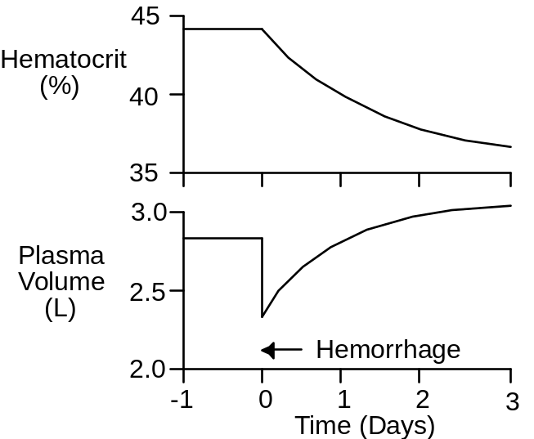

Advance the solution to 2 days and note the amount and composition of blood volume.

Select the Erythropoietin panel to see if EPO secretion has been stimulated.

Select the Blood Volume panel to see if red cell production is increased.

Advance the solution to 30 days, following changes in blood volume and particularly red cell volume. Note the final amount and composition of the blood.

Variable | 30 Days | Control | Units
Blood Volume |  | 5400 | mL
Red Cell Volume |  | 2400 | mL
Plasma Volume |  | 3000 | mL
Hematocrit |  | 44 | %

References

Adamson, J. and R. S. Hillman. Blood volume and plasma protein replacement following acute blood loss in normal man. J. Amer. Med. Assn. 205:609-612, 1968.

Ebert, R. V., E. A. Stead, Jr. and J. G. Gibson, II. Response of normal subjects to acute blood loss. Arch. Int. Med. 68:578-590, 1941.

Kaihara, S., R. B. Rutherford, E. P. Schwentker and H. N. Wagner, Jr. Distribution of cardiac output in experimental hemorrhage in dogs. J. Appl. Physiol. 27:218-222, 1969.

Mr. Parks - Notes

Mr. Parks’ thumbnail sketch notes that he was found in a pool of blood and was rushed to the ER.

Mr. Parks has hemorrhaged and may expire if left untreated.

Creating Mr. Parks

The first step in creating Mr. Parks is to create a large hemorrhage. The new parameter values are:

“Arterial Hemorrhage, Final Volume” = 1800.0
“Arterial Hemorrhage, Duration” = 30.0
“Arterial Hemorrhage, Switch” = 1.0 // On

Then the solution was advanced for 10 minutes and Mr. Parks was constrained to lying down (1.0).

“Posture Control, Restraint” = 1.0 // Lying

Then the solution was advanced for another 20 minutes to complete the hemorrhage.

Finally, a smaller continuing hemorrhage was defined to create a dynamic setting. The new parameter values are:

“Arterial Hemorrhage, Final Volume” = 500.0
“Arterial Hemorrhage, Duration” = 10.0
“Arterial Hemorrhage, Switch” = 1.0 // On

Mr. Parks is now ready for observation and intervention.

Recap

The immediate physiological response to hemorrhage is neural and humoral vasoconstriction that directs available blood flow toward vital organs. Then, renal salt and water retention expands plasma and blood volume. The slowest part of the response is replacement of lost red cells by increased red cell production.

The effectiveness of volume replacement depends on

- The replacement fluid's tendency to stay in the circulation.

- The replacement fluid's net effect on oxygen delivery to the tissues.

Mr. Parks Wrap-up

Summary

The immediate physiological response to hemorrhage is neural and humoral vasoconstriction that directs available blood flow toward vital organs. Then, renal salt and water retention expands plasma and blood volume. The slowest part of the response is replacement of lost red cells by increased red cell production.

The effectiveness of volume replacement depends on

- The replacement fluid's tendency to stay in the circulation.

- The replacement fluid's net effect on oxygen delivery to the tissues.

Mr. Stone

Load Mr. Stone (MR_STONE.ICS) using the File / Load Initial Conditions main menu selection.

Is Mr. Stone OK? We don't know, but he is in the ER. Check his blood pressure, heart rate, temperature and respiration using the Monitor panel.

Normal values were taken from Norm Subject.

Variable | Mr. Stone | N. Subject | Units
Blood Pressure |  | 120 / 81 | mmHg
Heart Rate |  | 73 | Beats / Min
Temperature |  | 98.8 | degree F
Respiration Rate |  | 12 | Breaths / Min

These values seem quite normal, but there are some slight worries. Pulse pressure seems a little narrow and heart rate is a little high. And, respiration rate is up a little bit.

Blood Chemistry

Blood chemistry might be useful. Go to the Blood And Urine Samples panel. Click Take Sample Now in the Venous Blood Sample box. Are the blood electrolytes normal?

Variable | Mr. Stone | N. Subject | Units
[Na+] |  | 145 | mEq/L
[K+] |  | 4.4 | mEq/L
[Cl-] |  | 108 | mEq/L
[BUN] |  | 13 | mG/dL
[Protein] |  | 6.9 | G/dL
Osmolarity |  | 292 | mOsm/L
Hematocrit |  | 44 | %

Several values are not quite normal. Plasma [Na+], osmolarity and hematocrit are all elevated a little bit. What does this suggest? We might consider a drip later on.

A bigger worry is the elevated plasma [Cl-]. What does this suggest? We'll investigate further.

Check Mr. Stone's acid/base status. Click Take Sample Now in the Arterial Blood Gases box. Is there evidence of an acid/base disturbance?

Variable | Mr. Stone | N. Subject | Units
pCO2 |  | 37 | mmHg
pH |  | 7.45 | pH Units
[H+] |  | 35 | pMol/L
[HCO3-] |  | 26 | mEq/L

These values definitely suggest that Mr. Stone has an acid/base disturbance of some sort.

Would you expect the pH in a venous blood sample to be higher or lower than in this arterial sample? Why?

pH Or [H+]?

The definition of pH (see Guyton and Hall, p. 347) is

pH = -log [H+]

when the physical units for [H+] are Mol/L. But [H+] concentrations are usually tiny and nMol/L are more appropriate units. The definition of pH becomes

pH = 9 - log [H+]

Here are some commonly encountered values.

[H+] | pH
25 | 7.60
40 | 7.40
63 | 7.20
100 | 7.00

Calculator buttons () on the Blood And Urine Samples panel can calculate additional values.

The Anion Gap

An analysis of Mr. Stone's anion gap may be useful.

The anion gap (see Guyton and Hall, p. 361-362) is an estimate of anions in a blood sample that are present but not measured in ordinary blood chemistries. The anion gap is calculated as

Anion Gap (mEq/L) = [Na+] - [Cl-] - [HCO3-]

What anions are normally in the anion gap? What ions are in Mr. Stone's anion gap?

Variable | Mr. Stone | N. Subject | Units
[Na+] |  | 145 | mEq/L
[Cl-] |  | 108 | mEq/L
[HCO3-] |  | 26 | mEq/L
Anion Gap |  | 11 | mEq/L

This Shoe Didn't Fit

If we encounter a blood sample with a low [HCO3-] concentration (we did) and a normal or decreased [Cl-] concentration (we didn't), there will probably be a large anion gap. Likely candidates to fill this gap are ketoacids (diabetic ketoacidosis) and lactate (anaerobic organ failure). Mr. Stone is not showing us this profile at all, so its time to move along.

Respiratory Function And pH

Respiratory function is always involved in acid/base status.

First, consider the physiological loop that helps to stabilize blood pCO2. This loop operates as follows: if blood pCO2 increases, pH falls; decreased pH stimulates ventilation; increased ventilation increases exhaled CO2; increased CO2 blow off decreases blood pCO2. Thus, stability.

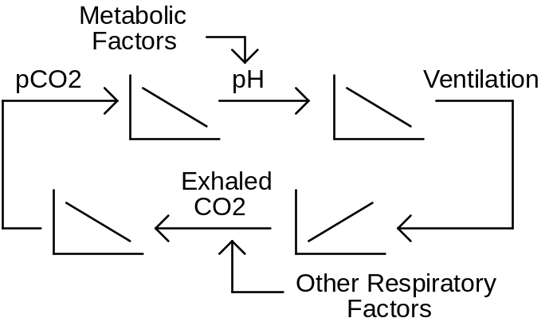

Now suppose metabolic factors lower pH. Decreased pH stimulates ventilation and increased ventilation increases exhaled CO2, lowering blood pCO2. The decreased blood pCO2 tends to increase pH, buffering the original metabolic event. This is metabolic acidosis with respiratory compensation.

Suppose a respiratory factor, such as pulmonary membrane damage, decreases exhaled CO2. This increases blood pCO2 and lowers pH. This is respiratory acidosis. But decreased pH again stimulates ventilation and this increases exhaled CO2, which tends to buffer the initial insult.

In simplest terms, acidosis with decreased blood pCO2 is probably caused by metabolic factors. Acidosis with increased blood pCO2 is probably caused by respiratory factors.

With this background, we can analyze Mr. Stone’s venous blood.

Variable | Mr. Stone | N. Subject | Units
pH |  | 7.45 | pH Units
pCO2 |  | 37 | mmHg

What is your diagnosis at this point?

Mr. Stone's Kidney

It's time to look at Mr. Stone's kidney.

Use the View / Basic Physiology and Nephron Details main menu selections to install the basic physiology and nephron toolbar buttons.

It might be useful to see what Mr. Stone's kidney is excreting. Go to Urine and record excretion rates for water and important electrolytes.

Variable | Mr. Stone | N. Subject | Units
H2O Rate |  | 0.76 | mL/Min
Na+ Rate |  | 0.114 | mEq/Min
K+ Rate |  | 0.056 | mEq/Min
Cl- Rate |  | 0.125 | mEq/Min
HCO3-Rate |  | 0.010 | mEq/Min
NH4+ Rate |  | 0.024 | mEq/Min

Review G&H Chapter 30 and complete your diagnosis. Focus particularly on the excretion rates for Na+, HCO3- and NH4+.

Body Fluids

We've also had some hints that Mr. Stone may be a little dehydrated. What were those hints? Go to Water and record the volumes of important body fluid compartments.

Variable | Mr. Stone | N. Subject | Units
Total Body H2O |  | 43.2 | L
ECFV |  | 15.0 | L
Plasma |  | 3.0 | L
Interstitium |  | 12.0 | L
Cell H2O |  | 28.2 | L

Use this information below in prescribing a drip for Mr. Stone.

Interventions

The proper intervention is to remove the primary cause of the acid/base disturbance, but a drip may temporarily improve Mr. Stone's acid/base status.

Go to IV Drip. Create a plan for infusing sodium bicarbonate. Set the bicarbonate concentration, infusion volume and infusion timespan. Click the drip switch to on. Advance time to complete the drip.

If you don't like the results, click the Restart main menu selection and try a different strategy.

Record the final results below and show your instructor.

Variable | Control | Now | Units
[Na+] |  |  | mEq/L
[K+] |  |  | mEq/L
[Cl-] |  |  | mEq/L
[BUN] |  |  | mG/dL
[Protein] |  |  | G/dL
Osmolarity |  |  | mOsm/L
Hematocrit |  |  | %
pCO2 |  |  | mmHg
pH |  |  | pH Units
[H+] |  |  | pMol/L
[HCO3-] |  |  | mEq/L

Show these results to your instructor.

Mr. Stone - Notes

Mr. Stone’s thumbnail sketch notes only that he speaks Estonian and so there is no history at the outset.

Mr. Stone has had prolonged diarrhea, producing hyperchloremic metabolic acidosis.

Creating Mr. Stone

Mr. Stone looses 100 mEq of Na+ (along with bicarbonate) a minute and 1 mL of water per minute in his feces. We anticipate not only metabolic acidosis but also dehydration.

The new parameter values are:

“GI Lumen Diarrhea, [Na+] Target” = 100.0
“GI Lumen Diarrhea, H2O Target” = 1.0

Then the solution was advanced for 3 days (3800 minutes).

Mr. Stone is ready.

Recap

Metabolic acidosis presents with decreased blood pH and bicarbonate concentration.

If ketoacids or lactate are the cause of the acidosis, their blood concentrations will be hiding in a widened anion gap. Otherwise the anion gap will be smaller than normal and blood chloride concentration will be increased.

Ventilation has a role in metabolic acidosis. Decreased pH stimulates ventilation which, in turn, blows down blood pCO2. This decrease in pCO2 decreases the severity of the acidosis.

The proper treatment of metabolic acidosis is to remove its primary cause, but sodium bicarbonate administration should provide temporary benefit.

Postscript

An Estonian translator was located. It turns out that Mr. Stone has had a severe, continuing diarrhea for several days. Treatment of lower bowel inflammation is planned.

To see the cause of Mr. Stone's distress, go to Miscellaneous and scroll to the bottom of the panel.

Mr. Stone Wrap-up

Summary

Metabolic acidosis presents with decreased blood pH and bicarbonate concentration.

If ketoacids or lactate are the cause of the acidosis, their blood concentrations will be hiding in a widened anion gap. Otherwise the anion gap will be smaller than normal and blood chloride concentration will be increased.

Ventilation has a role in metabolic acidosis. Decreased pH stimulates ventilation which, in turn, blows down blood pCO2. This decrease in pCO2 decreases the severity of the acidosis.

The proper treatment of metabolic acidosis is to remove its primary cause, but sodium bicarbonate administration should provide temporary benefit.

Postscript

An Estonian translator was located. It turns out that Mr. Stone has had a severe, continuing diarrhea for several days. Treatment of lower bowel inflammation is planned.

To see the cause of Mr. Stone's distress, go to Miscellaneous and scroll to the bottom of the panel.

Ms. Thomas

Load Ms. Thomas (Ms Thomas.ICS) using the File / Load Initial Conditions main menu selection.

Is Ms. Thomas OK? Actually, the thumbnail sketch on the Charts panel suggests that she is not OK. She is confused – maybe worse.

To get a rough idea of Ms. Thomas’s condition, advance the solution in 1 hour intervals for a total of 3 hours, collecting data at the start and at the end of each interval. Check Ms. Thomas’s blood pressure, heart rate, temperature and respiration using the Monitor panel.

Variable | 12:00 | 1:00 | 2:00 | 3:00
Systolic Blood Pressure (mmHg)
Diastolic Blood Pressure (mmHg)
Heart Rate (/Min)
Temperature
(deg F)
Respiration Rate
(/Min)

The initial values look pretty good, but trouble soon develops. What does the pulse pressure and heart rate data suggest?

Click main menu selection Restart to restart the solution.

Attend to Ms. Thomas. Be prepared to discuss the following points.

- What is the matter with Ms. Thomas?

- What interventions are possible? Which do you recommend? Can you describe a beneficial course of action?

- What physiological and pathophysiological mechanisms are causing Ms. Thomas’s condition?

- What physiological mechanisms, if any, are actually beneficial to Ms. Thomas condition?

- Summarize Ms. Thomas’s acid/base status?

- What is Ms. Thomas’s fluid volume status?

- What is Ms. Thomas’s renal excretory status?

- Specifically, what are the neurological, endocrine and metabolic components of Ms. Thomas’s condition?

Ms. Thomas – Notes

Ms. Thomas has untreated Type I diabetes mellitus or insulin dependent diabetes mellitus (IDDM).

The key word here is untreated. Ms. Thomas has had little or no insulin therapy and is at extreme risk of falling into a coma caused either by hyperglycemia or ketoacidosis.

Creating Ms. Thomas

Ms. Thomas was created by simulating nearly complete loss of pancreatic beta cells. Specifically, pancreatic insulin secretion was clamped at 1 mU/Min compared to a typical secretion of 10 mU/Min.

The new parameters values are:

“Insulin Secretion, Clamp Level” = 1.0
“Insulin Secretion, Clamp Switch” = 1.0 // On

Then the solution was advanced for 18 hours (1080 minutes). Hyperglycemia and ketoacidosis quickly developed.

Interventions

Ms. Thomas’s condition is initially not very clear. So go to the Blood Chemistry panel.

Several values jump out. Ms. Thomas has a blood glucose concentration of 1200 mG/dL compared to a normal of around 100 mG/dL. This increase is enough to produce a hyperglycemic coma.

There is also a severe acidosis. It is metabolic since blood pCO₂ values are normal to low.

Blood ketoacids concentration is very high, causing a large anion gap and a small strong ion difference.

This looks like IDDM with inadequate insulin replacement. You could check the plasma insulin levels just to make sure.

The proper intervention is to inject insulin to bring the blood glucose concentrations down. I injected 20 U, but ended up with ventricular fibrillation due to hypokalemia.

So there are some additional issues during treatment that I should look into. Ms. Thomas is excreting 11 mL/Min urine vs. a normal flow of 1 mL/Min. She has become dehydrated and the dehydration is intracellular, with a cell water of 23 L vs. a normal volume of 28 L. Plasma [K+] is increased and this has stimulated aldosterone secretion.

I’ll look into this further. With a shot of insulin, the osmolarity falls and water rushes into the cells. Apparently K+ rushes in also, lowering plasma [K+] to lethal levels.

Apparently, an aggressive drip must accompany the insulin. At minimum, careful management is needed.

Some useful panels are

Glucose
Insulin
Glucagon
pH

References

I’m looking for some suitable references now.

Ms. Thomas – Instructors Notes

Ms. Thomas has Type I diabetes mellitus (IDDM).

She has had little or no insulin therapy and is at extreme risk of falling into a coma caused either by hyperglycemia or ketoacidosis.

The clinical buttons toolbar group has several useful interventions.

- Dietary salt.
- Diuretics
- IV drip including protein

Note that steroids are not available.

Select View | Basic Physiology to put the basic physiology group of panels on the toolbar.

- Pressures and flows.
- Volumes.
- Pulmonary edema.

Select View | Orthostasis to put the orthostasis group of panels on the toolbar. These panels show regional interstitial fluid volume, protein concentration and lymph flow.

Select View | Nephron Details to put the nephron group of panels on the toolbar. The click on Glomerulus to view the cause to the nephrotic syndrome. Click Urine to see what is being excreted.

Sodium Retention In Nephrotic Syndrome

Here is the classic picture of nephrotic syndrome. Albumin is lost into the urine. Plasma colloid pressure falls and water shifts from the plasma to the interstitium. Sodium retaining mechanisms are activated by the decreased plasma volume and sodium is retained. The retained sodium leaks into the interstitium and edema forms.

But Dorhout Mees noted in 1979 that the typical nephrotic syndrome patient does not show signs of plasma volume contraction and activation of sodium retaining mechanisms. In fact, the opposite is seen.

The best evidence comes from serial studies in patients that have episodes of nephrotic syndrome followed by spontaneous remission or favorable response to steroids.

In the new picture of nephrotic syndrome, plasma volume and blood volume are expanded, plasma renin activity and aldosterone concentration are normal or decreased (Dorhout Mees et.al., Shapiro et.al.). Glomerular filtration is decreased. Dorhout Mees reported one patient that had a creatinine clearance of 34 mL/Min during nephrotic syndrome and 127 mL/Min during recovery. A water load is excreted slowly during nephrotic syndrome (Shapiro et.al.). Arterial pressure tends to be elevated.

The glomerular membrane is a complex tissue, but it appears that protein permeability is increased in nephrotic syndrome while sodium permeability is decreased. Note that albumin is an anion while sodium is a cation and the glomerular membrane is normally loaded with negative charges.

Experimental Nephrotic Syndrome.

In rats. Puromycin aminonucleoside (PAN) will produce a very good model of nephrotic syndrome in rats following close or systemic infusion.

These rats dump albumin and other small proteins as expected.

These animals also retain sodium. The whole kidney and single nephron glomerular filtration rates are decreased (Ichikawa et.al.). Sodium excretion as a function of renal perfusion pressure is greatly reduced (Firth et.al.). Firth has a great graph.

There is also some evidence for increased distal sodium reabsorption, although the reason is not clear. I need to look into this a bit more.

COP And Na+ Excretion In Normal Kidneys

Christine Bayliss, Thomas Maack and other have investigated the effect of colloid osmotic pressure on sodium excretion in normal kidneys. Usually using rats.

Decreased colloid osmotic pressure increases glomerular filtration and decreases tubular reabsorption. This two factors combine to net a big increase in sodium excretion, which is basically the opposite of what is seen in nephrotic syndrome.

Bayliss Amer. J. Physiol. 232:F58-F64, 1977 has some nice data.

Some other potentially useful references are:

AJP 226:426-430, 1974.
AJP 226:512-517, 1974.
Pflugers 301:7-15, 1968.
Circ. Res. 61:531-538, 1987.
Pfluger 306:92-102, 1969.
JCI 82:1757-1768, 1988.
Kid. Int. 34:220-223, 1988.

Physiological Compensations

There may be many important physiological compensations that help to keep the nephrotic syndrome patient alive. I don’t have a big list at this time.

Falling plasma protein concentration slows the flux of protein from plasma to interstitium and this helps to keep available protein in the plasma.

Falling plasma protein concentration increases the Starling pressure gradient across the capillary wall. This increases the flux of water from plasma to interstitium. Interstitial pressure increases (Noddeland et.al.). Lymph flow increases and washes interstitial protein back into the plasma. Interstitial protein concentration can fall to a very low level (Noddeland et.al., Koomans et.al.) Koomans has a very nice graph..

These responses in total keep as much of the available protein as possible in the plasma (where it is needed) and not in the interstitium.

References

Dorhout Mees, E.J., J.C. Roos, R. Boer, O.H. Yoe and T.A. Simatupang. Observations on edema formation in the nephrotic syndrome in adults with minimal lesions. Amer. J. Med. 67:378-384, 1979,

Firth, J.D., A.E.G. Raine and J.G.G. Leddingham. Abnormal sodium handling occurs in the isolated perfused kidney of the nephrotic rat. Clin. Sci. 76:387-395, 1989.

Ichikawa, I., H.G. Renke, J.R. Hoyer, K.F. Badr, N. Schor, J.L. Troy, C.P. Lechene and B.M Brenner. Role for intrarenal mechanisms in the impaired salt excretion of experimental nephrotic syndrome. J. Clin. Invest. 71:91-103, 1983.

Koomans, H.A., W. Kortlandt, A.B. Geers and E.J. Dorhout Mees. Lowered protein content of tissue fluid in patients with nephrotic syndrome: observations during disease and recovery. Nephron 40:391-395, 1985.

Joles, J.A., T.J. Rabelink, B. Braam and H.A. Koomans. Plasma volume regulation: Defences against edema formation (with special emphasis on hypoproteinemia). Am. J. Nephrol. 13:399-412, 1993.

Noddeland, H., S.M. Riisnes and H.O. Fadnes. Interstitial fluid colloid osmotic and hydrostatic pressures in subcutaneous tissue of patents with nephrotic syndrome. Scand. J. Clin. Lab. Invest. 42:139-146, 1982.

Shapiro, M.D., K.M. Nicholls, B.M. Groves and R.W. Schrier. Role of glomerular filtration rate in the impaired sodium and water excretion of patients with the nephrotic syndrome. Amer. J. Kid. Dis. 8:81-87, 1986.

Mr. White

Load Mr. White (MR_WHITE.ICS) using the File / Load Initial Conditions main menu selection.

Is Mr. White OK? In his thumbnail sketch on the Charts panel, he says the he feels OK.

Check his blood pressure, heart rate, temperature and respiration using the Monitor panel.

Normal values were taken from Norm Subject.

Variable | Mr. White | N. Subject | Units
Blood Pressure |  | 120 / 80 | mmHg
Heart Rate |  | 72 | Beats / Min
Temperature |  | 98.6 | degree F
Respiration Rate |  | 12 | Breaths / Min

Do No Harm

We might first observe Mr. White for awhile. Use the Go main menu selection to advance the solution for 1 week.

Blood Chemistry

Maybe Mr. White needs more aggressive treatment. Click the Restart main menu selection to restart Mr. White.

Its time for some blood chemistry. Go to the Blood And Urine Samples panel. Get venous blood gases. Click Take Sample Now in the Venous Blood Gases box. Is there evidence of an acid/base disturbance?

Variable | Mr. White | N. Subject | Units
pCO2 |  | 45 | mmHg
pH |  | 7.39 | pH Units
[H+] |  | 41 | pMol/L
[HCO3-] |  | 26 | mEq/L

Check blood electrolytes. Click Take Sample Now in the Venous Blood Sample box. Are the blood electrolytes normal?

Variable | Mr. White | N. Subject | Units
[Na+] |  | 144 | mEq/L
[K+] |  | 4.4 | mEq/L
[Cl-] |  | 108 | mEq/L
[BUN] |  | 12 | mG/dL
[Protein] |  | 7.0 | G/dL
Osmolality |  | 292 | mOsm/L
Hematocrit |  | 45 | %

Invasive Studies

Use the View / Basic Physiology and Nephron Details main menu selections to install the basic physiology and nephron toolbar buttons.

The blood samples taken above suggest that something is abnormal in Mr. White's electrolyte balance. We will now get numbers for Na+ and K+ excretion.

Go to the Urine panel and note the rate of Na+ and K+ excretion.

Na+ ______ mEq/Min x 1440 = ______ mEq/Day
K+ ______ mEq/Min x 1440 = ______ mEq/Day

If Mr. White is in balance, these excretion values will be nearly the same as Mr. White's dietary intake values. But, Mr. White may not be in balance. We better check it out.

Go to the Diet panel and note daily electrolyte intake.

Variable | Mr. White | N. Subject | Units
Na+ Intake |  | 180 | mEq/Day
Na+ Output |  | 180 | mEq/Day
K+ Intake |  | 70 | mEq/Day
K+ Output |  | 70 | mEq/Day

Mr. White appears to be a big salt user. We will look at his extracellular Na+ mass. Go to Na+ and note the extracellular Na+ mass.

Variable | Mr. White | N. Subject | Units
ECFV Na+ Mass |  | 2150 | mEq

Expanded extracellular Na+ may be contributing to Mr. White's hypertension. A low salt diet may be beneficial. We'll return to this idea later.

But for now, the electrolyte balance data suggests a bigger problem. It appears that Mr. White is excreting considerably more K+ than he is taking in. If this has persisted for awhile, Mr. White could be severely K+ depleted.

Go to K+ and note the extracellular and intracellular K+ mass and concentration.

Variable | Mr. White | N. Subject | Units
ECFV K+ Mass |  | 66 | mEq
ECFV [K+] |  | 4.4 | mEq/L
Cell K+ Mass |  | 3960 | mEq
Cell [K+] |  | 141 | mEq/L

Note that hypokalemia increases the risk of cardiac dysrhythmias.

Hormones In The Blood

We're getting close to an explanation. Go to Blood Chemistry and examine the hormones in the blood.

Variable | Mr. White | N. Subject | Units
[AII] |  | 20 | pG/mL
Renin (PRA) |  | 2.0 | GU/mL
[Aldo] |  | 330 | pMol/L
[ADH] |  | 2.0 | pG/mL
[ANP] |  | 20 | pMol/L

Examine the values above, remembering that Mr. White is on a high-salt diet, and explain any unusual values. What is your diagnosis at this point?

Note the forces influencing hormone secretion.

Mr. White's Kidneys

Three nephron segments will be examined: the distal tubule, the glomerulus and the proximal tubule.

Go to Distal Tubule and note the status of sodium reabsorption.

Variable | Mr. White | N. Subject | Units
Na+ Inflow |  | 1.8 | mEq/Min
Na+ Reabsorption |  | 1.4 | mEq/Min
Na+ Outflow |  | 0.4 | mEq/Min
Fractional Na+ Reabsorption |  | 78 | %

Note also the status of potassium secretion. Effects on secretion can be estimated from the bar graph.

Variable | Mr. White | N. Subject | Units
K+ Secretion |  | 0.05 | mEq/Min
[Aldo] Effect |  | 1.0 | X Normal
[K+] Effect |  | 1.0 | X Normal
Na+ Load Effect |  | 1.0 | X Normal

Go to Glomerulus and note the glomerular filtration rate.

Variable | Mr. White | N. Subject | Units
GFR |  | 125 | mL/Min

What factors are causing the change in glomerular filtration rate? What factors are opposing the change?

Go to Proximal Tubule and note the status of sodium reabsorption.

Variable | Mr. White | N. Subject | Units
Na+ Inflow |  | 17.3 | mEq/Min
Na+ Reabsorption |  | 10.1 | mEq/Min
Na+ Outflow |  | 7.2 | mEq/Min
Fractional Reabsorption |  | 58 | %

Note the forces influencing potassium excretion. What effect will this reabsorption pattern have on downstream sodium movement?

Treatment

Initial treatment should focus on correcting the abnormal potassium values and on lowering blood pressure.

We'll work on the potassium first, administering a potassium supplement. Begin by recording initial values (Day 1). Note the time and date display in the upper, right-hand corner of most panels. Next, go to Diet and slide potassium up to 130 and extra chloride up to 80. Go to the Monitor panel to track blood pressure. Advance the solution 1 week and record values at the end of the week (Day 8).

Check on blood pressure and plasma [K+].

Variable | Day 1 | Day 8 | Units
Blood Pressure |  |  | mmHg
Plasma [K+] |  |  | mEq/L

So far, so good.

Next, we'll block the formation of angiotensin formation. Go to Blockers and slide converting enzyme inhibition up to 100%. Again, go to the Monitor panel to track blood pressure. Advance the solution 1 week and record values at the end of the week (Day 15)

Check on blood pressure and plasma [K+].

Variable | Day 8 | Day 15 | Units
Blood Pressure |  |  | mmHg
Plasma [K+] |  |  | mEq/L

Norm Subject's response to 100% converting enzyme over one week is shown below.

Variable | Day 1 | Day 8 | Units
Blood Pressure | 120/81 | 109/71 | mmHg
Plasma [K+] | 4.4 | 4.6 | mEq/L

Describe and explain the differences between Mr. White's response and Norm Subject's response to converting enzyme inhibition.

Finally, let's reduce the amount of NaCl in Mr. White's diet. But first, we should remove the effects of converting enzyme inhibition. Record current (Day 15) data below. Then go to Blockers and slide converting enzyme inhibition back down to 0%. Again, go to the Monitor panel to track blood pressure. Advance the solution 1 week and record values at the end of the week (Day 22).

Variable | Day 15 | Day 22 | Units
Blood Pressure |  |  | mmHg
Plasma [K+] |  |  | mEq/L

Mr. White is now ready for a reduction in salt intake. Record current (Day 22) data below. Then go to Diet and slide table salt (mMol/Day) down to 100. Again, go to the Charts panel to track blood pressure. Advance the solution 1 week and record values at the end of the week (Day 29).

Variable | Day 22 | Day 29 | Units
Blood Pressure |  |  | mmHg
Plasma [K+] |  |  | mEq/L

How can a change in sodium intake alter K+ balance?

Go to Distal Tubule and note the status of sodium reabsorption.

Variable | Mr. White | N. Subject | Units
Na+ Inflow |  | 1.8 | mEq/Min
Na+ Reabsorption |  | 1.4 | mEq/Min
Na+ Outflow |  | 0.4 | mEq/Min
Fractional Reabsorption |  | 78 | %

Note also the change in the forces influencing potassium excretion. Effects on secretion can be estimated from the bar graph.

Variable | Mr. White | N. Subject | Units
K+ Secretion |  | 0.05 | mEq/Min
[Aldo] Effect |  | 1.0 | X Normal
[K+] Effect |  | 1.0 | X Normal
Na+ Load Effect |  | 1.0 | X Normal

Wrap up by revisiting all important variables and then making a general assessment of Mr. White's condition. K+ is worth a look. What is your final diagnosis?

Mr. White - Notes

Mr. White’s thumbnail sketch notes only that he says that he feels pretty good. Of course, he is mistaken.

Mr. White is suffering from the 1 – 2 punch of an aldosterone secreting tumor plus elevated dietary table salt intake. This combination will create a fatal hypokalemia (via ventricular fibrillation) if left untreated.

Creating Mr. White

The tumor is turned on and intake of table salt is increased. The new parameter values are:

“Zona Glomerulosa, Tumor Secretion” = 2000.0
“Diet Goal, Table Salt (mMol/Day)” = 300.0

The units for tumor aldosterone secretion are pMol/Min. It appears that the tumor is not displayed in any panel, so it is a hidden variable.

Then the solution was advanced for 10 days (10080 minutes).

Mr. White is ready.

Recap

Uncontrolled secretion of aldosterone by adrenal tissue produces inappropriately high potassium excretion that decreases both intracellular and extracellular potassium stores. Severe hypokalemia can cause serious (and potentially fatal) dysrhythmias.

Excessive aldosterone secretion also leads to sodium retention and hypertension.

We would expect renin, angiotensin and aldosterone concentrations to be decreased with a high salt diet. Low renin with high aldosterone concentration on a high salt diet is abnormal; a defect in aldosterone synthesis or secretion is highly likely.

The primary site of aldosterone's action for both potassium secretion and sodium reabsorption is the kidney's distal tubule.

With regard to Mr. White's distal sodium reabsorption, aldosterone has caused a large increase in fractional reabsorption. The body's response has been to retain sodium, increase blood pressure, increase glomerular filtration rate and to increase sodium flow into the distal tubule. Sodium balance has been reestablished; the price is hypertension.

With regard to Mr. White's distal potassium secretion, aldosterone has caused a large increase in secretion that has been made worse by increased distal tubule sodium flow. The body's response has been to lose potassium that in turn decreases the plasma potassium concentration. This hypokalemia works at the distal tubule to offset (partially) the effect of increased aldosterone and increased sodium flow; the price is the likelihood of a fatal dysrhythmia.

High salt intake makes both the hypokalemia and hypertension worse.

Postscript

Mr. White has an aldosterone secreting tumor.

Use the View / Organ Details main menu selection to install the organ details toolbar buttons. Then go to Zona Glomerulosa to confirm the tumor secretion rate.

You can simulate surgical excision of the tumor by decreasing tumor secretion to zero.

But before doing surgery, note what Williams Textbook of Endocrinology, 9th Edition has to say: "All patients should receive medical treatment prior to surgery to control blood pressure and replete potassium stores."

We have replaced Mr. White’s potassium loss and treated his hypertension, so he appears to be ready for surgery. Slide tumor secretion down to 0. Advance the solution for 1 week. Note additional changes in blood pressure and plasma [K+].

Variable | At Surgery | 1 Week Post-OP | Units
Blood Pressure |  |  | mmHg
Plasma [K+] |  |  | mEq/L

Wrap up by revisiting all important variables and then making a general assessment of Mr. White's condition.

Mr. White Wrap-up

Summary

Uncontrolled secretion of aldosterone by adrenal tissue produces inappropriately high potassium excretion that decreases both intracellular and extracellular potassium stores. Severe hypokalemia can cause serious (and potentially fatal) dysrhythmias.

Excessive aldosterone secretion also leads to sodium retention and hypertension.

We would expect renin, angiotensin and aldosterone concentrations to be decreased with a high salt diet. Low renin with high aldosterone concentration on a high salt diet is abnormal; a defect in aldosterone synthesis or secretion is highly likely.

The primary site of aldosterone's action for both potassium secretion and sodium reabsorption is the kidney's distal tubule.

With regard to Mr. White's distal sodium reabsorption, aldosterone has caused a large increase in fractional reabsorption. The body's response has been to retain sodium, increase blood pressure, increase glomerular filtration rate and to increase sodium flow into the distal tubule. Sodium balance has been reestablished; the price is hypertension.

With regard to Mr. White's distal potassium secretion, aldosterone has caused a large increase in secretion that has been made worse by increased distal tubule sodium flow. The body's response has been to lose potassium that in turn decreases the plasma potassium concentration. This hypokalemia works at the distal tubule to offset (partially) the effect of increased aldosterone and increased sodium flow; the price is the likelihood of a fatal dysrhythmia.

High salt intake makes both the hypokalemia and hypertension worse.

Postscript

Mr. White has an aldosterone secreting tumor.

Use the View / Organ Details main menu selection to install the organ details toolbar buttons. Then go to Zona Glomerulosa to confirm the tumor secretion rate.

You can simulate surgical excision of the tumor by decreasing tumor secretion to zero.

But before doing surgery, note what Williams Textbook of Endocrinology, 9th Edition has to say: "All patients should receive medical treatment prior to surgery to control blood pressure and replete potassium stores."

We have replaced Mr. White’s potassium loss and treated his hypertension, so he appears to be ready for surgery. Slide tumor secretion down to 0. Advance the solution for 1 week. Note additional changes in blood pressure and plasma [K+].

Variable | At Surgery | 1 Week Post-OP | Units
Blood Pressure |  |  | mmHg
Plasma [K+] |  |  | mEq/L

Wrap up by revisiting all important variables and then making a general assessment of Mr. White's condition.

Mr. Wilson

Load Mr. Wilson (Mr Wilson.ICS) using the File | Load Initial Conditions main menu selection.

Is Mr. Wilson OK? Actually, the thumbnail sketch on the Charts panel suggests that he is not OK. It indicates that he is having a seizure and this is verified by the neurological signs workup.

To get a rough idea of Mr. Wilson’s condition, advance the solution in 5 minute intervals for a total 10 minutes, collecting data at the start and at the end of each interval. Check Mr. Wilson’s blood pressure, heart rate, temperature and respiration using the Monitor panel.

Variable | 12:00 | 12:05 | 12:10
Systolic Blood Pressure (mmHg)
Diastolic Blood Pressure (mmHg)
Heart Rate (/Min)
Temperature
(deg F)
Respiration Rate
(/Min)

Which values are outside of the normal range? What does this data set, in total, suggest.

Click main menu selection Restart to restart the solution.

Attend to Mr. Wilson. Be prepared to discuss the following points.

- What is the matter with Mr. Wilson?

- What interventions are possible? Which do you recommend? Can you describe a beneficial course of action?

- What physiological and pathophysiological mechanisms are causing Mr. Wilson’s condition?

- Specifically, what are the neurological, endocrine, and metabolic components of Mr. Wilson’s condition?

Mr. Wilson – Notes

Mr. Wilson was seen in the Emergency Room as his thumbnail sketch indicates. An injection thought to be an analgesic turned out instead to be a rather large dose of insulin.

Mr. Wilson’s blood glucose dropped rapidly, he had a seizure with very a significant activation of the sympathetic nervous system. He will soon fall into a hypoglycemic coma.

Creating Mr. Wilson

Mr. Wilson was created by injecting 40 units of regular insulin. In addition, dietary goals were set to zero, although this probably is not necessary.

The following parameter changes were made:

“Diet Goal, Carbo’s (kCal/Day)” = 0.0
“Diet Goal, Fat (kCal/Day)” = 0.0
“Diet Goal, Protein (kCal/Day)” = 0.0
“Insulin Inject, Amount Injected” = 40.0

Then a function named “INS_INJECT” was fired and the solution was advanced 40 minutes. Blood glucose fell steadily during this period while blood insulin was increasing.

Interventions

The severe hypertension with tachycardia (not bradycardia) suggest a primary CNS lesion such as a stroke. But the low blood glucose level is fully diagnostic.

The value for blood glucose concentration can be obtained at the Blood Chemistry panel. The toolbar button group named Basic Physiology must be visible – use the View main menu selection to make it visible.

The proper intervention for insulin overdose is glucose infusion. A glucose infusion pump is available at the Infusion Pumps panel.

The question then is how much glucose is needed. Dump it in and do a follow up blood sample. I used 1000 mG/Min with a good outcome.

Some useful panels are

Glucose
Insulin
Glucagon

References

I’m looking for some suitable references now.

Mr. Wilson – Instructors Notes

Mr. Wilson has Type I diabetes mellitus (IDDM).

Unfortunately Mr. Wilson has been given too much insulin and has fallen into a diabetic coma.

Need to revive him. Glucose drip.

It’s severe. If you advance the solution for 1 week without intervention, Mr. Johnson develops a fatal case of pulmonary edema.

The clinical buttons toolbar group has several useful interventions.

- Dietary salt.
- Diuretics
- IV drip including protein

Note that steroids are not available.

Select View | Basic Physiology to put the basic physiology group of panels on the toolbar.

- Pressures and flows.
- Volumes.
- Pulmonary edema.

Select View | Orthostasis to put the orthostasis group of panels on the toolbar. These panels show regional interstitial fluid volume, protein concentration and lymph flow.

Select View | Nephron Details to put the nephron group of panels on the toolbar. The click on Glomerulus to view the cause to the nephrotic syndrome. Click Urine to see what is being excreted.

Sodium Retention In Nephrotic Syndrome

Here is the classic picture of nephrotic syndrome. Albumin is lost into the urine. Plasma colloid pressure falls and water shifts from the plasma to the interstitium. Sodium retaining mechanisms are activated by the decreased plasma volume and sodium is retained. The retained sodium leaks into the interstitium and edema forms.

But Dorhout Mees noted in 1979 that the typical nephrotic syndrome patient does not show signs of plasma volume contraction and activation of sodium retaining mechanisms. In fact, the opposite is seen.

The best evidence comes from serial studies in patients that have episodes of nephrotic syndrome followed by spontaneous remission or favorable response to steroids.

In the new picture of nephrotic syndrome, plasma volume and blood volume are expanded, plasma renin activity and aldosterone concentration are normal or decreased (Dorhout Mees et.al., Shapiro et.al.). Glomerular filtration is decreased. Dorhout Mees reported one patient that had a creatinine clearance of 34 mL/Min during nephrotic syndrome and 127 mL/Min during recovery. A water load is excreted slowly during nephrotic syndrome (Shapiro et.al.). Arterial pressure tends to be elevated.

The glomerular membrane is a complex tissue, but it appears that protein permeability is increased in nephrotic syndrome while sodium permeability is decreased. Note that albumin is an anion while sodium is a cation and the glomerular membrane is normally loaded with negative charges.

Experimental Nephrotic Syndrome.

In rats. Puromycin aminonucleoside (PAN) will produce a very good model of nephrotic syndrome in rats following close or systemic infusion.

These rats dump albumin and other small proteins as expected.

These animals also retain sodium. The whole kidney and single nephron glomerular filtration rates are decreased (Ichikawa et.al.). Sodium excretion as a function of renal perfusion pressure is greatly reduced (Firth et.al.). Firth has a great graph.

There is also some evidence for increased distal sodium reabsorption, although the reason is not clear. I need to look into this a bit more.

COP And Na+ Excretion In Normal Kidneys

Christine Bayliss, Thomas Maack and other have investigated the effect of colloid osmotic pressure on sodium excretion in normal kidneys. Usually using rats.

Decreased colloid osmotic pressure increases glomerular filtration and decreases tubular reabsorption. This two factors combine to net a big increase in sodium excretion, which is basically the opposite of what is seen in nephrotic syndrome.

Bayliss Amer. J. Physiol. 232:F58-F64, 1977 has some nice data.

Some other potentially useful references are:

AJP 226:426-430, 1974.
AJP 226:512-517, 1974.
Pflugers 301:7-15, 1968.
Circ. Res. 61:531-538, 1987.
Pfluger 306:92-102, 1969.
JCI 82:1757-1768, 1988.
Kid. Int. 34:220-223, 1988.

Physiological Compensations

There may be many important physiological compensations that help to keep the nephrotic syndrome patient alive. I don’t have a big list at this time.

Falling plasma protein concentration slows the flux of protein from plasma to interstitium and this helps to keep available protein in the plasma.

Falling plasma protein concentration increases the Starling pressure gradient across the capillary wall. This increases the flux of water from plasma to interstitium. Interstitial pressure increases (Noddeland et.al.). Lymph flow increases and washes interstitial protein back into the plasma. Interstitial protein concentration can fall to a very low level (Noddeland et.al., Koomans et.al.) Koomans has a very nice graph..

These responses in total keep as much of the available protein as possible in the plasma (where it is needed) and not in the interstitium.

References

Dorhout Mees, E.J., J.C. Roos, R. Boer, O.H. Yoe and T.A. Simatupang. Observations on edema formation in the nephrotic syndrome in adults with minimal lesions. Amer. J. Med. 67:378-384, 1979,

Firth, J.D., A.E.G. Raine and J.G.G. Leddingham. Abnormal sodium handling occurs in the isolated perfused kidney of the nephrotic rat. Clin. Sci. 76:387-395, 1989.

Ichikawa, I., H.G. Renke, J.R. Hoyer, K.F. Badr, N. Schor, J.L. Troy, C.P. Lechene and B.M Brenner. Role for intrarenal mechanisms in the impaired salt excretion of experimental nephrotic syndrome. J. Clin. Invest. 71:91-103, 1983.

Koomans, H.A., W. Kortlandt, A.B. Geers and E.J. Dorhout Mees. Lowered protein content of tissue fluid in patients with nephrotic syndrome: observations during disease and recovery. Nephron 40:391-395, 1985.

Joles, J.A., T.J. Rabelink, B. Braam and H.A. Koomans. Plasma volume regulation: Defences against edema formation (with special emphasis on hypoproteinemia). Am. J. Nephrol. 13:399-412, 1993.

Noddeland, H., S.M. Riisnes and H.O. Fadnes. Interstitial fluid colloid osmotic and hydrostatic pressures in subcutaneous tissue of patents with nephrotic syndrome. Scand. J. Clin. Lab. Invest. 42:139-146, 1982.

Shapiro, M.D., K.M. Nicholls, B.M. Groves and R.W. Schrier. Role of glomerular filtration rate in the impaired sodium and water excretion of patients with the nephrotic syndrome. Amer. J. Kid. Dis. 8:81-87, 1986.

Misc Notes

Mr. Parks’ thumbnail sketch notes that he was found in a pool of blood and was rushed to the ER.

Mr. Parks has hemorrhaged and may expire if left untreated.

Creating Mr. Parks

The first step in creating Mr. Parks is to create a large hemorrhage. The new parameter values are:

“Arterial Hemorrhage, Final Volume” = 1800.0
“Arterial Hemorrhage, Duration” = 30.0
“Arterial Hemorrhage, Switch” = 1.0 // On

Then the solution was advanced for 10 minutes and Mr. Parks was constrained to lying down (1.0).

“Posture Control, Restraint” = 1.0 // Lying

Then the solution was advanced for another 20 minutes to complete the hemorrhage.

Finally, a smaller continuing hemorrhage was defined to create a dynamic setting. The new parameter values are:

“Arterial Hemorrhage, Final Volume” = 500.0
“Arterial Hemorrhage, Duration” = 10.0
“Arterial Hemorrhage, Switch” = 1.0 // On

Mr. Parks is now ready for observation and intervention.

Mr. Stone’s thumbnail sketch notes only that he speaks Estonian and so there is no history at the outset.

Mr. Stone has had prolonged diarrhea, producing hyperchloremic metabolic acidosis.

Creating Mr. Stone

Mr. Stone looses 100 mEq of Na+ (along with bicarbonate) a minute and 1 mL of water per minute in his feces. We anticipate not only metabolic acidosis but also dehydration.

The new parameter values are:

“GI Lumen Diarrhea, [Na+] Target” = 100.0
“GI Lumen Diarrhea, H2O Target” = 1.0

Then the solution was advanced for 3 days (3800 minutes).

Mr. Stone is ready.

Mr. White’s thumbnail sketch notes only that he says that he feels pretty good. Of course, he is mistaken.

Mr. White is suffering from the 1 – 2 punch of an aldosterone secreting tumor plus elevated dietary table salt intake. This combination will create a fatal hypokalemia (via ventricular fibrillation) if left untreated.

Creating Mr. White

The tumor is turned on and intake of table salt is increased. The new parameter values are:

“Zona Glomerulosa, Tumor Secretion” = 2000.0
“Diet Goal, Table Salt (mMol/Day)” = 300.0

The units for tumor aldosterone secretion are pMol/Min. It appears that the tumor is not displayed in any panel, so it is a hidden variable.

Then the solution was advanced for 10 days (10080 minutes).

Mr. White is ready.

Ms. Lake’s thumbnail sketch notes that she claims to be in good health but gets too many headaches.

In fact, Ms. Lake has severe hypertension caused by a renin secreting tumor and elevated table salt intake.

Creating Ms. Lake

The renin secreting tumor is turned on and intake of table salt is increased. The new parameter values are:

“Renin Secretion, Tumor Secretion” = 1000.0
“Diet Goal, Table Salt (mMol/Day)” = 260.0

The units for tumor renin secretion are GU (Goldblatt Units)/Min. Tumor secretion is displayed at the bottom of the Angiotensin panel.

Then the solution was advanced for 1 month (43200 minutes).

Ms. Lake is ready.

Ms. Nance’s thumbnail sketch notes that she’s tired and can’t get enough air.

In fact, Ms. Nance is in heart failure.

Creating Ms. Nance

This is a new look Ms. Nance who shows weight gain, peripheral edema, and the start of pulmonary edema. She has bilateral dysfunction that has both systolic and diastolic components.

The new parameter values are:

“Right Heart Contractility, Basic (%)” = 50.0
“Right Heart Pumping, Stiffness” = 0.0132
“Left Heart Contractility, Basic (%)” = 50.0
“Left Heart Pumping, Stiffness” = 0.0227

Advance the solution 2 weeks (20160 minutes).

Ms. Nance is ready.

Interventions

Some useful panels are

Glucose
Insulin
Glucagon
pH

