Quantitative
Circulatory
Physiology



User’s
Guide

About

QCP®
Quantitative Circulatory Physiology

User’s Guide

©1997 - 2005

Biological Simulators, Inc
P.O. Box 14014
Jackson, MS 39236-4014 USA

Fax: (601) 362-4741
Web: www.biosim.com
E-Mail: support@biosim.com

Important Notice

The CD inside the back cover of this manual contains the Windows program QCP 2005.

This software specifically does not do the following:

- Write anything to your computer’s hard drive or other storage devices without your consent (with one exception, see Installation chapter).

- Connect to the Internet.

- Alter your computer’s registry.

- Require the installation of any additional dynamic link libraries (DLL’s).

Visit

physiology.umc.edu/themodelingworkshop

or

biosim.com

for downloading and installation information.

Contents

Overview
Basic Stuff
A Complete Simulation
Display Of Results
Patients
Emergencies
Special Features

Overview

This program contains a mathematical description of many of the important physiological functions in the human body. Algebraic and differential equations are involved as well as the methods used to solve the equations.

You interact with these equations through an interface that allows you to create a disturbance and then track the subsequent physiological response. The emphasis is on responses that change with time.

Disturbances may involve normal physiology, such a physical exercise, or pathophysiology, such as diabetes mellitus.

This program initially focused on quantitative circulatory physiology. Over time it has kept its original name but expanded its horizons to include circulation, lungs, kidneys, hormones, nervous system, metabolism, acid-base balance, temperature regulation and more.

If QCP 2005 is not installed on your computer, visit

physiology.umc.edu/themodelingworkshop

or

biosim.com

for downloading and installation information. When in doubt, look for the QCP 2005 icon.



If QCP 2005 is installed on your computer but you have never used the program, read Basic Stuff and A Complete Simulation in this manual.

If you have used QCP 2005, you might find some useful, more advanced information in Patients, Emergencies and Special Features in this manual.

Basic Stuff

Simulations are created and interactively controlled using menu selections displayed on QCP’s main menu. The terms simulation and solution (of the model’s equations) are used interchangeably here.

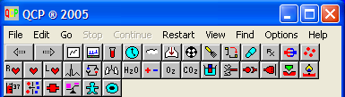

Controlling A Solution
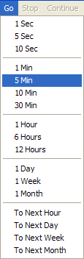

Solutions are calculated as a function of time. The Go main menu selection is used to advance time.

Available solution intervals are shown at the right.

During calculation, the solution may be interrupted using the main menu’s Stop selection. The solution may then be resumed using the Continue selection.

The Restart main menu selection resets the model to initial conditions.

Viewing The Results

The numerical values calculated during a simulation are displayed in many different formats including formatted numerical values, x-y graphs, bargraphs, functions of time, and qualitative values.

The sample at the right shows time displayed as a clock and calendar, blood pressure displayed numerically and a graph of systolic and diastolic pressure as a function of time during a 5 minute control period, 5 minutes of exercise bike at 150W, and 5 minutes of recovery.
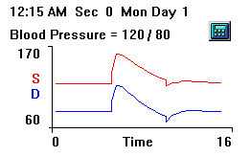

The calculator button evokes a calculator that can be used to convert blood pressure among the commonly used physical units.

Controlling The Display Of Results
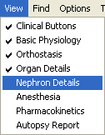
The display of results is controlled by the toolbar buttons immediately below the main menu (shown above).

Button groups may be added to and removed from the toolbar by clicking menu selections in the View menu.

A check indicates that the group is now displayed on the toolbar.

Changing Parameters

A variety of devices, including radiobuttons and slidebars are used to change QCP’s parameters.

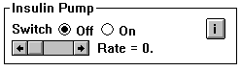

The figure above shows the radiobuttons used to turn on an insulin pump and the slidebar used to set the infusion rate.

A Complete Simulation

The General Idea

The section describes the steps that are needed to create and control a complete simulation. The topic is physical exercise. The goal is to monitor the physiological mechanisms that help to deliver large amounts of oxygen to working skeletal muscle.

The simulation will be divided into 3 periods: a 5 minute control period, a 5 minute exercise period, and a 5 minute cooldown period.

The Control Period
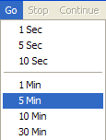

We begin by clicking Restart to reset the model’s variables to their initial values.

Use the Go menu to advance the solution 5 minutes.

Use the toolbar buttons to select the relevant panels and record values of interest.

The Exercise Period

We begin the exercise period by clicking the exercise toolbar button.

Select exercise bike for the type of exercise and slide the exercise level slidebar up to moderate (150 watts).

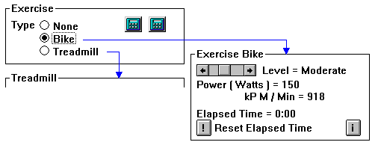

Exercise is under way.

Advance the solution another 5 minutes. Record values of interest.

Look for big increases in ventilation and blood flow.

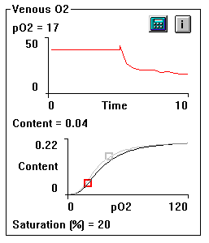

Note the large decrease in venous pO2 that occurred during exercise, the leftward and downward movement of the operating point on the oxygen dissociation curve and the change in the shape of the dissociation curve. The ghost shows the initial dissociation curve and operating point.

The Cooldown Period

We end exercise by again clicking the exercise toolbar button. Select none for the type of exercise; this gets the guy off the exercise bike.

Advance time a final 5 minutes and record values. You should see many of the variables that you have been following return toward their control values.

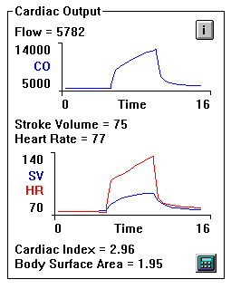

Notice the recovery of cardiac output, stroke volume and heart rate in the next figure.

The simulation is complete.

Panels that provided useful information during this simulation include

Charts
Monitor
Blood Chemistry
Ventilation
Blood Flow
Skeletal Muscle
Heat & Water Losses

Display Of Results

QCP displays numerical values and graphs on panels. Panels are selected for display by clicking on the appropriate toolbar buttons, shown below.

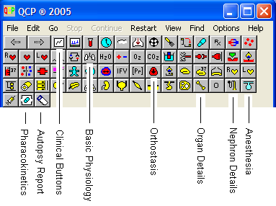

Panels are organized in groups. The View main menu selection invokes a pop down menu (shown above) that displays the names of available groups and allows you to move a group’s toolbar buttons to and from the toolbar.

A summary of toolbar buttons is presented next.

Clinical Buttons

Charts
Monitor
Blood And Urine Samples
Daily Planner

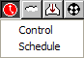

Environment
Air Supply
Exercise
Diet
Orthostasis
Rx – Drugs

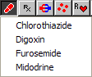

Rx – Miscellaneous

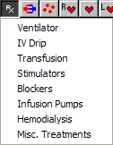

Basic Physiology

Hemodynamics

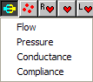

Blood

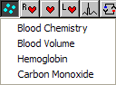

Right Heart

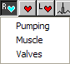

Heart – General

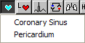

Left Heart

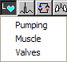

Heart Rate

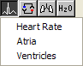

Respiratory Center

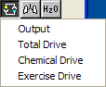

Ventilation

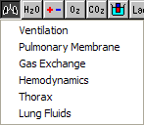

Water
Electrolytes

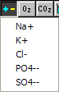

Oxygen
Carbon Dioxide
Acid – Base
Autonomics - Afferents

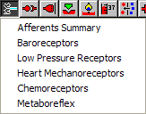

Autonomics - CNS

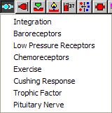

Autonomics – Efferents

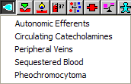

Hormones

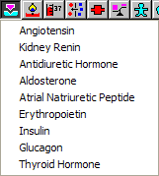

Metabolism

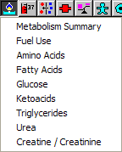

Temperature

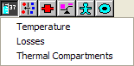

Osmolarity
Vascular Compartments

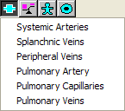

Body Composition
Organ Structure – Function
Cell Composition

Orthostasis

Pressure Gradients

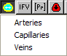

Interstitium

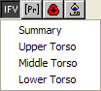

Protein Distribution
Sequestered Blood
Posture - Energetics

Organ Details

Brain

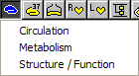

Brain – Temperature Regulation

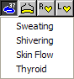

Respiratory Muscle
Right Heart
Left Heart

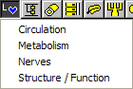

Gut – Circulation
Gut – Lumen

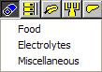

GI Tract

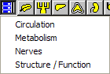

Pancreas

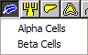

Portal Vein

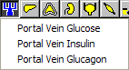

Liver

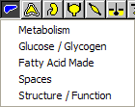

Adrenal Gland

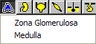

Kidney

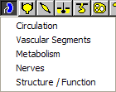

Bladder
Skeletal Muscle

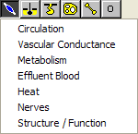

Skin

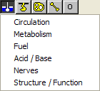

Sweat Glands

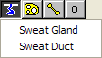

Adipose Tissue

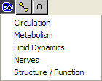

Bone
Other Tissue

Nephron Details

Nephron

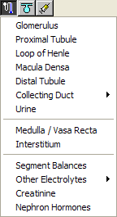

Anesthesia

Gas

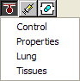

IV

Pharmacokinetics

Drugs

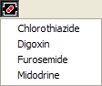

Autopsy Report

Details

Find Main Menu Selection

In addition to the toolbar buttons described above, you can search for individual variables by name using the Find main menu selection.

Patients

Patients Are Not Really Patients

Patients are really simulations that begin with a set of unusual initial conditions. It is your job to make an accurate diagnosis and to correct the condition if possible.
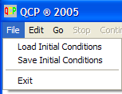

To see a patient, click on the File main menu selection and then click on Load Initial Conditions. A dialog box will list available patients as file names with an ICS extension, such as MR_SMITH.ICS. Select a patient, the patient’s data will be loaded, and the simulation can be undertaken.

Initially, the toolbar may only show buttons that are relevant to clinical medicine. You may be able to add additional buttons to the toolbar using the View main menu selection. If the View main menu selection is grayed out, you’re stuck with the initial lineup of toolbar buttons. You’ll be working with a limited amount of information in this case, rather than the full physiological picture.
A brief patient history is presented in the upper left-hand corner of the Charts panel.

Returning To Normal After Seeing Patients

Mr. Norm Subject represents a normal subject. Norm is described in the patient history section of the Charts panel as “... a middle-aged male in apparently good health.” When QCP is first run, Norm supplies the model’s initial conditions.

When a patient is loaded, the patient’s initial conditions replace Norm’s initial conditions and the patient history section of the Charts panel is updated.

After a patient is loaded, the Restart main menu selection starts the solution again using the patient’s initial conditions.

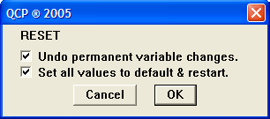

To re-establish Norm Subject’s initial conditions, click Options / Reset... The default checks are correct. Click OK. If successful, Norm’s thumbnail sketch will reappear on the Charts panel.

Thumbnail Sketches

QCP is supplied with a variety of patients, i.e., initial conditions files with ICS file extensions. A sampling of patients’ thumbnail sketches follows.

Mr. Baker Mr. Baker is in the ER with shortness of breath. He has tachycardia and a very strong pulse.

Mr. Best Mr. Best is a political activist who has been on a hunger strike for the past 30 days.

Mr. Cook You have just discovered Mr. Cook in his closed garage, unresponsive, with his automobile running. You immediately turned off his automobile.

Ms. Craft Ms. Craft is a diabetic. The nurse gave her an insulin shot when she awoke. Unfortunately, it was the wrong dose.

Mr. Davis Mr. Davis was in an automobile accident about an hour ago. Hemorrhaging was severe and it may be continuing.

Mr. Doe John Doe was shot in the neck and chest about an hour ago. He is hypotensive and not responding.

Ms. Goode Ms. Goode was sitting next to you in Wendy’s when she suddenly gasped and slumped to the floor.

Mr. Green Mr. Green was struck in the head in an industrial accident. He is now recovered, but he says that he is always thirsty.

Mr. Hobbs Mr. Hobbs was in a marine accident and was lost at sea for three days with no food and water.

Ms. Jones Ms. Jones is a lifelong smoker. She says she tires easily and complains of dyspnea.

Ms. Kelso Ms. Kelso is a Haitian immigrant who was very ill several times as a child. She has a murmur.

Mr. Rosco Mr. Rosco’s power saw severed an electrical wire. Fellow workers started CPR. EMT’s installed a ventilator.

Ms. Smith Ms. Smith reports periods of sweating and palpitations.

Mr. West Sgt. West stepped on a land mine in Croatia. He seemed to recover OK but something happened. He feels bad and has no stamina.

Mr. Wheat Mr. Wheat took one or more bullets to the chest. A friend rushed him to the ER.

Creating New Patients

The initial conditions to a solution can be stored in a file and reloaded at any time using the File / Load Initial Conditions menu selection. The file extension for initial condition files is traditionally .ICS, but any file extension can be used.

You can create a new initial condition file at any point in a solution using the File / Save Initial Conditions menu selection.

In addition to numerical values, the patient’s thumbnail sketch is also saved in an initial conditions file. You can edit the thumbnail sketch before saving to reflect the new initial conditions using the Options / Notes menu selection.

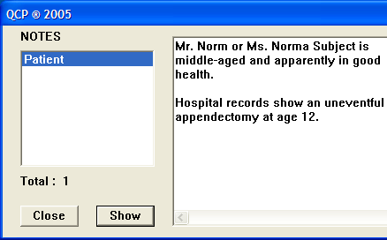

Some additional information is saved in an initial conditions file. You can adjust the value of the independent variable (time) and control the availability of toolbar groups using the Options / Saving IC’s menu selection before saving the initial conditions. This feature can be used to ensure that only clinical buttons are displayed, for example, when a particular initial conditions file is loaded.

Emergencies

This section describes some interventions that might be useful in an emergency. The list is not exhaustive.

Ventilator. There are three controls. You must turn the ventilator on and set the rate and tidal volume.

Air Supply. Use this intervention to change the inhaled gas mixture. There are several controls. You must turn the gas tanks on. Then the O₂ concentration is typically increased while the N₂ concentration is decreased.

IV Drip. Turn the drip on. Set the total volume to be infused, the duration of the infusion and the NaCl concentration.

Transfusion. Turn the transfusion on. Set the total volume to be transfused, the duration of the transfusion and the hematocrit of the transfused blood.

Hemodialysis. Install a shunt to obtain vascular access. Adjust shunt conductance to get a shunt blood flow of about 500 mL/Min. Then turn the dialyzer on. Adjust schedule and dialysate composition. Dialyzer activity panel will show the status.

Stimulators. Turn the cardiac pacer switch on and set the rate.

Insulin. Set the dose and duration of action. Then click the action button (!) to inject.

Orthostasis. If recumbency seems desirable, you can specify lying down.

Environment. Adjust the ambient temperature and type of clothing.

Diet. Augment or limit water access here. Change water intake from supplement when thirsty to fixed amount and then set the daily intake.

Defibrillator. Set the energy level. Then click the action button (!) to shock.

CPR. Set the chest compression and ventilator parameters. Turn switch on. CPR will begin on fibrillation and/or asystole as specified.

Special Features

Properties – The Right Mouse Button

The mouse cursor changes from an arrow to a hand when the cursor is over a panel item that has properties. Click the right mouse button to get a menu of available properties. The left mouse button is reserved for selecting images to send to the clipboard or printer.

The menu items illuminated on the properties menu are determined by the item under the hand cursor. Here are some possibilities.

Variable Provides detailed information about the variable under the hand cursor. Most of this information is in memory, but an additional, optional database file is also consulted if present.

History / View Shows all numerical values in the solution for a variable or group of variables in a graph. These values can be sent to the clipboard for import into another program such as a charting program.

History / Layout Lets you specify rows or columns as the formal for numerical values in History / View.

Graph / Background Lets you save the current tracing in a graph as a background image for the graph, to be overwritten by subsequent solutions.

Graph / Mark Lets you mark one or more graphs with a vertical and/or horizontal line at the graph’s current value.

Graph / Refresh Lets you select the values displayed in a graph: all values, new values, recent values. The graph is refreshed using the specified values.

Change Applies to parameters. A dialog box lets you make parameter changes permanent , i.e. not set to default value on restart.

To The Clipboard
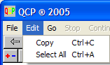
Images of part or all of a panel may be selected and sent to the clipboard for import into another program using the Edit / Copy menu selection. See also Properties above.

Hold down the left mouse button and drag to select part of a panel. Use the Edit / Select All menu selection to select all of a panel.
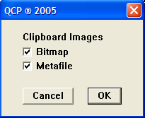

By default, images are sent to the clipboard in duplicate using two different graphics formats: Windows bitmap and Windows metafile. The receiving application will generally select the most appropriate format to paste from the clipboard. But, if this isn’t satisfactory, you can explicitly specify the graphics format for clipboard images using the Options / Clipboard menu selection.

Display Speed
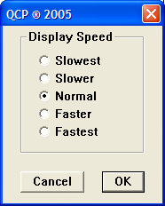

Panels are refreshed at evenly spaced intervals. You might want to slow down the display for demonstrations or speed it up for longer duration simulations where only the final values are of interest. Adjust the display speed using the Options / Display Speed menu selection.

Going Backward In A Solution

Use the Options / Backup menu selection to return to a previous point in a solution.

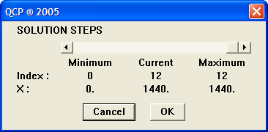

Hint: You may know in advance the point in a solution that you want to return to. If so, when you are initially at that point in the solution, click the Options / Backup menu selection and note the value of the solution index. Then exit by canceling. Later on you can readily return to this point by selecting Options / Backup again and sliding the solution back to the solution index that you previously noted.

Hint: If you want to repeatedly return to a particular point in a solution, it might be useful to make an initial conditions file at that point (see Creating New Patients in another section).

