Anemia

Red cell volume is below normal in anemia, as signaled by a decreased hematocrit.Anemia impairs oxygen delivery to the tissues due to the decreased oxygen carrying capacity of the blood. A main part of the homeostatic response is tissue vasodilation, which improves tissue oxygen delivery via increased cardiac output (shown below, data from Brannon).

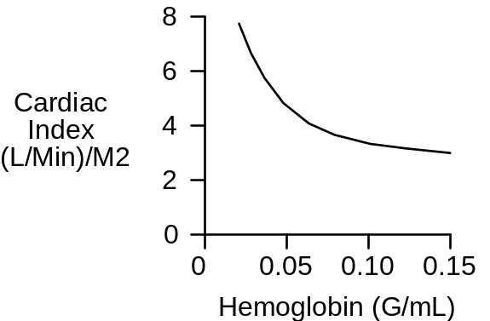
Blood viscosity is decreased in anemia, and this may be beneficial.

Erythropoietin production is stimulated in anemia that is caused by a non-erythropoietic defect in red cell production (shown below, data from Garcia).

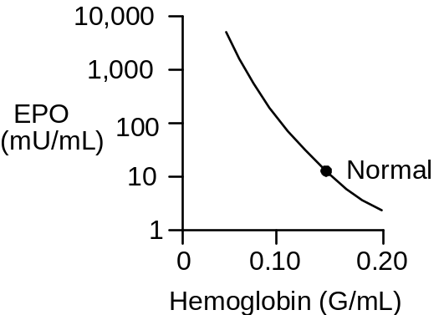

The Anemia Protocol

Click Restart to reestablish initial conditions and then record the control data. Go to Blood Volume. In the red cell production box, set the basic production rate to 0. Advance time and record data. Note the slow decline in red cell volume over time due to the long life span of redcells.

Red Cell Volume (mL)
Plasma Volume (mL)
Hematocrit (%)
Arterial [O2] (mL/mL)
Arterial pO2 (mmHg)
Venous [O2] (mL/mL)
Venous pO2 (mmHg)
Cardiac Output (mL/Min)

Time | 0  Min | 1  Month | 2  Months
Red Cell Volume(mL) | 2400 | 1869 | 1456
Plasma Volume(mL) | 3000 | 3495 | 3957
Hematocrit(%) | 44 | 35 | 27
Arterial [O2](mL/mL) | .20 | .15 | .12
Arterial pO2(mmHg) | 91 | 92 | 86
Venous [O2](mL/mL) | .15 | .11 | .08
Venous pO2(mmHg) | 42 | 39 | 35
Cardiac Output (mL/min) | 5361 | 6149 | 6944

Exercise Tolerance

Tolerance to exercise is decreased in acute and chronic anemia (shown below, data from Davies).

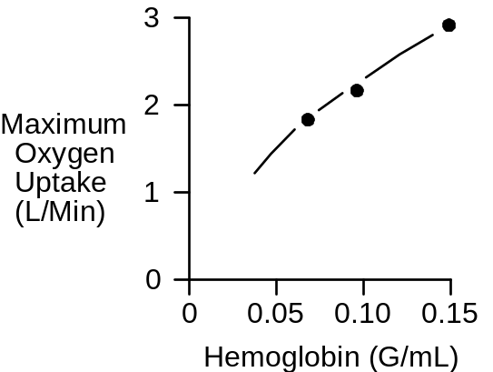

Use an exercise stress test to characterize QCP’s exercise tolerance in anemia.

Treadmill Speed (MPH)
Treadmill Grade (%)
Heart Rate (/Min)

Time | 0’ | 1’ | 2’ | 3’ | 4’ | 5’
Speed | 0 | 6 | 6 | 6 | 6 | 6
Grade | 0% | 0% | 2% | 4% | 6% | 8%
Heart Rate | 87 | 126 | 137 | 155 | 152 | X
Heart Rates recorded at the end of each period, exercise was started after two months.

Record the elapsed time and distance when this subject finally gives up.

Elapsed Time (Min) | 5:16
Distance Traveled (Ft) | 2257

Wrapup

Return basic red cell production to its normal value of 0.014 mL/Min and follow the recovery of red cell volume. Note the role of EPO.

Blood Viscosity And Anemia

Blood viscosity is a function of hematocrit (shown below, data from Whittaker, Stone).

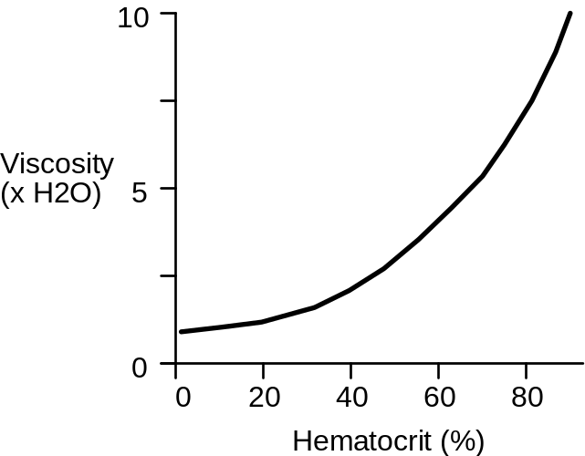

Follow changes in blood viscosity during the development of anemia at Conductance.

Click Restart to reestablish initial conditions and then record the control data. Again, go to Blood Volume and decrease basic red cell production rate to 0. Advance time and record data.

Hematocrit (%)
Blood Viscosity (x Normal)
Cardiac Output (mL/Min)

Time | 0  Min | 1  Month | 2  Months
Blood Viscosity(unitless) | 1.0 | 0.8 | 0.7
Hematocrit(%) | 44 | 35 | 27
Cardiac Output(mL/min) | 5361 | 6149 | 6944

Decreased blood viscosity in anemia has a beneficial effect on cardiac output. Return viscosity to normal using the fixed viscosity switch at Conductance and note the fall in cardiac output.

References

Brannon, E. S., A. J. Merrill, J. V. Warren and E. A. Stead, Jr. The cardiac output in patients with chronic anemia as measured by the technique of right atrial catheterization. J. Clin. Invest. 24:332-336, 1945.

Davies, C. T. M., A. C. Chukweumeka and J. P. M. vanHaaren. Iron-deficiency anaemia: Its effect on maximum aerobic power and responses to exercise in African males aged 17-40 years. Clin. Sci. 44:555-562, 1973.

Garcia, J. F., S. N. Ebbe, L. Hollander, H. O. Cutting, M. E. Miller and E. P. Cronkite. Radioimmunoassay of erythropoietin: Circulating levels in normal and polycythemic human beings. J. Lab. Clin. Med. 99:624-635, 1982.

Stone, H. O., H. K. Thompson, Jr. and K. Schmidt-Nielsen. Influence of erythrocytes on blood viscosity. Amer. J. Physiol. 214:913-918, 1968.

Whittaker, S. R. F. and F. R. Winton. The apparent viscosity of blood flowing in the isolated hindlimb of the dog, and its variation with corpuscular concentration. J. Physiol. 78:339-369, 1933.

