Diabetes Insipidus

Antidiuretic hormone (ADH) normally conserves the body's water by concentrating the urine.

Inadequate ADH secretion, known as diabetes insipidus, may occur when the brain is traumatized.Diabetes insipidus is characterized by excretion of large amounts of dilute urine (shown below, data from Valtin).

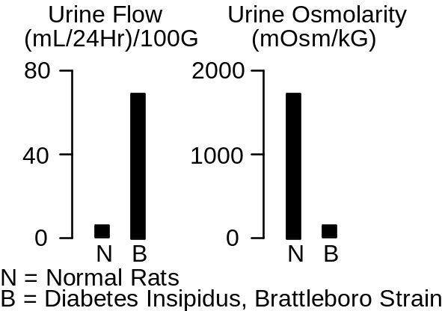
Plasma osmolarity and thirst are both increased in diabetes insipidus (shown below, data from Valtin).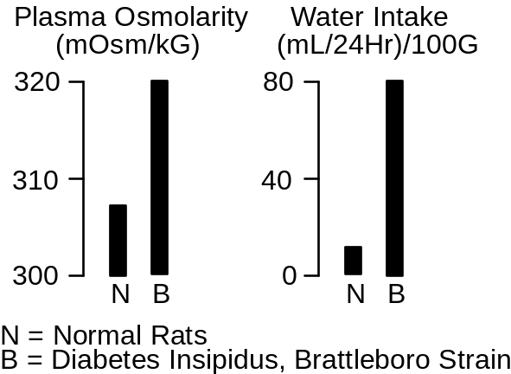

A popular experimental model of diabetes insipidus is a strain of rats, called the Brattleboro strain, which was created upon the chance discovery of a litter of rats with inherited or familial diabetes insipidus (Valtin & Schroeder).

The Diabetes Insipidus Protocol

Click Restart to reestablish initial conditions and then record the control data. Go to Antidiuretic Hormone. Set the secretion basic fraction to 0. Advance the solution and record data. Note the rapid decrease in plasma [ADH].

Plasma [ADH] (pG/mL)
Plasma [Osmolarity] (mOsm/L)
Water Intake (mL/Min)
Extracellular Fluid Volume (L)
Urine Flow (mL/Min)
Urine [Osmolarity] (mOsm/L)

Time | 0  Min | 10  Min | 1  Day | 1  Week
Plasma [ADH](pg/mL) | 2.0 | 1.3 | 2.0 | .2
Plasma [Osm](mOsm/L) | 290 | 290 | 295 | 316
H2O Intake(mL/min) | 2 | 1.4 | 1.4 | 8.6
ECFV(L) | 15.2 | 15.2 | 14.9 | 13.4
Urine Flow(mL/min) | .77 | 1.04 | .93 | 8.12
Urine [Osm](mOsm/L) | 812 | 667 | 828 | 99

What are the initial and final water intakes in L/Day?

References

Valtin, H. and H. A. Schroeder. Familial hypothalamic diabetes insipidus in rats (Brattleboro strain). Amer. J. Physiol. 206:425-430, 1964.

