High Altitude

The partial pressure of inspired oxygen decreases with increasing altitude. This causes a decrease in oxygen saturation in the arterial blood and impairs oxygen delivery to the tissues.

Record barometric pressure and inspired pO2 as altitude is increased from sea level to 25,000 feet in 5000 foot increments.

Altitude (Feet)
Barometric Pressure (mmHg)
Inspired pO2 (mmHg)

Altitude | 0 | 5000 | 10000 | 15000 | 20000 | 25000
Baro. Pressure(mmHg)
Inspired pO2(mmHg)

Ventilation At High Altitude

An important part of the acute response to high altitude is increased ventilation (shown below, data from Huston, Pugh).

Other important parts of the acute response to high altitude are vasodilation of hypoxic tissues and increased cardiac output supported in part by increased sympathetic outflow.

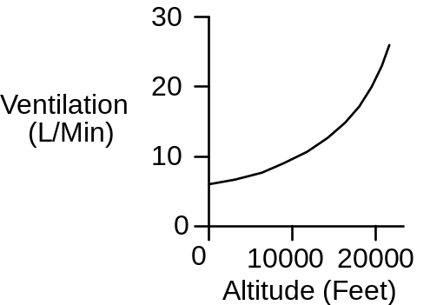

Blood Volume At High Altitude

An important part of the chronic response to high altitude is increased erythropoiesis, leading to increased red cell volume and hematocrit (shown below, data from Rotta). The positive part of this response is that the blood's oxygen carrying capacity is increased. The negative part is that blood viscosity is increased.

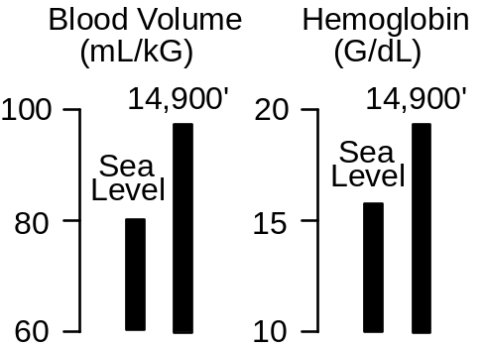

The High Altitude Protocol

Click Restart to reestablish initial conditions. Go to . In the Altitude box slide the Feet slidebar up to 10,000. Advance the solution 10 minutes.

Acutely, focus on effect of altitude on oxygen’s partial pressure and the ability of the body to load arterial hemoglobin. Chronically, focus on compensations that alter the body’s ability to deliver oxygen to the tissues.

Arterial pO2 (mmHg)
Arterial [O2] (mL/mL)
Venous pO2 (mmHg)
Venous [O2] (mL/mL)
Arterial pCO2 (mmHg)
Venous pH
Cardiac Output (mL/Min)
Heart Rate (/Min)
Stroke Volume (mL)
Sympathetic Nerve Activity
Plasma Renin Activity
Na+ Excretion (mEq/Min)

Erythropoietin
Blood Volume (mL)
Red Cell Volume (mL)
Plasma Volume (mL)
Hematocrit (%)
Oxygen Uptake (mL/Min)

Time | 0  Min | 10  Min | 1  Day | 1  Month
Arterial pO2(mmHg)
Arterial [O2](mL/mL)
Venous pO2(mmHg)
Venous [O2](mL/mL)
Arterial pCO2(mmHg)
Venous pH
Cardiac Output(mL/min)
Heart Rate(bpm)
Stroke Volume(mL)
Symp Nerves(Hz)
Plasma Renin(ng AI/mL/hr)
Na+ Excretion(mEq/min)
Erythropoietin(mU/mL)
Blood Volume(mL)
Red Cell Volume(mL)
Plasma Volume(mL)
Hematocrit(%)
Oxygen Uptake(mL/min)

Use an exercise stress test to characterize cardiac function.

Treadmill Speed (MPH)
Treadmill Grade (%)
Heart Rate (/Min)

Time | 0’ | 1’ | 2’ | 3’ | 4’ | 5’
Speed | 0 | 6 | 6 | 6 | 6 | 6
Grade | 0% | 0% | 2% | 4% | 6% | 8%
Heart Rate

Record the elapsed time and distance when this subject finally gives up.

Elapsed Time (Min)
Distance Traveled (Ft)

Discussion Question

What is the cardiovascular and respiratory response to loss of cabin pressure in an aircraft flying at 30,000 feet?

References

Houston, C. S. & R. L. Riley. Respiratory and circulatory changes during acclimatization to high altitude. Amer. J. Physiol. 149:565-588, 1947.

Pugh, L. G. C. E. Resting ventilation and alveolar air on Mount Everest: With remarks on the relation of barometric pressure to altitude in mountains. J. Physiol. 135:590-610, 1957.

Rotta, A., A. Cánepa, A. Hurtado, T. Velásquez, & R. Chávez. Pulmonary circulation at sea level and at high altitude. J. Appl. Physiol. 9:328-336, 1956.

