Cardiac Output via Fick’s Principle

Fick’s principle has been stated in various ways. The paraphrase used here is: At steady-state, the rate of flow of a material into a compartment is equal to the rate of flow out of the compartment.

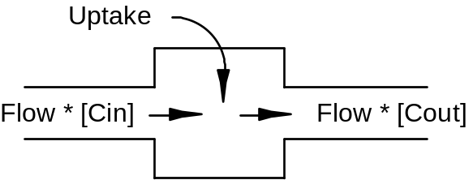

In this exercise, we’ll calculate cardiac output using the rate of flow of oxygen into and out of the lungs. Oxygen inflow (O2 Inflow) into the lungs is equal to the cardiac output (Flow) multiplied by the oxygen concentration in the pulmonary artery ([Cin]) plus the rate of oxygen uptake from the environment (Uptake).

O2 Inflow = Flow * [Cin] + Uptake (1)

Oxygen outflow from the lungs (O2 Outflow) is equal to the cardiac output (Flow) multiplied by the oxygen concentration in the pulmonary veins ([Cout]).

O2 Outflow = Flow * [Cout] (2)

We now assume oxygen outflow is equal to oxygen inflow. From equations (1) and (2) above, we get

Flow * [Cout] = Flow * [Cin] + Uptake (3)
We now rearrange equation (3) to solve for cardiac output (Flow).

Flow = Uptake / ([Cin] - [Cout]) (4)

Click Restart to reestablish initial conditions. Record oxygen concentration (content) in the pulmonary artery and veins and the oxygen uptake. Calculate cardiac output and compare to the actual cardiac output.

Pulmonary Artery [O2] (mL/mL)
Pulmonary Vein [O2] (mL/mL)
O2 Uptake (mL/Min)
Cardiac Output (mL/Min))

Pulmonary Artery [O2](mL/mL) | .15
Pulmonary Vein [O2](mL/mL) | .20
O2 Uptake(mL/min) | 249
Calculated Cardiac Output(mL/min) | 4980
Actual Cardiac Output(mL/min) | 5361

What is the error in calculated cardiac output when either of the 2 oxygen concentrations has a 10% error? What is the error in calculated cardiac output when oxygen uptake has a 10% error?

Questions For Discussion

Can Fick’s principle be used to accurately calculate cardiac output during exercise?

Where else in the body can Fick’s principle be put to good use?

