Software Design Document
Team | Project ID | Member | SRN
DND | 16 | Huma | PES2UG24AM066
 |  | Ashmitha Sri Anand | PES2UG24AM031
 |  | Chennupati Niraj Kumar | PES2UG24AM046
 |  | Dhruv Jagadeesh Hemmige | PES2UG24AM053

Repository: github.com/Huma13/DND-JobConnect

Introduction

Purpose and Scope
This document describes the design of DND-JobConnect as it was built. It breaks the architecture into modules, classes, data structures, interfaces and runtime behaviour, and shows how the work was split in the team. It is used for code reviews, testing and maintenance.
The system finds jobs on LinkedIn, Naukri.com and X, ranks them against the profile taken from the user's resume, and helps the user apply in three ways. It also suggests recruiters, drafts outreach messages, schedules searches within rate limits and shows application analytics. It is a Django REST backend with Celery workers and a React web client.

References
- SRS, Project 16, v1.0 (REQ-1 to REQ-24, SRS section 6).
- SW Architecture document, Team 16.
- Project Test Plan, Team 16 (TC-01 to TC-36).
- Repository README, docs/deviations.md and docs/testing/test-report.md.

Design constraints carried over from the SAD
- Layered architecture: Presentation, Business/Service, Integration, Data and Infrastructure. A layer only calls the layer below it.
- Platform terms: LinkedIn and Naukri have no application API and do not allow bots, so applying and messaging there is done by the user with help from the system (SAD section 2.1).
- Safety: nothing is submitted without confirmation unless the user turns on Full-Auto for that channel. There are daily caps and a Pause All switch.
- Technology: Python 3.12, Django 5.2, Django REST Framework, SimpleJWT, Celery 5 with Redis, PostgreSQL 15, React 19 with Vite and Tailwind CSS, Docker Compose, GitHub Actions.

Design Overview
Each SAD component is a Django app with its own models, services, serializers, views and URLs. Business rules sit in services modules so the REST views, Celery tasks and management commands all use the same checks.
SAD component | Package | Key modules | Requirements
Web Client | frontend/src | api/client.js, pages/*, components/* | SRS 3.1
REST API Gateway | config, */views.py, */urls.py | config/urls.py, DRF routers, JWT auth | SRS 3.3, 6.3
Auth & Access Control | accounts | models.User, views, gates.py, disclaimer.py, permissions.py | 6.2, 6.3, 6.5, 7
Resume & Profile Optimizer | resume_parser | upload.py, extract.py, profile_views.py, profile_tips.py | REQ-1 to 4, #12
Job Aggregation & Matching | matching | services.py, scoring.py, dedup.py, filters.py | REQ-5 to 8
Scheduler & Rate Limiter | scheduler | tasks.py, ratelimit.py, beat.py | REQ-18 to 20
Application Manager | applications | services.py, kit.py, views.py | REQ-9 to 13
Analytics & Reporting | applications (views) | statistics, response-analytics, keyword-analytics, export | REQ-21 to 24
Outreach & Connection Manager | outreach | services.py, views.py | REQ-14 to 17
Notification Service | applications | notifications.py, Notification model | REQ-13
Job sources, ATS, X adapters | integrations | base.py, registry.py, x_source.py, listings.py, ats.py, x_dm.py, demo.py | SRS 3.2
Persistence / Task queue / Vault | Django ORM, Celery, Redis | models.py, config/celery.py, credential_crypto.py | 2.4, 6.3

Request flow: the React client calls /api/... with a JWT token. A DRF view validates the input with a serializer, calls a service function and returns JSON. Long tasks (searches, scheduled runs) go to a Celery worker and the client polls the run record.

Module Design

accounts: authentication and access control
- User extends Django's AbstractUser. Email is the login field, and it stores the role (JOB_SEEKER or ADMIN), automation_paused (Pause All) and the accepted disclaimer version.
- Registration always creates a Job Seeker (SRS 6.5). Passwords are hashed with Argon2.
- Login gives a SimpleJWT access token (30 minutes) and a refresh token (7 days).
- gates.disclaimer_accepted() runs before any automation (search, submit, outreach). Changing DISCLAIMER_VERSION makes users accept the new text again.
- pause_all sets automation_paused. Services and Celery tasks check it first, and a run in progress stops saving results.

resume_parser: resume upload, profile and tips
- upload.validate_upload checks the file type (extension and signature, %PDF- or PK zip) and size (5 MB). The file is parsed in memory and thrown away, only the profile is stored.
- extract.parse_resume_file pulls text using pdfplumber or python-docx and raises ScannedResumeError if a PDF has no text layer (REQ-4). It splits sections by headings and finds name, skills, years of experience, highest qualification and up to five roles.
- ProfileView (GET/PUT/PATCH) lets the user edit every field (REQ-3). Saving calls matching.services.rescore_feed so the ranking updates.
- profile_tips.generate_profile_tips compares the profile with the user's top feed postings and returns missing keywords, coverage and headline suggestions.

matching: search, relevance and de-duplication
Relevance score (REQ-6). score = 50 × skill match + 30 × role match + 10 × location match + 10 × experience match, rounded to 0 to 100. Skills in the title count double. Abbreviations (ML, SDE, Sr.) are expanded before roles are compared, and skill matching uses word boundaries.
De-duplication (REQ-7). dedup_key is the SHA-256 of the normalised title and company (case, punctuation, "Pvt Ltd" and "Sr." removed). The first FeedItem with a key is the main one. Later copies point to it through duplicate_of, and the main item keeps the higher score.
Search (REQ-5). run_search(user) builds a SearchQuery from the profile, checks the rate limiter for each platform, calls the sources in parallel with a thread pool and timeout, and saves results in one transaction per posting. If one source fails it is logged and the others carry on.
Filters (REQ-8). FeedFilter supports platform, location, min_score and posted_within_days.

scheduler: schedules, runs and rate limits
- Schedule stores cadence, time, weekday and time zone. beat.sync writes a django-celery-beat crontab for each user (REQ-18).
- execute_run saves a ScheduledRun with platforms, postings found, new matches, duplicates hidden, errors and deferred platforms (REQ-20), then notifies the user.
- ratelimit.acquire uses fixed windows per user, platform and action, locked with SELECT … FOR UPDATE so parallel workers cannot go over the limit. At 90% of the limit (hold_threshold) it returns Deferred(retry_at) and the task is queued again for the next window (REQ-19). A 429 from a platform marks the window as used up until its reset time.

integrations: adapters to external systems
- IJobSource (Protocol): XJobSource (X API v2 recent search through Tweepy), LinkedInListingSource and NaukriListingSource (public listings through PoliteFetcher: GET only, own User-Agent, delay per host, robots.txt followed) and DemoJobSource (recorded postings, enabled with DEMO_SOURCES=1).
- registry.get_source(platform) is the only place that picks an implementation, so adding a source changes one module (SRS 6.4).
- IAtsAdapter (Protocol): GreenhouseAdapter and LeverAdapter fill the standard application forms, and detect_ats(url) picks the adapter from the posting URL. A CAPTCHA raises CaptchaDetected.
- XMessenger.send(handle, text) sends an X direct message and returns the event id.

applications: kits, channels, review and analytics
- build_kit(profile, user, posting) makes a tailored resume text, cover letter and answers to common questions (REQ-9). The user can edit and download the kit.
- Three channels: manual (assisted apply on LinkedIn/Naukri, finished with mark-applied), ats (Greenhouse/Lever) and email (sent from the user's own SMTP mailbox, password stored encrypted).
- services.submit checks in this order: Pause All (409), method allowed, not already submitted (409), confirmation unless Full-Auto (428, REQ-10), and daily limit per channel, default 20 (429, REQ-11). Every attempt is saved with status success, failure or captcha (REQ-12). A CAPTCHA sets manual_review_required and notifies the user, with no retry (REQ-13).
- Analytics endpoints give counts by platform and status for a date range (REQ-21), response rate overall and per platform (REQ-23), keyword yield and a CSV export (REQ-24). Users can change status by hand and log replies and interviews (REQ-22).

outreach: recruiters and messages
- suggest_recruiters(posting) takes contacts from the posting itself: the X author, LinkedIn profile links and @handles in the description, across all merged duplicates (REQ-14).
- draft_message writes a personal note with the role, company and the user's matching skills (REQ-15). LinkedIn notes are limited to 300 characters.
- _guard checks Pause All and the daily limit per platform, default 15 (REQ-16). It also rejects text already sent to a different recipient, compared by hash ignoring case and spaces (REQ-17).
- X messages go through XMessenger. LinkedIn notes are sent by the user from the opened profile and recorded with mark-sent.

frontend: web client
- api/client.js: one axios instance with the JWT header, a single refresh and retry on 401, readable error messages from DRF, and pagination helpers.
- auth/AuthContext and DisclaimerGate: route protection and the legal disclaimer before any screen.
- Pages and components map one to one to requirements (see Requirements Traceability).

Data Design
All data is stored in PostgreSQL through the Django ORM. Lists (skills, roles, platforms) use JSON fields and enumerations use Django TextChoices. The models are grouped by area in the diagrams below.
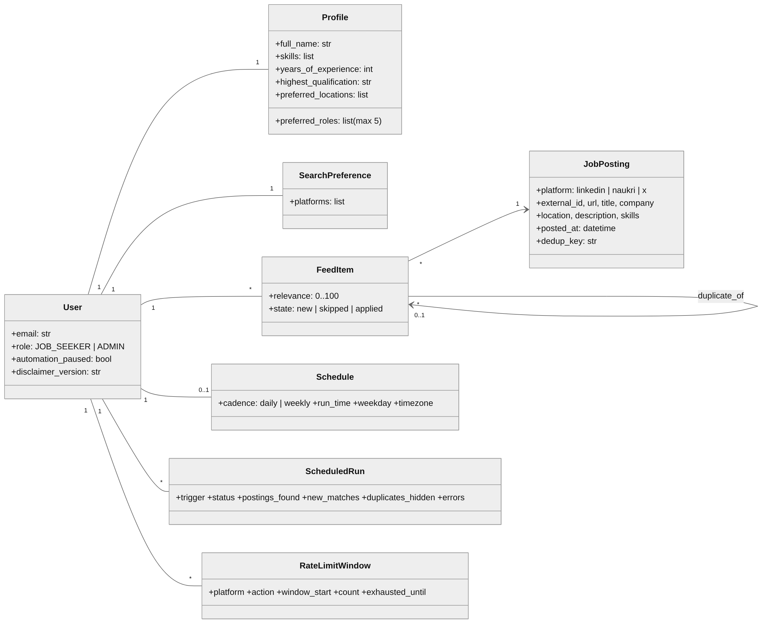
Figure 1: Class diagram: users, profile, postings, feed and scheduling
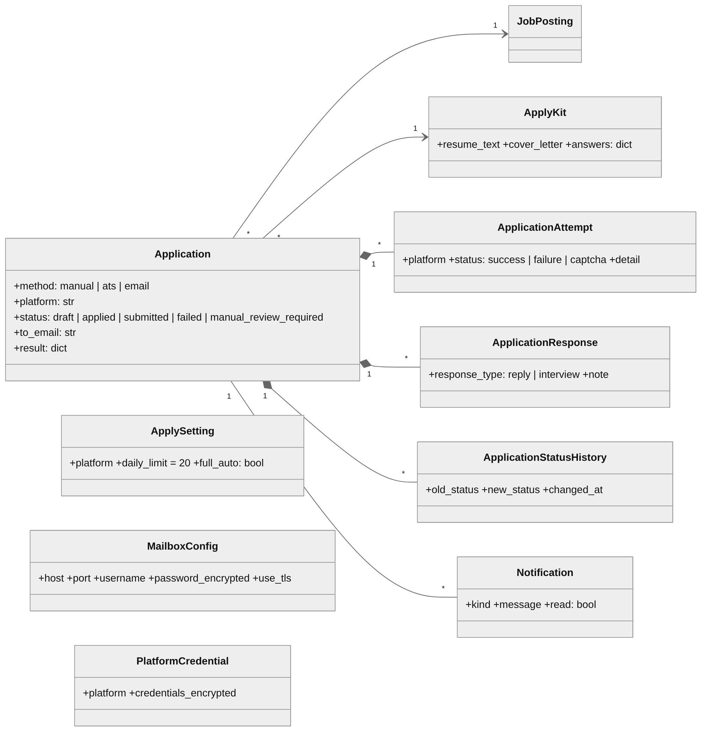
Figure 2: Class diagram: applications and their history
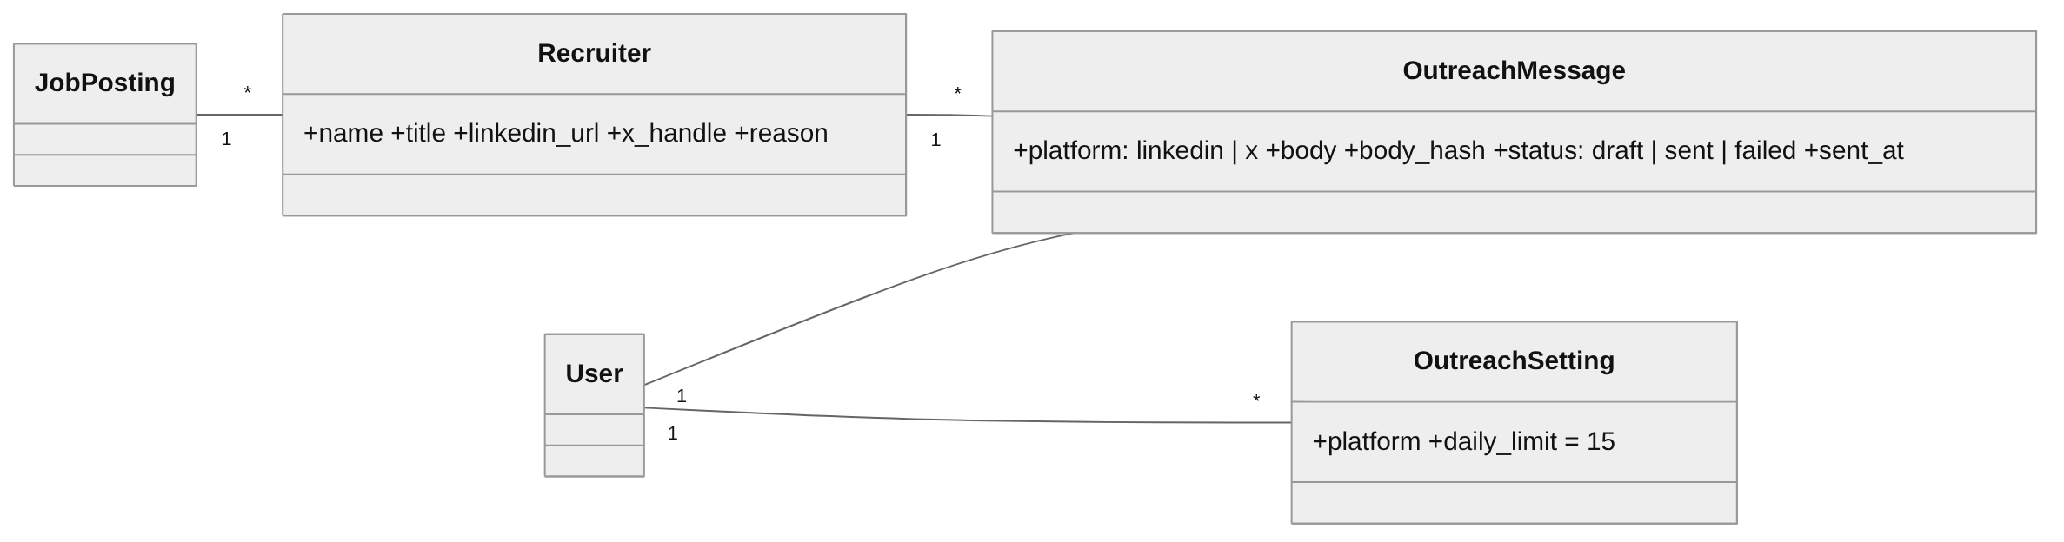
Figure 3: Class diagram: recruiter outreach

Integrity rules
Rule | Where enforced
A posting is stored once per platform | UniqueConstraint(platform, external_id) on JobPosting
A posting appears once in a user's feed | UniqueConstraint(user, posting) on FeedItem
Feed ordering | Index (user, duplicate_of, -relevance)
One schedule and one mailbox per user | OneToOne fields
An application's kit cannot be deleted while used | Application.kit on_delete=PROTECT
Secrets never stored in plain text | AES-256-GCM (credential_crypto.py) for platform credentials; Fernet for the mailbox password; write-only in serializers

Interface Design

External API (REST)
All endpoints are under /api/, use JSON and need Authorization: Bearer <access token>, except register, login and refresh. Lists are paginated (25 per page) as {count, next, previous, results}.
Method | Endpoint | Purpose | Req.
POST | /auth/register/, /auth/login/, /auth/refresh/ | Create Job Seeker; obtain and refresh JWT | 6.3, 6.5
GET, POST | /auth/disclaimer/ | Show and accept the legal disclaimer | 7
GET, POST | /auth/pause/ | Read or set Pause All | 6.2
POST | /resume/upload/ | Upload PDF/DOCX (multipart field file), returns parsed fields | REQ-1, 2, 4
GET, PUT, PATCH | /resume/profile/ | View and edit the profile | REQ-3
POST | /resume/tips/ | Profile optimisation tips | #12
GET, PUT | /jobs/preferences/ | Platforms to search | REQ-5
GET | /jobs/feed/?platform&location&min_score&posted_within_days | Ranked, de-duplicated feed | REQ-6 to 8
POST | /jobs/feed/search/, /jobs/feed/{id}/skip/ | Start a search (202 + run_id); hide a posting | REQ-5
GET, PUT, DELETE | /scheduler/schedule/ | Daily or weekly schedule | REQ-18
GET | /scheduler/runs/, /scheduler/rate-limits/ | Run log; current rate-limit usage | REQ-19, 20
POST | /applications/ | Start an application {feed_item, method, to_email?} | REQ-9
GET | /applications/{id}/review/ | Content shown before submitting | REQ-10
POST | /applications/{id}/submit/ {confirmed} | Submit through career page or email | REQ-10, 12, 13
POST | /applications/{id}/mark-applied/ | Record an assisted application | REQ-12
PATCH | /applications/{id}/change-status/ | Change status manually | REQ-22
GET, POST | /applications/{id}/responses/ | Log employer reply or interview | REQ-22, 23
GET, PUT | /applications/limits/ | Daily limit and Full-Auto per channel | REQ-10, 11
GET, PUT, PATCH | /applications/mailbox/ | User's SMTP mailbox for email apply | REQ-9
GET | /applications/statistics/, response-analytics/, keyword-analytics/, export/ | Analytics and CSV export | REQ-21, 23, 24
GET, POST | /applications/notifications/, …/{id}/read/ | In-app notifications | REQ-13
GET | /outreach/recruiters/?feed_item= | Suggested recruiters with reason and best channel | REQ-14
POST, PATCH | /outreach/messages/, /outreach/messages/{id}/ | Create and edit a personalised draft | REQ-15
POST | /outreach/messages/{id}/send/ (X), …/mark-sent/ (LinkedIn) | Send or record a message | REQ-16, 17
GET, PUT | /outreach/limits/ | Daily outreach limit per platform | REQ-16

Error contract
Status | Meaning in this API
400 | Validation error: {field: [message]} or {error: message}
401 | Missing or expired token; the client refreshes once, then signs out
403 | Wrong role (for example a Job Seeker calling admin endpoints), or disclaimer not accepted
404 | Object not found or owned by another user (ownership is never revealed)
409 | Automation paused, already submitted, a search already running, or identical outreach text
428 | Confirmation required before submitting (REQ-10)
429 | Daily limit reached (REQ-11, REQ-16) or platform rate limit

Internal interfaces (ABI)
Inside the backend, components talk through Python interfaces. They are the stable contracts that let an adapter be replaced or added without changing the callers, and are declared with typing.Protocol and frozen dataclasses.
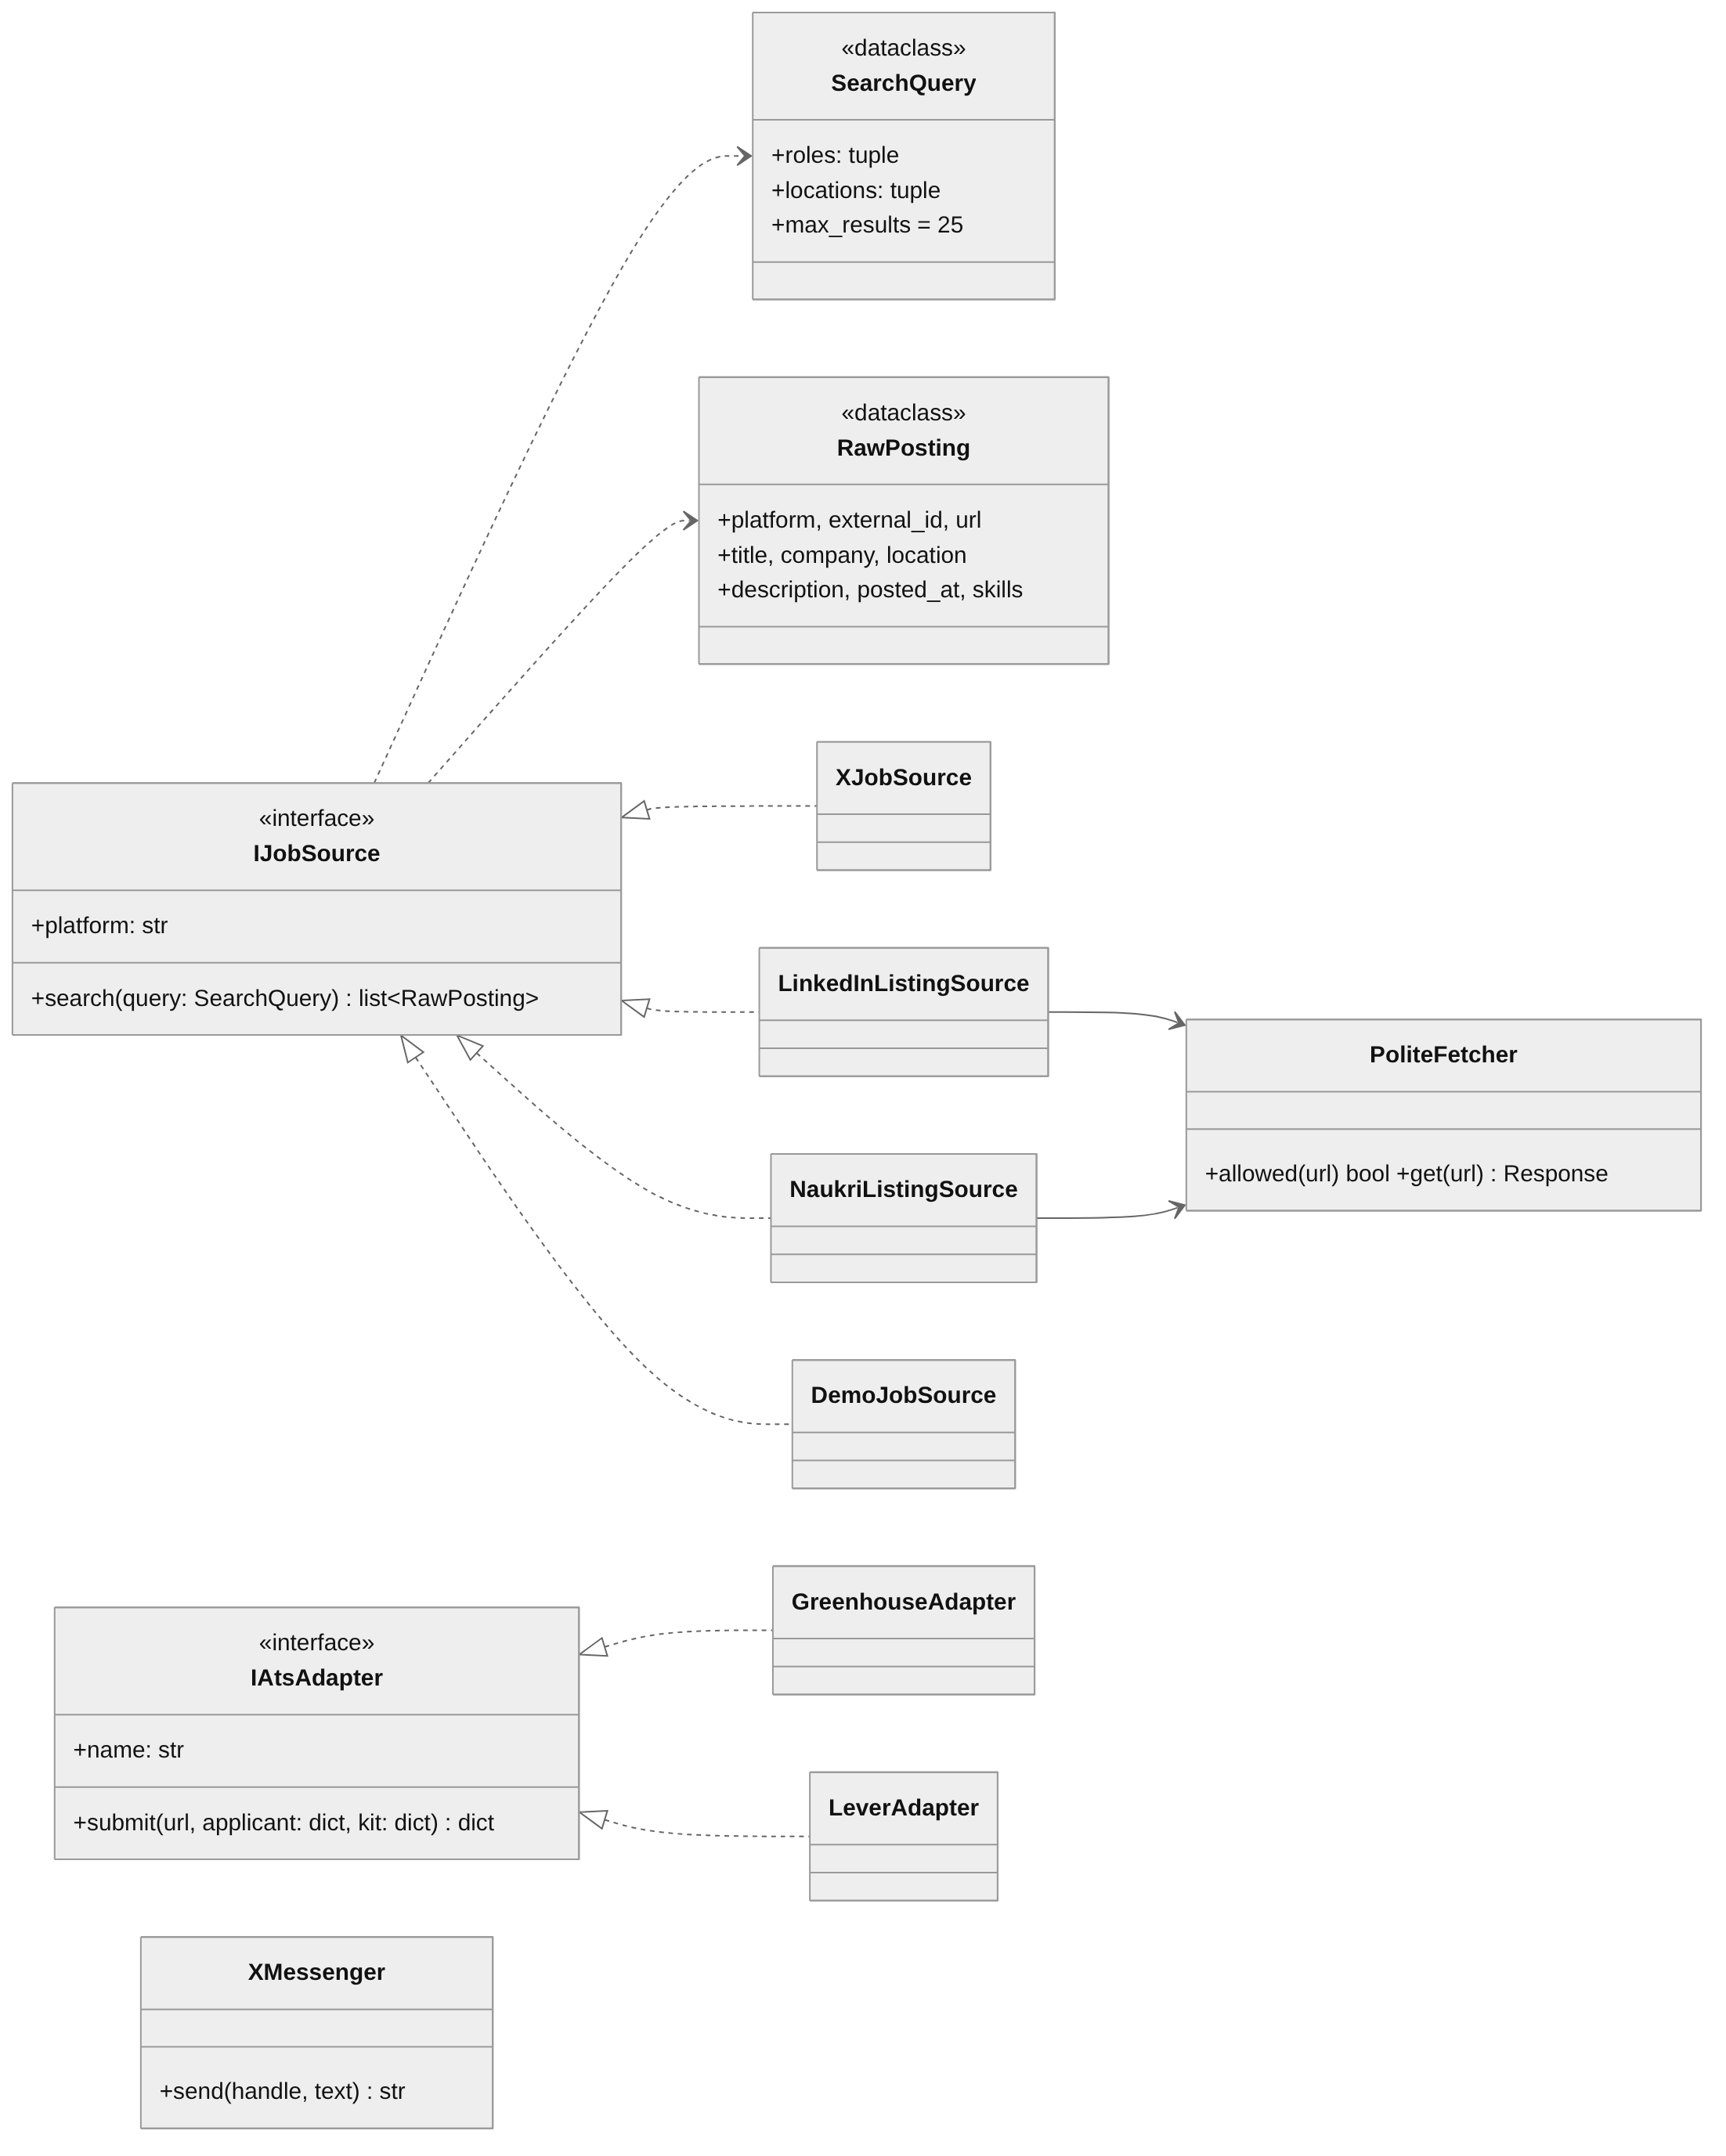
Figure 4: Internal interfaces and their implementations
class IJobSource(Protocol):
platform: str
def search(self, query: SearchQuery) -> list[RawPosting]: ...

@dataclass(frozen=True)
class SearchQuery: roles: tuple[str, ...]; locations: tuple[str, ...] = (); max_results: int = 25

class IAtsAdapter(Protocol):
name: str
def submit(self, url: str, applicant: dict, kit: dict) -> dict: ...

Errors: SourceError, SourceRateLimited(retry_at), CaptchaDetected, SubmitError, SubmitRateLimited

Compatibility and versioning
- Backward compatibility: endpoints only gain optional fields, and existing fields keep their name and type. New behaviour is opt-in (for example DEMO_SOURCES, Full-Auto).
- Database changes are Django migrations. CI fails if a model change has no migration (makemigrations --check).
- The disclaimer is versioned, so a new version needs re-acceptance without breaking older accounts.
- A breaking API change would go under /api/v2/ while /api/ stays for one release.

Dynamic Behaviour
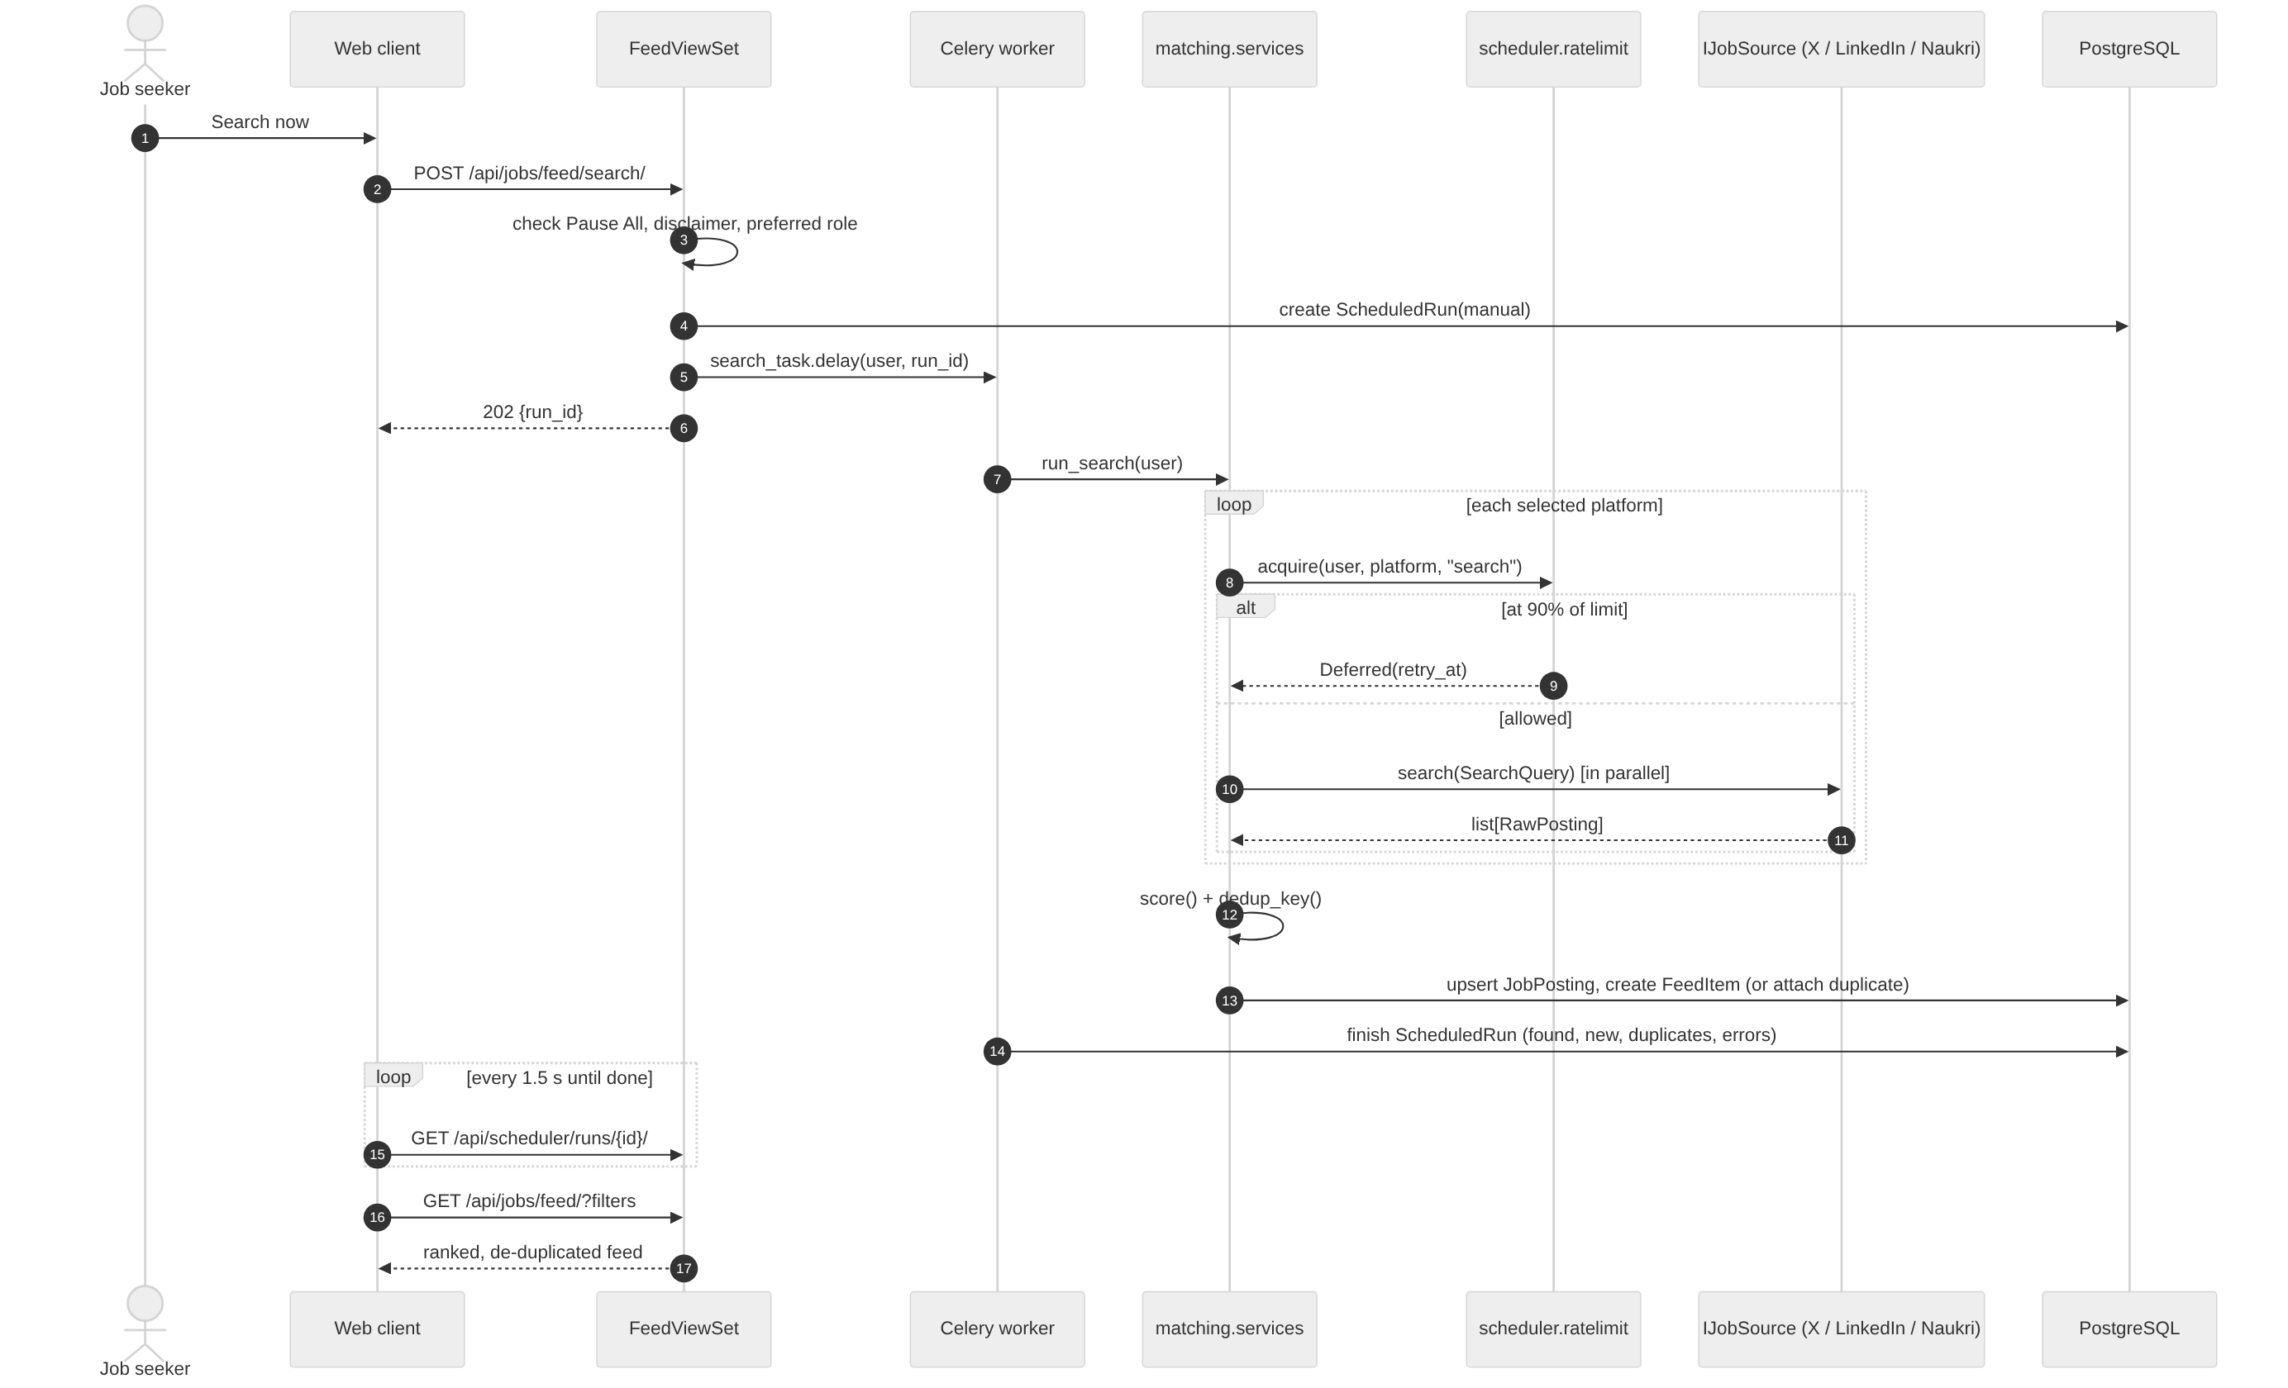
Figure 5: Sequence: manual search, ranking and de-duplication
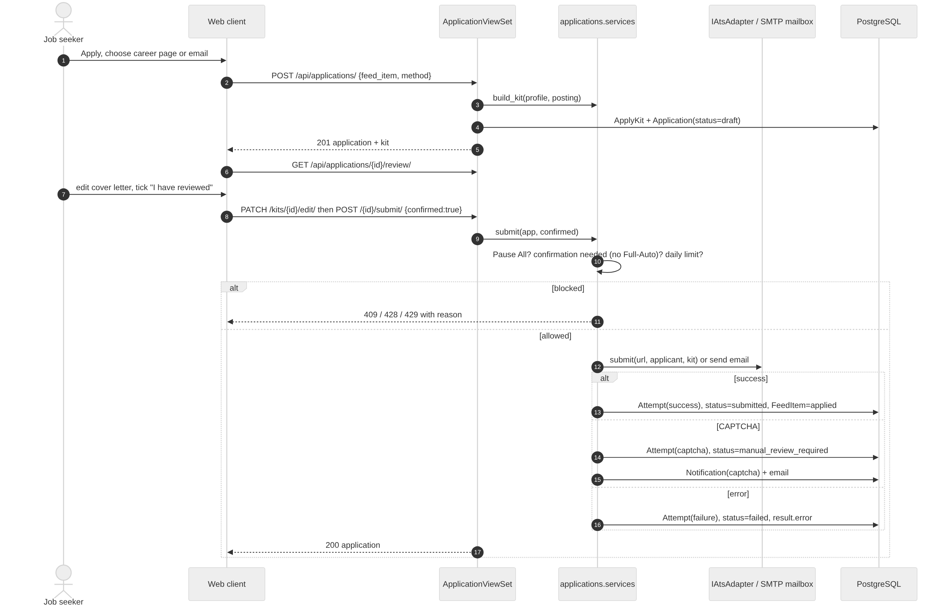
Figure 6: Sequence: career-page or email application with review before submit
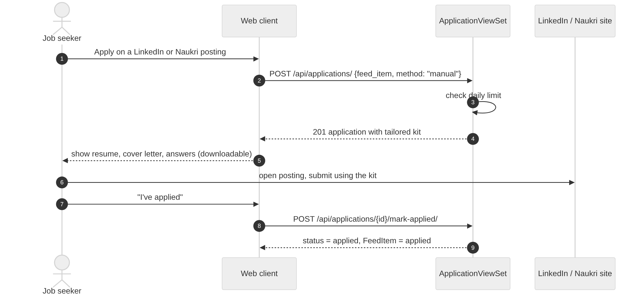
Figure 7: Sequence: assisted apply on LinkedIn or Naukri
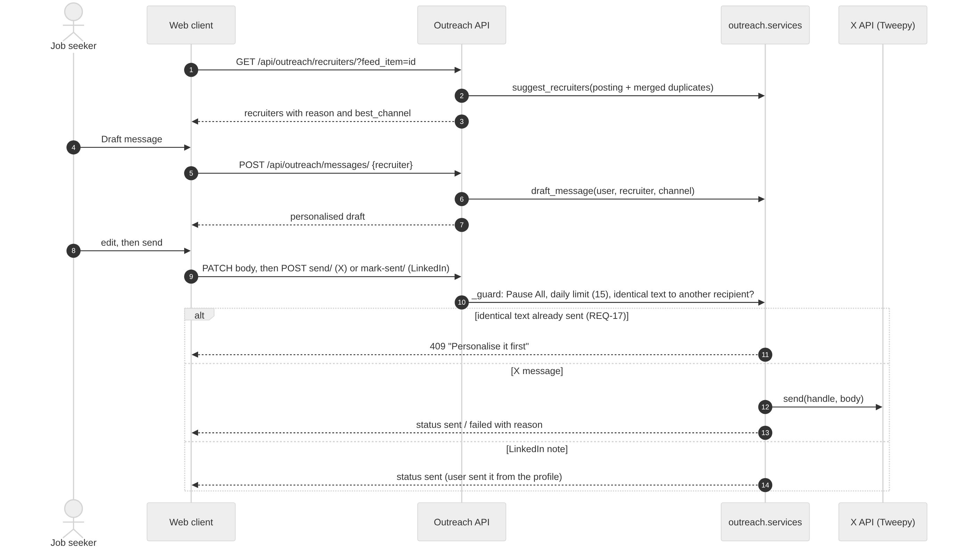
Figure 8: Sequence: recruiter outreach with limits and the identical-message block
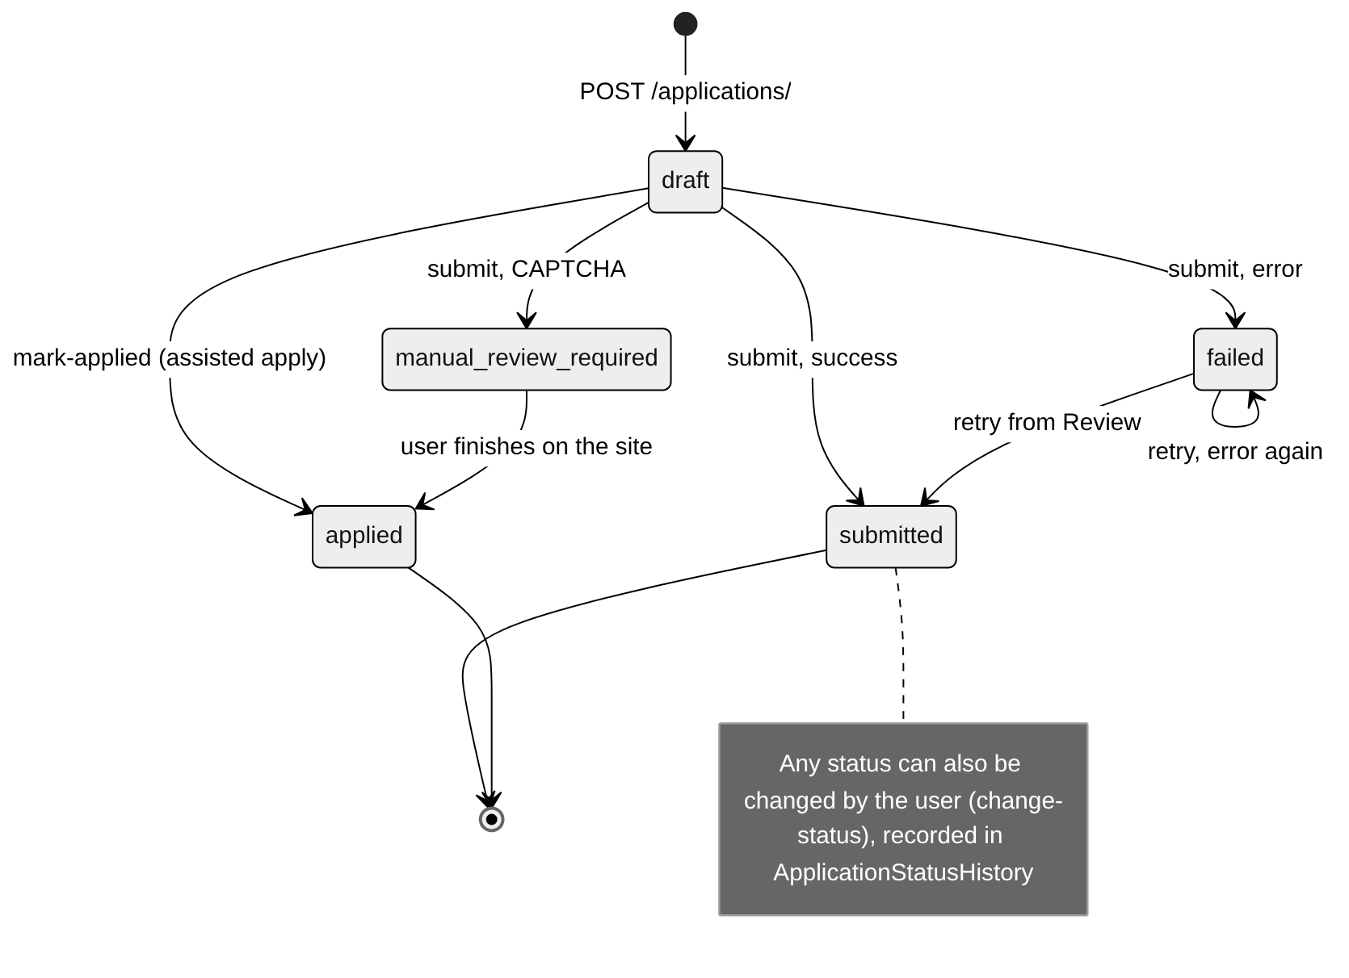
Figure 9: State diagram: Application.status

User Interface Design
Screen | Main elements | Requirements
Sign in / create account | Email and password; errors shown inline | 6.3, 6.5
Disclaimer | Versioned text, accept once per version | 7
Profile | Drag-and-drop upload, editable fields with tag inputs, profile tips | REQ-1 to 4
Job feed (home) | Filter rail, ranked rows with score pill and bar, "Also on" badge, Apply, Recruiters, Skip, Search now | REQ-5 to 8
Apply dialog | Channel choice, tailored kit tabs and downloads, open posting, I've applied | REQ-9, 12
Review | Queue of drafts, failures and CAPTCHA stops; review modal with explicit confirmation | REQ-10, 13
Outreach | Suggested recruiters, personalised draft, daily cap, send or mark sent | REQ-14 to 17
Analytics | KPIs, by-channel charts, keyword yield, history with status change and reply/interview logging, CSV export | REQ-21 to 24
Settings | Pause All, sources, schedule, limits and Full-Auto, mailbox, rate-limit usage, run log | 6.2, REQ-5, 10, 11, 16, 18 to 20
Notification bell | Unread count and list | REQ-13

Design rules: every action that sends something to a third party needs an explicit click, errors explain the reason in plain language, every list has loading, empty and error states, and the layout works down to phone width.

Security Design
Threat | Control
Stolen passwords | Argon2 hashing; no password ever returned by the API
Session theft | 30-minute JWT access tokens, 7-day refresh tokens
Privilege escalation | Registration cannot set the role; admin endpoints check the ADMIN role (403 otherwise)
Reading other users' data | Every queryset is filtered by request.user; foreign IDs return 404
Leaked credentials | Platform credentials AES-256-GCM, mailbox password encrypted, both write-only
Account bans and spam | Review before submit, daily caps, rate-limit hold at 90%, identical-message block, Pause All, robots.txt respected
Malicious uploads | Extension and file-signature checks, 5 MB limit, file not stored
Vulnerable code | SonarQube quality gate, OWASP ZAP baseline scan and ruff on every pull request

Design Patterns Used
Pattern | Where | Why
Adapter | IJobSource and IAtsAdapter implementations | Each external platform hidden behind one interface
Registry / Factory | integrations.registry.get_source, ats.get_ats_adapter | Single place to choose an implementation
Service layer (Facade) | */services.py | Views, tasks and commands share the same business rules
Strategy | Application.method: manual, ats, email | Channel chosen per application, same lifecycle
Observer (notifications) | notify_captcha, notify_status_change | Status changes create in-app and email notices
Repository | Django ORM managers and querysets | Persistence isolated from business logic
Command + queue | Celery tasks | Searches run outside the request

Division of Work
Member | Modules and features | Issues
Huma (PES2UG24AM066) | accounts (registration, login, roles, Pause All, disclaimer, admin logs); resume upload and parsing; profile tips; encrypted platform credentials; SonarQube; OWASP ZAP and security testing | #1 to #5, #7, #9, #10, #12, #13, #44
Ashmitha Sri Anand (PES2UG24AM031) | Analytics: statistics, response rate, keyword yield, CSV export; manual status history; profile editing; email and in-app notifications; new-user onboarding | #11, #35 to #40, #42
Chennupati Niraj Kumar (PES2UG24AM046) | Application manager (kits, three channels, confirmation, caps, CAPTCHA) and recruiter outreach; first frontend screens (review, outreach, dashboard) | #20 to #31, #45
Dhruv Jagadeesh Hemmige (PES2UG24AM053) | Project scaffold, Docker Compose, CI; job sources and adapters; matching, scoring, de-duplication, filters; scheduler and rate limits; performance tests; web client connected to the API; demo mode; documentation | #6, #8, #14 to #19, #32 to #34, #41, #43

Work was tracked as GitHub issues with story points and assignees, built on feature branches and merged through reviewed pull requests with CI.

Requirements Traceability
Requirement | Design element | Tests
REQ-1 to 4 | resume_parser.upload, extract, ProfileView | test_resume_parsing.py
REQ-5 to 8 | matching.services, scoring, dedup, filters | test_matching.py, test_sources.py
REQ-9 to 13 | applications.kit, services.submit, mark_applied, notifications | test_applications.py, test_notifications.py
REQ-14 to 17 | outreach.services | test_outreach.py
REQ-18 to 20 | scheduler.beat, tasks, ratelimit | test_scheduler.py
REQ-21 to 24 | applications analytics views, responses | test_applications.py, test_employer_responses.py
SRS 6.1 | parallel sources, indexes, Celery | test_performance.py, loadtest/
SRS 6.2, 6.3, 6.5, 7 | accounts, gates, credential_crypto | test_accounts_auth.py, test_disclaimer_and_pause.py, test_platform_credentials.py

Changes from the SRS and SAD (assisted apply on LinkedIn/Naukri, demo sources, GitHub Actions instead of Jenkins, two sprints) are explained in docs/deviations.md.

