System Validation Report
and Maintenance Plan
Team | Project ID | Member | SRN
DND | 16 | Huma | PES2UG24AM066
 |  | Ashmitha Sri Anand | PES2UG24AM031
 |  | Chennupati Niraj Kumar | PES2UG24AM046
 |  | Dhruv Jagadeesh Hemmige | PES2UG24AM053

PART A: SYSTEM VALIDATION REPORT

Introduction
This report covers the validation of the full DND-JobConnect system against the SRS, using the methods in the Validation Specification Update (Test Plan v2.0). It includes black-box system tests through the web client, white-box unit and integration tests, security and performance validation, the defects found and a release recommendation.

Build and environment under test
Item | Value
Build | main branch, commit e36d13f (merge of pull request #50), 10 November 2026
Run date | 14 November 2026
Backend | Python 3.12, Django 5.2, Django REST Framework, Celery (eager mode for system tests), PostgreSQL 16, Redis 7
Frontend | React 19 web client (Vite dev server) in Chromium 1360 × 900 and 390 × 844
Data | seed_demo account with recorded postings (DEMO_SOURCES=1); local SMTP catcher for email
CI | GitHub Actions run on main (tests, SonarQube, frontend build, Docker, deploy); OWASP ZAP baseline workflow

Summary of Results
Validation level | Box | Result | Evidence
System tests (end to end) | Black | 16 / 16 scenarios passed | System Test Results, screenshots
Unit and integration tests | White / grey | 270 / 270 passed | White-box Validation
Code coverage | White | 97.7% lines, 90.3% branches (96.4% combined; CI gate 85%) | White-box Validation
Static analysis | White | ruff clean; SonarQube quality gate PASSED on main | Security Validation
Dynamic security scan | Black | OWASP ZAP: 65 rules passed, 0 failures, 3 low-risk warnings | Security Validation
Load test (50 users) | Black | 1,153 requests, 0 failures; median 17 ms → 16 ms | Performance Validation
Requirements | - | All REQ-1 to REQ-24 and SRS 6.1 to 6.5, 7 validated | Requirements Validation

Conclusion: the system meets its requirements and is ready for the final demonstration. One low-severity defect and three low-risk security warnings are still open (see Defects and Observations).

System Test Results
Each scenario was run automatically in Chromium with Playwright against the running application, using only the user interface (black box). The actual result column is the text recorded during the run.
ID | Req. | Scenario | Expected | Actual (recorded) | Result
ST-01 | SRS 6.5, 7 | Register a new account and accept the disclaimer | Account created; disclaimer shown once; app opens; not shown again after reload | Disclaimer shown, accepted, not shown again after reload | Pass
ST-02 | SRS 6.3 | Sign in with a wrong and a correct password, then sign out | Clear error for wrong password; correct one opens the feed; sign out returns to login | Wrong password: "Email or password is incorrect."; correct password opened the feed; sign out returned to login | Pass
ST-03 | SRS 6.3 | Open a protected page without signing in | Redirected to the login page | Redirected to /login | Pass
ST-04 | REQ-1 to 5, SRS 6.4 | New user onboarding: upload resume, review profile, reach the feed | Wrong type rejected; fields filled from resume; feed filled after search; feed reached in 3 screens | .txt rejected ("Only PDF and DOCX files are accepted."); parsed name "Riya Sharma", 8 skills; after search: 15 matching jobs | Pass
ST-05 | REQ-6, 7, 8 | Ranked feed, duplicate merge and filters | Scores descending; merged duplicates marked "Also on"; every filtered row matches the filters | 16 jobs, scores 93, 79, 74, 64… descending; 2 merged duplicates; LinkedIn filter: 6 rows, all LinkedIn; + score ≥ 60: 1 rows (64) | Pass
ST-06 | REQ-8 | Skip a posting | Job disappears and stays hidden after reload | "QA Automation Engineer" hidden; 16 → 15 rows after reload | Pass
ST-07 | REQ-9, 12, SAD 2.1 | Assisted apply on a LinkedIn posting | No automated submit offered for LinkedIn/Naukri; tailored kit shown; job marked Applied | Channels offered: Assisted apply on Naukri / Apply by email; kit cover letter starts "Dear Hiring Team at Northwind Labs,"; row marked Applied: true | Pass
ST-08 | REQ-9, 10, 12 | Email application with review before sending | Submit disabled until confirmed; email with resume attachment delivered; status submitted | Confirm disabled until ticked; email to hr@northwind.example.com delivered with resume.txt attached | Pass
ST-09 | REQ-12, 13 | Career-page application when the ATS is unreachable | Failure shown with reason; listed in Review for retry | Reason shown: "Not submitted: GREENHOUSE_API_KEY is not configured."; in Review queue: true | Pass
ST-10 | REQ-14, 15, 16, 17 | Recruiter outreach with the identical-message block | Personalised draft; cap counter increases; identical text refused | Recruiters: Ananya Rao Northwind, Karthik Menon Lumen, @northwind_hr; draft "Hi Ananya, I saw the Backend Engineer (Python/Django) openin…"; Daily LinkedIn outreach cap: 1/15 used today; second identical send: "This exact message was already sent to someone else. Personalise it first." | Pass
ST-11 | REQ-16 | X message when X API credentials are missing | Not marked as sent; reason shown | Shown: "Not sent: X API credentials (X_API_KEY, X_API_SECRET, X_ACCESS_TOKEN, X_ACCESS_SECRET) are not configured." | Pass
ST-12 | REQ-21 to 24 | Analytics: KPIs, status change, logging an interview, CSV export | KPIs from real data; changes saved; CSV downloaded | KPIs 11 | 4 | 50%; interview logged; status changed; CSV "application_history.csv" with 11 rows, header: Application ID,Job Title,Company,Platform,Method,Status,Recipient Emai… | Pass
ST-13 | SRS 6.2 | Pause All stops automation | Search refused while paused; works again after resume | While paused: "Automation is paused."; after resume the search ran | Pass
ST-14 | REQ-10, 11, 18 | Settings: schedule, limits and Full-Auto | All settings saved and still shown after reload | After reload: weekly at 08:30; Lever limit 5; Lever Full-Auto true | Pass
ST-15 | REQ-13 | CAPTCHA notification in the app | Unread CAPTCHA notice listed; marked read on click | "Notifications, 6 unread"; first notice: "CAPTCHA on Quanta Finserv (Junior Data Scientist). Manual review required." | Pass
ST-16 | SRS 6.4 | Phone-width layout | Usable layout with no horizontal page scroll | No horizontal scroll (overflow 0px); 15 jobs listed | Pass

Evidence
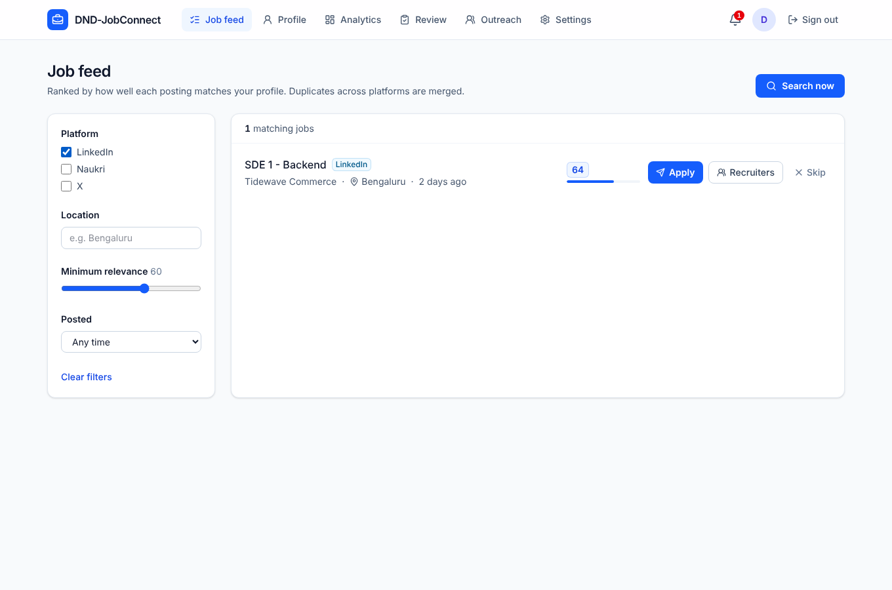
Figure 1: ST-05: ranked feed after filtering by LinkedIn and minimum relevance 60
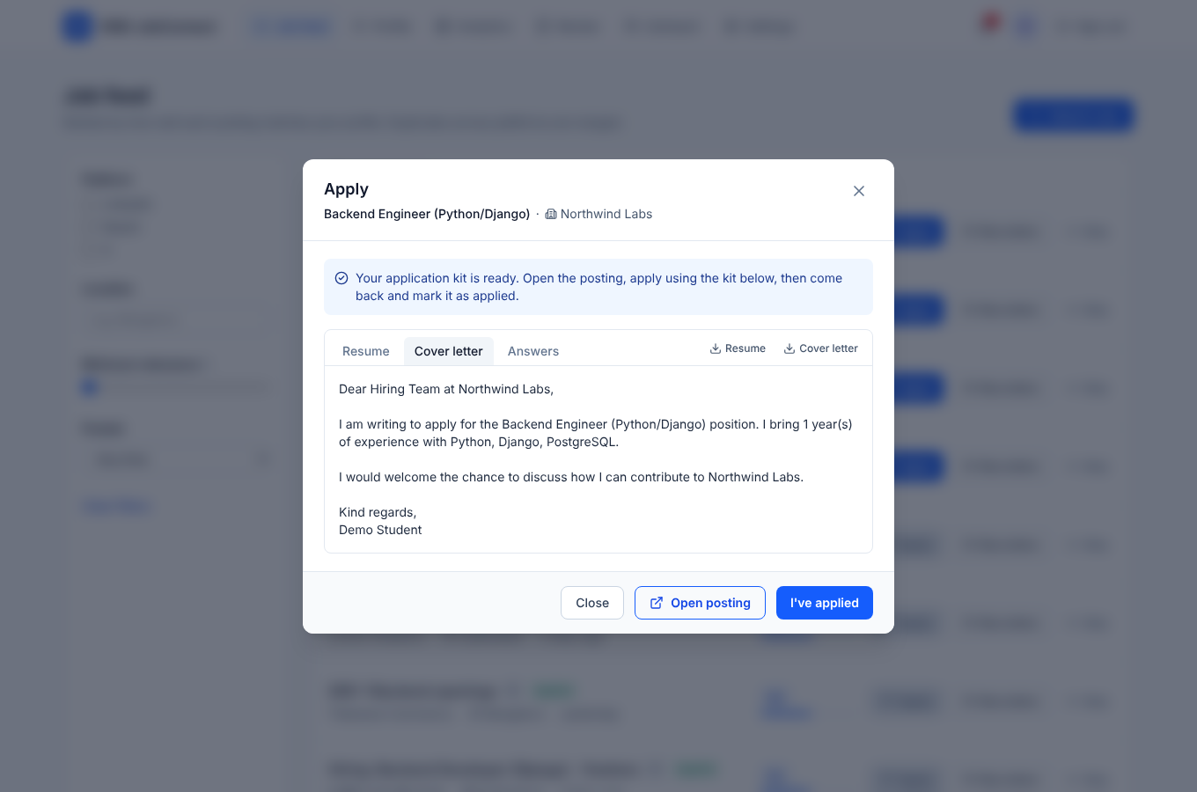
Figure 2: ST-07: assisted apply with the tailored kit
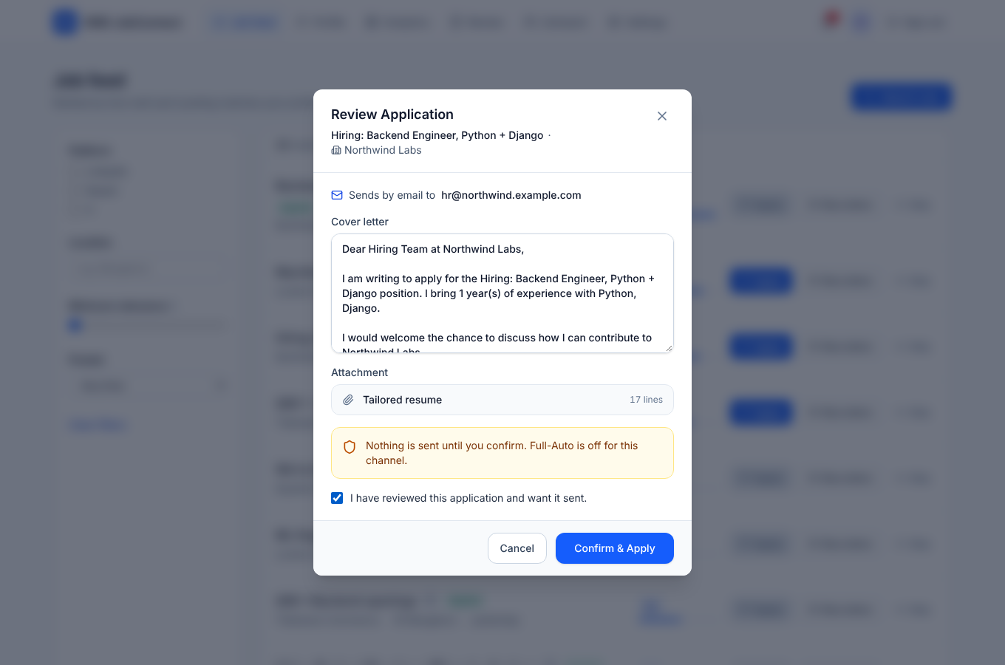
Figure 3: ST-08: review step; nothing is sent until the box is ticked
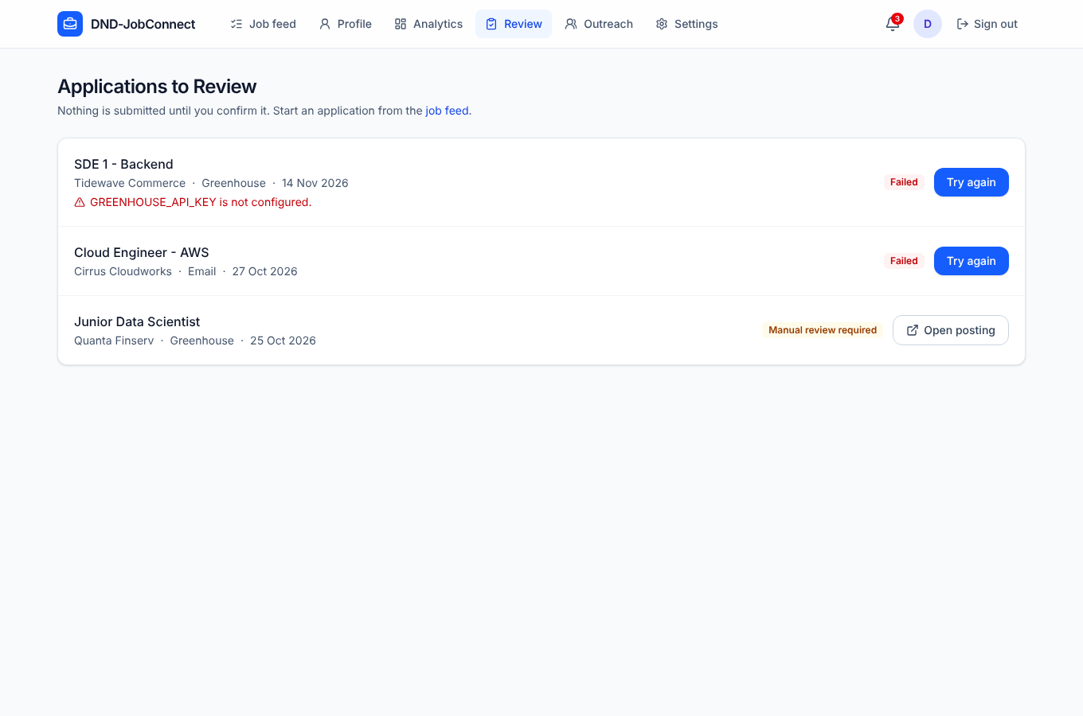
Figure 4: ST-09: failed and CAPTCHA-stopped applications waiting in Review
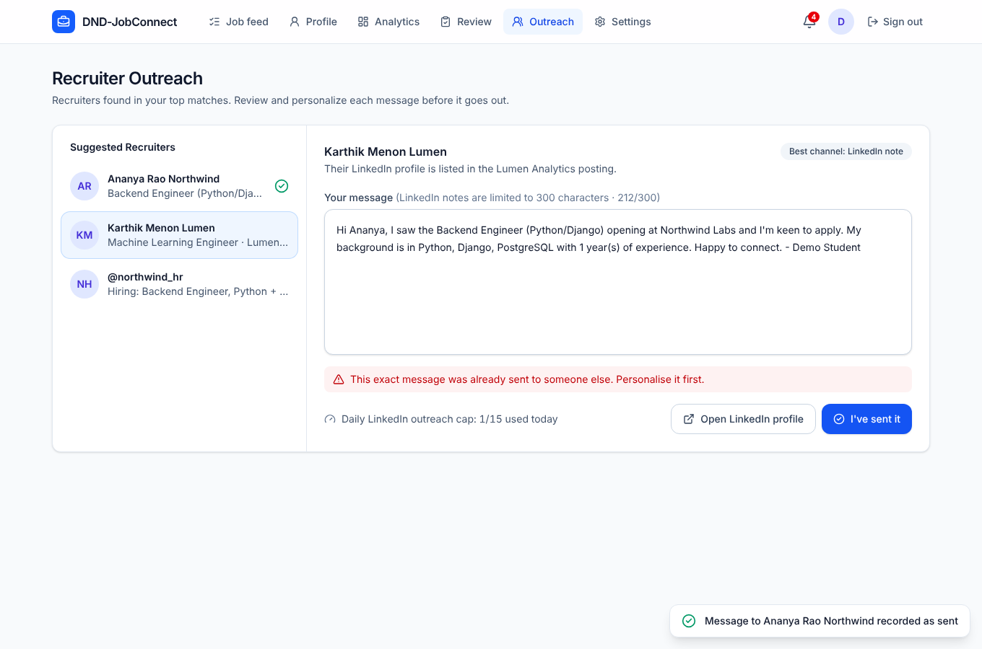
Figure 5: ST-10: identical outreach text refused (REQ-17)
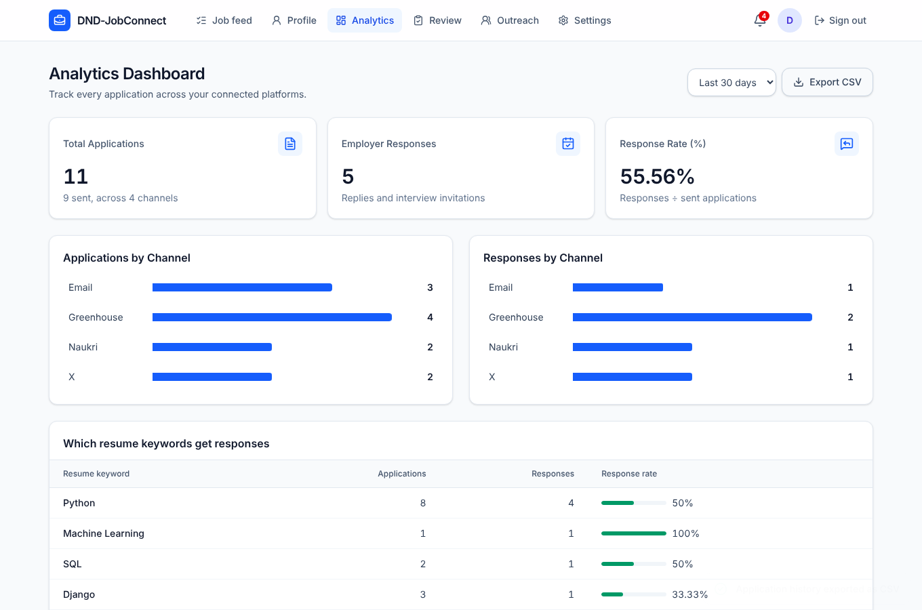
Figure 6: ST-12: analytics after logging an interview and changing a status
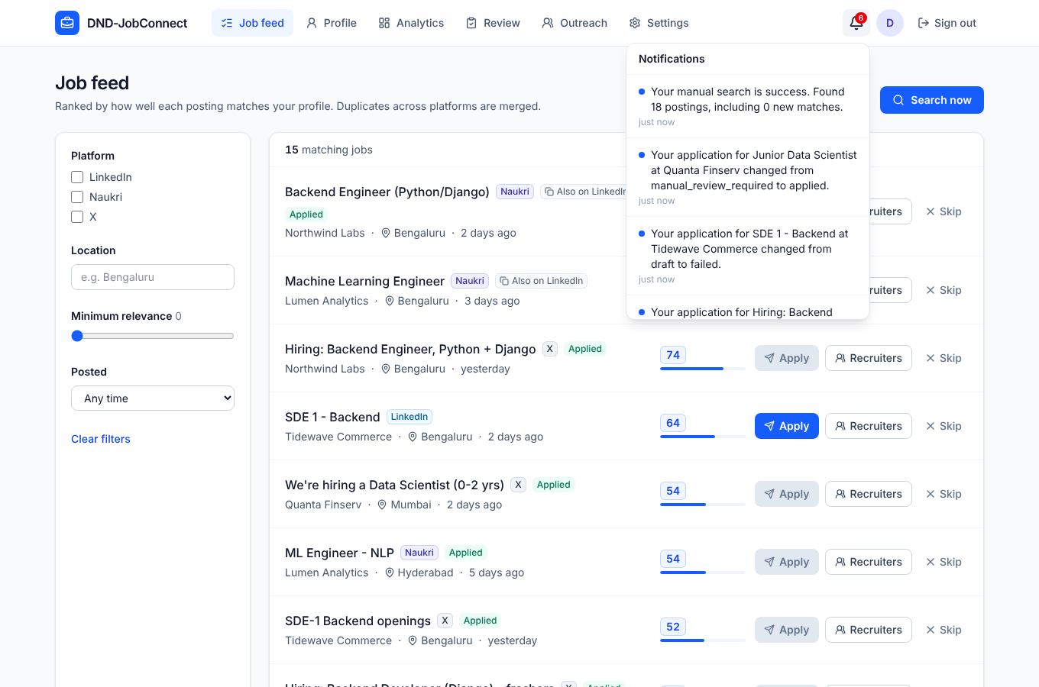
Figure 7: ST-15: CAPTCHA notification in the notification bell
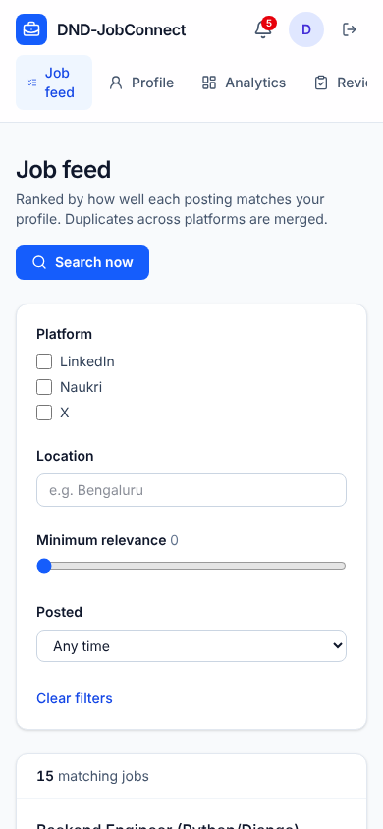
Figure 8: ST-16: phone-width layout

White-box Validation: Unit and Integration Tests
The automated suite (270 tests in 19 files) ran on PostgreSQL with branch coverage on. All tests passed.
Module | Lines covered | Line % | Branches covered | Branch %
accounts | 93/93 | 100.0% | 14/14 | 100.0%
applications | 609/628 | 97.0% | 95/106 | 89.6%
config | 86/93 | 92.5% | 3/6 | 50.0%
core | 5/5 | 100.0% | - | -
integrations | 355/365 | 97.3% | 80/90 | 88.9%
matching | 428/430 | 99.5% | 73/78 | 93.6%
outreach | 256/259 | 98.8% | 45/50 | 90.0%
resume_parser | 503/517 | 97.3% | 162/180 | 90.0%
scheduler | 303/311 | 97.4% | 52/56 | 92.9%

Total: 2,638 of 2,701 lines (97.7%) and 524 of 580 branches (90.3%). The lowest branch coverage is in config, which has settings switches for environments not used in tests.

Security Validation

OWASP ZAP baseline scan (dynamic)
The ZAP baseline scan runs in GitHub Actions against the app started with Docker Compose. Latest run: 10 November 2026, result success.
Outcome | Count
Rules passed | 65
Failures | 0
Warnings | 3

Warning | Risk | Assessment and action
Content Security Policy header not set [10038] | Low | The API returns JSON, not HTML, so CSP has little effect there. Add a CSP header to the web client's production server (maintenance item M-03).
Storable and cacheable content [10049] | Low (info) | Public pages may be cached by proxies. Set Cache-Control: no-store on authenticated API responses (M-03).
Permissions-Policy header not set [10063] | Low | Add a restrictive Permissions-Policy header (M-03).

Static analysis
- SonarQube (SonarCloud) quality gate: PASSED on main (CI run of 12 November 2026).
- ruff lint: no issues. Django migration check: no missing migrations.

Security test cases
TC-26 (encryption), TC-27 (token expiry), TC-28 (roles), TC-37 (disclaimer gate), TC-42 (data isolation) and TC-43 (rate-limit concurrency) all passed, along with system tests ST-01 to ST-03 and ST-13.

Performance Validation
Locust ran a realistic mix of users (feed, filtered feed, paging, run log, rate limits and the three dashboard requests) against Gunicorn with 4 workers, 50 users and 100,000 feed rows, 45 seconds per phase.
Measure | 1 user (baseline) | 50 users | Target | Result
Requests | 25 | 1,153 | - | -
Failures | 0 | 0 | 0 | Pass
Median response time | 17 ms | 16 ms | ≤ 20% degradation | Pass
Slowest endpoint p95 | - | login 1,600 ms (Argon2 by design) | ≤ 3,000 ms | Pass
Feed p95 | - | 880 ms | ≤ 3,000 ms | Pass
Dashboard requests p95 | - | 13 ms to 820 ms | ≤ 3,000 ms (TC-31) | Pass

CI also checks that a three-platform search finishes within the 30 second target with sources running in parallel (TC-30).

Requirements Validation
Requirement | System tests | Test cases (Validation Spec) | Result
REQ-1 to REQ-4 (resume, profile) | ST-04 | TC-01 to TC-05 | Pass
REQ-5 to REQ-8 (search, ranking, duplicates, filters) | ST-04, ST-05, ST-06 | TC-06 to TC-09 | Pass
REQ-9 to REQ-13 (applying) | ST-07, ST-08, ST-09, ST-15 | TC-10 to TC-14, TC-35, TC-38 | Pass
REQ-14 to REQ-17 (outreach) | ST-10, ST-11 | TC-15 to TC-18, TC-41 | Pass
REQ-18 to REQ-20 (scheduling, rate limits) | ST-14 | TC-19 to TC-21, TC-43 | Pass
REQ-21 to REQ-24 (analytics) | ST-12 | TC-22 to TC-25, TC-36 | Pass
SRS 6.1 performance | Load test | TC-30 to TC-32 | Pass
SRS 6.2 Pause All | ST-13 | TC-29 | Pass
SRS 6.3, 6.5 security, roles | ST-01 to ST-03 | TC-26 to TC-28, TC-42 | Pass
SRS 6.4 usability | ST-04, ST-16 | TC-33 | Pass
SRS 7 legal disclaimer | ST-01 | TC-37 | Pass

Defects and Observations
ID | Description | Severity | Status | Owner
D-01 to D-06 | Six defects found in earlier validation (profile tips 401, profile 500, recruiters in merged duplicates, no way to log responses, load-test endpoint, failed X message shown as sent) | High / Medium | Fixed (PR #67) | Dhruv
D-07 | Run notification reads "Your manual search is success": the raw status value is inserted into the sentence (scheduler/tasks.py) | Low | Open | Ashmitha
O-01 | When the same job is on several platforms, which copy is shown (LinkedIn or Naukri) depends on which source answered first, because sources run in parallel. Ranking and merging are correct; only the displayed platform varies | Low | Accepted (by design) | Dhruv
O-02 | ZAP warnings: CSP, cache-control and Permissions-Policy headers | Low | Planned (M-03) | Huma

Release Recommendation
All High and Medium defects are fixed, every requirement is validated, coverage is above the gate and the security scans show no failures. The build on main is recommended for the final demonstration and the v1.0.0 release tag. D-07 and O-02 should be fixed in the first maintenance release (v1.0.1).

PART B: MAINTENANCE PLAN

Purpose and Scope
This plan explains how DND-JobConnect will be kept correct, secure and usable after the v1.0.0 release. It covers who does what, how changes are controlled and released, how dependencies and patches are handled, and how the system is monitored and backed up. It applies to the backend, web client, Docker deployment, CI pipeline and documentation.

Types of Maintenance
Type | Meaning | Examples for this system
Corrective | Fixing defects | D-07 notification text; any failing test or user-reported bug
Adaptive | Keeping up with a changing environment | LinkedIn or Naukri page changes, X API tier or policy changes, Greenhouse/Lever API changes, new Python/Django versions
Perfective | Improving features and performance | Frontend unit tests, smarter keyword scoring, more ATS platforms, dashboard caching
Preventive | Reducing future risk | Security headers (O-02), dependency updates, raising branch coverage, refactoring large views

Roles and Responsibilities
Role | Person | Responsibilities
Maintenance lead / release manager | Dhruv | Triage, release tagging, CI/CD, Docker images, matching, scheduler, integrations
Security and accounts owner | Huma | Authentication, encryption, disclaimer, SonarQube and ZAP findings, dependency security patches
Applications and outreach owner | Niraj | Apply channels, ATS adapters, outreach, platform-terms compliance
Analytics and notifications owner | Ashmitha | Analytics endpoints, notifications, user-reported UI issues
Reviewer | Any other member | Every pull request needs one approving review from someone other than the author

Change Control Process
- Report: every change starts as a GitHub issue (bug, enhancement or maintenance) with steps to reproduce or acceptance criteria.
- Triage (weekly, or immediately for Critical): the lead sets severity, labels, owner and target release.
- Impact analysis: the owner lists affected modules, API endpoints, database migrations and tests using the traceability matrix.
- Implement on a branch named fix/<issue>-<short-name> or feature/<issue>-<short-name>, with tests.
- Open a pull request with "Closes #<issue>". CI must pass (tests, 85% coverage gate, SonarQube, frontend build, ZAP) and one reviewer must approve.
- Merge to main. The branch is deleted automatically and the change goes into the next release notes.
- Emergency hotfix (Critical only): branch from the latest release tag, make a minimal fix with a test, get a fast review, release a patch version, then merge back to main.

Defect Management
Severity | Definition | Response | Fix target
Critical | Data loss, credentials exposed, or anything sent without the user's consent | Same day; Pause All advised to users | Hotfix within 24 hours
High | Core flow broken (login, upload, feed, apply, analytics) | Within 1 day | Next patch release (≤ 3 days)
Medium | Feature wrong but a workaround exists | Within 3 days | Next minor release
Low | Cosmetic or wording (for example D-07) | Weekly triage | When convenient

Every fixed defect gets a regression test. Defects are tracked as GitHub issues with the label bug and a severity label.

Configuration Management and Versioning
- Semantic versioning MAJOR.MINOR.PATCH. v1.0.0 is the baseline for the final demo. Patches fix defects, minor versions add backward-compatible features, and a major version is needed for breaking API changes (served under /api/v2/).
- Baselines are git tags (v1.0.0, v1.0.1, …) on main, with release notes in GitHub Releases.
- main is always releasable and protected: no direct pushes, pull requests only, required status checks.
- Database schema changes only through Django migrations, kept backward compatible for one release (add columns before removing old ones).
- Configuration is kept in environment variables (.env, never committed), and .env.example lists every setting.
- Secrets (Django secret key, encryption keys, API keys) are stored only as GitHub Actions secrets and on the server. Keys are rotated if exposed.

Release and Deployment
- Tag the release on main. CI builds the backend image and pushes it to GitHub Container Registry as :<commit> and :latest.
- Back up the database before deploying (see Operations: Monitoring, Backup and Data).
- Deploy with docker compose pull and docker compose up -d. The migrate service applies migrations before the web, worker and beat services start.
- Check /health/ and run a smoke test: sign in, open the feed, run Search now, open Analytics.
- Rollback: redeploy the previous image tag. Restore the backup only if a migration cannot be reversed.
- Publish release notes (changes, migrations, configuration changes) and tell users about anything they need to act on, such as a new disclaimer version.

Dependency and Patch Management
- Enable GitHub Dependabot for pip, npm, GitHub Actions and Docker base images, and review its pull requests weekly.
- Security advisories: apply Critical/High patches within 7 days and others in the next minor release. Run pip-audit and npm audit in CI.
- Stay on supported versions: Django 5.2 LTS, Python 3.12, PostgreSQL 15/16, Node 22 LTS. Plan upgrades before support ends.
- Generate a CycloneDX SBOM for each release (cyclonedx-py for the backend, @cyclonedx/cyclonedx-npm for the frontend) and attach it to the GitHub Release.

Operations: Monitoring, Backup and Data
Area | Practice
Health | /health/ checks the database; Docker restarts failed services; external uptime check every 5 minutes
Logs | Structured application logs from web, worker and beat; errors reviewed weekly; platform 429s and CAPTCHA rates watched for adaptive changes
Background jobs | Run log (ScheduledRun) reviewed for failing sources; admin automation-log endpoint for support
Backups | Daily pg_dump, keep 7 daily and 4 weekly copies off the server; restore tested monthly
Redis | Append-only file enabled; holds only queue data, rebuilt on loss
Privacy | Resume files are never stored; on account deletion all profile, feed, application and outreach data is removed; credentials stay encrypted

Adaptive Maintenance for External Platforms
Change | Detection | Action
LinkedIn/Naukri page or API change | Collector errors in the run log; contract tests fail on new fixtures | Re-record fixtures, update the parser, keep robots.txt compliance
X API pricing or policy change | SourceRateLimited or auth errors | Update the adapter or disable the X source; demo sources keep the demo working
Greenhouse/Lever API change | Failed attempts with the adapter's error | Update the adapter; applications stay in Review for retry
New platform terms | Quarterly review of each platform's terms | Adjust limits and channels; update the disclaimer and its version

Maintenance Schedule
When | Activity | Owner
Every pull request | CI tests, coverage gate, SonarQube, ZAP, review | Author and reviewer
Daily | Database backup; check failed runs and CAPTCHA notifications | Automated / lead
Weekly | Issue triage; Dependabot pull requests; log review | Lead, Huma
Monthly | Restore test; dependency audit; performance spot check | Dhruv, Huma
Quarterly | Platform terms review; rate-limit review; load test | Niraj, Dhruv
Each release | Release notes, SBOM, tag, smoke test | Release manager

Known Maintenance Backlog
ID | Item | Type | Priority | Owner
M-01 | Fix D-07 run-notification wording | Corrective | Low | Ashmitha
M-02 | Frontend unit tests for the API client and key components | Perfective | Medium | Niraj
M-03 | CSP, Cache-Control and Permissions-Policy headers (ZAP warnings) | Preventive | Medium | Huma
M-04 | Enable Dependabot, pip-audit, npm audit and SBOM generation | Preventive | Medium | Dhruv
M-05 | Show all platforms of a merged job consistently (O-01) | Perfective | Low | Dhruv
M-06 | Automate the browser system tests in CI | Preventive | Medium | Dhruv
M-07 | Raise branch coverage in applications and integrations above 90% | Preventive | Low | Ashmitha, Niraj

Documentation and Handover
The maintenance documentation is the README (setup, demo mode, API), the SRS, SW Architecture, SW Design and Validation Specification documents, docs/deviations.md, docs/testing/test-report.md and this report. Each owner updates the documents for their modules in the pull request that changes them.

