LABORATORY EXERCISE 3
OBJECTIVE
Follow instructions in understanding and working with basic concepts of declaring variables, using datatypes and format specifiers.

THEORY
Variable
A variable name is a location in memory where a value can be stored for use by a program. All variables must be defined with a name and a data type in the code before they can be used in a program. A variable name in C should be a valid identifier. An identifier is a series of characters consisting of letters, digits and underscore and does not begin with a digit. C is case sensitive i.e. area and Area can’t be treated as same. There are certain reserved words called Keywords that have standard, predefined meanings in C. These keywords can be used only for their intended purpose; they can’t be used as programmer defined identifier.

Basic Data Types of C language
C support five basic data type described below:

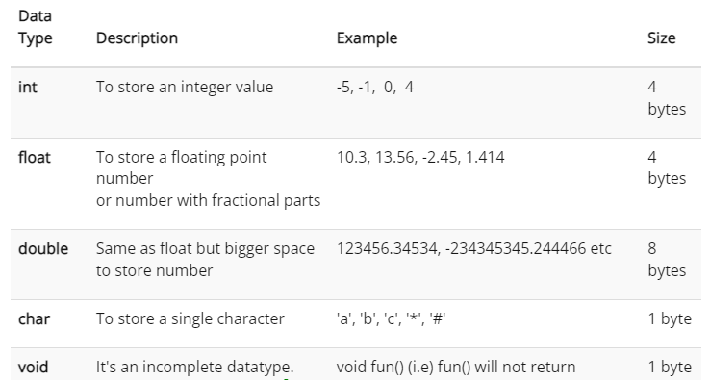

Character:
It is bit long and it is most commonly used to hold a single character. A variable of type char can also be used as a “little integer” if desired.

Integer:
Integer may hold signed whole number (Number with no fractional part). It may hold values in the range –32768 to 32767.

Float and Double:
Data type float and double hold signed floating-point values, which may have fractional components. The difference between float and double is that double provide about twice the precision as does float. They both can hold very large values.

Variable Declaration

Variables are generally declared as:

Type var-name;

Here ‘Type’ is C data type and ‘var-name’ is the variable name. You can also declare more than one variable of same type by using a comma-separated list.

Example: int a,b,c ;

Value Assignment to the Variable
A programmer can assign a unique value to the variable. The general form of an assignment statement is

Variable name = value;
For example; X = 1000;

Example Program 1:
This program declare variables and assigns values to them.
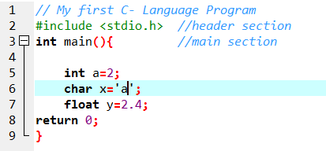

Format Specifiers:

Format specifier specifies that which type of data has to be print or read into. Following is a list:

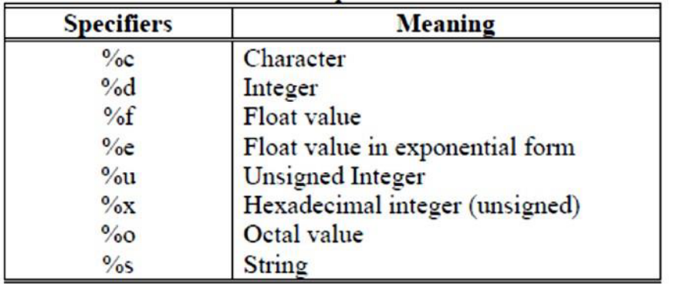
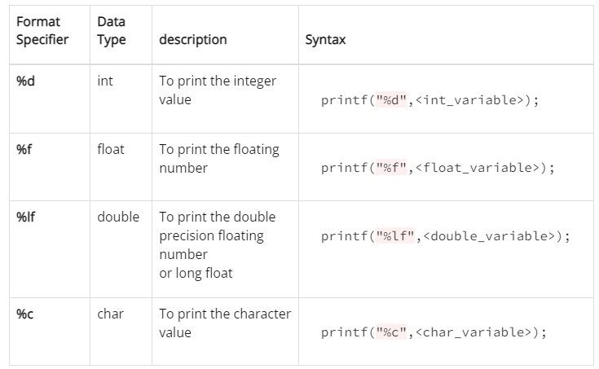

Example Program 2: Print the values of variables declared in program 1.
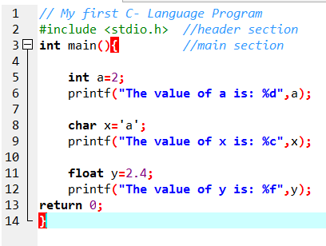
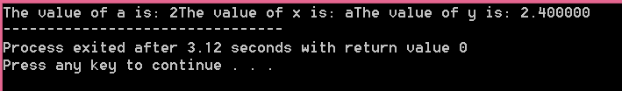

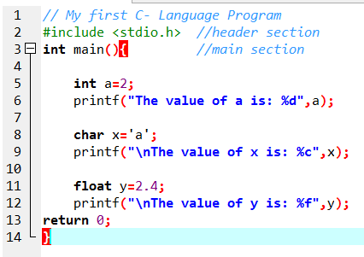

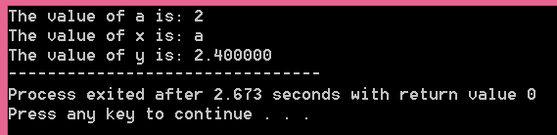
scanf() Function:
The purpose of scanf() function is to except data from keyboard, and place that data to a memory location specified in its argument.

Syntax:-
scanf( “fomat specifiers” , address of variable);

Examples:-
scanf(“ %d” , &r);

Example Program 3:
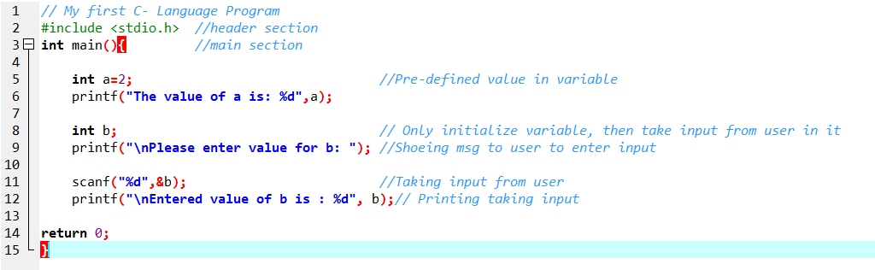
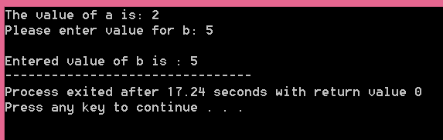

Example 4: Storing and taking more than one characters from user

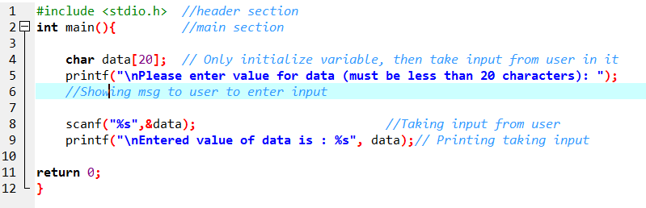
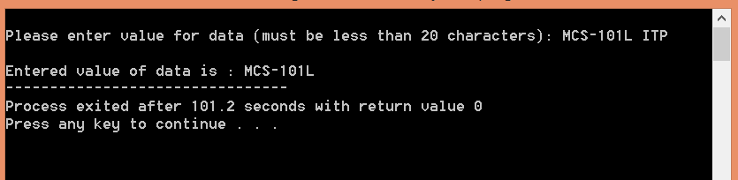
Example 5: Printing multiple data in single printf( )
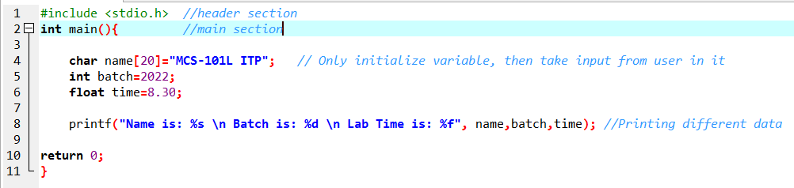

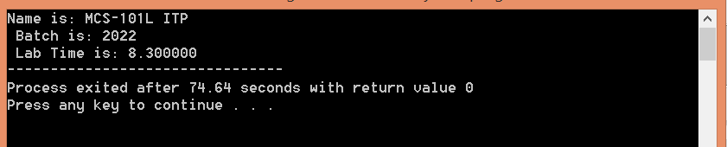

Example 6: Scanning Multiple data.

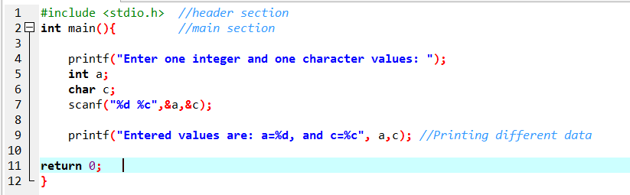

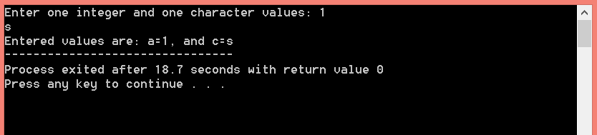

LAB EXERCISES
Task 01: Identify and correct the errors in the following statements:
- scanf(“d”, value);
________________________________________________________________________
- printf( “The number is %d /n” ,&number1);
________________________________________________________________________
- printf( “ The answer of %d+%d is “\n,x,y);
________________________________________________________________________
- scanf(“ %d%d” ,&number1,number2);
________________________________________________________________________

Task 02: Write single C statements to perform the following tasks:
- Prompt the user to enter an integer in inverted commas. Like this “Enter an integer: “
_____________________________________________________________________
- Read your roll number from the keyboard and store the value entered in the variable RollNo.
_____________________________________________________________________
- Read two integers from the keyboard and store the value entered in the variable a & b .
_____________________________________________________________________

Task 03: Write an algorithm using C- programming to ask the user to enter following details and print it on the screen.
Name:
Father Name:
Roll Number:
Batch:
Department:
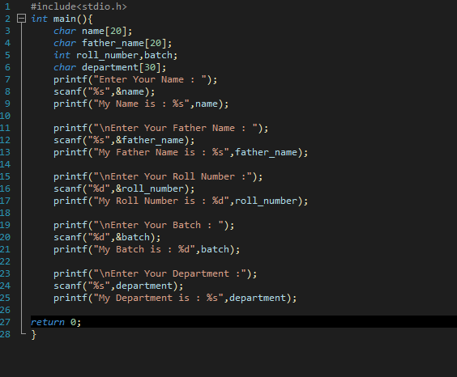
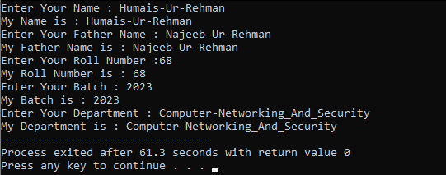

CONCLUSION
_____________________________________________________________
_____________________________________________________________
_____________________________________________________________
_____________________________________________________________
_____________________________________________________________
LABORATORY EXERCISE 4
OBJECTIVE
Follow instructions to understand and apply the different types of arithmetic and logical operators in C programming.
THEORY
In C programming, there are various operators, used to form expressions. The data items on which the operators act upon are called operands. Some operators require two operands while other act upon only one operand. They are classified as:
1. Arithmetic Operators (binary type)
2. Unary Operators/Increment-decrement
3. Relational and Logical Operators
4. Assignment Operator

Arithmetic Operators
In C programing, most programs perform arithmetic calculations. Arithmetic calculations can be performed by using the following arithmetic operators.
+ Addition
- Subtraction
* Multiplication
/ Division
% Modulus

Example Program 1:

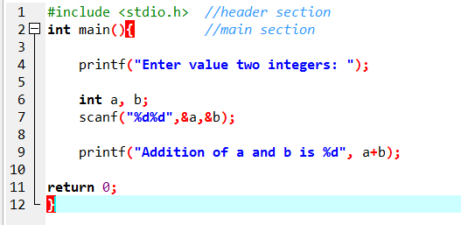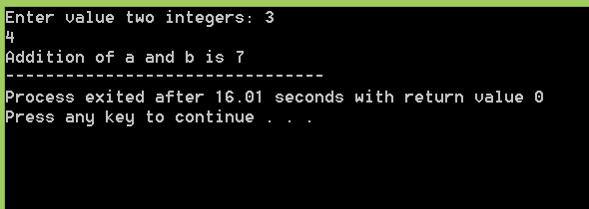

Unary Operators
In addition to the arithmetic assignment operators, C programming also provides two unary operators that act upon on a single operand to produce a new value, for adding 1 to or subtracting 1 from the value of a numeric variable. These are the unary increment operator, ++, and the unary decrement operator, --.

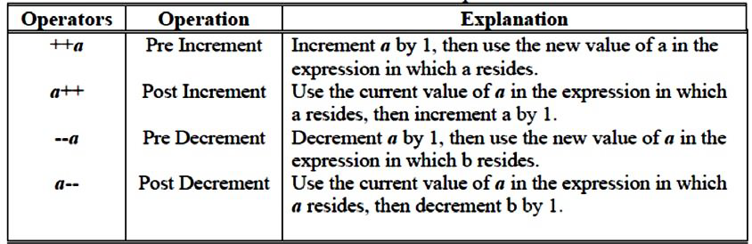

Example Program2:

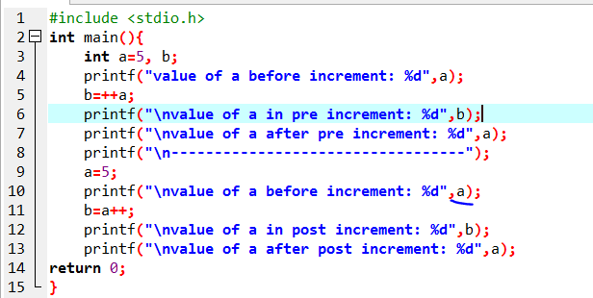

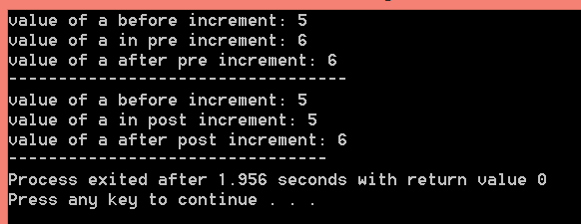

Assignment Operators
C provides several assignment operators for abbreviating assignment expressions. For example, the statement: c = c + 3; can be abbreviated with the addition assignment operator += as c += 3;
The += operator adds the value of the expression on the right of the operator to the value of the variable on the left of the operator and stores the result in the variable on the left of the operator. Thus the assignment c += 3 adds 3 to c.

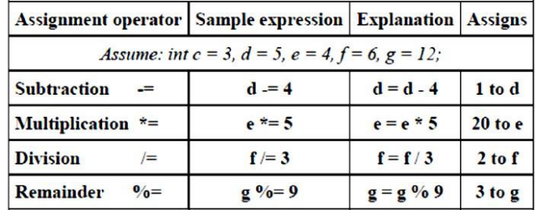

Example Program 3:
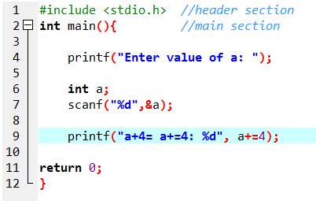

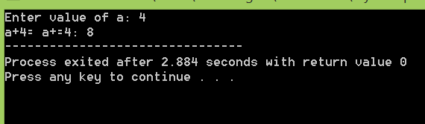

Summary of Operator Precedence and Associativity:
Following table adds the logical operators to the operator precedence and associativity chart. The
operators are shown from top to bottom, in decreasing order of precedence.

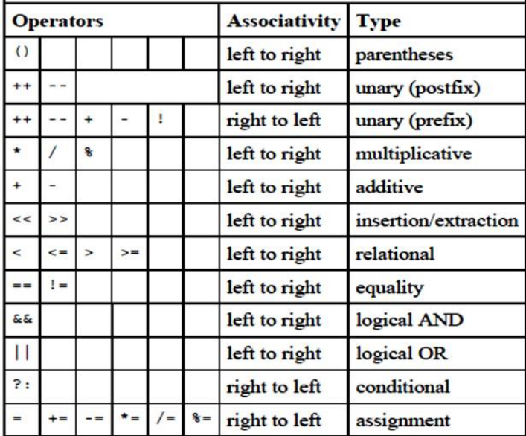

Example Program 4:

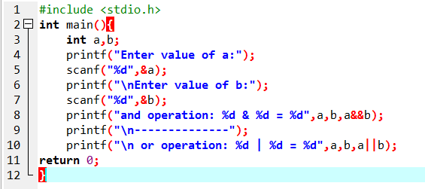

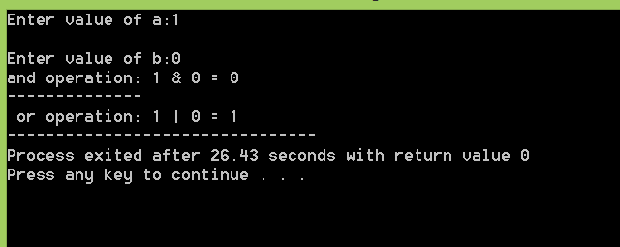

LAB EXERCISES
Task 01: Write single line C statements to Evaluate the following using C Arithmetic operators.
1) 9.0/6.0 +5/2 =______________________________________
2) 9*3/4 =___________________________________________
3) 14%7 +3%4 =______________________________________

Task 02: Write the output of the following statements sequentially after execution of each statement, if x is initially your roll number:
- printf( %d\n , x );
- printf( %d\n , ++x );
- printf( %d\n , x++ );
- printf( %d\n , x );
- printf( %d\n , x );
- printf( %d\n , --x );
- printf( %d\n , x-- );
- printf( %d\n , x );

Task 03: Write an algorithm to calculate the area of circle using C-Programming Language, if radius is your roll number.
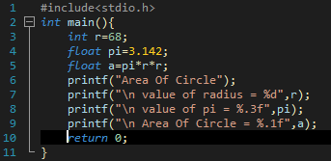
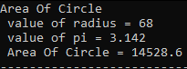

Task 04: Write an algorithm to solve the following equation using C-Programming Language:
X=a²+2ab+b²

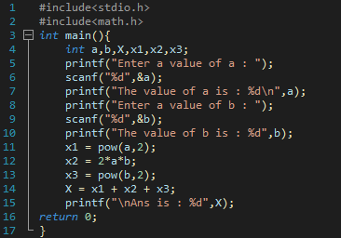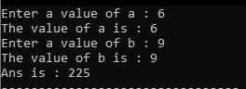

Task 05: Write an algorithm to calculate the percentage of your last exam using C-Programming Language.
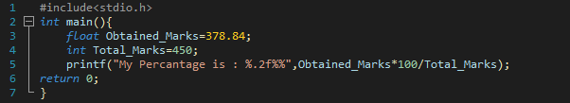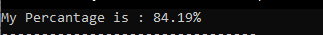
CONCLUSION
_____________________________________________________________
_____________________________________________________________
_____________________________________________________________
_____________________________________________________________
_____________________________________________________________

LABORATORY EXERCISE 5
OBJECTIVE
Follow instructions to get familiar with looping constructs, their working and uses. (for, while and do-while loops).
THEORY
Loop
“The concept of looping provides us a way to execute a set of instructions more than once until a particular condition is true.”
There are many situations where a certain operation is repeated number of times, this repetition is termed as ‘loop’ in programming languages. In C, loop is constructed by three ways:
- for Loop
- while Loop
- do-while Loop
- for Loop
The “for” loop is appropriate when programmer knows in advanced that how many times the loop will be executed. Here we have a counter variable whose limits are predefine. The ’For’ loop is considered as most flexible loop, because it allows number of variations. In its most common form, the ‘For’ loop is used to repeat a statement or a block of statements a specified number of times.
General Form of for loop
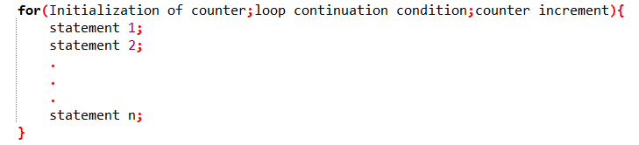
The initialization expression initializes the loop's control variable or counter (it is normally set to 0); loop continuation condition determines whether the loop counter is within its limits or not and finally the increment statement increments the counter variable after executing the inner loop statements.
Flow Chart of for loop
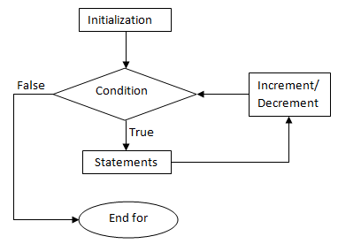
Example Programs:
Program 1: Print your department name 5 times on screen.
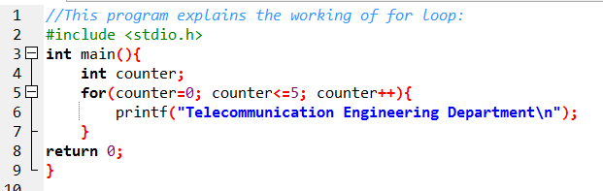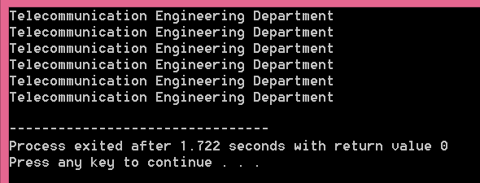

Program 2: Print numbers from 1-10.
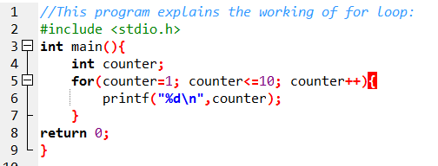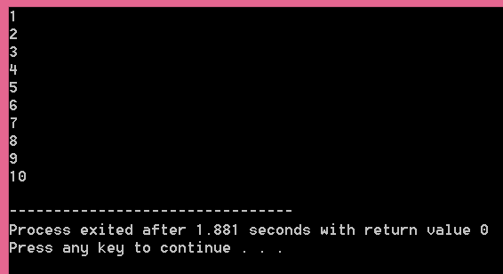

Program 3: This program prints table of 2.
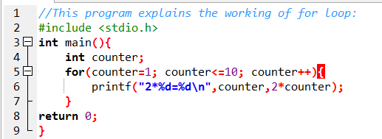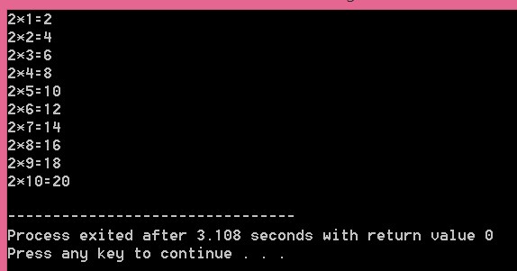
- While Loop
The while loop is used to carry out looping operations, in which a group of statements is executed repeatedly, if condition following while is true otherwise control is transferred to the end of the loop. Here we do not know how many times the loop will be executed.
General Form of while loop
‘While’ loop structure looks simpler than the ‘for’ loop. Although it uses the same element as ‘for’ loop structure but these elements are distributed through out the program.
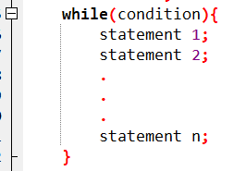
The value of the testing variable is checked at the top but all the variation like increment, decrement, comparison etc are taking place with in the statements in body of the loop.
Elements of ‘While’ loop
Certainly, the expression in the parentheses is simpler than the three part expression of the ‘for’ loop. It dispenses with the initialization and increment expression retaining only the test expression. The initialization step is included in the variable declaration usually while the increment or decrement is present in the body of the loop.
Flow chart of while loop
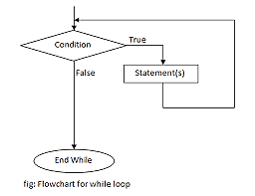
Example Programs
Program 1: Print your department name 5 times on screen.
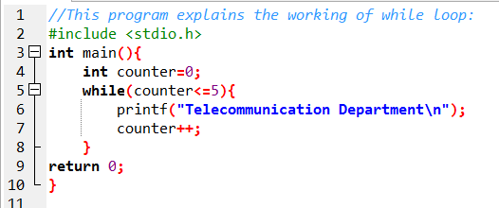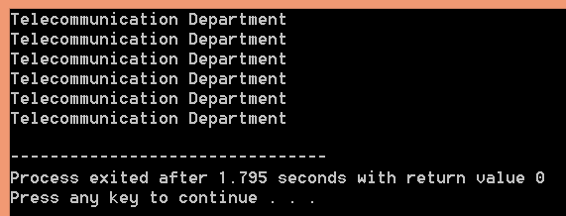

Program 2: Take any number as input until user enters 0.
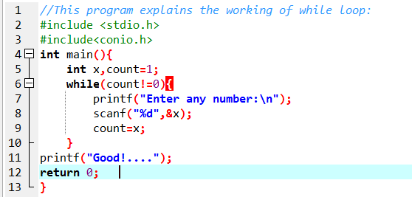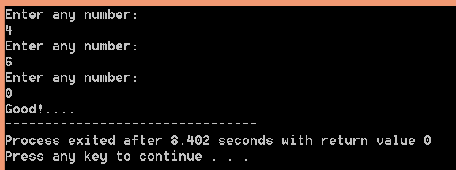

Program 3: Write an algorithm to guess a character.
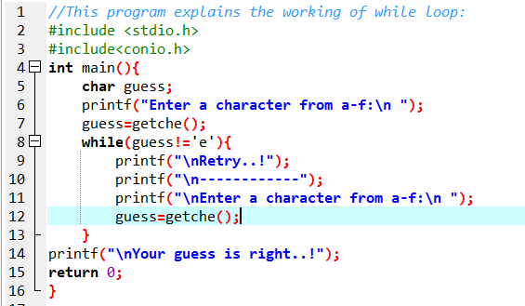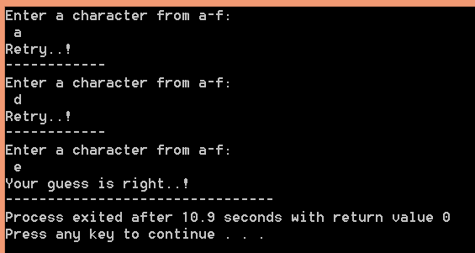

- Do while Loop
The do while repetition statement is similar to the while statement. In the while statement, the loop-continuation condition test occurs at the beginning of the loop before the body of the loop executes. The do while statement tests the loop-continuation condition after the loop body executes; therefore, the loop body always executes at least once.
This loop must be executed at least once because the condition is checked at the end. If the condition is following while is true the control is transferred to the beginning of the loop statement otherwise control is transferred to the statement following while statement.
General Form of do-while loop
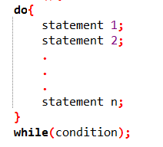
Flow chart of do-while loop
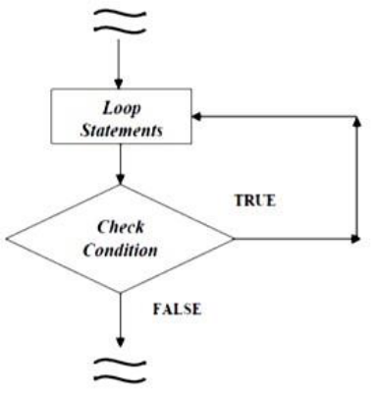
Difference between while and do-while loops
The difference between a while loop and a do-while loop is the order in which the loop-continuation-condition is evaluated and the loop body executed. We can write a loop using either the while loop or the do-while loop

Example Programs
Program 1: Take any number as input until user enters 0.
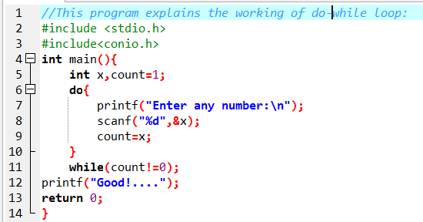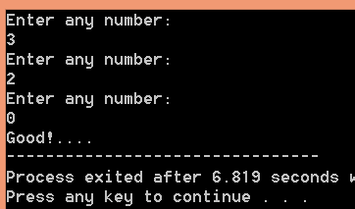

LAB EXERCISES
Task 01: Execute the following programs using Dev C++ and attach their outputs.

#include <stdio.h>
#include<conio.h>
int main(){
int i;
for(i=1; i<=10;i++){
printf("i=%d \n",i);
}
return 0;
}

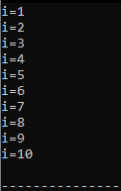

#include<stdio.h>
#include<conio.h>
int main(){
int i, a=10, b=10;
for(i=1; i<=10;i++){
a++;
b--;
printf("a=%d \t b=%d \n",a,b);
}
return 0;
}

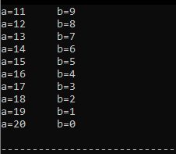

Task 02: Write an algorithm to generate first 20 even numbers.
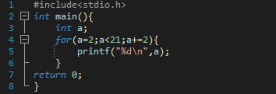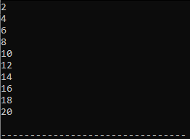

Task 03: Write an algorithm to take a sentence as input from the user with the characters till user press “.”.
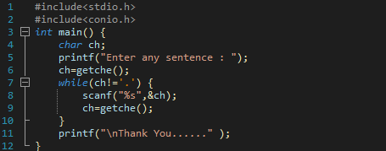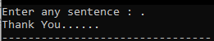

Task 04: Write an algorithm to generate factorial of a number (user input).
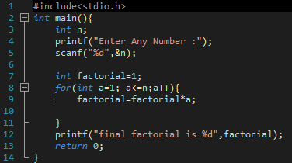

CONCLUSION
_____________________________________________________________
_____________________________________________________________
_____________________________________________________________
_____________________________________________________________
_____________________________________________________________

