Aqu-Scape

Introduction
Aqu-Scape is an online tool that helps aquarists to design their aquarium layouts. It allows user to select dimensions of the aquarium and then place variable sized plants, stones and tree branches and roots into the aquarium. The software will have a database where plant information is stored (scientific name, light requirement, height and perimeter of the plant). The tool will allow placing objects on top of another but will note that if a plant with high light requirement would be shaded by another taller plant.
There is an existing tool that allows user to pick plants and tell if their water requirements are compatible (temperature, pH and dH). Once user is done selecting the plants, he or she can design the layout of the tank using this new tool (all the selected plants will be passed as a url parameter to the new service).

User Interface Design and Prototype

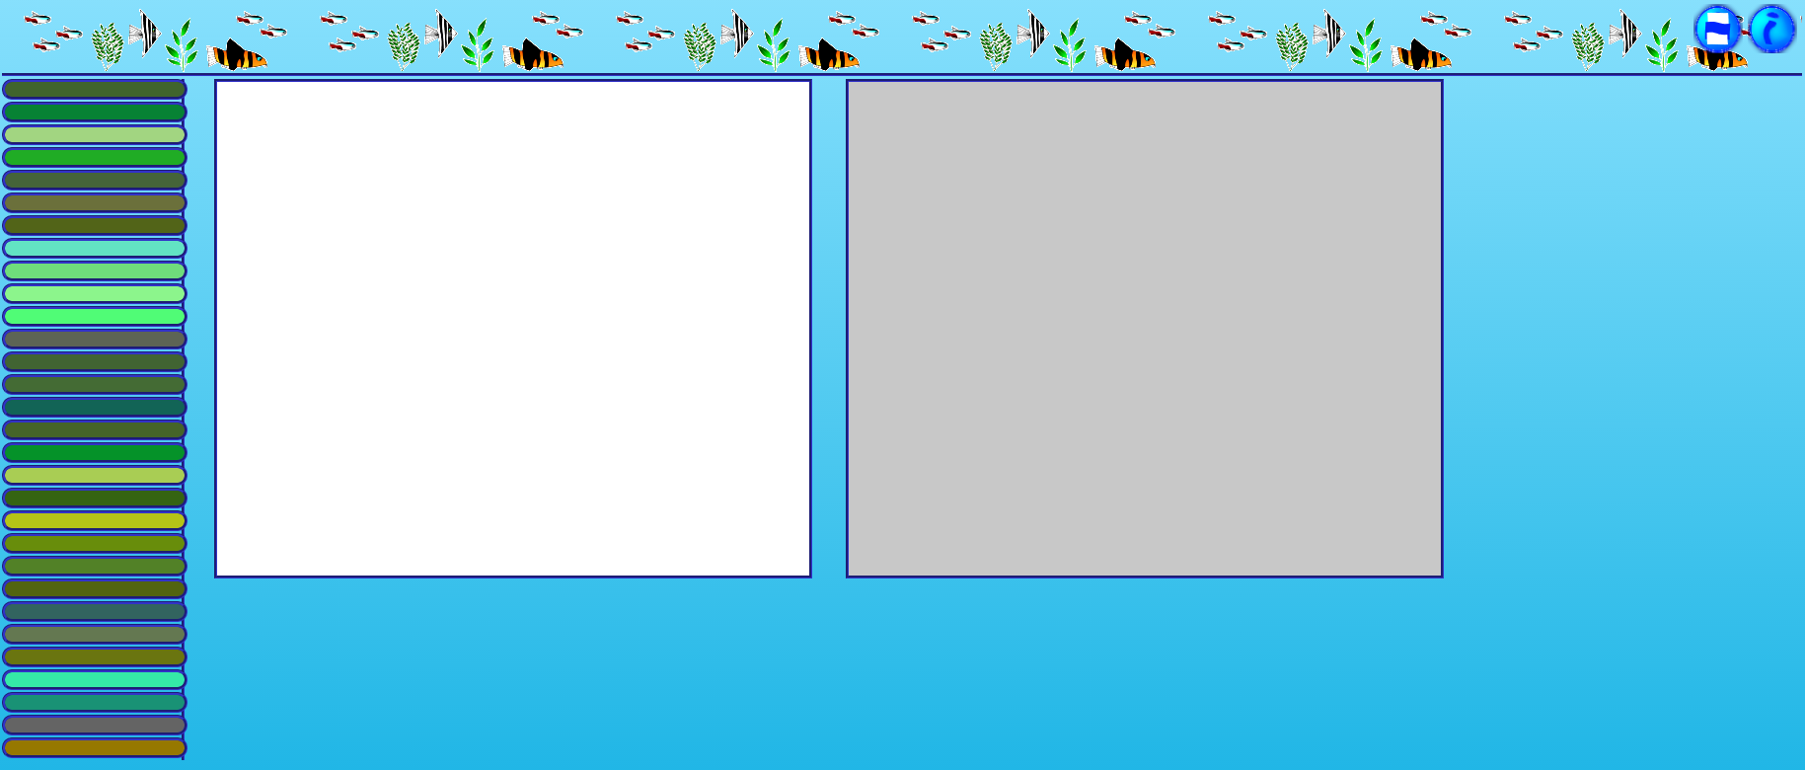
1 Browser client
Browser client will have the palette of plants on the left side, while the drawing canvas is on the middle. The canvas on the right will provide the view from the front of the aquarium and can not be modified by user. The title bar will have buttons for printing the canvas and a button that provides information about the page.
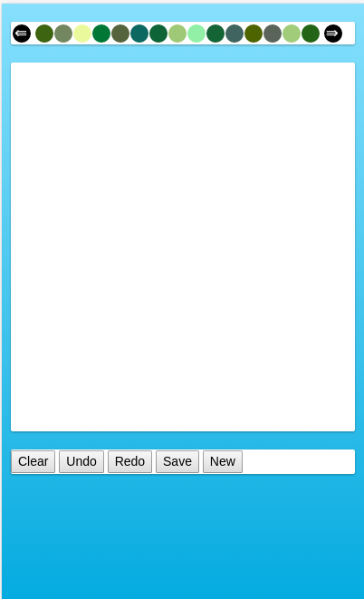
2 Mobile client
Mobile client will have the palette of plants and other objects on top of the UI while the lone drawing canvas that shows the layout from the top will be below the palette. Located on the bottom of the UI are the various buttons.
User selects a plant from the palette and then places those plants onto the canvas. Diameter of the plant will be automatically calculated to match the dimensions of the aquarium. Already placed plants can be moved via drag-drop.

Navigation Structure
There is very little navigation structure in the application due to its nature of being mostly a drawing program. However, users will be prompted to pick the dimensions for the aquarium before starting.
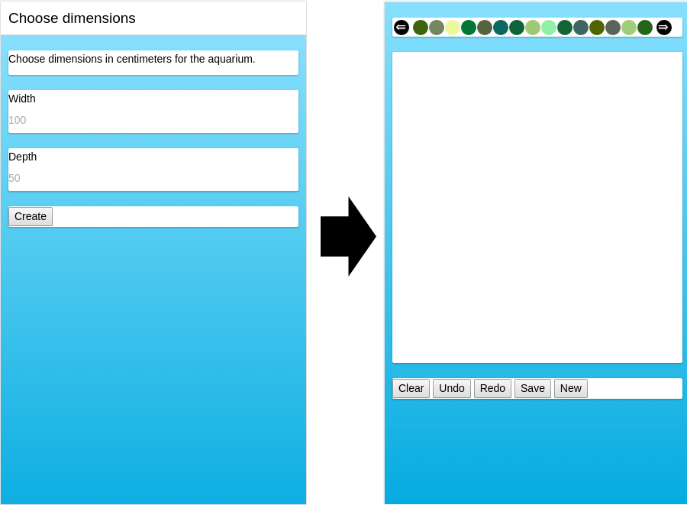
3. Selecting dimensions

References
Aqu-Choice is a online tool for selecting aquarium plants that will be used with Aqu-Scape (currently written for finnish users only) . It will be modified to transfer the chosen plants to the new tool. Mobile application, however, will most likely be standalone.

