Aqu-Scape

1. Introduction
Aqu-Scape is an online tool that helps aquarists to design their aquarium layouts. It allows user to select dimensions of the aquarium and then place variable sized plants, stones and tree branches and roots into the aquarium. The software has a database where plant information is stored (scientific name, light requirement, height and diameter of the plant). The tool will allow placing objects on top of another but will note that if a plant would be shaded by another taller plant.
There is an existing tool that allows user to pick plants and tell if their water requirements are compatible (temperature, pH and dH). Once user is done selecting the plants, he or she can design the layout of the tank using this new tool (all the selected plants will be passed as a url parameter to the new service). However, mobile version of the Aqua-Scape acts more as a standalone tool.
List of features:
- Choose dimensions (width, depth) of the aquarium.
- Drawing abilities
  - Place plants into the layout.
  - Place and (resize when placing) stones, branches and roots into the layout.
  - Move placed objects in the layout.
- Various tools
  - Undo
  - Redo
  - Clear
- Save the layout as image (mobile)
- Make a printable view of the layout and plants (browser)

2. Design and Implementation

2.1 The REST API Specification
TITLE | Fetch plants
URL | /plants
Method | GET
URL Parameters | None
Success Response | Code: 200  Content:  [{"_id":"57de6c47ba9681f980b23644","identificationNumber":1,"tempMax":26,"tempMin":23,"dhMax":12,"phMax":7.5,"phMin":5.8,"height":10,"diameter":15,"finnishName":"Kiharakriinumi","scientificName":"Crinum calamistratum","__v":0,"dhMin":2}]
Notes | This is actually used by Aqu-Choice service to fetch full plant data

TITLE | Fetch plants lite
URL | /plants/lite
Method | GET
URL Parameters | None
Success Response | Code: 200  Content:  [{"scientificName":"Crinum calamistratum","diameter":15,"height":10,"identificationNumber":1}]
Notes | This is used by Aqu-Scape to fetch required information about the plants for drawing.

2.2 Front-end Architecture Design
Both mobile and browser applications are using npm for dependency management and git for version control.

2.2.3 Browser
Browser side is implemented using newly released Angular2 with TypeScript. This is a more modern framework than Angular 1 and will most likely be used a lot more in the future, I also had prior experience with it, so it seemed like a right choice. Gulp is used as a build tool and canvas related functionality is handled using PaperJS, which makes working with canvas a lot easier and more structures. Styles are handled without Bootstrap using simple css which I feel is more appropriate for this project and makes it look more distinct.
Aqu-Scape tool on browser is not a standalone tool but requires a use of existing online tool to select the plants for aquascaping.
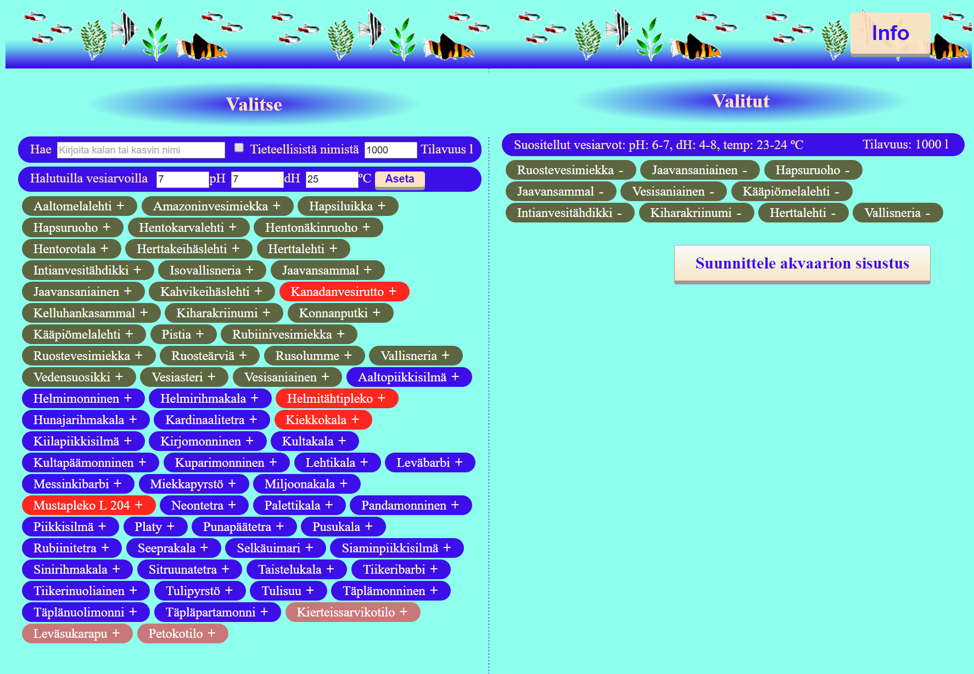
1. Aqu-Choice is an existing online tool that is used to navigate to Aqu-Scape. Large button reading ”Suunnittele akvaarion sisustus” will be used to navigate to the Aqu-Scape.
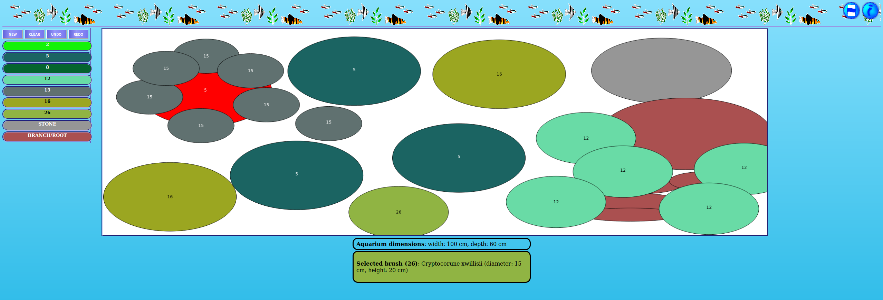
2. Picture of the Aqu-Scape tool where user has already placed plants. Notice that the red plant is shadowed by other taller plans placed on it.
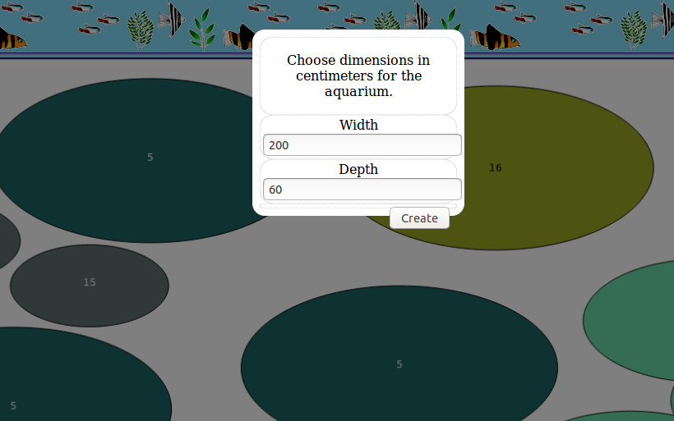
3. Choosing dimensions
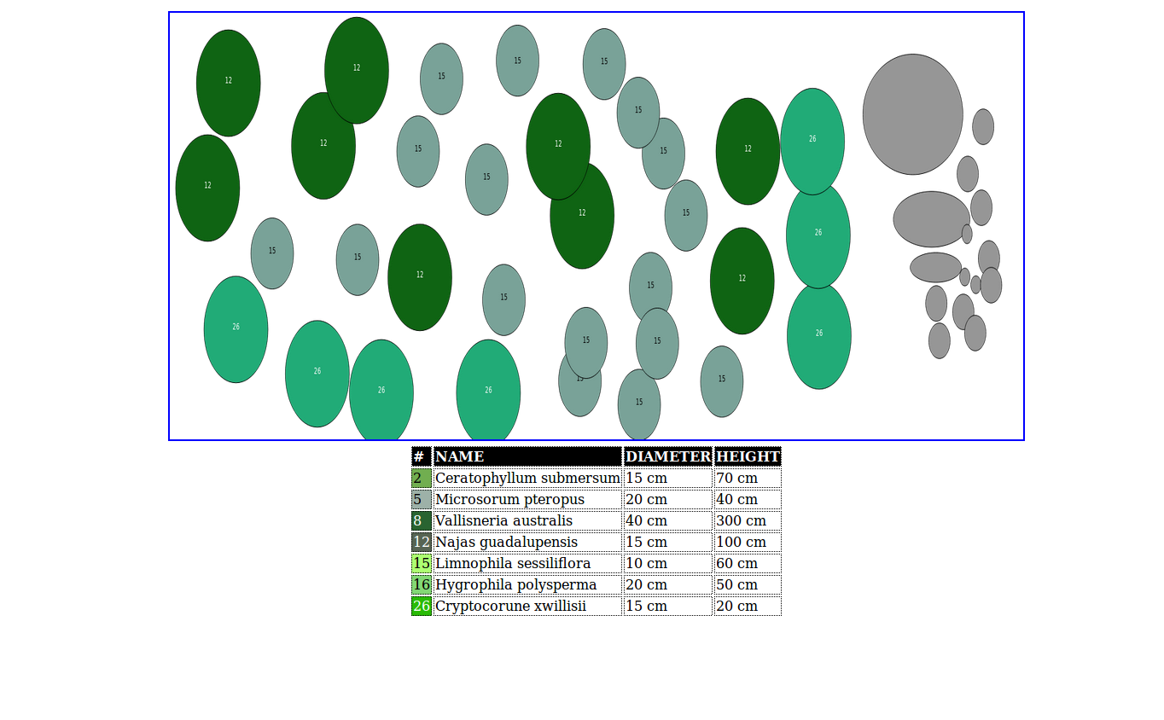
4. Print layout for the canvas showing plant data in tabular format.

2.2.4 Mobile
Mobile is using Ionic framework with AngularJS, this mostly because Ionic2 which would be more compatible with Angular2 is still strongly in beta. PaperJS is used to implement the canvas tools and drawing. Saving picture of the canvas is implemented using File-Saver library.
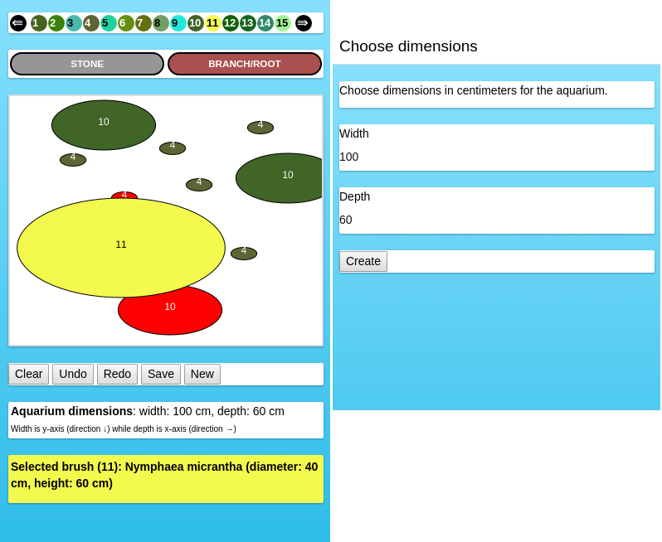
5. Left: main view of the mobile application. Right: dialog for choosing dimensions.

2.3 Database Schemas, Design and Structure
Database has been implemented using mongoDb which is ideal for handling json data.
There is a single collection for plants. Its schema is as follows:
- identificationNumber: { type: Number, unique: true, required: true }
- scientificName: { type: String, required: true, unique: true },
- finnishName: { type: String, unique: true },
- diameter: { type: Number, required: true },
- height: { type: Number, required: true },
- tempMin: { type: Number, required: true },
- tempMax: { type: Number, required: true },
- phMin: { type: Number, required: true },
- phMax: { type: Number, required: true },
- dhMin: { type: Number, required: true, default: 0},
- dhMax: { type: Number, required: true }

Note that the aqu-scape tool uses only the name, identification and size attributes from these (other values are being used by aqu-choice service).

2.4 Communication & Server
On browser side, the plants to use for aquascaping are transferred to Aqu-Scape by Aqu-Choice as URL parameters (using identificationNumber). The serverside is queried for all plants anyway by Aqu-Scape, but the plants are filtered browser side by their identification numbers.
Server is developed using NodeJS and Express and Mongoose is utilized with database mapping.
On mobile side, the server side is queried for plant data and no other communications will be done.
Both mobile and browser side are using CORS for communication with the server side.
3. Conclusions
Most of the difficulty with the project has been on the deploy side of things. I originally used seed project of the angular2 to kickstart development on the browser side, but I had to use a simpler approach when it came apparent that it could not create a suitable distribution package.

There were some nice challenges implementing canvas-related functionality but otherwise things worked out relatively smoothly.

4. References
Aqu-Choice is a online tool for selecting aquarium plants that is used with Aqu-Scape (currently written for finnish users only) . It has been modified to transfer the chosen plants to the new tool.

