Predictive Health User interfaces

Application has two user interfaces, one for the client/patient and one for the doctor. Both user interfaces are implemented with same technologies.

Technologies
User interfaces are implemented using VueJS framework. It was chosen because it is modern, verbose and familiar; creating user interfaces with it is fast. Styles are created using sass which is compiled into css.

Npm (Node Package Manager) is used to install all the dependencies and project files were generated originally using vue-cli client library, which uses webpack under the hood to build the application.

User interfaces connect to backend through REST using axios library.

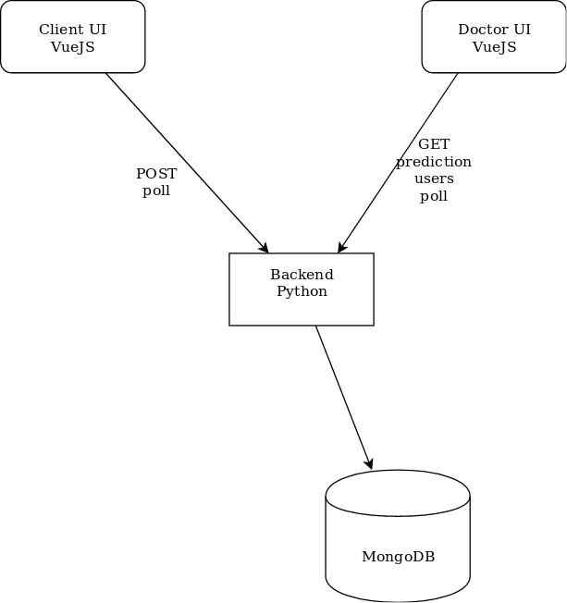Illustration 1: Software architecture

Use cases

User answers a set of questions in a poll that has following options for used food types (Daily – Weekly – Monthly – Never).

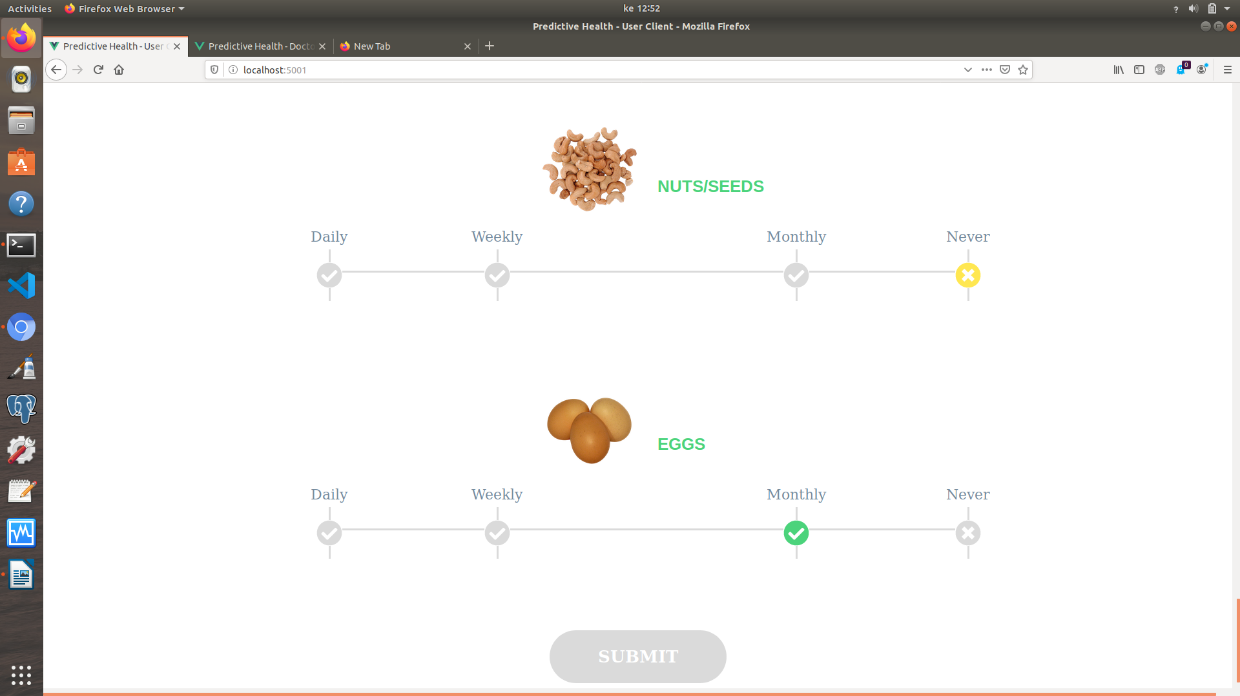Illustration 2: Selecting answers in client UI
Then doctor can see the answers and predictions user have made using the doctor UI.
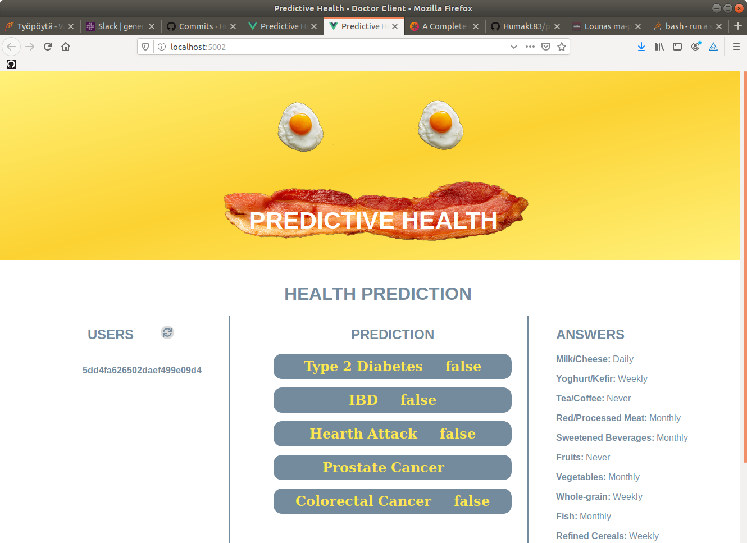Illustration 3: Doctor UI with list of users, prediction and user's answers

