Symprap design documentation

# Architecture

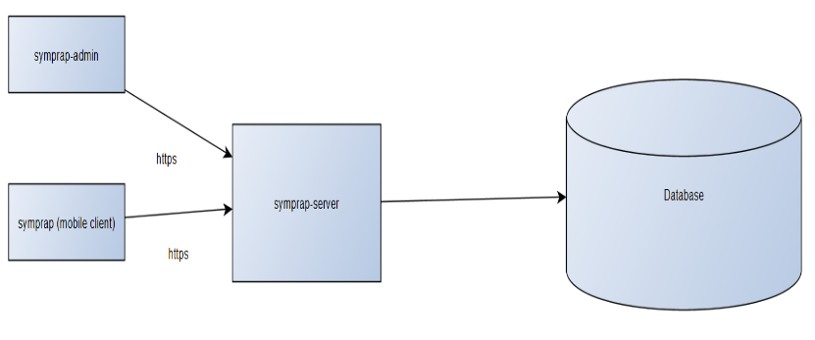

# Symprap server

### Entity relations

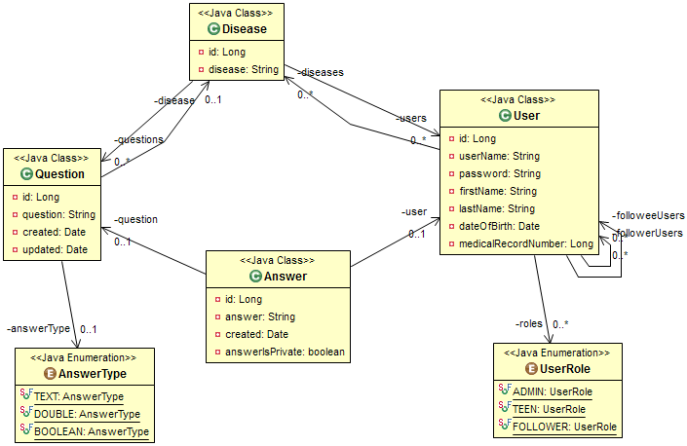

### Requirements

* Java 8+
* Maven 3.2+

### Testing

# Symprap mobile client

### Requirements

### Testing

# Symprap administrator interface

### Requirements

### Testing