**Nutil: Neuroscience Image Processing and Analysis Utilities**

Contents

**Introduction** 2

**Installation and usage** 3

**Operation: TiffCreator** 4

**Operation:** **Transform** 5

**Operation: Resize** 6

**Operation: Quantifier** 7

Input files 7

Requirements 8

Running Quantifier 9

How to generate customised reports with Quantifier (optional) 11

How to interpret the Quantifier output 13

**Technical information** 16

Development platform 16

Authors 16

Licence 16

Cite 16

Acknowledgements 17

Contact us 17

**Introduction**

Nutil aims to both simplify and streamline the mechanism of pre-and-post processing 2D brain image data from mouse and rat. Nutil is developed as a stand-alone application that runs on all operating systems requiring little-to-no experience to execute. The user specifies the path to the input and output directories and the parameters for the pre-and post- processing operations in the Nutil GUI.

Pre-processing operations include conversion of images from JPEG/PNG format to tiled TIFF format, 2D transformations of extremely large tiled TIFF files (rotation, flipping and scaling), in addition to renaming, copying and downsizing. Post-processing is based on analysis of segmented images in the context of brain regions defined by a reference atlas, such as the Allen Mouse Brain reference atlas or the Waxholm Space Atlas of the Sprague Dawley rat brain. All functions operate in batch mode, and operate in parallel on multiple CPUs.

*Nutil* enables four operations:

1. ***TiffCreator*:** convert JPEG/PNG images to tiled TIFF format
2. ***Transform:*** rename, rotate, resize and compile thumbnails of large tiled TIFF images
3. ***Quantifier***: for the batch extraction, quantification and spatial analysis of labelling segmented from 2D mouse or rat brain section images (for example, immunohistochemical labelling).
4. ***Resize:*** for resizing JPEG/PNG images with output in PNG format.

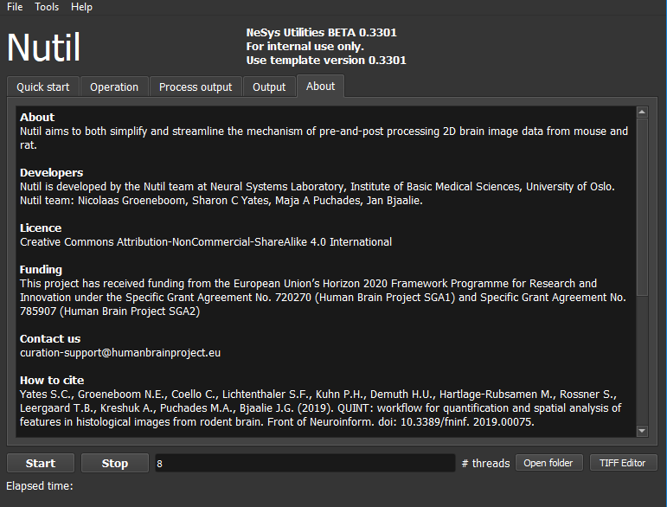

**Figure 1**: Nutil GUI.

**Installation and usage**

*Nutil* is a stand-alone 64-bit Windows application with a simple GUI. There are no installation procedures, just extract the folder and double click on "Nutil.cmd". Nutil is an integral part of the QUINT workflow developed by the Nesys laboratory.

**Download:** <https://www.nitrc.org/projects/nutil/>

**Licence**: [Creative Commons Attribution-NonCommercial-ShareAlike 4.0 International](https://www.nitrc.org/search/?type_of_search=group&offset=0&s=relevancy&rows=20&term%5b%5d=cat:793:Creative%20Commons%20Attribution-NonCommercial-ShareAlike%204.0%20International)

**Funding:** This work was supported by the European Union’s Horizon 2020 Framework Programme for Research and Innovation under the Specific Grant Agreement No. 720270 (Human Brain Project SGA1) and Specific Grant Agreement No. 785907 (Human Brain Project SGA2).

**Cite:** Yates SC, Groeneboom NE, Coello C, Lichtenthaler SF, Kuhn P-H, Demuth H-U, Hartlage-Rübsamen M, Roßner S, Leergaard T, Kreshuk A, Puchades MA and Bjaalie JG (2019) QUINT: Workflow for Quantification and Spatial Analysis of Features in Histological Images From Rodent Brain. Front. Neuroinform. 13:75. doi: 10.3389/fninf.2019.00075.

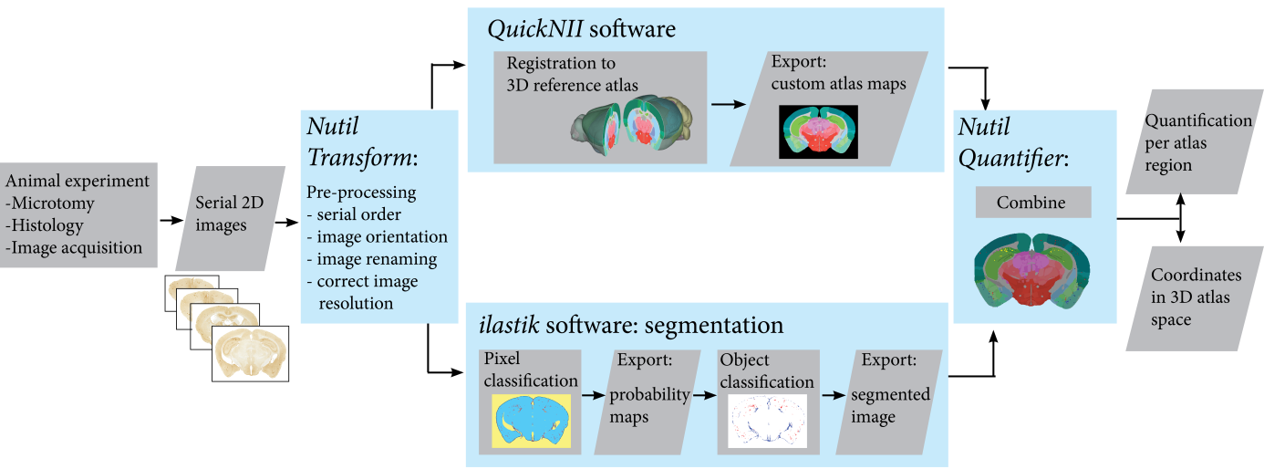

**Figure 2**: QUINT workflow

**Operation: TiffCreator**

***TiffCreator*** converts JPEG, PNG, BMP and GIF images to the tiled TIFF format that is compatible with *Transform*. *TiffCreator* operates in batch, converting all the images in an input folder and saving them in the specified output directory.

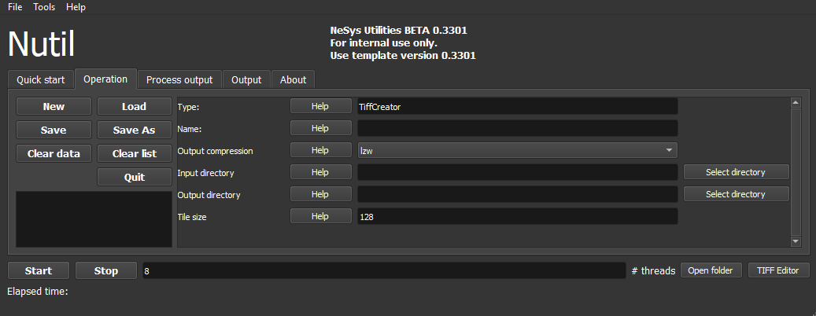

**Figure 3:** TiffCreator GUI

1. To begin, click “New”. Select “TiffCreator”.
2. Select the input folder (containing the images to be converted), output folder and enter the TiffCreator parameters in the Nutil GUI (e.g. desired output compression type).
3. Press “Save as”. This saves a copy of the selected settings in a simple text file in .NUT format. The NUT file is for your own records but may also be reloaded into Nutil via the “load” button.
4. *Nutil* automatically detects the number of core processor available (8 in the example). Choose one less than the total available to ensure adequate processing power (6 or 7 here) and press “Start”. Wait until the process is complete.
5. The tiled TIFFs save automatically in the specified output folder.

The GUI includes an inbuilt user manual accessed via the “Help” buttons.

**Operation:** **Transform**

Transform allows the batch renaming, rotation, resizing and thumbnail compilation of large tiled TIFF images.

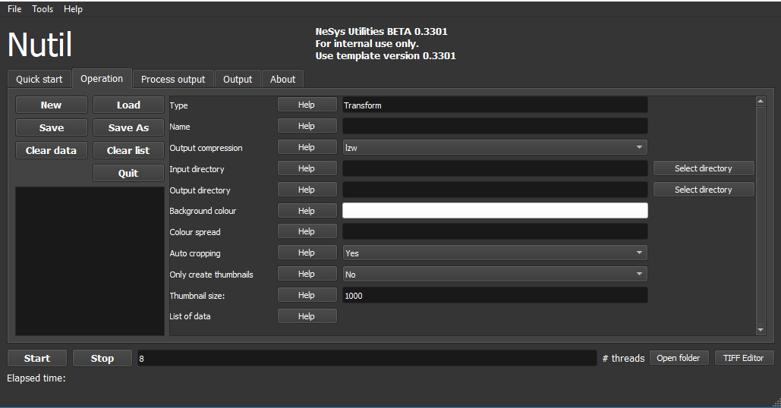

**Figure 4:** Transform GUI

1. Click “New”. Select “Transform”.
2. Select the input folder (containing the images to be transformed), output folder and enter the transformation parameters in the Nutil GUI. The GUI includes an inbuilt user manual accessed via the “Help” buttons.
3. Once everything is filled in press the “Save as” button. This saves a copy of the transformation parameters in a simple text file in .NUT format. This is for your own records, but may also be reloaded into Nutil via the “load” button.
4. *Nutil* automatically detects the number of core processor available (8 in the example). Choose one less than the total available to ensure adequate processing power (6 or 7 here).
5. Press “Start” and wait until the process is complete.

**Operation: Resize**

Resize enables rapid resizing of PNG and JPEG images by application of a resize factor or a fixed pixel width.

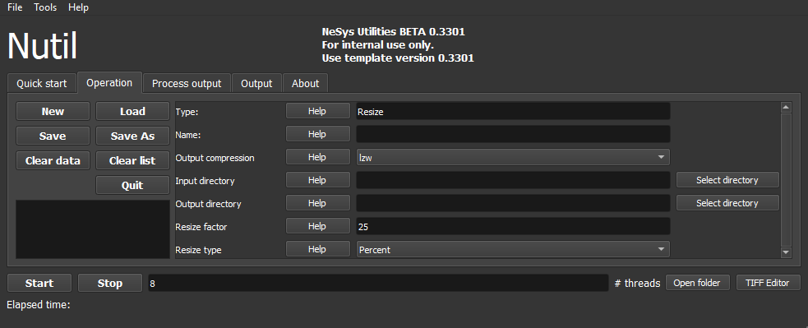

**Figure 5:** Resize GUI

1. To begin, click “New”. Select “Resize”.
2. Select the input folder, output folder and resize factor in the Nutil GUI (see the “help” buttons for more information).
3. Press “Save as”. This saves a copy of the parameters in a simple text file in .NUT format. This is for your future records but may also be reloaded into Nutil via the “load” button.
4. *Nutil* automatically detects the number of core processor available (8 in the example). Choose one less than the total available to ensure adequate processing power (6 or 7 here) and press “Start”. Wait until the process is complete.
5. The PNG files save automatically in the specified output folder.

**Operation: Quantifier**

## Input files

1. **Segmentations** with the labelling displayed in one RGB (red green blue) colour

(e.g. here shown in red: 255, 0, 0).

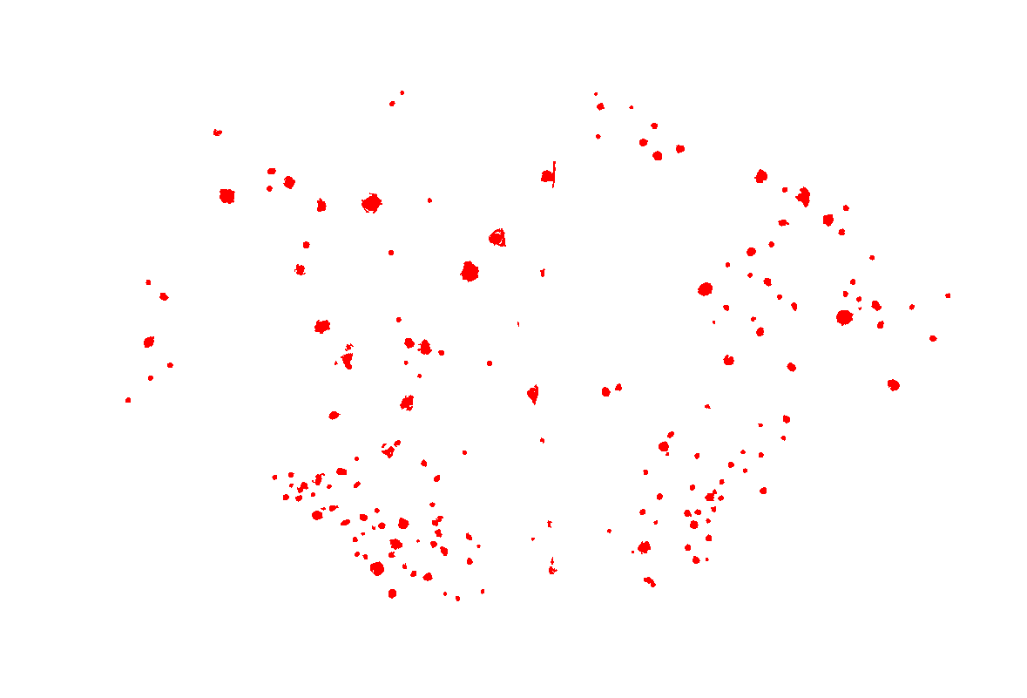

**Requirement:**

* must be 24-bit RGB images in PNG format
* same proportions as the atlas maps (must have the same proportions, but not necessarily the same size as the images used in *QuickNII* to generate the atlas maps)
* ***Quantifier*** is only able to extract one RGB colour at a time. Apply one RBG colour to all of the objects of interest, and specify this colour code in the GUI.

Any image analysis software may be used to generate the segmentations. We use the Pixel and Object Classification workflows in the ilastik software (ilastik.org).

1. **Customised brain atlas maps**

Generate the atlas maps with the *QuickNII* software with nonlinear refinement with *VisuAlign* if necessary. See the *QuickNII* and *VisuAlign* manuals for more information.

([www.nitrc.org/projects/quicknii](https://www.nitrc.org/projects/quicknii))

(https://www.nitrc.org/projects/visualign)

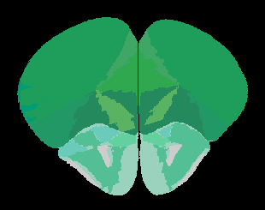

1. **Anchored XML** file generated with the *QuickNII* software.

|  |
| --- |
| **QuickNII** is a stand-alone tool for user guided affine spatial registration (anchoring) of sectional image data, typically high resolution microscopic images, to a 3D reference atlas space. A key feature in the tool is the capability to generate user defined cut planes through the atlas templates, matching the orientation of the cut plane of the 2D experimental image data (customised brain atlas maps). The reference atlas is transformed to match anatomical landmarks in the corresponding experimental images. In this way, the spatial relationship between experimental image and atlas is defined, without introducing transformations in the original experimental images. Following anchoring of a limited number of sections containing key landmarks, transformations are propagated across the entire series of images to reduce the amount of manual steps required.  QuickNII is available at: [www.nitrc.org/projects/quicknii](https://www.nitrc.org/projects/quicknii) |

|  |
| --- |
| **VisuAlign** is a stand-alone tool applying user-guided nonlinear refinements (inplane) to an existing, affine 2D-to-3D registration (compatible with the output of the QuickNII tool).  VisuAlign is available at: <https://www.nitrc.org/projects/visualign>) |

## Requirements

The file names of the segmentation and atlas maps that correspond to a particular section must contain a unique ID.

*Nutil Quantifier* support*s* IDs in the format: sXXX.., with XXX representing the section number. The section number should reflect the serial order and spacing of the sections (e.g. s002, s006, s010 for every 4th section starting with section 2). The IDs must match those in the .xml file.

**Example**: tg2345_MMSH_s001_segmentation.png

(It is fine to include a string of letters and numbers followed by the unique ID).

*Nutil Quantifier*also supports user defined IDs (using regular expressions). For more information see the “help” button in the Nutil GUI.

NOTE: The sXXX naming convention applies to both *QuickNII* and *Nutil* *Quantifier.* We therefore recommend changing the file names as the first step in the workflow (with *Nutil Transform,* see Figure 1).

## Running Quantifier

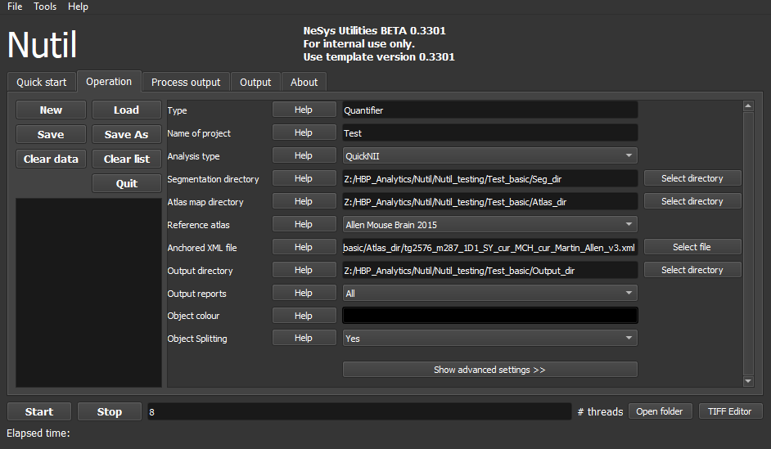

**Figure 5:** Quantifier GUI

1. To begin, click “New”. Select “Quantifier” and analysis type “QUINT”. Enter the name of your project.
2. Select the folder containing the segmentations, the atlas maps and the desired output folder, and navigate to the anchored XML file.
3. Select the reference brain atlas. This must match the version used to generate the brain atlas maps (Allen mouse brain 2015 or 2017, or Waxholm Space Atlas of the Sprague Dawley Rat v2 or v3).
4. Fill in the rest of the parameters. The Nutil GUI includes an inbuilt user manual accessible via the “Help” buttons, and gives an in depth description of each parameter/setting.
5. The “show advanced settings” button reveals more settings that may be chosen and altered by the user (e.g. max and min object size cut-off, option to generate customised reports, etc.). This gives more flexibility for customised analysis. If nothing is changed in the advanced settings, the default settings shown in the table below are automatically applied.

|  |  |
| --- | --- |
| **Advanced Parameter** | **Default settings** |
| Minimum object size | 1 pixel |
| Maximum object size | 100000 pixels |
| Pixel scale | 1 pixel |
| Use custom masks? | No |
| Output report type | CSV |
| Apply customised regions? | No |
| Coordinate extraction? | Yes, for whole series and per section (All) |
| Pixel density | 1 coordinate per pixel |
| Nifti size | 0 (no nifti file generated) |
| Unique ID format | _sXXXX… |

1. Press “Save as”. This saves a copy of the selected settings in a simple text file in .NUT format. This is for your future records, but may also be reloaded into Nutil via the “load” button (for example, to repeat the analysis on a new set of images, etc).
2. *Nutil* automatically detects the number of core processor available (8 in the example). Choose one less than the total available to ensure adequate processing power (6 or 7 here) and press “Start”. Wait until the process is complete.
3. The output files are automatically saved in the specified output folder.

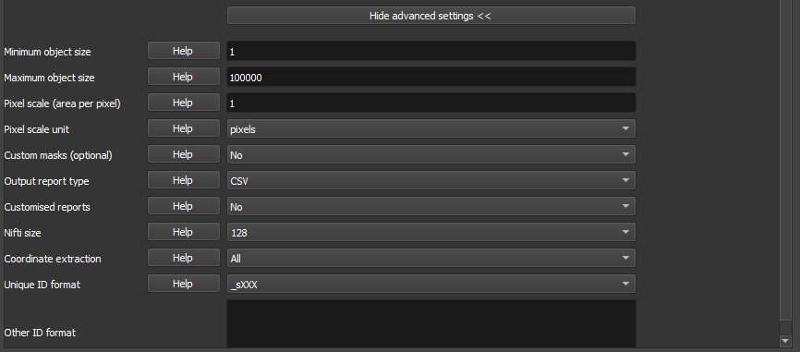

**Figure 6:** Quantifier advanced settings GUI

|  |
| --- |
| **Object Splitting Explained**  In Quantifier, users must specify whether to turn on or off “object splitting”. Object splitting divides segmented objects that overlap atlas regions, with individual pixels assigned their precise location. This gives accurate load measurements (load is the percentage of the region occupied by objects), but invalidates the object counts.  **Recommendation:** Select NO for small objects to get accurate object counts (e.g. cells). Select YES for large objects that overlap atlas regions (e.g connectivity data). This gives precise load output. See the help button for more information. |

## **How** to generate customised reports with Quantifier (optional)

For the QUINT analysis type, reports are always generated with outputs organised based on the regions in the specified reference brain atlas (mouse or rat).



There is an optional feature for defining customised regions - compilations of reference atlas regions (e.g. hippocampus) - with a customised report organised based on these.

Nutil has inbuilt region suggestions for each reference atlas (mouse and rat). To use these, select “default”. More info on these are found in the DefaultCustomRegions files included in the Nutil package.

**How to define your own regions**

1. To define your own regions, use the *CustomRegionsTemplate.xlsx* that is included in the Nutil package, and populate as described below:

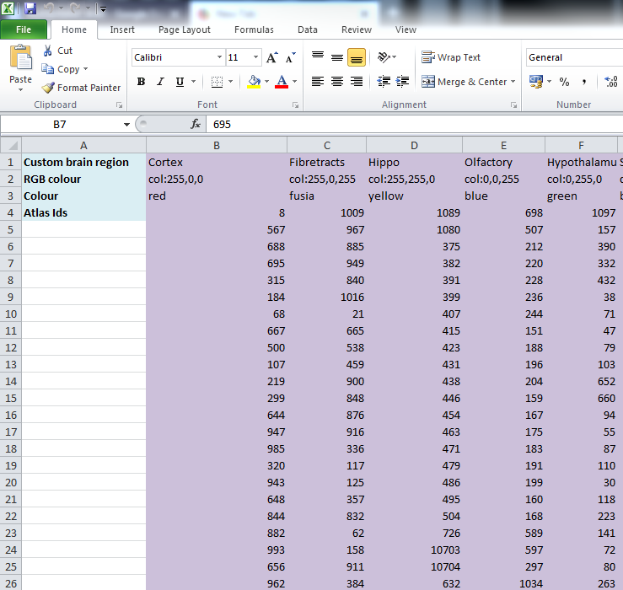

**ROW 1:** assign your own names to the regions (for example: hippocampus).

**ROW 2**: assign colours to the regions. Do this by typing a RGB colour code in the following format: 255;0;0 (for red). This colour will be assigned to the objects located in the custom region for the purposes of the image and coordinate output (for display purposes only).

**ROW 3**: enter the colour name (this is for your information only).

**ROW 4**: define the region by listing the relevant reference atlas IDs. The excel sheets in the AtlasHierarchy folder for more information.

For mouse, see the *ABAHier2015.xlsx or ABAHier2017.xlsx* file for the full list of regions and IDs.

For rat, see the *WHS_SD_rat_atlas_v2.label* file for the full list of regions and IDs.

NOTE: Use the default xlsx as a guide to filling in the template.

## **How to** interpret the Quantifier output

1. **IMAGES**

Segmentations superimposed on the atlas maps (PNG format). Object colours are assigned based on the customised regions. If no regions are specified, or object falls outside of the specified areas, the objects are shown in red by default.

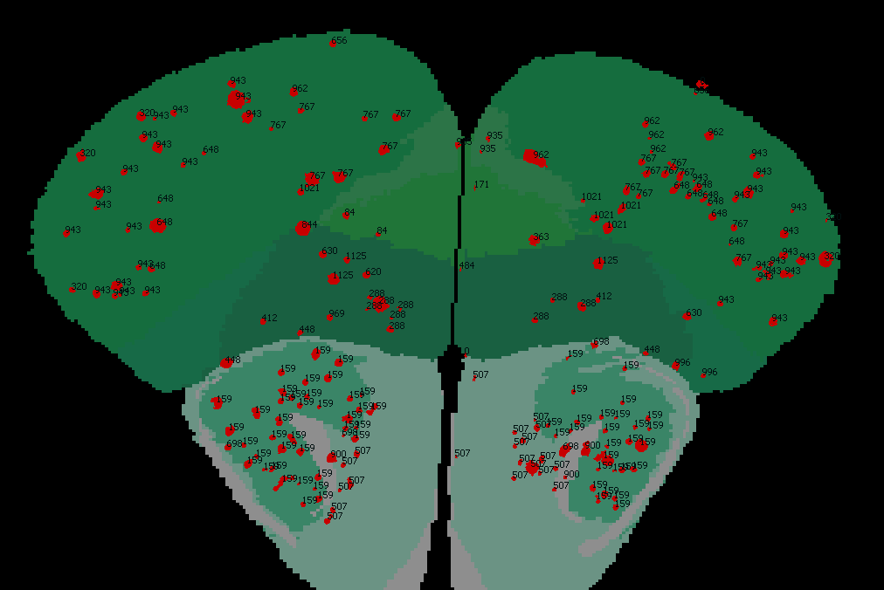

1. **Reports** (CSV or HTML format)

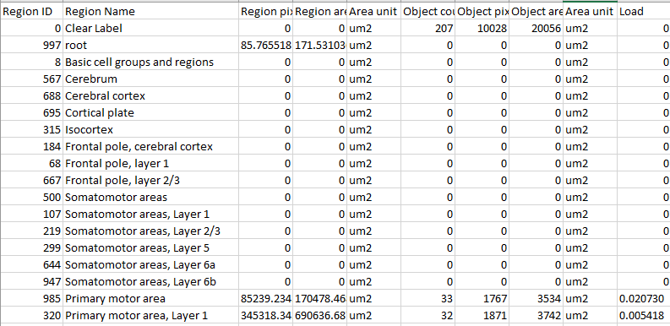

* 1. **RefAtlasRegions**

Report with output organised based on all the regions in the reference atlas: per section and for the whole series (all sections combined).

* 1. **CustomRegions**

Reports with the output organised based on the customised regions defined in the CustomRegionsTemplate.xlsx: per section and for the whole series.

* 1. **Objects**

List of all the objects in the whole series and per section.

In each report, interpret the results as follows:

|  |  |
| --- | --- |
| **Region pixels** | No. of pixels representing the region. |
| **Region area** | Area representing the region |
| **Area unit** | Region area unit |
| **Object count** | No. of objects located in the region.  NOTE: Object counts are not generated if object splitting is switched “on”. |
| **Object pixels** | No. of pixels representing objects in this region. |
| **Object area** | Area representing objects in this region. |
| **Load** | Ratio of Object pixels to Region pixels (Object pixels/Region pixels). |

1. **COORDINATES**

JSON files containing point clouds that can be visualised with the MeshView atlas viewer, which is available at [www.nitrc.org/projects/meshview](https://www.nitrc.org/projects/meshview) via the MediaWiki link.

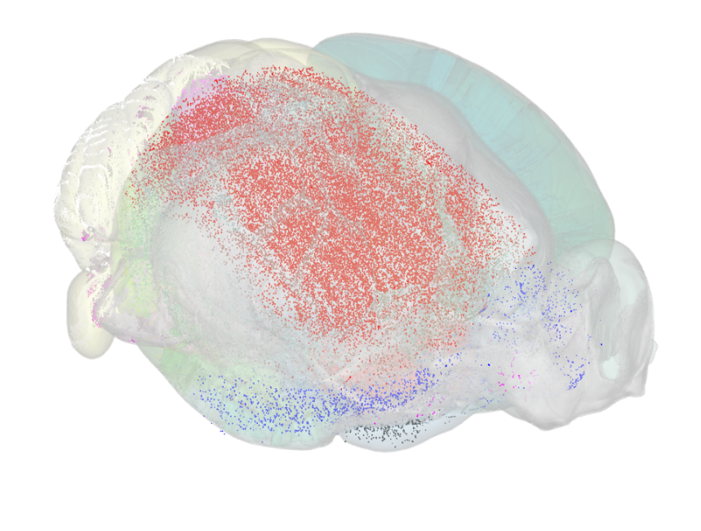

1. **NUT file**

The NUT file is a text file containing the analysis parameters.

**Technical information**

### Development platform

*Nutil* is written as a stand-alone windows 64-bit application written in Qt C++, which enables the full usage of both memory and processor cores. *Nutil* can be downloaded and compiled from the [github page](https://github.com/leuat/nutil). When performing batch processes, *Nutil* will utilise all cores available on the system.

The external libraries that are used in *Nutil* are:

* Libtiff for fast and efficient TIFF file handling (<http://www.libtiff.org/>)
* LibXLNT for excel file IO (<https://github.com/tfussell/xlnt/>)

***TiffCreator***

TiffCreator produces tiled TIFF files from JPEG or PNG images, and employs the support of multiple CPUs for efficient, parallelised operations.

***Transform***

*Transform* enables rotations, scaling and thumbnail compilation of large tiff files (currently up to 4GB).

***Quantifier***

*Quantifier* identifies individual binary objects in a PNG file, while matching these to output from *QuickNII*. The method first finds and sorts areas by using a standard pixel filler routine. Afterwards, a random area pixel is chosen as the look-up in the binary QuickNII label slice for this particular image. When all areas have been assigned a label ID, multiple selections of pre-defined area IDs are assembled (ID list from the excel input file), and finally output reports are assembled and written to disk (in xlsl format). In addition, original ilastik .png files with colour/ID coding added to underlying atlas slice data are assembled and saved to the output directory.

### Authors

Nicolaas E Groeneboom, Sharon C. Yates, Maja A. Puchades, Jan G. Bjaalie.

### Licence

Creative Commons Attribution-NonCommercial-ShareAlike 4.0 International

### Cite

Yates SC, Groeneboom NE, Coello C, Lichtenthaler SF, Kuhn P-H, Demuth H-U, Hartlage-Rübsamen M, Roßner S, Leergaard T, Kreshuk A, Puchades MA and Bjaalie JG (2019) QUINT: Workflow for Quantification and Spatial Analysis of Features in Histological Images From Rodent Brain. Front. Neuroinform. 13:75. doi: 10.3389/fninf.2019.00075.

### Acknowledgements

Nutil was development with support from the European Union’s Horizon 2020 Framework Programme for Research and Innovation under the Specific Grant Agreement No. 720270 (Human Brain Project SGA1) and Specific Grant Agreement No. 785907 (Human Brain Project SGA2).

### Contact us

curation-support@humanbrainproject.eu