READ ME INFORMATION

All files necessary to obtain predicion from the Dawson Clint Fup QSAR model are contained in the folder, **NewPredictions**. The model has not changed, only the presentation is more intuitive.

Marked with a pink in line , for new predictions the user supplies only 2 files, the PaDEL descriptors and the OPERA predictors. Marked with a blue line, the folder contains the original model files. These files are processed by the R-markdown file **NovelChemicalFupClintPrediction_021324.RMD** creating the output files of marked with a green line.

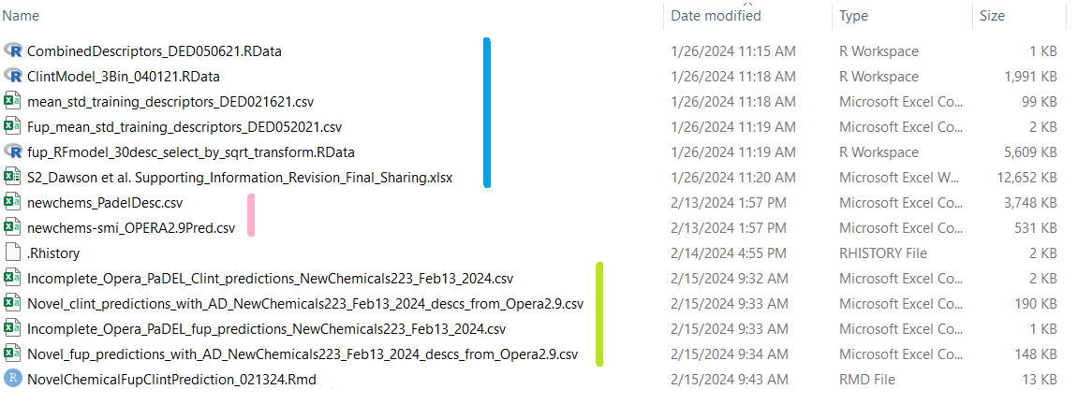

OPERA 2.9 Setting Minimum* requirements for Dawson (*can remove FUB/Clint)

