FACULTY OF ELECTRONICS

COMPUTER ENGINEERING AND TELECOMMUNICATIONS DEPARTMENT

LABORATORY WORK #3

Introduction to Cisco LAN Equipment and Router Configuration

Student: Mark Mikula

Teacher: Artūras Medeišis

Vilnius, 2025

Contents

Part 1. Answers to Questions Presented in Part 1 2

Part 2. 3

Part 3: Network Implementation and Testing 3

Conclusion 4

## Part 1. Answers to Questions Presented in Part 1

This lab work aimed to introduce the Network Laboratory's Cisco LAN equipment, specifically the Cisco 1941 router, its basic management functions, and how to configure it to connect two LAN subnets with dynamic IP addressing

1.

What is Cisco 1941 and what application scenarios is it intended for?

The Cisco 1941 is identified as a modular Integrated Services Router (ISR G2)It is intended for small to medium-sized businesses and enterprise branch offices. Its application scenarios include supporting high-performance routing, secure WAN connectivity, and integrated services like voice, video, security, and wireless. Common uses include secure branch office connectivity, internet access, VPN termination, and acting as a platform for network services. The lab environment includes Cisco 1941 routers as part of its standard 19-inch telecom equipment rack setup

2.

The Cisco 1941 has two Ethernet ports, as shown in Figure 3. Please answer what is the maximum data transmission speed of these ports and what physical layer media/standard is used in them?

The Cisco 1941 router has two built-in Gigabit Ethernet port, labeled GigabitEthernet0/0 and GigabitEthernet0/1. These ports have a maximum data transmission speed of 1 Gbps (10/100/1000 Mbps). They utilize twisted-pair copper cables (Cat5e/Cat6) with RJ-45 connectors, adhering to Ethernet standards such as IEEE 802.3ab (1000BASE-T). These operate at the OSI Layers 1 and 2.

The lab involved setting up a LAN with two subnets connected by a Cisco 1941 router, following a specific connection diagram and IP numbering scheme

## Part 2.

Initial Steps: Access to the router's Command Line Interface (CLI) was established, using a serial console connection via PuTTY

Upon booting the router, the initial setup prompt was bypassed by typing 'no'. The initial status of the router interfaces and IOS version was checked using show ip interface brief and show version commands  
I ran all of the needed commands to get interfaces up and running, created dhcp pools, etc.

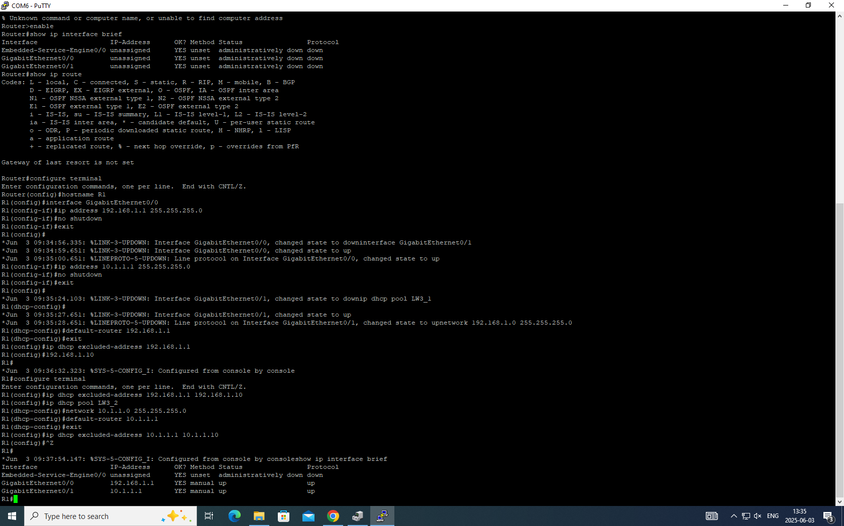

Part 3: Network Implementation and Testing

I used ipconfig /renew and gui in order to get new ip for each pc, tested whether the devices can ping each other, used wireshark, which allowed me to closely inspect dhcp and ping processes.

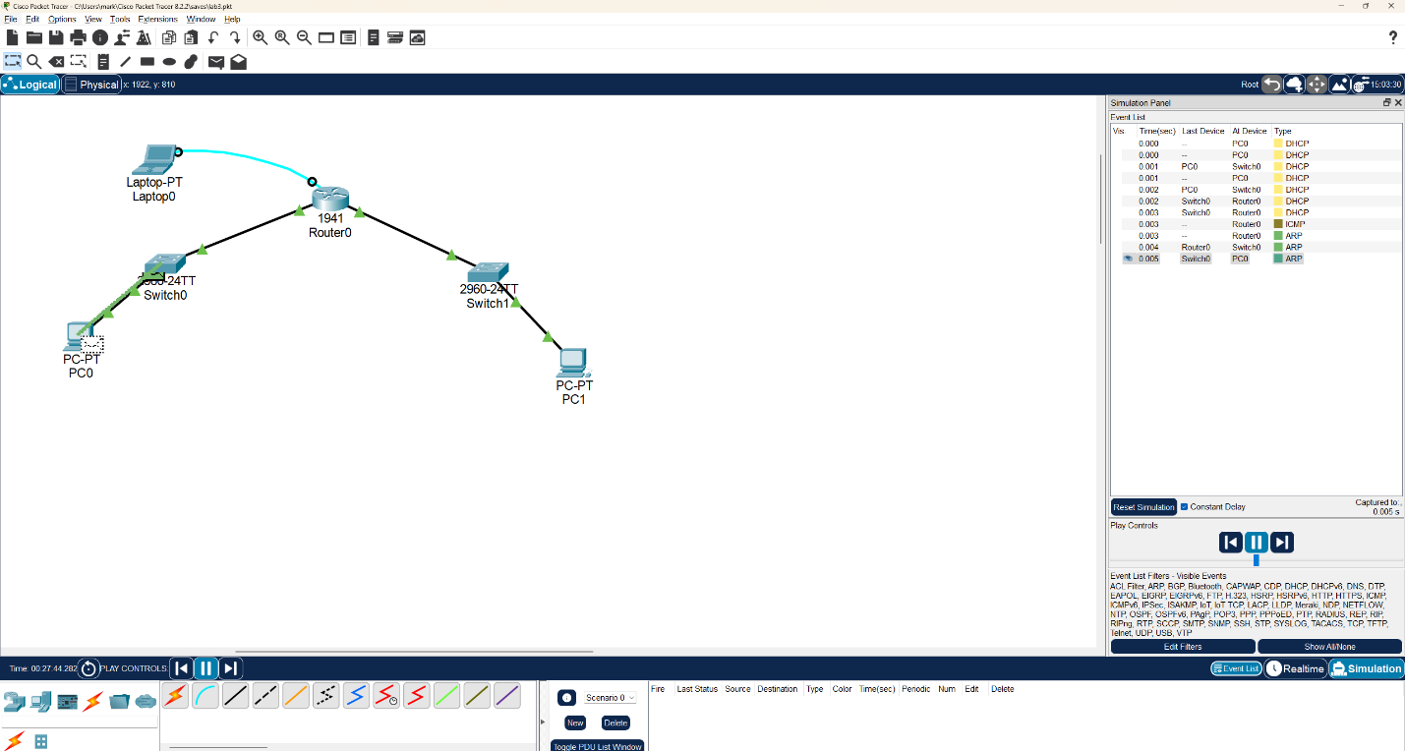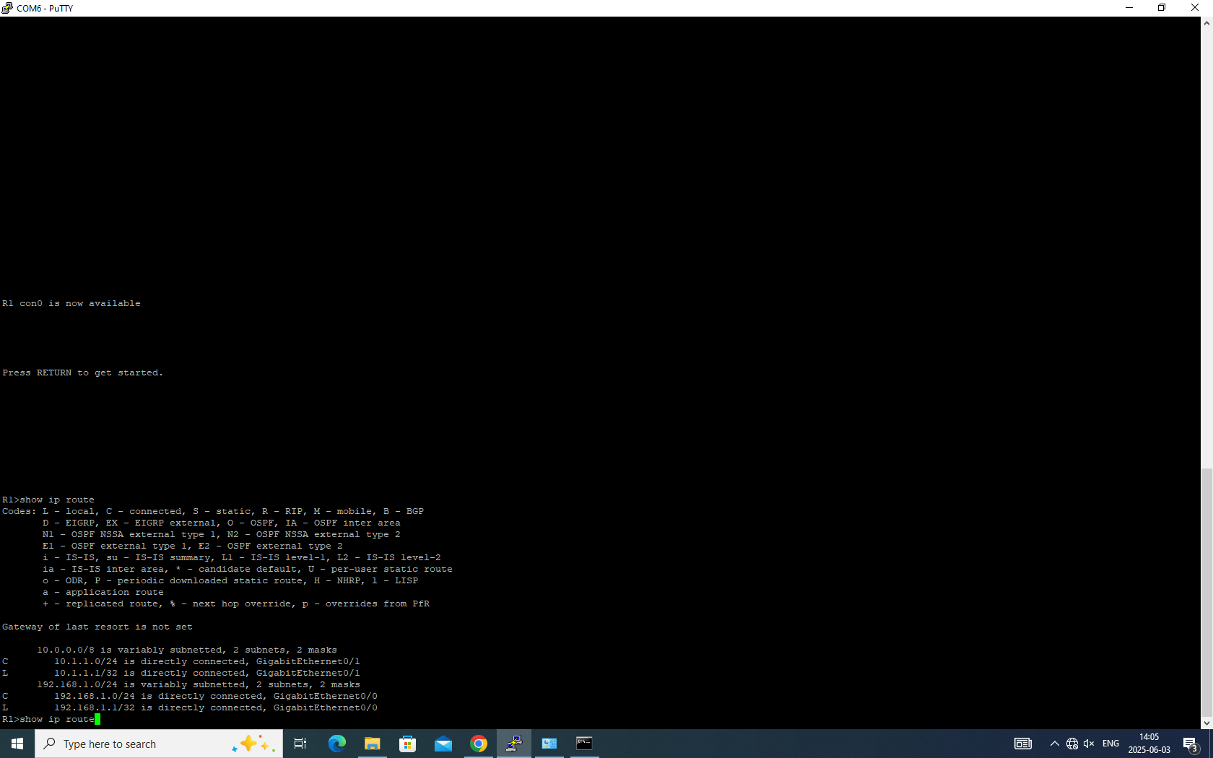

## Conclusion

This lab successfully provided practical experience in basic Cisco device configuration and wired LAN setup simulation

Key activities included configuring router interfaces with IP addresses, enabling DHCP services, and testing connectivity within and between two subnets. Using packet capture helped analyze the DHCP process. Connectivity tests using ping confirmed the configuration, though potential challenges like PC firewalls were noted as a factor in inter-subnet communication outcomes. Overall, the lab offered valuable hands-on experience applying networking knowledge.