FACULTY OF ELECTRONICS

COMPUTER ENGINEERING AND TELECOMMUNICATIONS DEPARTMENT

LABORATORY WORK #4

Switches, MAC-IP Addressing, and ARP

Student: Mark Mikula

Teacher: Artūras Medeišis

Vilnius, 2025

Contents

Objective 2

Part 1: Familiarising with Cisco Catalyst Switches 2

Part 2: Connecting Subnets and investigating MAC-IP Addressing 3

Conclusion 9

Objective

This lab built upon previous exercises to provide familiarisation with Cisco Catalyst switches, explore the interplay between Ethernet MAC and IP addressing, and demonstrate the Address Resolution Protocol (ARP) process

The lab involved setting up a LAN topology using a router and multiple switches, configuring devices, and analyzing Layer 2 (MAC) and Layer 3 (IP) addressing using CLI commands and packet capture.

## Part 1: Familiarising with Cisco Catalyst Switches

The lab introduced Cisco Catalyst switches, such as the Catalyst 3750 series, which are commonly used in enterprise access and distribution layers

Cisco Catalyst 3750 switches are typically used for aggregation of access layer switches or providing connectivity to end devices in a large network. They are considered Layer 3 devices, meaning they can perform both Layer 2 switching (forwarding frames based on MAC addresses) and Layer 3 routing (forwarding packets based on IP addresses), which offers enhanced usage possibilities like inter-VLAN routing and static routing

The physical setup involved connecting a Cisco 1941 router to switches (SW1-2 and SW2) and connecting two switches directly (SW1-1 and SW1-2)

Connecting two switches directly often requires a crossover UTP (Unshielded Twisted Pair) cable. A crossover cable is special because it swaps the transmit (TX) and receive (RX) wire pairs within the cable, allowing two devices configured to transmit on the same pins (like switch ports without auto-MDIX) to communicate directly

Basic router configuration was performed, similar to Lab 3, including setting IP addresses on interfaces

Basic switch configuration involved connecting via console and setting the hostname, e.g., to SW1-1. While switches can forward frames without configuration, basic control commands are used for management. The initial state of the switch's MAC address table was checked using show mac address-table

## Part 2: Connecting Subnets and investigating MAC-IP Addressing

The lab topology included a router (R1), two connected switches (SW1-1, SW1-2), and another switch (SW2), with PCs and a Laptop connected to the switches, forming two subnets (192.168.1.0/24 and 10.1.1.0/24) interconnected by the router

PCs were configured to obtain IP addresses via DHCP, and the ipconfig /all and arp -a commands were used to verify their network configurations and initial ARP tables

The assigned IP addresses corresponded to the addressing scheme in Figure 2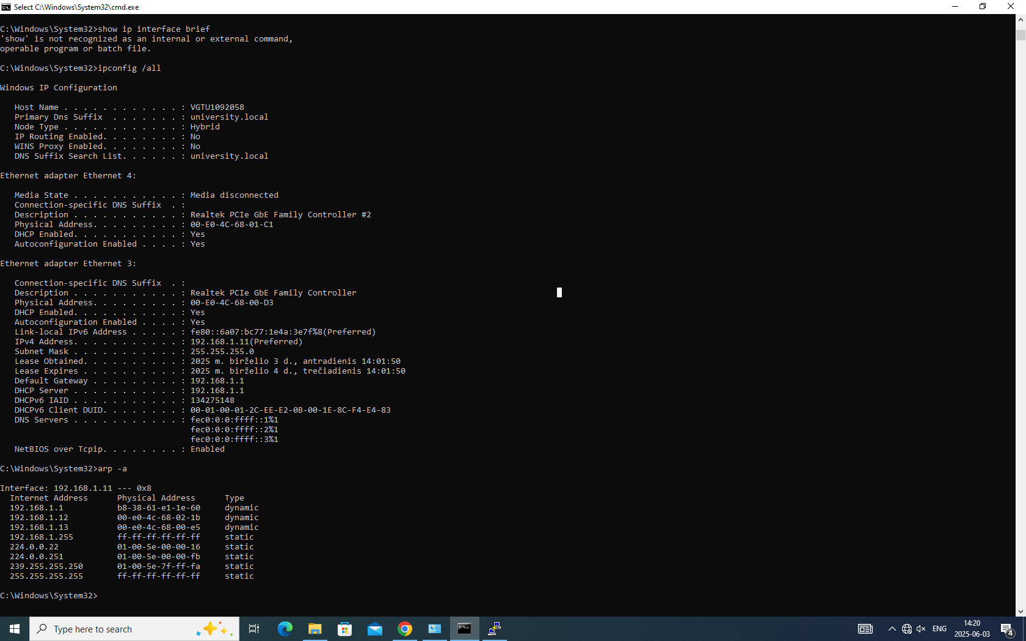

Hosts connected to SW1-1 and SW1-2 received IPs in the 192.168.1.0/24 network (e.g., 192.168.1.11, 192.168.1.12), while hosts on SW2 received IPs in the 10.1.1.0/24 network (e.g., 10.1.1.11).

Ping tests were performed between devices on the same and different subnets to confirm communication

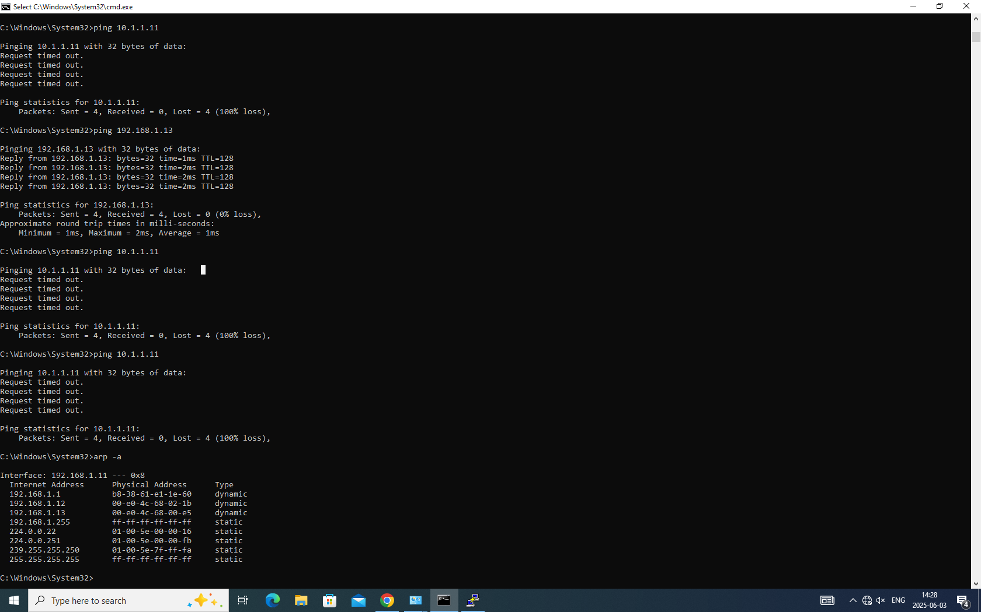

MAC and ARP Table Analysis:

The SW1-1 MAC table lists MAC addresses learned on its ports

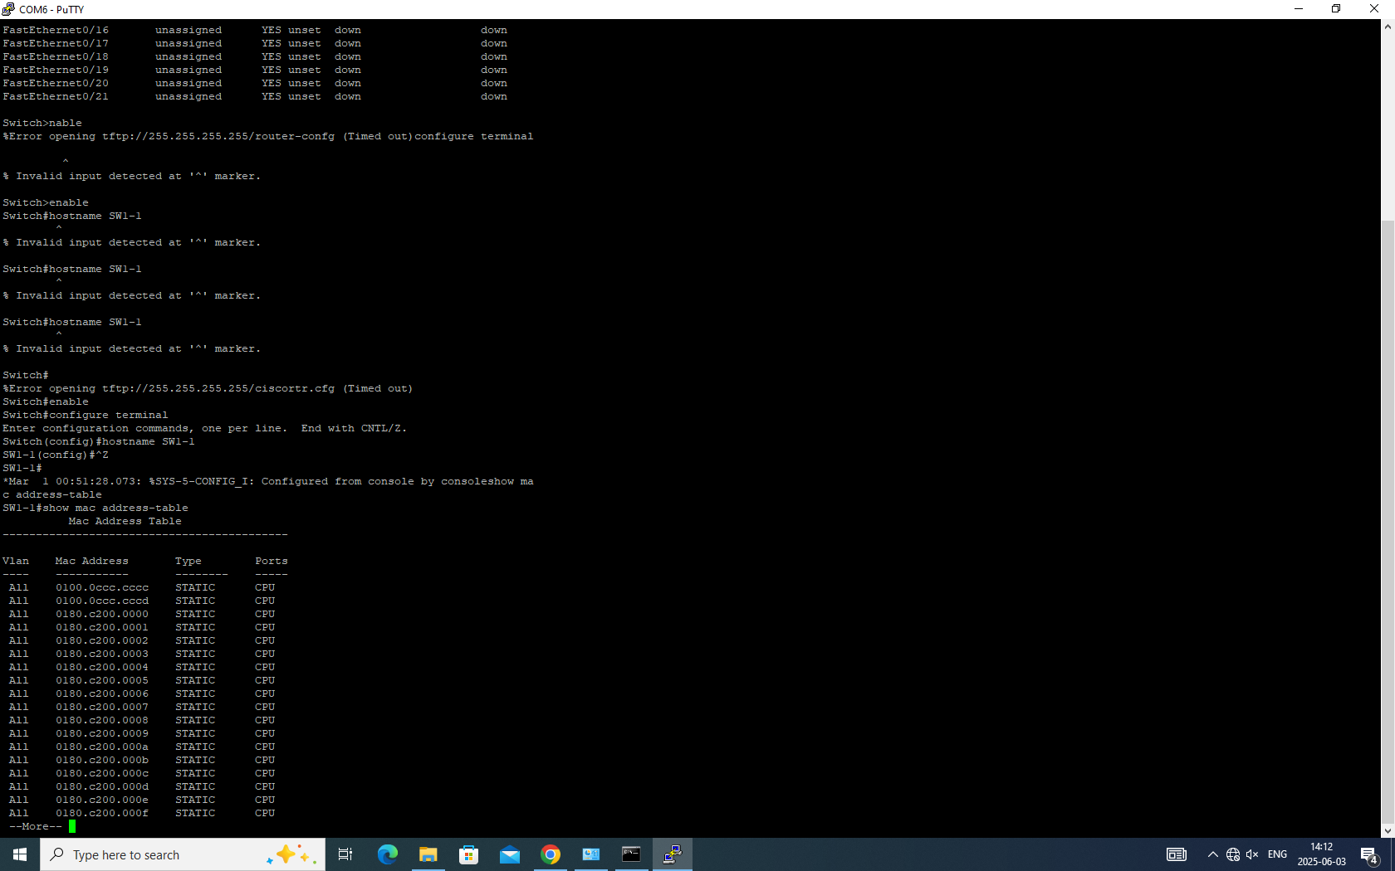

After communication, this would include the MAC addresses of PC1, PC2 (directly connected), R1's Gi0/0 interface (connected via SW1-2), and potentially the Laptop's MAC (learned via SW1-2 and SW2)

Switch ports can have more than one MAC address assigned

This occurs on ports connected to other switches (like the link between SW1-1 and SW1-2) or hubs, where traffic from multiple devices passes through a single port. SW1-1's port connected to SW1-2 would learn the MACs of PC1, PC2, and R1 if they communicate through that link

There is a significant difference between the ARP table of a PC and the MAC table of a switch

A PC's ARP table is a Layer 3 to Layer 2 mapping (IP to MAC) used for communication within its local IP subnet or to find its default gateway's MAC for inter-subnet communication. A switch's MAC address table is a Layer 2 mapping (MAC to Port) used for forwarding Ethernet frames and is unaware of IP addresses

LAN Addressing Table

|  |  |  |  |  |
| --- | --- | --- | --- | --- |
| Host Name | MAC address | IP address | Switching port | Switch Port |
| R1 Gi0/0 | 0001.C916.A301 | 192.168.1.1 |  | SW1-2 |

|  |
| --- |
|  |
| R1 Gi0/1 | 0001.C916.A302 | 10.1.1.1 |  | SW2 |

|  |
| --- |
|  |
| PC1 Ethernet | 00D0.BC0B.8CD1 | 192.168.1.11 |  | SW1-1 |

|  |
| --- |
|  |
| PC2 Ethernet | 0060.2F44.92BB | 192.168.1.12 |  | SW1-1 |

|  |
| --- |
|  |
| Laptop Ethernet | 00E0.B098.C6AD | 10.1.1.11 |  | SW2 |

|  |
| --- |
|  |

Packet Encapsulation Analysis: was used to analyze packets during ping operations. Specifically, the ARP process and ICMP (ping) packets were observed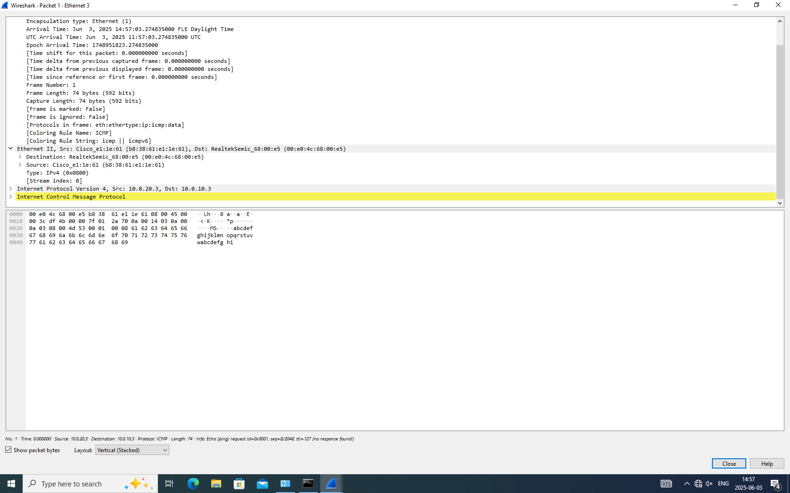

Deleting the ARP cache (arp -d) before pinging a destination on the same subnet triggers an ARP request for the destination's IP address to discover its MAC address

The first packet sent in this scenario is typically an ARP broadcast request. When pinging a destination on a different subnet, the PC ARPs for its default gateway's IP address to get the router's MAC. The sequence of packets would differ: an ARP request/reply for the gateway followed by the ICMP packet for inter-subnet ping, versus an ARP request/reply for the destination followed by the ICMP packet for same-subnet ping (if the MAC is not known)

The encapsulation of packets, particularly MAC addresses, changes as they traverse different network segments and pass through a router

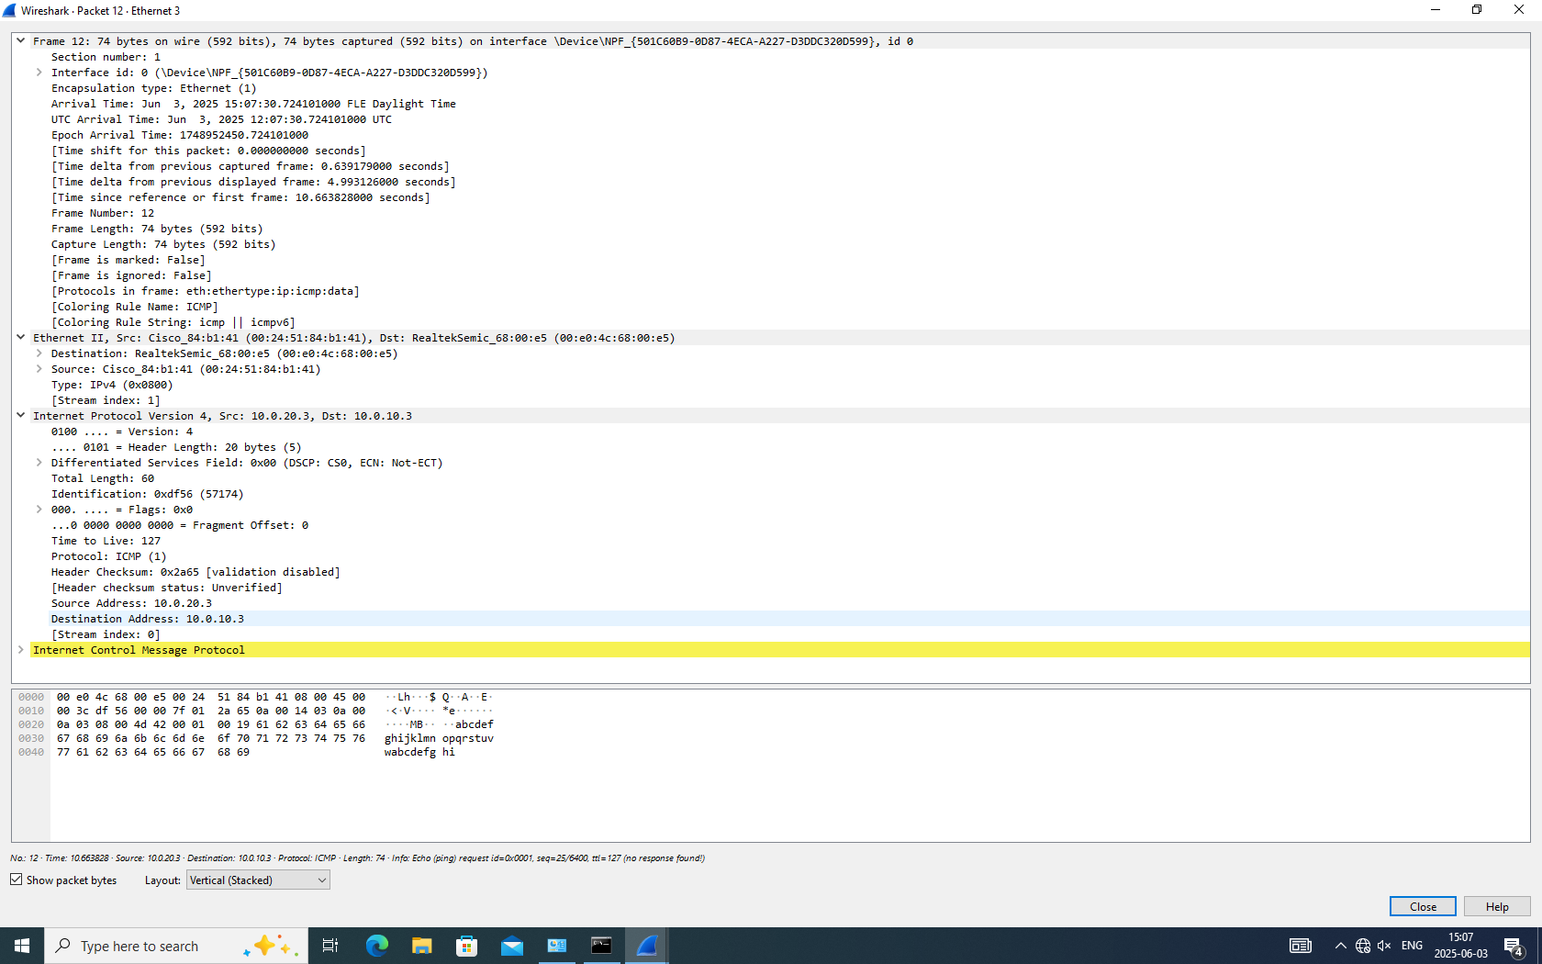

Ping Packets Addressing Tables

Ping packet sent from PC1 (192.168.1.11) to Laptop (10.1.1.11) - Different Subnet

|  |  |  |
| --- | --- | --- |
| Addresses: | Host: PC1 (Source) | Host: Laptop (Destination) |
| Destination MAC | 0001.C916.A301 (R1's Gi0/0 MAC) |  |
| Source MAC | 00D0.BC0B.8CD1 (PC1's MAC) |  |
| Source IP | 192.168.1.11 |  |
| Destination IP | 10.1.1.11 |  |

Ping packet sent from PC1 (192.168.1.11) to PC2 (192.168.1.12) - Same Subnet

|  |  |  |
| --- | --- | --- |
| Addresses: | Host: PC1 (Source) | Host: PC2 (Destination) |
| Destination MAC | 0060.2F44.92BB (PC2's MAC) |  |
| Source MAC | 00D0.BC0B.8CD1 (PC1's MAC) |  |
| Source IP | 192.168.1.11 |  |
| Destination IP | 192.168.1.12 |  |

Ping packet from PC1 (192.168.1.11) as received in PC2 (192.168.1.12) - Received Frame

|  |  |  |
| --- | --- | --- |
| Addresses: | Host: PC1 (Source - IP Header) | Host: PC2 (Destination - IP Header) |
| Destination MAC |  | 0060.2F44.92BB (PC2's MAC) |
| Source MAC |  | 00D0.BC0B.8CD1 (PC1's MAC) |
| Source IP | 192.168.1.11 |  |
| Destination IP | 192.168.1.12 |  |
|  |  |  |

Addressing Differences and Encapsulation Change: The difference in MAC-IP addressing for the two initial ping packets (PC1 to Laptop vs. PC1 to PC2) lies in the destination MAC address

For the same-subnet ping (PC1 to PC2), the destination MAC is the target host's (PC2's) MAC address. For the different-subnet ping (PC1 to Laptop), the destination MAC is the MAC address of the default gateway (R1's interface Gi0/0), because the PC knows the destination IP is not local and must send it to the router. The source IP and destination IP addresses in the IP header remain the actual source and destination IPs (PC1 and Laptop/PC2, respectively) in both cases

The encapsulation of the PC1->Laptop packet changed at the router

The IP packet itself (containing the original source and destination IPs) remained intact. However, upon receiving the frame from PC1, the router (R1) decapsulated the Ethernet frame to read the destination IP address in the IP header. It then looked up the destination network (10.1.1.0/24) in its routing table and determined the packet needed to exit via interface Gi0/1. R1 then re-encapsulated the IP packet into a new Ethernet frame with the source MAC address being R1's Gi0/1 MAC (0001.C916.A302) and the destination MAC address being the Laptop's MAC (00E0.B098.C6AD), after performing an ARP request for the Laptop's IP if necessary. MAC addresses are local to each Layer 2 segment, hence they change at Layer 3 boundaries (routers)

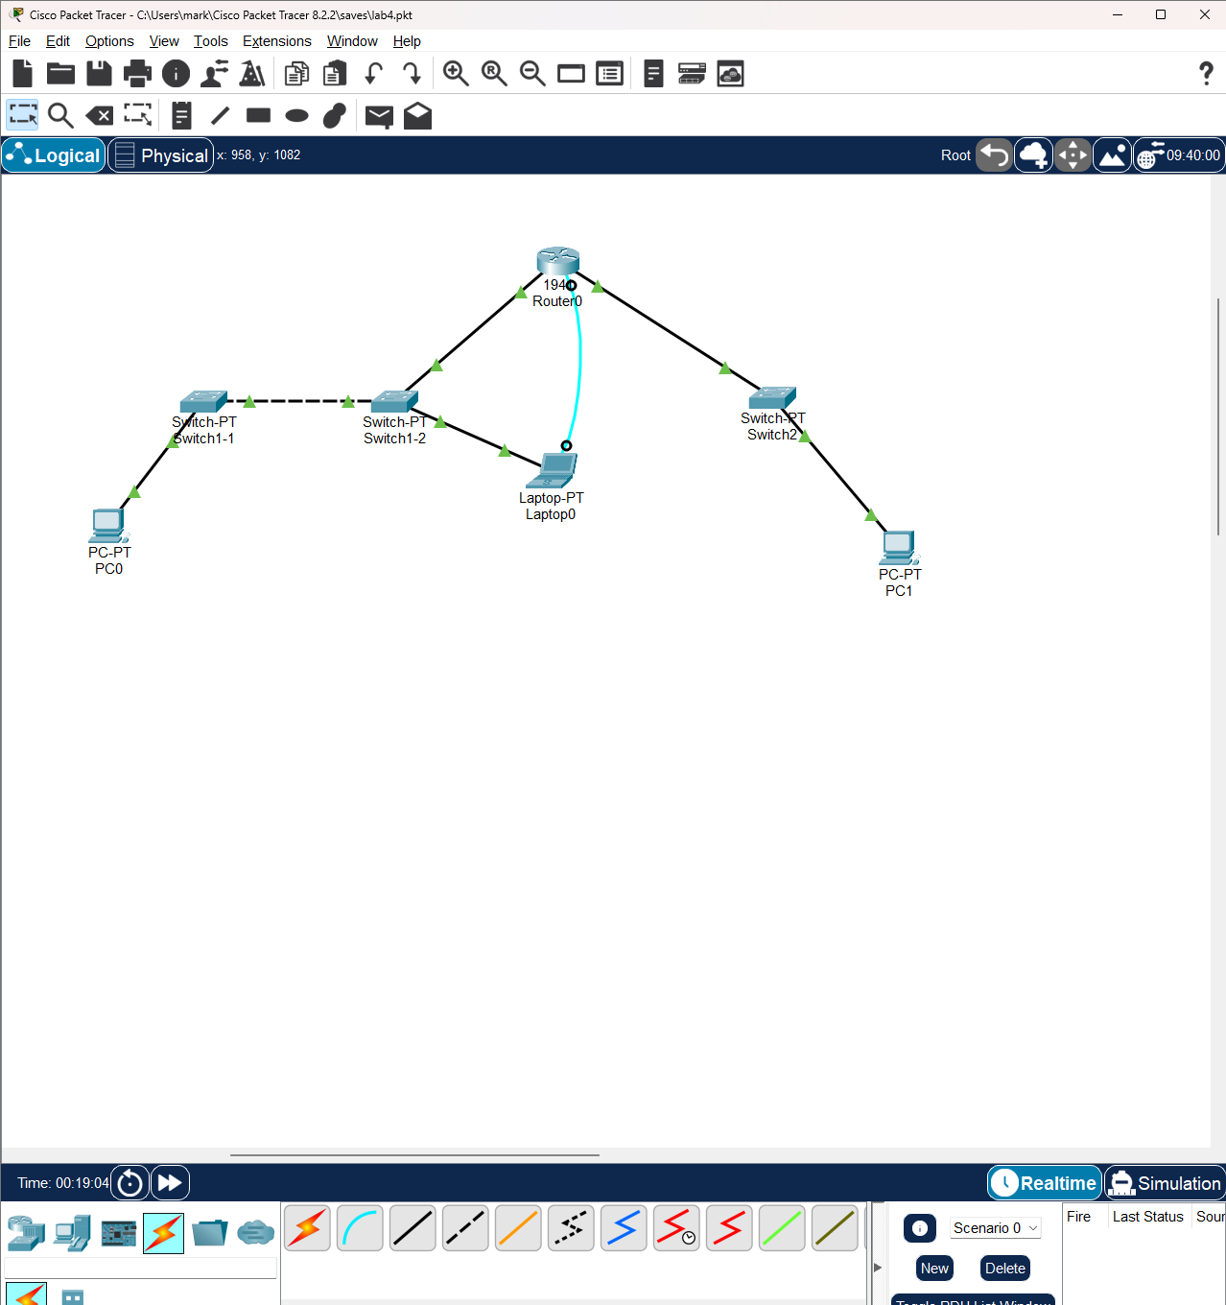

## Conclusion

This lab provided valuable practical experience in configuring Cisco switches and a router to create a layered LAN topology

It deepened understanding of Ethernet MAC and IP addressing principles and the ARP process, which is fundamental for Layer 2/Layer 3 interaction. By examining ARP tables and MAC address tables and analyzing packet captures, the lab clearly demonstrated how devices resolve IP addresses to MAC addresses for communication and how MAC addresses are used and updated by switches and routers. Connectivity tests verified the network configuration and the functionality of ARP and routing. The analysis of packet encapsulation highlighted the crucial role routers play in changing Layer 2 information while preserving Layer 3 information when forwarding packets between different subnets. Overall, the lab successfully clarified the interplay between MAC and IP addressing at different layers of the network stack