HumanCrush.com
Merchant Underwriting Response
Prepared for Payroc — September 18, 2026
Website: https://www.humancrush.com
Merchant contact: lgtopseller@yahoo.com
Legal entity: ______________________________ (as on the application forms)
This document answers each of the nineteen items in the bank's request, in the order asked. Where an item asks for a policy, the policy is reproduced in full in Appendix A and is published on the site at the address given. Where an item asks for something only the merchant can supply (credentials, financial statements), the section says what will be provided and how.

What the service is
HumanCrush.com is an adults-only entertainment service in which users chat with fictional AI companions and request AI-generated pictures, voice notes and short video clips of them. Every companion is a computer-generated character. There are no performers, models, creators or content partners; no photograph, video or recording of any real person is used or hosted; users cannot upload images or files; and users cannot see, find or contact one another. The only interaction on the service is between one user and one fictional character.
Several items on the bank's list — performer age verification, content-partner agreements, third-party content review, crawling for uploaded material — are written for sites that host content made by or about real people. They do not apply here, and each section below says so and describes the control that exists in its place. The controls that do apply — an automated content screen on every request, a complete log of every generation, staff review and removal tooling, published policies, a law-enforcement process and a payment flow in which card data never touches our servers — are all in place as of the date above.

1. Account credentials for all websites
The merchant operates one website, www.humancrush.com (humancrush.com redirects to it). There are no other sites, mirrors or white-labels.
A reviewer account with a full credit balance, plus a read-only view of the administration console, is provided to the bank in a separate secure message rather than in this document. The account is created from the console (Admin → Users → Create user) and can be revoked at any time.
Merchant action: create the reviewer account and send the credentials separately, referencing this document.

2. Copy of the merchant's policies and procedures
The following policies are published on the site, linked from every page's footer and menu, accepted at sign-up, and reproduced in full in Appendix A:
Policy | Published at
Terms of Service | https://www.humancrush.com/legal/terms
Privacy Policy | https://www.humancrush.com/legal/privacy
Prohibited Content Policy | https://www.humancrush.com/legal/prohibited-content
Anti-Human-Trafficking Statement | https://www.humancrush.com/legal/anti-trafficking
Law Enforcement & Legal Requests Policy | https://www.humancrush.com/legal/law-enforcement
Complaints, Reporting & Content Removal | https://www.humancrush.com/legal/complaints
Billing, Refunds & Cancellation | https://www.humancrush.com/legal/billing
Affiliate & Marketing Policy | https://www.humancrush.com/legal/affiliate-terms
AI-Generated Content Statement | https://www.humancrush.com/legal/ai-content

Internal procedures
- Content screening: every chat message and generation request passes an automated screen before any AI model is called (section 8 has the flow).
- Media review: staff review generated pictures and clips, with the account and the prompt, in the administration console's Media review tool, and remove content with one action; each removal is written to an audit log with the reason.
- Support and complaints: every message to support opens a ticket, alerts the operator by email and push notification, and is answered from the console; urgent reports (minors, non-consent, trafficking) are handled within 24 hours.
- Law-enforcement requests: the process, verification steps and response times in the Law Enforcement Policy; every request is logged.
- Billing: refunds and cancellations per the Billing policy; failed generations are refunded automatically; every credit movement is a ledger row.
- Affiliates: applications are reviewed and approved individually; traffic is monitored; commission is reversed on refund or chargeback; violations of the marketing policy end the relationship.
- Access control: administrative access is limited to named accounts with an admin role; settings changes, credit adjustments, suspensions and content removals are written to an audit log.

3. Policies and controls against human trafficking
The service cannot be used to promote or facilitate human trafficking, and the reason is structural rather than a matter of moderation: there are no real people on it. The full statement is the Anti-Human-Trafficking Statement in Appendix A. The controls, in brief:
- No performers, models or creators, and no way to become one. There is nobody to traffic.
- No user-to-user contact of any kind, and no profiles of real people.
- No uploads: all imagery is generated by our own pipeline from text.
- Requests for real-world contact, escort or prostitution services, paid sex or trafficking are refused automatically by the content screen and the companions are instructed never to suggest or arrange any.
- Advertising that implies real people, meetings, 'girls near you' or paid services is prohibited and ends an affiliate relationship.
- Generation requests are logged and reviewable; indications of exploitation or a person at risk are escalated and reported to law enforcement.

4. Most recent report of marketing traffic from other URLs
Traffic reaches the site from three sources: direct and search; the merchant's own social creative (the fully-clothed, non-explicit set in section 17); and the affiliate programme, in which every affiliate has a unique referral code carried in the link, recorded on landing and attributed on sign-up, with commissions reversed on refund or chargeback.
Referrer-level reporting is provided by Vercel Web Analytics, which is installed on the site and reports page views and referring domains without cookies or cross-site profiles. The current export (top referrers and landing pages, last 30 days) is attached as Attachment 4; affiliate-level attribution is available from the administration console's Affiliates tab on request.
Merchant action: enable Web Analytics for the project in the Vercel dashboard if not already on, export Top Referrers for the last 30 days, and attach as Attachment 4.

5. Company and third-party content provider documents; signed agreements and age verification in a depository
Not applicable: the service has no third-party content providers and no performers. No content on the site was created by, features, or is licensed from any third party; every image and clip is generated by the merchant's own pipeline from a text description of a fictional character.
The depository that does exist is the generation log. For every picture and clip the service has ever produced it holds the account that requested it, the time, the exact prompt sent to the model, the model and provider used, and the output file, and it is reviewable by staff in the administration console (section 15). The AI-Generated Content Statement in Appendix A sets out why performer age-verification records (18 U.S.C. § 2257) do not arise.

6. Content Partners — New Content Account Decisioning
Not applicable in the sense intended, because there are no content partners. The equivalent decision — which characters appear on the public roster — is made only by staff, as follows:
- Only staff can add a companion to the public roster, from the administration console. Users cannot publish characters to other users: a companion created by a user is visible to that user alone (enforced at the database level, not only in the interface).
- Every companion has a stated age, validated on creation to be between 18 and 60; the models are told the character is an adult in every prompt.
- The character description is passed through the same automated screen as user requests before any portrait is generated, so a character cannot be described with any minor, non-consent or prohibited attribute.
- Portraits are generated by the merchant's pipeline; no photograph is uploaded or used.
- A new companion is reviewed by staff before its status is set to active and it appears on the site; it can be set inactive at any time.

7. New User / Model Decisioning

New users
- An 18+ gate is shown before any page of the site is usable; the visitor must affirm they are an adult or is sent away.
- Sign-up requires an email address, a password, and a separate affirmation that the user is 18 or over (21 where required) and accepts the Terms and Privacy Policy, with both linked.
- The email address must be confirmed by link before the account is usable.
- New accounts receive 25 free credits; no card is taken at sign-up, so no charge can occur before a deliberate purchase.
- Rate limits apply per account (chat messages and media requests per window); accounts that trip the content screen repeatedly, attempt fraud or chargebacks, or are the subject of a report can be suspended from the console, which blocks every paid action.
- One account per person; sharing, selling or transferring accounts is prohibited by the Terms.

Models
There are no human models. Section 6 describes how fictional companions are approved. User-created companions follow the same rules — adult age validated, description screened, portrait generated — and remain private to their creator.

8. Compliance and content upload flowchart
There is no upload: content is generated, and every piece follows one path. The same path applies to company-created content (companions and their portraits, made by staff from the console) and to user-requested content (pictures, voice notes and clips requested in chat).
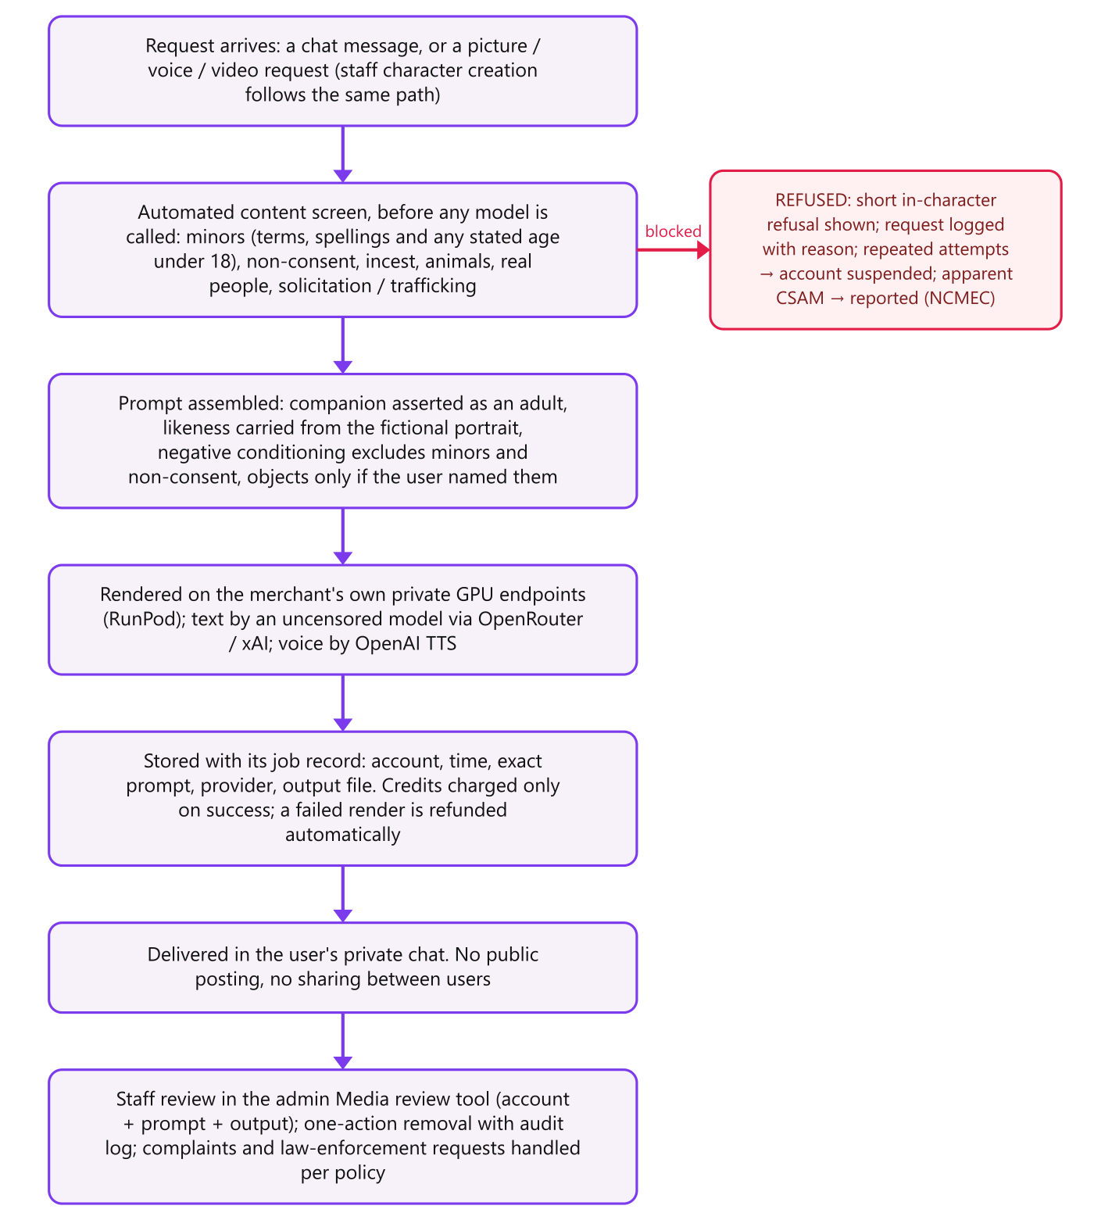
Figure 1 — The path every piece of content takes

9. Policy for banned words linking to the site
The Affiliate & Marketing Policy (Appendix A, published at https://www.humancrush.com/legal/affiliate-terms) lists the words and phrases that may not appear in any advertisement, post, link text, landing page or domain leading to the site, grouped as: anything implying minors; non-consent, coercion or violence; family/incest; anything implying real people, real contact or paid sex; animals; and deceptive claims. The same terms in a request on the site are refused by the content screen.
Enforcement: every affiliate is identified and every referral carries their code; traffic arriving with prohibited terms in the referrer or landing parameters, or from placements that break the policy, is not paid and the affiliate is removed; commissions are reversed on refund or chargeback; anyone can report an advertisement under the Complaints policy.

10. Law Enforcement Policy and Process
Published at https://www.humancrush.com/legal/law-enforcement and reproduced in Appendix A. In summary: a dedicated contact address monitored daily with the operator alerted by email and push notification; identity verification of the requesting agency; non-content data on valid subpoena, content on court order or warrant, emergency disclosures where the law allows; 10-business-day response, 24 hours for emergencies and child-safety matters; 90-day renewable preservation; a log of every request; and proactive reporting of apparent CSAM to NCMEC and of credible trafficking or threat-to-life indications to law enforcement.
What can be produced: account records (email, display name, sign-up date, IP and device data), payment records and the full credit ledger, every conversation, every generation request with its exact prompt and output, every refused request with the reason, and support records.

11. Prohibited Content Policy
Published at https://www.humancrush.com/legal/prohibited-content and reproduced in Appendix A. Absolutely prohibited: minors or anyone presented as under 18 or child-like; non-consent; incest; bestiality; real people; real-world contact, solicitation or trafficking; sexualised violence; anything illegal where the user is. Enforced by the automated screen on every request, adult-only conditioning of every model prompt, complete logging, staff review and removal, suspension, and reporting where the law requires.

12. Significant third-party, business and supplier relationships
Provider | Role | What they receive
Vercel | Web hosting, serverless functions, page analytics | Application code and traffic; no card data
Supabase | Database, authentication, file storage | Account, conversation, ledger and generated-media data
RunPod | Private GPU endpoints that render pictures and clips | The generation prompt and the fictional companion's portrait; no user identity
OpenRouter / xAI | Text models for chat replies and prompt writing | Conversation text; no user identity
OpenAI | Text-to-speech for voice notes | The line to be spoken; no user identity
Authorize.Net (via Payroc) | Card processing, recurring billing (ARB), webhooks | Payment data, tokenised in the customer's browser; the merchant never holds a full card number
Resend | Transactional email (support, notifications) | Email address and message content
Google Fonts | Web fonts | Nothing personal
Affiliates | Individuals promoting the site under the Affiliate & Marketing Policy for a revenue share | A referral code; no customer data
There are no content partners, no performers or creators, no resellers, no white-label or licensing arrangements, and no other significant business relationships.

13. Age verification tools

Users
- Site-wide 18+ gate before any page is usable, remembered per browser.
- Affirmative 18+ (21 where required) declaration at sign-up, linked to the Terms, and email confirmation before the account works.
- No content is unlocked without a purchase by payment card, which in the served markets is itself an adult instrument.
- The merchant will integrate a third-party age-verification provider (ID document or database check) if required by the acquirer or by the law of a jurisdiction served.

Performers
Not applicable: no human being is depicted. Every companion is an AI-generated fictional adult; its age is validated on creation to be 18 or over, the prompts describe an adult, and content involving anyone under 18 is refused before generation. See the AI-Generated Content Statement in Appendix A.

14. Website crawling tools
Crawling tools exist to find prohibited third-party content on sites that accept it. This site accepts none: users cannot upload, post or publish, and the only public content is the staff-curated companion roster and the merchant's own pages. Accordingly:
- Public pages are fixed and staff-controlled; a change to the site is a code deployment, reviewed and versioned.
- Generated content is never public: each picture or clip is delivered only into the private chat of the account that requested it.
- In place of crawling, the generation log is reviewed in the Media review tool (section 15), and inbound marketing traffic is reviewed for prohibited terms under the Affiliate & Marketing Policy.
- The merchant reviews the public pages at each release and on any report.

15. Image and video verification tools
Every image and clip is made by the merchant's pipeline, so verification happens at the source and afterwards:
- Before generation: the automated screen refuses every prohibited category, including every way of writing an age under 18; the companion is asserted as an adult in every prompt; the model's negative conditioning excludes minors and non-consent; objects and other people appear only when the request names them.
- At generation: the job record stores the account, time, exact prompt, provider and output, so provenance of any file is established.
- After generation: the administration console's Media review tool lists every generated picture and clip newest first, with the account and prompt, and removes any item — file, chat message and all — in one action with an audit-log entry and reason.
- Reporting: anyone can report content; urgent categories are reviewed within 24 hours; apparent CSAM is reported to NCMEC and the records preserved.

16. PCI compliance
- Card data is captured by Authorize.Net's Accept.js in the customer's browser and exchanged for a one-time payment token there. The merchant's servers receive only the token, the last four digits and the transaction outcome; no full card number, expiry or security code is ever transmitted to, processed by or stored on the merchant's systems.
- Recurring subscriptions are created as Authorize.Net ARB subscriptions from that token; renewal charges, refunds and chargebacks are reconciled by signed webhook, verified against the Authorize.Net signature key.
- The applicable self-assessment questionnaire is SAQ A-EP (merchant page collects the data via processor-provided JavaScript; no card data touches the merchant's environment). The questionnaire and attestation are completed and attached as Attachment 16.
- All pages and APIs are served over TLS; hosting and database providers hold SOC 2 attestations; administrative access is restricted to named accounts with an admin role and is logged.
Merchant action: complete SAQ A-EP and the Attestation of Compliance through the acquirer's PCI portal and attach as Attachment 16.

17. Advertisements, marketing materials and sales practices

Sales practices
- Sign-up is free and takes no card; 25 free credits let a customer try the service before buying anything.
- Prices are shown in full before payment; there are no hidden fees, no free trials that convert, and no negative-option billing other than a clearly labelled monthly subscription whose price, credits and renewal date are shown before purchase and on the account page.
- Subscriptions cancel in one click from the account page; the customer keeps the credits already granted.
- Refunds per the Billing policy: unused packs within 14 days, unspent renewals within 7 days, failed generations automatically, duplicate charges always.
- Charges carry a neutral statement descriptor.
- All advertising follows the Affiliate & Marketing Policy: truthful description of a fictional AI service, 18+ marker, adult-appropriate placements only, and none of the banned words in section 9.

Prices
Item | Price | Credits
Starter pack (one-time) | $5.00 | 50
Lover pack (one-time) | $10.00 | 120
Devoted pack (one-time) | $25.00 | 350
Flirt subscription (monthly) | $12.99 | 800 / month
Lover subscription (monthly) | $24.99 | 2500 / month
Soulmate subscription (monthly) | $49.99 | 8000 / month
A text message costs 1 credit, a voice note 3, a picture 8 and a video clip 15. Prices are managed from the administration console and the charge is always what the page displayed.

Creative — mainstream networks (Facebook, Instagram, TikTok)
Deliberately tame by design: fully clothed, no lingerie, no suggestive posing, no explicit copy.

"Make your own AI companion" — 1200×630 feed

"She texts you first." — 1200×630 feed

"Your companion. Your rules." — 1200×630 feed

Creative — adult ad networks
Suggestive but non-explicit; 18+ placements only.

"She'll send you anything" — 300×250

"She always texts back" — 300×250
The complete creative set (all sizes, and the 8-second social reels) is attached as Attachment 17.

18. Financial statements and/or tax returns
CPA-prepared financial statements (income statement and balance sheet) for the most recent years available, and/or tax returns with supporting schedules, are provided by the merchant's accountant directly to the bank as Attachment 18. They are not included in this document.
Merchant action: send the financial statements / tax returns with supporting schedules to the bank, referencing this document.

19. Executive summary

Transaction flow
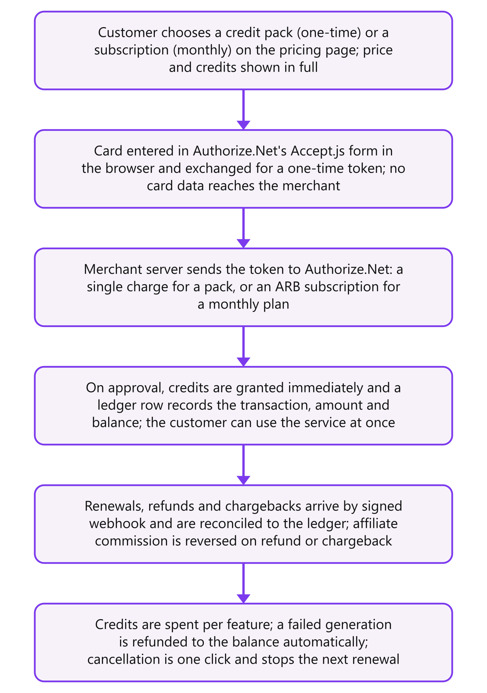
Figure 2 — The money

Risk assessment and exposure
- Product risk: adult content, digital, delivered instantly. There is no physical shipment, no delayed fulfilment and no third-party content, so the classic causes of 'goods not received' and content-legality disputes do not arise. The content that is generated is fictional, adult-only by construction, screened before generation, logged and reviewable.
- Chargeback risk: the main exposure is a customer disputing a charge for a service they used, or a forgotten subscription renewal. Mitigants: free credits before any purchase, prices shown in full, a neutral descriptor, one-click cancellation with credits retained, generous and fast refunds (most disputes are resolved by refund the same day), renewal dates on the account page, and closure of accounts that dispute used services.
- Fraud risk: card testing and stolen cards. Mitigants: no card at sign-up, email confirmation, per-account rate limits on every paid action, Authorize.Net's fraud tools on every transaction, immediate suspension from the console, a full ledger for every credit movement, and affiliate commission that is reversed rather than paid on any refunded or disputed sale.
- Regulatory and reputational risk: the risks specific to adult sites — minors, non-consent, real people, trafficking — are addressed structurally (no real people, no uploads, no user contact) and operationally (automated screen, logging, review tooling, published policies, law-enforcement process, proactive reporting).
- Average ticket: $5.00 to $49.99; a low-ticket, high-frequency profile.

Financial and credit analysis
Projected monthly volume, average ticket, refund and chargeback ratios, and the financial statements in Attachment 18 are provided by the merchant. The service's cost base is variable (GPU and model usage per generation, paid only on success) with modest fixed hosting costs, so gross margin scales with volume and there is no inventory or fulfilment exposure.
Merchant action: fill in projected monthly volume, average ticket and expected refund/chargeback ratios here or on the application form.

Approval justification
- A fully digital, instantly fulfilled service with no third-party content and no real persons, which removes the categories of dispute and legal exposure that make adult merchants high-risk.
- Published, enforced policies covering every item the bank has asked about, with a law-enforcement process and proactive reporting.
- Automated screening on every request, complete logging, and staff review and removal tooling in place and demonstrable on the reviewer account.
- A payment flow in which the merchant never holds card data, with recurring billing, refunds and chargebacks reconciled by signed webhook to a full ledger.
- Clear pricing, free trial credits without a card, one-click cancellation and a fast refund policy — the practices that keep chargeback ratios low.

Loss-prevention strategy and mitigants
- Refund first: support answers billing complaints with a refund where the policy allows, before a dispute can be raised.
- Descriptor, receipts and renewal reminders: the charge is recognisable, and the account page shows the next renewal date.
- Velocity and suspension: rate limits per account; suspension blocks all paid actions instantly; suspended and disputing accounts cannot repurchase.
- Ledger and audit log: every credit movement, refund, suspension, settings change and content removal is recorded with who did it.
- Affiliate exposure: commission is paid on settled revenue only and reversed on any refund or chargeback, so affiliates carry the risk of the traffic they send.
- Monitoring: refund and chargeback ratios are reviewed monthly; any rise triggers a review of the traffic source and the affiliate involved.

Appendix A — Published policies
Reproduced from the site as of September 18, 2026. Each is published at the address shown and linked from every page.

Terms of Service
https://www.humancrush.com/legal/terms · Last updated 18 September 2026
The agreement between you and HumanCrush.com when you use the service.
These Terms of Service ("Terms") govern your use of HumanCrush.com (the "Service"), operated by HumanCrush ("we", "us"). By creating an account or using the Service you agree to these Terms, our Privacy Policy and our Prohibited Content Policy. If you do not agree, do not use the Service.

1. Adults only
The Service is for adults. You must be at least 18 years old, or the age of majority where you live if that is higher (21 in some jurisdictions), to use it. You confirm this when you enter the site and again when you create an account. We may ask for proof of age at any time and may suspend an account until it is provided.

2. What the Service is
The Service lets you chat with fictional AI companions and request AI-generated pictures, voice notes and short video clips of them. Every companion is a computer-generated character. No companion is, depicts or is based on a real person. Nothing on the Service is a real photograph or recording of a human being.
The Service is entertainment. It does not offer, arrange or facilitate contact with any real person, any meeting, any dating, escort or sexual service, or anything outside the Service.

3. Your account
- One account per person. You are responsible for everything done with it and for keeping your password private.
- Your email address must be real and confirmed; we use it to reach you about your account, your purchases and support.
- You may not share, sell or transfer an account, or use the Service on behalf of anyone under 18.

4. Credits, subscriptions and payment
Features are paid for with credits. Credits can be bought in one-time packs or granted monthly by a subscription. Prices are shown before you pay. Subscriptions renew monthly until cancelled; you can cancel any time from your account page and keep the credits already granted. Our Billing, Refunds & Cancellation policy sets out refunds.
Payments are processed by our payment processor. We never see or store your full card number.

5. Acceptable use
Our Prohibited Content Policy is part of these Terms. In short: no content involving minors or anyone who looks like a minor, no non-consent, no incest, no animals, no real people, no requests for real-world contact or paid sex, and nothing illegal where you are. Requests that break these rules are refused automatically, logged, and may result in suspension without refund.
- Do not attempt to bypass the content screen, the age gate or any technical limit.
- Do not scrape, reverse-engineer, resell or redistribute the Service or its output.
- Do not use generated content to harass, defame, impersonate or deceive anyone, or present it as a real person.
- Do not use the Service to advertise, solicit or arrange anything with any other person.

6. Generated content
Pictures, clips and text the Service generates for you are yours to keep for personal, non-commercial use. They are fictional and AI-generated and must be described as such if you share them. We keep a record of every generation request and its result for safety, fraud prevention and legal compliance, and we remove content that breaks our policies.

7. Suspension and termination
We may suspend or close an account that breaks these Terms, attempts fraud or chargebacks, or is used in a way that puts other users, the Service or the public at risk. We may also close accounts on request of law enforcement. Credits on a terminated account are forfeited where the termination is for a breach.

8. Disclaimers and liability
The Service is provided as is. AI output can be wrong, odd or unexpected. To the fullest extent the law allows, we are not liable for indirect or consequential loss arising from use of the Service, and our total liability for any claim is limited to the amount you paid us in the three months before the claim.

9. Changes and contact
We may update these Terms; the date at the top shows the current version and material changes are announced on the site. Questions go to lgtopseller@yahoo.com.

Privacy Policy
https://www.humancrush.com/legal/privacy · Last updated 18 September 2026
What we collect, why, who sees it and how long we keep it.

What we collect
- Account data: email address, a display name you choose, your age confirmation and the date you joined.
- Usage data: your conversations with companions, the companions you create, the pictures and clips generated for you, and your credit balance and purchase history.
- Technical data: IP address, browser and device type, and the pages you visit, used for security, fraud prevention and to see which marketing brings people to the site.
- Payment data: handled by our payment processor. Card details are entered into the processor's own secure form and tokenised in your browser; we receive a token, the last four digits and the outcome, never the full card number.
- Support data: what you send us when you contact support, and our replies.

Why we use it
- To run the Service: your conversations are sent to the AI models that generate replies and media, and stored so your companions remember you.
- To bill you and to prevent fraud and chargebacks.
- To keep the Service lawful: generation requests are screened and logged, and we retain records needed to respond to lawful requests.
- To contact you about your account, purchases, support tickets and, if you opt in, notifications from your companions.

Who sees it
Our staff, on a need-to-know basis. Our infrastructure and service providers, each bound by contract to process data only for us: hosting (Vercel), database and file storage (Supabase), AI model providers that generate text, voice and images (they receive the text of the request and, for images, the companion's fictional portrait; never your name or email), our payment processor (Authorize.Net) and our email provider. We do not sell personal data. We disclose data to authorities only as described in our Law Enforcement Policy.

How long we keep it
Account and conversation data for as long as your account exists, and up to 90 days after you close it. Generation logs, purchase and ledger records for at least 24 months, because payment rules and the law require it. You can delete your account and its conversations from the account page or by emailing support.

Your rights
You can ask for a copy of your data, correct it, or have it deleted, subject to records we are required to keep. Email lgtopseller@yahoo.com. You can turn notifications off at any time in your browser or on the account page.

Cookies and storage
We use your browser's local storage for your session, your age confirmation, your language choice and, if you arrived through an affiliate link, the referral code, so the affiliate is credited if you sign up. We use privacy-respecting page analytics that do not build cross-site profiles.

Prohibited Content Policy
https://www.humancrush.com/legal/prohibited-content · Last updated 18 September 2026
What can never be requested, generated or shown on the Service, and how that is enforced.
Every companion is an adult, fictional, computer-generated character. Within that, adult content between consenting adults is what the Service is for. The following is prohibited without exception, is refused by the content screen before any generation runs, and results in suspension:

Absolutely prohibited
- Minors: any content that depicts, describes, suggests or role-plays a person under 18, or a character presented as under 18 or as child-like (age play, school settings, 'teen', 'loli', diapers, and any stated age under 18). Companions cannot be created with an age below 18.
- Non-consent: rape, coercion, drugging, unconscious or incapacitated persons, and any scenario presented as unwilling.
- Incest and family scenarios.
- Bestiality and any sexual content involving animals.
- Real people: content depicting, named after or intended to resemble any real person — public figures included. Users cannot upload photographs; every companion image is generated from a text description.
- Real-world contact, solicitation or trafficking: requests to meet, to pay or be paid for sex, escort or prostitution services, or anything that promotes or facilitates human trafficking or sexual exploitation.
- Violence, gore, torture, self-harm and death presented as sexual.
- Content that is illegal where the user is, or that infringes anyone's rights.

How it is enforced
- Every chat message and every picture or video request is screened by an automated filter before it reaches an AI model. The filter blocks a list of prohibited terms and phrasings (including every way of writing an age under 18) and the categories above. A blocked request is refused with a short message and is not generated.
- Every generation request and its output are logged with the account, the time and the exact prompt used, and are reviewable by staff in the admin console's Media review tool, where content can be removed with one action.
- Companions are described to the image and text models as adults in every prompt, and the models' negative conditioning excludes minors and non-consent.
- Repeated blocked requests, or any single attempt at content involving minors, results in suspension. We report apparent child sexual abuse material to the relevant authorities (in the United States, NCMEC's CyberTipline) as required by law.
- Anyone can report content to us — see Complaints & Reporting.

Banned words
The list of terms that the content screen refuses in requests, and that may not appear in any advertising or link to the site, is published in the Affiliate & Marketing Policy. It is maintained by staff and updated as new evasions appear.

Anti-Human-Trafficking Statement
https://www.humancrush.com/legal/anti-trafficking · Last updated 18 September 2026
The controls that ensure the Service cannot be used to promote or facilitate trafficking.
HumanCrush.com has zero tolerance for human trafficking, sexual exploitation and the commercial sexual exploitation of anyone. The design of the Service makes it unusable for those purposes, and the following controls keep it so:
- No real people. Every companion is an AI-generated fictional character. There are no performers, models, creators or content partners, and no way for anyone to appear on the Service. There is nothing and no one to traffic.
- No user-to-user contact. Users cannot message, see, find or contact each other. The only conversations are between a user and a fictional AI character.
- No uploads. Users cannot upload photographs, videos or files. All imagery is generated by our own pipeline from text, so no third party's image can be published here.
- No contact information, no meetings. The content screen refuses requests for meetings, escort or prostitution services, paid sex, phone numbers and real-world contact, and the companions are instructed never to arrange or suggest any. Advertising that implies real people, meetings, 'girls near you' or paid services is prohibited under the Affiliate & Marketing Policy and ends the affiliate relationship.
- Monitoring and reporting. Generation requests are logged and reviewable. Any indication of trafficking, exploitation or a person at risk is escalated to the operator and reported to law enforcement under our Law Enforcement Policy.
- Staff. Everyone with access to the admin console is identified, access is logged, and this policy is part of onboarding.
Reports: lgtopseller@yahoo.com, or the support form on the site. Reports of a person at risk are treated as urgent.

Law Enforcement & Legal Requests Policy
https://www.humancrush.com/legal/law-enforcement · Last updated 18 September 2026
How police, courts and regulators can reach us, what we can provide, and how fast.

Contact
Requests from law enforcement, courts and regulators go to lgtopseller@yahoo.com with the subject line "LAW ENFORCEMENT REQUEST". The mailbox is monitored daily; the operator is notified immediately by email and by push notification for every message with that subject. Emergency requests (an imminent risk to life or of serious harm) should say EMERGENCY in the subject and will be acted on as soon as they are read, ahead of formal process where the law allows.

What we hold
- Account records: email address, display name, sign-up date, IP addresses and device information from sign-in and payment events.
- Payment records: transaction identifiers, amounts, dates, last four card digits, subscription identifiers and the ledger of every credit granted, spent or refunded.
- Content records: every conversation, every generation request (the exact prompt), every generated image or clip and when it was made, and every request the content screen refused, with the reason.
- Support records: tickets and our replies.
- Retention: content and account records for the life of the account plus 90 days; payment and ledger records for at least 24 months; blocked-request logs for at least 12 months. We preserve records beyond these periods on receipt of a preservation request.

Process
- We verify that a request comes from a genuine agency, using an official email domain and a call-back number, before disclosing anything.
- Non-content account information is provided in response to a valid subpoena or equivalent lawful request. Content of conversations and generated media is provided in response to a court order or warrant, or where an emergency exception applies.
- We respond within 10 business days, and within 24 hours where the request is marked emergency or concerns minors.
- Preservation requests are honoured for 90 days and renewable.
- We notify the account holder of a request unless the law prohibits it or the request concerns child safety, an emergency or an ongoing investigation and the agency asks us not to.
- We keep a log of every request received, the agency, what was provided and when.

Proactive reporting
We report apparent child sexual abuse material to NCMEC's CyberTipline (in the United States) or the equivalent national body, and preserve the related records, whether or not a request has been received. We report credible indications of human trafficking or an imminent threat to life to the relevant law enforcement agency.

Complaints, Reporting & Content Removal
https://www.humancrush.com/legal/complaints · Last updated 18 September 2026
How to report content or an account, and what happens when you do.

How to report
Anyone — a user or not — can report content, a companion, an account, an advertisement or an affiliate by emailing lgtopseller@yahoo.com or using the support form on the site. Include the link or a description and, if you have it, the time. Reports about minors, non-consent, trafficking or a person at risk should say URGENT in the subject.

What happens
- Every report opens a ticket, visible to staff in the admin console and emailed to the operator, with a push notification for urgent ones.
- Reports of prohibited content are reviewed within 24 hours; the content is removed on sight if it breaks the Prohibited Content Policy, and the account that generated it is suspended. Where the law requires, the matter is reported to the authorities.
- Other reports are answered within 5 business days.
- The reporter is told the outcome by email unless they asked not to be, or the matter is with law enforcement.

Claiming a likeness
Companions are generated from text and are not based on any real person. If you believe a companion resembles you and you want it removed, tell us and we will remove it; we do not require proof of identity beyond what is needed to prevent abuse of the process, and we act within 5 business days.

Appeals
An account holder whose content was removed or account suspended may reply to the notice within 14 days with their reasons. A different member of staff reviews the appeal and answers within 10 business days. Decisions concerning minors, non-consent or trafficking are not appealable.

Billing, Refunds & Cancellation
https://www.humancrush.com/legal/billing · Last updated 18 September 2026
What you are charged, when, how to cancel and when we refund.

What you pay for
- Credit packs: a one-time charge for a fixed number of credits, shown before you pay. Credits do not expire while your account is open.
- Subscriptions: a monthly charge that grants a fixed number of credits each month. The price, the credits and the renewal date are shown before you subscribe and on your account page.
- New accounts receive free credits on sign-up so the Service can be tried before anything is bought. No card is needed to sign up.

How you are charged
Card details are entered into our payment processor's secure form and tokenised in your browser; we never see the full card number. Charges appear on your statement under a neutral descriptor. Subscriptions renew automatically every month on the same date until cancelled.

Cancelling
Cancel any time from your account page in one click, or by emailing support. Cancellation stops the next renewal; you keep the credits already granted and access continues until they are used. There are no cancellation fees and no minimum term.

Refunds
- Unused credit packs bought in the last 14 days are refunded in full on request.
- A subscription renewal is refunded in full if requested within 7 days and no credits from that renewal have been spent; otherwise it is refunded pro rata for the unused credits.
- A failed generation (a picture, voice note or clip that never arrived) is refunded to your balance automatically, and the refund is shown in your history.
- Duplicate or mistaken charges are refunded in full.
- Refunds go back to the original payment method within 5–10 business days. Requests go to support with the email address on the account and the date of the charge.

Disputes
Before disputing a charge with your bank, contact lgtopseller@yahoo.com: most issues are resolved with a refund the same day. Accounts that dispute charges for services actually used may be closed.

Affiliate & Marketing Policy
https://www.humancrush.com/legal/affiliate-terms · Last updated 18 September 2026
The rules for anyone who advertises or links to the site, and the words that may never appear in that advertising.
These rules apply to affiliates in our referral programme and to anyone advertising, posting or linking to HumanCrush.com. They also describe our own advertising. Breaking them ends the affiliate relationship and forfeits unpaid commission.

What advertising must say and do
- Describe the Service truthfully: fictional AI companions, adults only, chat and AI-generated media. Never imply real people, real photographs, live performers, meetings, dating, hook-ups or any sexual service.
- Carry an adults-only marker (18+) wherever the platform allows, and run only on platforms and placements that accept adult-themed advertising and do not reach minors.
- Use only creative we supply or that we have approved in writing. Off-platform creative for mainstream networks is fully clothed and non-explicit by design.
- Disclose the affiliate relationship where the platform or the law requires (for example #ad).
- Never send unsolicited messages, use pop-unders, forced redirects, cookie stuffing, brand bidding on our name, or misrepresent an offer, price or free trial.

Banned words and phrases
None of the following may appear in any advertisement, post, link text, landing page or domain that leads to the site. The same terms in a request on the site are refused by the content screen.
- Anything implying minors: teen, teens, teenage, young girl, young boy, schoolgirl, school girl, student, barely legal, jailbait, loli, lolita, shota, underage, child, kid, little girl, little boy, daughter, stepdaughter, stepsister, petite, innocent
- Non-consent, coercion or violence: rape, forced, drugged, unconscious, sleeping, blackmail, kidnap, abuse, hurt, torture, snuff, revenge
- Family / incest: incest, mom, mother, dad, father, sister, brother, family
- Implying real people, real contact or paid sex: real girls, real women, real models, cam girls, live girls, meet, hookup, hook up, dating, date tonight, escort, escorts, call girl, sex work, in your area, near you, local, phone number, whatsapp
- Animals: bestiality, zoo, animal, dog, horse
- Deceptive claims: free forever, unlimited free, no charge, guaranteed, risk free, cure, celebrity names, names of real people

Enforcement
- Every affiliate is identified by email and a unique referral code; every referred sign-up and every commission is recorded against that code.
- Traffic sources are reviewed. Traffic that arrives with prohibited terms in the referrer or landing parameters, or from placements that break these rules, is not paid and the affiliate is removed.
- Commission is reversed when the underlying payment is refunded or charged back.
- Anyone can report an advertisement under our Complaints policy.

AI-Generated Content Statement
https://www.humancrush.com/legal/ai-content · Last updated 18 September 2026
Every companion is fictional and computer-generated. What that means and why no performer records exist.
All companions on HumanCrush.com, and all pictures, voice notes and video clips of them, are generated by artificial-intelligence models from text descriptions. No companion is a real person or is based on a real person. No photograph, video or recording of any human being is used to create or is contained in any companion, and users cannot upload images.
Because no actual human being is depicted, the record-keeping requirements that apply to depictions of real performers (in the United States, 18 U.S.C. § 2257) do not apply to this content. We nonetheless keep, for every generated image and clip, the account that requested it, the time, the exact prompt, the model used and the output, so that the provenance of any piece of content can be established.
Every companion is defined as an adult: the age given to the models is 18 or over and is validated on creation, the prompts describe an adult, and content involving anyone under 18 is refused before generation. See the Prohibited Content Policy.
Generated content may not be presented as a real person or as a real photograph, and may not be used to impersonate, harass or deceive.

Attachments supplied separately
# | Attachment | Supplied by
1 | Reviewer account credentials (separate secure message) | Merchant
4 | Vercel Web Analytics export — top referrers, last 30 days | Merchant
16 | PCI SAQ A-EP and Attestation of Compliance | Merchant
17 | Complete creative set (marketing/ folder, all sizes and reels) | Merchant
18 | CPA-prepared financial statements and/or tax returns with schedules | Merchant's accountant

