DataMind360
Product Guide

Real-world data, checked before you see it.
A complete guide to the platform for clients, delivery partners and their field teams.
A Cosarathi product
Version 1.0 · October 2026

Contents
1. Welcome to DataMind360 4
What DataMind360 gives you 4
Who this guide is for 4
2. How it works at a glance 5
The five parties 5
The life of a job 5
3. Apps and access 8
The three ways in 8
Your menu 8
Access levels inside your organisation 8
4. Getting started 10
How your organisation joins 10
Signing in for the first time 10
Everyday account tasks 11
5. For clients 12
5.1 Connect your storage 12
5.2 Write an RFP 12
5.3 Receive and compare proposals 14
5.4 Award the contract 15
5.5 Follow progress 15
5.6 Review and approve the delivery 16
6. For delivery partners 18
6.1 Find opportunities 18
6.2 Respond 18
6.3 Build your network 18
6.4 Run the contract 19
6.5 Quality gate 2 and delivery 19
6.6 Invoice and rate 20
7. For aggregators and business partners 21
7.1 Your crowd roster 21
7.2 Put people on a task 21
7.3 Quality gate 1: review captures 22
7.4 Equipment 22
7.5 Reminders 23
8. For device sponsors 24
9. For crowd workers: the phone app 25
9.1 Getting set up 25
9.2 Your assignments 25
9.3 Capturing and the automatic checks 26
9.4 Working offline 26
9.5 Notifications and settings 26
9.6 Uploading from a computer 26
10. Quality assurance in depth 28
A. On-device checks 28
B. Gate 1: aggregator review 28
C. Gate 2: delivery partner review 28
D. Client approval 28
11. Billing and invoices 29
How an invoice works 29
Invoice limits 29
Invoice statuses 29
12. DataHub: the dataset marketplace 31
Selling a dataset 31
Buying a dataset 31
13. Notifications and reminders 33
Bidding deadline notices 33
Automatic reminders for crowd workers 33
14. Privacy, consent and security 34
Consent set by the client 34
Field worker privacy 34
Where your data lives 34
Accountability 34
15. Reference 36
15.1 Status glossary 36
15.2 Limits and file types 36
15.3 Who can do what 37
15.4 Frequently asked questions 37
15.5 Glossary 38

If the contents list shows no page numbers, right-click it in Word and choose Update Field.

1. Welcome to DataMind360
DataMind360 is a data collection and delivery platform. It connects organisations that need real-world data (photographs, video, structured and unstructured data, sensor readings and people-based field work) with delivery partners who collect it through their own networks of field teams, vendor businesses and equipment providers.
You describe the data you need once. Qualified partners compete to deliver it. Their field teams capture it with a phone app that checks every shot as it is taken, two independent quality gates review the work, and only work that has passed reaches you, delivered straight into your own cloud storage.

What DataMind360 gives you
Promise | What it means for you
One brief, many bidders | Publish a request for proposal (RFP) once and receive competing proposals from delivery partners. Only you see the bids.
Quality before delivery | Every capture is checked automatically on the phone, then reviewed at two human quality gates before you are asked to look at it. Bad shots go back for a retake, not to you.
Your data stays yours | Captures upload directly into your own storage (Amazon S3-compatible, Azure Blob or Google Cloud Storage). DataMind360 keeps no copy of your delivered data.
Clear accountability | Every list shows whose turn it is ("Waiting on"), every rejection needs a written reason, and every important action is recorded in a tamper-evident activity trail.
Consent built in | Your RFP states who may appear in frame, the lawful basis for collection and the permitted uses. Field workers accept a privacy notice before their first assignment.
A path to reuse | Through DataHub, finished datasets can be listed, discovered and bought, so data you are allowed to share can find new buyers.

Who this guide is for
This guide explains the whole platform. Read the sections that match your role, or read it end to end to see how a job travels from brief to invoice.
If you are… | Start with
A client buying data | Sections 2–5, then 10, 11 and 14
A delivery partner fulfilling RFPs | Sections 2–4 and 6, then 10–13
An aggregator or business partner running field teams | Sections 2–4 and 7, then 10 and 13
A device sponsor lending equipment | Sections 2–4 and 8
A crowd worker capturing data | Section 9

Screens shown in this guide come from the DataMind360 web console running with demonstration data; the organisations, people and figures in them are fictional. Phone-app pictures are illustrations of the app's screens.

2. How it works at a glance

The five parties
A DataMind360 job involves up to five kinds of organisation. DataMind360 holds an account relationship with clients and delivery partners only. Everyone else works inside a delivery partner's own network.
Party | Role in a job | Relationship
Client | Needs data. Writes the RFP, chooses a partner, approves the delivery and pays the partner's invoice. | Account holder
Delivery partner | Bids on RFPs, wins contracts, splits the work into tasks for its network, runs the final quality gate and delivers. | Account holder
Aggregator | Manages a crowd of field workers, hands out assignments, and runs the first quality gate. | In a partner's network
Business partner | A vendor business that takes on tasks (an "engagement") with its own staff. | In a partner's network
Device sponsor | Lends specialised equipment (cameras, sensors) to field teams. | In a partner's network
Crowd worker | Captures the data in the field with the DataMind360 Capture phone app. | Belongs to an aggregator or business partner

The DataMind360 team operates the platform: onboarding organisations, reviewing DataHub listings and keeping accounts in good standing.
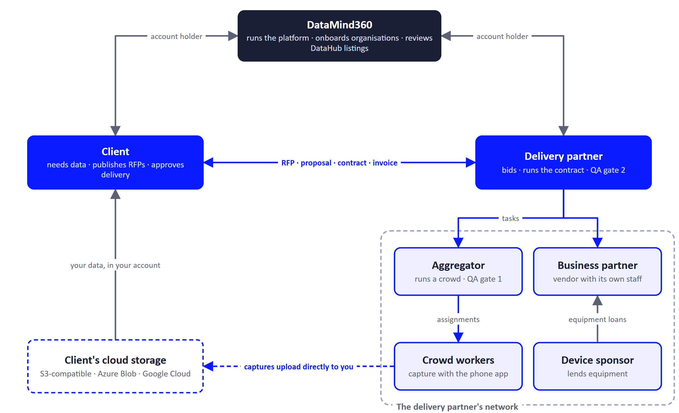
Figure 1. Who works with whom. Captures travel straight from the field to the client's own storage.

The life of a job
1  Brief  Client | 2  Bids  Partners | 3  Award  Client | 4  Tasks  Partner | 5  Capture  Crowd

6  Gate 1  Aggregator | 7  Gate 2  Partner | 8  Deliver  Partner | 9  Approve  Client | 10  Invoice  Partner → Client

Figure 2 shows the same journey by role, including the three places where work can be sent back.
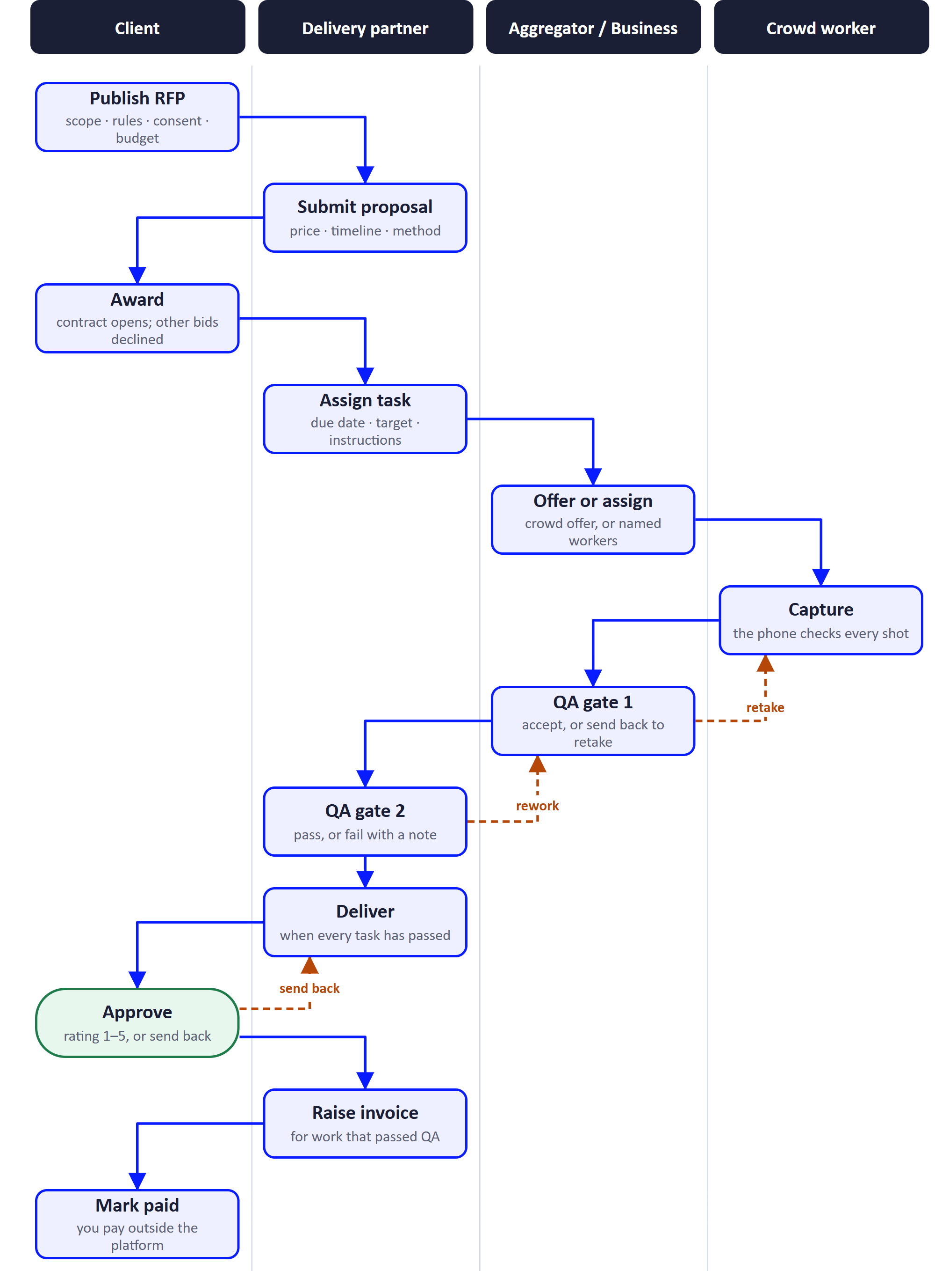
Figure 2. A job from brief to payment, by role. Dashed arrows show work going back for a retake or rework.
- Brief. The client publishes an RFP describing the data, the capture rules, consent, budget and deadlines, and where the data must be delivered.
- Bids. Delivery partners see the RFP in their Opportunities list, ask questions privately, and submit proposals before bidding closes.
- Award. The client accepts one proposal. A contract opens and all other bids are declined automatically.
- Tasks. The partner splits the contract into tasks and assigns them to aggregators or business partners in its network.
- Capture. Aggregators assign work to crowd workers, who capture it with the phone app. The app checks each capture and uploads it straight to the client's storage.
- Gate 1. The aggregator reviews captures batch by batch, sends poor ones back for a retake, and submits the task to the partner.
- Gate 2. The partner passes or fails each task. Failed tasks go back for rework.
- Deliver. When every task has passed, the partner marks the contract delivered.
- Approve. The client approves with a rating, or sends the work back with a reason.
- Invoice. The partner raises an invoice; the client pays it outside the platform and marks it paid.
Good to know
DataMind360 does not process payments or hold funds. Invoices are tracked on the platform; money moves directly between client and partner by your usual means.

3. Apps and access

The three ways in
App | Who uses it | What it is for
Web console | Clients, delivery partners, aggregators, business partners, device sponsors (and crowd workers for web uploads) | The main workspace. The menu and the Overview page adapt to your organisation type.
DataMind360 Capture (phone app, Android first) | Crowd workers | Receive assignments, capture photos and video with built-in quality checks, upload, and fix retakes. Works offline.
Public pages (no sign-in) | Anyone with a link | Accept an invitation, reset a password, respond to a task offer, read the privacy policy, and browse the public DataHub storefront.

Your menu
Each organisation type sees its own menu in the web console:
Organisation type | Menu
Client | Overview · RFPs · Deliverables for Review · Vendors · DataHub · Billing
Delivery partner | Overview · Opportunities · Responses · Contracts · Network · QA and delivery · DataHub · Billing
Aggregator | Overview · Tasks · Review · Crowd roster · Equipment
Business partner | Overview · Engagements · Capacity · Equipment
Device sponsor | Overview · Inventory · Requests
Crowd worker (web) | My assignments

Access levels inside your organisation
What your organisation can do depends on its type. Within it, each person also has an access level:
Level | Can use the product | Can manage people | Can edit the organisation profile
Owner | Yes | Everyone, including other owners | Yes
Manager | Yes | Everyone except owners | Yes
Member | Yes | No | No

Owners and managers add colleagues from Manage users. Each new colleague receives an email invitation. A person's invitation shows as No login, Invited, Signed up or Invitation expired.
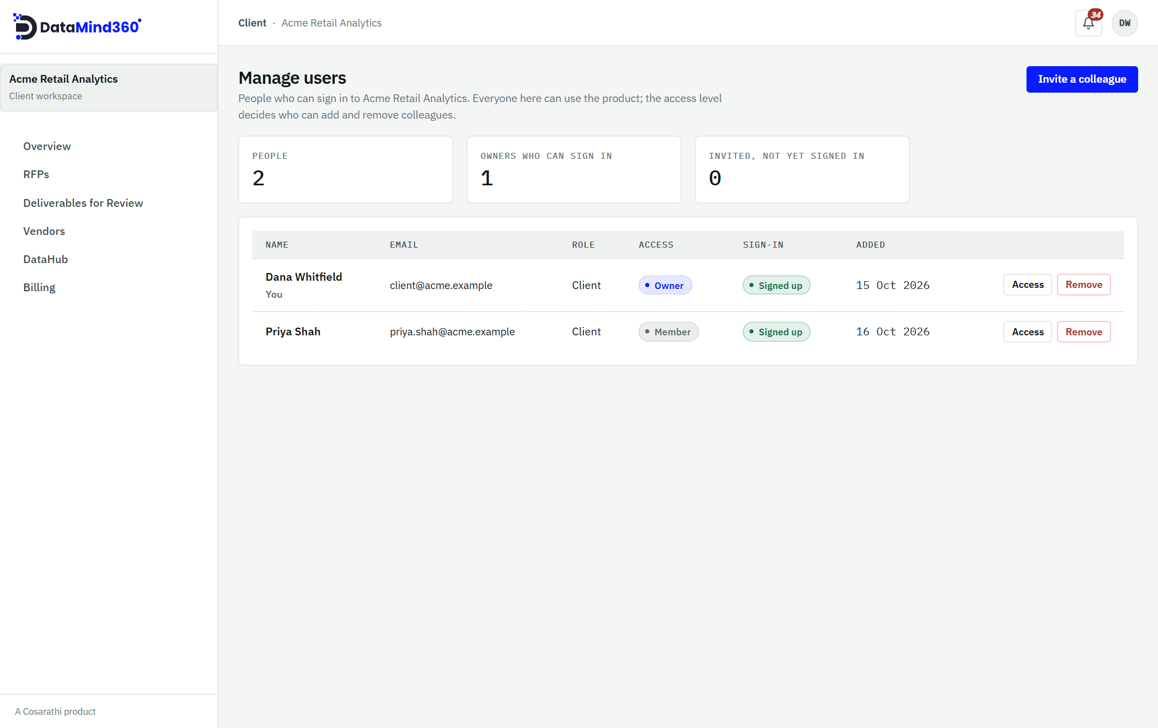
Figure 3. Manage users: colleagues, their access level and invitation status.

4. Getting started

How your organisation joins
There is no public self-sign-up. Organisations are onboarded so that every party on the platform is known.
- Clients and delivery partners are onboarded by the DataMind360 team.
- Aggregators, business partners and device sponsors are proposed by the delivery partner whose network they join (from the partner's Network page). The DataMind360 team reviews and approves each request.

What to have ready
Onboarding follows four steps: Organisation → Registered address → Plan and first user → Review. Please prepare:
- Your legal name, website and country.
- Your registered address.
- A logo (PNG, JPEG or WebP, up to 2 MB). Optional.
- The name and email of your first user. This person becomes the organisation's owner.
- Your plan and your preferred data residency region (US, EU or APAC).
- For clients: confirmation that a Data Processing Agreement (DPA) has been signed.
An onboarding request moves through these statuses: Draft, Submitted, Under review, Changes requested, Approved, Rejected, Withdrawn or Expired. If changes are requested or the request is rejected, the reason is always given.
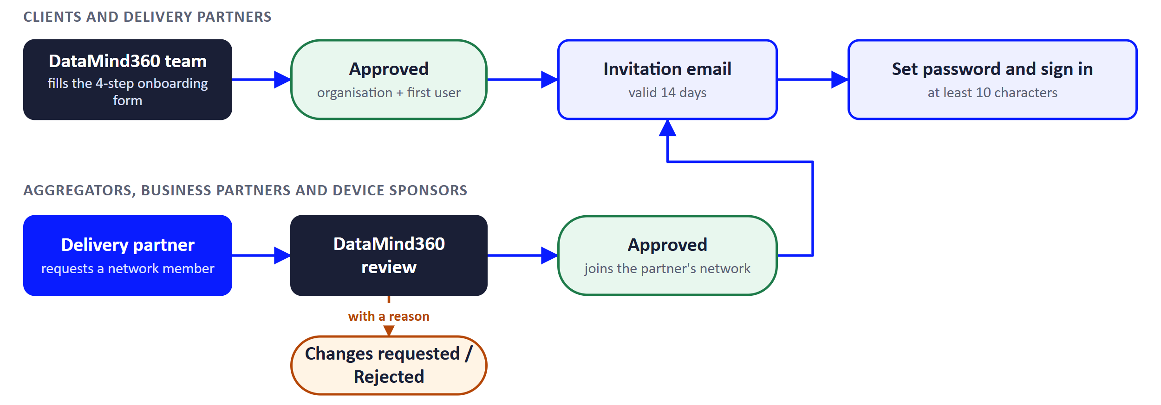
Figure 4. The two ways an organisation joins DataMind360.

Signing in for the first time
- When your organisation is approved, your first user receives an invitation email.
- Open the link (valid for 14 days) and choose a password of at least 10 characters.
- Sign in to the web console. If you were given a temporary password, you will be asked to change it before anything else.
- Complete your organisation profile: website, description, size, year founded, address and logo. Delivery partners also list their areas of expertise.
- Invite your colleagues from Manage users.
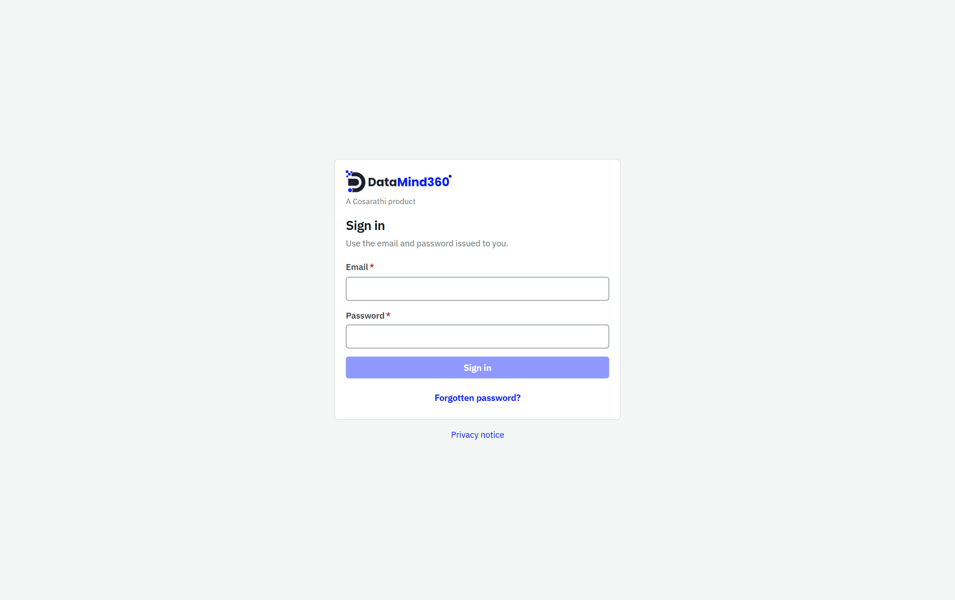
Figure 5. The sign-in page.

Everyday account tasks
I want to… | How
Reset a forgotten password | Choose Forgot password on the sign-in page. The emailed link is valid for 1 hour.
Switch between organisations | If you belong to more than one, the Choose a workspace screen appears after sign-in.
Change my password | Open your account menu and choose Change password.
Change the look | Choose a theme: System, Light or Dark.

Good to know
After 5 failed sign-in attempts an account is locked for 15 minutes, to protect against password guessing.

5. For clients
As a client you publish RFPs, choose a partner, follow progress and approve the final delivery. Your Overview page shows a Needs you list of items waiting for your action and a Captures per day chart for work in progress.
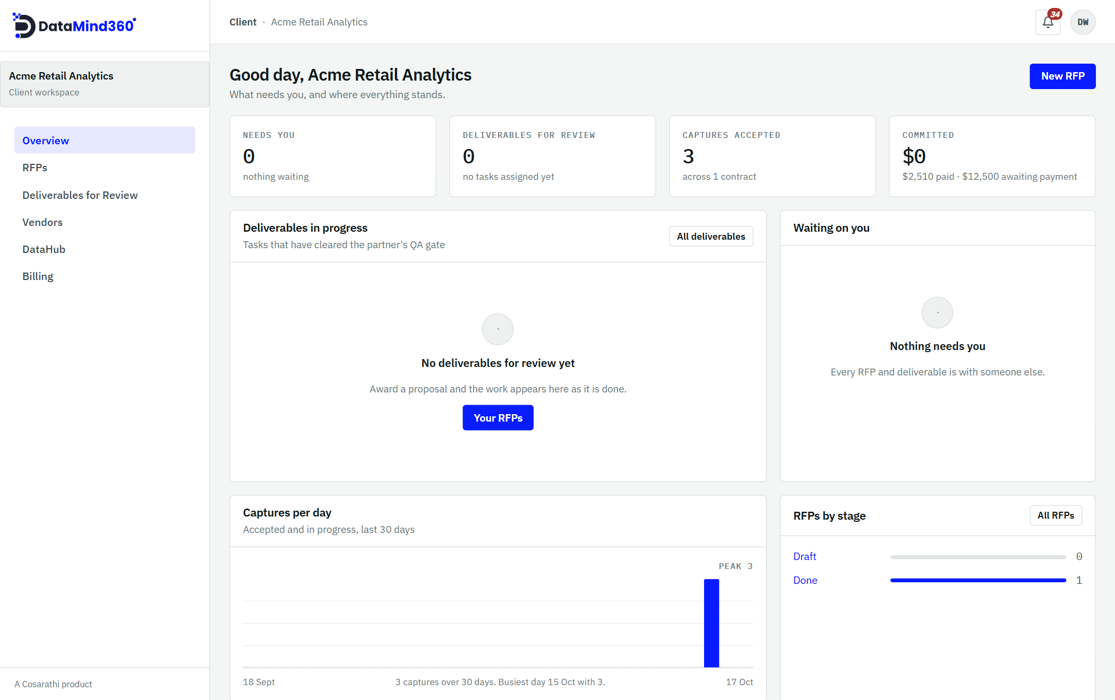
Figure 6. The client Overview: what needs you, deliverables in progress, captures per day and RFPs by stage.

5.1 Connect your storage
Delivered data goes straight to your own cloud storage. DataMind360 never keeps a copy. Before you can publish your first RFP, add a storage destination:
- Amazon S3 or an S3-compatible store
- Azure Blob Storage
- Google Cloud Storage
Enter the destination details and choose Test the connection. A destination must pass this test before an RFP using it can be published.

5.2 Write an RFP
Open RFPs and start a new request. The builder has four steps: Scope → Guidelines → Budget and Timelines → Review. Your draft is saved as you go, and you can edit it freely until you publish.

Step 1: Scope
- Title (at least 3 characters) and category: Image, Video, Structured data, Unstructured data, or People-based deliverable.
- Quantity (how many units you need), the location and location type.
- Purpose and objective, so partners understand what the data is for.
- Device specifications and crew requirements, if any.
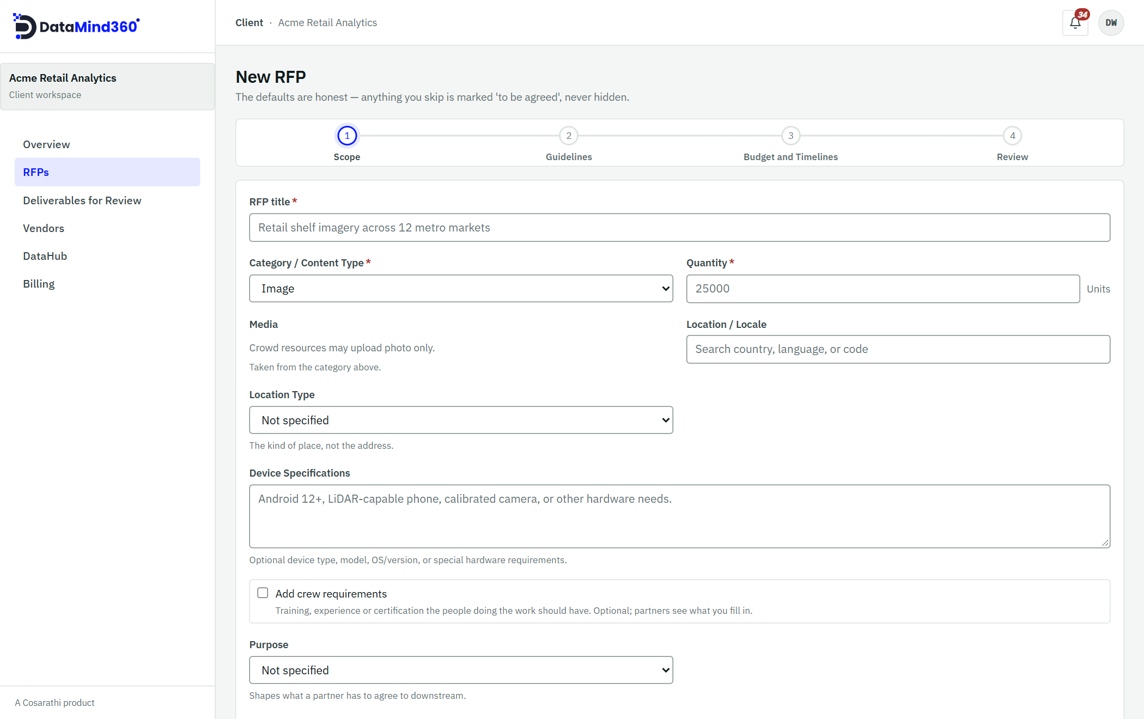
Figure 7. The RFP builder, step 1 (Scope). The four steps are shown across the top.

Step 2: Guidelines
This is where you set the quality bar. The capture rules you enter here are enforced automatically by the field workers' phone app (see Section 10).
- Capture rules: minimum megapixels, orientation, maximum tilt, clip length (up to 600 seconds) and video size.
- What the camera must show and must not show.
- Supporting documents: a specification, capture examples, guidelines, compliance documents and acceptance documents (up to 5 per slot, 25 MB each).
- Acceptance criteria and the pass rate you expect.
- An optional rejection policy and an optional pilot.
- Consent and permitted use (see Section 14): who may appear in frame, whether children may appear, the lawful basis for collection, de-identification preferences, permitted uses, applicable regulations, whether biometric data is involved, and any compliance documents such as a DPA, site-access rules or a privacy notice.

Exclusivity
Option | What it means
Exclusive to us (default) | The data is yours alone. The partner may not resell it.
Non-exclusive | Once you approve the delivery, the partner may list the dataset for resale in DataHub. This can lower your price.

Step 3: Budget and Timelines
- Budget basis: "One amount for the whole job" or "An amount per block of units", in USD. You can hide the budget from bidders.
- Start date and delivery deadline.
- Bids close on: the last moment partners can bid.
- Delivery destination: one of your tested storage destinations.

Step 4: Review and publish
Check the summary and choose Publish. Your RFP appears in delivery partners' Opportunities lists.
Good to know
"Bids close on" must be in the future and no later than the delivery deadline (times are in UTC).
After publishing, only the bidding deadline can be changed, and only until you award.

5.3 Receive and compare proposals
While bidding is open, partners send proposals. Each proposal states:
- A price on your budget basis
- A delivery time in days
- How you will do the work: the partner's method
- Supporting documents (up to 10) and notes
Each partner can have only one live proposal per RFP. Once bidding closes, partners can no longer submit, edit or withdraw proposals. You may award at any time.

Private questions and answers
A partner can open a private conversation with you about your RFP. Each conversation is between you and that one partner; no other partner sees it. Conversations become read-only for unsuccessful partners when you award, and for the winning partner once you approve the delivery.

The Vendors directory
Vendors lists every active delivery partner, with filters and track-record indicators: rating, On time, Accepted first time and QA pass at its own gate. Use it to judge proposals or to see who is available.
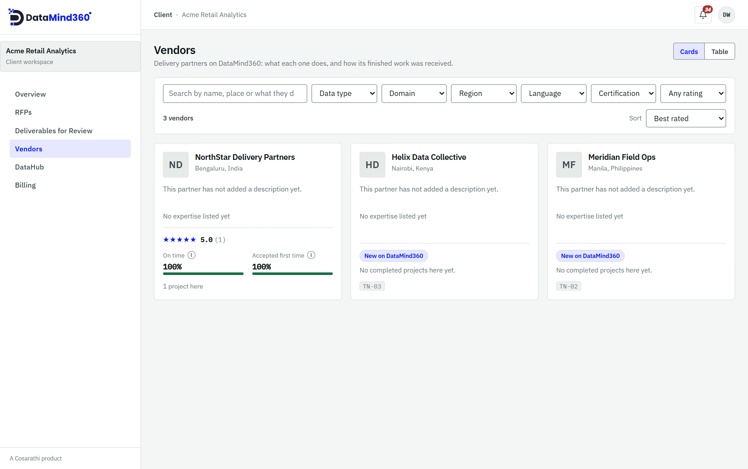
Figure 8. The Vendors directory, with filters and each partner's track record.

5.4 Award the contract
Open the proposal you prefer and Accept it. A contract opens with that partner and every other proposal is declined automatically. Each RFP leads to one contract with one partner.

5.5 Follow progress
- Your RFP moves through: Draft → Published → Proposals received → Awarded → In Progress → Delivered → Done (or Cancelled). A Bidding closed marker appears once the deadline passes.
- The Waiting on column shows whose turn it is: You, the Client, the Delivery partner, a Supplier or the Platform.
- Your Overview shows Needs you items and Captures per day as data arrives.
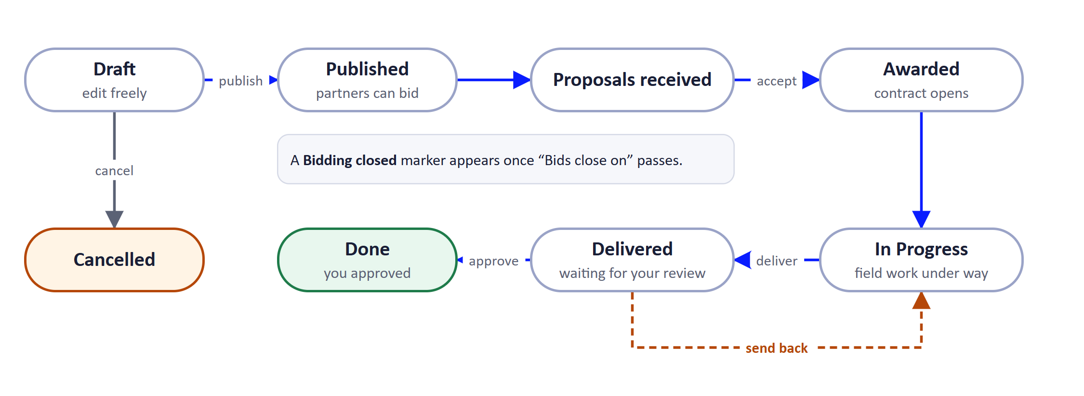
Figure 9. The stages of an RFP. A delivery you send back returns to In Progress.
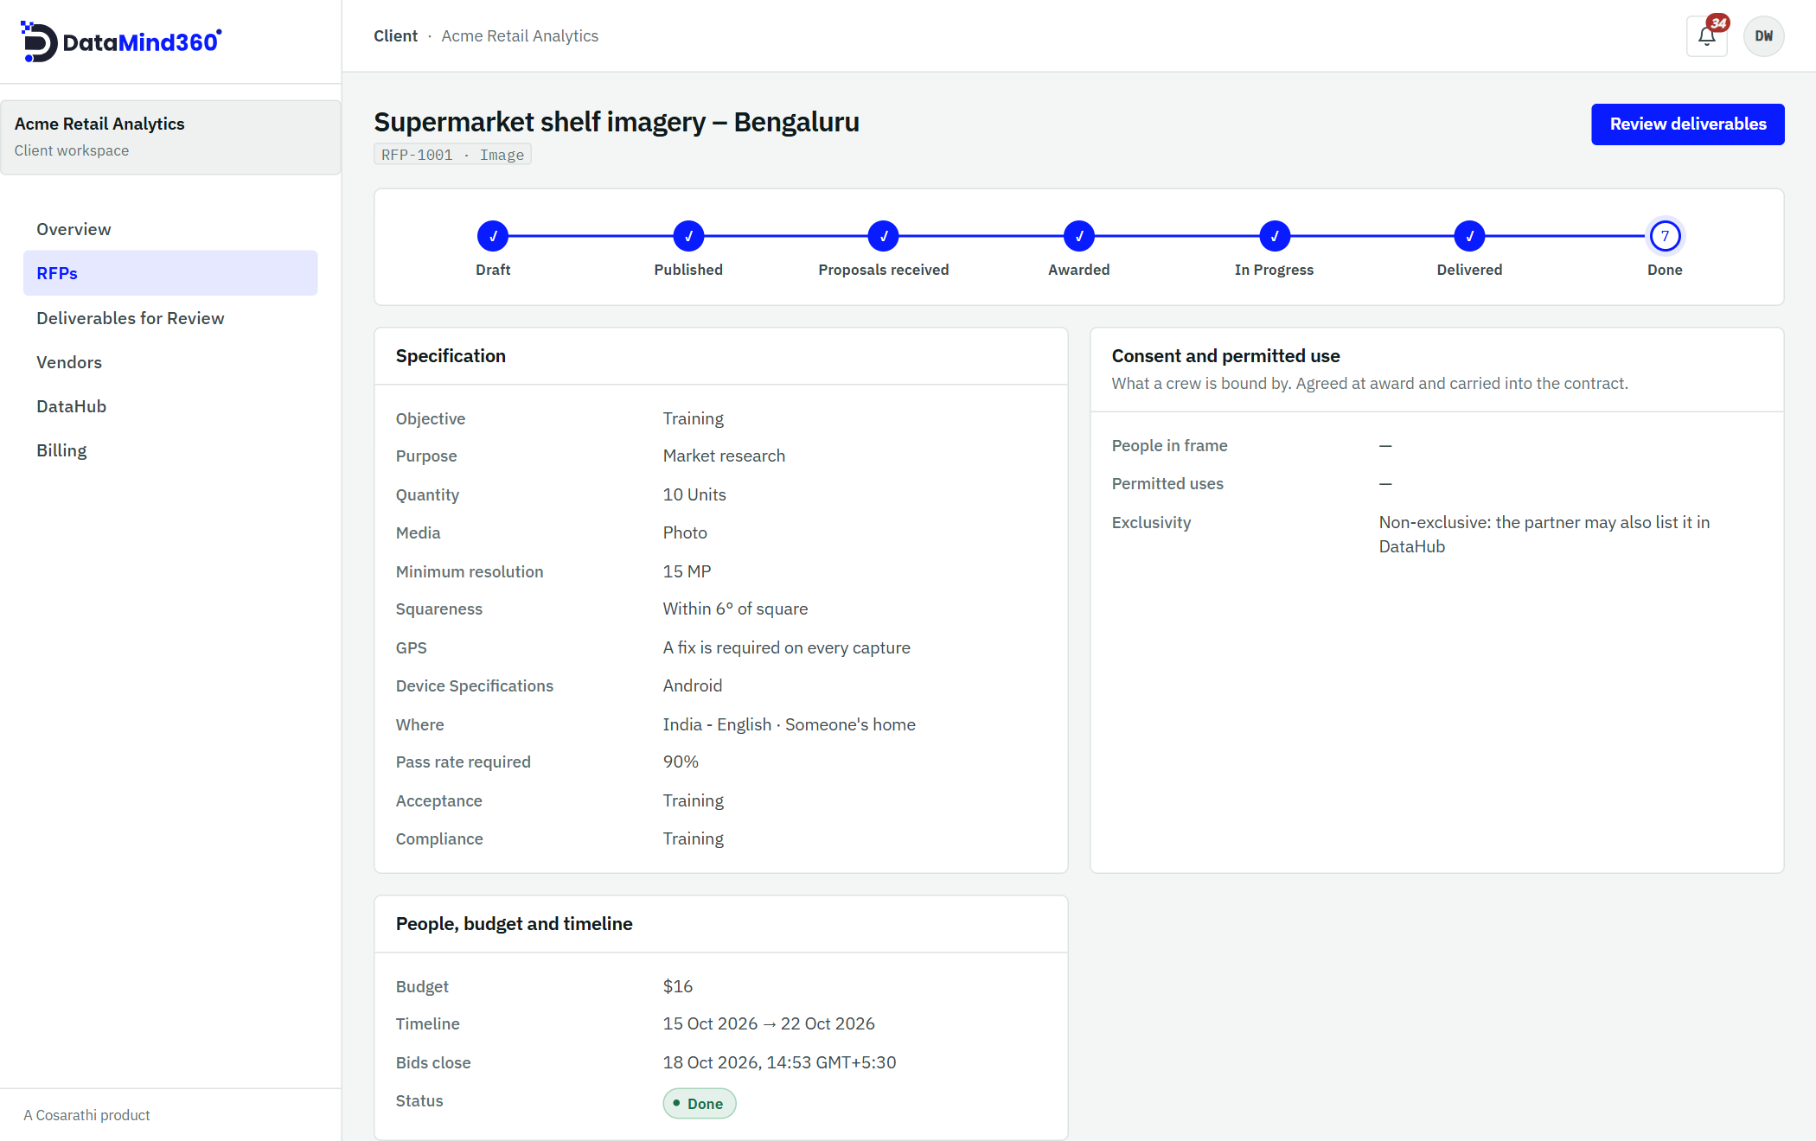
Figure 10. An RFP's page: its progress through the stages, the specification, and the consent and permitted-use terms.

5.6 Review and approve the delivery
When the partner delivers, the contract appears in Deliverables for Review. Everything you see there has already passed the automatic checks and both quality gates. You then choose one of two actions:
Action | What you provide | What happens
Approve | A rating from 1 to 5 and a comment | The contract is complete. This cannot be undone. The partner can then invoice in full.
Send back | A reason | The contract returns to In Progress so the partner can fix the issue.

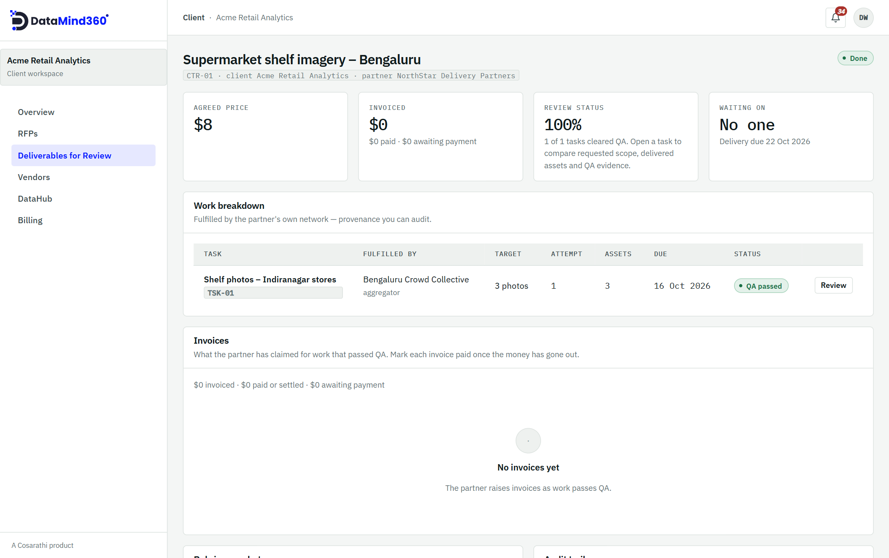
Figure 11. A deliverable under review: agreed price, invoices, QA status and the work breakdown showing who fulfilled each task.
Tip
Rate honestly. Ratings feed the Vendors directory and help every client choose well.

6. For delivery partners
Delivery partners win and fulfil client RFPs using their own network. Your Overview shows your win rate and the work waiting in your QA queue.

6.1 Find opportunities
Opportunities lists every published RFP you can bid on, soonest deadline first. Open one to read the scope, capture rules, consent requirements, budget (unless hidden) and documents. Use the private Q&A to ask the client anything.

6.2 Respond
Submit a proposal with your price on the client's budget basis, a delivery time in days, How you will do the work, up to 10 supporting documents and any notes. Track your bids under Responses, where they show as Submitted, Accepted, Rejected or Withdrawn. You can edit or withdraw a proposal until bidding closes.
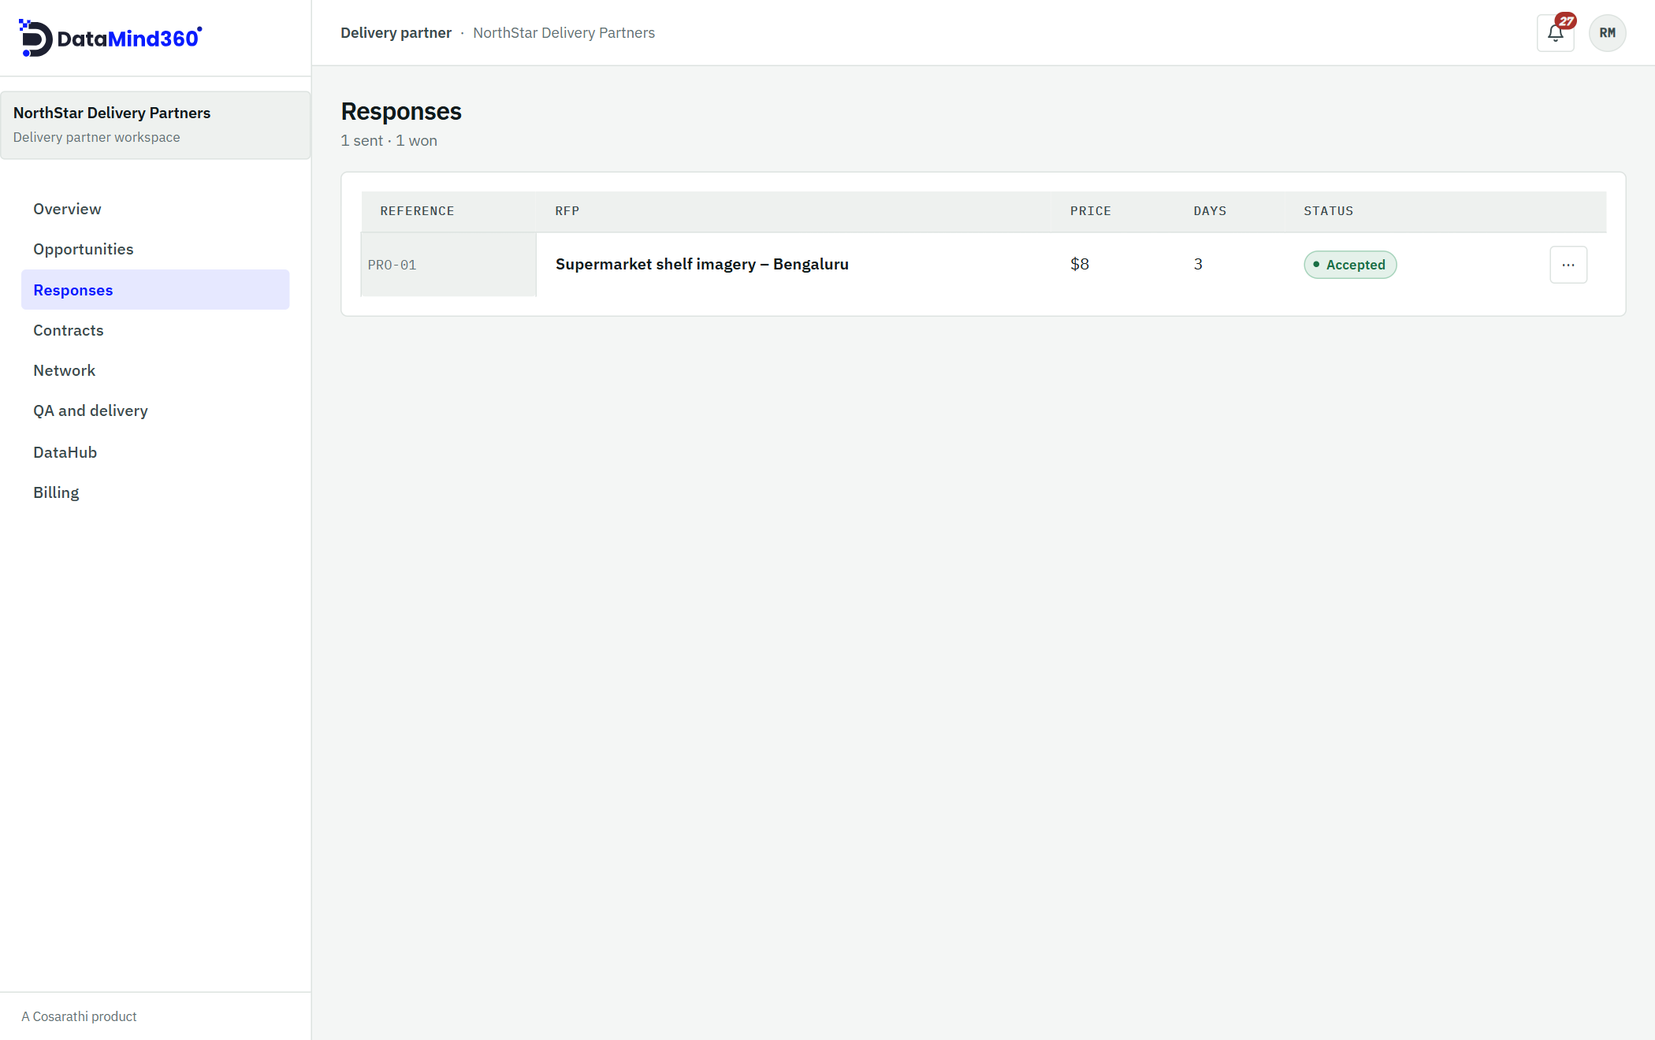
Figure 12. Responses: every proposal you have submitted and its status.

6.3 Build your network
From Network, ask the DataMind360 team to onboard the aggregators, business partners and device sponsors you work with. You submit the request; the DataMind360 team approves it. Once approved, they receive an invitation and appear in your network.
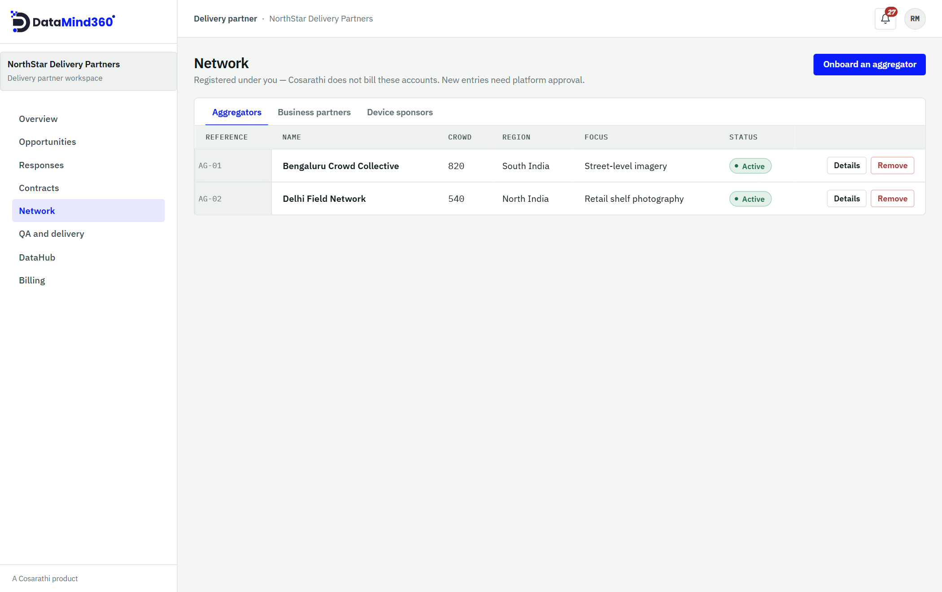
Figure 13. Network: the aggregators, business partners and device sponsors working with you.

6.4 Run the contract
Won work appears under Contracts (In Progress, In QA, Delivered, Done, Disputed or Cancelled). Use Assign a task to give work to an aggregator or business partner, with:
- A due date (no later than the contract's delivery date) and a target quantity
- Field instructions and attachments
- What the camera Must show and Must not show
Tasks move through Assigned → In Progress → Submitted → QA passed or QA failed (or Cancelled).

6.5 Quality gate 2 and delivery
When an aggregator submits a task, it appears under QA and delivery. Pass it, or fail it with a note explaining what must change. A failed task reopens for rework, and every attempt is kept. When every task has passed, choose Deliver to send the contract to the client for approval.
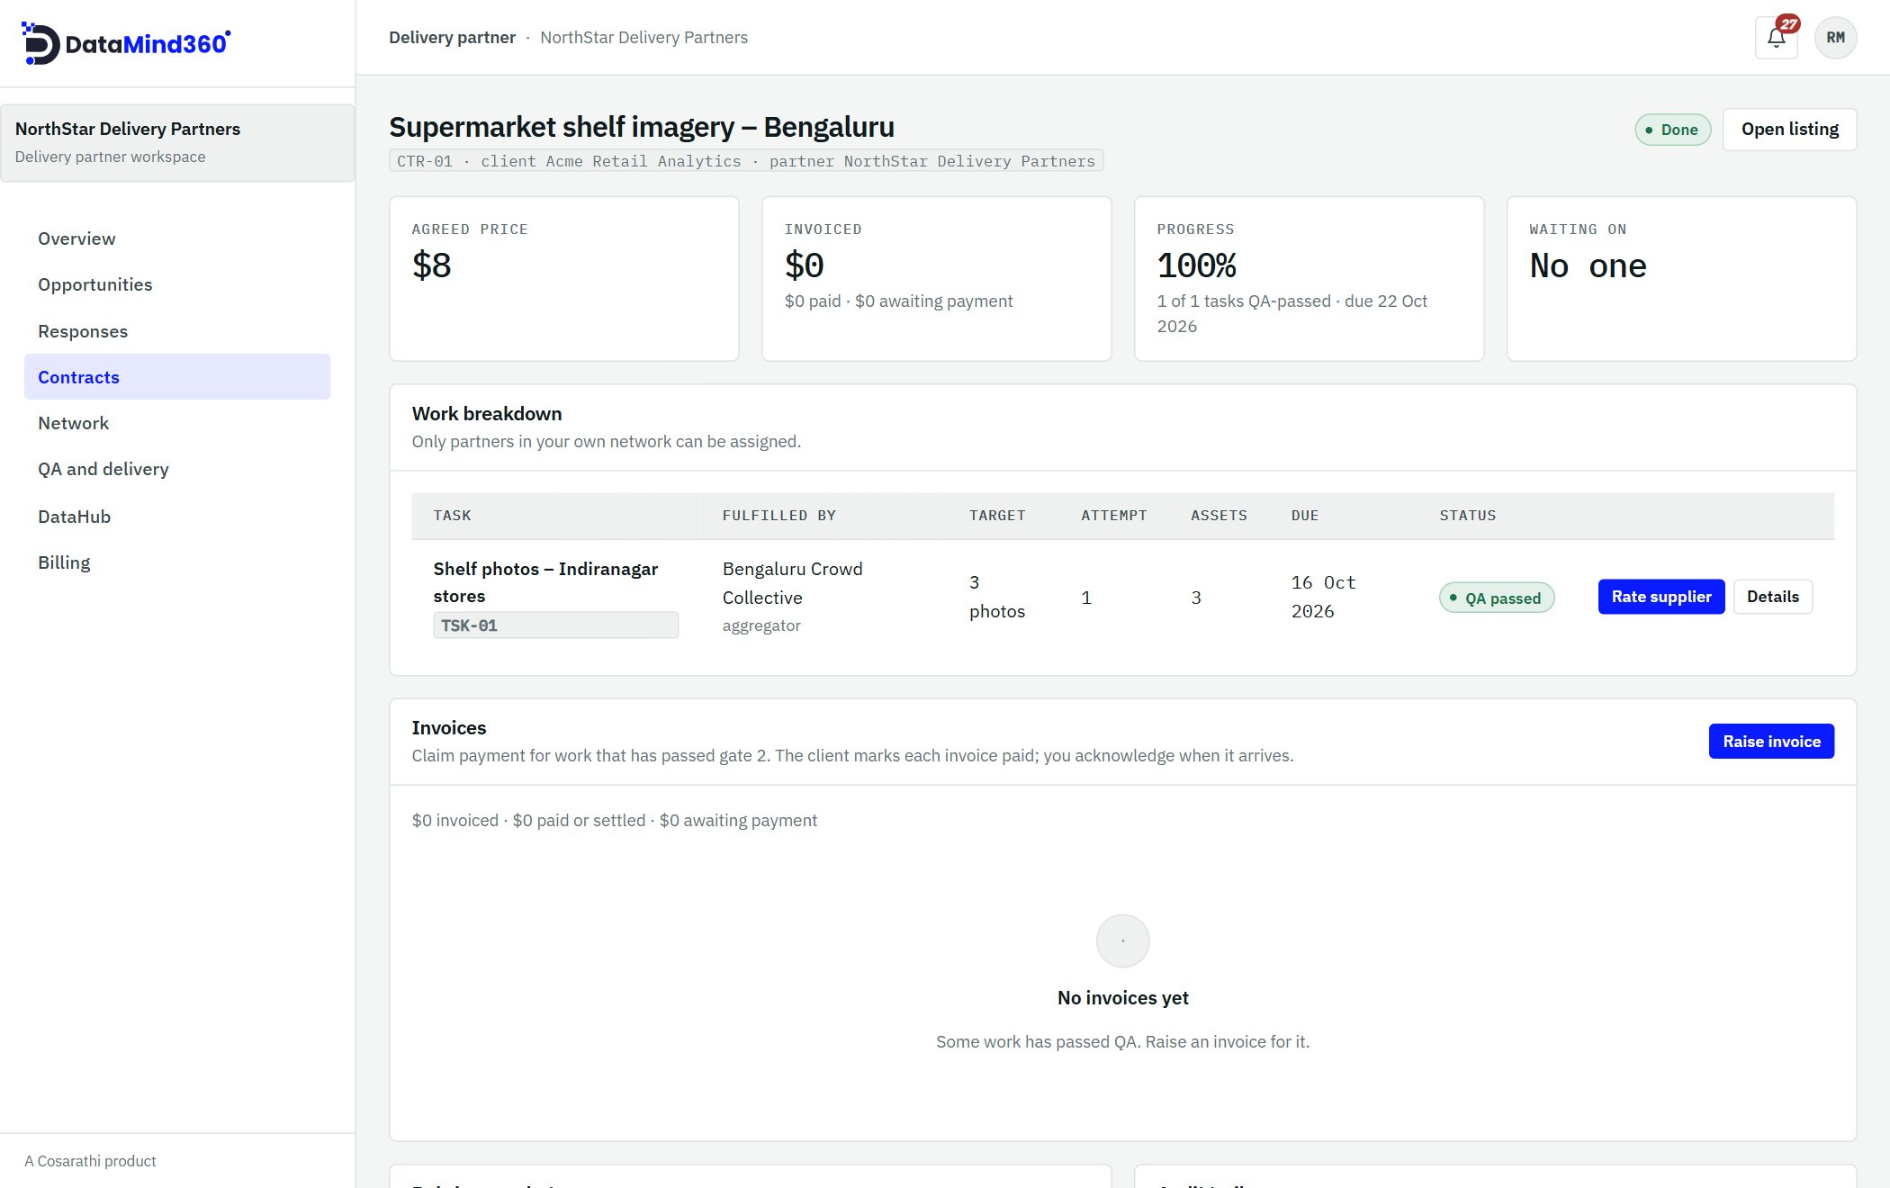
Figure 14. A contract from the partner's side: each task, who is fulfilling it, its QA status, and where to raise invoices.

6.6 Invoice and rate
After work passes gate 2 you can raise invoices (see Section 11). You can also rate the members of your network after each job.

7. For aggregators and business partners
Aggregators run crowds of field workers; business partners take on work with their own staff. Both receive tasks from a delivery partner. Aggregators see them under Tasks; business partners see them under Engagements, and maintain their Capacity profile.

7.1 Your crowd roster
Aggregators manage their workers on the Crowd roster page. Add people one by one, or import a CSV or XLSX file of up to 1,000 rows. People are matched by email address, so importing the same person twice does not create a duplicate. Each new worker receives an invitation to set up their account.
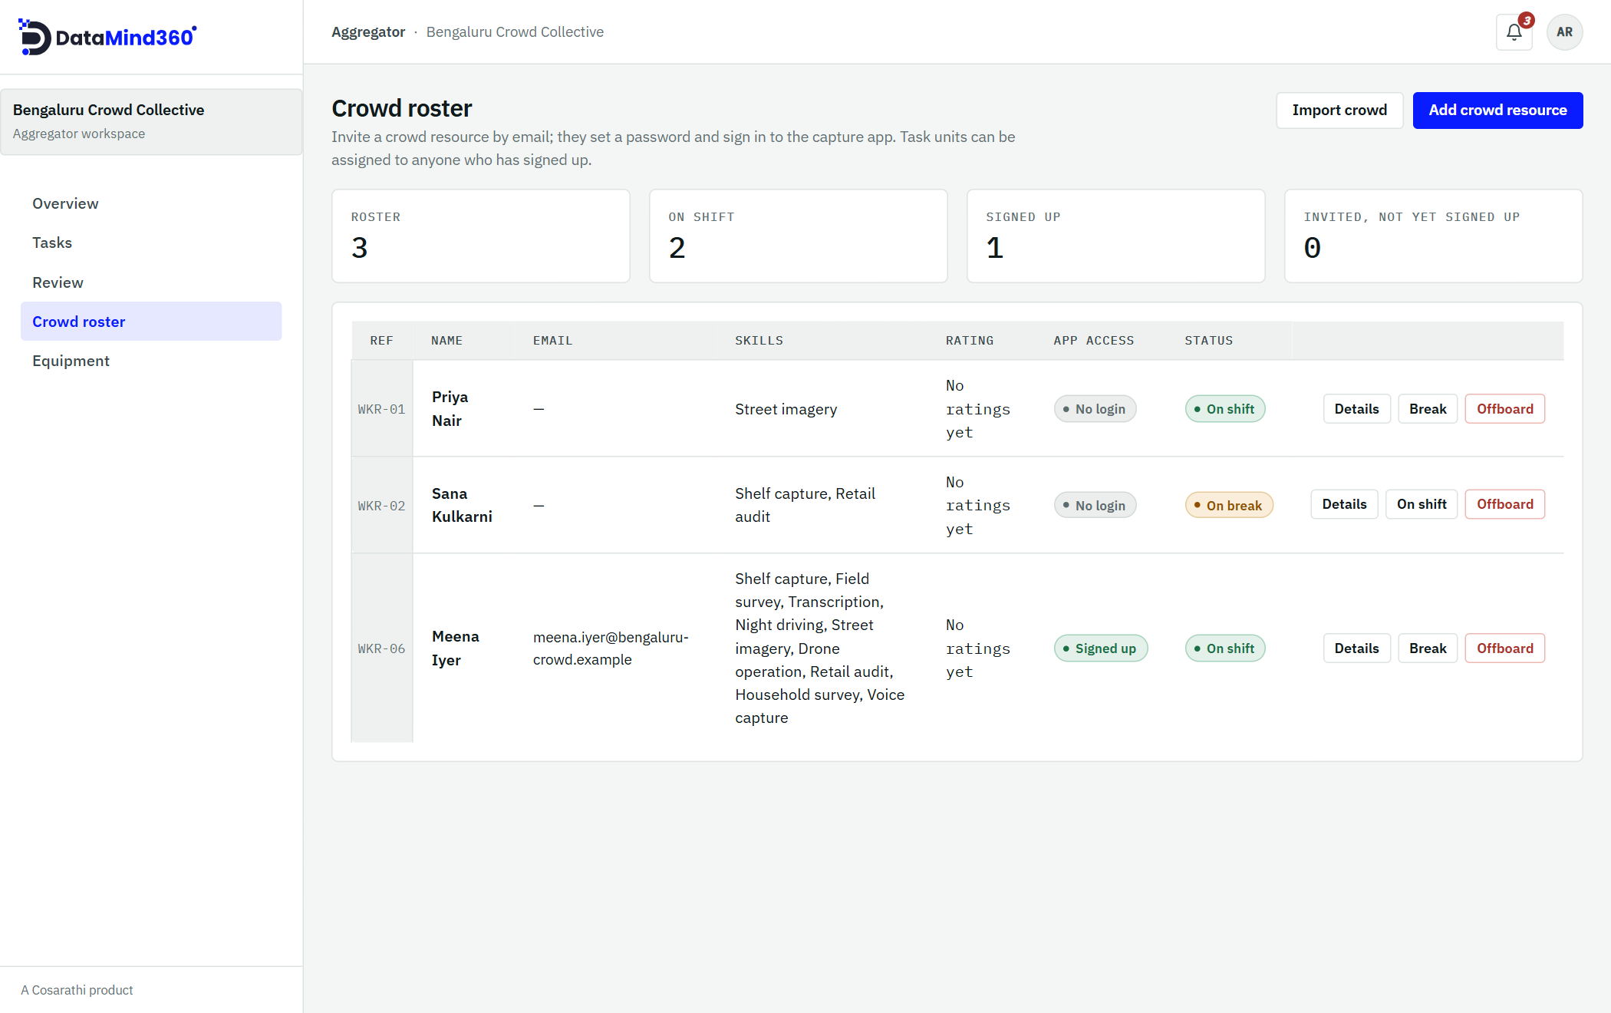
Figure 15. The Crowd roster: each worker's skills, rating, app sign-in status and availability.

7.2 Put people on a task
Method | How it works | Best for
Offer to the crowd | Send an email offer for a number of places and units, with an optional respond-by time. Workers accept first come, first served. Offers show as Open, Filled, Closed or Expired. | Filling many places quickly
Direct assignment | Choose a specific worker and the quantity they should capture. | Specialist or trusted workers

Total assignments cannot exceed the task's target. A worker can have only one open assignment per task, and a task can have only one open offer at a time. From an assignment you can Reassign, Cancel, Remind or Rate.
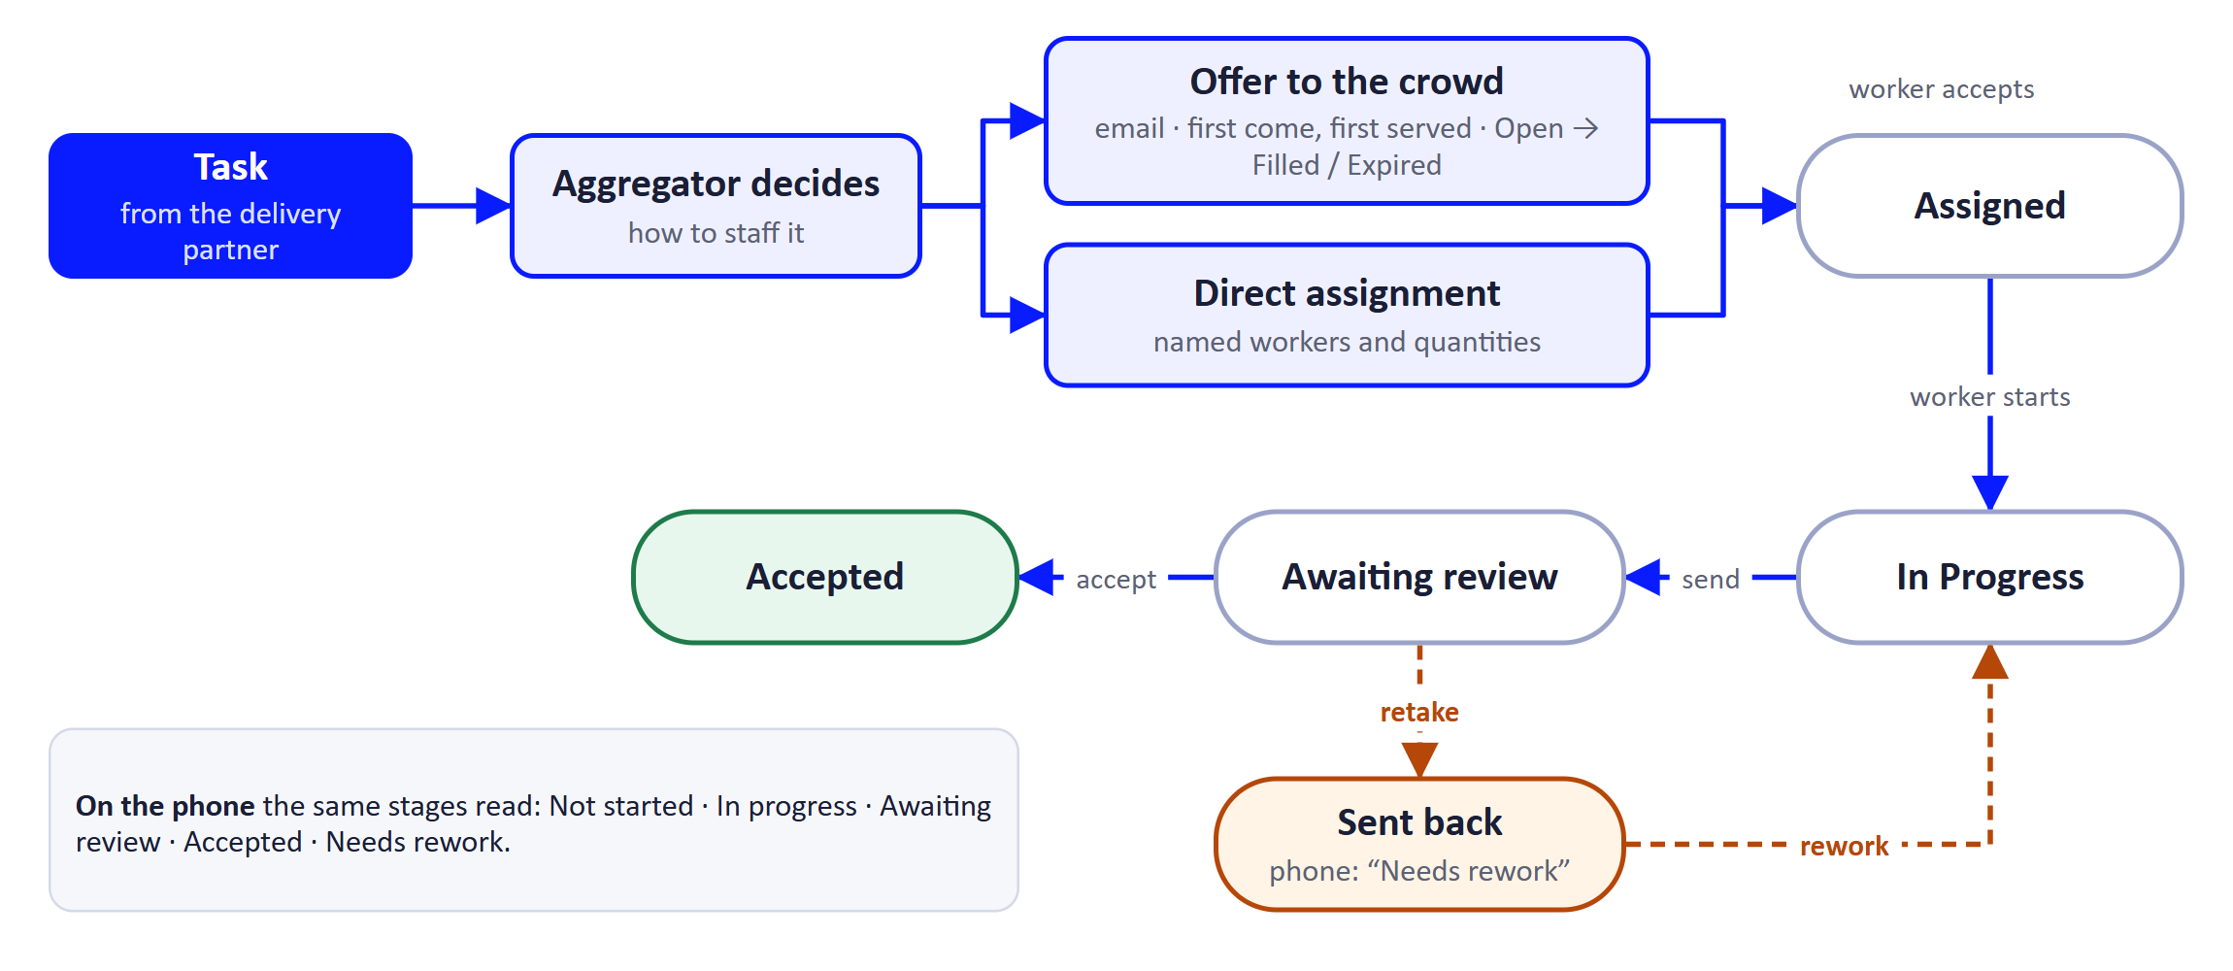
Figure 16. Staffing a task and the life of an assignment.
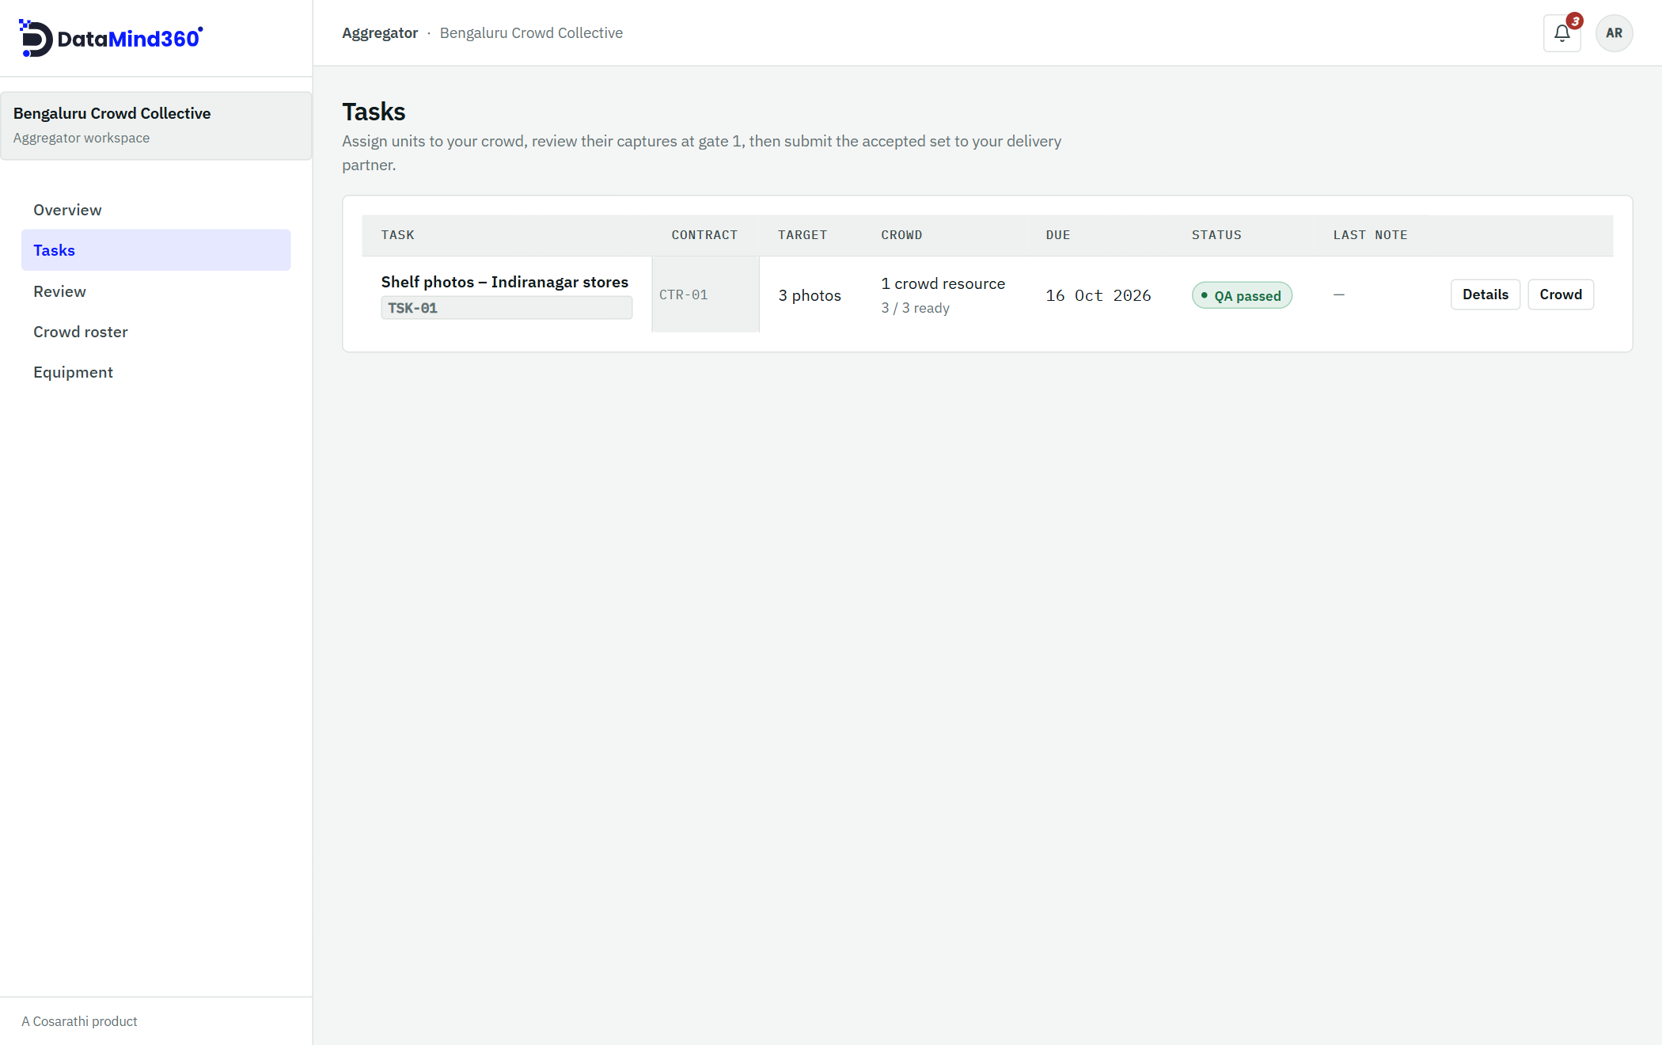
Figure 17. Tasks: work received from the delivery partner, with target, due date and QA status.

7.3 Quality gate 1: review captures
Open Review to look at submitted captures batch by batch. Mark any capture that needs to be redone and choose a reason from the list (for example blur, exposure, wrong subject or tilt, or something else). Everything not marked for retake is accepted and stays accepted. The worker is notified and the assignment shows Sent back ("Needs rework" on the phone).
When the task is complete, choose Submit to partner to send it to quality gate 2.

7.4 Equipment
If a task needs specialised kit, request a loan from a device sponsor on the Equipment page.
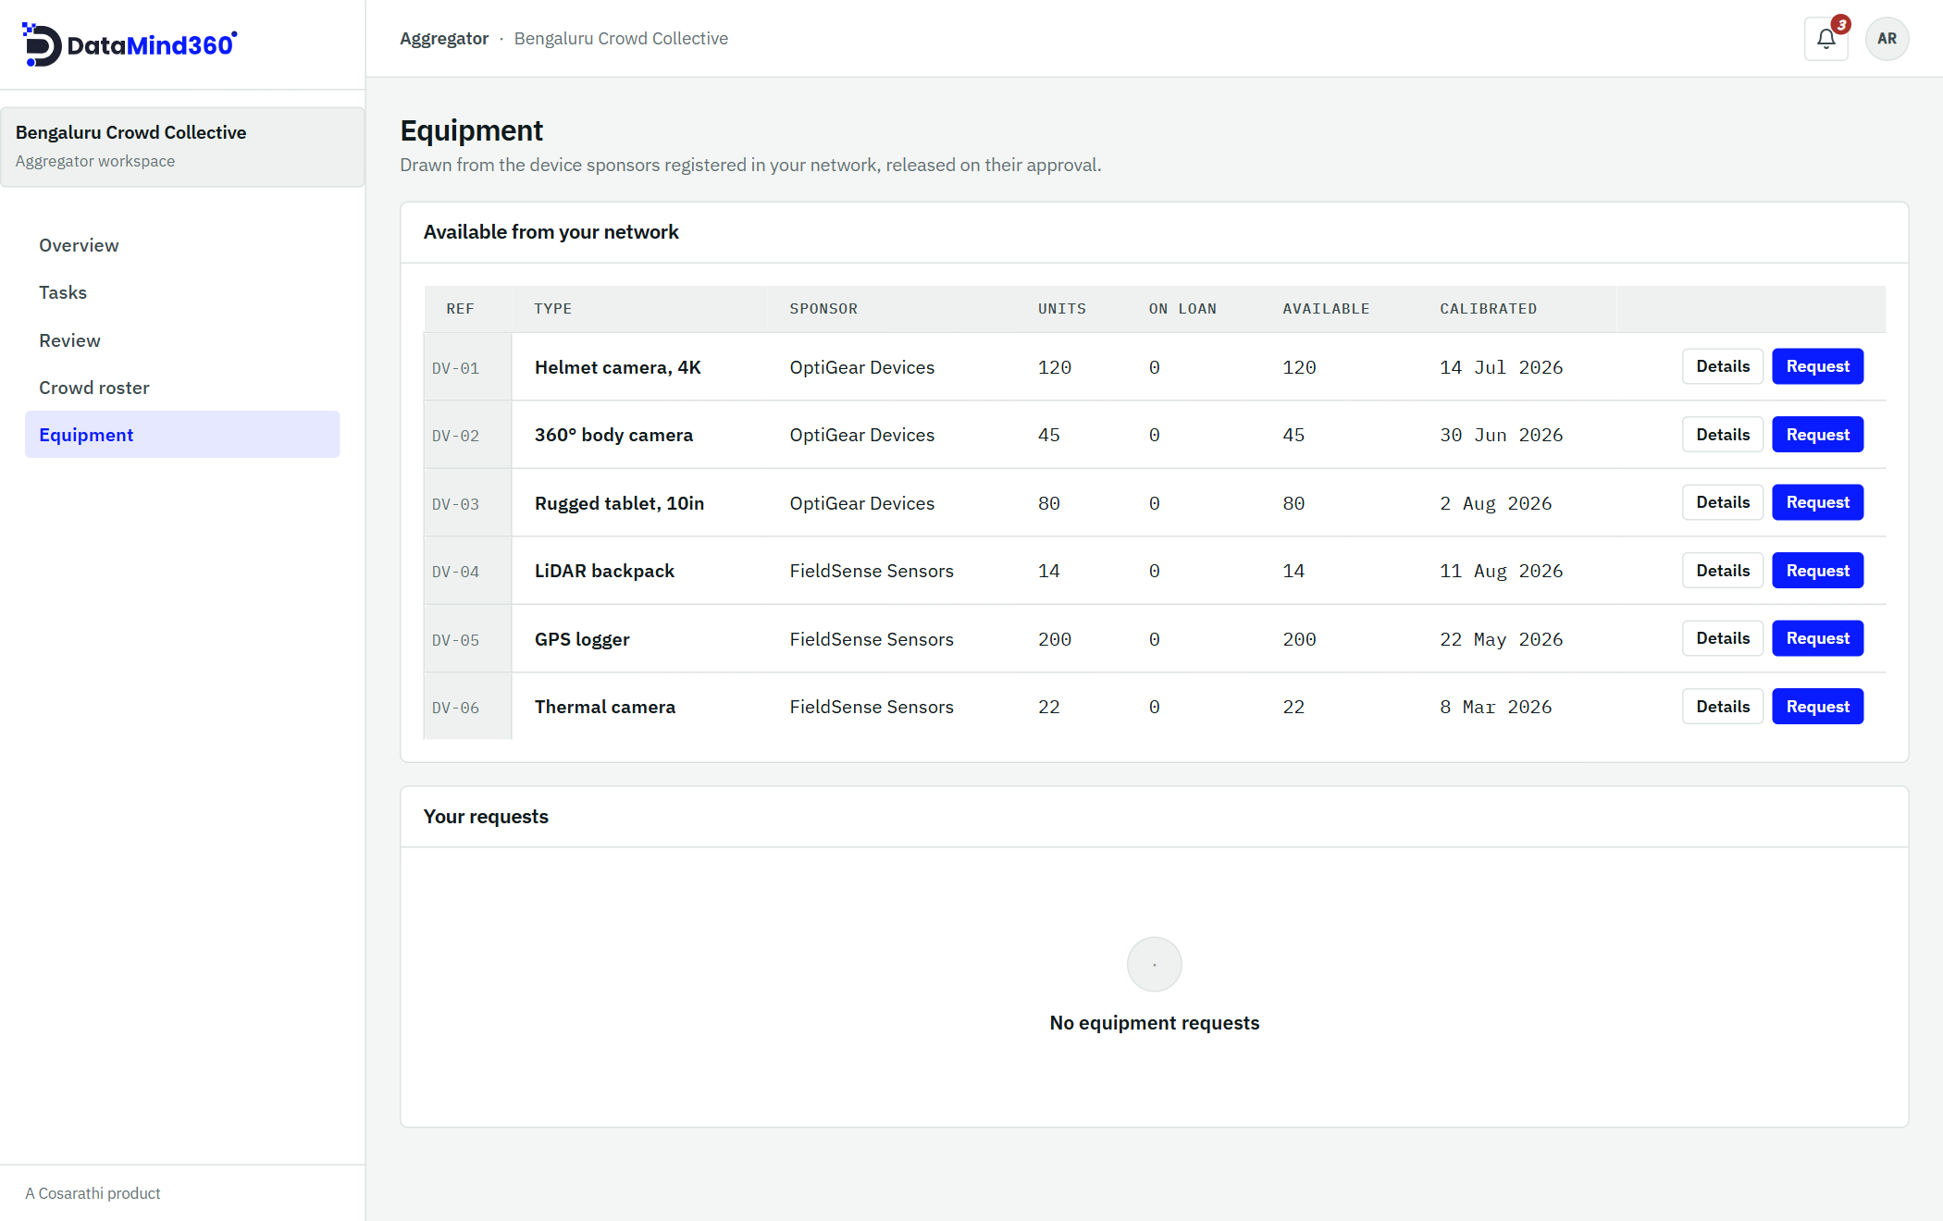
Figure 18. Equipment available from sponsors in your network, with stock and calibration dates.

7.5 Reminders
DataMind360 reminds workers automatically about offers, unstarted work, retakes and due dates (see Section 13). You can also send a manual reminder, at most once an hour per assignment.

8. For device sponsors
Device sponsors lend equipment to field teams in a delivery partner's network.
- Inventory: record your devices, stock levels and calibration dates.
- Requests: approve or reject loan requests. A reason is required to reject.
- Overview: see the status of your fleet at a glance.
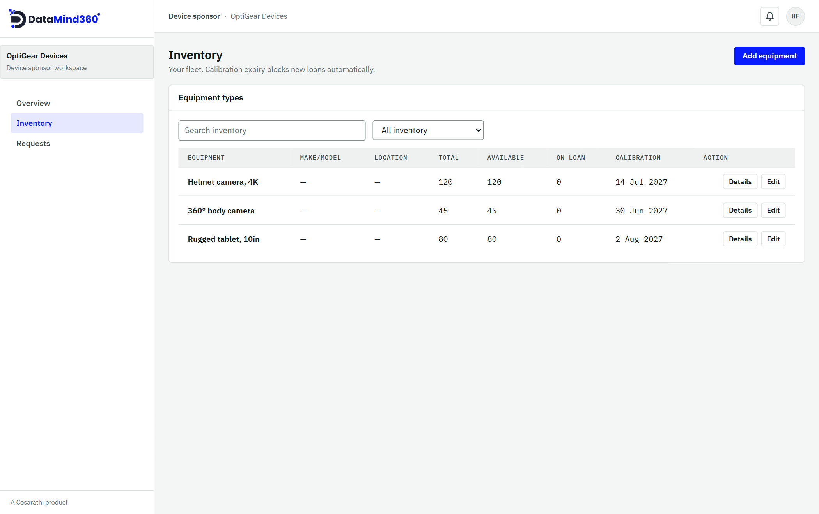
Figure 19. Inventory: equipment types, stock on loan and calibration due dates.
Good to know
A loan cannot exceed available stock, and a device whose calibration has expired cannot be lent until it is recalibrated.

9. For crowd workers: the phone app
Crowd workers capture data with DataMind360 Capture, available for Android. (Earlier releases are named Cosarathi Capture.)

9.1 Getting set up
- Accept the invitation email from your aggregator or business and set your password.
- Install the app and sign in.
- Read and accept the Before you start privacy notice. It explains what is collected and why. You accept it once, before your first assignment.

9.2 Your assignments
The home screen lists your assignments with their status:
Status on the phone | Meaning
Not started | You have been given this work. Start it before capturing.
In progress | You are capturing.
Awaiting review | You sent captures in; your aggregator is reviewing them.
Needs rework | Some captures were sent back. The reason is shown on each one.
Accepted | Your work was accepted.
Cancelled / Reassigned | The work was withdrawn or given to someone else.

Open an assignment to read the instructions, what the camera must and must not show, and the attachments. Then use the buttons: Start and capture, Capture more (N left), Send N for review and Retake N.
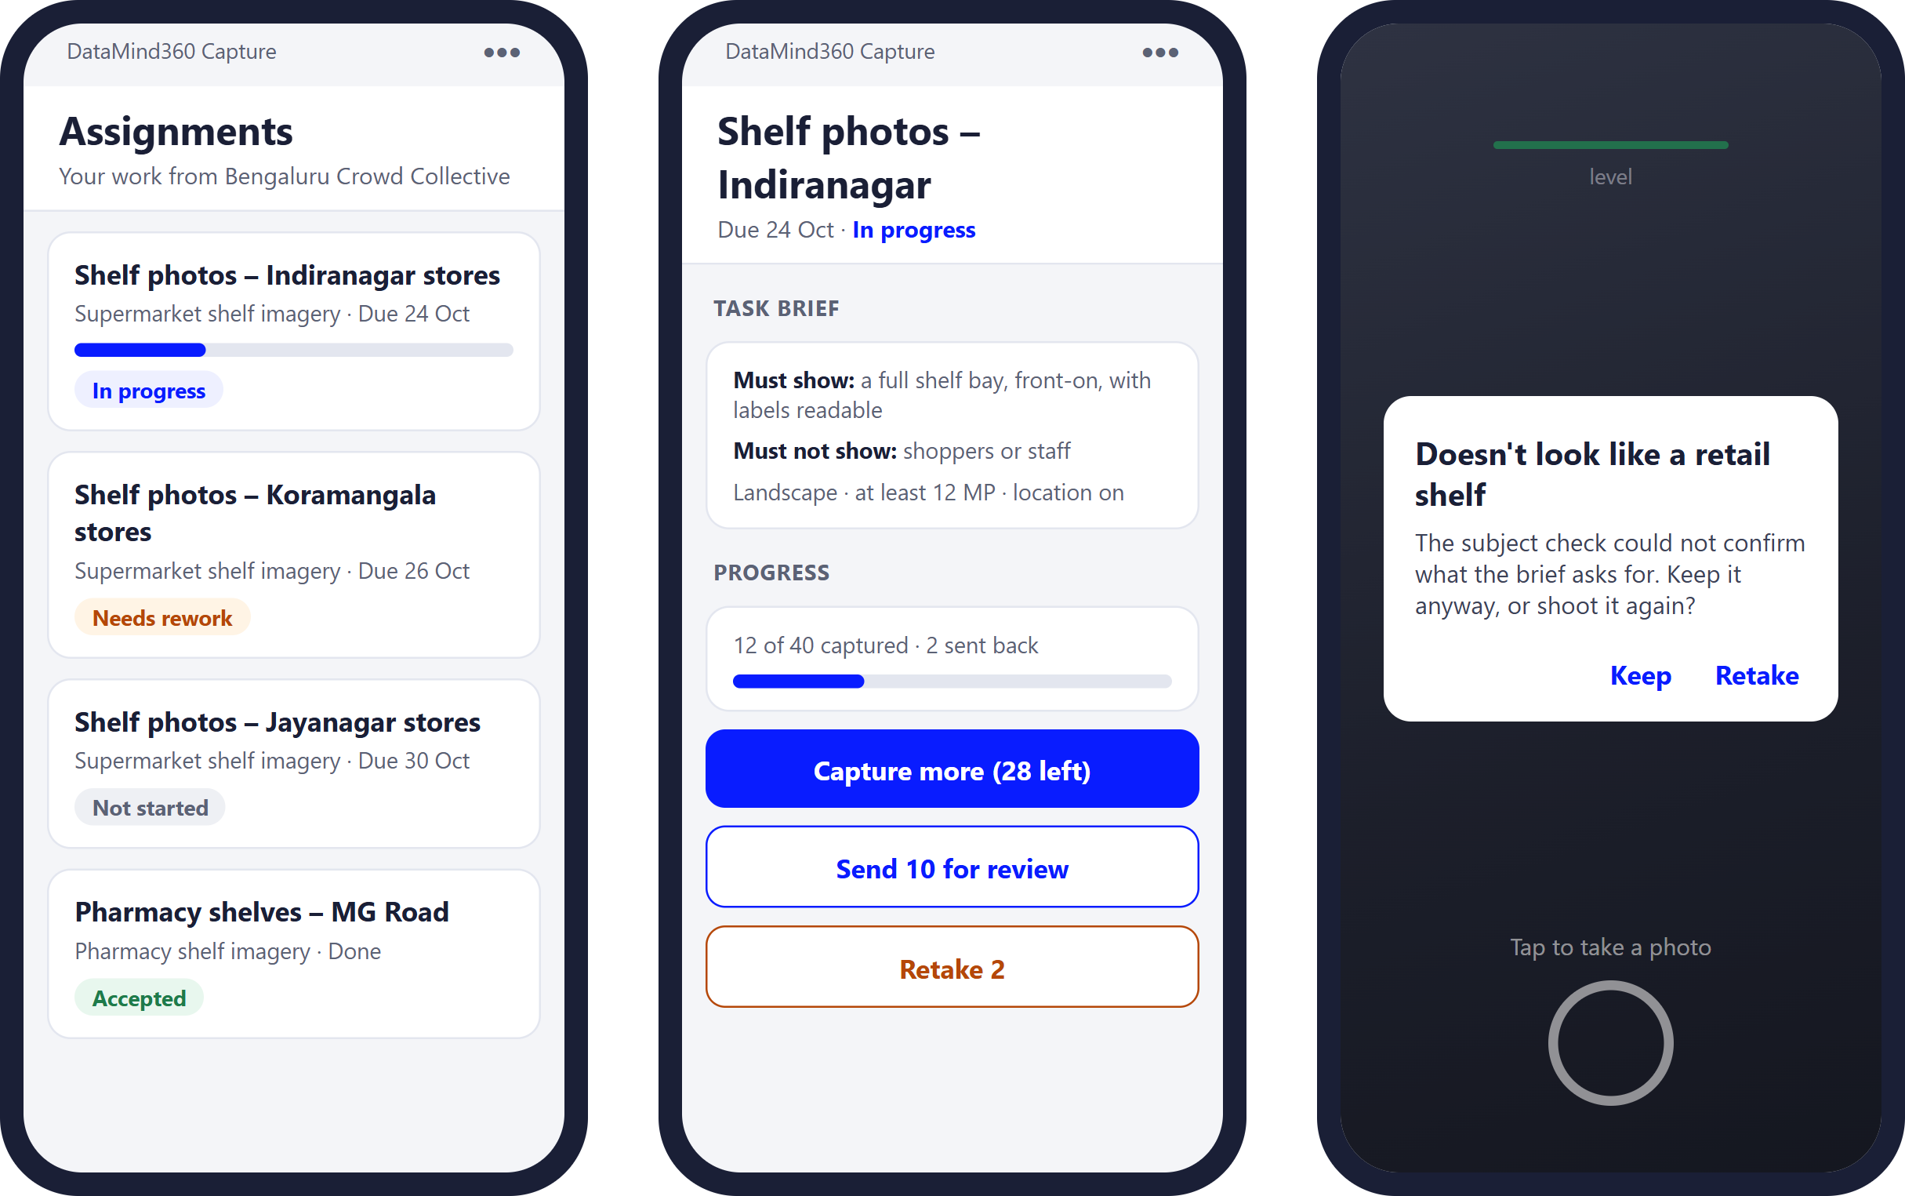
Figure 20. Illustration of the phone app: the assignment list, an assignment's brief and actions, and the subject check asking whether to keep or retake a photo.

9.3 Capturing and the automatic checks
The app checks every photo or clip the moment you take it, against the client's rules:
Result | Examples | What you do
Refused | Wrong file type or size, too few megapixels, wrong orientation, too much tilt, no GPS location, clip too long or too large, very dark or unreadable clip | Retake it. A refused capture cannot be sent.
Warning | Possible blur or poor exposure, a weak GPS fix, the subject may not match, faces detected when no people should be in frame | Decide whether to keep it or retake it.

9.4 Working offline
No signal? Keep working. Captures are queued on the phone and upload automatically when you are connected and the app is open. Settings shows the upload queue.

9.5 Notifications and settings
The app sends push notifications for new work, offers, retakes and reminders. In Settings you can see the upload queue, turn notifications on or off, change your password and sign out.

9.6 Uploading from a computer
If you already have the files, you can sign in to the web console and upload them under My assignments. The same checks run where a browser can perform them; tilt and GPS cannot be verified this way and are marked unverified.
Good to know
You can upload at most 500 captures per assignment, and no more than you were assigned.
Photos: JPG, JPEG, PNG, HEIC or WebP up to 25 MB. Video: MP4 or MOV up to 2 GB and 600 seconds.

10. Quality assurance in depth
Quality is checked at four points, so that what you receive is already clean.
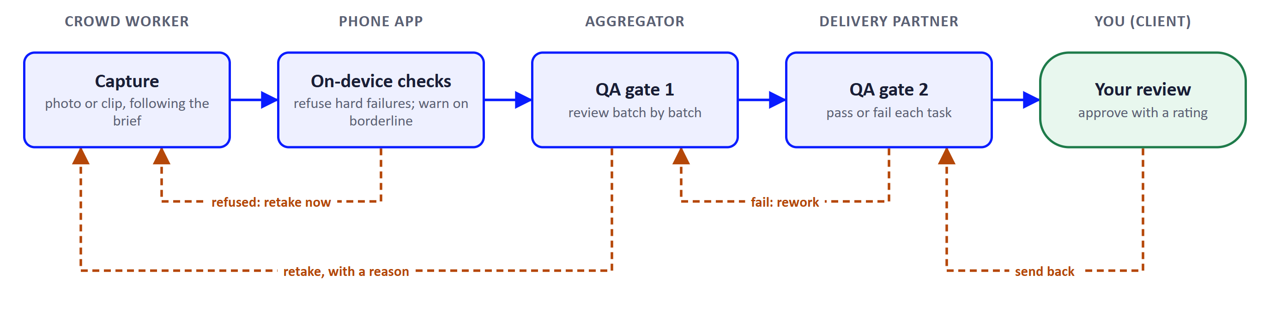
Figure 21. The four quality checkpoints and where each one sends work back.

A. On-device checks
The capture rules in the client's RFP are turned into automatic checks on the phone. Captures that break a hard rule are refused and never leave the device. Borderline captures raise a warning for the worker to decide. Some measurements (such as text legibility, device model and exact tilt) are recorded quietly for reviewers without interrupting the worker.

B. Gate 1: aggregator review
The aggregator reviews every batch. Captures can be accepted or sent back with a reason from a fixed list. Accepted captures stay accepted. Once the task is complete the aggregator submits it to the partner.

C. Gate 2: delivery partner review
The partner passes or fails each task as a whole. A fail requires a note and reopens the task for rework. All attempts are kept, so the history of a task is never lost.

D. Client approval
The partner can deliver only when every task has passed gate 2. The client then approves with a rating, or sends the delivery back with a reason.
Tip
Because problems are caught at the earliest point, they cost the least to fix: a retake in the field rather than a re-shoot after delivery.

11. Billing and invoices
Billing on DataMind360 is a shared record between client and delivery partner. DataMind360 does not process payments, hold funds in escrow or charge a transaction fee. Payment happens directly between you, by your usual means.

How an invoice works
- Once work has passed quality gate 2, the partner raises an invoice from Billing.
- The client pays outside the platform, then marks the invoice Paid with a payment reference.
- The partner acknowledges the payment and the invoice becomes Settled.
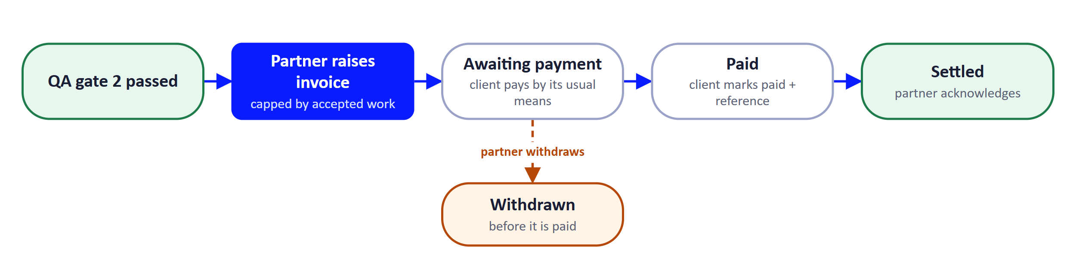
Figure 22. The life of an invoice.

Invoice limits
Contract basis | What can be invoiced
Per unit ("an amount per block of units") | A quantity at the agreed rate, up to the number of captures accepted so far.
Fixed price ("one amount for the whole job") | Any amount up to the contract value.

Invoice statuses
Status | Meaning
Awaiting payment | Raised by the partner; the client has not yet marked it paid.
Paid | The client has marked it paid and given a reference.
Settled | The partner has confirmed receipt.
Withdrawn | The partner withdrew it before it was paid.

DataHub purchases (Section 12) create invoices in the same Billing page automatically.
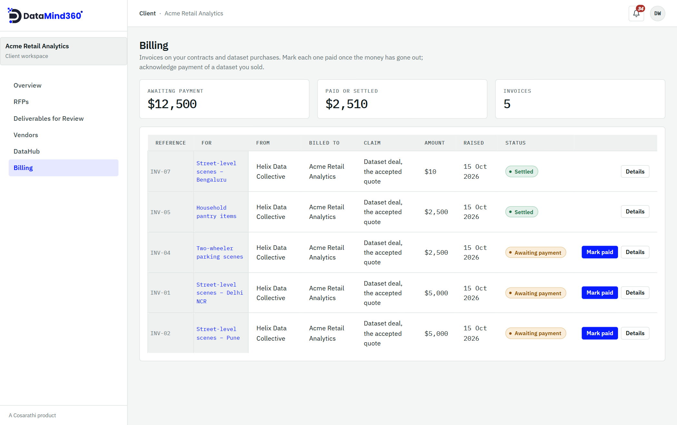
Figure 23. Billing: what is awaiting payment, what is paid or settled, and Mark paid for each open invoice.

12. DataHub: the dataset marketplace
DataHub lets clients and delivery partners sell finished datasets, and anyone to discover and request them.

Selling a dataset
- Create a listing in DataHub, either for your own dataset or, for partners, a non-exclusive contract the client has approved. Exclusive RFP data can never be listed.
- Add a description and up to 50 samples.
- Submit it for review. The DataMind360 team checks every listing before it goes on sale.
Listing statuses: Draft, In review, On sale, Sent back or Withdrawn.

Buying a dataset
- Signed-in clients and partners browse DataHub inside the console. Anyone else can browse the public DataHub storefront and request a quote without an account.
- Request a quote. The seller replies with a price.
- Accepting a quote issues an invoice in Billing automatically. You cannot buy your own dataset.
- The seller delivers the files directly to you; DataMind360 holds only the samples.
Quote statuses: Quote requested, Quoted, Awaiting payment, Paid (to deliver), Delivered, Declined or Withdrawn.
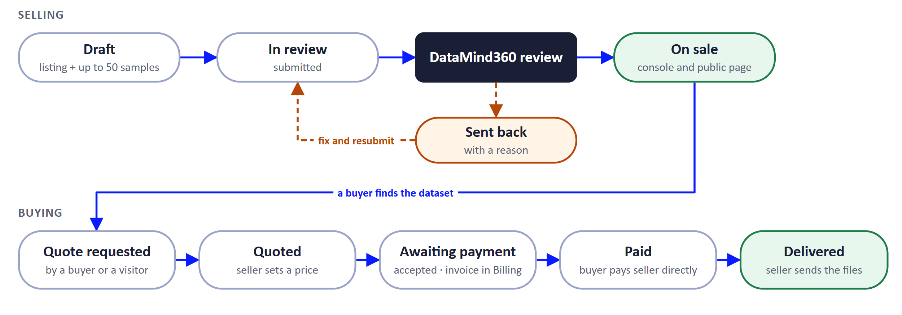
Figure 24. Selling and buying a dataset in DataHub.
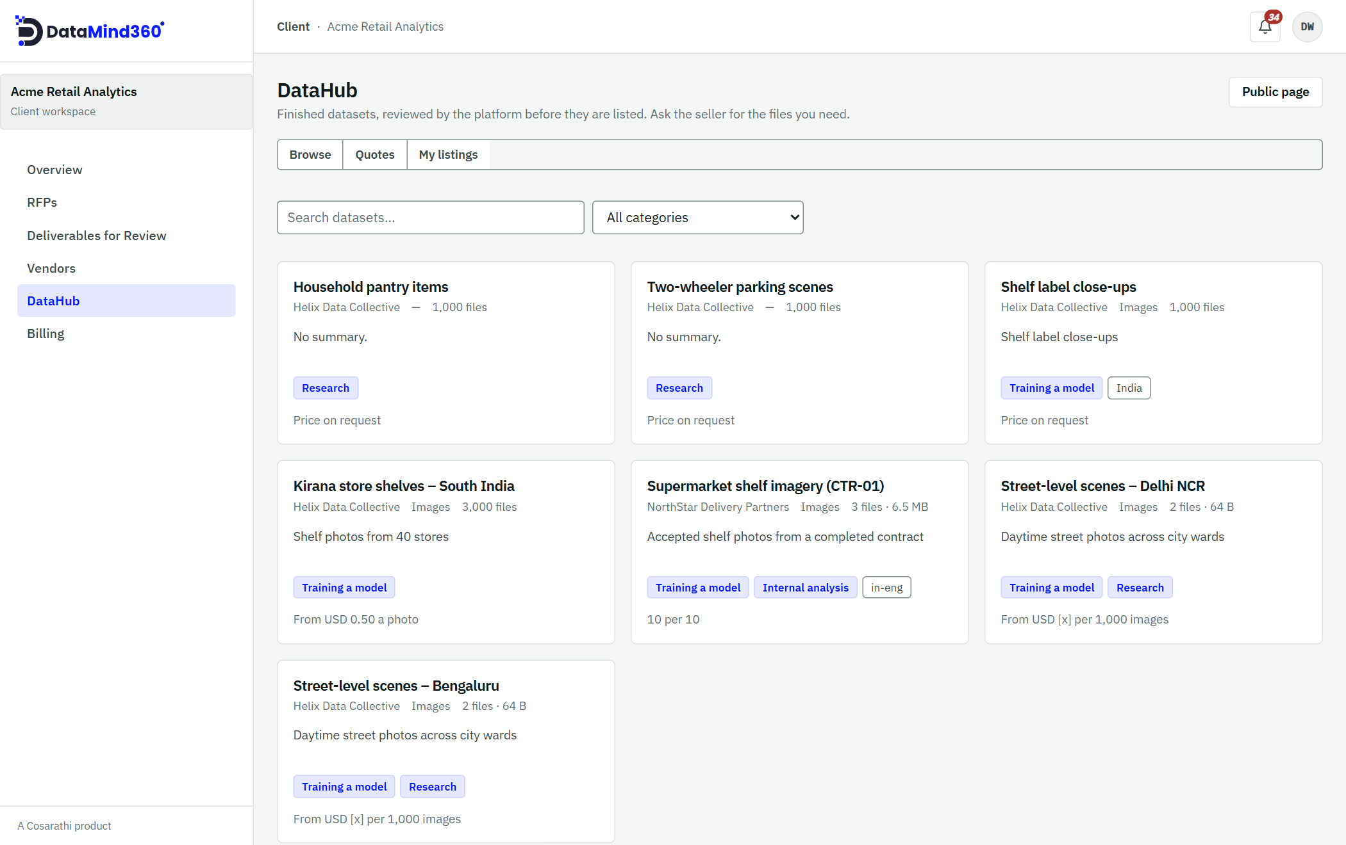
Figure 25. Browsing DataHub inside the console. Each card shows the seller, size, uses and indicative price.

13. Notifications and reminders
Channel | Who receives it | Used for
In-app bell | Everyone using the web console | Every update that concerns you, including bidding deadlines. Refreshes automatically.
Email | Invitees and crowd workers | Invitations, password resets, task offers and reminders, and DataHub replies to public enquiries.
Push notifications | Crowd workers (phone app) | New work, offers, retakes and reminders.

Bidding deadline notices
Clients and partners are notified in the app when an RFP is published, when its deadline changes, one day before bidding closes, and when it closes.

Automatic reminders for crowd workers
Situation | When reminders are sent
An open offer | Half-way through the respond window, and 24 hours before it closes
Work not started, or sent back for rework | 2 days after, then every 2 days
Due soon | 2 days before the due date
Overdue | Then every 3 days

No one receives the same reminder twice within 20 hours. Aggregators can also send a manual reminder at most once an hour.

14. Privacy, consent and security

Consent set by the client
Every RFP records the consent and use terms for its data:
Field | Options
People in frame | Nobody · Incidentally · As subjects (consented)
Children | Not permitted · Only with parental consent
Lawful basis | The GDPR Article 6 bases
De-identification | Blur faces · Redact number plates · Strip GPS
Also recorded | Permitted uses, applicable regulations, whether biometric data is involved, and compliance documents (for example a DPA, site-access rules or a privacy notice)

These terms travel with the RFP to the partner and its field teams. When "Nobody" is set, the phone app warns the worker if it detects faces. De-identification preferences are recorded and passed to the partner to apply; DataMind360 does not alter your images.

Field worker privacy
Before their first assignment, every crowd worker reads and accepts a privacy notice in the app explaining what is collected (including location for captures) and why.

Where your data lives
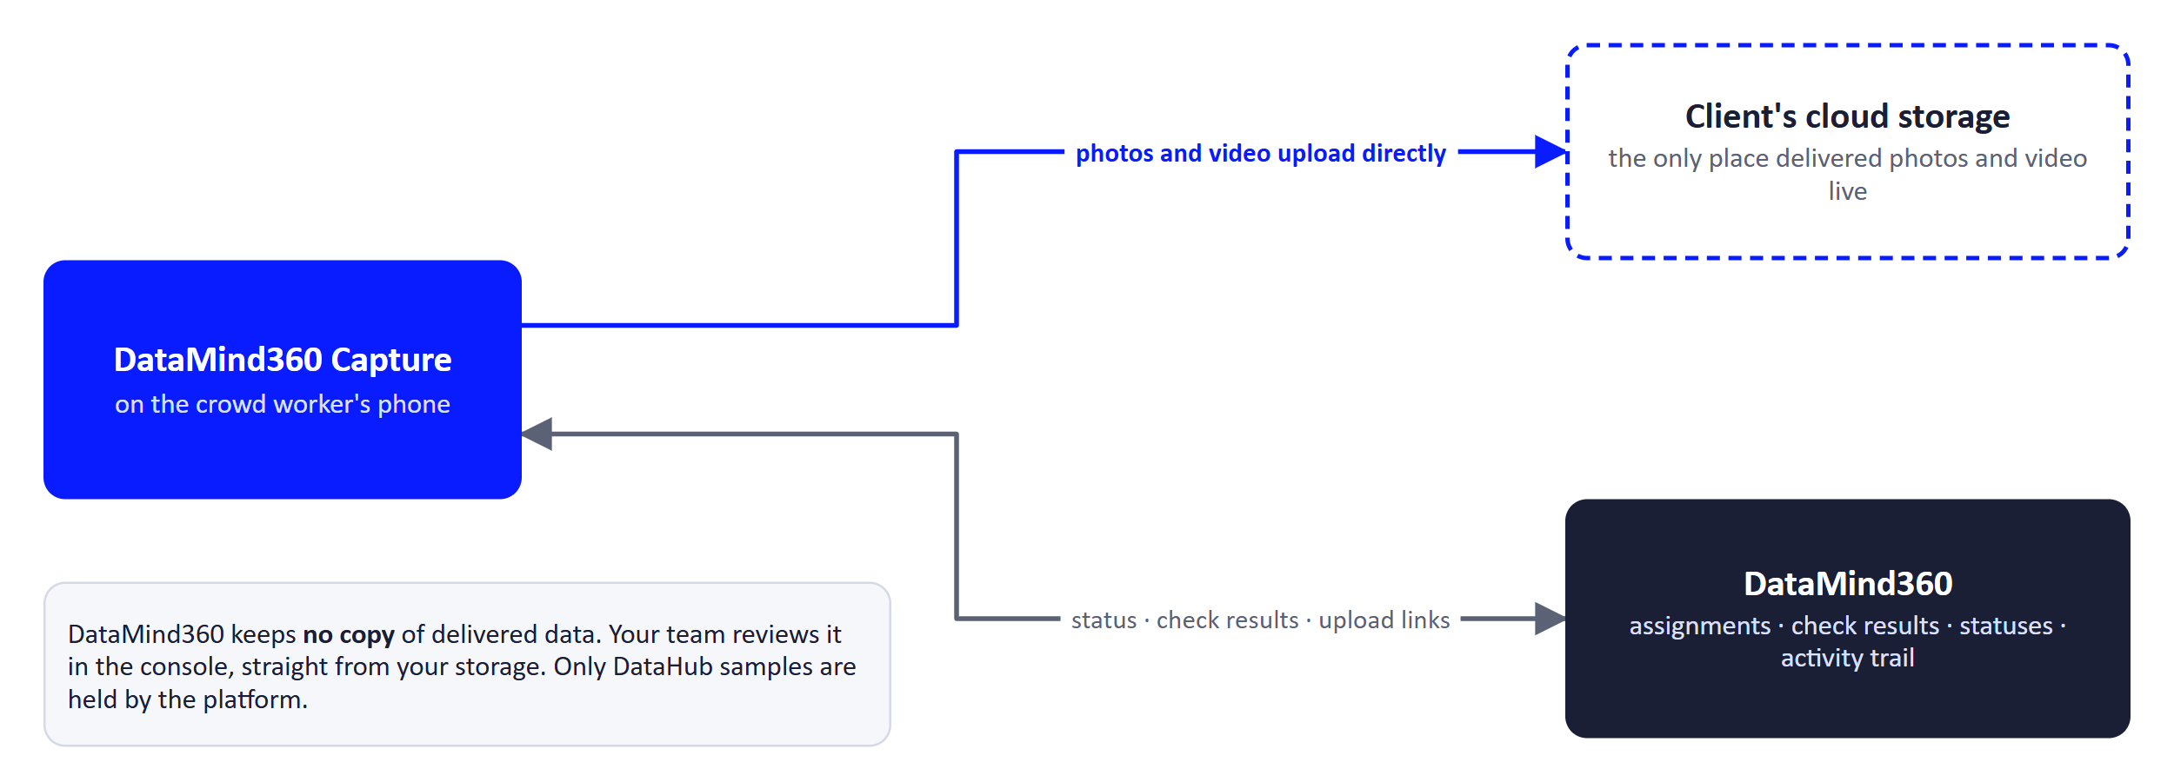
Figure 26. How data moves. Photos and video go from the phone straight into your storage.
- Captures upload directly to the client's own storage. DataMind360 keeps no copy of delivered data.
- Each organisation chooses a data residency region (US, EU or APAC) at onboarding.
- Clients confirm a Data Processing Agreement at onboarding.
- Each organisation's data is walled off from every other organisation's. Crowd workers can see only their own assignments.

Accountability
- Every important action is written to an activity trail that makes tampering detectable.
- Every rejection on the platform (proposals, quality gates, loans, onboarding, disputes) requires a written reason.
- Accounts can be suspended, reinstated or terminated by the DataMind360 team, always with a recorded reason.
- Sign-in is protected by a minimum password length and automatic lockout after repeated failures.
The full privacy policy is available from the Privacy link in the console and the app.

15. Reference

15.1 Status glossary
Item | Statuses (in typical order)
RFP | Draft · Published · Proposals received · Awarded · In Progress · Delivered · Done · Cancelled (plus a Bidding closed marker)
Proposal | Submitted · Accepted · Rejected · Withdrawn
Contract | In Progress · In QA · Delivered · Done · Disputed · Cancelled
Task | Assigned · In Progress · Submitted · QA passed · QA failed · Cancelled
Assignment (console) | Assigned · In Progress · Awaiting review · Accepted · Sent back · Cancelled · Reassigned
Assignment (phone) | Not started · In progress · Awaiting review · Accepted · Needs rework · Cancelled · Reassigned
Crowd offer | Open · Filled · Closed · Expired
Invoice | Awaiting payment · Paid · Settled · Withdrawn
DataHub listing | Draft · In review · On sale · Sent back · Withdrawn
DataHub quote | Quote requested · Quoted · Awaiting payment · Paid (to deliver) · Delivered · Declined · Withdrawn
Onboarding request | Draft · Submitted · Under review · Changes requested · Approved · Rejected · Withdrawn · Expired
User invitation | No login · Invited · Signed up · Invitation expired

15.2 Limits and file types
Item | Limit
Photo captures | JPG, JPEG, PNG, HEIC, WebP · up to 25 MB each
Video captures | MP4, MOV · up to 2 GB and 600 seconds each
Captures per assignment | Up to 500, and no more than the assigned quantity
Documents (RFPs, proposals) | Up to 25 MB each · 5 per RFP document slot · 10 per proposal  Types: csv, tsv, json, jsonl, xml, txt, md, pdf, png, jpg, jpeg, webp, gif, mp4, mov, mp3, wav, zip, xlsx, docx, pptx, ppt, parquet  Uploading a file with the same name creates a new version
Organisation logo | PNG, JPEG or WebP · up to 2 MB
Crowd roster import | CSV or XLSX · up to 1,000 rows per file
DataHub samples | Up to 50 per listing
Messages | Up to 4,000 characters each · 500 per conversation
Ratings | 1–5 stars with a comment of 3–2,000 characters
RFP title | At least 3 characters
Password | At least 10 characters · lockout for 15 minutes after 5 failed attempts
Links | Invitations: 14 days · password reset: 1 hour

15.3 Who can do what
Capability | Client | Delivery partner | Aggregator / Business | Device sponsor | Crowd worker
Publish RFPs and award | ✓
Bid on RFPs |  | ✓
Assign tasks to a network |  | ✓
Assign work to crowd workers |  |  | ✓
Capture and upload |  |  |  |  | ✓
Quality gate 1 |  |  | ✓
Quality gate 2 and deliver |  | ✓
Approve delivery | ✓
Raise invoices |  | ✓
Mark invoices paid | ✓ | ✓ (DataHub purchases)
Request equipment loans |  |  | ✓
Approve equipment loans |  |  |  | ✓
Buy and sell in DataHub | ✓ | ✓
Rate others | ✓ | ✓ | ✓
Manage users and profile | ✓ | ✓ | ✓ | ✓

15.4 Frequently asked questions
Can other partners see my proposal or my questions?
No. Proposals are visible only to the client, and each Q&A conversation is private between the client and one partner.
Does DataMind360 store my data?
Captured data goes directly into the client's own storage. DataMind360 keeps no copy of delivered data. Only DataHub samples are held by the platform.
Can I change my RFP after publishing?
Only the bidding deadline, until you award. Plan the scope carefully, or use the pilot option to test first.
Can I split one RFP between two partners?
Not at present. Each RFP leads to one contract with one partner.
What if the delivery isn't right?
Choose Send back with a reason. The contract returns to In Progress for the partner to fix.
How do we pay?
Directly to the partner by your usual means. Then mark the invoice Paid in DataMind360 with your payment reference.
Do field workers need constant signal?
No. The app queues captures offline and uploads them once the phone is connected and the app is open.
Can a partner resell my data?
Only if you chose Non-exclusive for the RFP, and only after you approve the delivery. Exclusive data can never be listed.
How do new organisations join?
Clients and delivery partners are onboarded by the DataMind360 team. Network members are proposed by their delivery partner and approved by the DataMind360 team.

15.5 Glossary
Term | Meaning
RFP | Request for proposal: the client's brief describing the data needed.
Proposal / Response | A delivery partner's bid on an RFP.
Contract | The agreement created when a client accepts a proposal.
Task / Engagement | A portion of a contract assigned to an aggregator or business partner.
Assignment | A portion of a task given to one crowd worker.
Capture | A single photo or video clip.
Gate 1 / Gate 2 | The aggregator's and the delivery partner's quality reviews.
Retake / Rework | A capture or task sent back to be done again.
Storage destination | The client's cloud storage, where delivered data is written.
Exclusive / Non-exclusive | Whether a partner may resell an RFP's data through DataHub.
DataHub | DataMind360's marketplace for finished datasets.
Waiting on | The party whose action is needed next.

