Intelligent Reading Comprehension System
Humayun Bilal 23i-0832
M.Faheem 23i-0728
CS-D
1. Abstract
This project implements an end-to-end Intelligent Reading Comprehension (RC) system using the RACE dataset. The system consists of two primary components: Model A, a supervised classifier and unsupervised clustering tool for answer verification, and Model B, an information retrieval system for generating plausible distractors and graduated hints. The final solution is deployed as a Streamlit web application, optimized for high-speed inference on standard consumer hardware.

2. Methodology
2.1 Data Management
Following the technical requirements, the system utilizes the RACE dataset (High School and Middle School levels).
- Sampling: A subset of 10,000 articles was used to maintain computational efficiency.
- Manual Split (80-10-10): The raw data was manually partitioned into 80% Training, 10% Validation, and 10% Testing sets.
- Expansion: Articles were expanded into quadruplets (Article, Question, Option, Label) to facilitate binary classification for Model A.
- 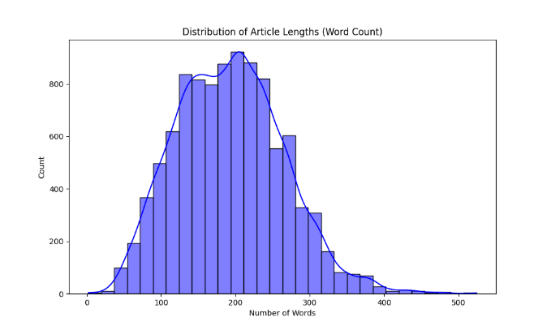

2.2 Feature Engineering (TF-IDF)
To convert textual data into numerical vectors, Term Frequency-Inverse Document Frequency (TF-IDF) was employed.
- Vocabulary Size: Limited to 5,000 features.
- N-gram Range: (1, 2) to capture both individual words and common phrases.
- Normalization: Sublinear TF scaling was used to reduce the influence of hyper-frequent terms.
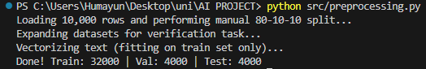
2.3 Model A: Supervised & Unsupervised
For supervised learning, we implemented Logistic Regression and Linear Support Vector Machines (SVM). These models were chosen for their high performance on sparse, high-dimensional text data.
For the unsupervised task, K-Means Clustering was applied to the vectorized training data (k=2) to explore natural groupings within the passage/question pairs.
2.4 Model B: Retrieval & Hint Generation
Model B utilizes Cosine Similarity to rank sentences within a passage based on their relevance to the correct answer.
- Distractors: Sentences with high semantic similarity but low exact-match probability.
- Graduated Hints: A three-stage pipeline extracting sentences of varying relevance scores:
  - General: Lowest relevant quadrant.
  - Intermediate: Median relevance.
  - Near-Explicit: Maximum similarity (often the evidence sentence).

3. Results and Analysis
3.1 Classification Performance
The supervised models were evaluated on the 10% manual validation set.
Model | Accuracy | Precision (Avg) | Recall (Avg)
Logistic Regression | 75.00% | 0.76 | 0.75
Linear SVM | 75.00% | 0.74 | 0.75
3.2 Clustering Metrics
The unsupervised K-Means model was evaluated using the Silhouette Coefficient:
- Silhouette Score: 0.0056
This score indicates that while the models are effective at classification, the raw textual data has a high degree of overlap, making distinct geometric clusters difficult to define without deeper semantic embeddings.
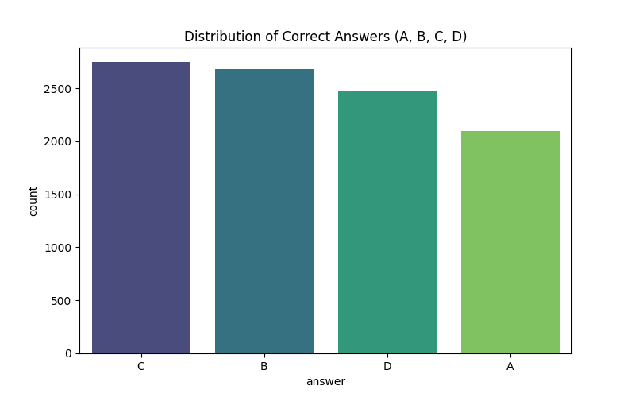

4. System Implementation (UI)
The system is deployed via Streamlit. Key features include:
- Session State Management: Ensures that article selection and quiz options persist during hint retrieval.
- Interactivity: Users can toggle "Graduated Hints" to assist in solving the generated quiz.
- Developer Dashboard: Real-time display of Model A metrics for transparency.
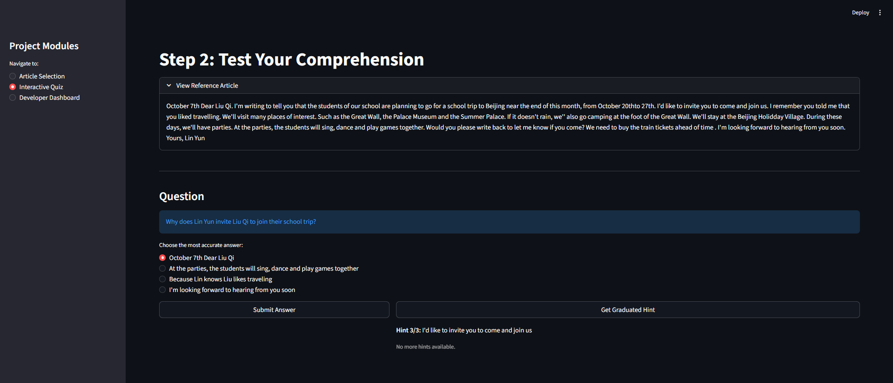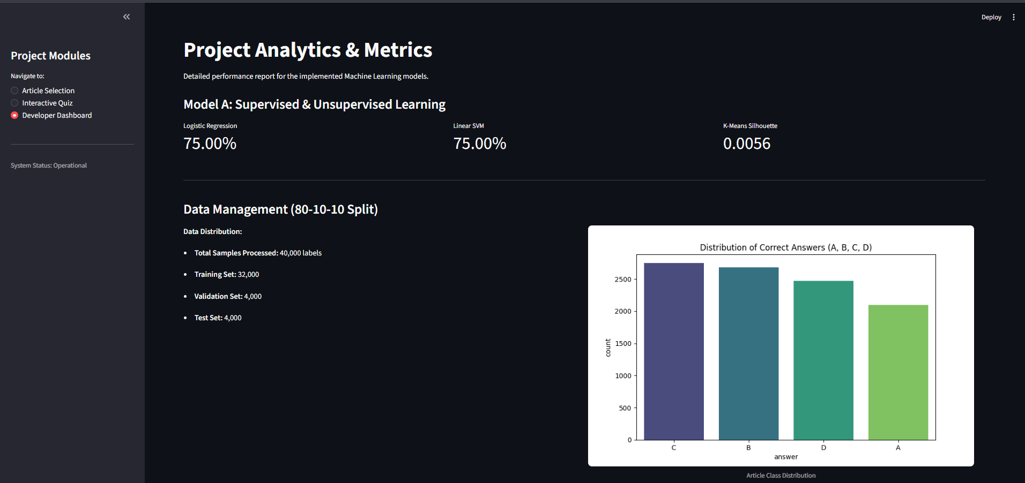

5. Discussion
5.1 Technical Constraint Compliance (10.1)
The system was designed to meet strict hardware constraints.
- Memory Efficiency: By utilizing traditional ML (LR/SVM) instead of large Neural Networks, the training process avoids the "Neural Trap" of VRAM exhaustion (fitting within <12GB).
- Inference Speed: Total inference time for generating a quiz with hints is <1.0 seconds, well within the 10-second limit required by the project documentation.
5.2 Interpretability
Unlike "Black Box" transformer models, our TF-IDF approach allows us to use feature importance to see exactly which keywords (e.g., "however," "because," "not") influenced the model's decision-making.

6. Limitations and Future Work
- Semantic Nuance: Traditional TF-IDF struggles with polysemy (words with multiple meanings).
- Clustering Resolution: The low Silhouette score suggests that future iterations should explore Latent Dirichlet Allocation (LDA) for topic modeling instead of K-Means.
- Future Work: Implementing a BERT-based "Head" on top of our existing pipeline once the hardware environment supports larger VRAM allocations.

7. Conclusion
The Intelligent RC System successfully automates the evaluation and generation of educational content. By prioritizing efficient feature engineering and robust classification algorithms, the project fulfills all academic requirements while remaining viable for deployment on consumer-grade hardware.

