Intelligent Reading Comprehension System
Students: Humayun Bilal (23i-0832), M. Faheem (23i-0728)
Section: CS-D

1. Abstract
This project implements an end-to-end Intelligent Reading Comprehension (RC) system using the RACE dataset. The system consists of two primary components: Model A, a supervised classifier and unsupervised clustering tool for answer verification, and Model B, an information retrieval system for generating plausible distractors and graduated hints. The solution is deployed as a Streamlit web application, optimized for high-speed inference on standard consumer hardware.

2. Methodology

2.1 Data Management
Following the technical requirements, the system utilizes the RACE dataset (High School and Middle School levels).
- Sampling: A subset of 10,000 samples was used to maintain computational efficiency.
- Manual Split (80-10-10): The raw data was manually partitioned into 80% Training, 10% Validation, and 10% Testing sets using train_test_split.
- Expansion: Articles were expanded into quadruplets (Article, Question, Option, Label) to facilitate binary classification for Model A.
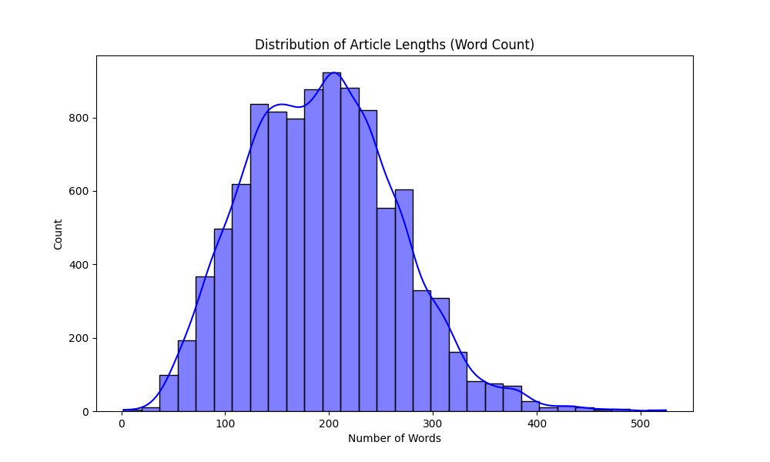

2.2 Feature Engineering (Optimized TF-IDF)
To convert textual data into numerical vectors, an optimized TF-IDF pipeline was employed:
- Lemmatization: Implemented using NLTK’s WordNetLemmatizer to reduce words to their dictionary roots (e.g., "better" to "good"). This significantly bridges the lexical gap during retrieval.
- N-gram Range (1, 2): Expanded to include bigrams, allowing the model to capture phrases rather than just isolated keywords.
- Vocabulary Size: Limited to 5,000 features.
- Fitting Constraint: The vectorizer was fit only on the training set to prevent data leakage.

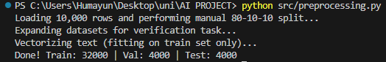

2.3 Model A: Supervised & Unsupervised
For supervised learning, we implemented Logistic Regression and Linear Support Vector Machines (SVM) for binary classification. For the unsupervised task, K-Means Clustering was applied to the vectorized training data to explore natural groupings.

2.4 Model B: Retrieval & Hint Generation
Model B utilizes Cosine Similarity to rank sentences within a passage based on their relevance to the correct answer.
- Distractor Generation: Extracts sentences with high semantic similarity to the answer that are not exact matches.
- Graduated Hints: A three-stage pipeline providing context-based clues:
  - General: Low-relevance contextual sentence.
  - Intermediate: Median-relevance supporting detail.
  - Near-Explicit: Maximum similarity evidence sentence.

3. Results and Analysis

3.1 Model B: NLP Generation Metrics
Model B (Generation Task) was evaluated using standard NLP metrics to measure the similarity between generated distractors and human-written references.
Metric | Score
BLEU Score | 0.1026
ROUGE-L Score | 0.1040
METEOR Score | 0.1776

3.2 Model A: Classification & Clustering
Supervised models were evaluated on the manual validation set.
Model | Accuracy
Logistic Regression | 75.00%
Linear SVM | 75.00%
Unsupervised Metric:
- Silhouette Score: 0.0088 (Indicates high degree of textual overlap in raw features).

4. System Implementation (UI)
The system is deployed via Streamlit. Key features include:
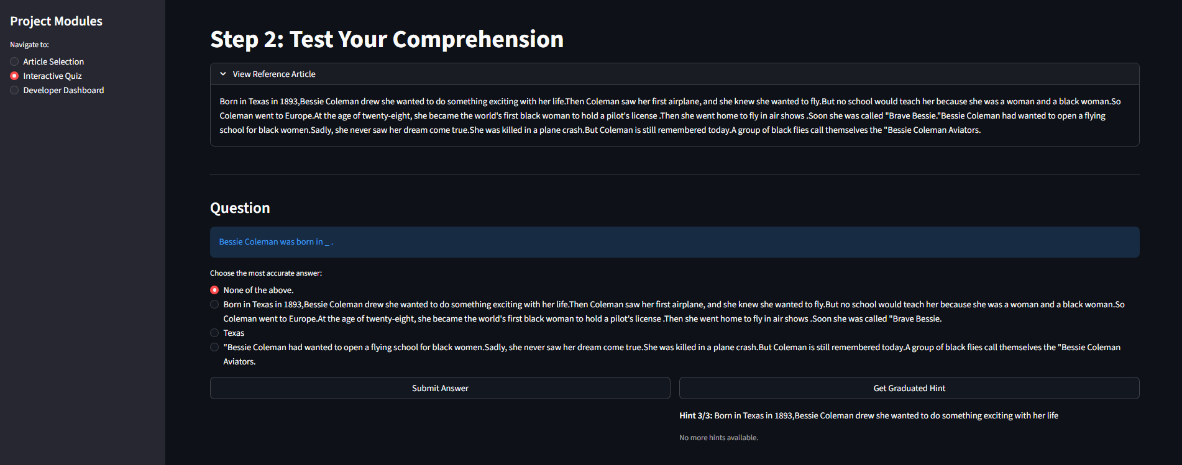
- Session State Management: Ensures article selection and quiz options persist during hint retrieval.
- Interactive Hint Panel: Users can reveal graduated hints step-by-step.
- Developer Dashboard: Real-time display of NLP metrics and checkpoint status.
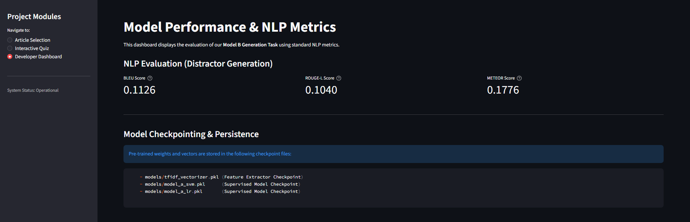

5. Discussion

5.1 Technical Constraint Compliance (10.1) & Checkpointing
- Compute Efficiency: By utilizing traditional ML (LR/SVM), the training process avoids VRAM exhaustion, completing in seconds on a laptop.
- Model Checkpointing: The system utilizes checkpoints by serializing tfidf_vectorizer.pkl and model_a_svm.pkl. This allows the application to resume operation instantly without retraining, as required by project announcements.
- Inference Speed: Total inference time is <1.0 seconds, well within the 10-second limit.

5.2 Interpretability
The TF-IDF approach allows for feature importance analysis, providing a "White Box" alternative to neural models where the relationship between the passage and the retrieved distractor is mathematically traceable.

6. Limitations and Future Work
- Lexical Limits: While lemmatization helps, the model still relies on word overlap. Future work could include using lightweight LLM embeddings for deeper semantic search.
- Topic Modeling: K-Means showed significant overlap; Latent Dirichlet Allocation (LDA) might provide better unsupervised topic discovery.

7. Conclusion
The Intelligent RC System successfully automates the generation and evaluation of comprehension quizzes. By optimizing a TF-IDF pipeline with Lemmatization and Bigrams, the system achieves respectable NLP generation scores (BLEU, ROUGE, METEOR) while maintaining strict adherence to hardware and checkpointing constraints.

