**Homepage:**

Welcome to pocket designs, get your website designed exactly the way you want, buy now and get a special new year discount

**About us:**

**Mission statements:** At pocket designs we create personalized websites for your business

**Designer Resume**: we create websites using Dreamweaver

**Our services page**

Basic: Basic help creating a website, limited features included, up to 10 pages

Advanced: Basic help creating a website, All features included, up to 20 pages

Premium: Creating a whole website from scratch, all features included, up to 30 pages

**Portfolio page**

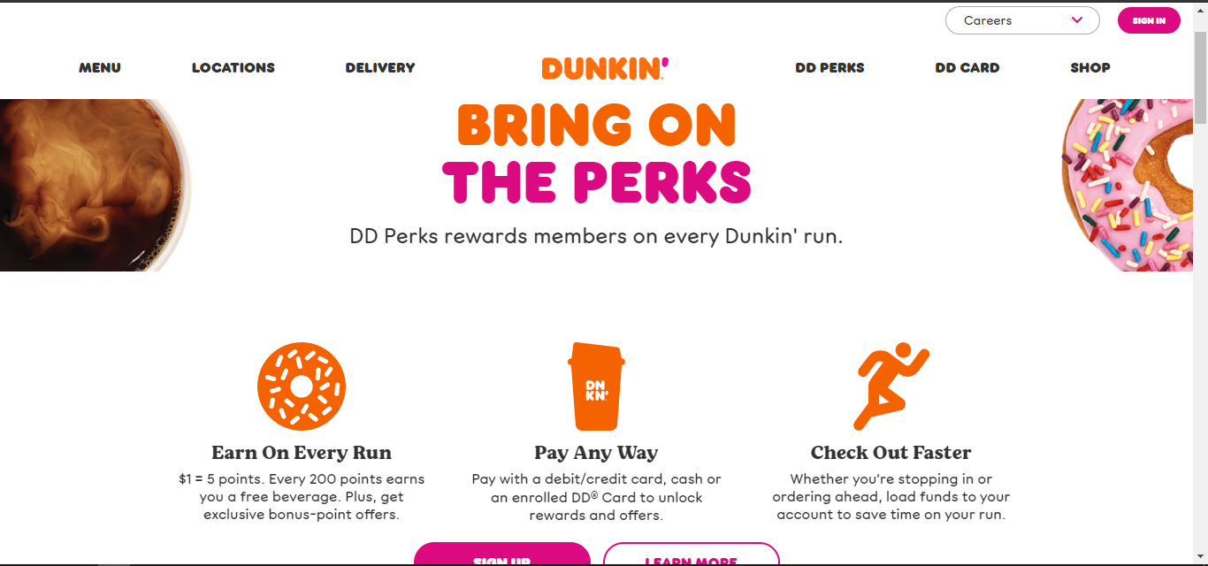

<https://www.dunkindonuts.com/en>

This page is very attractive to their audience because it is bright and colorful.

They have added calls to action to get the audience to buy their product.

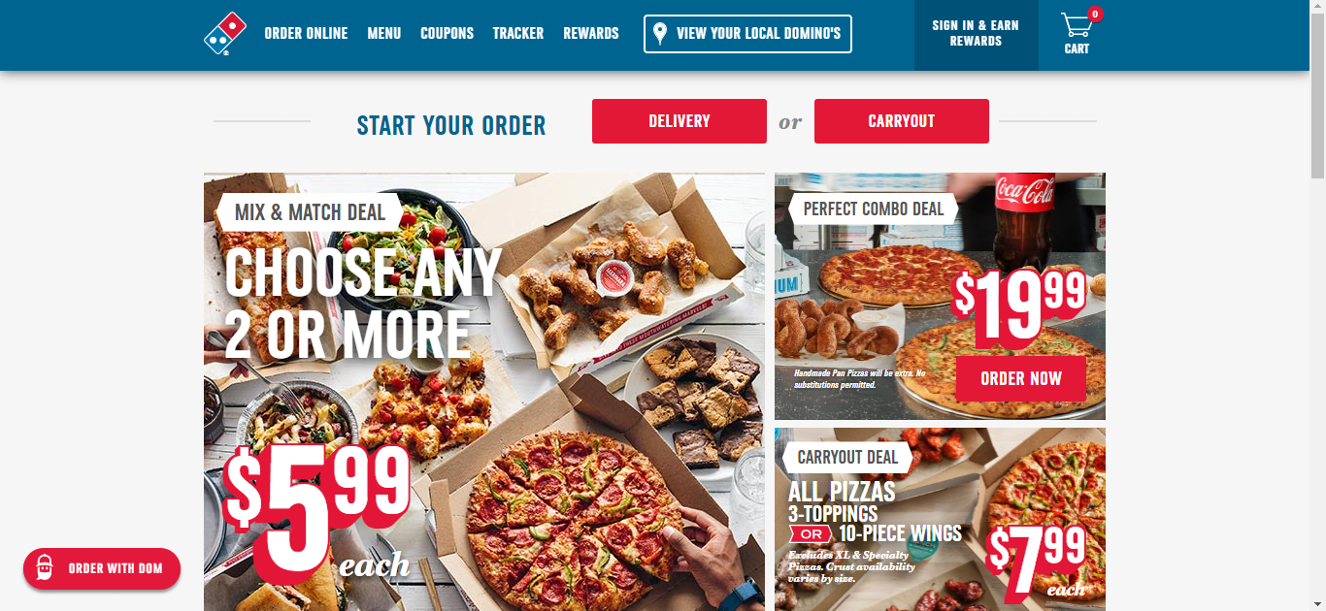

<https://www.dominos.com/en/>

They have lots of pictures, so the audience know what they sell at dominos

They added the prices of their pizzas and any deals on the home page

**Contact us**

Name: Zubaria Humayun

Address: 1234, N Street, City

Email: [Humayun.Z034@student.cbsd.org](mailto:Humayun.Z034@student.cbsd.org)

Phone: (123) 456 7890

Add icons to make this page more interesting