

Movie Watchlist
  - Python mini project ‘Phase-2’
Professor- Muhammad Khan
Shreya Bhoir- N01606928| Vimmi Cherruserykkaran- N01617667

Database Demonstration
- Created Database and Tables
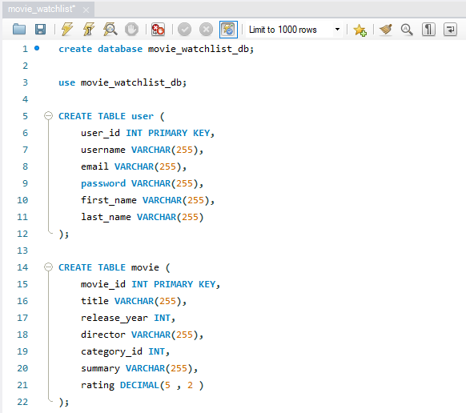
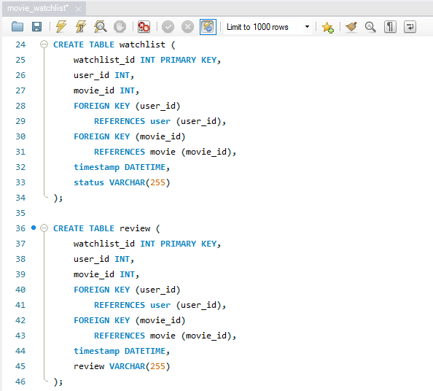
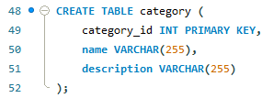
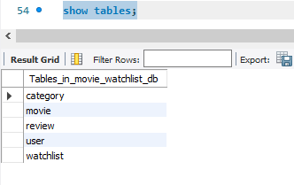
- Inserted Data in All Tables
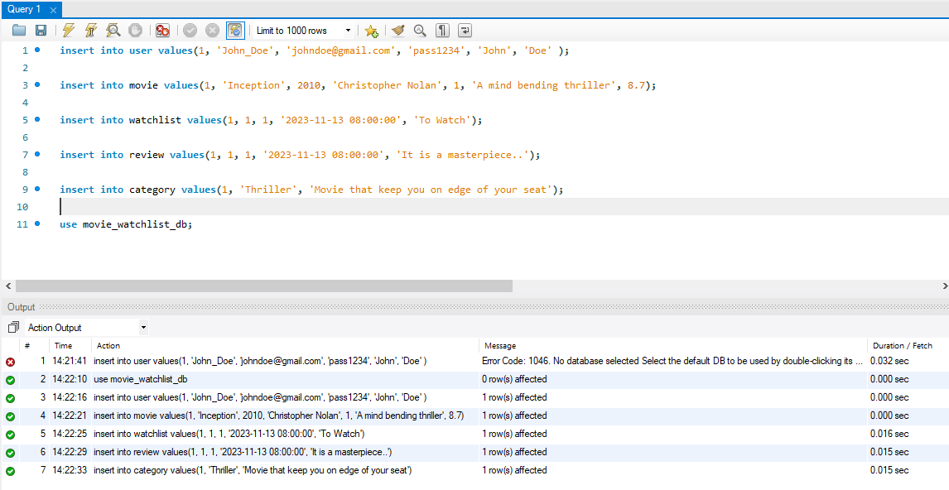
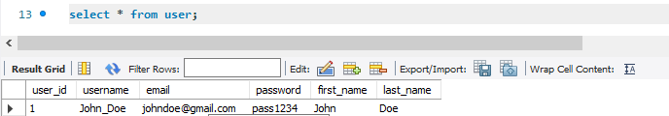
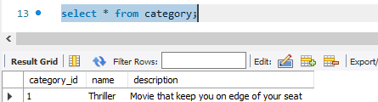
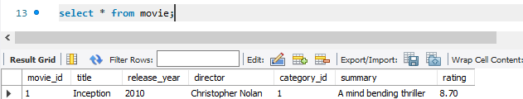
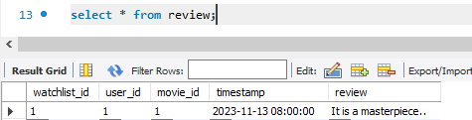
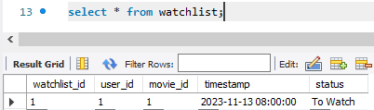

ER-Diagram
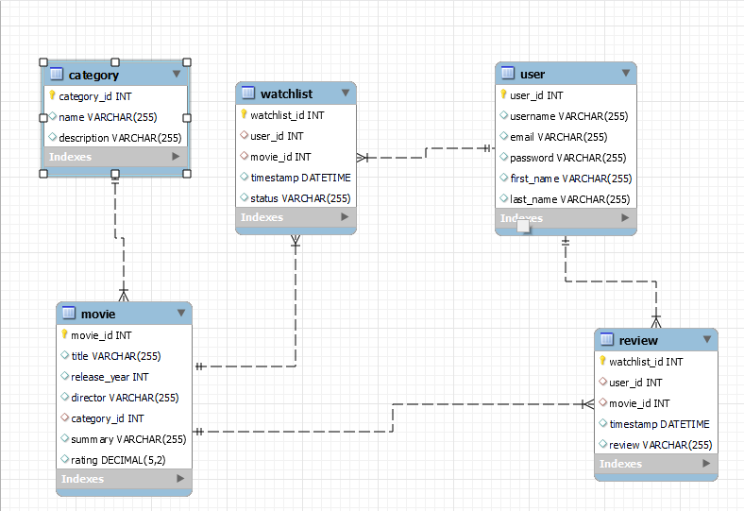

Summary
We did not make any changes in Phase-2.

Roles
Shreya Bhoir
- Created Database and Tables also Tested the Use-cases.
Vimmi Cherruserykkaran
- Created ER-Diagram in SQL workbench

THANK YOU

