

Movie Watchlist
Python mini project ‘Phase-2’
Professor- Muhammad Khan
Shreya Bhoir- N01606928| Vimmi Cherruserykkaran- N01617667

Home screen:
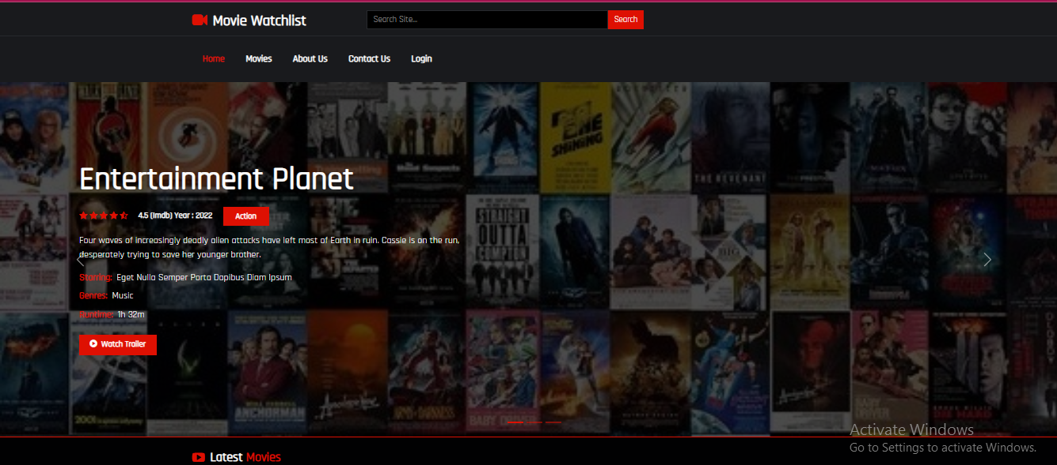
Category :
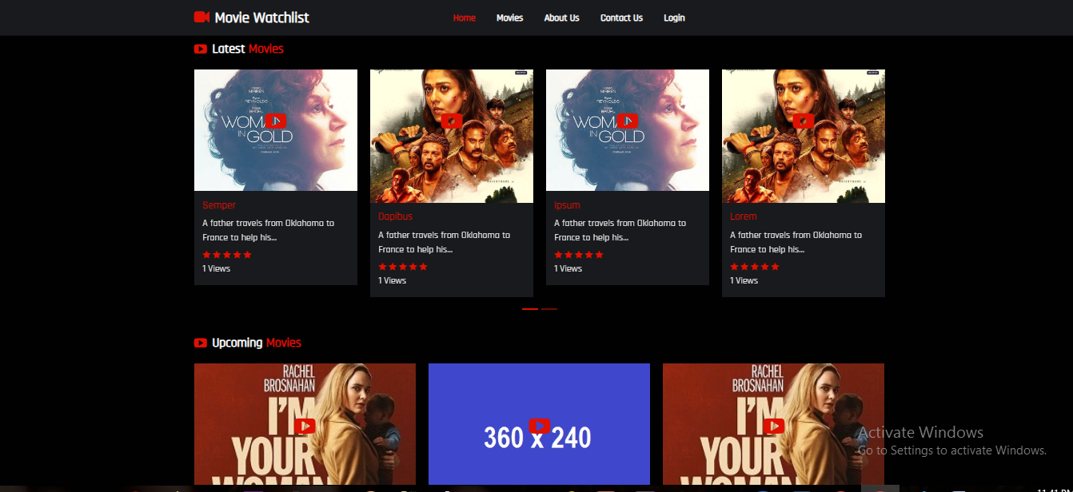

Movie List:
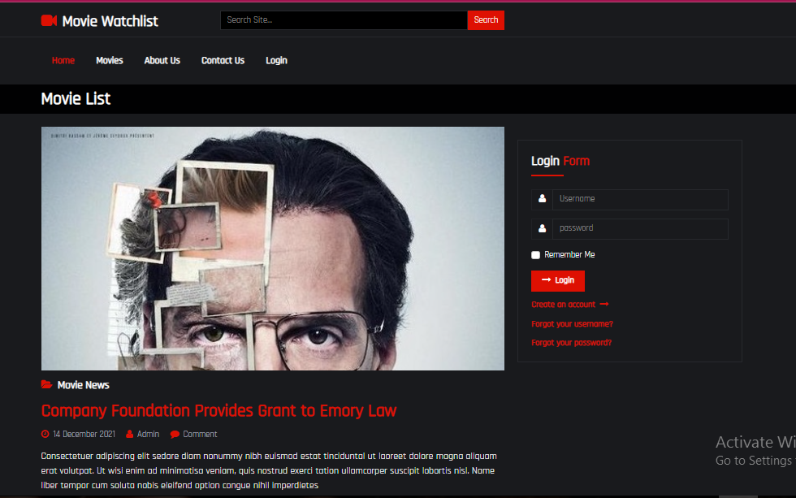

Login Screen:
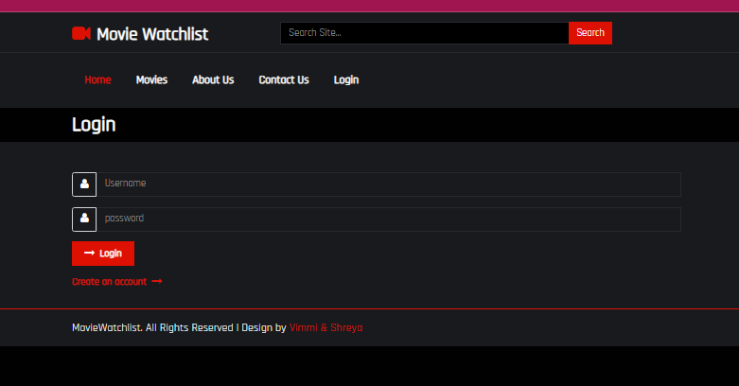

Register Screen:
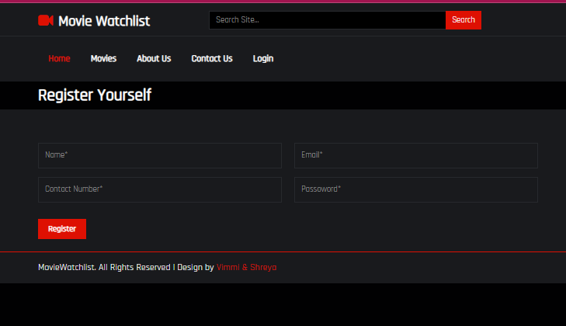

About us;
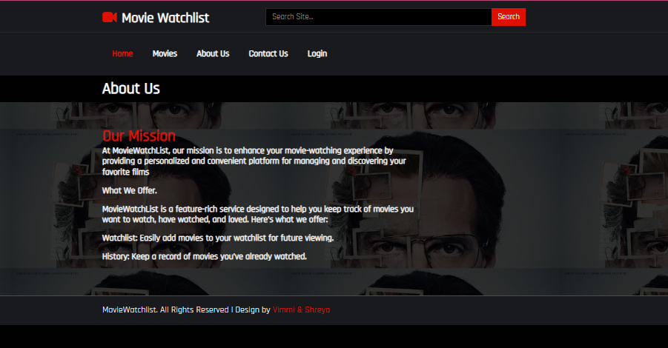

Contact us:
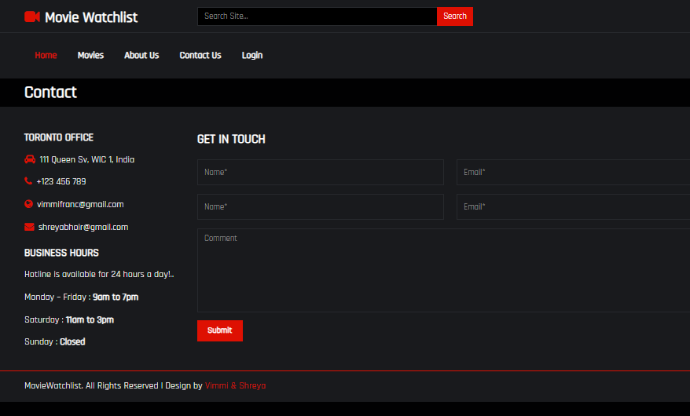

Summary
We did not make any changes in Phase-3.

Roles
Shreya Bhoir
- Created this following screens using HTML, CSS, JavaScript and Bootstrap
- Login Screen
- Register Screen
- About Us
Vimmi Cherruserykkaran
- Created this following screens using HTML, CSS, JavaScript and Bootstrap
- Home Screen
- Category
- Movie List
- Contact Us

THANK YOU

