Week 6-HW3-Alanis
https://github.com/HumbertoAlanis15/Week-6-HW3-Alanis
#1.
SELECT
d.name,
COUNT(m.id) AS num_movies
FROM directors d
JOIN movies m
ON d.id = m.director_id
GROUP BY d.id, d.name
HAVING COUNT(m.id) > (
SELECT AVG(movie_count)
FROM (SELECT COUNT(id) AS movie_count FROM movies GROUP BY director_id)
)
ORDER BY d.name;
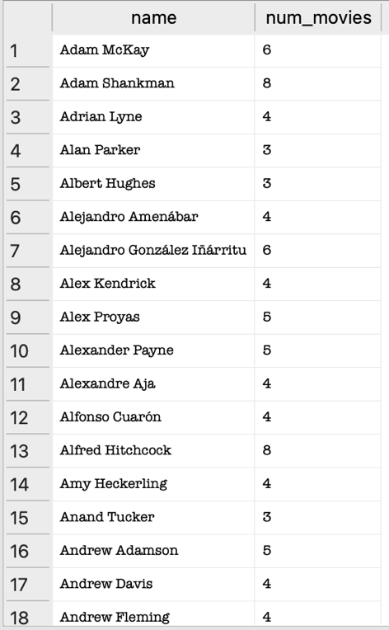
#2.
SELECT
d.name,
SUM(m.revenue) AS total_revenue
FROM directors d
JOIN movies m
ON d.id = m.director_id
GROUP BY d.id, d.name
HAVING SUM(m.revenue) > (
SELECT AVG(dir_rev)
FROM (SELECT SUM(revenue) AS dir_rev FROM movies GROUP BY director_id)
)
ORDER BY d.name;
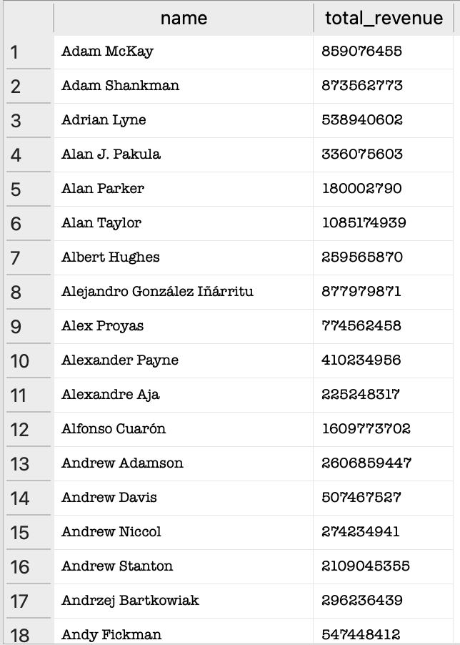

#3.
SELECT
m.title,
SUBSTR(m.release_date, 1, 4) AS release_year,
m.revenue
FROM movies m
WHERE m.revenue > (
SELECT AVG(m2.revenue)
FROM movies m2
WHERE SUBSTR(m2.release_date, 1, 4) = SUBSTR(m.release_date, 1, 4)
);
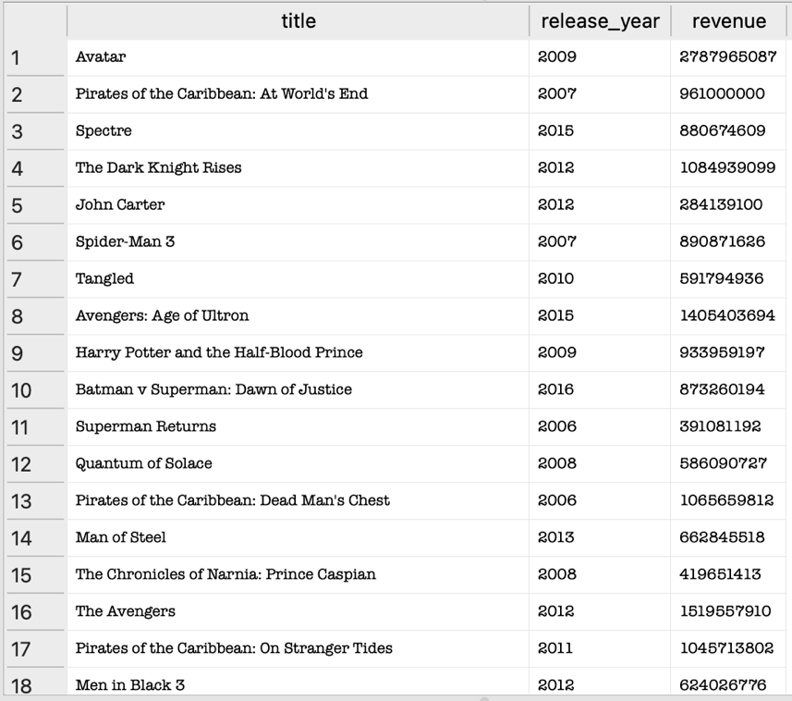

#4.
SELECT
SUBSTR(release_date, 1, 4) AS year,
MIN(revenue) AS min_revenue
FROM movies
WHERE SUBSTR(release_date, 1, 4) >= '2000'
AND vote_count > 10
AND revenue > 0
GROUP BY year
ORDER BY year;
