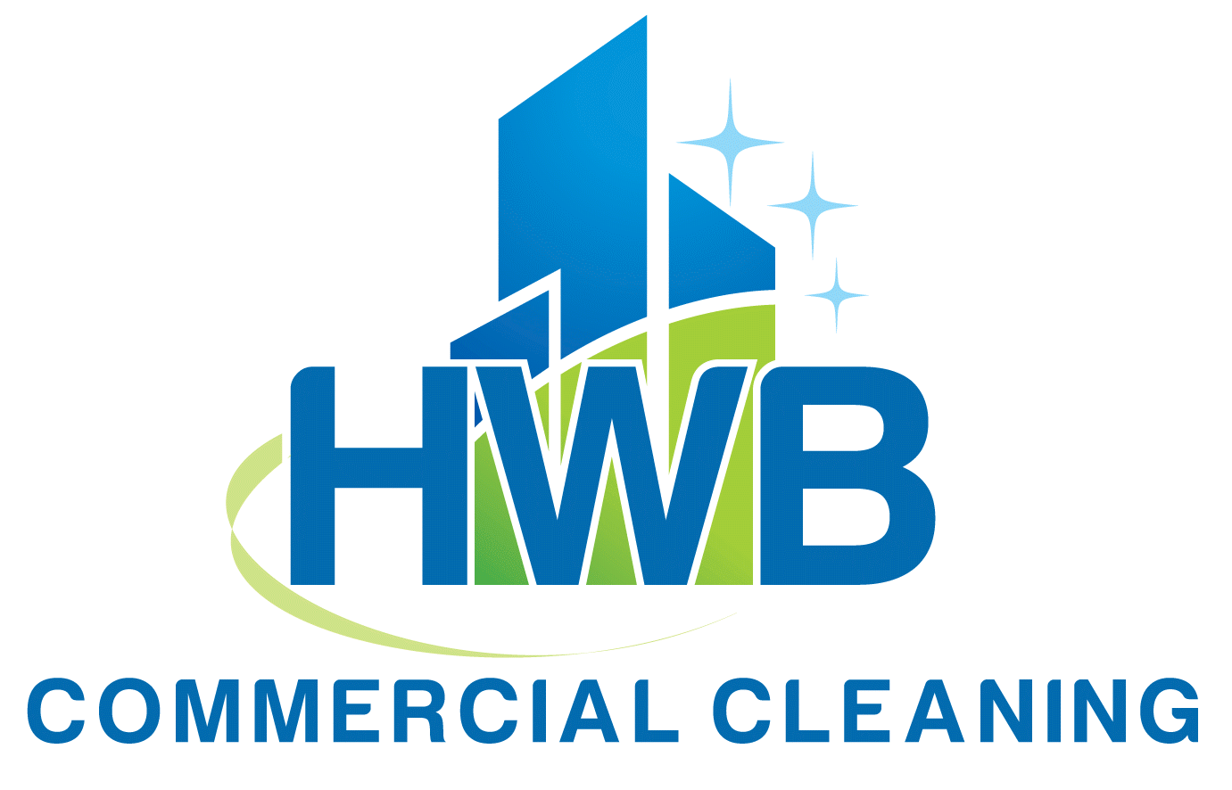

MONTHLY CLEANING PROPOSAL

FOR

XPLOR

Prepared for Lacey Marney
Date: 03/04/2025
By: Humberto Dominguez, Manager
hdominguez@hwbcleaning.com
972-800-7808
www.hwbcleaning.com

March 04, 2025
Lacey Marney
1615 West Chester Pike, Suite 200
West Chester, PA 19382

Good morning Ms. Marney,

Here’s the contract for Xplor branch #1714 2525 E. Trinity Mills Rd. Carrollton TX as requested. If you have any other branches to add this year to our roster, please let me know. We service the entire State of Texas.

Thank you!

Sincerely,

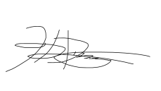

Humberto Dominguez
CEO
Hdominguez@hwbcleaning.com
www.hwbcleaning.com
972-800-7808

Addressing your needs

Fast response infection outbreak team

COVID-19 and now the new outbreak of MEASEALS has changed the way we do business; HWB has emergency plans in place to protect its clients. At no cost, we can switch our cleaning scope of work from normal to outbreak prevention mode as soon as announcements from State and local agencies begin to come out. In any case should there be an infection report within a facility we clean, HWB can dispatch an emergency crew to contain and disinfect the facility within 24 hours. We follow the State, local, CDC and OSHA guidelines.

School image

A large part of a school’s prestige comes from a positive, professional image. The effects of poor cleaning can easily contribute to increased complaints, the diminished appearance of the campus and the increased potential for accidents. Alternatively, a clean and well-maintained school helps attract families and retain teachers, while enhancing the working environment for faculty and staff.

Building security and turnover

High turnover of cleaning staff negatively affects students, faculty and staff. It can create fluctuations in cleaning quality and a reduced sense of building security. HWB understands the importance of maintaining a stable cleaning staff and we have several processes and programs in place to screen, select, train and retain employees. The HWB selection process ensures quality employees who meet your security procedures and requirements are placed at your schools. Employees will undergo background checks and fingerprinting in accordance with your requirements and wear uniforms and badges to be easily recognizable at your schools.

Your time spent on service issues

We understand your time is best spent on matters that enhance academic excellence and campus initiatives, not worrying about facility management problems. When you’re confident that your needs are addressed, you are able to focus on other priorities. HWB will be at your service to design a customized program that combines all of your needs, costs and expectations into one integrated plan.

Keeping costs down

The cost of facility services can be one of the largest monthly operating expenses. To enhance the value of your school, you must receive the best value for the dollars spent. The challenge is to balance this budget with your level of expectation. HWB will create a customized facility services program per your requirements. We have substantial expertise staffing campuses similar to yours. Our staffing levels and supervision are designed specifically for your schools. In addition, our technology solutions ensure that labor costs are within your budget and service quality meets your expectations.

Our Pricing

Your facility has + - an average of 10,000sqf + - of hard flooring and carpet to be vacuumed and mopped daily in addition to dusting, sanitizing, cleaning of fixtures, furniture and bathrooms. Our price matrix is as follows:

Item | Service Location | Unit Price  Per Sq. Ft. | Unit Price  Per Visit | Extended Monthly Price | Extended yearly
Facility Cleaning  10,000sqf + -average | Xplor branch #1714 2525 E. Trinity  Mills Rd. Carrollton TX | $ .23 | $115 | $2,300.00 | $27,600.00
 | Xplor branch #1711 3601 Meadowview Dr. Corinth TX
Xplor branch #1710 3153 S.
Stonebridge Dr. McKinney TX

We will assign a crew trained on academic facilities care to your account. Estimated calculated time to clean and maintain your facility daily is 2hr + - daily broken down to the scope of work specified on schedule A.

Preventive maintenance of your floor will keep your facility looking excellent reducing the cost for stripping and waxing as well. Our quote is based on time values outlined by the Building Service Contractors Association International. These time values are standards within our industry utilized in estimating Housekeeping Tasks. All supervision, labor, equipment, and insurance have been included in the pricing schedule. Our services are covered under an insurance policy for bodily injury, property damage, public liability, and workers compensation.

Schedule A --Cleaning Specifications

Job Site: XPLOR All locations
Daily cleaning schedule
Time Window: Start time after 6:30pm Mon to Fri

Serviced Areas: Reception, halls, offices, classrooms, bathrooms, common and kitchen areas.
- DISINFECTION AND CLEANING AS DEFINED BY CDC AND OSHA GUIADANCE
  - Spray door handles, faucets, sinks with disinfecting solution. Allow to air dry.
  - Spray bathroom areas with disinfecting solution. Allow to air dry.
  - Wipe down light switches.
  - Wipe down all high touch wall fixtures
  - Wipe down all door steel plates and protectors.

- GLASS
  - Disinfect and clean front entrance windows, door frame and glass panel sills.
  - Disinfect and clean glass panels (visible matter, handprints and insects).

- CEILING, WALLS, INSIDE WINDOWS AND DOORS
  - Remove cobwebs from ceiling corners.
  - Remove dust from air duct registers, fans, wall fixtures, emergency equipment.
  - Disinfect and clean door handles.
  - Dust baseboards.

- FLOORS (TILE/VCT/CARPET)
  - Remove all visual debris, bubble gum, foreign substances and insects.
  - Vacuum all floor mats and classroom educational carpets.
  - Vacuum floors with approved HEPA backpack equipment.
  - Remove, vacuum and replace furniture when possible.
  - Disinfect and mop all hard floor surfaces.

- WASTE DISPOSAL
  - Remove liner, disinfect receptacle and replace liner in all trash cans. (inside/outside).
  - Place all the waste inside the dumpster.

- CONSUMABLES
  - Bathrooms, kitchen, class rooms
    - Replace half empty toilet paper, hand soap dispensers and paper towels.
6
- FIXTURES
  - Clean and polish all sink metals and handles (when not in use for disinfection).

Additional Services

INCLUDED IN SERVICE CONTRACT
Service for floors, carpets and rugs
- Strip and wax twice a year
- Classroom carpet and rugs disinfected twice a year.
- Emergency spot carpet cleaning.
- Emergency disinfection services. (Viral, bacterial reported infections)

Service Pricing Agreement

CLIENT: | XPLOR BRANCH #
CLEANING LOCATION: | #1714
CONTRACT PERIOD | 2 YEAR
FREQUENCY: | Mon, Tue, Wed, Th, Fri
START DATE: | TBA
START TIME: | AFTER 6:30PM
PRICE – Regular Service per location | $2,300.00
Bundled services monthly breakdown
Strip and wax twice a year | $0.00
Carpet and rug cleaning twice a year | $0.00
Spot carpet cleaning | $0.00
Emergency disinfection services (electrostatic sprayings/deep cleans) | $0.00
TOTAL SALES TAX 8.025% | $189.75
TOTAL PER BRANCH | $2,489.75
PAYMENT TERMS: | NET 30 DAYS. Billing occurs at the beginning of every month.
HOLIDAYS (Days Not Serviced): | New Year’s, Labor Day, Memorial Day, Thanksgiving, Independence Day, Christmas Day

This Agreement, dated___________ , 2020, is made between HWB CLEANING LLC.. (“HWB”), 10925 Estate ln. Dallas TX 75238 and XPLOR (“CLIENT”). Both HWB and CLIENT agree that HWB will begin service on_________ , 2020, with the following terms and conditions:

1. CLIENT agrees to contract HWB to perform cleaning services FIVE ( 5 ) days per week.

2. HWB will provide all chemicals, equipment, labor and supervision. CLIENT will provide all restroom paper products, hand soap, and trash can liners.

3. CLIENT agrees to verbally notify HWB of any non-performance prior to written notification.

4. CLIENT agrees that during the term of this agreement and within ninety (90) days after termination of this agreement, will not employ directly or indirectly any employees or agent representatives of HWB.

5. This agreement is for a term of one (1) year which shall commence on the date of this agreement. Either party may terminate this agreement at any time by giving written notice of termination with at least thirty (30) days.

6. Terms: Invoices are sent out on the 1st of each month, with current payment due by the 30th of that month, delinquent by the 10th of the following month. A finance charge of 1.5% per month will be assessed on all delinquent accounts.

7. Holidays: HWB annually observes the following federally recognized holidays: New Year’s Day, President’s Day, Memorial Day, Fourth of July, Labor Day, Thanksgiving, and Christmas.

8. Notices: All notices shall be sent by registered mail to the following address:

HWB Cleaning Services LLC.
Attn: Humberto Dominguez
10925 Estate Ln. suite 225 Dallas TX 75238
Dallas TX 75238

XPLORE HWB CLEANING SERVICES LLC.

BY: _______________________________ BY: _______________________________

NAME: _____________________________ NAME: _____________________________

