 | HWB CLEANING SERVICES LLC (HWB)  STANDARD OPERATING PROCEDURE  FOR HWB CLEANING OPERATIONS
SUBJECT: Contractor Onboarding |  | S.O.P. |  | REV
Task inclusion executive team |  | 7 | 2020 | 1

INTRODUCTION

New Standard Operating Procedure (SOP 7-2020-1-CONTRACTOR ONBOARDING)
- Purpose. To onboard a new contractor in the morning shift to perform a walkthrough around the facility perimeter with the purpose of clean up all parking dock areas.
- Personnel Concerned. PIT crew members, office porter, crew backups and supervisors.
- SOP Canceled: none
- Originator. Felipe Castillo
DESCRIPTION
Activity | Assigned to | Photo
1. Access parking docks via approved personnel exits. Do not exit via dock doors or ramps. Proceed to walk and clean conspicuous debris covering all empty parking dock areas highlighted in green. | First shift. | 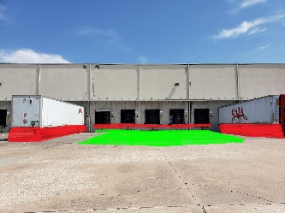
2. If parking dock space is occupied move to the next available empty space and clean. DO NOT ATTEMPT TO CLEAN IN BETWEEN OR BENEATH CONTAINERS. |  | 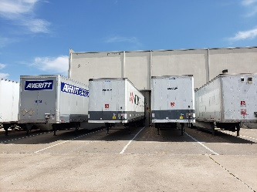
3. Use a forklift with the proper dumpster bin to pick up and store large debris. |  | 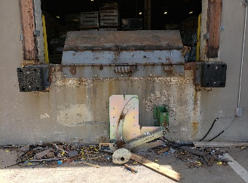
4. Use a shovel to pick up broken tile, dust and other large debris and place inside the dumpster carried by the forklift. |  | 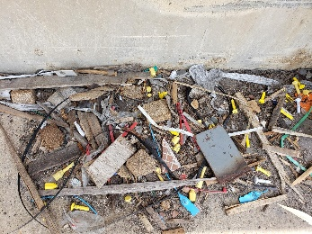
End of activity

SHIFT PERSONNEL RESPONSIBLE FOR TASK:

Name |  |  | Certified to operate
 | Shift | Status | Forklift and hopper | S20 | M20 | Office porter
Jorge Benitez | 1st | Regular and PIT | 7/1/2017 | 7/1/2017 | 7/01/2017 | 7/01/2017
Rocio Alvares | 1st | Regular/FLEX and PIT | N/A | 11/2018 | 11/2018 | 07/1/2017
Olga Martinez | 1st | Regular and PIT | N/A | 02/2019 | 02/2019 | 01/2019
Wendy Medrano | 2nd | Regular | N/A | N/A | N/A | 05/2019
Juan Sanchez | 2nd | Regular and PIT | 11/2017 | 11/2017 | 11/2017 | N/A
Sanjuana DelaRosa | 3rd | Regular/FLEX | N/A | N/A | N/A | 10/2018
Marlon Sneed | 3rd | Regular/PIT/backup | 8/2017 | 8/2017 | 8/2017 | 8/2017
Rosaura Damas | 1st, 2nd,3rd | Backup/FLEX and PIT | N/A | 01/2019 | 01/2019 | 12/2018
Juan Sanchez Zepeda | 1st,2nd,3rd | Backup and PIT | 7/2017 | 07/2017 | 07/2017 | 07/2017
Mirna Rondinella | 1st, 2nd,3rd | Backup/PIT /supervisor | 07/2017 | 7/2017 | 7/2017 | 7/2017
Humberto Dominguez | 1st,2nd.3rd | Backup/PIT /supervisor | 07/2017 | 7/2017 | 7/2017 | 7/2017

AUTHORIZED BY Dal-Tile management: |  | Approving IFS Manager  Scott Humphrey | EFFECTIVE DATE  July 18, 2019
Irene Goldstein  Felipe Castillo |  | IFS Site Manager  Humberto Dominguez  972-800-7808 | PAGES  2
Integrity Facility Solutions.

JOB HAZARD ANALISYS FORM

Department Supervisor  Felipe Castillo |  |  | Task  Parking docks cleaning
Prepared by  Humberto Dominguez IFS site supervisor |  |  | Date Approved  7/18/2019 | Next Review Date  11/18/2019 |  | SOP  6-2019-7-Outside warehouse loading docks cleaning
Personal protective equipment requirements: Eye goggles, steel toe shoes, cut resistant gloves, reflective vest.

Step # | Task | Potential Safety and Health Hazards |  |  | Controls
1. | Walking around/across active parking docks. | Crushing by vehicles |  |  | Wear reflective vests and inform area personnel of cleaning activities in the parking dock area.
2. | Cleaning activity while in high heat index. | Dehydration, heat stroke, fainting |  |  | Adjust first shift start time to 5am to 2pm.  Keep personnel hydrated
3 | Cleaning large debris | Cuts, muscle sprains |  |  | Use proper tools (shovel) to pick up loose large tile debris. Use correct body method to pick up bulky trash.
Filed with the following departments: IFS, Dal-tiles safety and operation departments.

