PIT

HWB Cleaning Services LLC

Powered Industrial Trucks
and
Safety Program
For

N3 Real Estate
1240 N. Kimball Ave.
Southlake, TX 76092

This PIT Safety Program is hereby approved by:
Instructor: Humberto Dominguez
Date:1/22/2024

The course will be completed by:
Operator:___________________
Training date:_______________
Table of Contents
Exterior cleaning crew schedule 5
Before you step foot on-site: PPE Required 6
Unauthorized use of PIT/procedures or frequent OSHA violations 6
Job hazard analysis form 8
PIT and Safety Communication Program 9
PURPOSE 9
SCOPE 9
RESPONSIBILITIES 9
Management 9
Safety Director 9
Project Managers & Estimators: 10
Foremen/Superintendents: 10
Employees: 11
Violations of Safety Rules 12
Rules of Safety and Conduct 12
PURPOSE: 12
POLICY: 12
TRAINING: 12
SAFETY RULES: 12
Injury & Accident Reporting: 13
Electric Power Tools: 14
Pneumatic Power Tools: 14
Hand Tools: 14
Ladder Safety Rules: 15
Hazardous Chemicals: 15
Flammable Materials: 16
Proper Lifting Procedures: 16
Protection of Tools & Equipment: 17
Drivers Safety Rules: 17
Waste Management Program/Job Cleanliness: 18
Disciplinary Action for Safety Violations 19
For Beeler Construction Employee Violations: 19
For Subcontractor Employee Violations: 19
Drug & Alcohol Policy 20
PURPOSE: 20
POLICY: 20
General Provisions: 20
OSHA Inspection Procedures 21
Purpose 21
Scope 21
Policies 21
Notification 21
Correct Any Unsafe Conditions 22
Inspection Procedures 22
Inspectors must be escorted 22
Forms must be completed 22
Inspectors must be accompanied 22
Be courteous 22
Correct any unsafe conditions immediately 22
The inspector may talk to employees 22
Inspections may be videotaped 23
Pictures may be taken 23
Identify the company responsible for violations 23
Post citations conspicuously 23
Inspection follow-up 23
Emergency Procedures 24
PURPOSE: 24
POLICY: 24
TRAINING: 24
Responsibilities: 24
1) Management: 24
2) Management and Employees: 24
3) Evacua tion Routes: 24
4) Emergency Exits: 25
5) Communicating the Emergency: 25
6) Accounting for Employees: 25
7) Fire Department and Press Communications: 26
8) Insurance Communications: 26
TRAINING 28
4 OPERATION 29
APPENDIX A 34
Powered Industrial Trucks 34
Operator Training, Evaluation and Certification 34
Initial Training 34
Refresher Training and Evaluation 35
Certification 36
APPENDIX B 36
PIT pre-operation inspection checklist 36
Lift truck operator skills evaluation form 38
Performance test for PIT operators 40
Skid loader PIT knowledge quiz 41
APPENDIX C 44
PIT identification card sample 44
APPENDIX D 45
PIT safety program meeting sign-in sheet 45
SAFETY DATA SHEETS MANUAL (GHS) 46
Right to understand 46
Review of the law 46
OBJECTIVE 47
ASSIGNMENT OF RESPONSIBILITY 47
Explanation of Safety Data Sheets 47
Forms 47
Simple green oxy solve 48
Diesel fuel 53

 | HWB CLEANING SERVICES (HWB)  STANDARD OPERATING PROCEDURE  FOR N3 PROPOSAL  Exterior cleaning crew schedule
SUBJECT: Proposed exterior cleaning schedule |  | S.O.P. |  | REV
Exterior cleaning only |  | 6 | 2024 | 4
INTRODUCTION
New Standard Operating Procedure (SOP 1-2024-exterior-cleaning-schedule)
- Purpose. To set the proposed schedule adopted and approved by general manager and site manager Kevin Bailey filed with safety and operations department for N3 proposal.
- Personnel Concerned. PIT crew members, labor crew, backups and supervisors.
- Originator. Humberto Dominguez
DESCRIPTION
1st shift---Exterior cleaning laborer schedule running 5 days a week 8am to 5pm Monday to Friday.
2nd shift---Exterior cleaning laborer schedule running 1 day a week 8am to 12pm Saturday.
Name |  |  | Certified to operate
 | Shift | Status | Forklift and hopper | Skid Loader | M20 | S20
Jorge BenitezM | M to F | Operator | 7/1/2017 | 7/1/2023 | 7/01/2023 | 7/01/2023
Juan Sanchez | M to F | Laborer | N/A | N/A | 11/2023 | 07/1/2023
Marlon Sneed | M to F | Laborer | N/A | N/A | 02/2019 | 01/2019
Wendy Medrano | M to F | Laborer | N/A | N/A | N/A | N/A
Juan Sanchez | M to F | Supervisor | 11/2017 | N/A | 11/2017 | N/A
Sanjuana DelaRosa | Saturday | Laborer | N/A | N/A | N/A | 10/2018
Marlon Sneed | Saturday | Supervisor | 8/2017 | 11/10/23 | 8/2017 | 8/2017
Rosaura Damas | TBA | Backup/FLEX and PIT | N/A | 01/2019 | 01/2019 | 12/2018
Juan Sanchez Zepeda | TBA | Backup and PIT | 7/2017 | 07/2017 | 07/2017 | 07/2017
Mirna Rondinella | TBA | Backup/PIT /supervisor | 07/2017 | N/A | 7/2017 | 7/2017
Humberto Dominguez | TBA | Backup/PIT /supervisor | 07/2017 | N/A | 7/2017 | 7/2017

AUTHORIZED BY HWB MANAGEMENT: |  | Approving HWB Manager  Kevin Bailey | EFFECTIVE DATE  TBA
Humberto Dominguez  Mirna Rondinella  Kevin Bailey |  | Site Manager  Humberto Dominguez  972-800-7808 | PAGE  1
HWB CLEANING SERVICES LLC.

POWERED INDUSTRIAL TRUCKS
PIT and PPE Safety program
Skid Loader

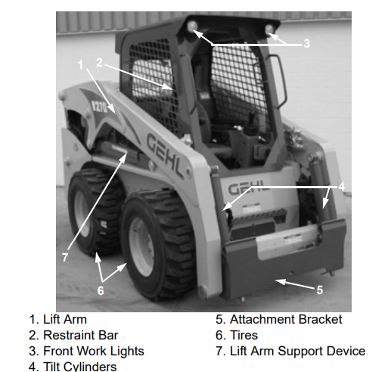 | 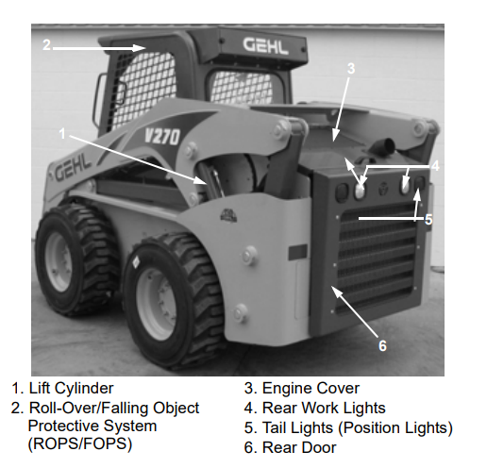

Before you step foot on-site: PPE Required

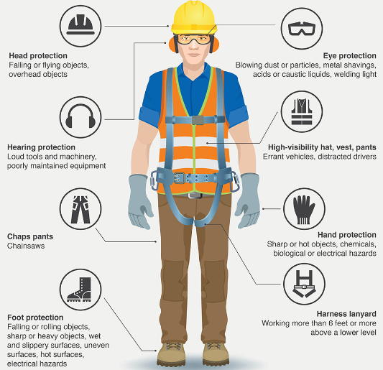 | 

- Head protection.
- Steel toe boots.
- Respiratory protection.
- Harness land yard when operating lifts.
- Puncture resistant gloves.
- Eye protection.
- Reflective vest.
- Ear protection

Unauthorized use of PIT/procedures or frequent OSHA violations

- OSHA VIOLATION Standard number 1910.178 1910.178(m)(2) No person is allowed to stand or pass under the elevated portion of any powered industrial truck. (WHEN METAL BUCKET UNLOADING SYSTEM NOT WORKING PROPERLY)

- Stopping PIT unproperly to pick up trash while power washing/sweeping operations. Keep the equipment moving to prevent accidents by distraction, running into people, or damaging the floors.

- Use of unauthorized original equipment while in use.

- USE OF CELL PHONE EQUIPMENT IS NOT AUTHORIZED WHILE OPERATING.

- PERSONAL PROTECTIVE EQUIPMENT REQUIRED AT ALL TIMES.

- MODIFIYING THE MACHINE, ADDING PARTS, SCREWS, DUCT TAPE, ZIP TIES, FIXES, OTHER NON-ORIGINAL WORK, MISSING PARTS, DAMAGED COMPONENTS OR MAINTENANCE FROM UNQUALIFIED PERSONELL.

Job hazard analysis form

Department Supervisor  Kevin Bailey |  | Task  Exterior cleaning
Prepared by  Humberto Dominguez HWB  Site supervisor |  | Date Approved: 1/22/2024 | Next review Date:  Date3/18/2024 | SOP 1-2024-22  Exterior Cleaning
Personal protective equipment requirements: Head protection, eye protection, mouth mask, steel toe shoes, cut resistant gloves, reflective vest.
Step # | Task | Potential Safety and Health Hazards |  | Controls
1. | Broom sweep | Dust inhalation, falls, dehydration. |  | Wear eye gear, reflective vests and inform area personnel of cleaning activities in the parking area.
2. | Power wash parking and fire lane striping | Dehydration, heat stroke, fainting, crushing by vehicles, water pressure lesions. |  | Wear reflective vests and inform area personnel of cleaning activities in the parking area.
3 | Cleaning large debris | Cuts, muscle sprains |  | Use proper tools (shovel) to pick up loose large debris. Use correct body method to pick up bulky trash.
Filed with the following departments: HWB safety and operation departments.

PIT and Safety Communication Program

Powered Industrial Trucks and Safety Communication Program

PURPOSE
To provide safe practices for the operation, maintenance, and inspection of PITs skid loaders, lifts, forklifts, PPE and Hazardous chemicals

SCOPE
This program applies to all HWB CLEANING SERVICES LLC employees. All employees shall ensure to operate the equipment and hazardous chemicals in compliance with safe work practices and standards and are properly trained and certified. Employees failing to adhere to applicable safe work practices and standards will be asked to terminate their work until their program is brought into compliance.

RESPONSIBILITIES
- Overall and ultimate responsibility for this policy lies with the owners and management of HWB Cleaning Services LLC.
- Establish an Environmental, Health & Safety department (EHS)
- Establish, maintain, and update the Program.
- Coordinate PIT training and re/certification.
- Maintain training documentation.

Management

Safety Director
The HWB Cleaning Services LLC Safety Director is a staff management function and is responsible for coordinating the overall safety program. The Safety Director’s primary job responsibilities include:
- Administering the overall safety program for Beeler Construction.
- Establishing requirements for ongoing and specialized training for employees and management.
- Maintaining and implementing safety programs that comply with changing governmental safety standards.
- Facilitating Incident Investigation Program
  - Every incident is reviewed with Safety Director, Management, and Field Team
  - All incidents requiring reporting to OSHA are done within 8 hours to OSHA and to client within 24 hours.
  - Training is provided for this program at time of hire, as needed, and at a minimum annual basis.
  - All evidence from incident shall be preserved & collected to the extent possible. o All incidents are documented (forms section has injury forms attached).
    - A final review of incident is conducted.
    - Corrective measures to eliminate a recurrence are put in place.
    - A lessons-learned summary is put together and communicated to the entire HWB team.

Project Managers & Estimators:
Project Managers have overall responsibility for the projects they manage, including safety issues affecting Beeler Construction employees and project subcontractors. Specific safety responsibilities include:
- Assess job specific safety requirements during estimating and account for such in the estimates/proposals.
- Define necessary job specific safety requirements prior to project start-up and review these with the project foreman/superintendent.
- Ensuring that routine jobsite safety inspections are conducted.
- Communicating safety requirements to subcontractors prior to project commencement.
- Enforcing jobsite safety requirements with subcontractors.
- Participating in Incident Investigation Program.
  - Every incident is reviewed with Safety Director, Management, and Field Team.
  - All incidents requiring reporting to OSHA are done within 8 hours to OSHA and to client within 24 hours.
  - Training is provided for this program at time of hire, as needed, and at a minimum annual basis.
  - All evidence from incident shall be preserved & collected to the extent possible. o All incidents are documented (forms section has injury forms attached).
    - A final review of incident is conducted.
    - Corrective measures to eliminate a recurrence are put in place.
    - A lessons-learned summary is put together and communicated to the entire Beeler team.

Foremen/Superintendents:
Project foreman are responsible for the safe condition and operation of each jobsite managed for Beeler Construction to the extent within their control. This includes all work operations performed by Beeler Construction employees as well as all subcontractors’ employees. Specific responsibilities include:
- Inspect work areas and equipment for compliance with work rules and standards.
- Evaluate all subcontractor operations for safety compliance.
- Instruct employees (including subcontractor employees) on hazards of the job, how to work safely according to operating procedures, and applicable safety regulations through periodic safety meetings.
- Ensure prompt treatment and reporting of injuries that occur to Beeler Construction employees.

- Investigation of all occupational accidents and injuries.
- Participating in Incident Investigation Program.
  - Every incident is reviewed with Safety Director, Management, and Field Team
  - All incidents requiring reporting to OSHA are done within 8 hours to OSHA and to client within 24 hours.
  - Training is provided for this program at time of hire, as needed, and at a minimum annual basis. o All evidence from incident shall be preserved & collected to the extent possible.
  - All incidents are documented (forms section has injury forms attached).
    - A final review of incident is conducted.
    - Corrective measures to eliminate a recurrence are put in place.
    - A lessons-learned summary is put together and communicated to the entire Beeler team.
    - Enforcement of jobsite safety rules and regulations.
    - Setting the proper example for safety by observing all applicable safety rules and regulations.

Employees:
Every HWB cleaning employee employee is responsible for following safety rules set forth in this safety manual and for reporting any unsafe conditions or unsafe acts that they may be aware of. Specific responsibilities include:
- Only performing jobs that they have been specifically trained to do.
- Following prescribed safety rules and regulations.
- Using required personal protective equipment.
- Reporting all unsafe conditions or practices.
- Reporting all injuries, no matter how minor.
- Participating in Incident Investigation Program.
  - Every incident is reviewed with Safety Director, Management, and Field Team
  - All incidents requiring reporting to OSHA are done within 8 hours to OSHA and to client within 24 hours.
  - Training is provided for this program at time of hire, as needed, and at a minimum annual basis.
  - All evidence from incident shall be preserved & collected to the extent possible.
  - All incidents are documented (forms section has injury forms attached).
    - A final review of incident is conducted.
    - Corrective measures to eliminate a recurrence are put in place.
    - A lessons-learned summary is put together and communicated to the entire Beeler team.
    - Cooperate during the investigation of any accidents that occur.

Violations of Safety Rules
Violations of Safety Rules or Company Safety Policies: Company safety rules and safety policies are necessary to prevent accidents and injuries from occurring. Safety rules and policies will be strictly enforced. Enforcement will be in the form of disciplinary action which will consider the seriousness of the violation. Serious violations of safety rules may result in unpaid time off or possible termination of employment. Minor violations may result in written warnings to employees. Repeat minor violations may result in unpaid time off, or in possible termination of employment. Specifics regarding Beeler Construction’s disciplinary action program are found in the Disciplinary Action section of the safety manual.

Rules of Safety and Conduct

PURPOSE:
This procedure provides general and specific company safety rules that apply to all employees, and specific jobs and activities performed by Beeler Construction. All employees are to be provided with a copy of these safety rules that will be enforced by their foreman or superintendent and management.

POLICY:
Beeler Construction provides a safe and healthful workplace for all of its employees and subcontractors. Safety rules have been developed to ensure that each employee works in a safe manner. Violations of the safety rules that follow, or any other generally accepted safety practice, will result in disciplinary action.

TRAINING:
All Beeler Construction employees shall receive initial training on the basic rules of safety and conduct, refresher training is provided periodically thereafter. Training shall be documented with the employee’s name, date of training and name of trainer recorded.

SAFETY RULES:
General Safety Rules:
- All employees must understand their work assignment and the associated hazards before starting a job. Any questions concerning the job or safety hazards must be directed to a foreman or superintendent.
- Employees must report all accidents and injuries, no matter how minor, immediately to their foreman or superintendent, and must report the injury to the office.
- All unsafe conditions and equipment and unsafe acts must be reported immediately to a foreman or superintendent and must be documented in the Daily Log book.
- Employees must attend scheduled safety training sessions and safety meetings.
- It is the intent of management to distribute Tool Box Talks and or similar safety information to the employee’s bi-monthly. Employees are to read the information and sign the acknowledgement receipts and return the signed receipts to the office. Employees are also requested to maintain a library/file of all safety handouts for their reference.
- Horseplay or fighting on the job is a serious safety violation and will not be tolerated at any time.
- Possession or working under the influence of alcohol or illegally obtained controlled substances during work will not be tolerated and may result in immediate termination.
- Possession of firearms is not allowed and may result in immediate termination.
- Running on the job is prohibited, except in cases involving emergencies where prompt evacuation is required.
- Employees shall observe and comply with all caution and danger signs, barricades and safety tags at the jobsite.
- Employees shall practice good housekeeping practices in their work area by properly and routinely disposing of scrap materials and waste to prevent an unsafe accumulation of trash at the jobsite. As a general rule all work is to be cleaned on a daily basis.
- Compressed air shall not be used for dusting off or cleaning off their body or clothing.
- Employees are required to report to their foreman or superintendent immediately any problem or defects present in tools and equipment that they are using or responsible for. These tools are too be subsequently tagged by the foreman, removed from the jobsite and returned to the office for repairs.
- Beeler Construction employees shall wear hard hats AT ALL TIMES when there is an overhead hazard or potential to be struck in the head by equipment. This includes management, office staff, drivers, and others that may be on site.
- Appropriate footwear shall be worn by all employees. Footwear shall consist of a substantial leather shoe or boot that protects the foot from injury as a result of incidental contact with falling tools or materials as well as providing proper ankle support.
- Shorts and sleeveless shirts are not allowed. Long pants and shirts are required. Any employee reporting for work without appropriate footwear and clothing WILL BE SENT HOME.
- Eye protection must be worn AT ALL TIMES when chipping, sanding, grinding, torching, or performing operations that generate dust or chips that can injure the eye. This includes while operating any and all power tools, no exceptions, failure to do so is an OSHA violation.
- Employees shall use all guards, tools, and safety devices provided to prevent injury. This includes shields, guards, interlocks, etc. on machinery and equipment such as grinders, saws, cutting equipment, etc. Removal or manipulation of any safety guards is considered a serious OSHA violation.
- All employees have a responsibility to protect the general public and provide for their safety. The safety of the public is as equally important as the safety of our employees.

Injury & Accident Reporting:
- It is the responsibility of all employees to immediately report to their foreman or superintendent the occurrence of any work-related injury or illness, no matter how minor the injury may seem.
- The first priority is to ensure that the injured employee receives the appropriate first aid or medical treatment. The foreman or superintendent will then determine the level of medical assistance necessary. The foreman or superintendent will then determine if the employee will be transported for treatment via ambulance or company vehicle.

- The foreman or superintendent must then contact the company office as soon as possible to report the injury, no matter how minor the injury appears. The foreman or superintendent will then be expected to thoroughly investigate and report the accident to the company office.
- The company office is responsible for completing the first report of injury form for reporting to the insurance company and state industrial accident commission.
- The office is also responsible for completion and maintenance of the OSHA 300 forms used to record occupational injuries and illnesses and for posting the log during the month of February.
- The office will maintain communications with the injured employee, treating physician, and insurance company to ensure that a proper course of treatment is being followed and that the employee is returned to work as quickly as possible.

Electric Power Tools:
- All guards and safety features furnished with hand and power tools shall remain in place and shall not be removed when in use.
- Electric power tools shall be of a double-insulated type or provided with proper grounding. The grounding prong on plugs of power tools shall not be removed.
- Power tool electric cords and electrical extension cords shall not be used to hoist or lower tools, equipment or supplies.
- Employees shall use the appropriate PPE’s whenever using electric power tools.

Pneumatic Power Tools:
- Tool retainers shall be used on all pneumatic equipment to prevent ejection of the tool being used in the pneumatic equipment.
- Pneumatic power tools shall be secured to the hose at all times by connecting with a wire, chain or other positive means to prevent the tool from becoming accidentally disengaged from the hose.
- Safety guards shall be used on all portable grinders. The guard shall be installed so that at least one half of the grinding wheel or abrasive disk is covered.
- The safe operating pressure for hoses and tools shall not be exceeded.
- Compressed air hoses shall not be used for hoisting tools, equipment or supplies.
- Employees shall use the appropriate PPE’s whenever using pneumatic power tools.

Hand Tools:
- Hand tools such as hammers, sledge hammers, axes, picks, shovels, etc. shall be inspected for evidence of damage such as splintered or damaged handles, cracking/splitting/spalling of the tool head or other signs of breakage.
- All hand tools shall be maintained in a safe condition. Damaged tools shall be removed from service immediately and the foreman or superintendent shall either have the tool repaired or disposed of. Employees must NEVER use a defective hand tool.
- Employees shall use the appropriate PPE’s whenever using hand tools.

Ladder Safety Rules:
  - Ladders shall be inspected prior to each use for chips, cracks and other defects.
  - Ladder rungs shall be kept clean and free of mud, grease or oil to prevent slips.
  - Where possible, ladders shall always be secured or lashed at the top of the ladder to prevent their tipping.
  - Ladders shall be erected so that the ladder side rails extend at least 36 inches above the landing or roof surface.
  - Cross bracing on the rear section of stepladders shall not be used for climbing unless the ladders are provided with steps for climbing on both sections.
  - Employees shall always face the ladder when climbing up or down.
  - Ladders shall NEVER be placed at an angle greater than 75 degrees to the horizontal.
  - The areas at the top and bottom of each ladder shall be kept clear of rubbish, debris, and equipment.
  - Stepladders shall only be used on flat, level surfaces.
  - All ladders shall be equipped with safety shoes, spikes, or secured in some manner to prevent them from slipping when in use.
  - Wood ladders shall NEVER be painted entirely. Paint is only allowed on wooden ladders as a means of identification and marking.
  - All ladders shall be inspected for defects such as broken or bent rungs, steps, rails, cross bracing, ropes, pulleys, feet, or any other structural part of the ladder.
  - A ladder found to be defective shall be removed from use immediately and the foreman or superintendent shall be notified of the problem. The foreman or superintendent shall arrange to have the ladder repaired by a qualified person or shall dispose of the ladder if it cannot be properly repaired.
  - Ladders shall NEVER be used as a platform, runway, or scaffold. Ladders shall also NEVER be used as a means of constructing scaffolding by placing planks in between step or extension ladders, except for their use in ladder jack scaffolding systems.
  - Step ladders near guardrails shall be no closer than the ladder’s height away (i.e. a 12- foot step ladder shall be 12 feet away).

Hazardous Chemicals:
- Employees who handle hazardous materials must receive Hazard Communication training prior to their initial work assignment and annually thereafter.
- A copy of the Beeler Construction Written Hazard Communication Program and Safety Data Sheets (SDS) are available and maintained on site by Beeler Construction foremen or superintendents.
- All containers of hazardous chemicals must be properly labeled. The label must provide the identity, or name of the hazardous chemical, the appropriate hazard warnings, and the name and address of the chemical manufacturer. Contact the foreman or superintendent if any container of hazardous chemicals is found with no label.
- All hazardous chemicals must be furnished by the supplier with a Safety Data Sheet (SDS). SDS’s contain information on the chemical make-up of materials, flammability, health risks, medical treatments, etc. SDS’s for all hazardous chemicals used at Beeler Construction jobsites available

and kept by each foreman or superintendent. Any questions concerning hazardous chemicals used by other contractors at a jobsite should be directed to your foreman or superintendent who will obtain an SDS from the other contractor(s) or general contractor responsible for the jobsite. All Beeler Construction employees may request a copy of the SDS from their foreman or superintendent if they so desire. Any employee who purchases a chemical should check the SDS binder to see if there is an SDS on file, if not they should contact the office so one can be obtained and implemented into the jobsite files.
- Each employee shall receive information and training concerning the hazardous chemicals they work with. This training will cover the following subjects.
  - The requirements of the federal Hazard Communication Standard.
  - The location of the written Beeler Construction Hazard Communication Program.
  - The location in work areas where hazardous chemicals may be present.
  - Training in methods used to detect the presence or release of a hazardous chemical.
  - Explanation of the potential physical & health hazards of chemicals used.
  - Measures that employees can take to protect themselves from the hazards of chemicals in the work area.
  - Specific actions that employees are to take in the event of an emergency leak or spill.
  - Hazardous chemical labeling, sections of the SDS, explanation of terms used on an SDS, where to find the SDS, and how to request a copy of an SDS.

Flammable Materials:
- NEVER refuel a piece of equipment or vehicle while the engine is running. Extra caution must be exercised when refueling portable equipment with a hot manifold such as pumps, generators, saws, etc.
- Do not store flammable liquids within 10 feet of a portable generator, pump, or electrical equipment.
- Portable containers used to store gasoline or other flammable liquids must be equipped with a self-closing lid, flash screen, and labeled with the contents of the container.
- Oxygen and fuel gas cylinders must be stored in approved areas and separated by at least 20 feet or a firewall with a ½ hour rating.
- All compressed gas cylinders must be used, stored, and secured with rope or chains in an upright position or kept in proper welding carts.
- When not in use, all cylinders must be closed at the cylinder valve, and any gas remaining in hoses bled off through the torch valve.
- Caps must be placed on all compressed gas cylinders not in use.
- Compressed gas cylinders must NEVER be used inside confined spaces such as drums, pits, excavations, etc.

Proper Lifting Procedures:
- Position your feet as close to the load or object to be lifted.
- Bend at the knees and keep your back as straight as possible.
- Get a firm grip on the load or object to be lifted.
- Hold the load or object close to your body; lift by using leg muscles.

- Lift the load or object slowly holding it as close to your body as possible.
- NEVER twist at the waist or jerk the load while carrying it.
- If it is necessary to turn, shuffle your feet and avoid twisting the back.
- Set the load or object down in the same manner as the lift.
- If the load or object is too heavy to lift or too bulky to carry, get help.

Protection of Tools & Equipment:
- All tools and equipment left at a jobsite at the conclusion of each work day shall be locked, secured, or otherwise protected from possible theft and vandalism.
- Heavy equipment and vehicles left at the jobsite shall be secured by removal of all keys, locking of fuel caps where possible, securing of steel plates, use of hidden kill switches or other anti-theft devices, and placement of equipment making it difficult to move.
- Portable tools and equipment shall be placed and locked in gang boxes at the end of each work day. Each foreman or superintendent shall be responsible for maintaining an inventory of tools and equipment at the jobsite and shall also be responsible for reporting the theft, disappearance, or damage to tools and equipment not occurring during normal work shifts.
- All employees shall also be responsible for reporting evidence of tampering or attempted theft of heavy equipment and machinery used at the jobsite.

Drivers Safety Rules:
- NEVER carry passengers unless authorized by management.
- All drivers and authorized passengers must wear lap and shoulder belts while the vehicle is in operation.
- Drivers must obey posted speed limits at client facilities, if applicable, and on the road. Drivers must know and obey all traffic rules and regulations.
- No driver shall operate a vehicle while under the influence of alcohol or drugs.
- Intentional damage, misuse, abuse, or improper handling of any vehicle driven during the conduct of company business will not be tolerated.
- NEVER operate or use any vehicle that has a “DO NOT OPERATE TAG” on it.
- Horseplay or the reckless operation of a motor vehicle is a serious safety violation.
- NEVER smoke while fueling vehicles or equipment and do not throw cigarette butts from a vehicle. Smoking on the premises is allowed only in designated areas.
- Drivers must inspect and ensure that all company vehicles contain the required safety equipment, such as fire extinguishers and first aid kit.
- Drivers must only operate a vehicle for which they have received appropriate state licensing.
- Any driver that develops serious medical symptoms which may affect their ability to safely drive must pull the vehicle safely off the road and stop. The driver should request medical assistance.
- All vehicles shall be kept clean of trash and debris. Large items, such as tool boxes, fire extinguishers, lunch boxes, thermos, etc. should be secured to prevent them from becoming missiles during an accident situation.
- Vehicles which haul equipment or material shall be carefully inspected and secured to prevent load shifting or vehicle overloading.

- Drivers must conduct pre-trip inspections of the following items: brakes, steering, head lights, brake lights, turn signals, emergency signals, fire extinguishers, tires, rear view mirrors, windshield wipers, seat belts, heater/defroster, red flags, tarpaulin, backup alarm, low air alarm, hook up, etc.
- Additional driving safety information is outline in the Beeler Construction Fleet Safety program in Section #7 of this manual.

Waste Management Program/Job Cleanliness:

- Training of this program is conducted at time of hire and refresher/ update training is conducted as needed and at a minimum annual basis.
- The waste management area will be designated areas on construction site for waste disposal dumpsters; locations are typically designated by the customer. Prior to dropping any dumpsters on site, the Beeler Construction superintendent shall obtain the customer’s/owner’s approval. Location, switch out times and debris removal routes all be agreed upon.
- Jobsites must be cleaned up on a daily basis; this shall be the responsibility of all employees on site including subcontractor employees. Debris shall not be allowed to over accumulate; if needed, clean up shall be done periodically during the day/shift so as not to affect work procedures and safety.
- Prior to removing materials from the work area to the dumpster, Beeler Construction’s superintendent shall review the best route thru the jobsite; this should involve input from the customer whenever necessary. This is of particular importance when working on jobsites with ongoing operations such as retail, hospitals/health care facilities, offices, educational, etc., when public safety is a concern. Furthermore, this rout should also be reviewed for employee safety by avoiding construction and public vehicular traffic.
- Prior to beginning work, the Beeler Construction superintendent shall review project scopes with all subcontractors to determine an estimated total number of dumpsters required and approximate switch-out dates and times.
- Prior to beginning work, the Beeler Construction superintendent and project manager should review the project for possible salvaged material reuse or material recycling. Some materials suitable for reuse could be: dimensional wood, wood trims and millwork, plywood, counters, cabinetry, metal studs, insulation, structural steel, etc. Other materials may be suitable for recycling such as: metals, glass, plastics, cardboard, carpet, concrete, etc. In an effort to minimize impact on the environment, Beeler Construction promotes the practice of material recycling. Recycling containers shall be provided when deemed beneficial or when requested by the customer; containers should be clearly labeled for respective materials.
- Only approved materials can be disposed of in dumpsters. As a rule of thumb, the following items are banned from landfills: plastic bottles and jars, aluminum containers, bi-metal containers, glass containers, steel (tin) cans, corrugated cardboard, magazines/catalogs, newspapers, office paper, grass clippings and yard debris, vehicle batteries/tires/waste oil/oil filters, household appliances such as washers, dryers, freezers, refrigerators, stoves, etc., and

electronics such as televisions and microwaves. Always check the State regulations where the project is located; the disposal vendor should also provide lists of acceptable and unacceptable materials.
- Never overfill or over-stack a dumpster; the typical fill line is the top of the container sides. Always pay attention to never overweight a dumpster, in particular when disposing soils, concrete or other heavy materials.
- Never dispose of any chemicals, fuels, caustic liquids, etc., or other hazardous materials in dumpsters. These should be stored safely on site and only disposed of by a qualified hazardous waste vendor.

Disciplinary Action for Safety Violations
Beeler Construction reserves the right to take any action it deems appropriate, including termination of employment, for safety violations whether they occur the first, second or third time. The following policy is to be implemented whether it is Beeler Construction employee violations or Subcontractor employee violations.

For Beeler Construction Employee Violations:
• 1st Offense: Verbal Warning
• 2nd Offense: Written Warning, superintendent to forward a copy to the office and keep a copy on file on site.
• 3rd Offense: Possible Employee Termination
Beeler Construction’s on site supervisor and safety director will be responsible for the policing and enforcement of all safety rules and regulations. A violation is considered as breaking and/or not following any of the rules, procedures or regulations set forth in this Safety Manual. The first violation will result in a verbal warning. After that, all violations are to be written up and kept on file on site. Safety Violation forms are included in each superintendent’s safety kits. A copy of this form is also located in the Forms Section of this manual. Periodic site safety inspections will be performed by the Beeler Construction safety director. Employee violations will be emphasized during these inspections.

For Subcontractor Employee Violations:
- 1st Offense: Verbal Warning
- 2nd Offense: Written Warning, superintendent to forward a copy to the office and keep a copy on file on site, Beeler Construction project manager will forward a copy to the Subcontractor’s office and the Subcontractor’s insurance carrier.
- 3rd Offense: Subcontractor employee terminated from the site. Possible termination of subcontract.
Beeler Construction’s on site supervisor and safety director will be responsible for the policing and enforcement of all safety rules and regulations. A violation is considered as breaking and/or not following any of the rules, procedures or regulations set forth in this Safety Manual. The first violation will result in a verbal warning. After that, all violations are to be written up and kept on file on site. Safety Violation forms are included in each superintendent’s safety kits. A copy of this form is also located in the Forms Section of this manual. Periodic site safety inspections will be performed by the Beeler Construction safety director. Employee violations will be emphasized during these inspections.

Drug & Alcohol Policy

PURPOSE:
As a part of its comprehensive health and safety program, Beeler Construction provides a workplace that is free from the hazards and effects of alcohol and other mood altering chemicals. This procedure clarifies the policy of the company with regard to the use of alcohol and other mood altering chemicals.

POLICY:
Beeler Construction strictly enforces its drug and alcohol policy that follows. Employees found to be in violation of its drug and alcohol policy will be subject to the provisions that follow, including disciplinary action. The health and safety of other employees, subcontractors, and the general public, will not be jeopardized by an employee found to be in violation of this policy.

General Provisions:
Conscientious efforts to seek and use help will not jeopardize an employee’s job or career. Use of a program, however, is not a substitute for a foreman or superintendent’s action or the application of normal discipline. The intent of this policy is to provide a drug-free, healthy, safe and secure work environment.
- A condition of employment at Beeler Construction is that employees report to their jobs in the appropriate mental and physical condition ready to work. A foreman or superintendent or management shall determine fitness for duty.
- Beeler Construction prohibits employees from using or consuming any amount of moodaltering, non-prescription substances on Beeler Construction premises, in Beeler Construction vehicles, or during working hours, including breaks, meals and overtime. Further, any illegal possession, transfer or sale of such substances is also prohibited. This includes all forms of alcohol, narcotics, depressants, amphetamines, hallucinogens, and marijuana. Violation will result in immediate removal from the work site and appropriate disciplinary action, which can include termination of employment.
- Since physician-prescribed use of mood-altering drugs, narcotics, depressants, amphetamines or other controlled substances can adversely affect work behavior, job performance, and the ability to safely drive a motor vehicle, it is in the best general interest of all the employees that the foreman or superintendent and management should know of such use. Therefore, in the interest of health and safety and to avoid a misunderstanding, employees should report the use of such prescriptions to their immediate foreman or superintendent, or if not available, to management. Disclosure of the use of prescriptions shall be considered confidential.

- When there is a reason to believe an employee is violating this policy, he/she can be required to report to a designated physician or clinic on Beeler Construction time and at Beeler Construction’s expense for a fitness-for-duty examination which may include testing. Employees who refuse to submit to an examination will be removed from the work site and subject to appropriate disciplinary action.

- Whenever appropriate, illegal substances found on Beeler Construction property or jobsites will be turned over to a local law enforcement agency for further investigation, which may result in criminal prosecution.

- If an employee with an alcohol or drug problem refuses assistance or fails to keep his/her commitment to treatment while showing no improvement in job performance, disciplinary action may be deemed appropriate.

- An employee who is arrested for illegal off-the-job drug activity may be considered in violation of this policy. An employee can be suspended with or without pay, pending resolution of criminal charges. In deciding what action to pursue, management shall consider:

  - The nature of involvement.
  - The employee’s present job assignment.
  - The employee’s record with Beeler Construction.
  - Other factors relative to the impact of the employee’s involvement upon the conduct of Beeler Construction business and the maintenance of the public trust.

OSHA Inspection Procedures

Purpose
It is Beeler Construction policy to fully cooperate with inspections by regulatory agencies such as the Occupational Safety and Health Administration (OSHA). Sc

Scope
This section applies to all Beeler Construction projects.

Policies
The following procedures must be followed when an OSHA or another regulatory agency representative arrives at a Beeler Construction project.

Notification
Notify the Safety Department as soon as the compliance officer arrives at the project site. The Safety Representative will immediately head to the project. Notify Beeler Construction management that OSHA is onsite.

Correct Any Unsafe Conditions
Look around before OSHA is walking the worksite. Fix any unsafe condition that was created by Beeler Construction. If Beeler Construction employees are exposed to other contractor’s hazard, remove workers from the hazardous area. While OSHA is onsite do not perform any high hazard work, such as working off ladders, scaffolding or where fall protection is needed.

Inspection Procedures
OSHA Inspections It is Beeler Construction policy to fully cooperate with inspections by regulatory agencies such as the Occupational Safety and Health Administration (OSHA).
The following procedures must be followed when an OSHA or another agency representative arrives at our project:

Inspectors must be escorted
Instruct all BEELER CONSTRUCTION personnel to escort the inspector to the Manager. This should be done without entering the job site if at all possible. Ask to see their identification “badge” and a business card. If there are any questions about their identification contact the OSHA’s Area Office for further identification.

Forms must be completed
Fill out Beeler Construction forms completely and give a copy to the Safety Department.

Inspectors must be accompanied
Manager will accompany the inspector at all times.

Be courteous
Extend every courtesy to make the inspector’s brief visit as pleasant as possible.

Correct any unsafe conditions immediately
Before the inspector leaves the site, request clarification of any hazards observed and the abatement that the inspector would like to see.

The inspector may talk to employees
If the inspector wishes to talk to employees during the walk around, he is allowed to do so by law. This talk should be limited to about five (5) minutes. The employee has the right to refuse to talk to the inspector. Cooperation is expected from all staff on the site. All employees, Beeler Construction and subcontractors, should cooperate with the inspection. Explain that Beeler Construction, subcontractors and OSHA are conducting this inspection together, and the welfare of ALL employees is the purpose for the inspection.

Inspections may be videotaped
Some inspectors may use a video camera. Be careful what is said when the recorder is being used.

Pictures may be taken
If the inspector takes a picture, Beeler Construction should take two or three to get a complete view of the hazard.

Identify the company responsible for violations
If violations are alleged by the OSHA representative, identify the company responsible for or contributing to the conditions leading to the violation during the closing conference.

Post citations conspicuously
Citations must be posted for three days or until the citation is abated, whichever comes first, on the job site in a place where employees pass frequently.

Inspection follow-up
1. Review all proposed penalties and citations.
2. Set-up and attend the informal conference with OSHA.
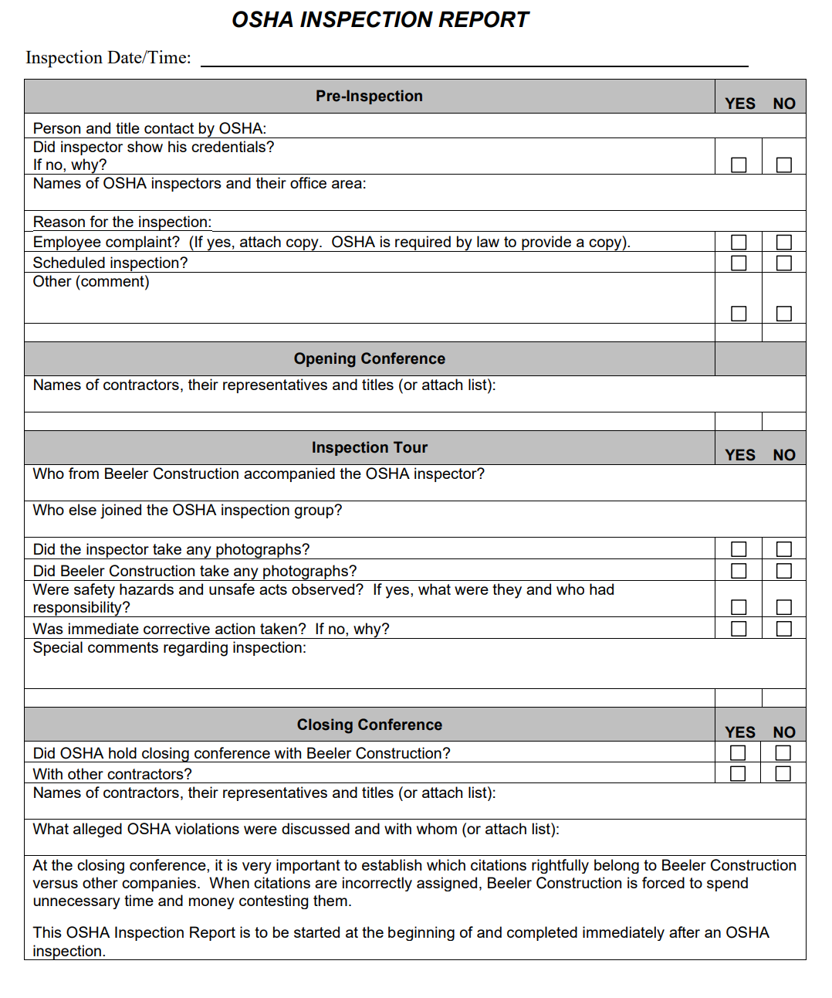

Emergency Procedures

PURPOSE:
The purpose of this policy is to provide Beeler Construction employees and management with the information necessary to safely and properly respond in the event of an emergency that affect the health and safety of employees.

POLICY:
Beeler Construction provides a safe and healthful workplace for all of its employees. All employees must become familiar with the following Emergency Action Plan requirements and their responsibilities in the event an emergency occurs.

TRAINING:
All Beeler Construction employees shall receive initial Emergency Action plan training and annual refresher training thereafter. This training shall be documented with the employee name, date and trainer recorded.

Responsibilities:

Management:
Beeler Construction management has overall responsibility for the safety of company employees, facilities and operations in the event of an emergency. Management is responsible for ensuring that the instructions in this plan are implemented in a timely manner once the emergency situation becomes apparent and for handling communications to emergency response agencies and the press.
  - Employees: Employees of Beeler Construction are responsible for becoming familiar with this procedure and the evacuation routes posted in each facility. Employees are also responsible for following the instructions of their foreman or superintendent or management during the actual emergency.

Management and Employees:
The primary objective during any emergency is the preservation of life. In the event of any emergency, the first priority is to safely evacuate or protect the lives of all persons affected. No employee or member of management shall put their health or safety at risk by taking any action to protect or secure the facility during the emergency. Additionally, no employee or member of management shall put their health or safety at risk by taking any action to rescue another person that may be in imminent danger as a result of the emergency.

Evacua tion Routes:
If it becomes necessary to safely evacuate a facility because of an emergency, evacuation routes need to be located. All employees shall become familiar with the emergency exits and evacuation routes within the facility as it may become necessary to use alternate means of exit during an emergency.

Emergency Exits:
Emergency exits must be kept accessible at all times. Aisles and paths to emergency exits must be kept open and free of debris and materials which might impede or trip persons attempting to exit. Emergency exits must NEVER be locked through the use of chains or hasps which prevent them from opening from the inside. Blocking or intentionally locking emergency exits and paths to emergency exits is a serious safety violation and subject to disciplinary action.

Communicating the Emergency:
The priority in all emergencies is the communication of the type and extent of the emergency to other Beeler Construction and subcontractor employees. The method of properly communicating the emergency is detailed in each specific emergency procedure that follows.
Fire and Chemical Spill Emergencies:
  - Communication: The first priority in the event of an emergency is the prompt communication of the emergency to all personnel at the project site and/or related field offices.
  - Communication of the existence of an emergency shall be by radio, cell phone or whatever means the employee has to announce the emergency, including existing alarm system or public address system, at jobsites so equipped.
  - Upon discovery of a spill, the employee must leave the immediate area and inform other employees of the spill in the area, unless the employee can safely contain or prevent the spread of the spill into other areas or into floor drains.
  - A foreman or superintendent, or other employee in absence of a foreman or superintendent, should inform occupants in adjacent buildings or occupancies of the existence, nature, and location of the emergency.
  - If safe to do so, jobsite personnel shall call 911 and notify the fire department of the nature and location of the emergency within the building.
  - Evacuation: After the emergency has been communicated, all employees must promptly and safely evacuate the facility.
  - All employees must NEVER run as they exit the building unless they must do so to escape the fire or spill.
  - Employees operating equipment that can be shut down in the immediate area where they are working can do so, but only if it is safe to do so, as they prepare to exit.
  - Employees evacuating the building may assist other employees if they are injured or disoriented, but only if it is safe to do so, as they prepare to exit.

Accounting for Employees:
  - Employees exiting the building shall assemble in areas located a safe distance from the building and away from fire department or emergency operations.
  - Employees should remain a safe distance away from the building, until informed otherwise by the responding fire department.
  - Employees should relocate to another designated assembly area if the area they are in is downwind of smoke, gases or vapors generated by the fire or spill.
  - Supervisors are responsible for taking a head count of their employees to determine if all employees have been safely evacuated from the facility, including subcontractor’s employees.

Fire Department and Press Communications:
  - The most senior management official from Beeler Construction shall meet the first responding unit from the fire department as they arrive to the emergency.
  - This person should communicate the nature, location and extent of the emergency within the building.
  - Other information, such as the location of the storage of any chemicals or flammable liquids and gases, existence of sprinkler system, etc. shall be communicated to the responding fire department official.
  - Only the most senior management official from Beeler Construction shall speak to a reporter from any radio, television or newspaper organization that responds to the emergency scene.
  - The management official should refer any specifics regarding the fire to the highest ranking official from the responding fire department.
  - NEVER offer speculation regarding any employees unaccounted for, the extent of the damage, or cause of the emergency to the press. Be polite, but offer little in the way of specific information.
  - Reassure the press that the situation is in the hands of the responding fire department and that every effort will be made to determine the cause and repair the damage.

Insurance Communications:
  - As soon as reasonably possible following the emergency, a management official from Beeler Construction should contact the insurance agent or company and inform them of the emergency.
  - It is important that salvage efforts be taken underway as soon as possible to minimize damage and to aid in re-establishing operations as soon as possible.
  - Severe Weather:
    - Communication: The first priority in the event of the onset of severe weather is the prompt communication of the emergency to all affected Beeler Construction and subcontractor’s employees.
    - Communication of the existence of severe weather shall be by radio, cell phone, intercom, or public address system, in facilities so equipped.
    - If severe weather, such as dangerous thunderstorms or tornadoes, is present in the area, a Beeler Construction employee shall monitor local radio, television or internet newscasts to keep updated on the location and movement of the storm.
    - If the news media broadcasts, or activation of local emergency horns indicate the approach of a tornado, the foreman or superintendent shall immediately be notified.
    - Protection of Employees at Jobsites:
    - All employees and subcontractor’s employees should relocate to an interior portion of the building away from glass windows and doors.
    - The foreman or superintendent should instruct employees to close all overhead doors, exit doors, and windows immediately.
    - Employees should congregate towards the center of the building away from any windows and doors.
    - Subcontractor’s employees working on scaffolding, roofs, or any other outdoor or elevated work platform must be instructed to stop work and seek shelter inside or the structure.
    - Insurance Communications: As soon as reasonably possible following the storm and resulting damage, a management official from Beeler Construction should contact the insurance agent or company and inform them of damage caused by the storm or tornado.
      - It is important that salvage efforts be taken underway as soon as possible to minimize the extent of the claim and to aid in re-establishing operations as soon as possible.

3.2.1 Service and/or repair equipment in a timely manner.
3.2.2 Contact outside vendor for repair as needed.
3.2.3 Ensure equipment is not put back in service until necessary repairs have
been made and is in safe operating condition.
3.2.4 Maintain maintenance records for each PIT. Records shall be kept for the life of the equipment.
3.2.5 Select proper PPE. The supervisor will identify and select appropriate PPE suitable for the specific task performed, conditions present, frequency and duration of exposure.
3.3 Managers, Supervisors and Department with Assigned PIT
3.3.1 Implement and administer this program as it applies to the department.
3.3.2 Ensure employees in the department follow all rules and procedures pertaining to this program.
3.3.3 Do not allow anyone to operate the equipment without proper training and a current certification from HWB CLEANING SERVICES LLC.
3.3.4 Do not authorize non-HWB CLEANING SERVICES LLC. employees to operate HWB CLEANING SERVICES LLC. powered industrial equipment.
3.3.5 Maintain PIT pre-operation inspection checklists. Checklists should be kept for at least one year or until noted issues have been corrected, whichever is longer.
3.3.6 Submit Work Request with Facilities Management for servicing and repair.
3.3.7 Do not allow anyone to operate malfunctioning equipment. If there is a condition affecting the equipment’s safety or operation, ensure a red or out of service tag is placed on the equipment’s steering wheel. Ensure equipment is not placed back in service until the safety concern has been addressed.
    - Report all PIT incidents/accidents to EHS immediately.

EMPLOYEES
    - Do not operate the PIT without proper training and a current certification from HWB CLEANING SERVICES LLC.

    - Perform pre-operation inspection of PIT prior to operation and turn in

    - Pre-Operation Inspection checklist to designated location. Place red or “out-of-service” tag on PIT’s steering wheel if there is any condition affecting the safety or operation of the equipment. Do not operate equipment or remove “out-of-service” tag until the safety concern has been corrected.

    - Report any deficiencies or issues with the equipment immediately to the appropriate personnel for repair/servicing. Do not tamper with the equipment.

    - Do not use malfunctioned equipment.

    - Maintain good housekeeping and do not abuse the equipment.

    - Comply with departmental instructions and procedures for checking equipment in/out.

    - Follow all rules and procedures pertaining to this Program.

    - Report all PIT incidents/accidents to their Supervisor immediately.

TRAINING

  - Employees must satisfactorily complete training and be certified by HWB CLEANING SERVICES LLC. or HWB CLEANING SERVICES LLC. designated trainer before being authorized to operate the PIT.

  - Employees who received PIT operator training through a prior employer must complete initial training.

  - Employees who were trained or certified on a different type of PIT than the type they are assigned to use are required to complete training on the “new” equipment. The training only needs to include the practical and operator’s performance evaluation, unless the trainer or EHS determines that the lecture portion also needs to be included.

  - Operator training, evaluation and certification shall be conducted by designated personnel who have the knowledge, training and experience to train powered industrial truck operators and evaluate their proficiency. This requirement can be met by attending a PIT train-the-trainer course.

  - Training will be provided by HWB CLEANING SERVICES LLC. and coordinated through EHS. A department can request training for an employee by contacting EHS.

  - Initial and refresher training will be provided as outlined in Appendix A. Training will consist of classroom lecture, demonstrations by the trainer, trainee hands-on equipment operation or practices, and trainer evaluation of the trainee’s performance. Upon successful completion of training, employees will be certified by the trainer and be issued a certification card.

  - HWB CLEANING SERVICES LLC. The trainer will provide EHS copies of the sign-in sheets, written quizzes, equipment hands-on evaluation checklists, and certification cards upon completion of training. EHS will update the certification records.

  - Operators must be recertified at least once every three years.

OPERATION

  - Re-Operation Inspection.
    - Employees shall inspect PIT and complete the Pre-Operation Inspection checklist (see Appendix B) prior to operating equipment. The checklist shall be turned into a designated location.

    - Attention shall be given to proper functioning of the tires, horn, lights, controls, brakes, steering mechanism, cooling system, and the lift system.

    - Any safety defects shall be noted on the inspection checklist and immediately reported for repair. Place a red or out-of-service tag on the PIT’s steering wheel. The tag shall not be removed, and the equipment shall not be placed in service until the safety issue has been corrected.

    - Inspection checklists shall be kept/ maintained by the department with the assigned PIT(s). Inspection checklists will be kept for at least 1 year or until the noted issues have been corrected, whichever is longer.

  - Carrying Loads
    - Do not exceed the equipment’s rated load capacity.

    - Loads should be safely arranged, stable, and centered. Forks should be spread as wide apart as possible and locked in place. Loads of excessive width, length or height shall be balanced, braced, and secured as to prevent tipping/falling.

    - When carrying a load downgrade travel with the load trailing, and the load first when traveling upgrade. Tilt forks slightly upward.

  - Operating Procedures
    - Only authorized and currently certified personnel may operate the PIT. Trainees may operate the PIT only under the direct supervision of a designated trainer, and where such operation does not endanger the trainee or other personnel.

    - Before operating PIT, inspect the equipment thoroughly using the PIT Pre-Operation Inspection checklist.

    - Equipment shall not be operated with a leak in the fuel system.

    - Operators must wear seatbelt at all times.

    - Passengers are not permitted, unless the PIT has an extra seat that allows the passenger to buckle-up while riding.

    - Lounging, meddling, or horseplay on or around the PIT is not permitted.

    - Do not allow anyone to stand or walk on/underneath the forks.

    - Do not elevate anyone with the PIT.

    - Do not drive up to anyone standing in front of a fixed object such that the person could be caught between the equipment and object.

    - Keep all parts of the body within the confine of the equipment.

    - The overhead guard and load backrest must be in place for protection against falling objects.

    - Operate the PIT with care and only for the purpose intended. Before starting or backing, look and be sure others are clear.

    - Do not operate the equipment on floors or surfaces that will not safely support the weight of the equipment.

    - Never operate the PIT without being in the driver’s seat.

    - When leaving the equipment unattended, fully lower the bucket/load, engage parking brake, turn off engine, remove the key, and turn off propane tank.

    - When parking on an incline, the wheels must be blocked/ chocked. Do not block walkway, roadway, or emergency access area.

  - Traveling
    - When traveling with or without a load, the bucket shall be retracted back and raised as high as necessary to clear the road surface, but no higher than 6 inches from the ground.

    - Follow all traffic regulations. Do not exceed the posted maximum speed limit (10 mph for intercampus roads) and yield to pedestrians at all times.

    - Adjust speed according to conditions of the road. Keep the PIT under control at all times to safely stop in an emergency.

    - Look in the direction of travel and keep a clear view of the path of travel.

    - Avoid running over loose objects in the roadway.

    - Maintain a safe distance, approximately three truck lengths, from the vehicle ahead.

    - Sound the horn when approaching workers, intersecting aisles, blind corners, or swinging doors.

    - Slow down and sound horn at cross aisles and other locations where vision is obstructed. If the load being carried obstructs forward view, the driver shall travel with the load trailing.

    - Do not pass another vehicle traveling in the same direction particularly at intersections, blind spots, or other dangerous locations.

    - Avoid quick starts and sudden stops and turns.

    - Never turn sideways on an incline. This can cause the equipment to tip over.

  - Changing Propane Cylinder (when applicable)
    - Empty propane cylinders are exchanged on campus by a contracted vendor on an as needed basis. Employees are not permitted to transport the cylinders in a vehicle or to fill/refuel the cylinders.

    - Cylinders not in use shall be chained/secured and properly stored.

    - The propane cylinder shall be replaced per the manufacturer’s instructions and shall only be handled by trained and authorized employees.

    - Maintenance and replacement of the cylinders will be done by the department with the assigned PIT(s).

  - Checking PIT in/out
    - Employees must be authorized to operate the PIT and be currently certified by HWB CLEANING SERVICES LLC.

    - Employees shall comply with all procedures established by this Program and the department with custody of the PIT.

    - HWB CLEANING SERVICES LLC. PIT checking procedures:
      - Employees must receive authorization from HWB CLEANING SERVICES LLC. PIT staff.

      - Employees must sign in the PIT Usage Log and note date and time equipment is checked out.

      - Complete Pre-Operation Inspection checklist prior to operating equipment and note any deficiencies observed.

      - Turn in completed inspection checklist to designated location office.

      - Verbally report any deficiencies noticed (physical and/or mechanical) during the inspection to HWB CLEANING SERVICES LLC. PIT staff.

      - Return equipment to designated area at end of task and note on PIT Usage Log date/time equipment is returned.

- MAINTENANCE

  - Repair should only be made by authorized personnel.

  - If there is a condition affecting the safety or operation of the vehicle, the operator shall place an out of service or “do not operate” tag on the PIT’s steering wheel to warn other personnel from operating the equipment. The tag shall not be removed, and the equipment shall not be put back in service until the repair has been made.

  - Work Request will be submitted with Facilities Management for servicing or repair. Facilities Management will contact an outside vendor to complete the repair, if needed.

  - Unless power is necessary for testing and repair, power sources shall be disconnected and stored energy shall be discharged before working on the primary electrical system.

  - All replacement parts shall be equivalent in safety to the originals.

  - The equipment shall not be altered or modified, unless approved by the manufacturer.

  - Repairs to the fuel and ignition system which involve fire hazards shall only be done in locations safe for such repairs.

  - Employees shall not work underneath elevated portion of the equipment, unless the equipment is properly supported to prevent falling or movement.

- EQUIPMENT LIST

Department | Skid Loader | Type
HWB Cleaning Services | 1300-2099 | D

APPENDIX A

Powered Industrial Trucks

Operator Training, Evaluation and Certification

In accordance with Title 8, General Industry Safety Orders, Section 3668, Powered Industrial Truck Operator Training, the requirements for initial training, refresher training, evaluation and certification are outlined below. The types of powered industrial trucks utilized by HWB Cleaning Services LLC are: PITs, skid loaders, forklift, aerial lifts, scissors lifts, scrubbing and sweeping trucks.

Initial Training

- Topics related to the Truck

  - The correct use and care of PPE.
  - Operating instructions, warnings, and precautions for the type(s) of truck the operator will be authorized to operate.
  - Differences between the truck and an automobile.
  - Truck controls and instrumentation:
    - Where are they located?
    - What do they do?
    - How do they work?

  - Engine or motor operation.
  - Steering and maneuvering.
  - Visibility (including restrictions due to loading).
  - Fork and attachment adaptation, operation, and use limitations.
  - Vehicle capacity.
  - Vehicle stability.
  - Any vehicle inspection and maintenance that the operator will be required to perform.
  - Refueling and/or charging and recharging of batteries.
  - Operating limitations.
  - Any other operating instructions, warnings, or precautions listed in the operator’s manual for the type(s) of vehicle that the employee is being trained to operate.

- Topics related to the Workplace

  - Surface condition where the vehicle will be operated.
  - Composition of loads to be carried and load stability.
  - Load manipulation, stacking, and restacking.
  - Pedestrian traffic in areas where the vehicle will be operated.
  - Narrow aisles and other restricted places where the vehicle will be operated.
  - Hazardous locations where the vehicle will be operated.
  - Ramps and other sloped surfaces could affect the vehicle’s stability.
  - Closed environments and other areas where insufficient ventilation or poor vehicle maintenance could cause a build-up of carbon monoxide or diesel exhaust.
  - Other unique or potentially hazardous environmental conditions in the workplace that could affect safe operation.

Refresher Training and Evaluation

- It is required to provide refresher training to the operator when:

  - The operator is not wearing the correct PPE.
  - The operator has been observed to operate the vehicle in an unsafe manner.
  - The operator has been involved in an accident or near-miss incident.
  - The operator has received an evaluation that reveals that the operator is not operating the truck safely.
  - The operator is assigned to drive a different type of truck.
  - Conditions in the workplace changes in a manner that could affect safe operation of the truck.

- An evaluation of each powered industrial truck operator’s performance is required to be conducted at least once every three years.

  - The initial training topics do not have to be duplicated for the evaluation of the operator if:
    - The training was appropriate to the truck and working conditions encountered.
    - The operator has been evaluated and found competent to operate the truck safely.

Certification

The trainer shall certify that each operator has been trained and evaluated as described above. The written certification will include the operator’s name, date of training, date of the evaluation, and identity of person(s) performing the training or evaluation.

APPENDIX B

PIT pre-operation inspection checklist

Operator Date ___________
Vehicle # Hour Meter Reading
Operator: Perform pre-operation inspection at start of task or prior to operating equipment. Note general vehicle condition. Clear away all collected debris. Check for mechanical damage and loose or leaking components.
Before starting engine check the following:
Visual Inspection | Status |  | Remarks | Date Corrected
 | OK | Service Needed
Warning decals, capacity plate, etc are legible  Bucket  Forks/locking pins, carriage, mast (physical damages)  Lift system (hydraulic lines, chains, etc)  Tracks, Wheels, Tires & Lug Nuts (condition/pressure)  Engine (check oil level and for leaks)  Transmission (check oil level and for leaks)  Engine belts (check for adjustment/wear)  Air cleaner  Radiator (check coolant level) | ____  ____  ____  ____  ____  ____  ____  ____ | ____  ____  ____  ____  ____  ____  ____  ____ | ________________________  ________________________  ________________________  ________________________  ________________________  ________________________  ________________________  ________________________
Hydraulic tank (check oil level & for leaks)  Fuel tank (secured, fuel level, connections, hoses, leaks)  Overhead guard (no damage)  Seat belt  Other (loose, damaged or missing parts) | ____  ____  ____  ____  ____ | ____  ____  ____  ____  ____ | ________________________  ________________________  ________________________  ________________________  ________________________

After starting engine check the following:
Operational Inspection | Status |  | Remarks | Date Corrected
 | OK | Service Needed
Engine (does it sound normal)  Instruments (check for normal readings)  Exhaust system (check for leaks & excessive smoke)  Wipers, lights & signals  Horn & back-up alarm  Lift system (lift, tilt, side shift)  Transmission & clutch (direction & speed range)  Brakes  Steering | ____  ____  ____  ____  ____  ____  ____  ____  ____ | ____  ____  ____  ____  ____  ____  ____  ____  ____ | ________________________  ________________________  ________________________  ________________________  ________________________  ________________________  ________________________  ________________________  ________________________  ________________________
Note anything abnormal or in need of repair:

Equipment must be tagged out if there is any condition affecting the equipment's safety or operation.
revised 11/12

Document History

Document Revision | Date | Prepared by: | Reviewed by: | Comment
Humberto Dominguez | 01/22/2024 | Humberto Dominguez

Lift truck operator skills evaluation form

Evaluation Date: | ____________________________________________________
Employee Name: | ____________________________________________________
Evaluator Name: | ____________________________________________________
TRUCK TYPE: | _____ Electric _____ Stand-Up Model
 | _____ Gasoline _____ Sit-Down Model
 | _____ LPG _____ Diesel

Can the operator demonstrate & describe inspection of the following?
1. Horn Yes ___ No ___ 2. Tires Yes ___ No ___
3. Hydraulic Fluid, Coolant & Oil Level Yes ___ No ___ 4. Tilt Yes ___ No ___
5. Raise/Lower Yes ___ No ___ 6. Horn Yes ___ No ___
7. Brakes Yes ___ No ___ 8. Leaks Yes ___ No ___ 9. Mast Chains Yes ___ No __
- Did operator utilize available operator restraints?  - If lift truck is an order picker requiring fall protection, did operator | Yes ___ No ___
utilize harness and lanyard?  12. Did operator pull forward toward designated section of racking | Yes ___ No ___
without striking anything? | Yes ___ No ___
13. Did operator properly place forks under pallet? | Yes ___ No ___
14. Did operator raise or tilt load properly? | Yes ___ No ___
15. Did posts strike any section of racking while removing pallet? | Yes ___ No ___
16. Did operator lower forks before traveling with load? | Yes ___ No ___
17. Did operator drive at safe rate of speed? | Yes ___ No ___
18. Did operator slow down or stop at intersections? | Yes ___ No ___
- Did operator sound the horn at intersections?  - Did operator properly position vehicle when returning pallet back to | Yes ___ No ___
the racking? | Yes ___ No ___
21. Did operator strike racking on the way up or going into the racking? | Yes ___ No ___
22. Did operator back out and lower forks before traveling? | Yes ___ No ___
- Did operator look behind before backing up?  - Did operator lower forks to ground, neutralize controls, and set brake | Yes ___ No ___
before getting off? | Yes ___ No ___
- Did operator put on hard hat before getting off?  - Was operator aware of surroundings (example: low overhead | Yes ___ No ___
obstructions)? | Yes ___ No ___

Performance test for PIT operators

Evaluation Date: | ____________________________________________________
Employee Name: | ____________________________________________________
Evaluator Name: | ____________________________________________________

- 1. Shows familiarity with truck controls.
- 2. Gave proper signals when turning.
- 3. Slowed down at intersections.
- 4. Sounded horn at intersections.
- 5. Obeyed signs.
- 6. Kept a clear view of direction of travel.
- 7. Turned corners correctly – was aware of rear end swing.
- 8. Yielded to pedestrians.
- 9. Drove under control and within proper traffic aisles.
- 10. Approached load properly.
- 11. Lifted load properly.
- 12. Maneuvered properly.
- 13. Traveled with load at proper height.
- 14. Lowered load smoothly / slowly.
- 15. Stops smoothly / completely. ◻ 16. Load balanced properly.
- 17. Forks under load all the way.
- 18. Carried parts / stock in approved containers.
- 19. Checked bridge plates / ramps.
- 20. Did place loads within marked area.
- 21. Did stack loads evenly and neatly.
- 22. Did drive backward when required.
- 23. Did check load weights.
- 24. Did place forks on the floor when parked, controls neutralized, brake on set, power off.

Total
Rating Evaluator____________________________________________________

Skid loader PIT knowledge quiz

- List the type(s) of PPE required for your task.

- What are the hazards you are been protected against for each type of PPE used in your job?

- Describe procedures for the use and care of the PPE you are using.

- What should you look for to determine if the PPE you are using is in good working order?

- What actions do you take when your PPE becomes defective?

- Employers must provide training and evaluation with employees.
A) Once every 3 years.
  - After a near-miss or an accident.
  - If an employee has been observed operating a forklift in an unsafe manner.
  - All of the above.

- An operator must inspect PIT for damage at the beginning of each shift, report the damage to the supervisor & take out of service until repaired.
  - True
  - False

- An operator must engage the brakes prior to dismounting.
  - True
  - False

- If an operator is assigned to a different type of truck, he/she should apply the general safety rules and guidelines and does not need additional training.
  - True
  - False

- Formal Instruction, practical training and evaluation of each operator is required at least once every 4 years.
  - True
  - False

- When refueling or recharging a powered industrial truck the operator should?
  - Make sure there is adequate ventilation
  - No smoking in the area
  - Have an extinguisher nearby
  - All of the above

- 10-15% of forklift accidents are, at least in part, caused by inadequate training.
  - True
  - False

- Only the supervisor needs to know the load capacity and center of gravity for the forklift.
A) True
B) False

- Copies of forklift certifications as well as copies of the test taken and evaluations of the driving must be retained.
A) True
B) False

10. The employer is not required to enforce forklift inspections to check on damage and remove
from service until repaired, as well as maintain a written record of the inspections.
  - True
  - False

APPENDIX C

PIT identification card sample

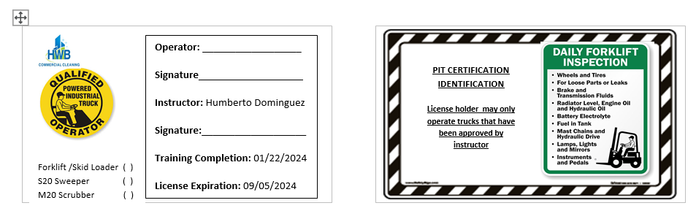

PIT id document history

Document Revision | Date | Prepared by | Reviewed by
Humberto Dominguez | 01/22/2024 | Humberto Dominguez | Kevin Bailey

APPENDIX D

PIT safety program meeting sign-in sheet

TOPICS: PPE, Power Industrial Trucks Training/ Most common OSHA Violations.
Instructor: Humberto Dominguez
Mandatory Attendance: HWB PIT Operators

Date:1/22/2024
Time:

Name | Skid Loader Training | Time | Signature
Alberto Benitez | Primary Operator
Kevin Bailey | Backup Operator

SAFETY DATA SHEETS MANUAL (GHS)

Right to understand

COMPANY SAFETY POLICY FOR POSTING AT ALL JOB SITES

Review of the law
UNDER THE PROVISIONS OF THE WORKPLACE HAZARDOUS MATERIALS INFORMATION SYSTEM, EMPLOYERS ARE RESPONSIBLE FOR INFORMING EMPLOYEES OF THE HAZARDS AND THE IDENTITIES OF WORKFORCE CHEMICALS TO WHICH THEY ARE EXPOSED. FIRST, YOU MUST DEVELOP A WRITTEN HAZARD COMMUNICATION PROGRAM.
It is a WHMIS 2015 requirement for an employer to have a joint health and safety committee/ representative, conduct workplace inspections, disseminate information, promote training and education and resolve occupational health and safety disputes.
It is helpful to have a written program to manage this. All employers are required to provide information to all employees concerning chemical safety in the workplace, according to WHMIS.
Enforcement of WHMIS is managed by provincial/territorial occupational health and safety authorities. Employer requirements:
• Educate and train workers on the hazards and safe use of products.
• Ensure that hazardous products are properly labelled.
• Provide access to up-to-date SDSs to workers.
• Ensure appropriate control measures are in place to protect the health and safety of workers.
IMPORTANT
• This Safety Data Sheet (SDS) Manual is designed to assist you in complying with Federal Hazard Communication regulations. It does not address any additional provincial or local regulations.
• This SDS Manual is designed to provide information regarding its subject matter that is accurate as of its preparation date.
• Be sure you have an SDS for each hazardous chemical on site. Contact your chemical product supplier immediately if you are missing any SDS.

OBJECTIVE
The objective of this program is to set forth policies and procedures concerning Hazard Communication to enhance the safety and well-being of employees. Furthermore, the execution of this program is designed to help comply with the Occupational Safety and Health Administration’s (OSHA) Hazard Communication Standard.

ASSIGNMENT OF RESPONSIBILITY
Humberto Dominguez is the Hazard Communication Officer and is responsible for ensuring responsible persons noted herein adhere to this program and report correctly.

Explanation of Safety Data Sheets

Forms

Simple green oxy solve
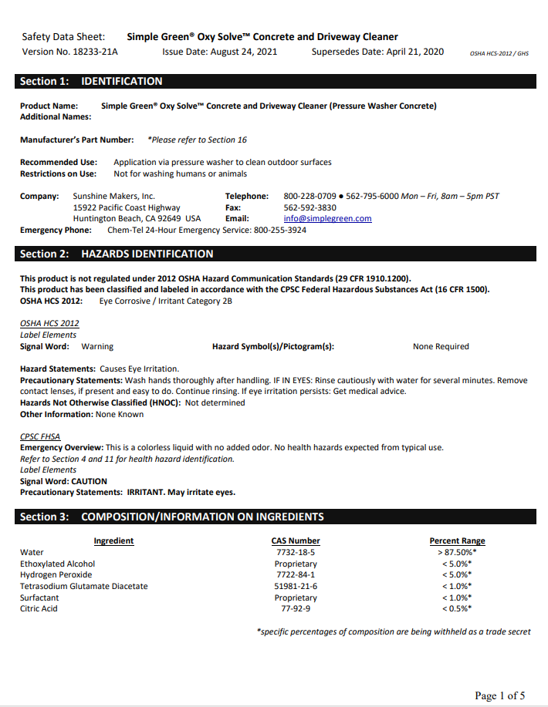
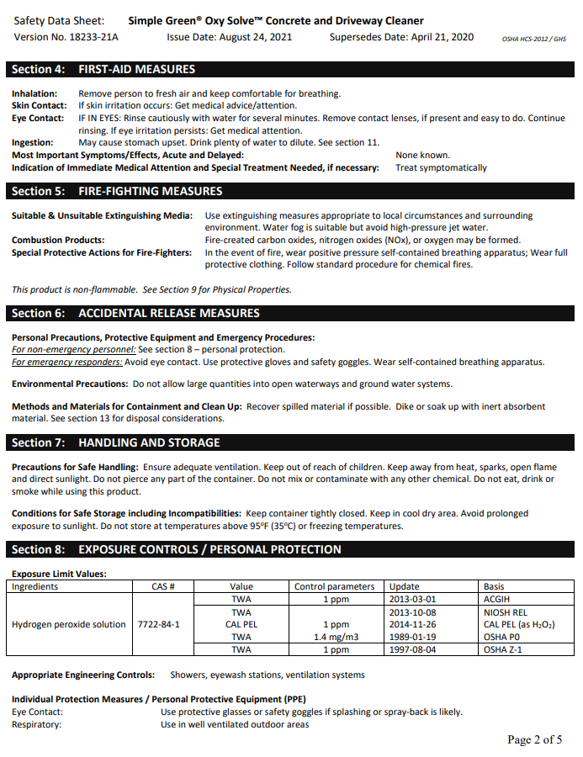
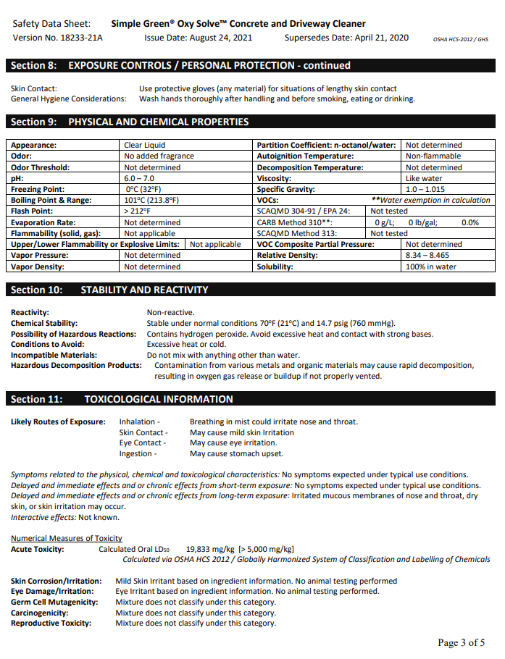
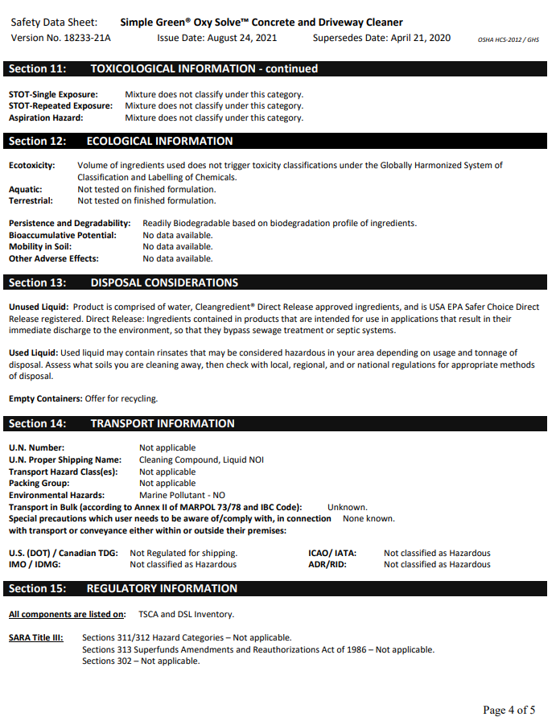
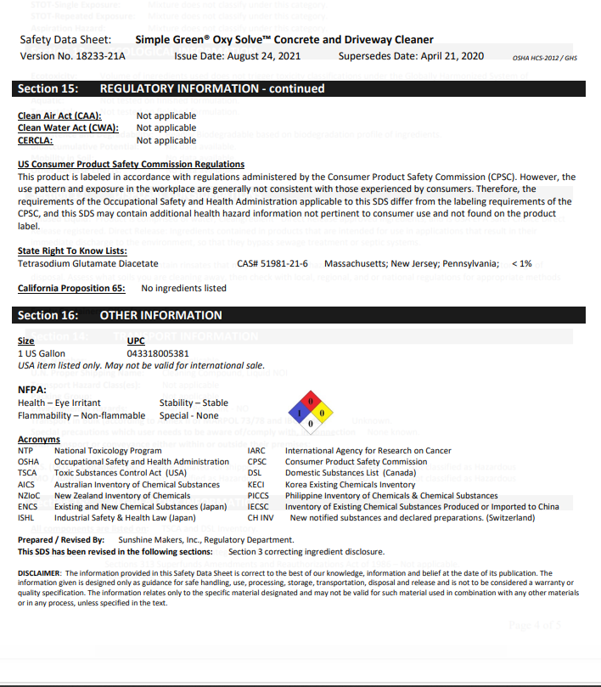

Diesel fuel
