
QUALITY ALERT

Customer: Reliance Date: August 2, 2018
Die: 1020 Colour: ANY
Type of Complaint: Reliance REJECTED

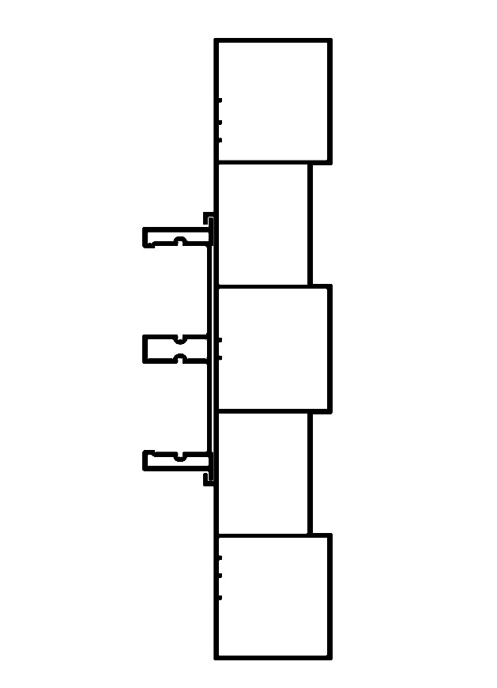
Q.A # Q.I.R # CUSTOMER NCR #

Description: Reliance rejected because of bowing/bending causing the window insert to be hard to slide in

CHECK WITH #1027 - 4 FT. OR LONGER, MUST SLIDE IN EASILY

PUT 2 – 48” PIECES ON FLOOR AND CHECK FOR BENDING AND BOWING
BY SIGNING BELOW, YOU ACKNOWLEDGE THE PROBLEM ABOVE AND AGREE TO MONITOR THIS ISSUE IN FUTURE PRODUCTION RUNS.
DAY SHIFT |  | AFTERNOON SHIFT |  | NIGHT SHIFT
NAME | SIGNATURE | NAME | SIGNATURE | NAME | SIGNATURE

