
QUALITY ALERT

Customer: Vision Building Date: July 15, 2025
Die: 1020 Colour: Any
Type of Complaint: Customer REJECTED

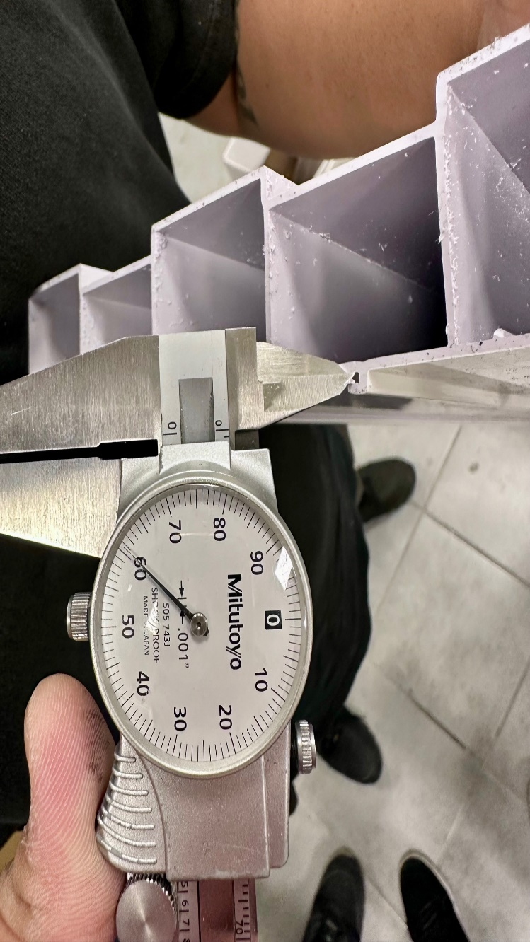
Q.A # 25-021 NCR: 195 RMA#: N/A

Description: Customer REJECTED due to engagement legs gap were too close, result in failure to assemble.
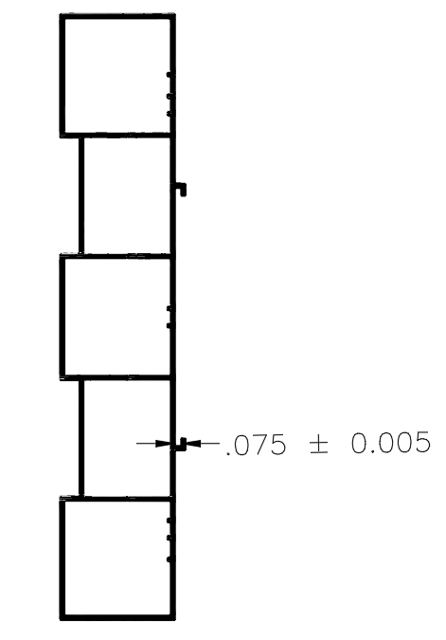

ENSURE ENGAGEMENT LEG GAPS MEET SPECIFIED TOLERANCES TO AVOID ASSEMBLY ISSUES.

Ask ChatGPT

Ask ChatGPT

BY SIGNING BELOW, YOU ACKNOWLEDGE THE PROBLEM ABOVE AND AGREE TO MONITOR THIS ISSUE IN FUTURE PRODUCTION RUNS.
DAY SHIFT |  | AFTERNOON SHIFT |  | NIGHT SHIFT
NAME | SIGNATURE | NAME | SIGNATURE | NAME | SIGNATURE
F-006: Quality Alert | Eff.Date: 05/03/2025 | CC# 25-046 | Rev.0

