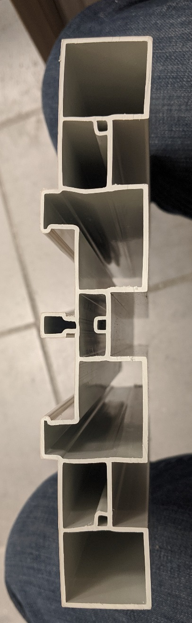

QUALITY ALERT

Customer: Reliance / Vision Building Products Date: December 17, 2019
Die: 1022 Customer NCR:
Type of Complaint: REJECT

Description: Reliance REJECT - the screw holes were not lining up when screwed into header. Upon inspection material was found not flat causing the screw ports to be off
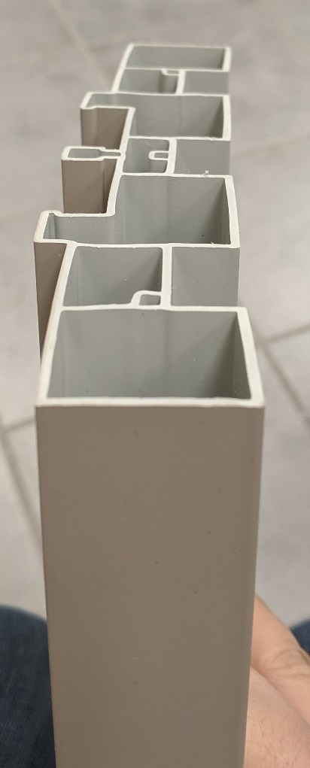

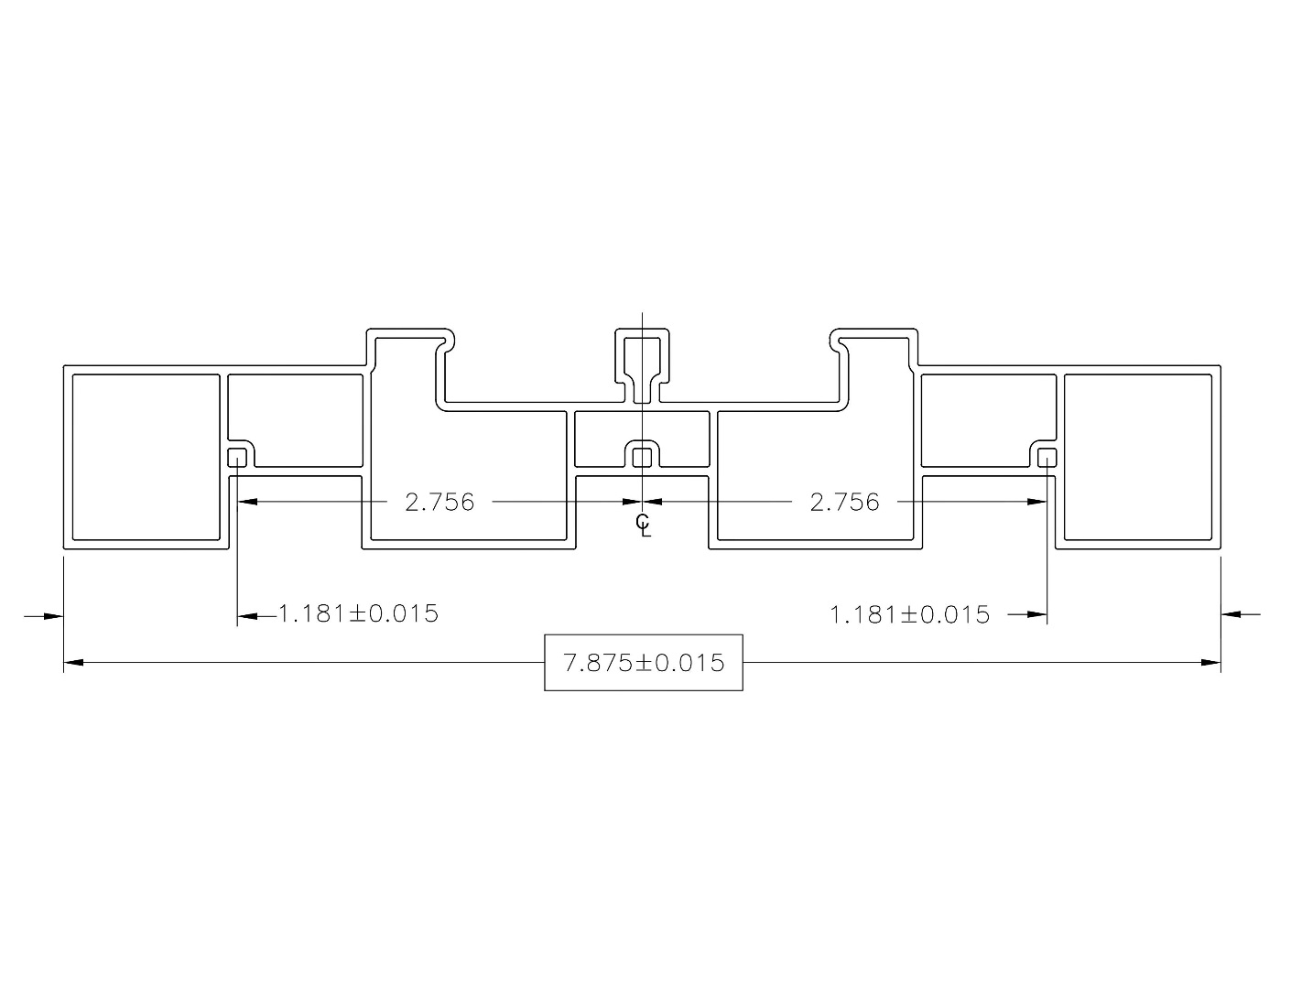

BY SIGNING BELOW, YOU ACKNOWLEDGE THE PROBLEM ABOVE AND AGREE TO MONITOR THIS ISSUE IN FUTURE PRODUCTION RUNS.
DAY SHIFT |  | AFTERNOON SHIFT |  | NIGHT SHIFT
NAME | SIGNATURE | NAME | SIGNATURE | NAME | SIGNATURE

