
QUALITY ALERT

Customer: Reliance Date: August 2, 2018
Die: 1024 Colour: ANY
Type of Complaint: Reliance REJECTED

Q.A # Q.I.R # CUSTOMER NCR #

Description: Reliance rejected because of bowing/bending causing the window insert to be hard to slide in
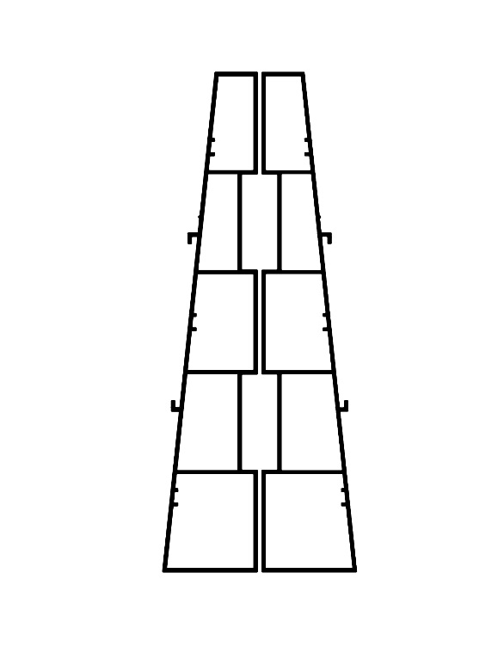

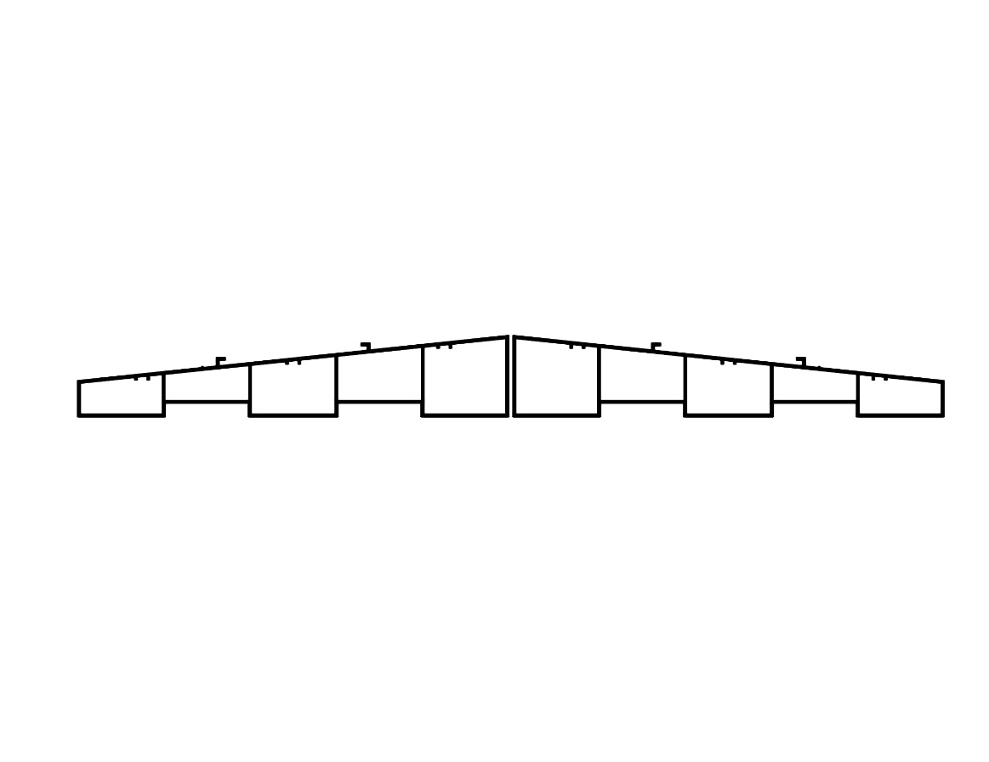

PLACE AS SHOWN TO CHECK BEND

PLACE AS SHOWN TO CHECK BEND

PUT 2 – 48” AND 2-FULL LENGTH PIECES ON FLOOR AND CHECK FOR BENDING AND BOWING
BY SIGNING BELOW, YOU ACKNOWLEDGE THE PROBLEM ABOVE AND AGREE TO MONITOR THIS ISSUE IN FUTURE PRODUCTION RUNS.
DAY SHIFT |  | AFTERNOON SHIFT |  | NIGHT SHIFT
NAME | SIGNATURE | NAME | SIGNATURE | NAME | SIGNATURE

