DIE# 1024 – RELIANCE (Extruder Side)
GREEN BUGGY – Wrap arms in cardboard
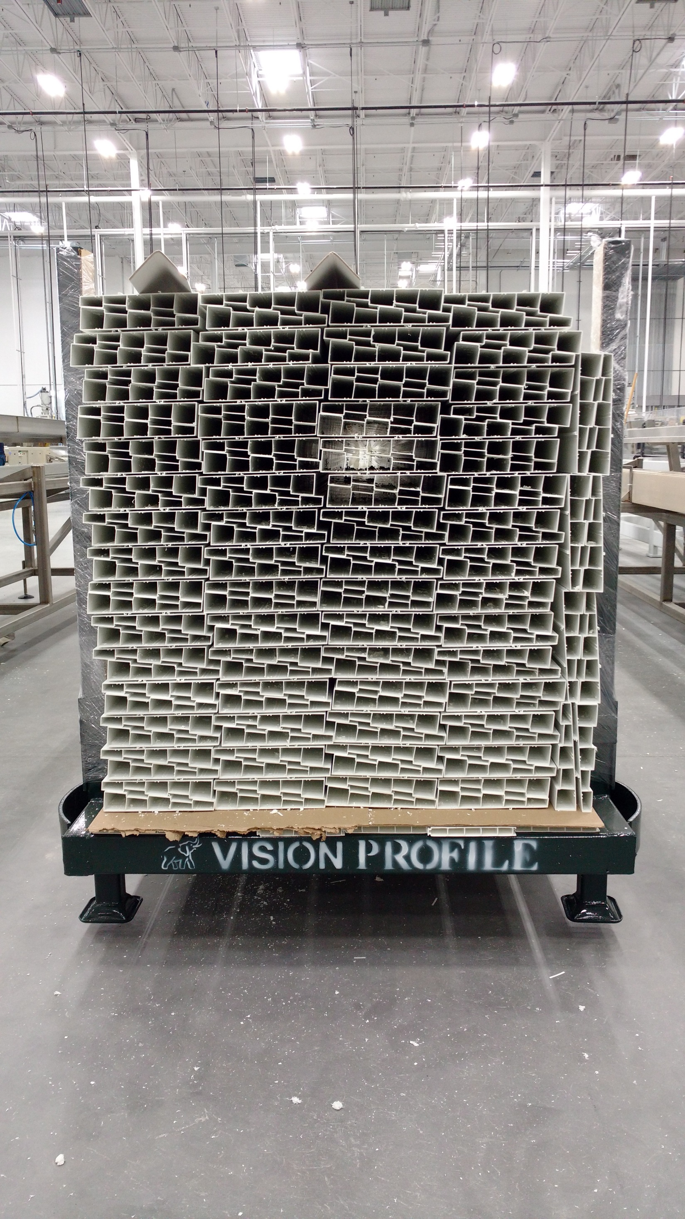
NO FOAM

